Documentation Form

Overview

Images
Top | Back
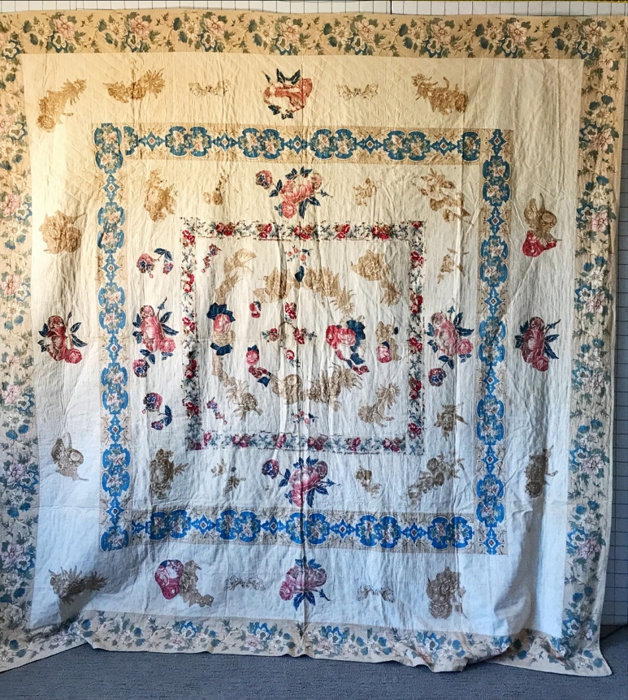 | 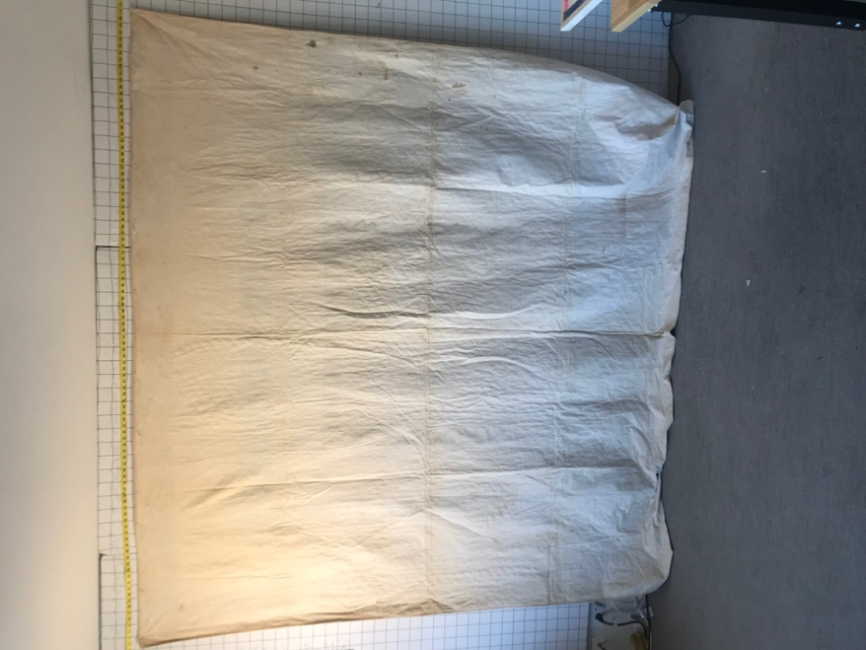

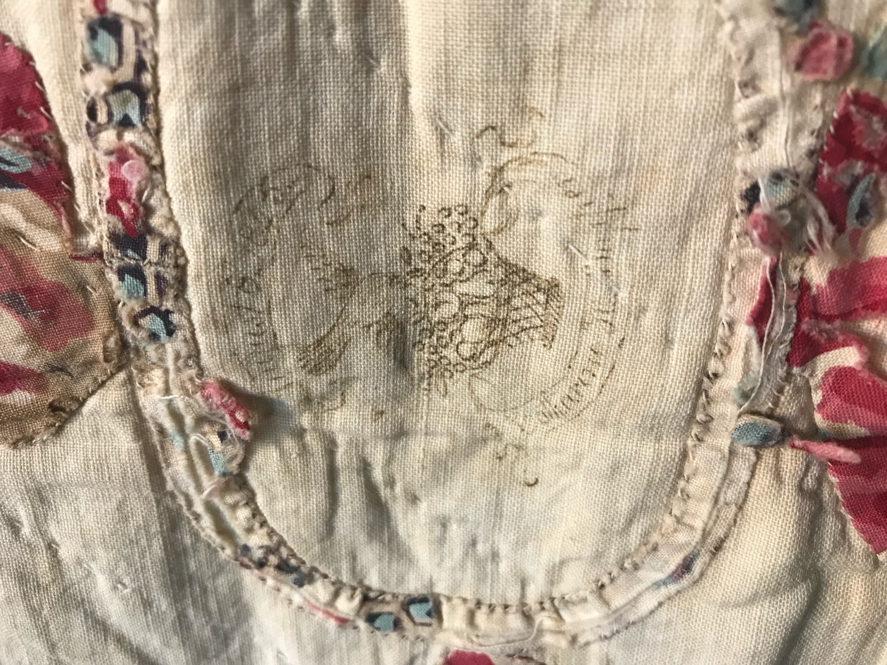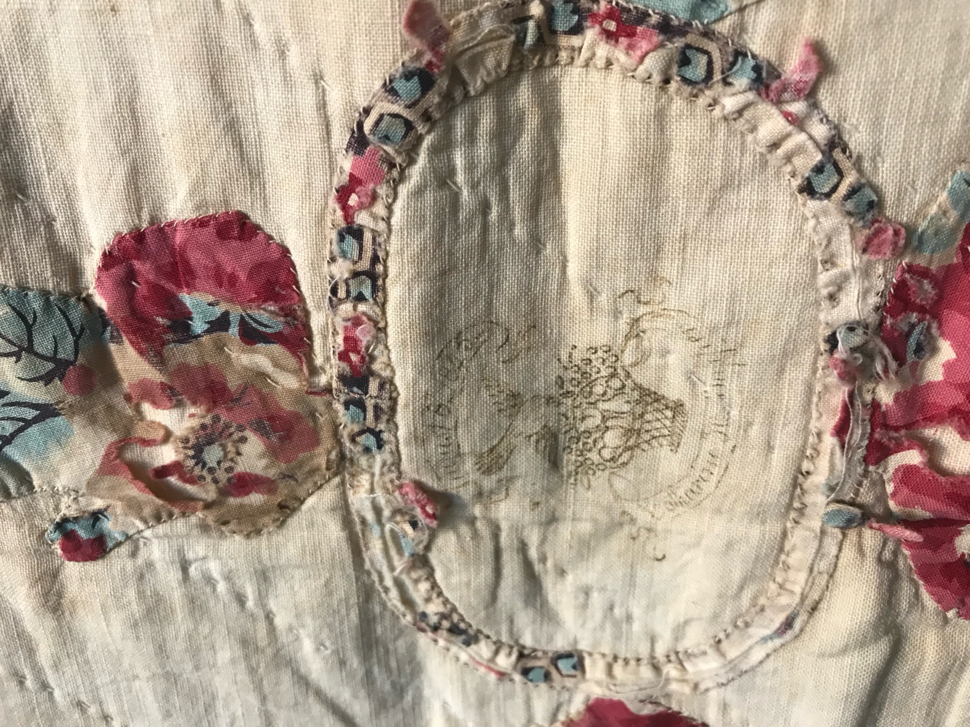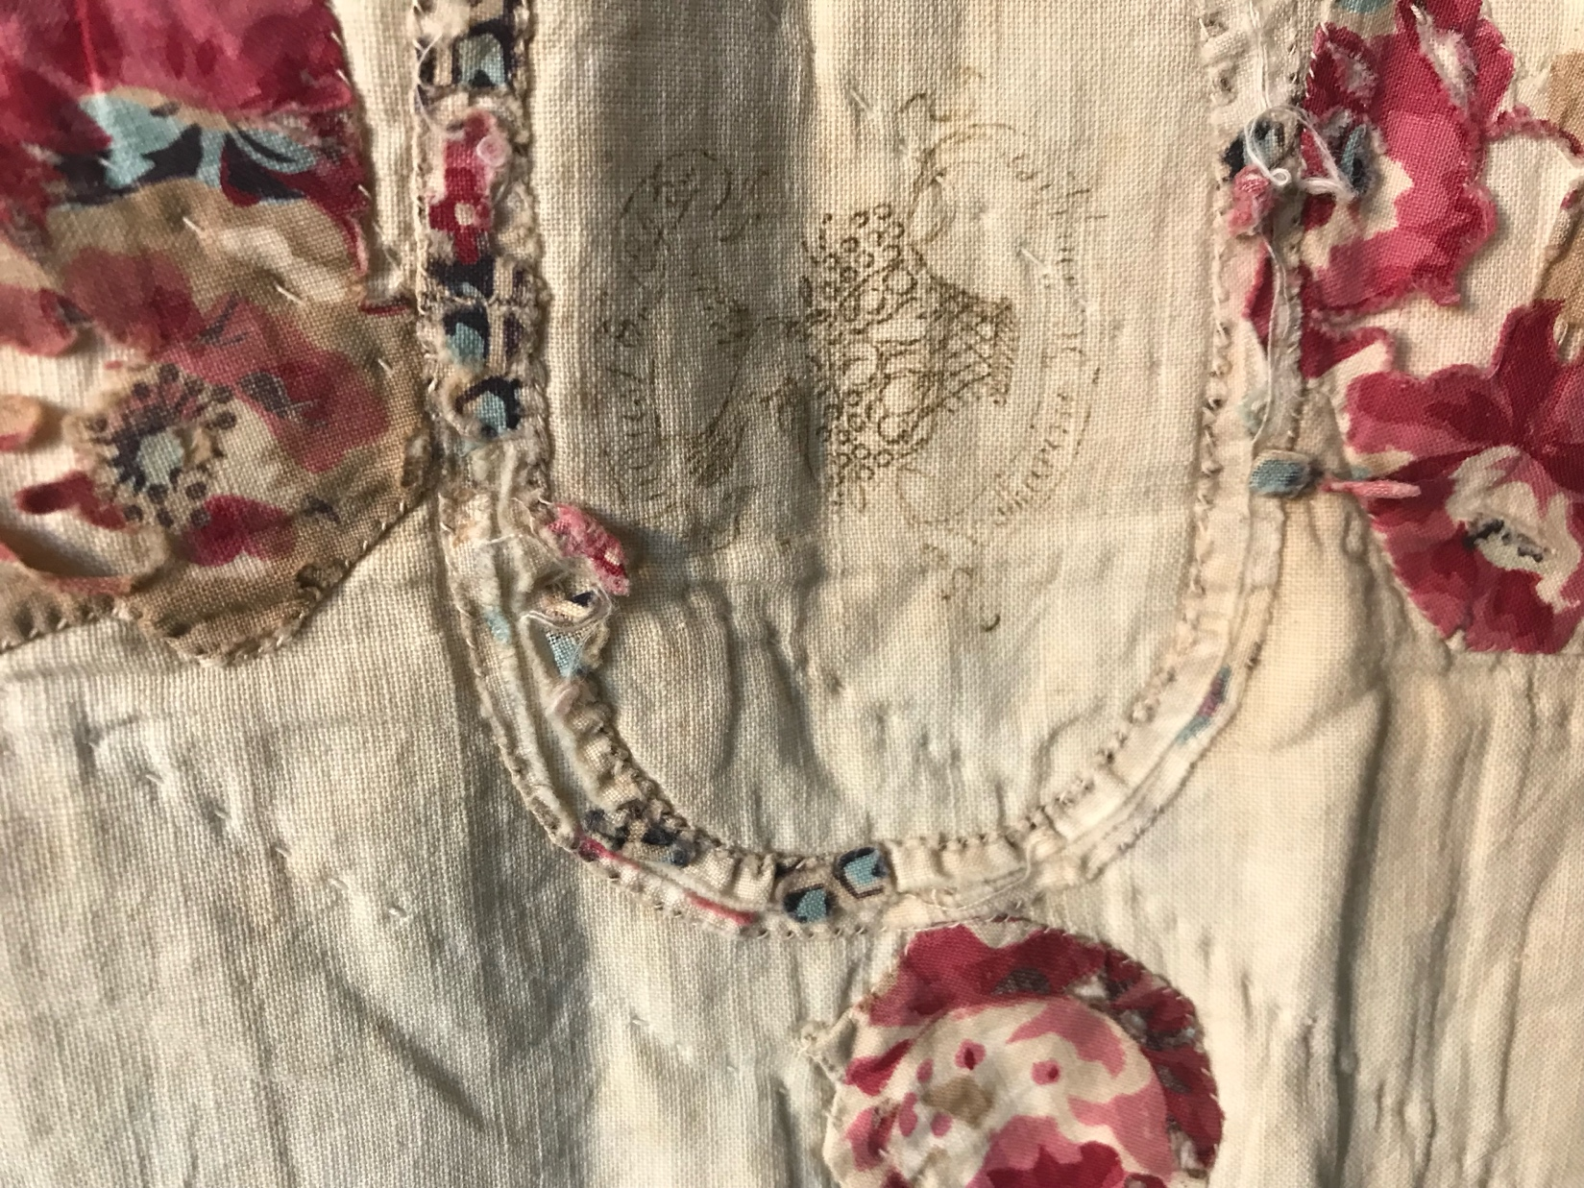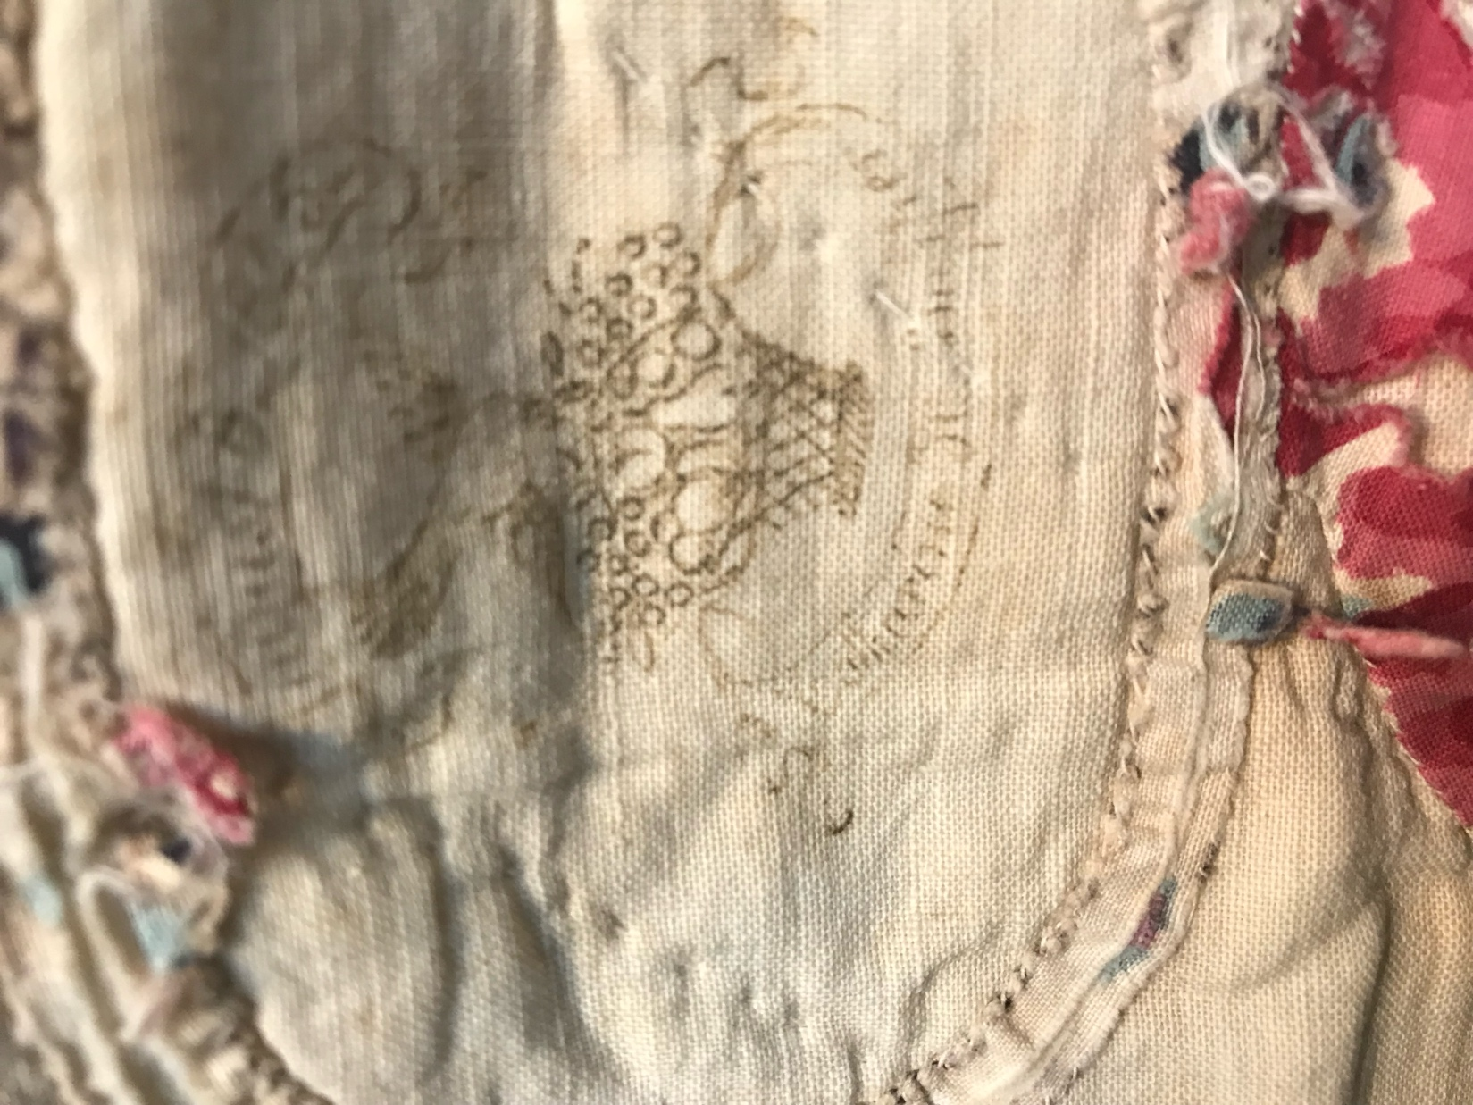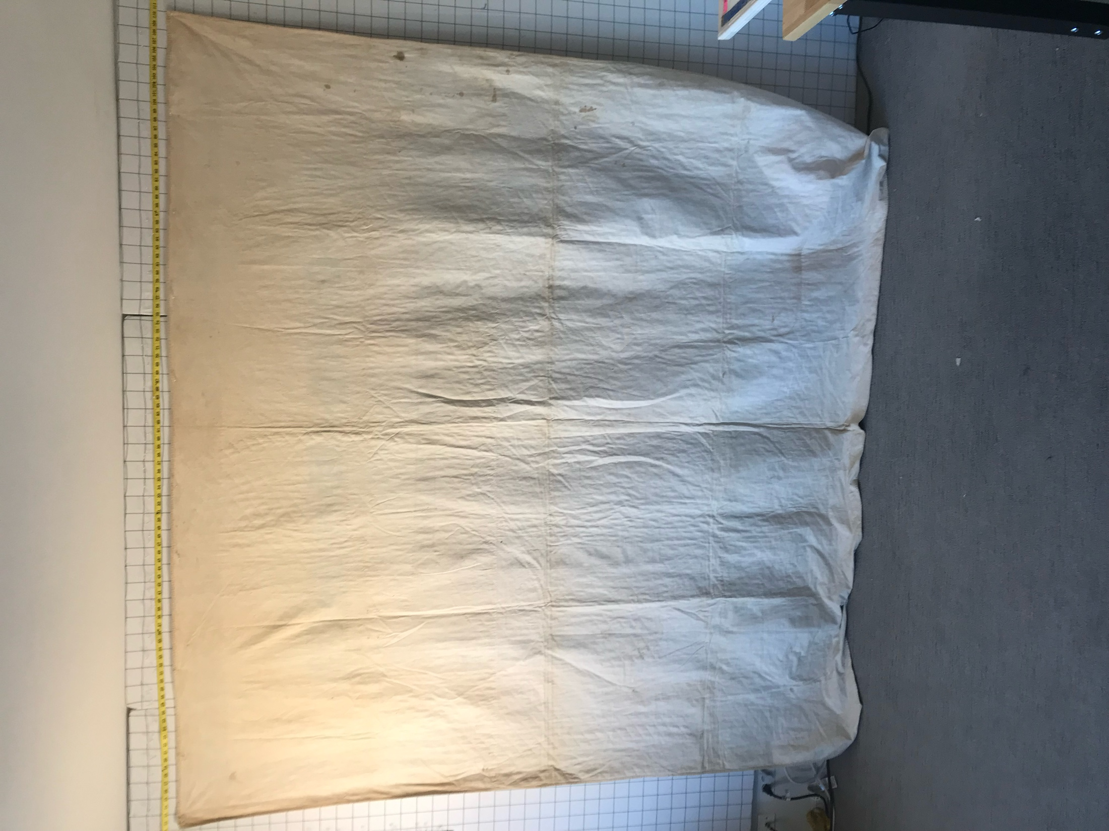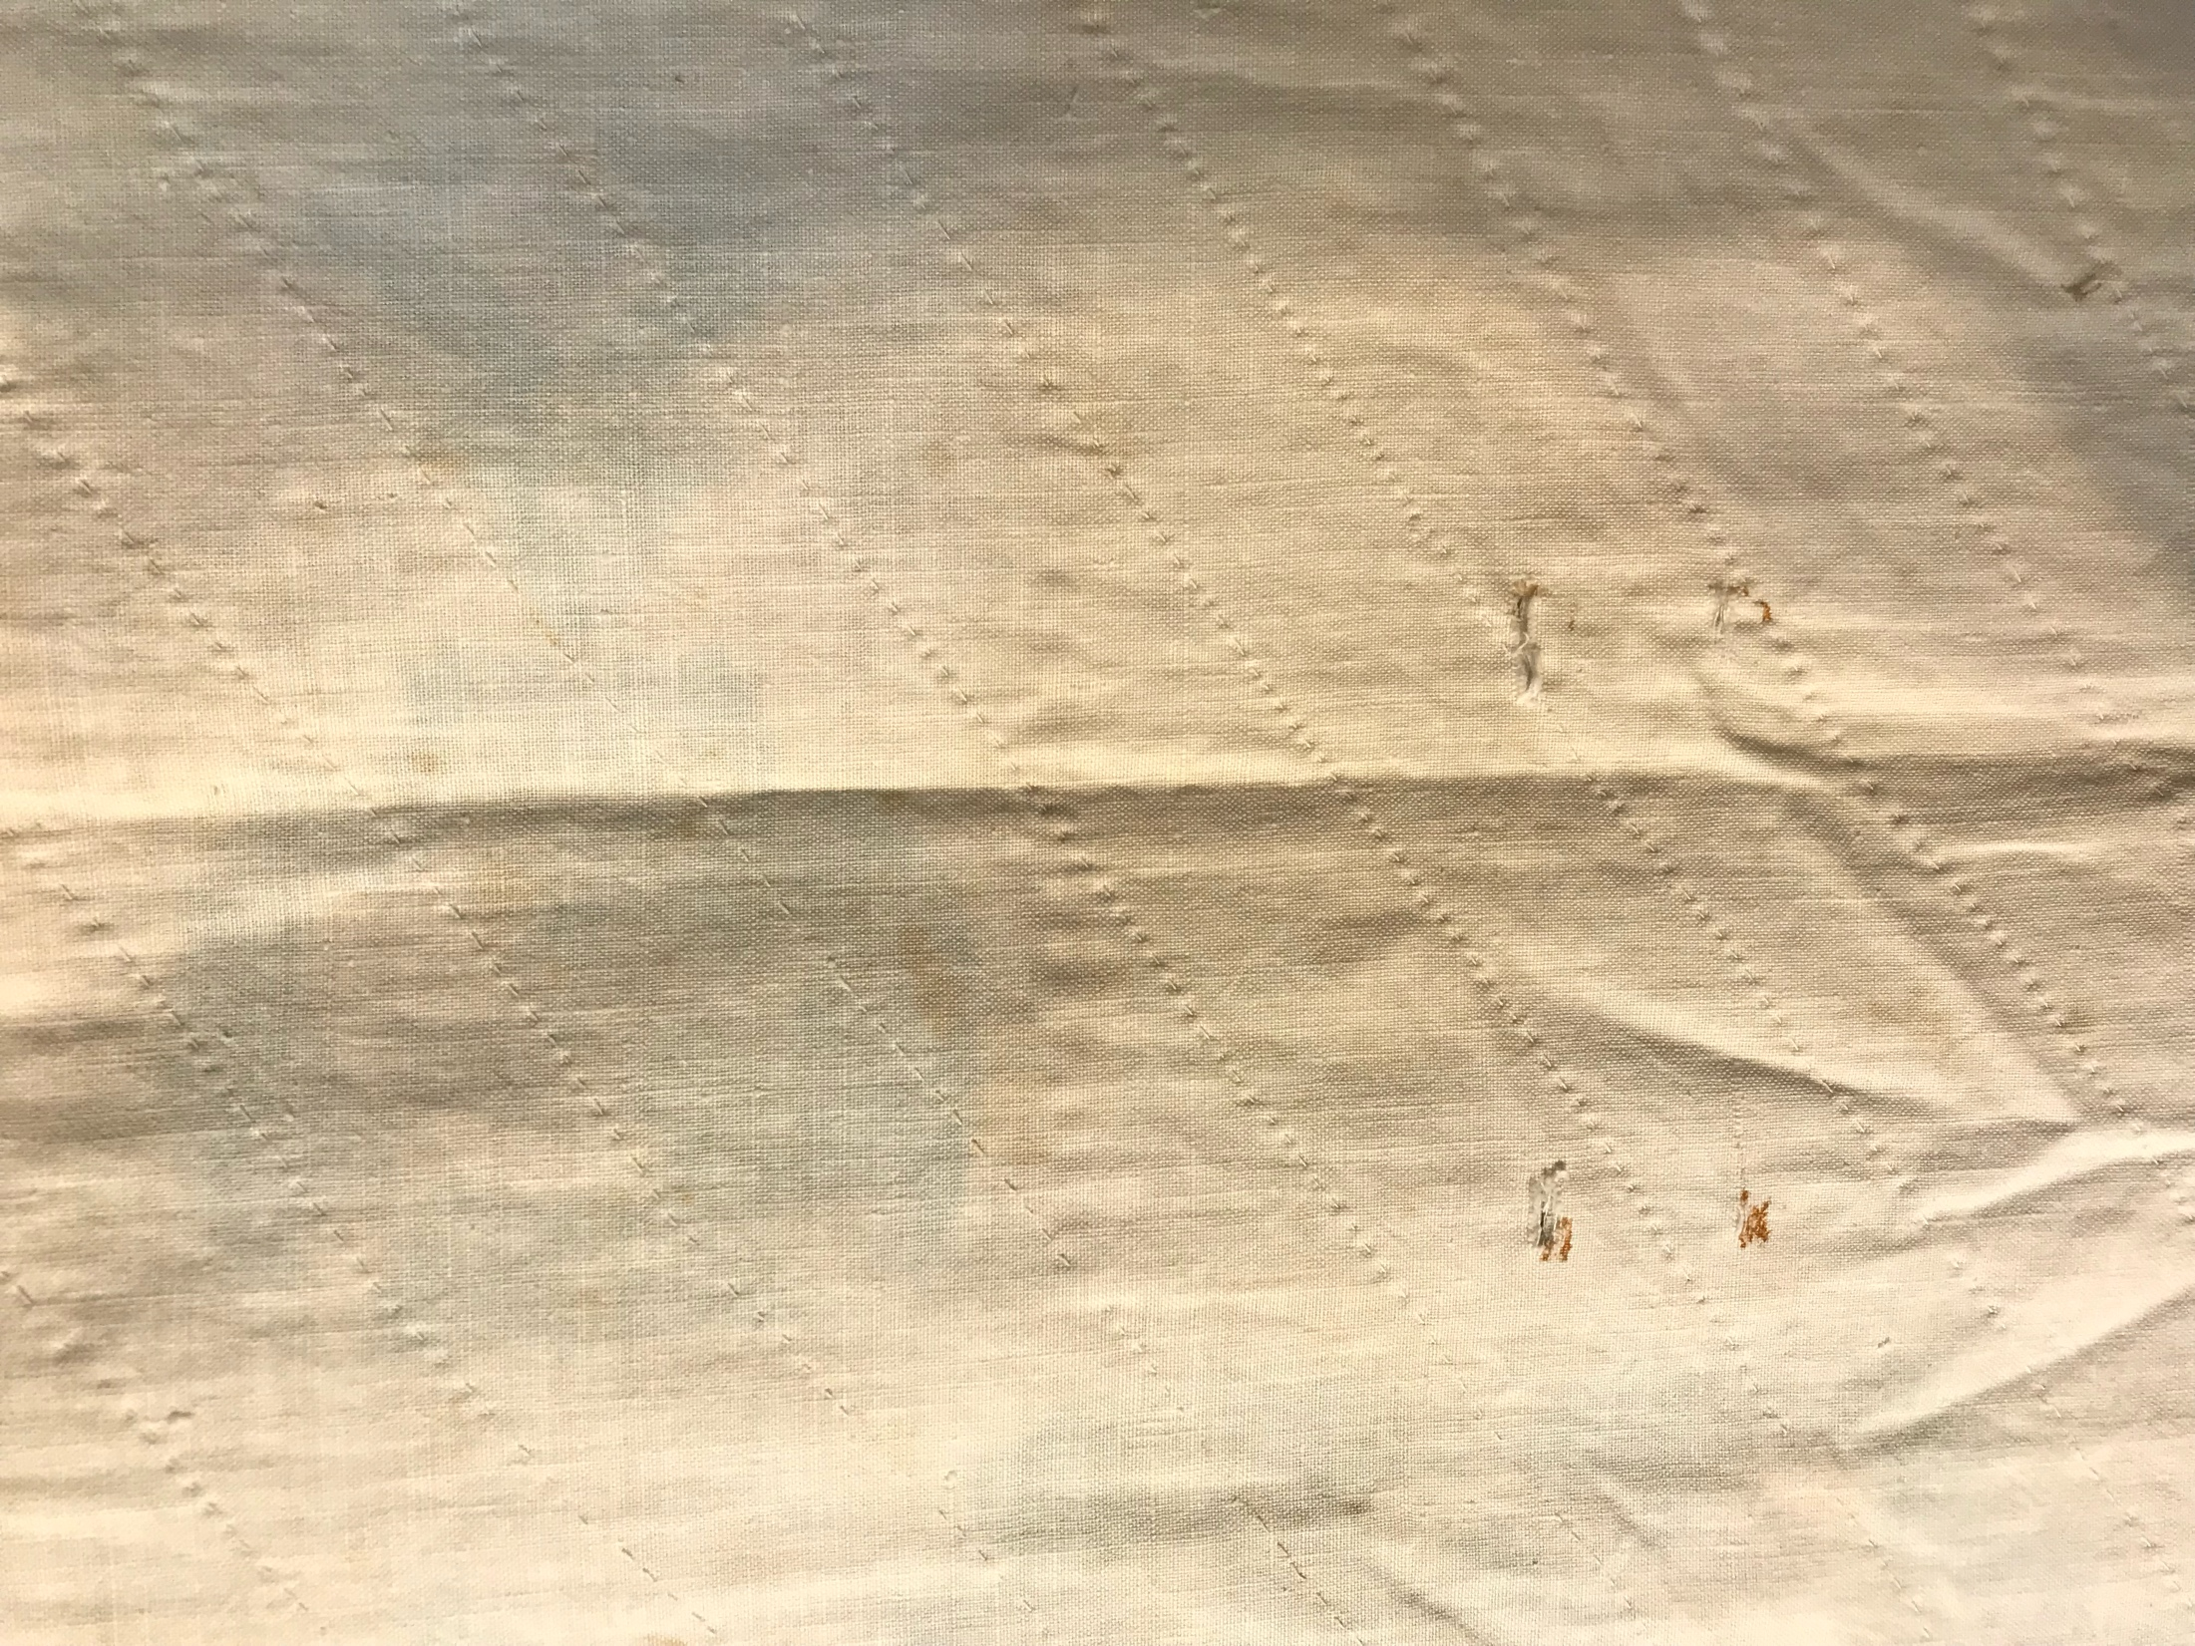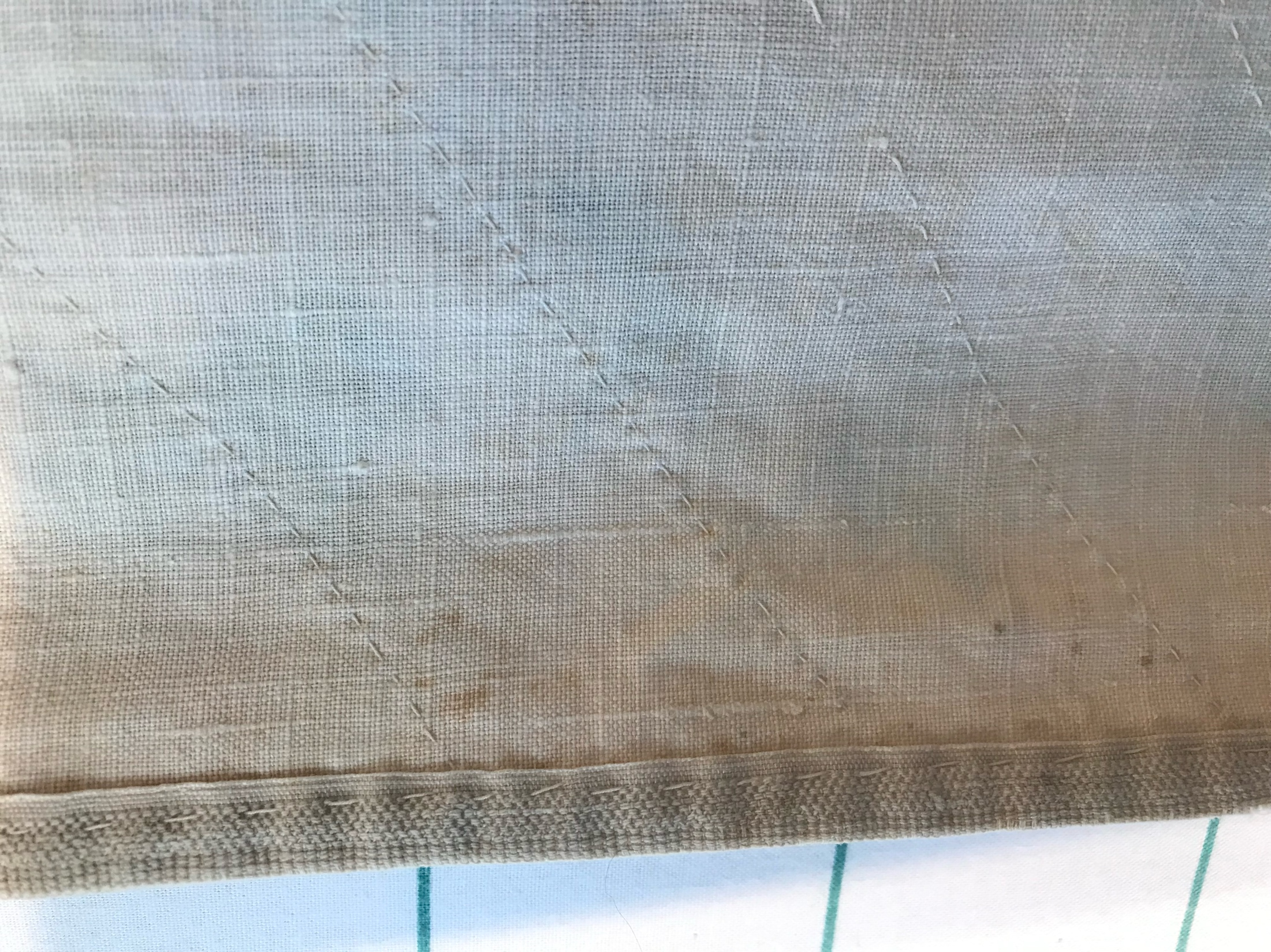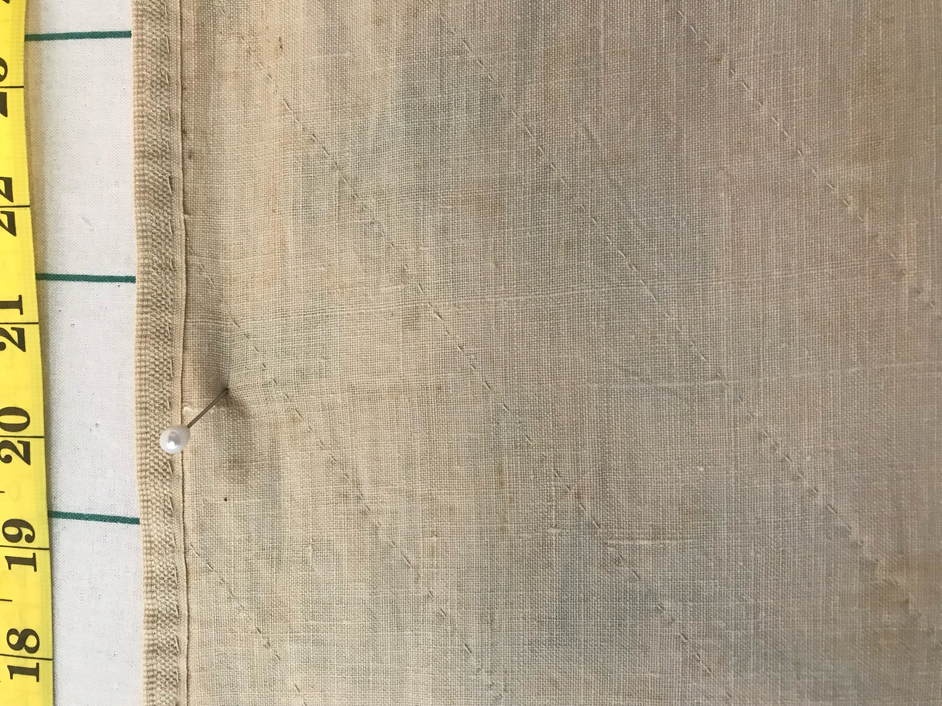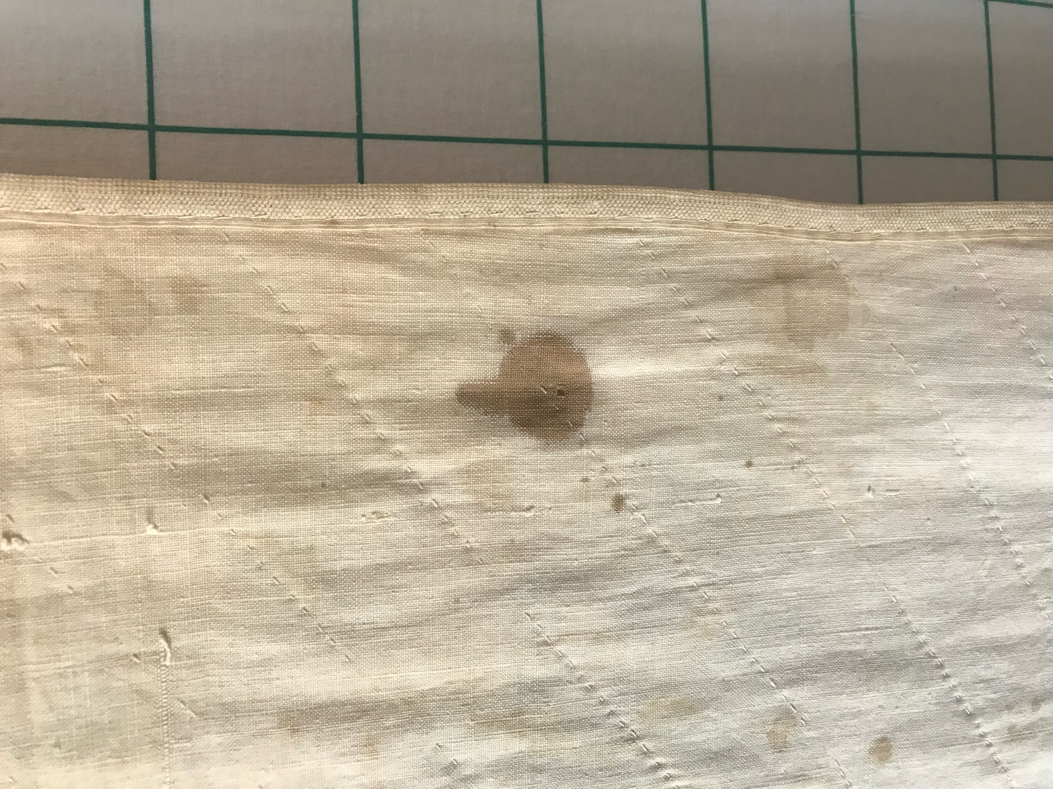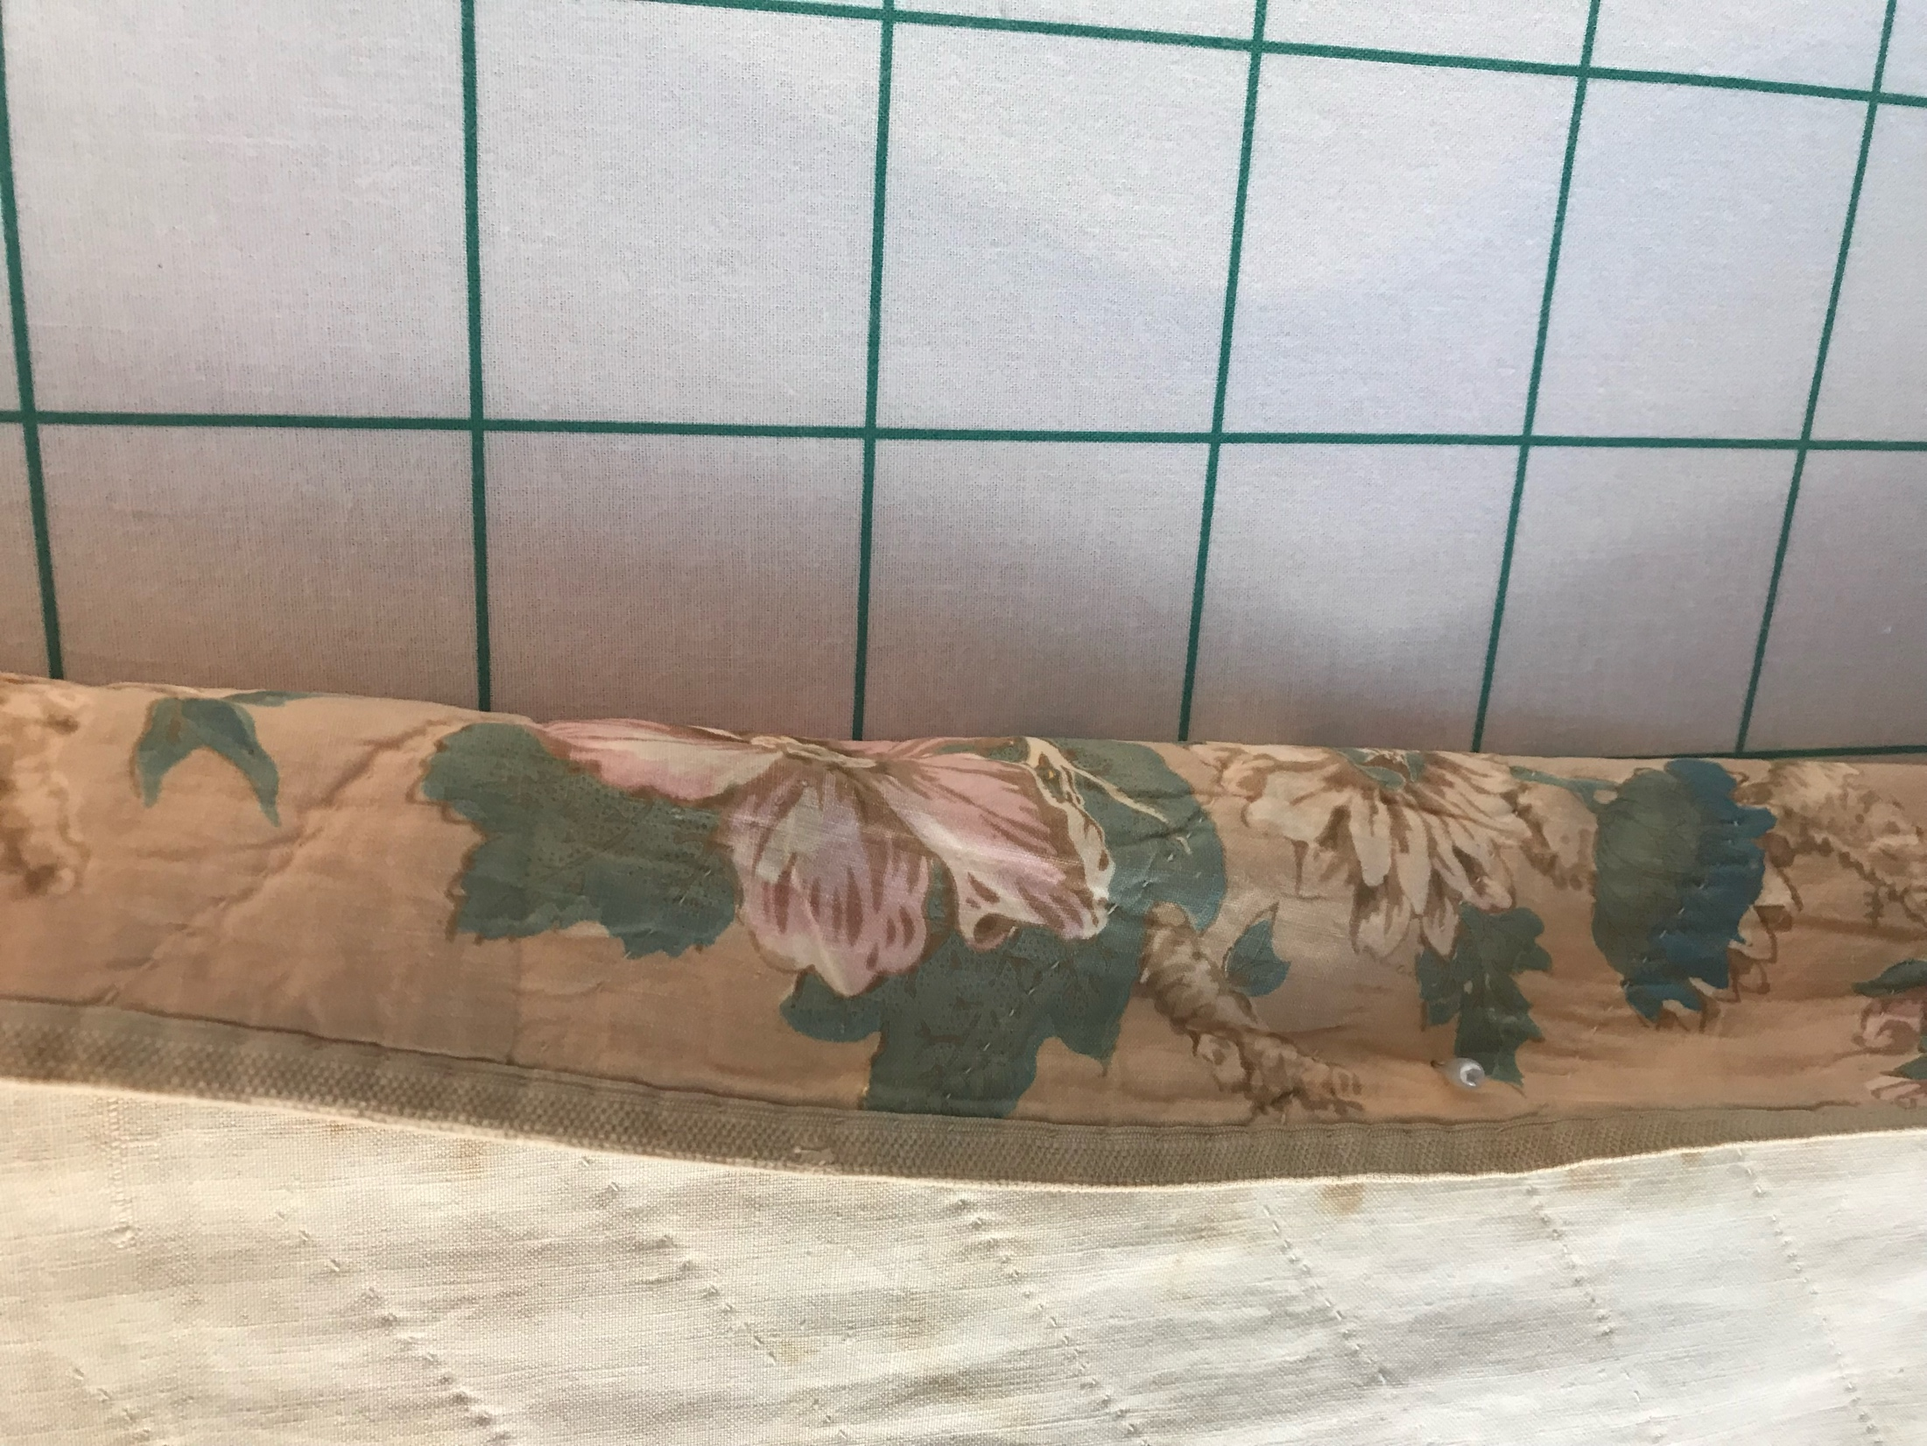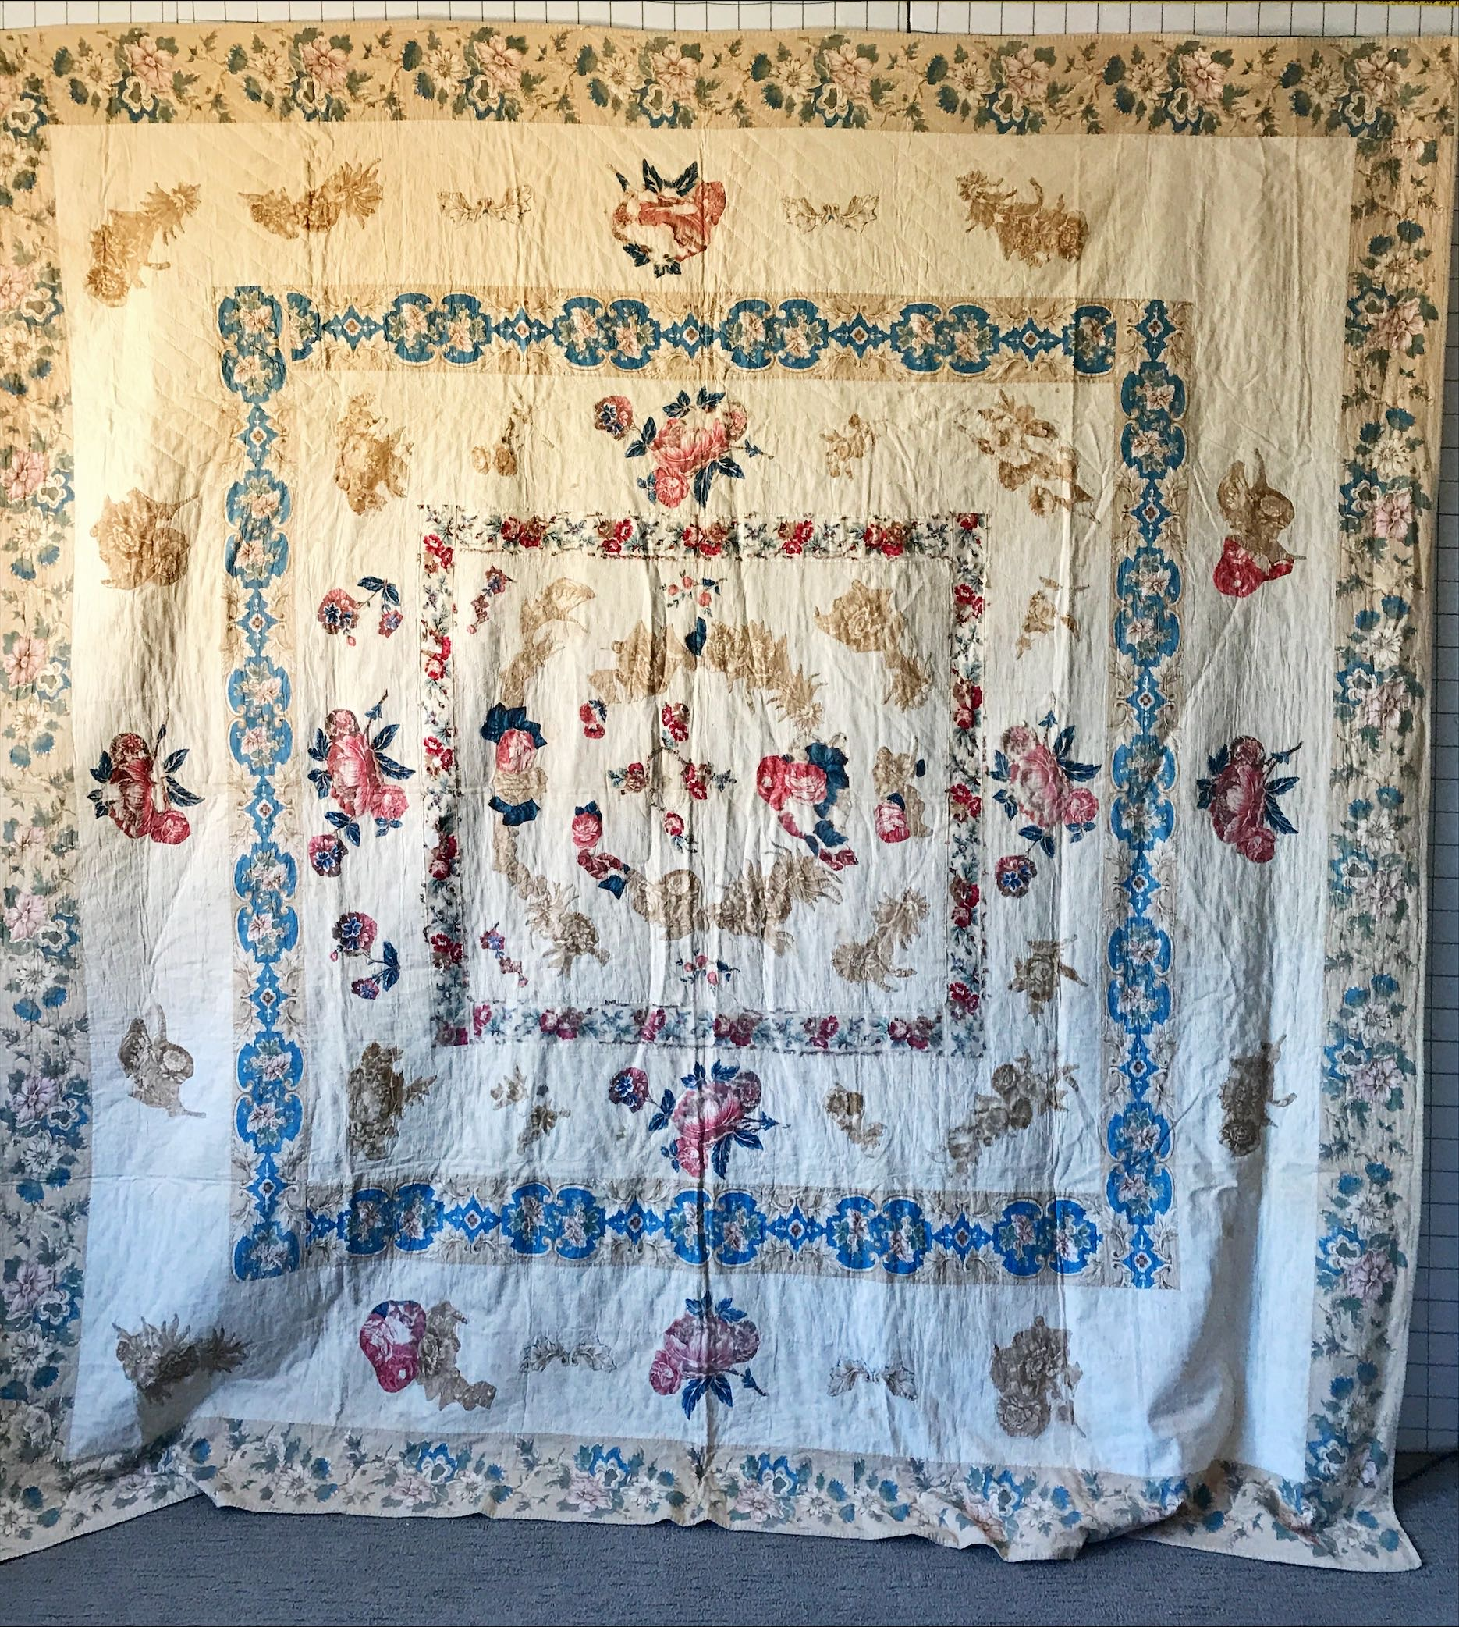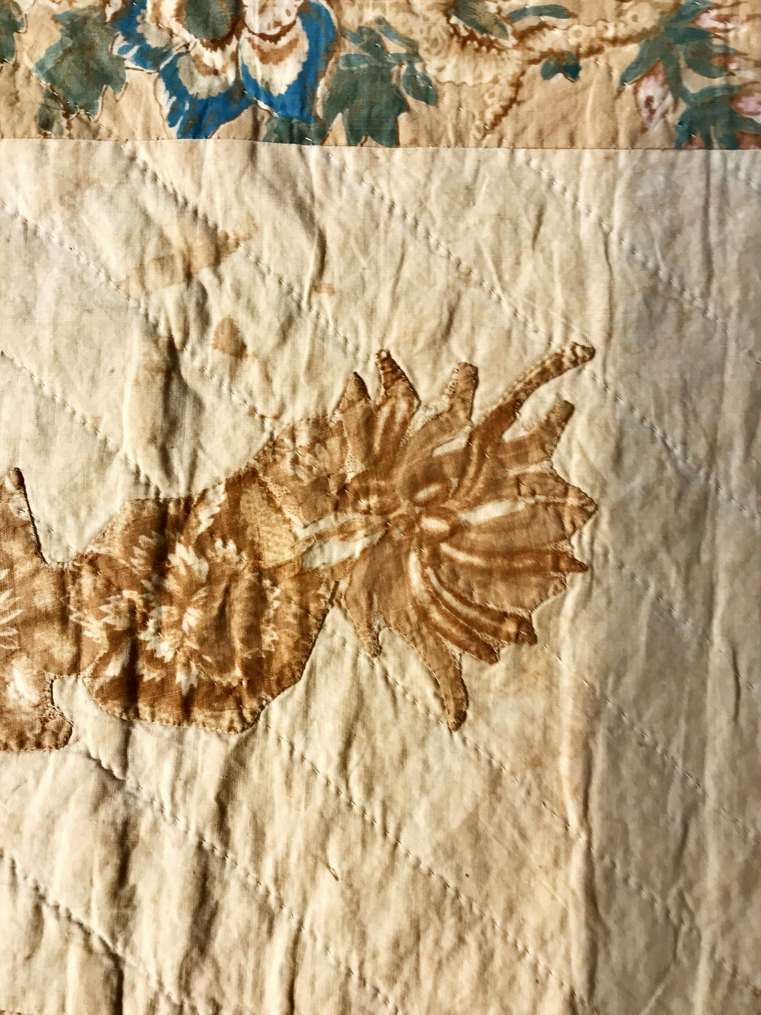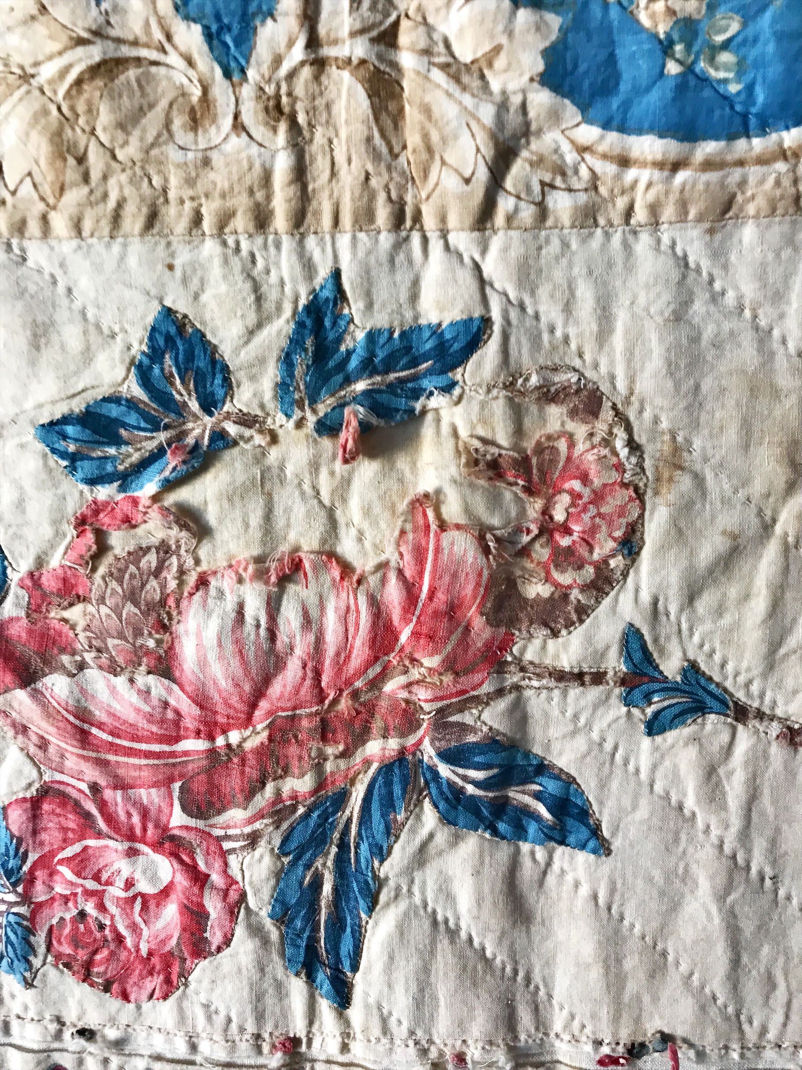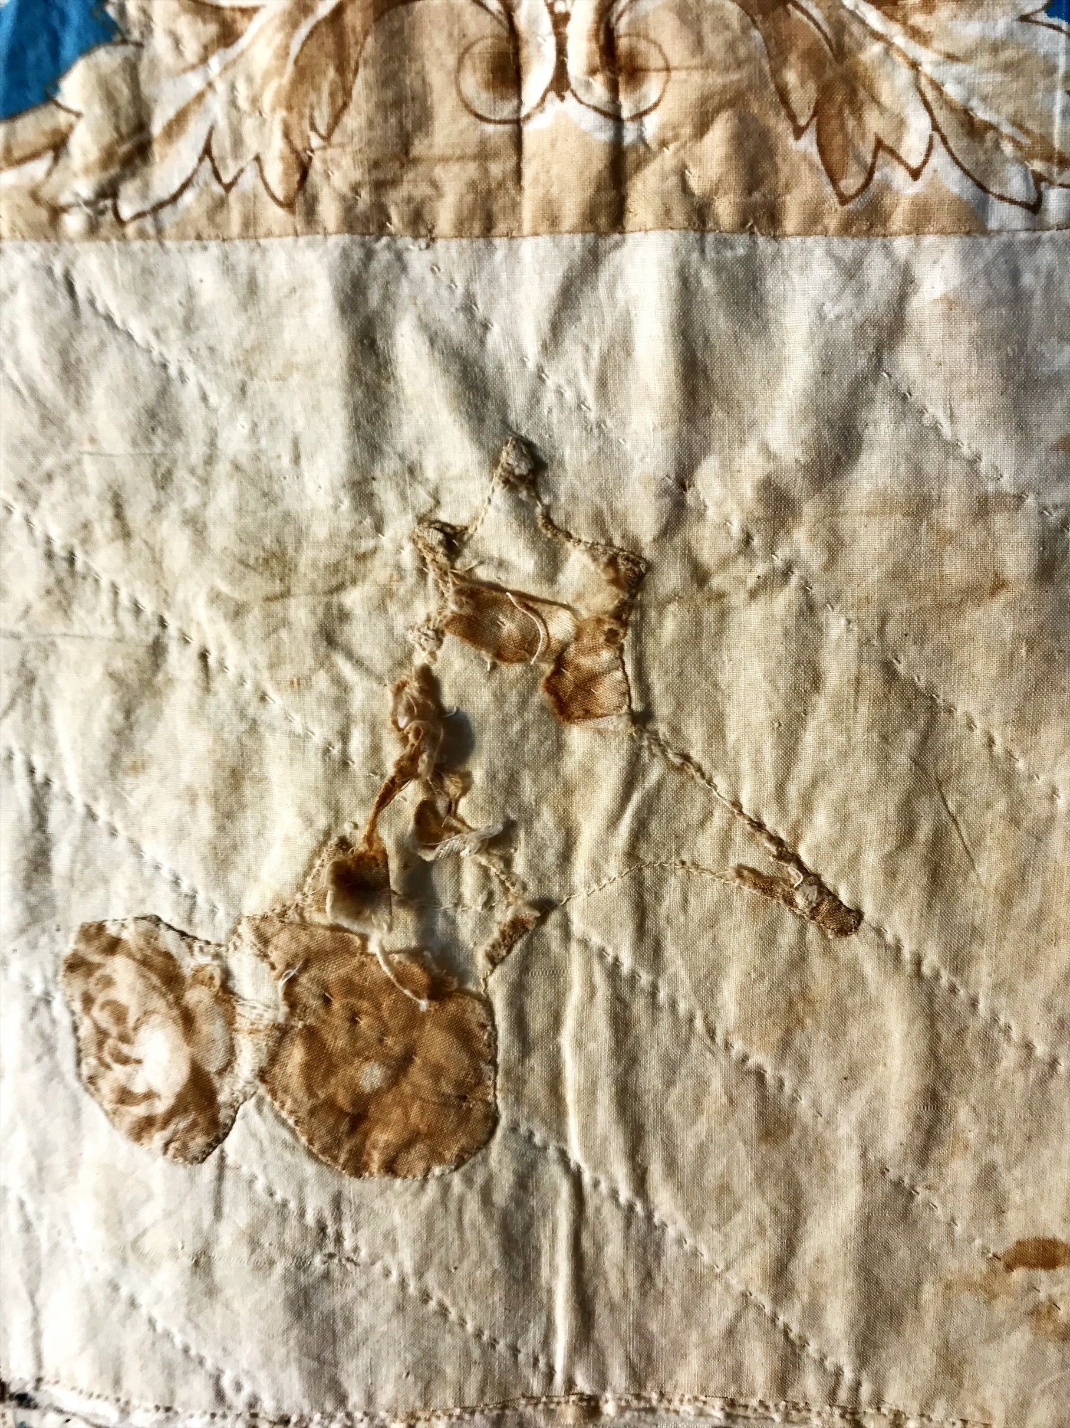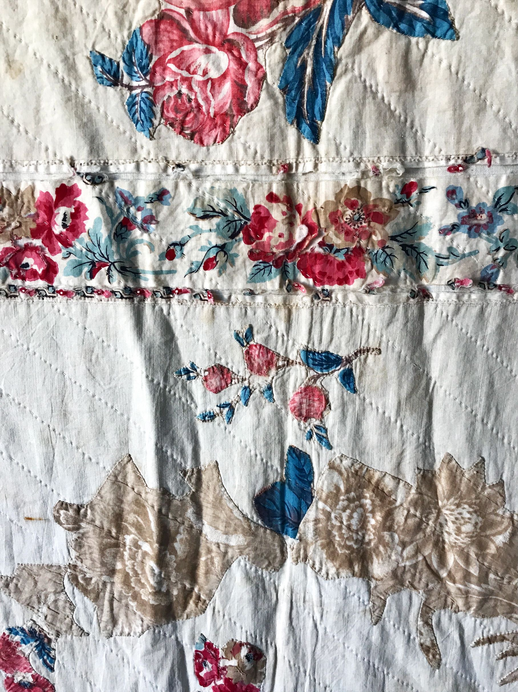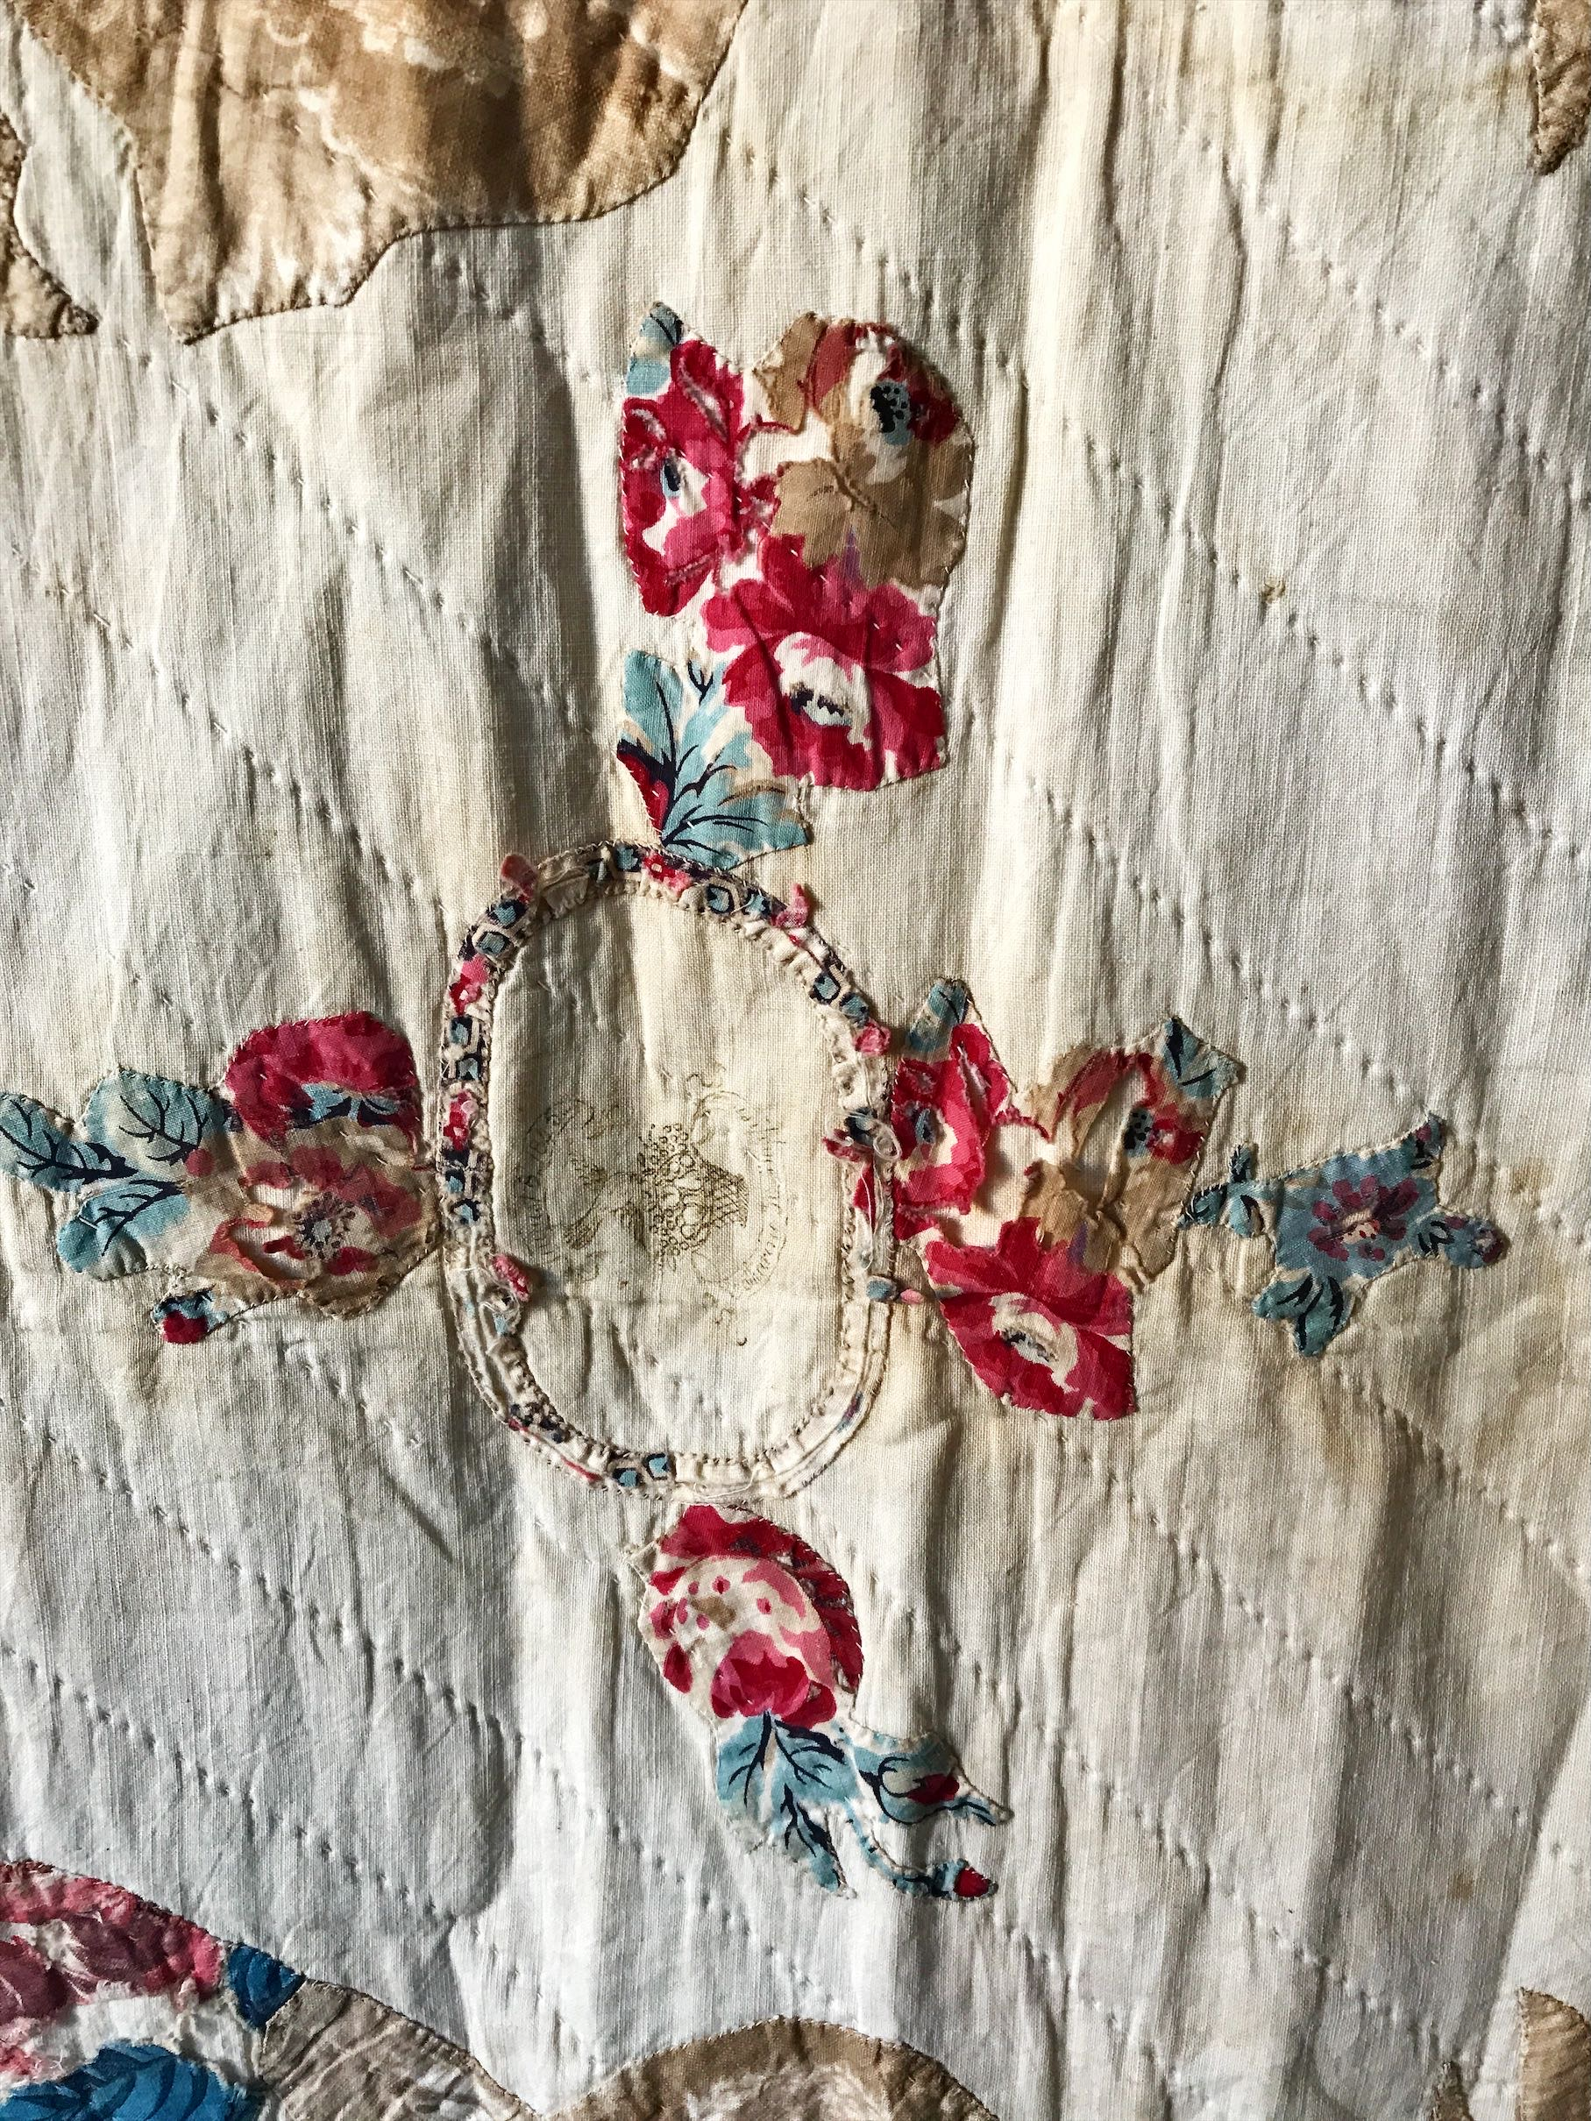

History

Known Owners
Owner | From Date | To Date | Acquired at: | Cost
David Bailey | 2025-11-14 | -- | Chris Moline | $100
Made in:
--
 | If not purchased, the estimated cost for materials: $0

Display & Publication History
Date | Event | Location / Publication
-- | -- | --

General Description
Quilt Title or Name:  Broderie Perse | Fabric Date Range: 1845 ± 10 Years  Date Made: -- ± 0 Years  Method of Determination: and is consistent with style and fabric.
Item Type:  Items in Set: 1 | Size: Length: 99“ x Width: 94“
Appraisals:  Has this quilt been professionally appraised?  If so, when: --  ----------- | Other Related Information:  Quilt Index #:  Scanned Patterns  Images  EQ 8 Files  Research Notes
Additional Information: This item is an example of broderie perse technique from the 1840's. It has conditions issues. Prior to coming into Chris's ownership, this quilt was owned by another appraiser who had the quilt cleaned. Now it is good for little more than to look at the technique, workmanship and an example of what can happen when a quilt is washed.

