Documentation Form

Overview

Images
Top | Back
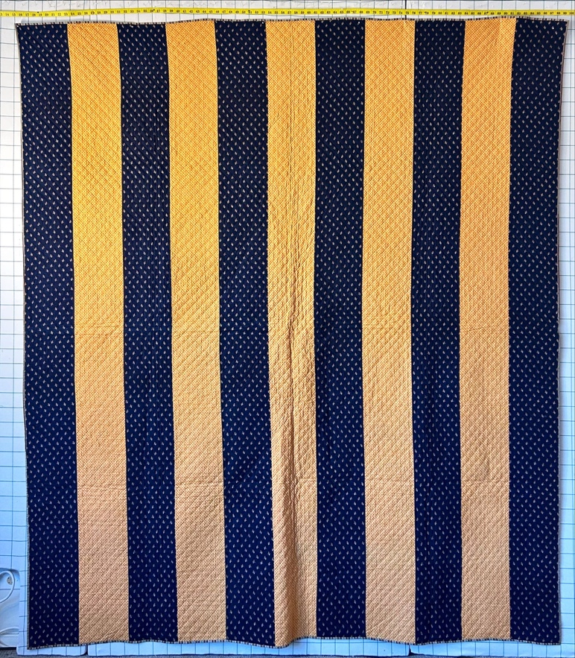 | 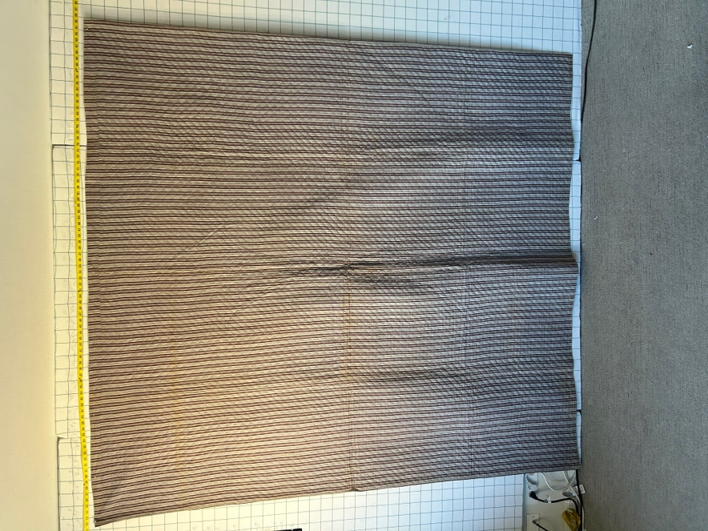

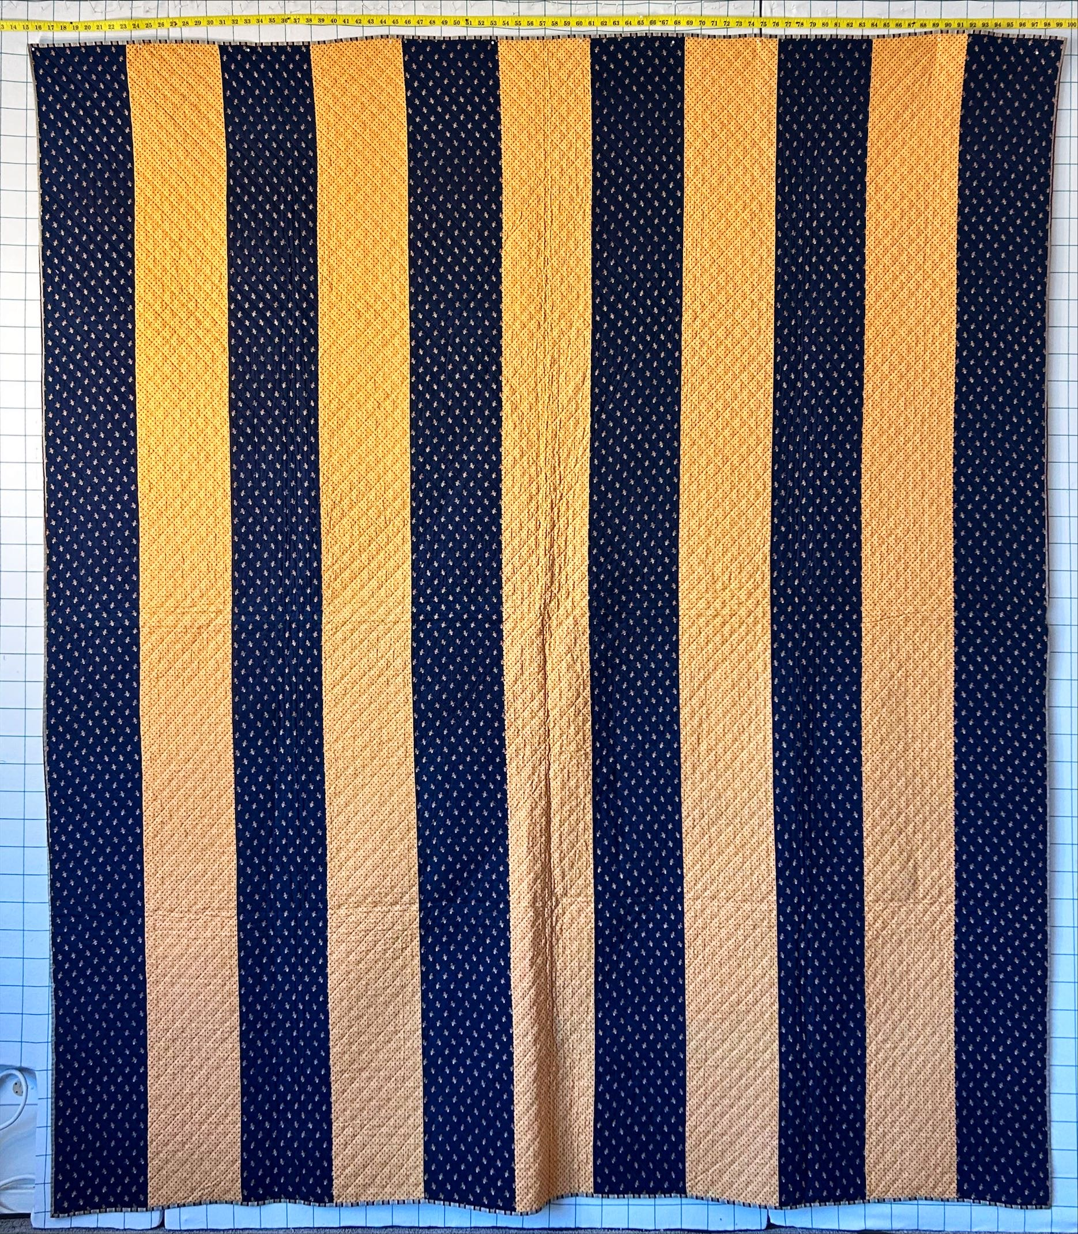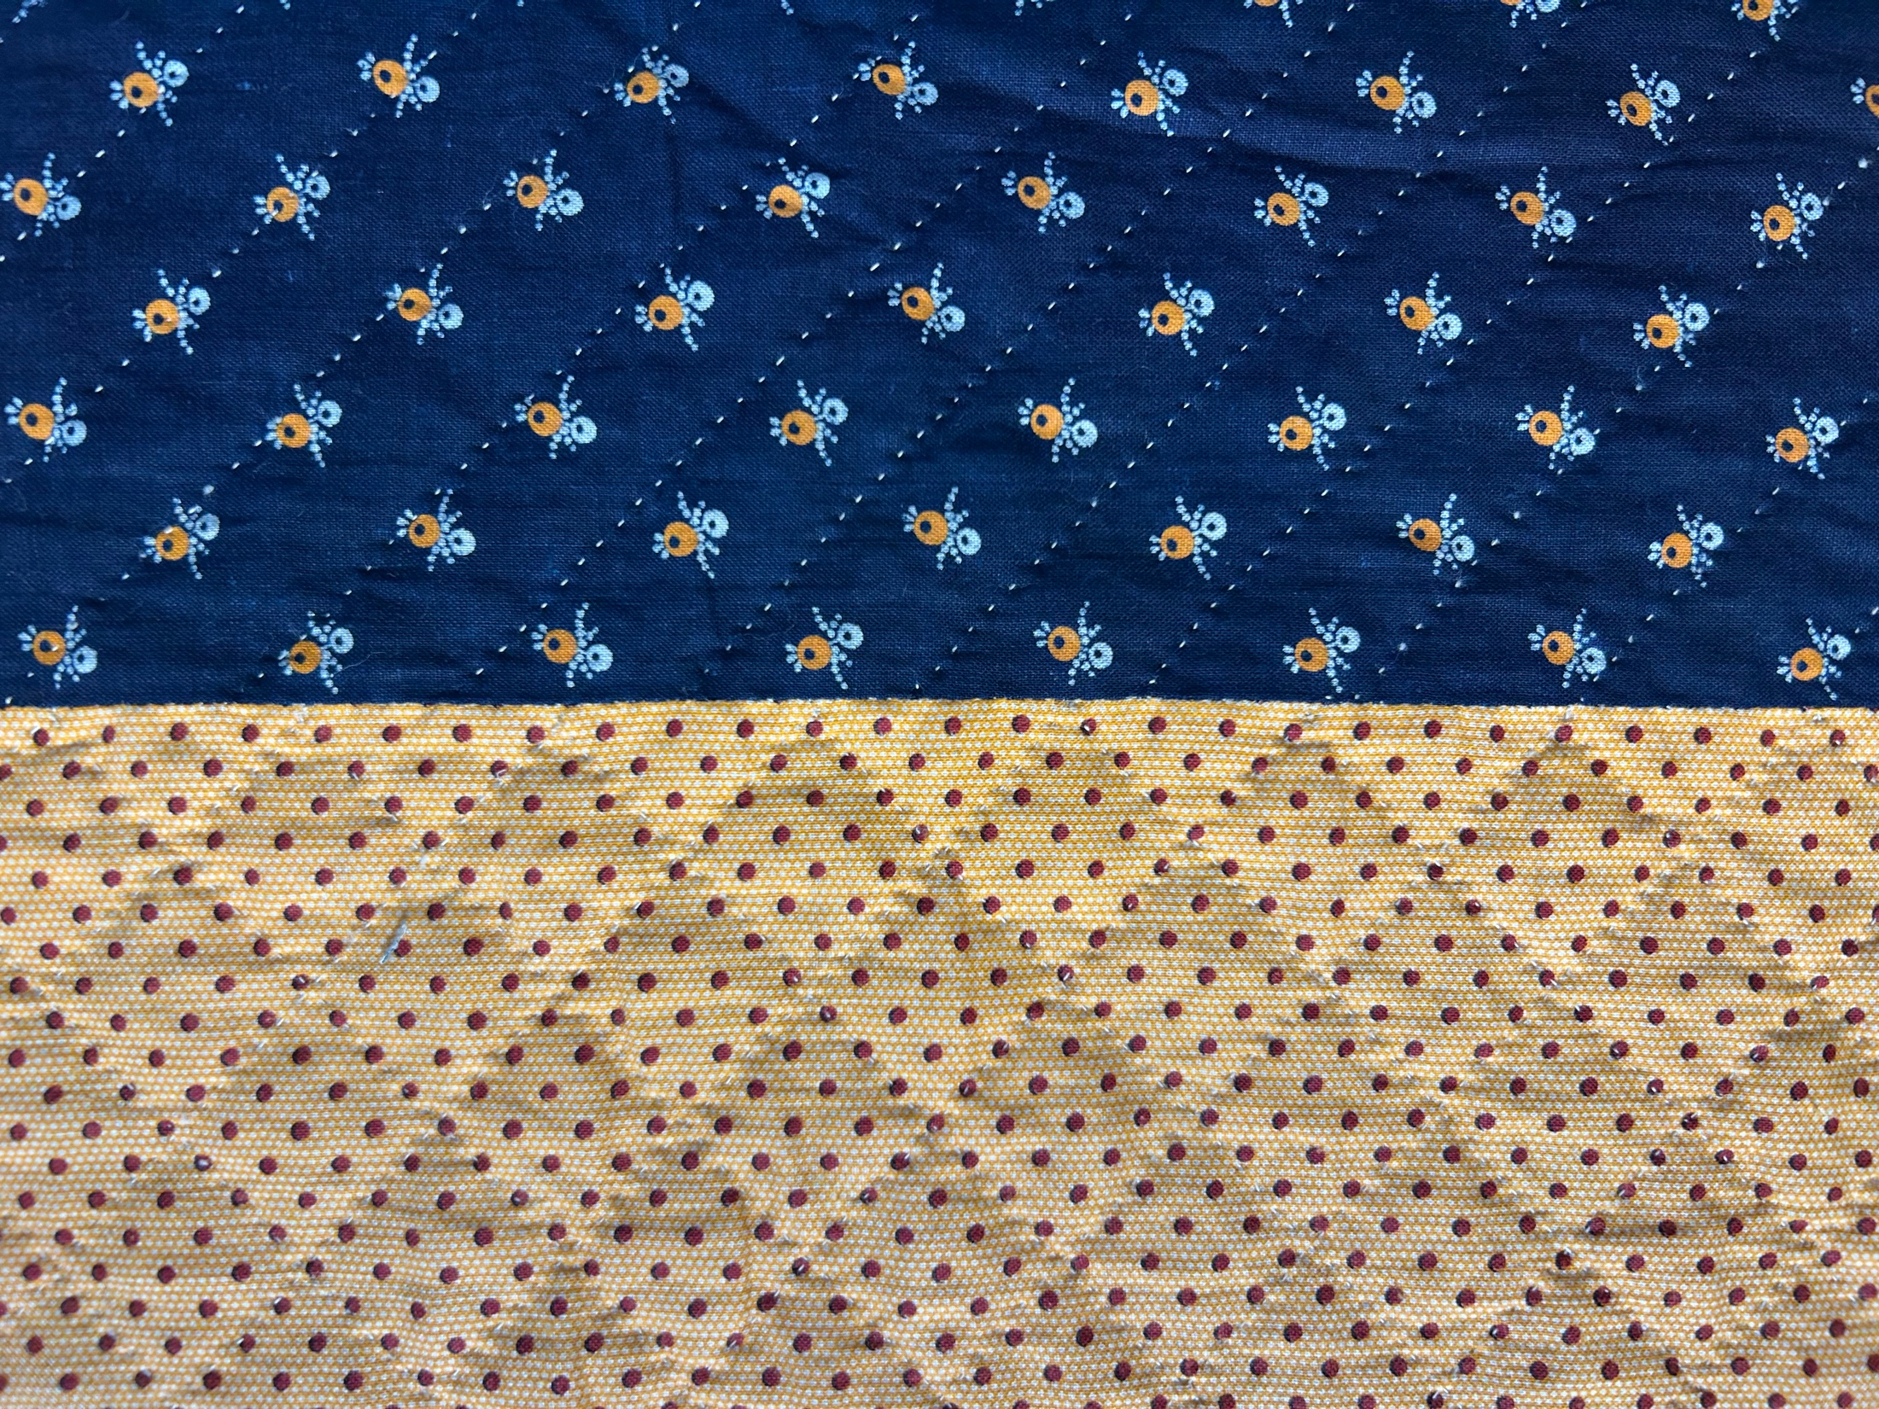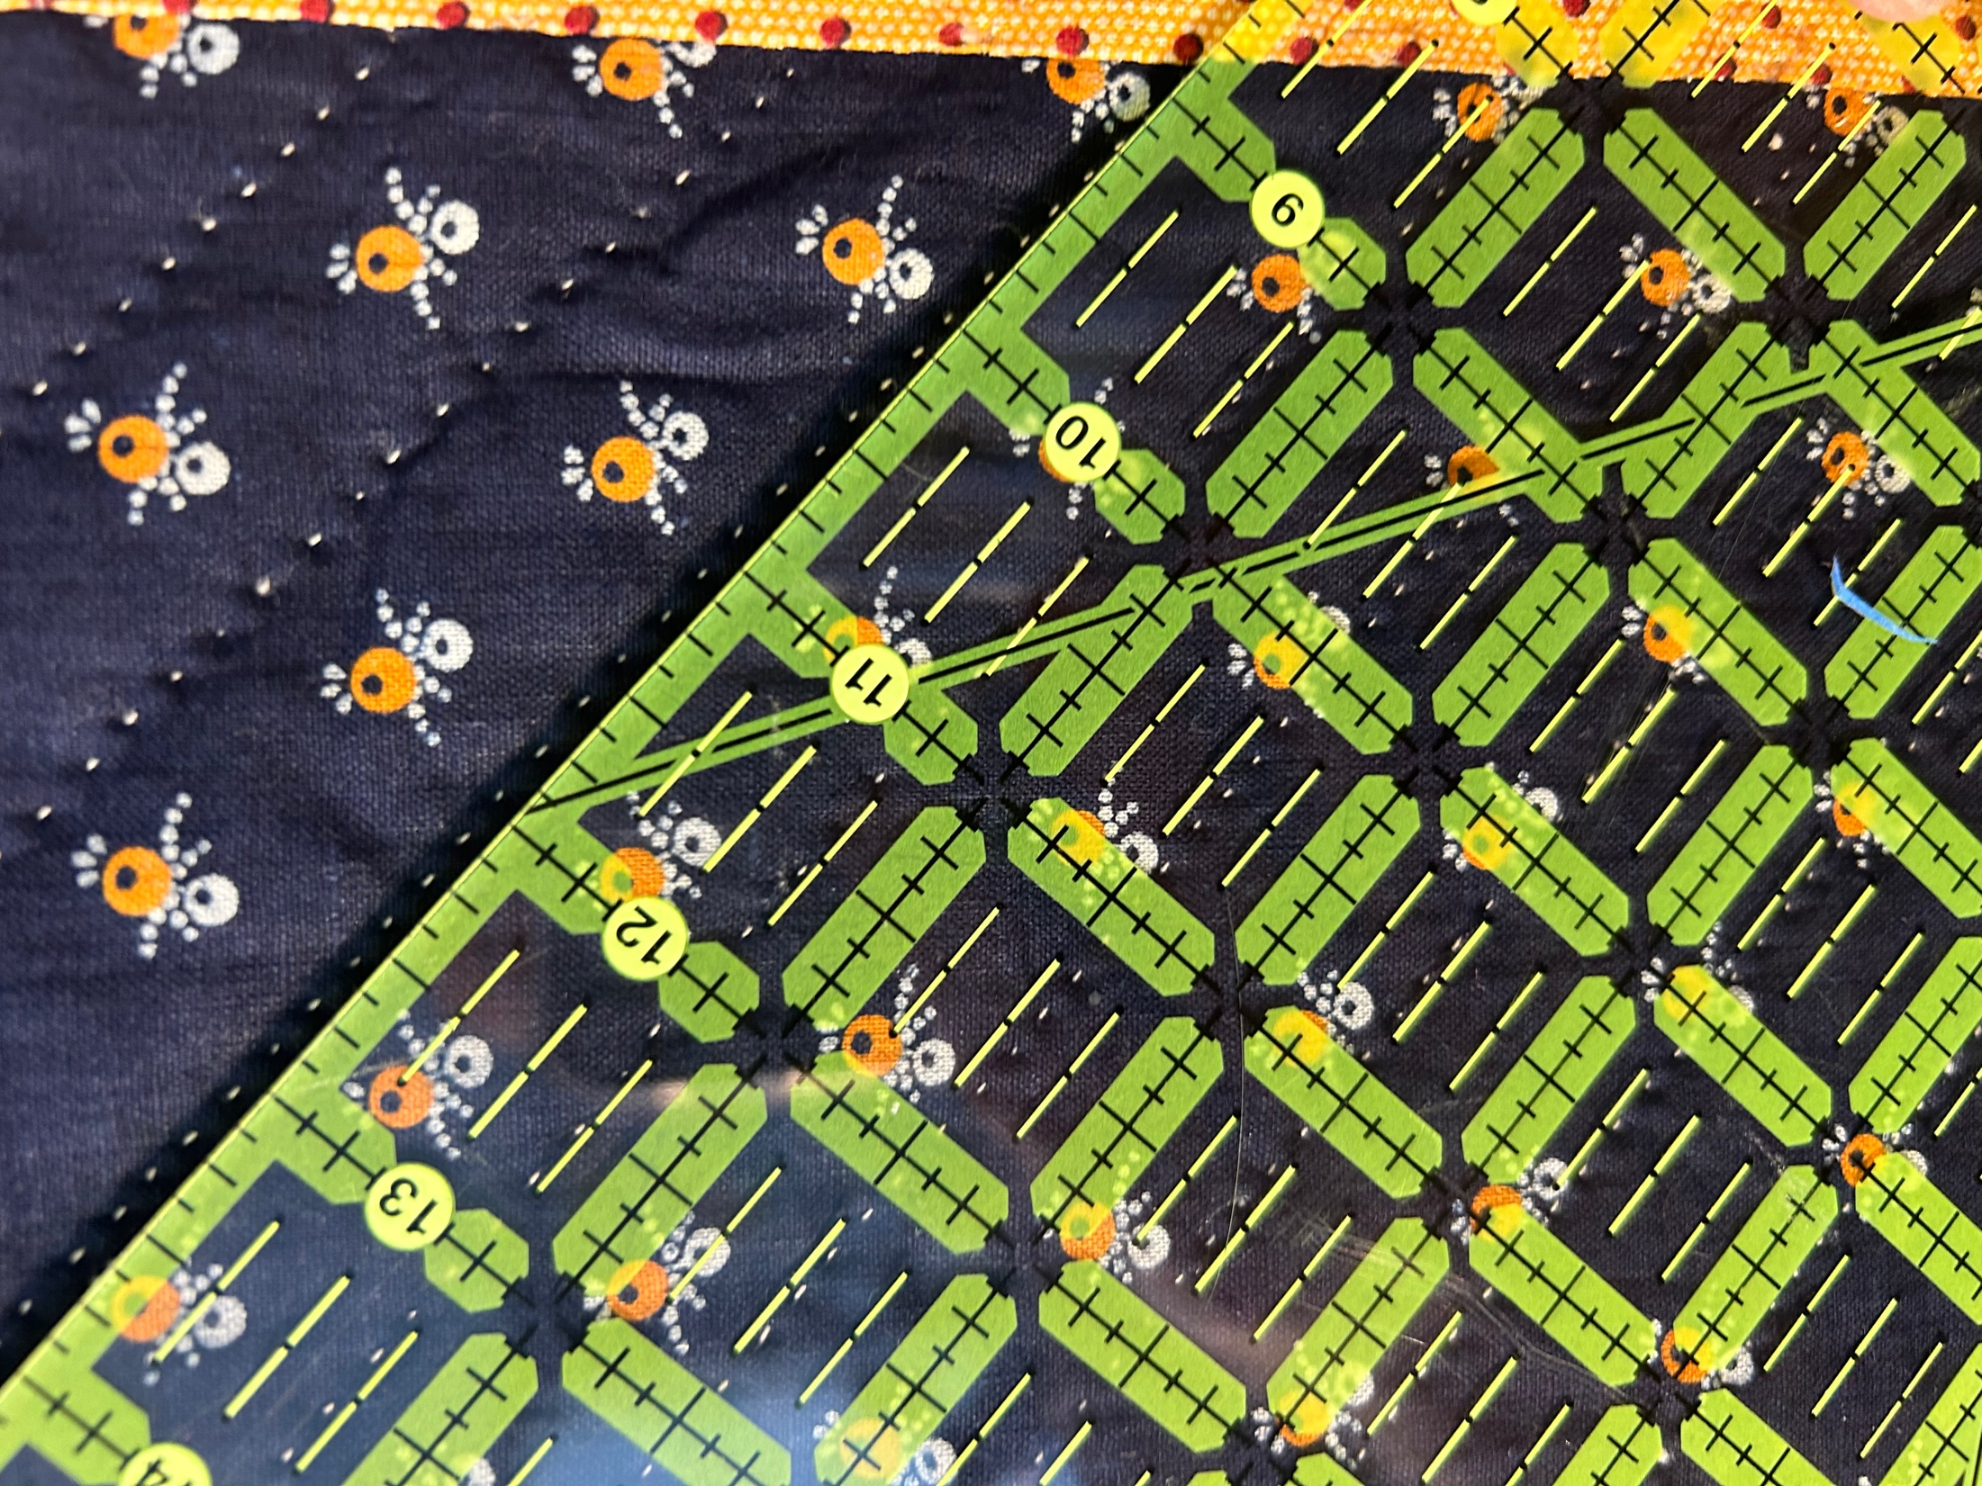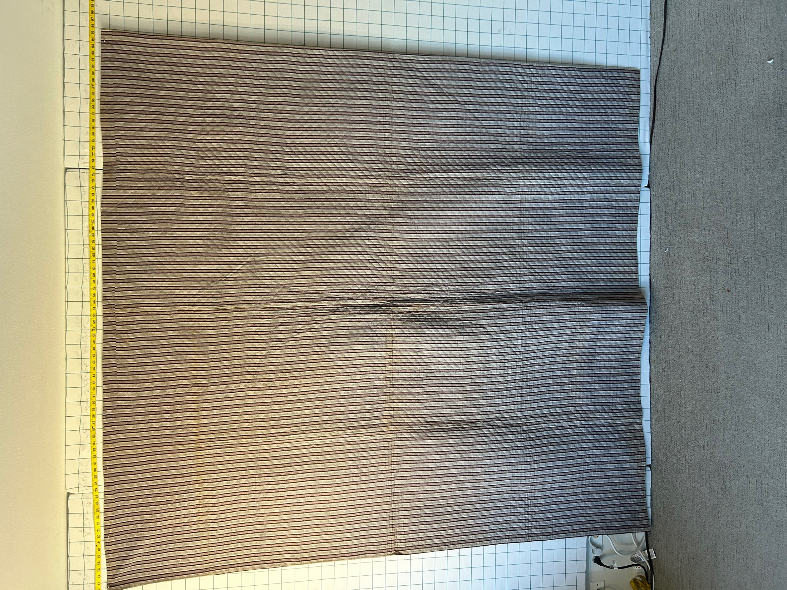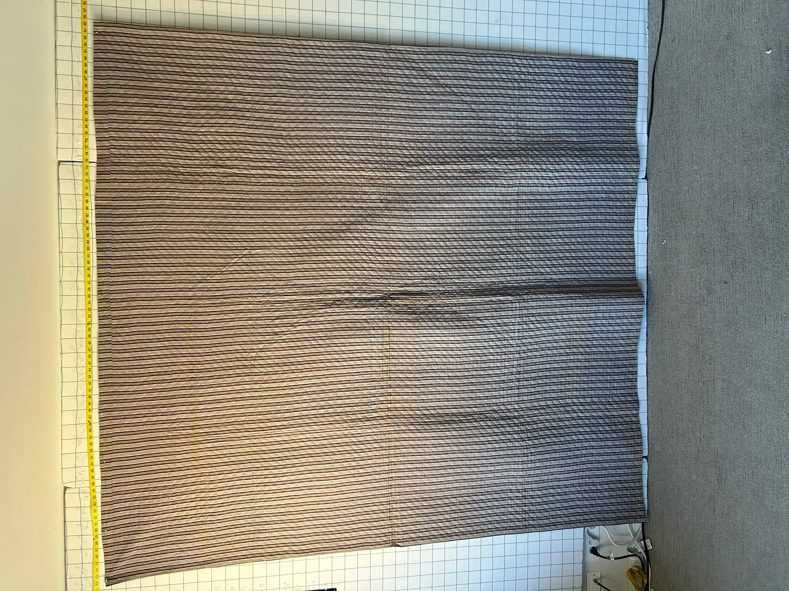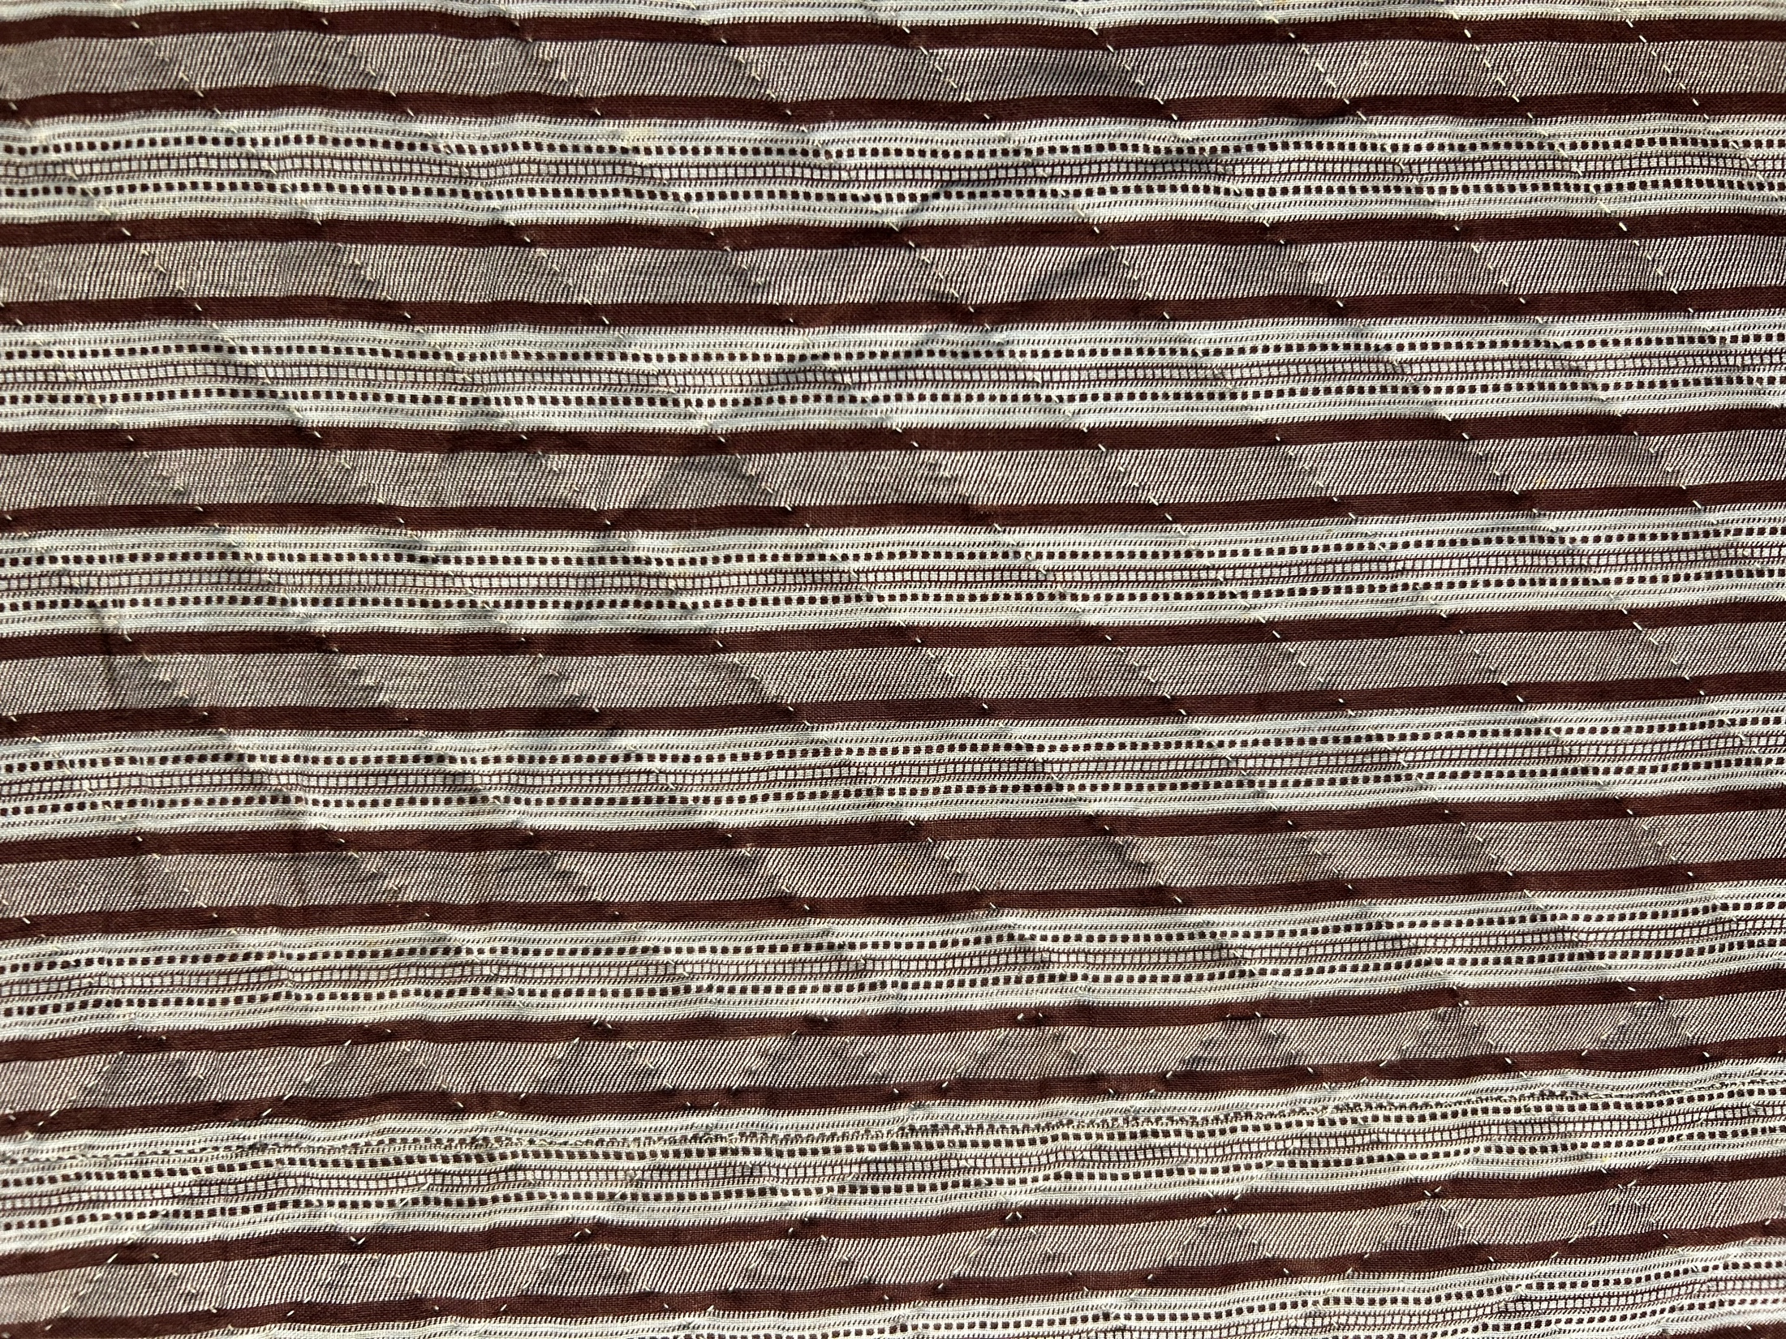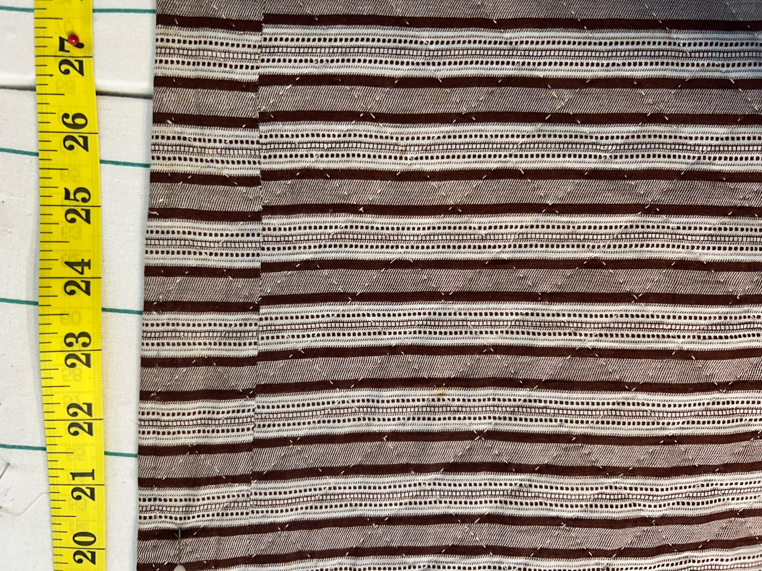

History

Known Owners
Owner | From Date | To Date | Acquired at: | Cost
David Bailey | 2025-11-14 | -- | Chris Moline  Naperville, IL | $450
Made in:
--
 | If not purchased, the estimated cost for materials: $0

Display & Publication History
Date | Event | Location / Publication
-- | -- | --

General Description
Quilt Title or Name:  Mennonite Strippy | Fabric Date Range: 1885 ± 10 Years  Date Made: -- ± 0 Years  Method of Determination:
Item Type:  Items in Set: 1 | Size: Length: 88“ x Width: 84“
Appraisals:  Has this quilt been professionally appraised?  If so, when: --  ----------- | Other Related Information:  Quilt Index #:  Scanned Patterns  Images  EQ 8 Files  Research Notes
Additional Information: Hand pieced, hand quilted (6-7/inch). 7.5" strips. Binding is a rolled back to front.
Chris stated that this is a Mennonite strippy quilt. She has sold this to me at her cost.

