Documentation Form

Overview

Images
Top | Back
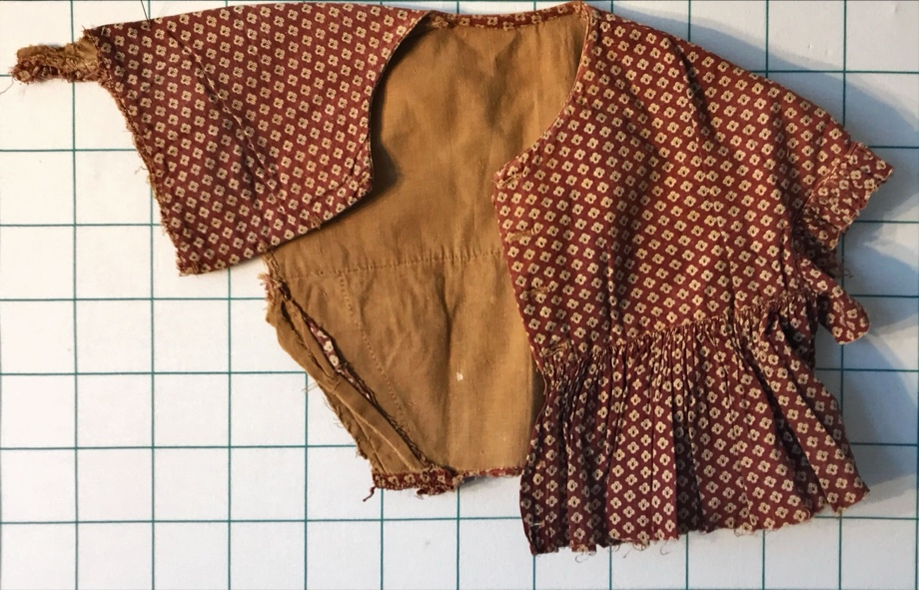 | 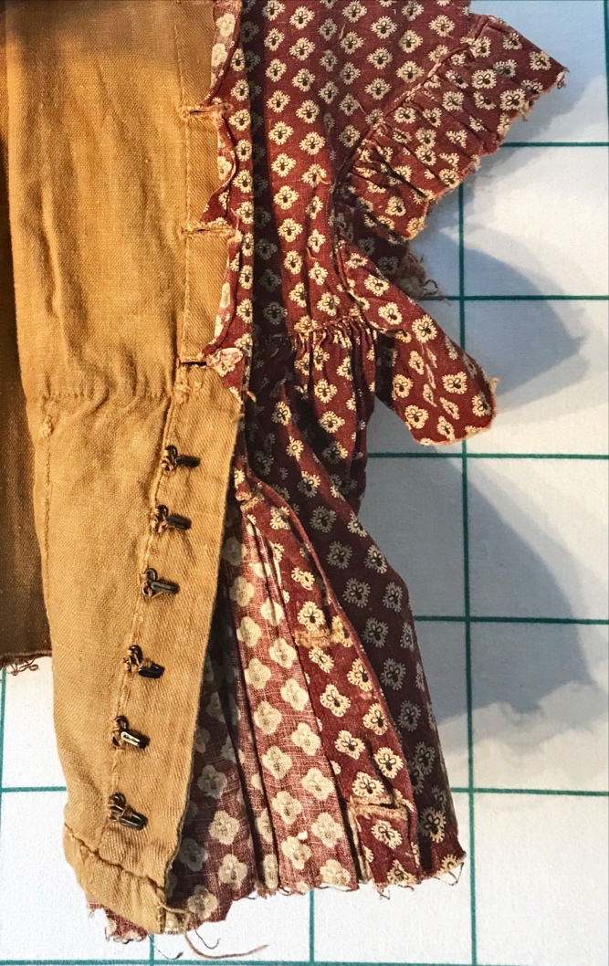

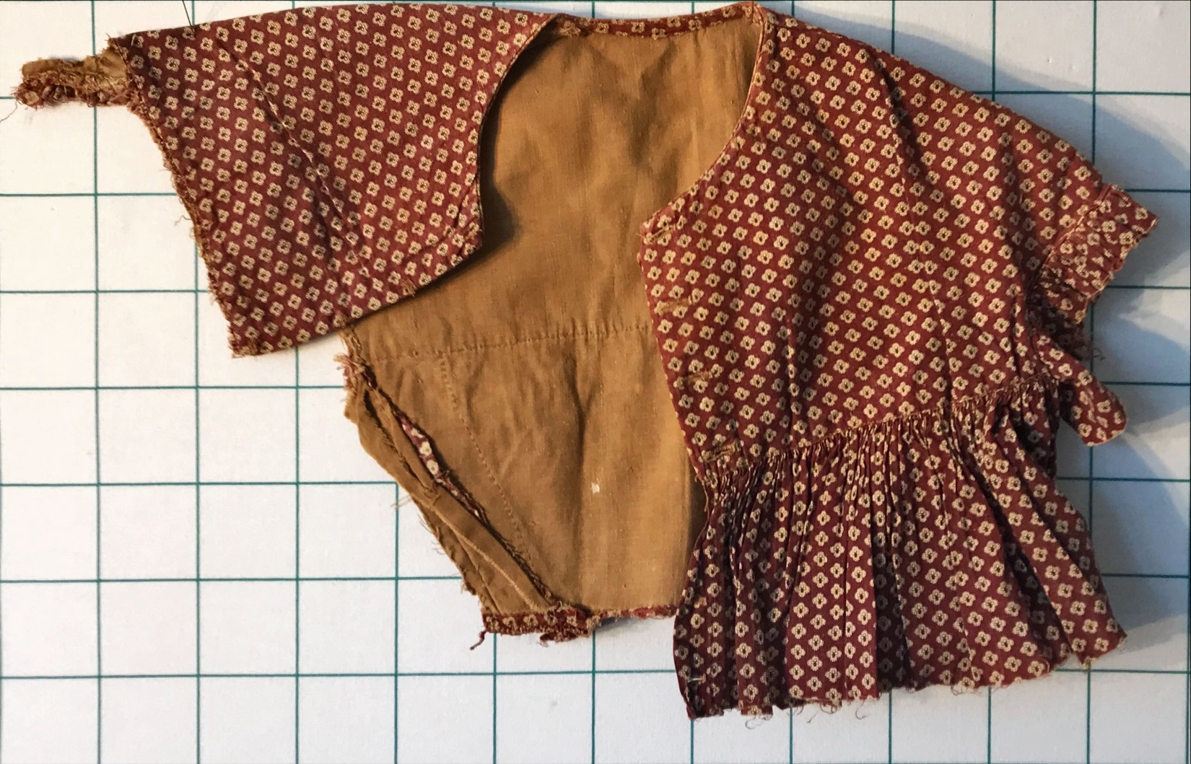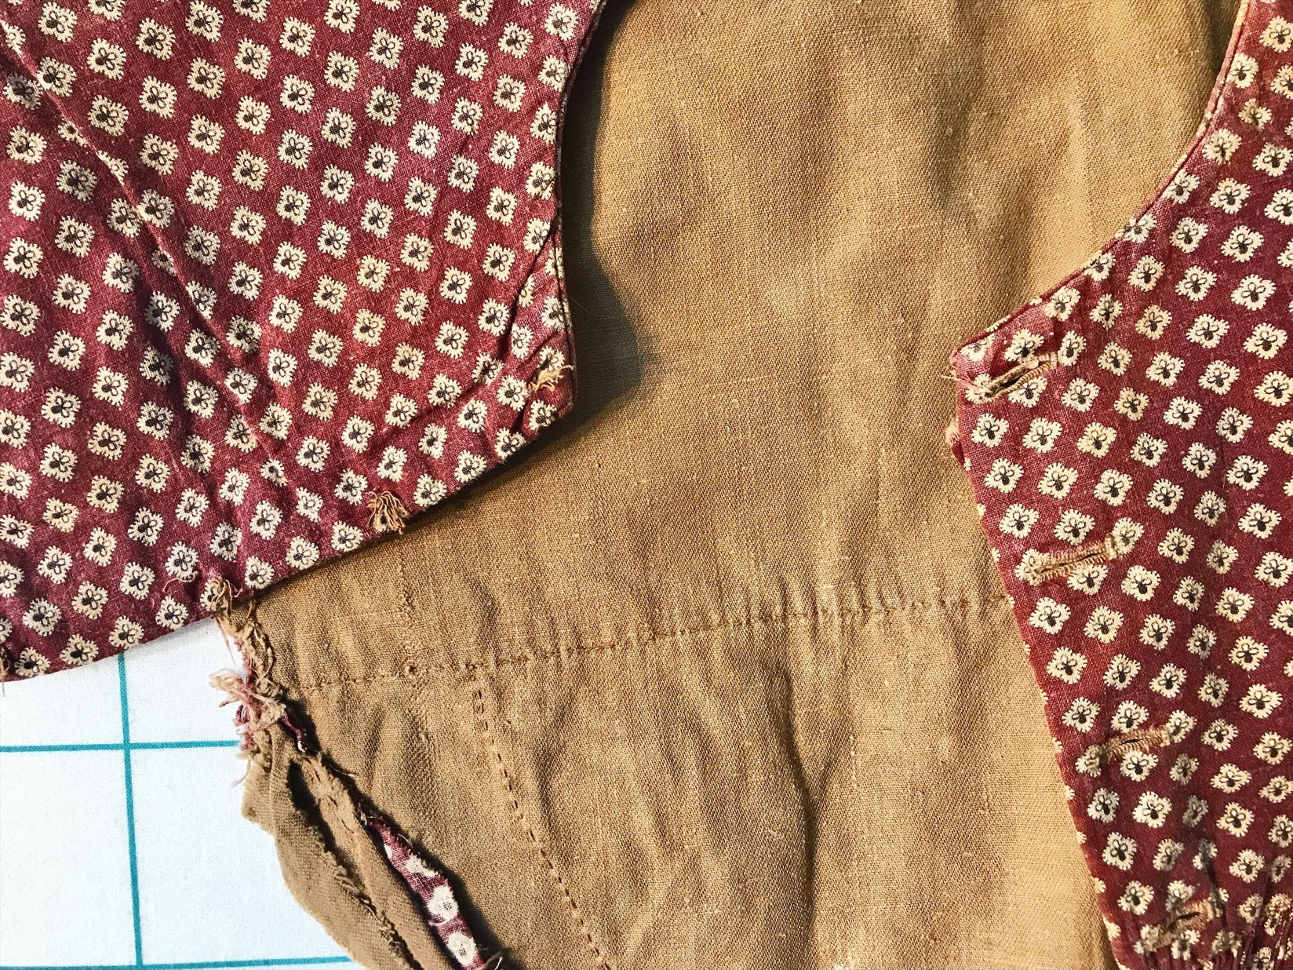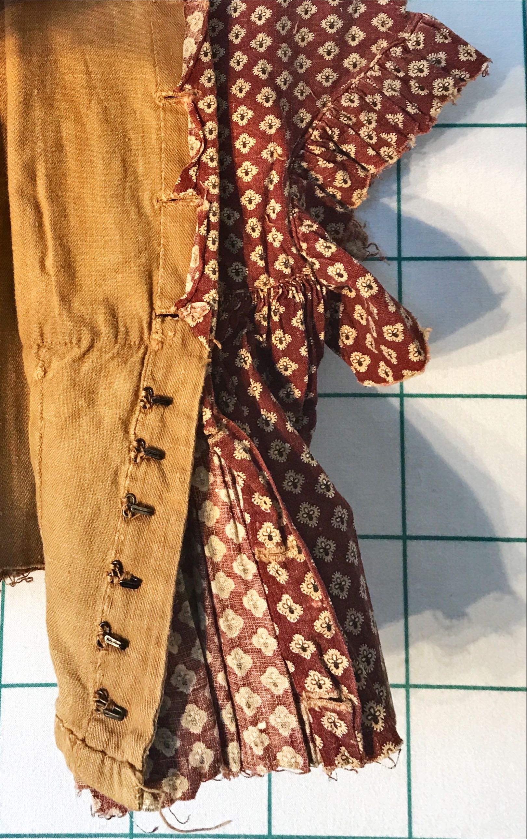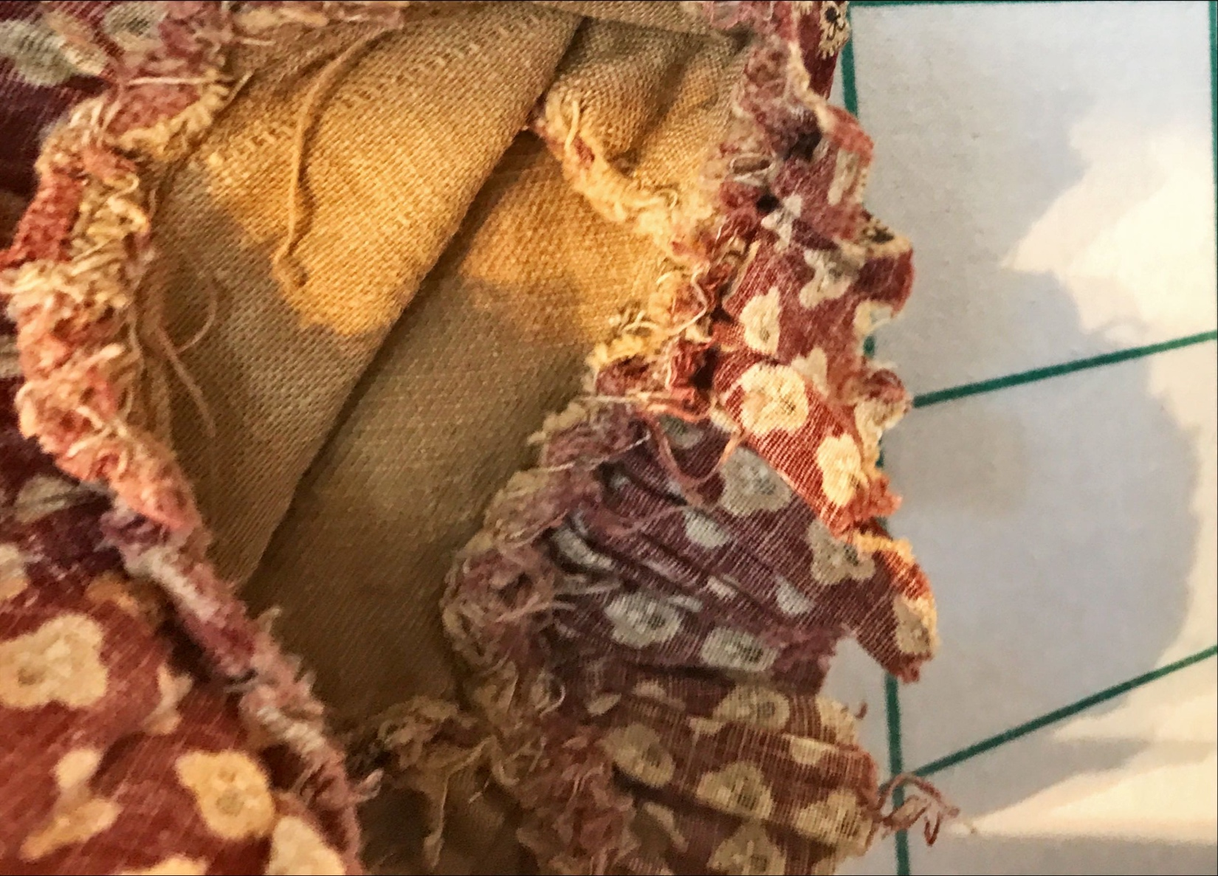

History

Known Owners
Owner | From Date | To Date | Acquired at: | Cost
David Bailey | 2025-11-1 | -- | Midwest Fabric Study Group | $43
Made in:
--
 | If not purchased, the estimated cost for materials: $0

Display & Publication History
Date | Event | Location / Publication
-- | -- | --

General Description
Quilt Title or Name:  Partial Dress Bodice | Fabric Date Range: 1835 ± 10 Years  Date Made: -- ± 0 Years  Method of Determination:
Item Type:  Items in Set: 1 | Size: Length: 21“ x Width: 15“
Appraisals:  Has this quilt been professionally appraised?  If so, when: --  ----------- | Other Related Information:  Quilt Index #:  Scanned Patterns  Images  EQ 8 Files  Research Notes
Additional Information: This pieced was purchased as part of a set at a live auction at the Fall North West Fabric Study group in Shipshewana, IN. The lot was $175 and included items 596, 597, 598, 599 and some ephemera. The donor to the autction is unknown. The pieces and ephemera are from Betty Harrigan's fabric collection.
Red grounds calico. Hand stitched. Linen liner. Fasters.

