Documentation Form

Overview

Images
Top | Back
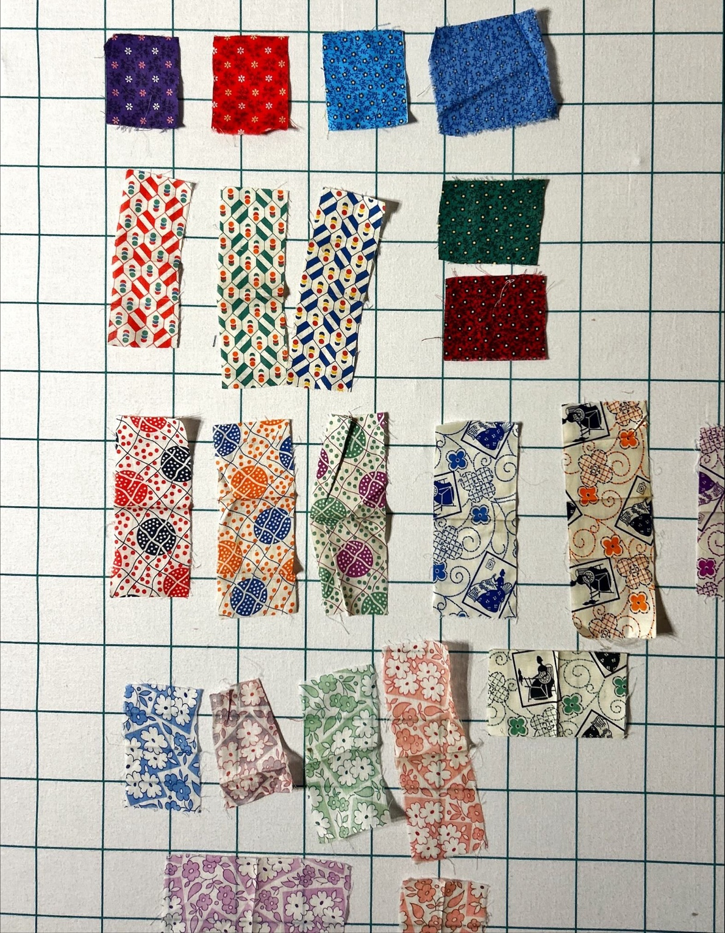

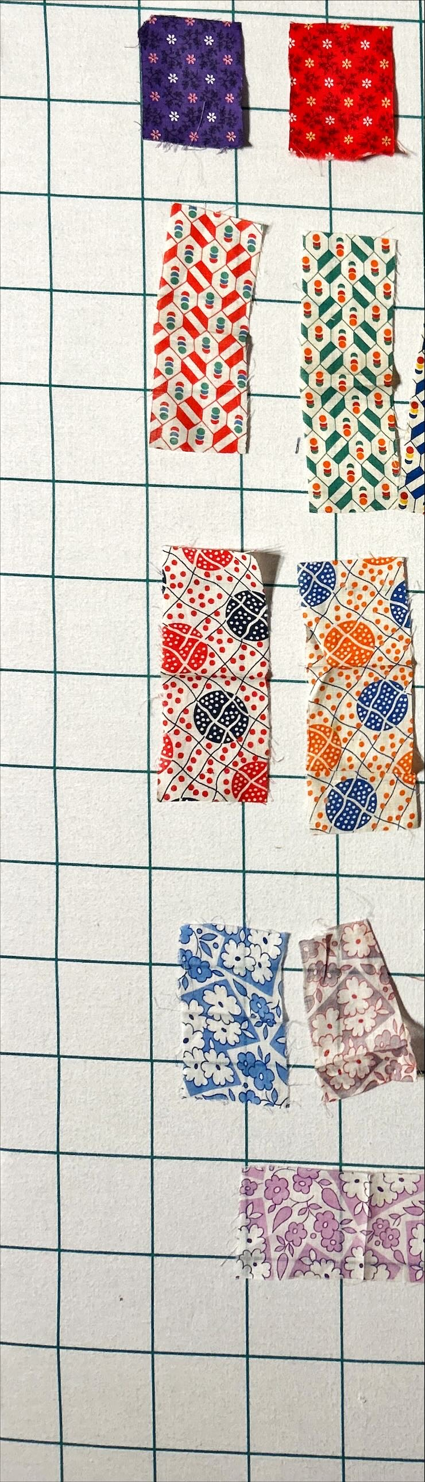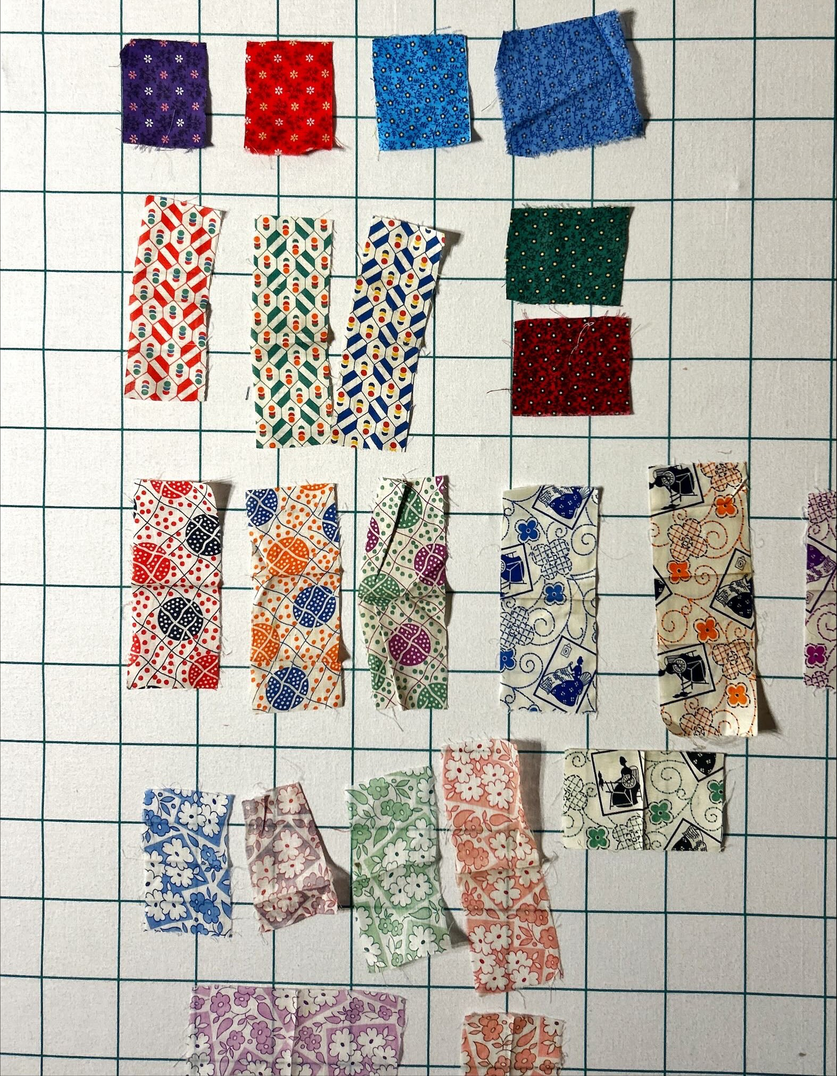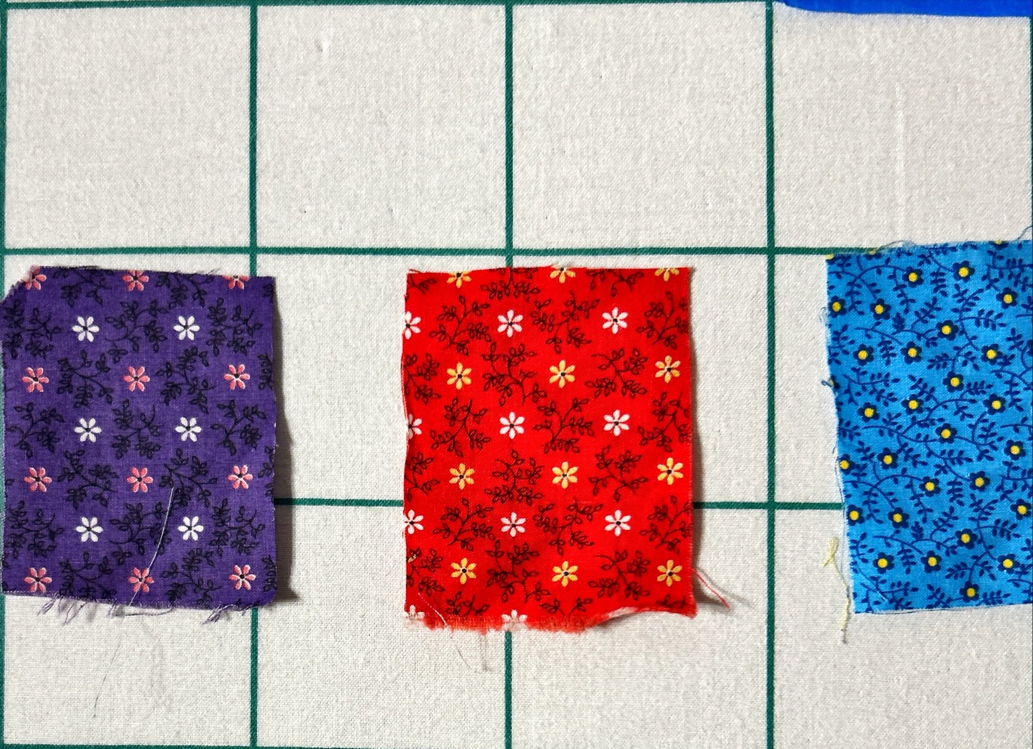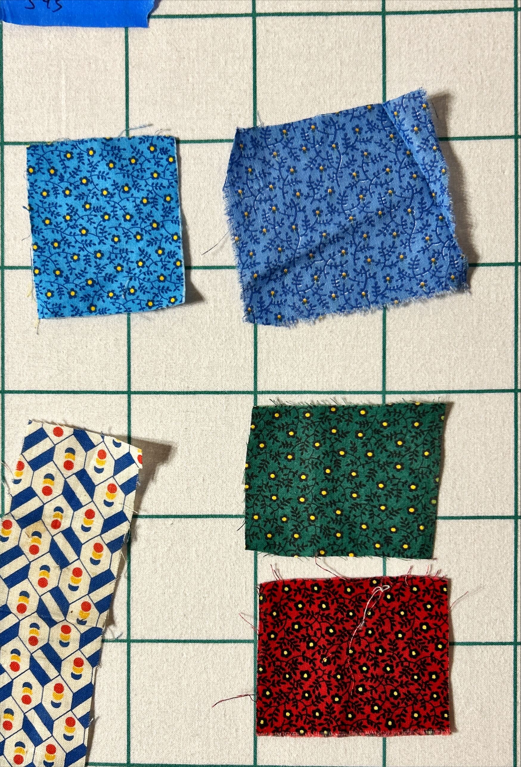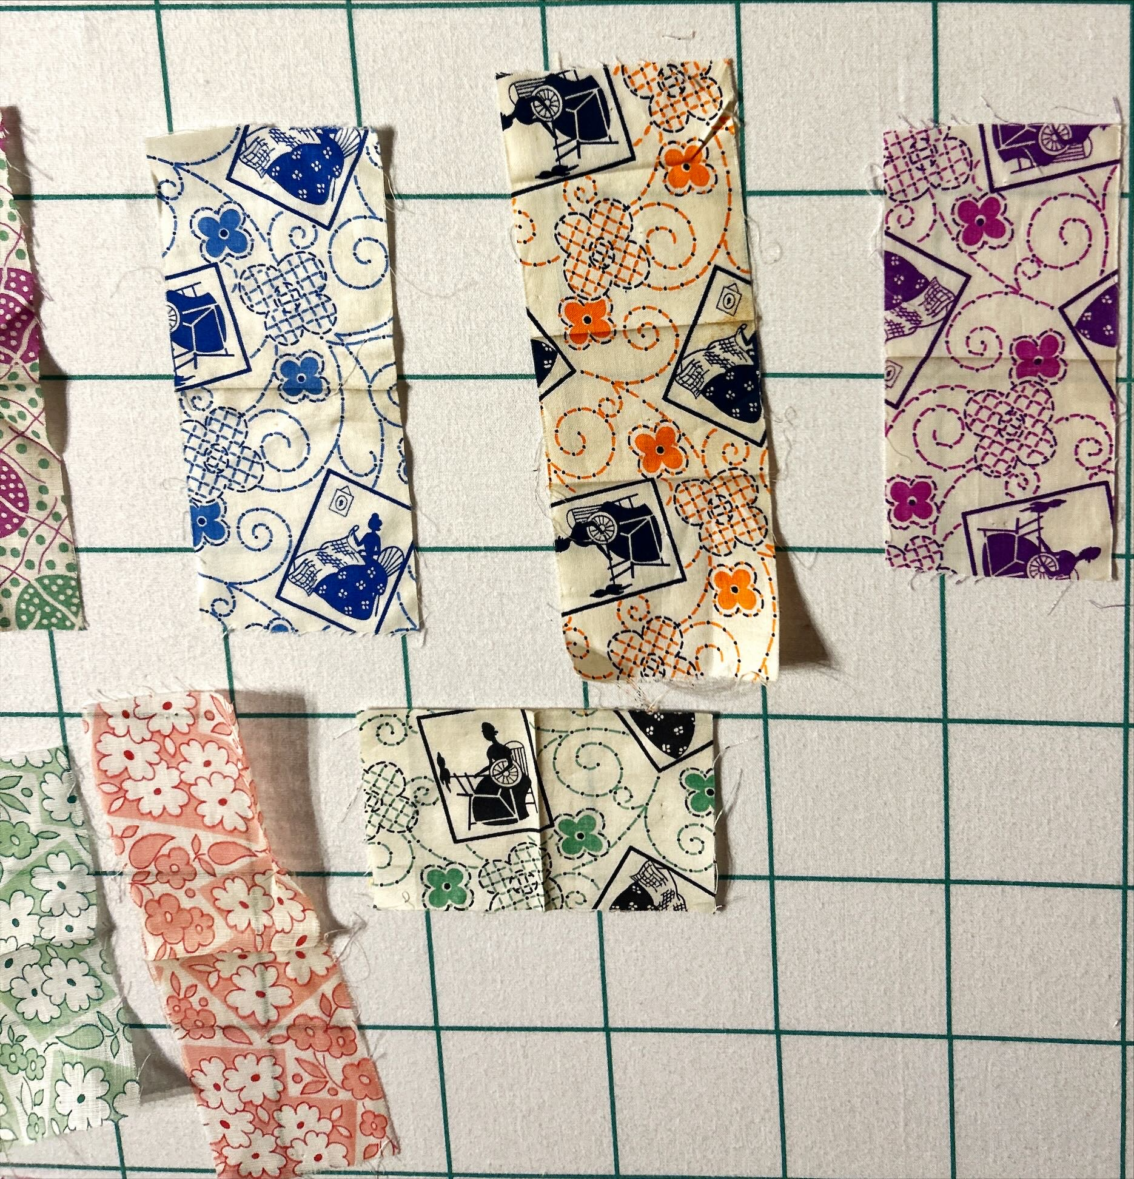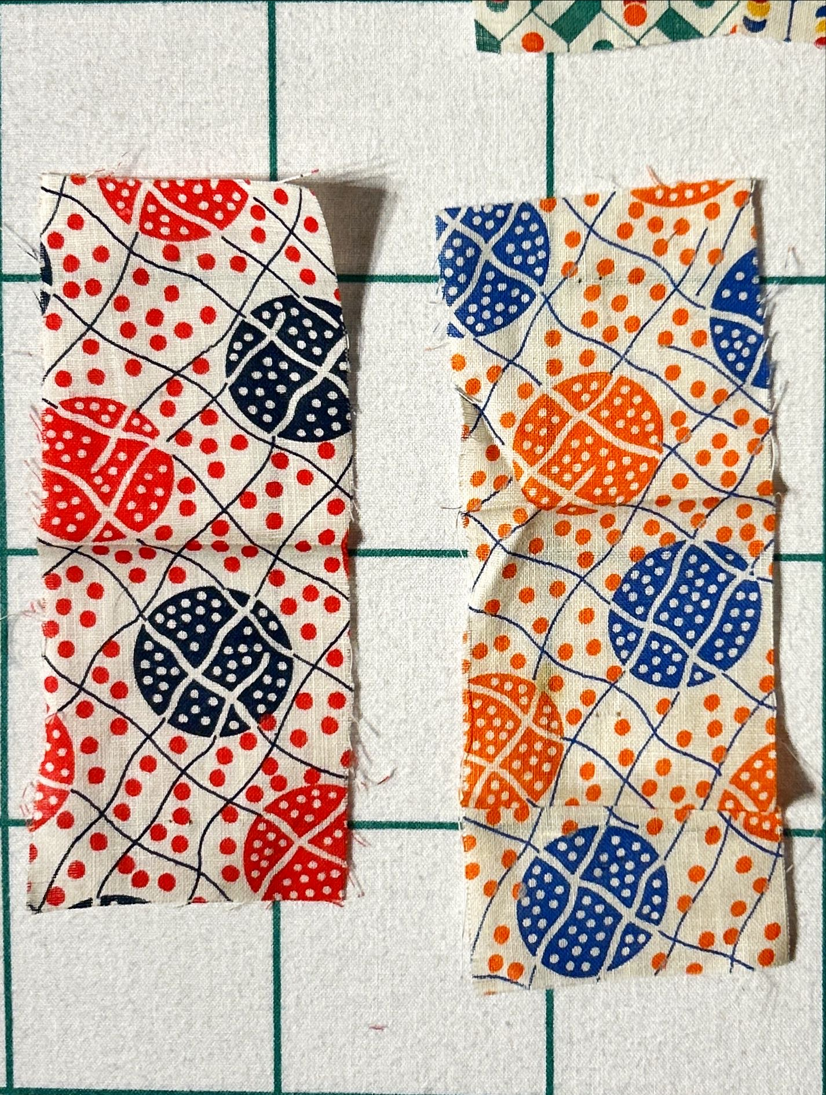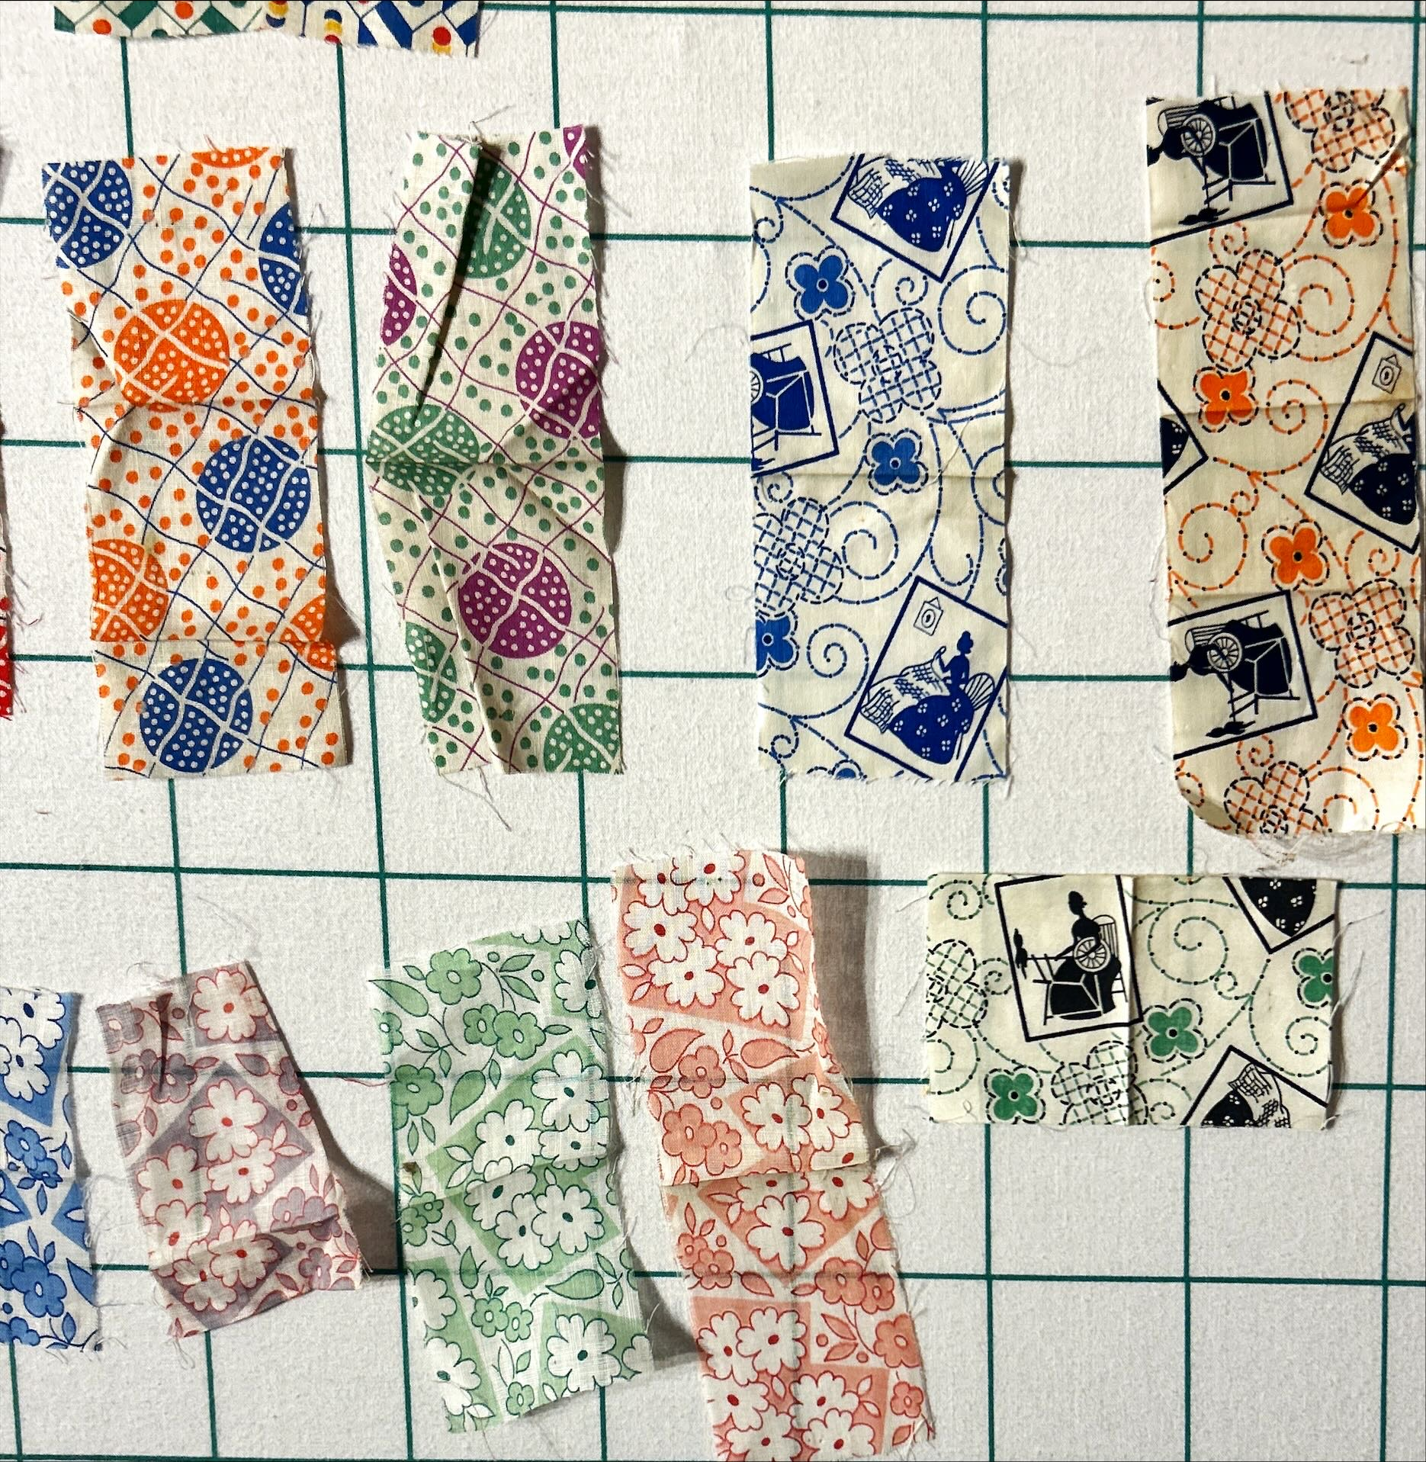

History

Known Owners
Owner | From Date | To Date | Acquired at: | Cost
David Bailey | 2025-10-1 | -- | Chris Moline  Naperville, IL | $0
Made in:
--
 | If not purchased, the estimated cost for materials: $0

Display & Publication History
Date | Event | Location / Publication
-- | -- | --

General Description
Quilt Title or Name:  Ely and Walker Prints | Fabric Date Range: 1940- ± 10 Years  Date Made: -- ± 0 Years  Method of Determination:
Item Type:  Items in Set: 44 | Size: various
Appraisals:  Has this quilt been professionally appraised?  If so, when: --  ----------- | Other Related Information:  Quilt Index #:  Scanned Patterns  Images  EQ 8 Files  Research Notes
Additional Information: Consider looking up Ely & Walker prints for ages. This date is only a guess.

