Documentation Form

Overview

Images
Top | Back
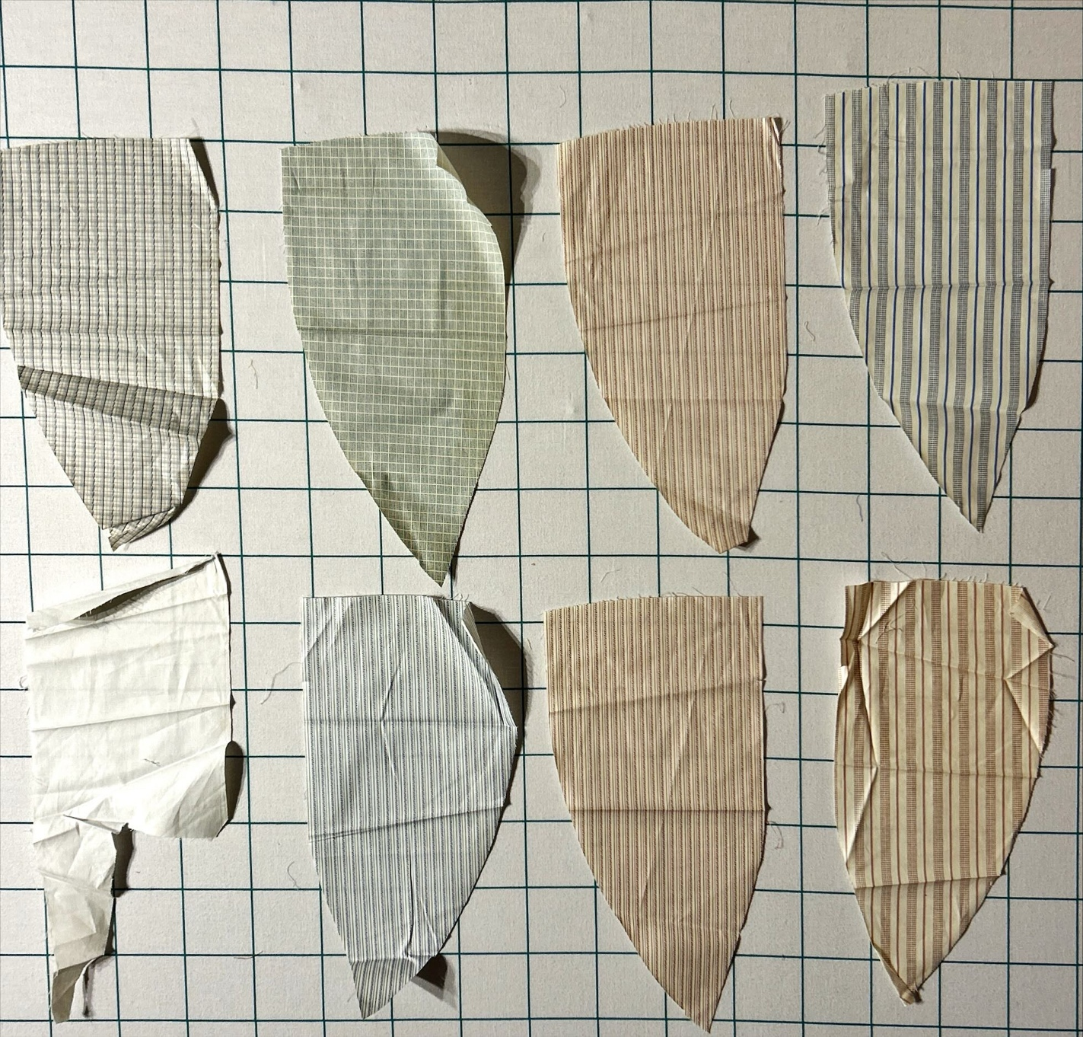
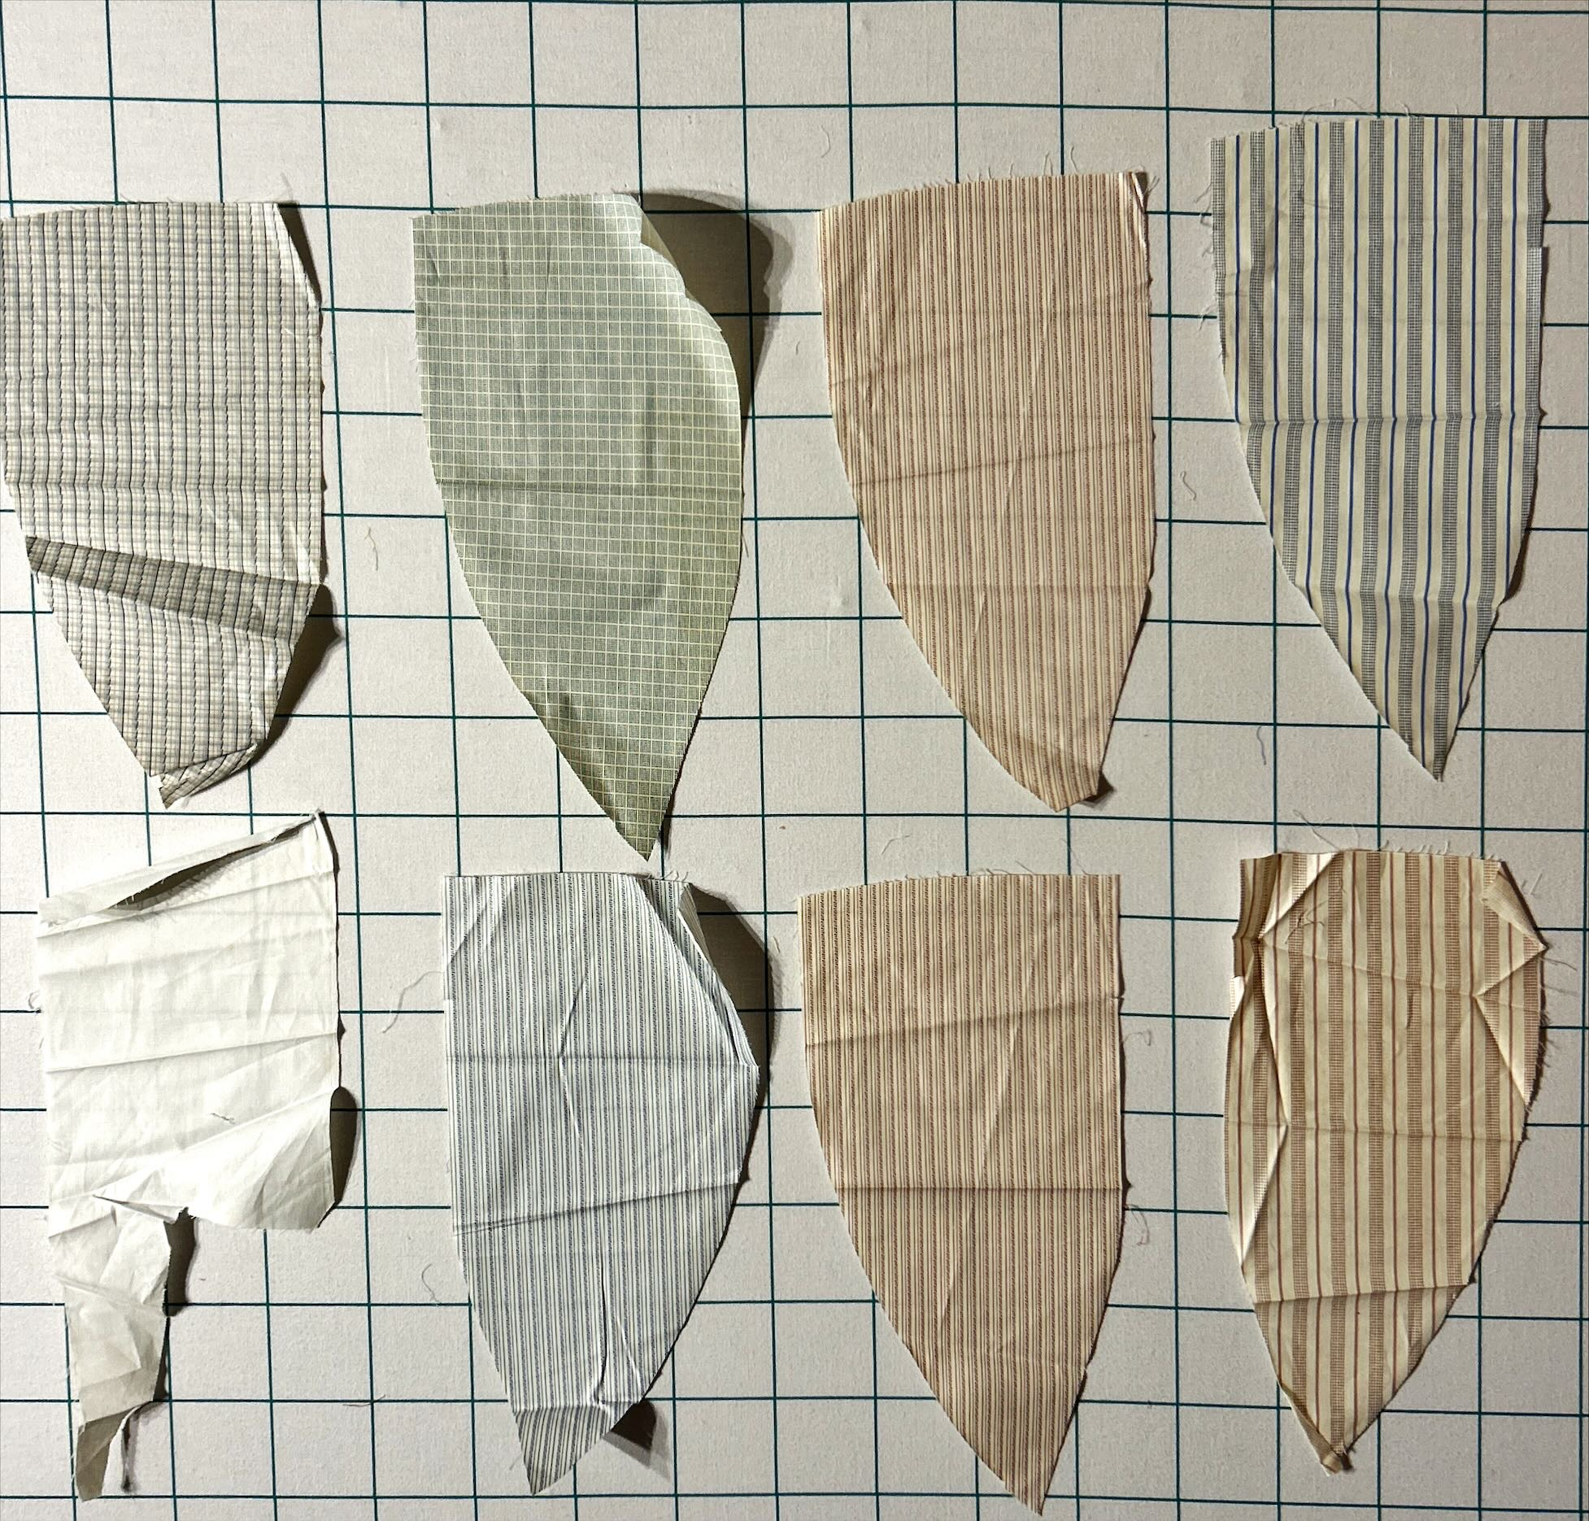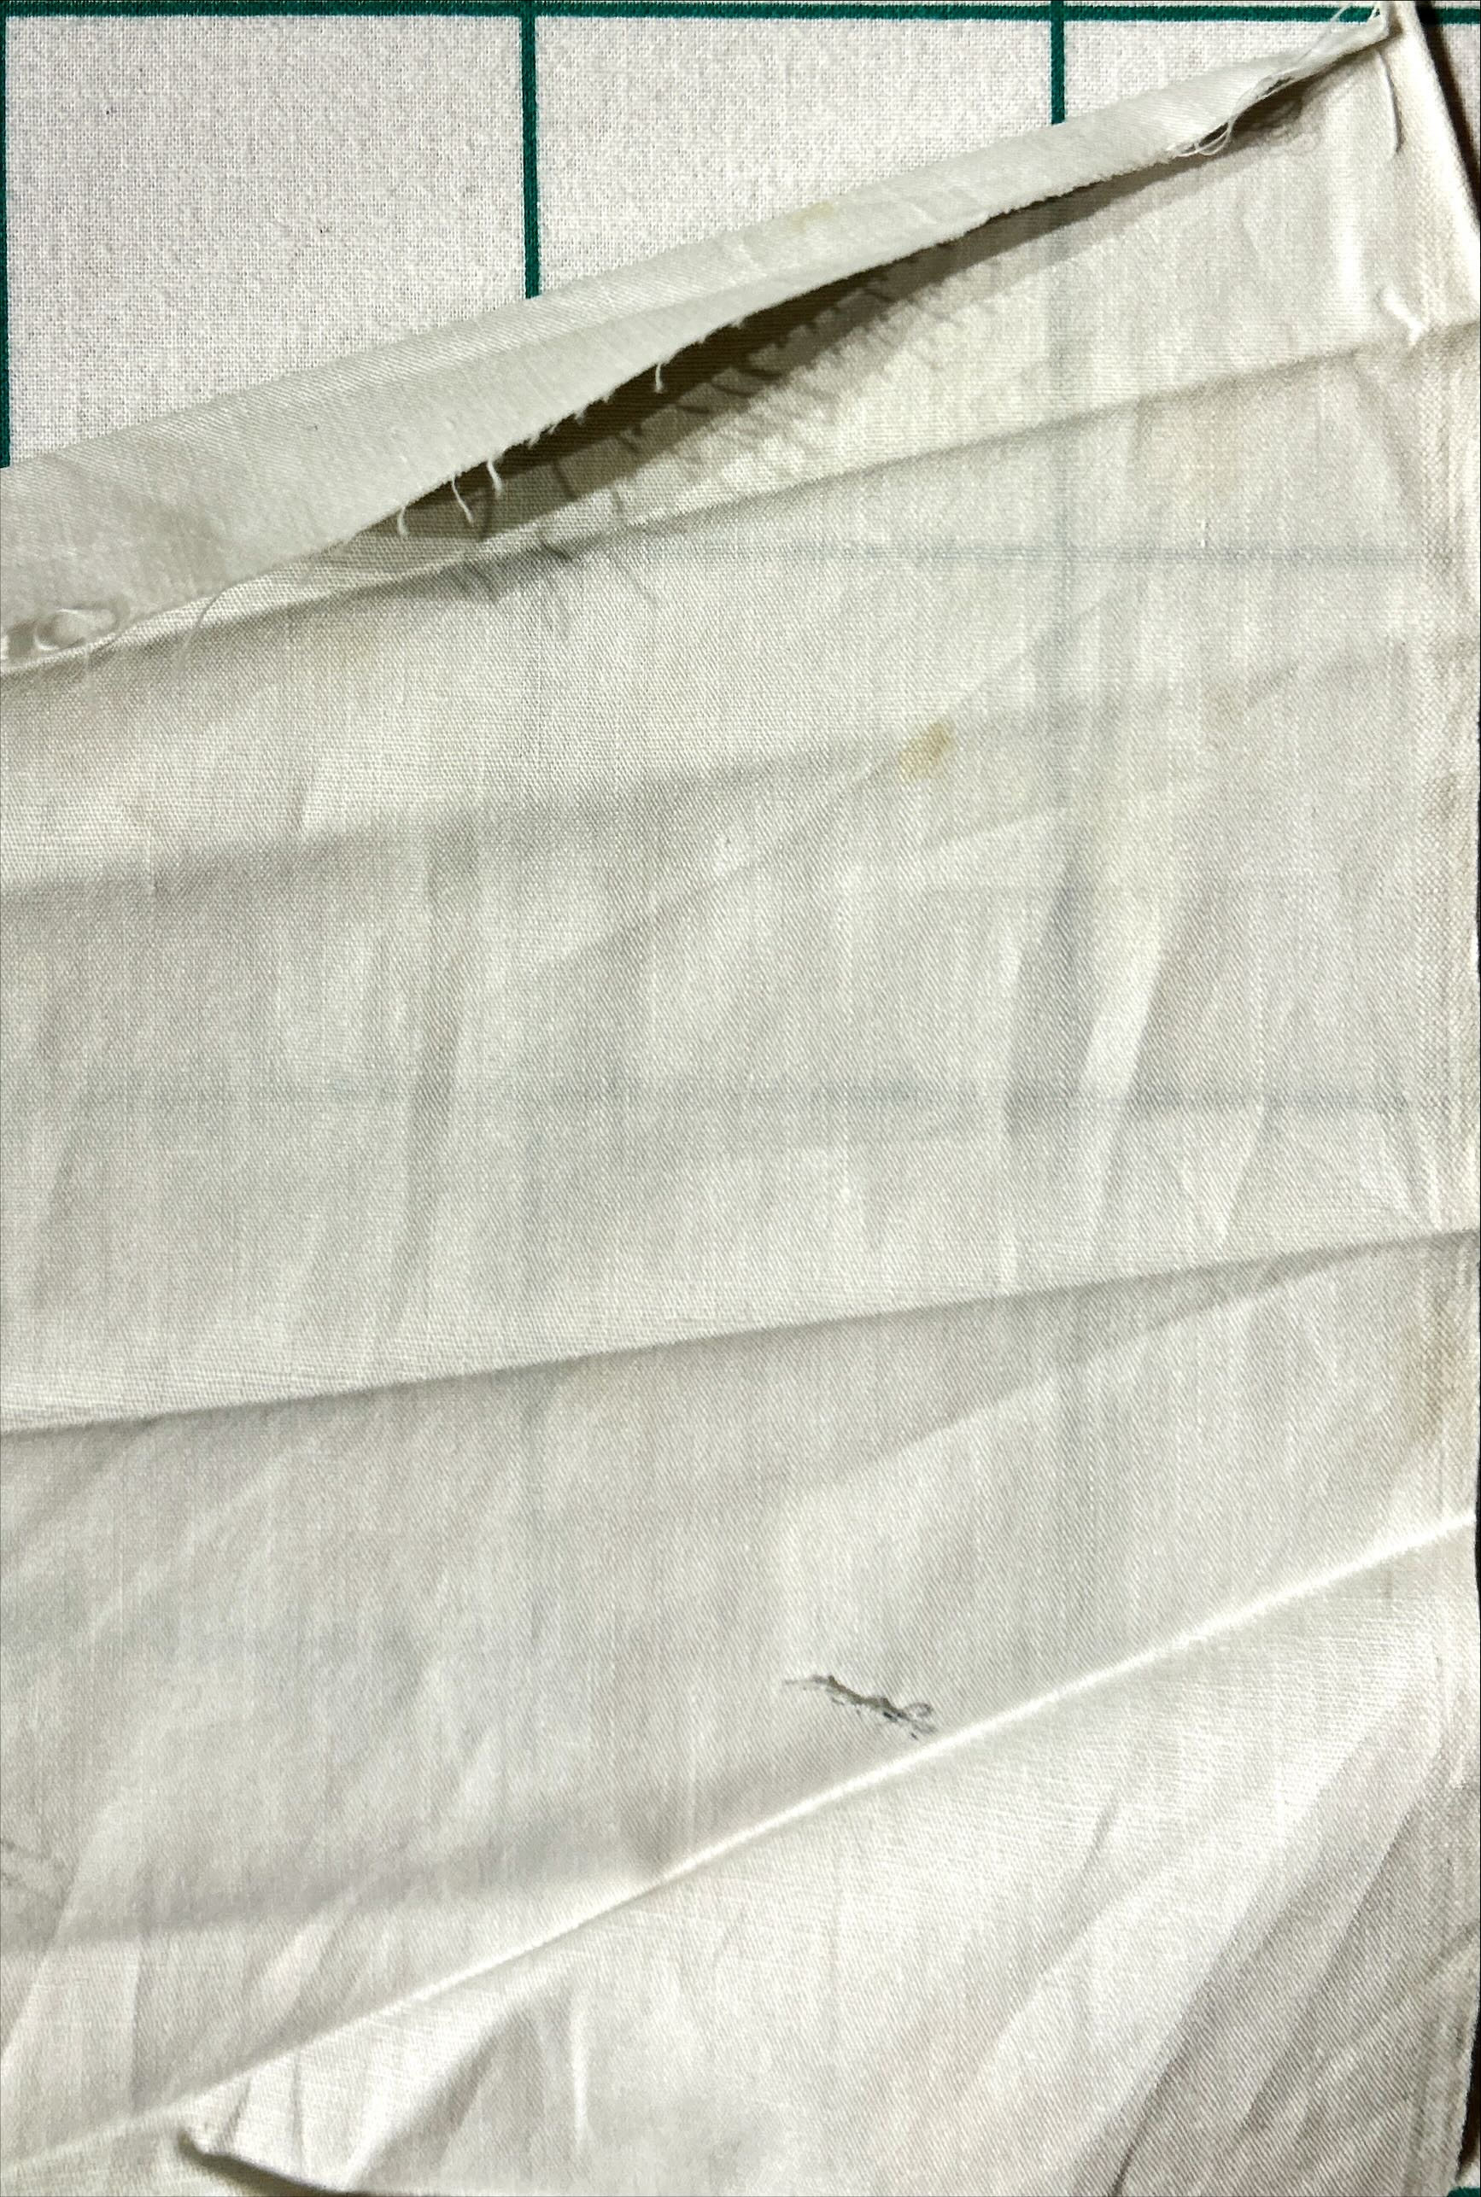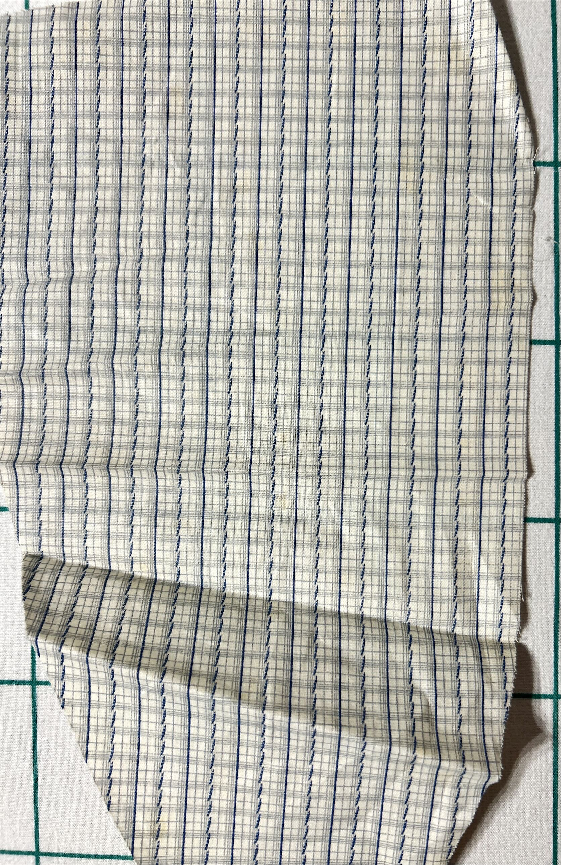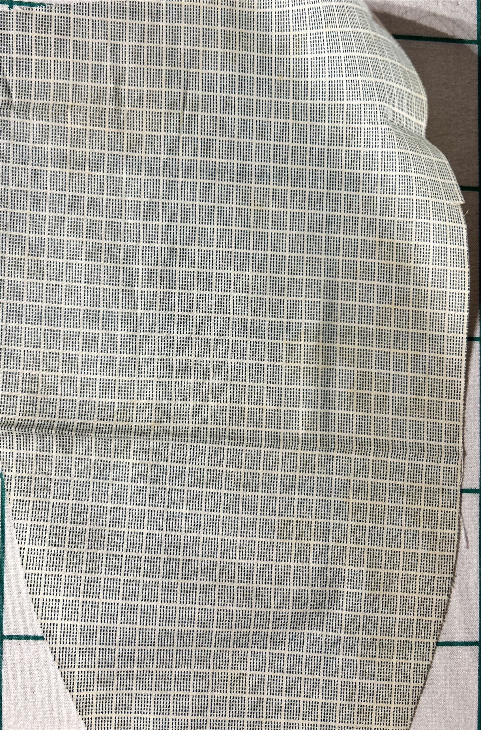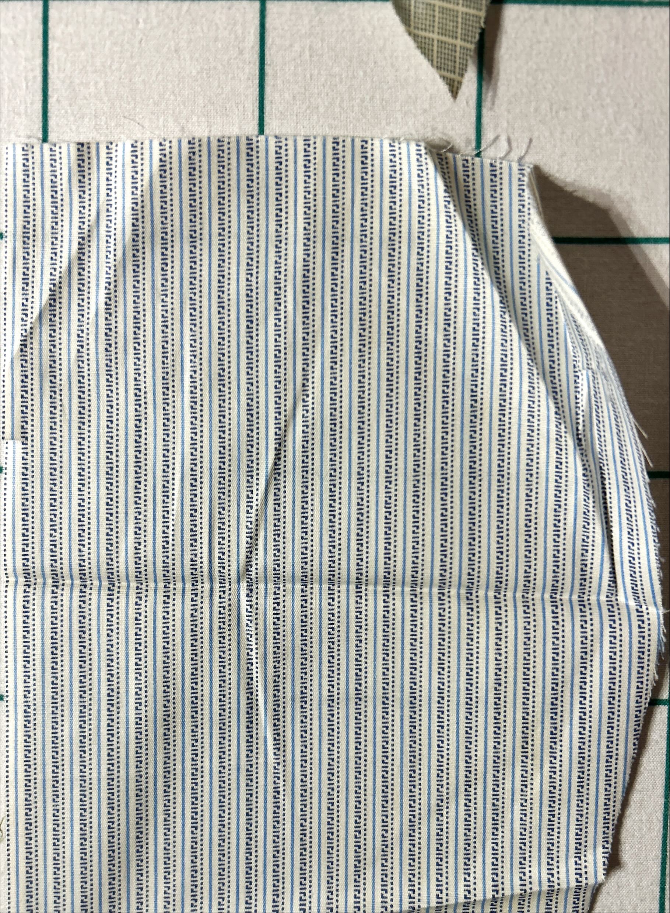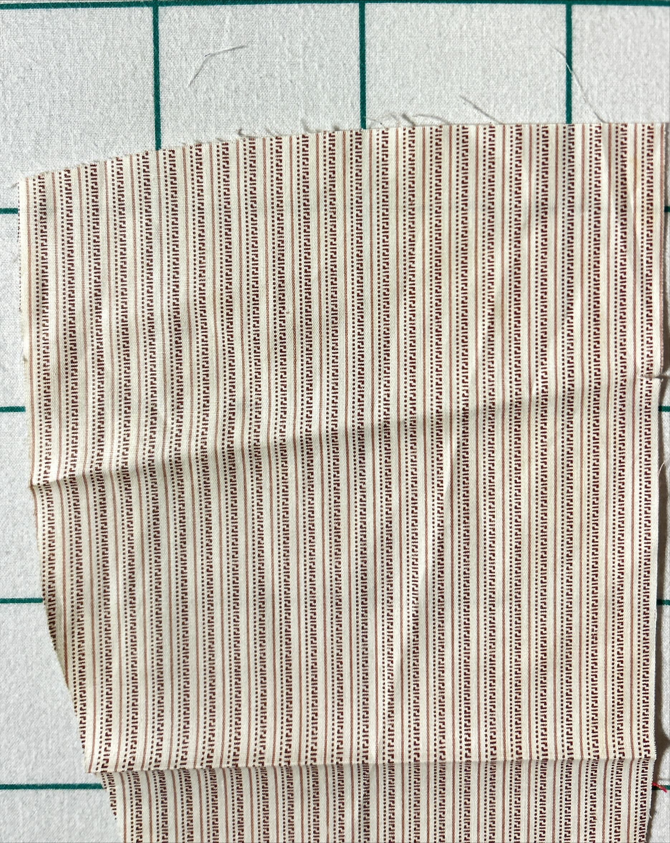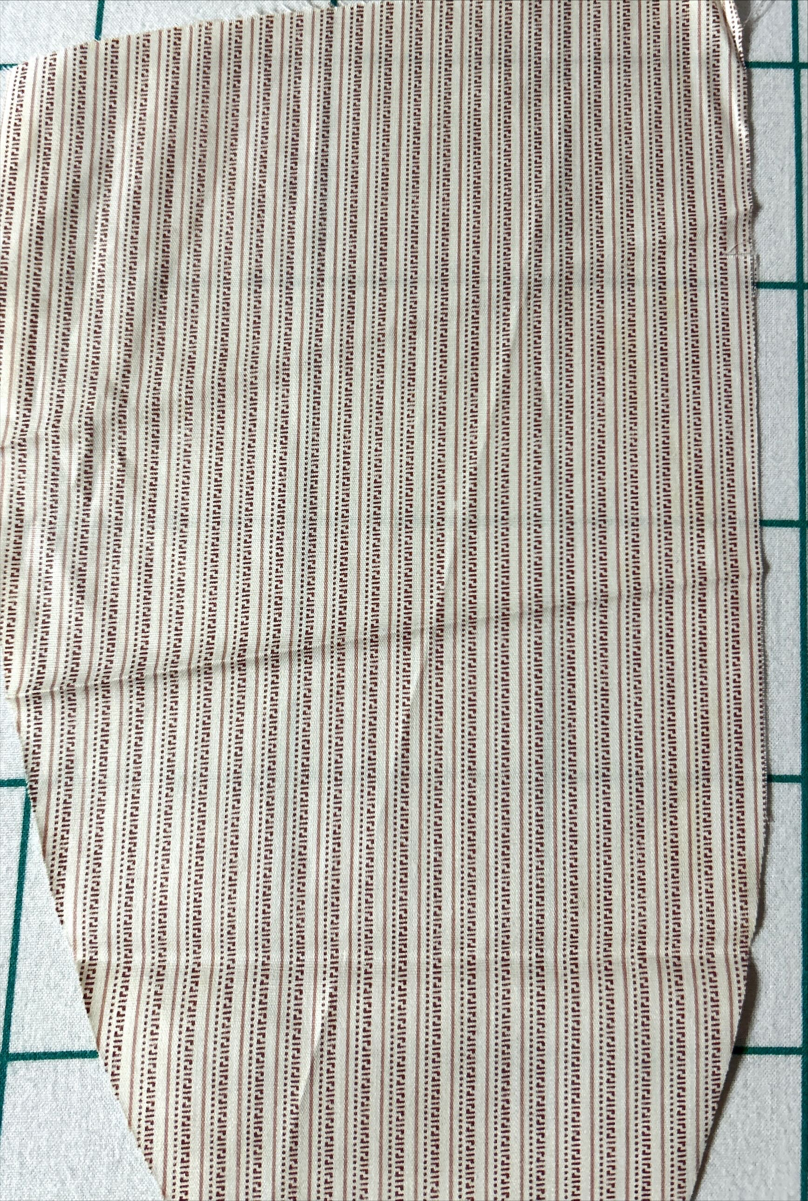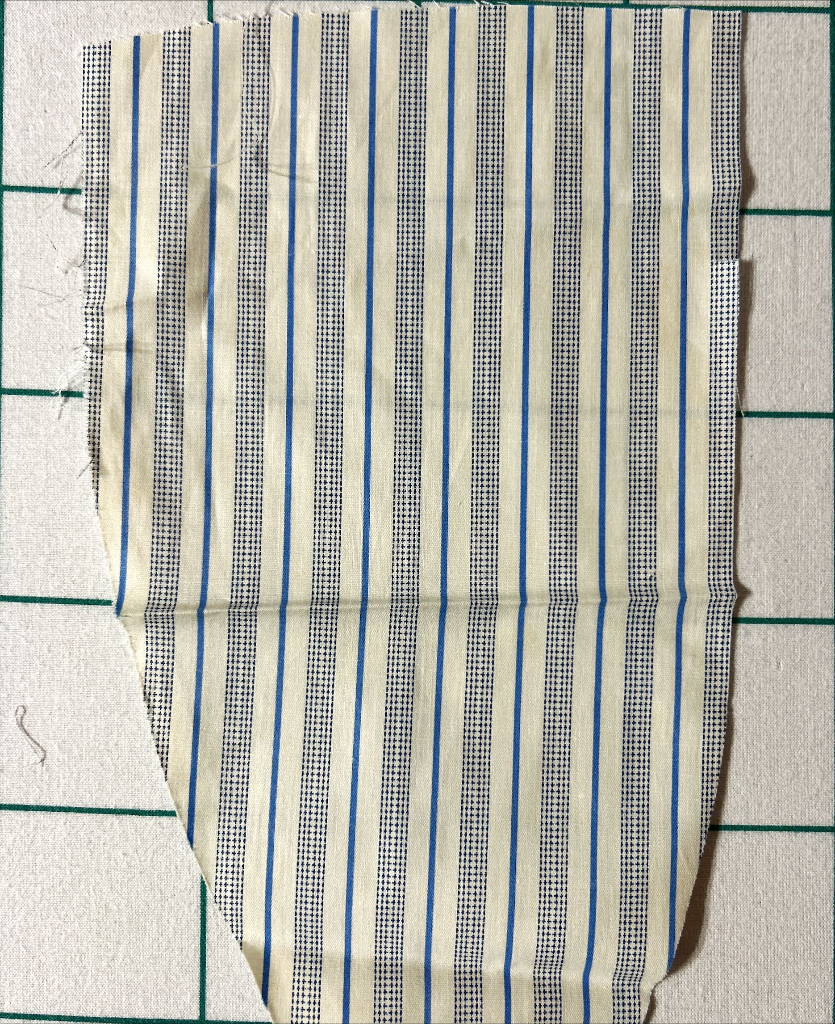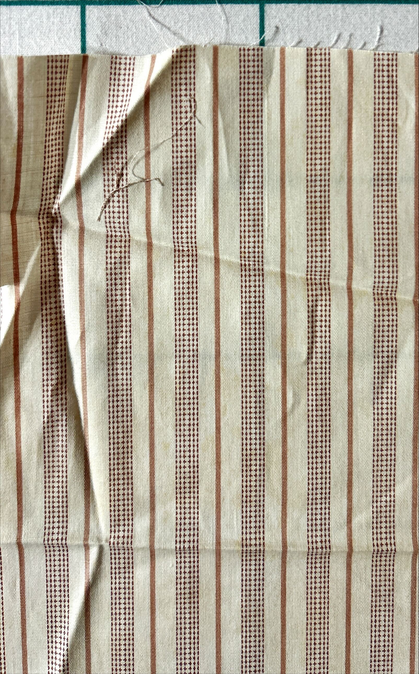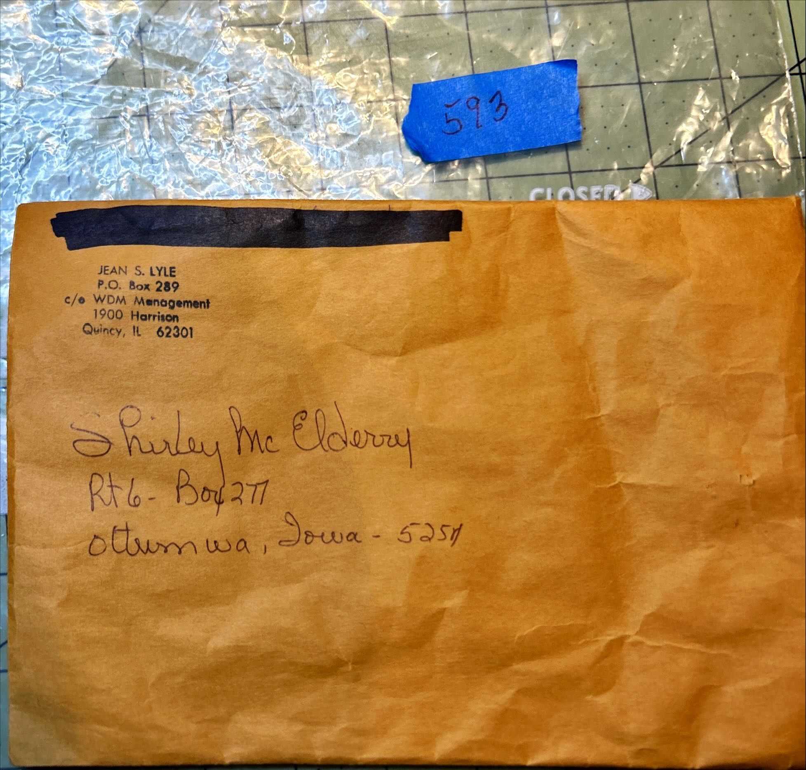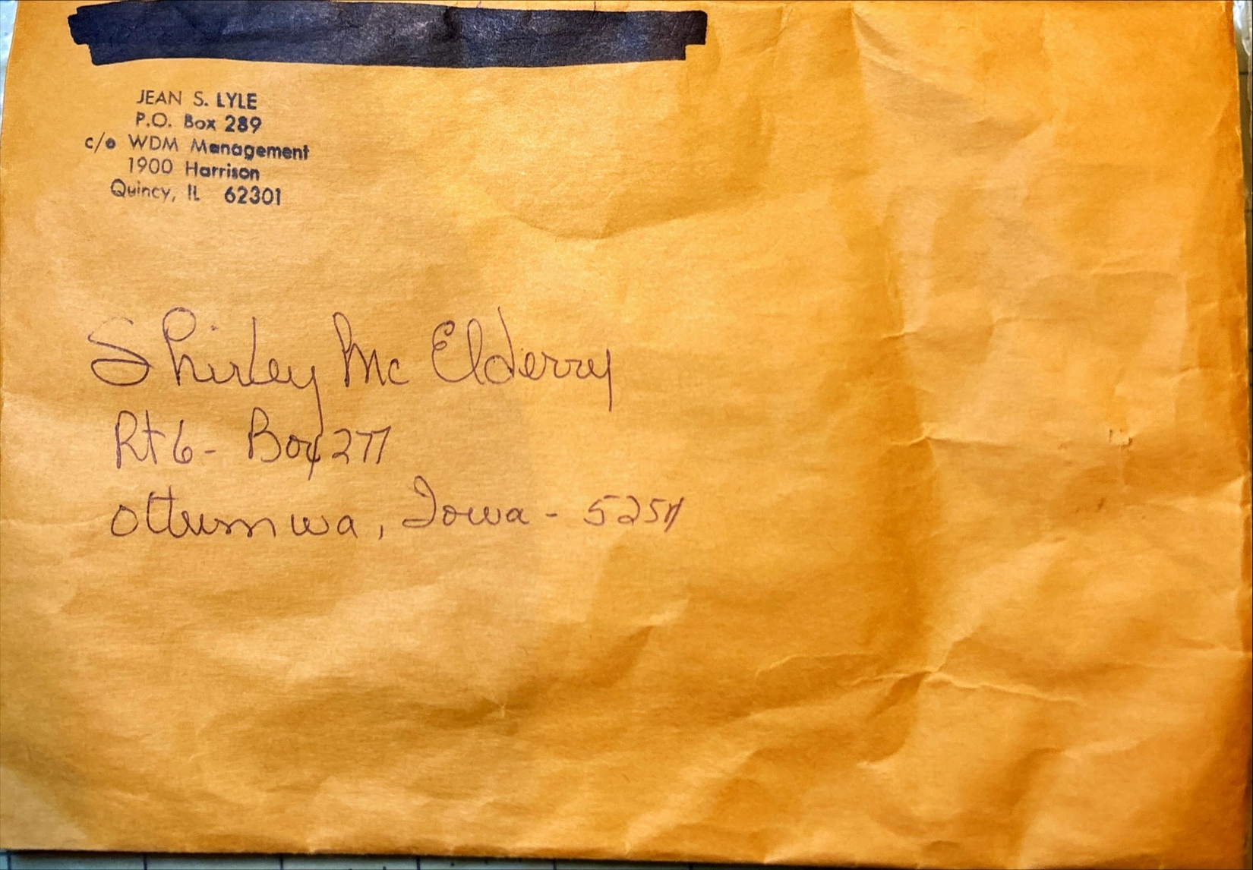

History

Known Owners
Owner | From Date | To Date | Acquired at: | Cost
David Bailey | 2025-10-1 | -- | Chris Moline  Naperville, IL | $0
 |  |  | Jean Lyle
Made in:
--
 | If not purchased, the estimated cost for materials: $0

Display & Publication History
Date | Event | Location / Publication
-- | -- | --

General Description
Quilt Title or Name:  Shirting Scraps | Fabric Date Range: 1925 ± 20 Years  Date Made: -- ± 0 Years  Method of Determination:
Item Type:  Items in Set: 8 | Size: Length: 13“ x Width: 6“
Appraisals:  Has this quilt been professionally appraised?  If so, when: --  ----------- | Other Related Information:  Quilt Index #:  Scanned Patterns  Images  EQ 8 Files  Research Notes
Additional Information: These items were packaged together with items in sample #594.

