Documentation Form

Overview

Images
Top | Back
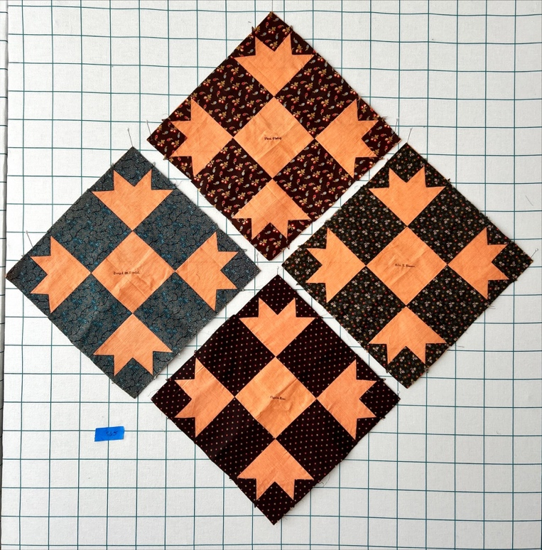 | 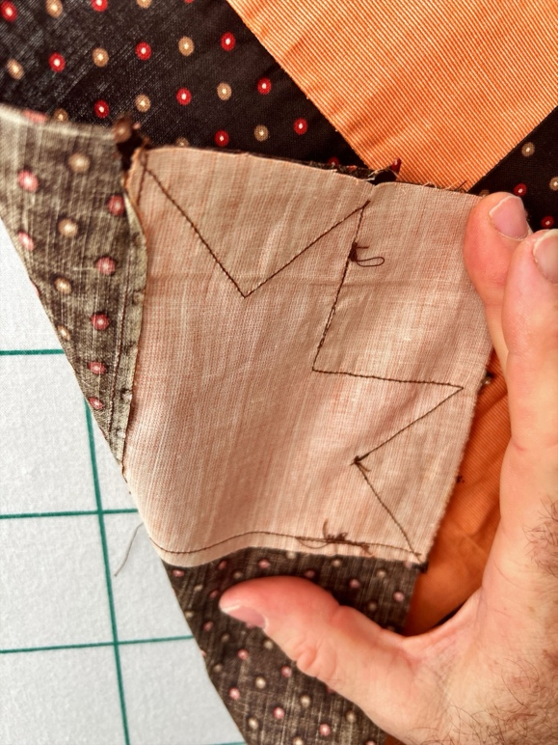

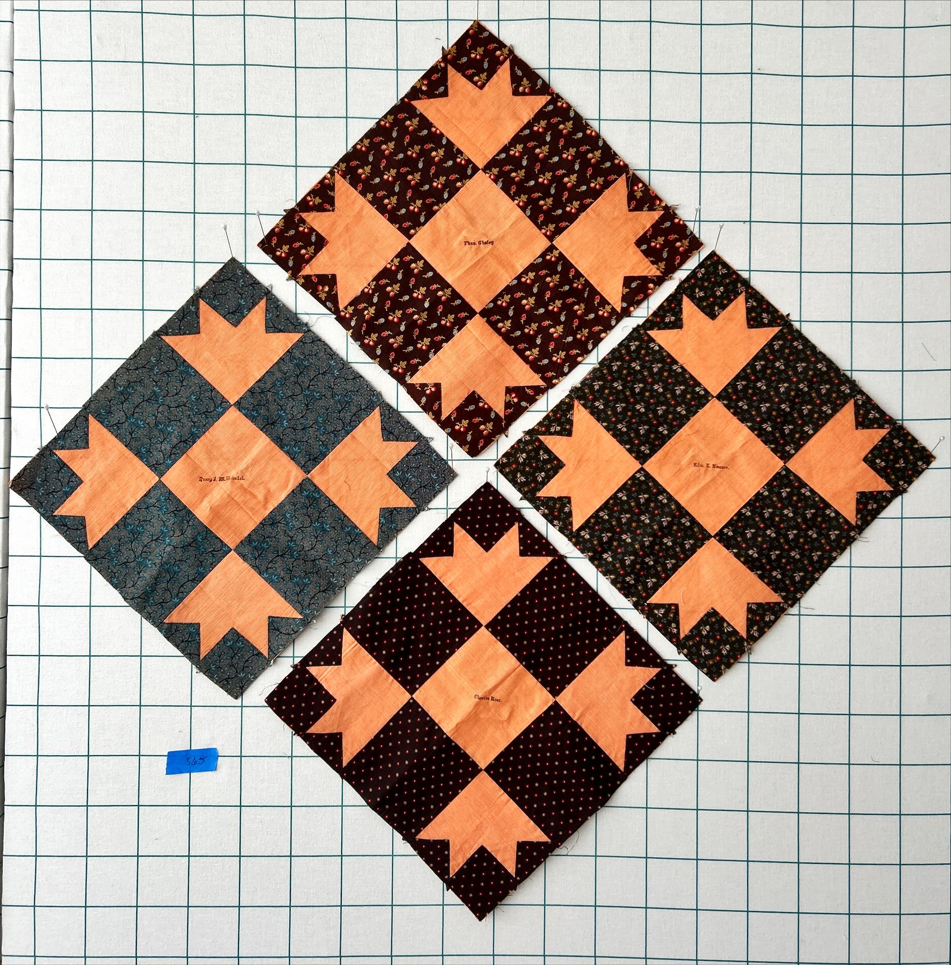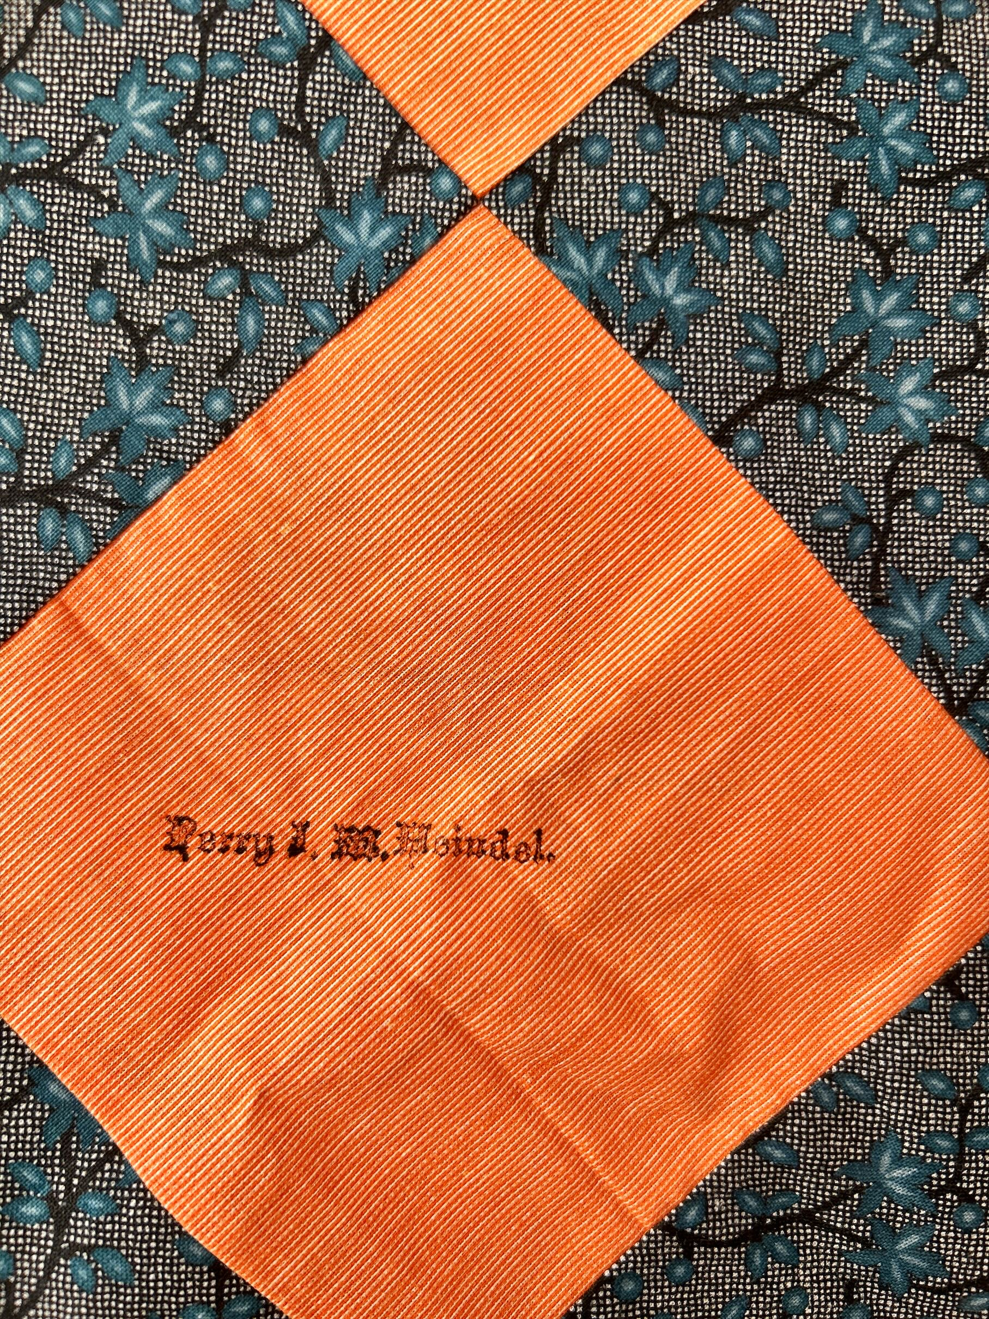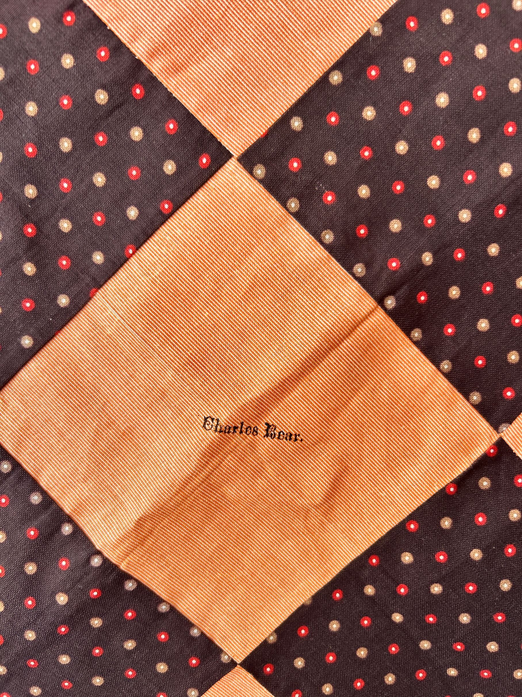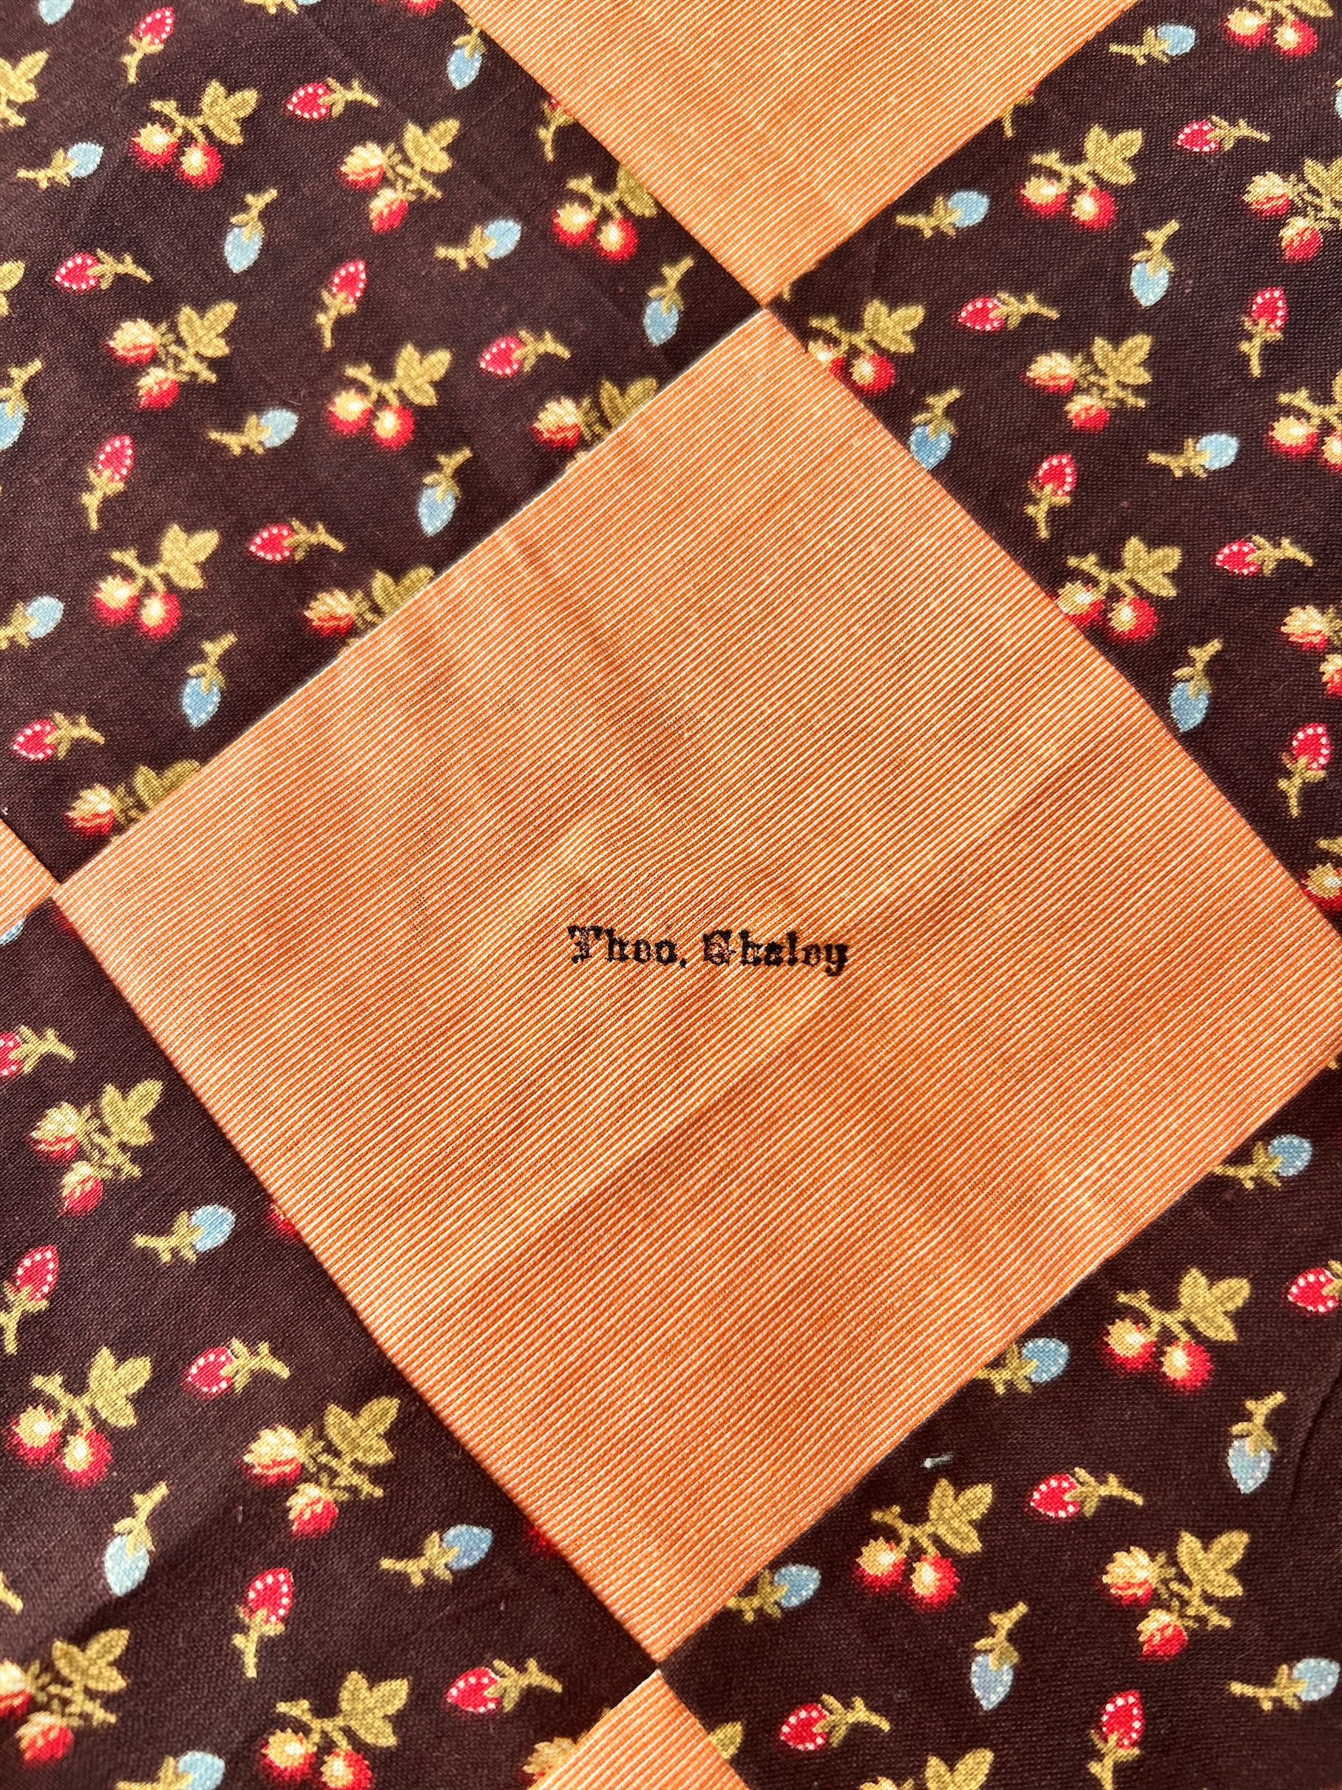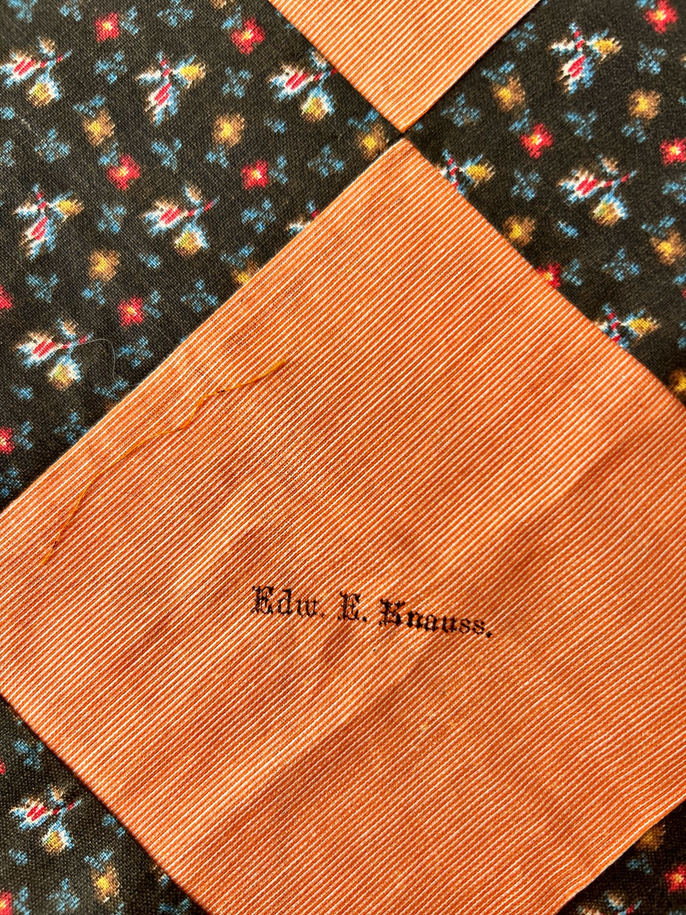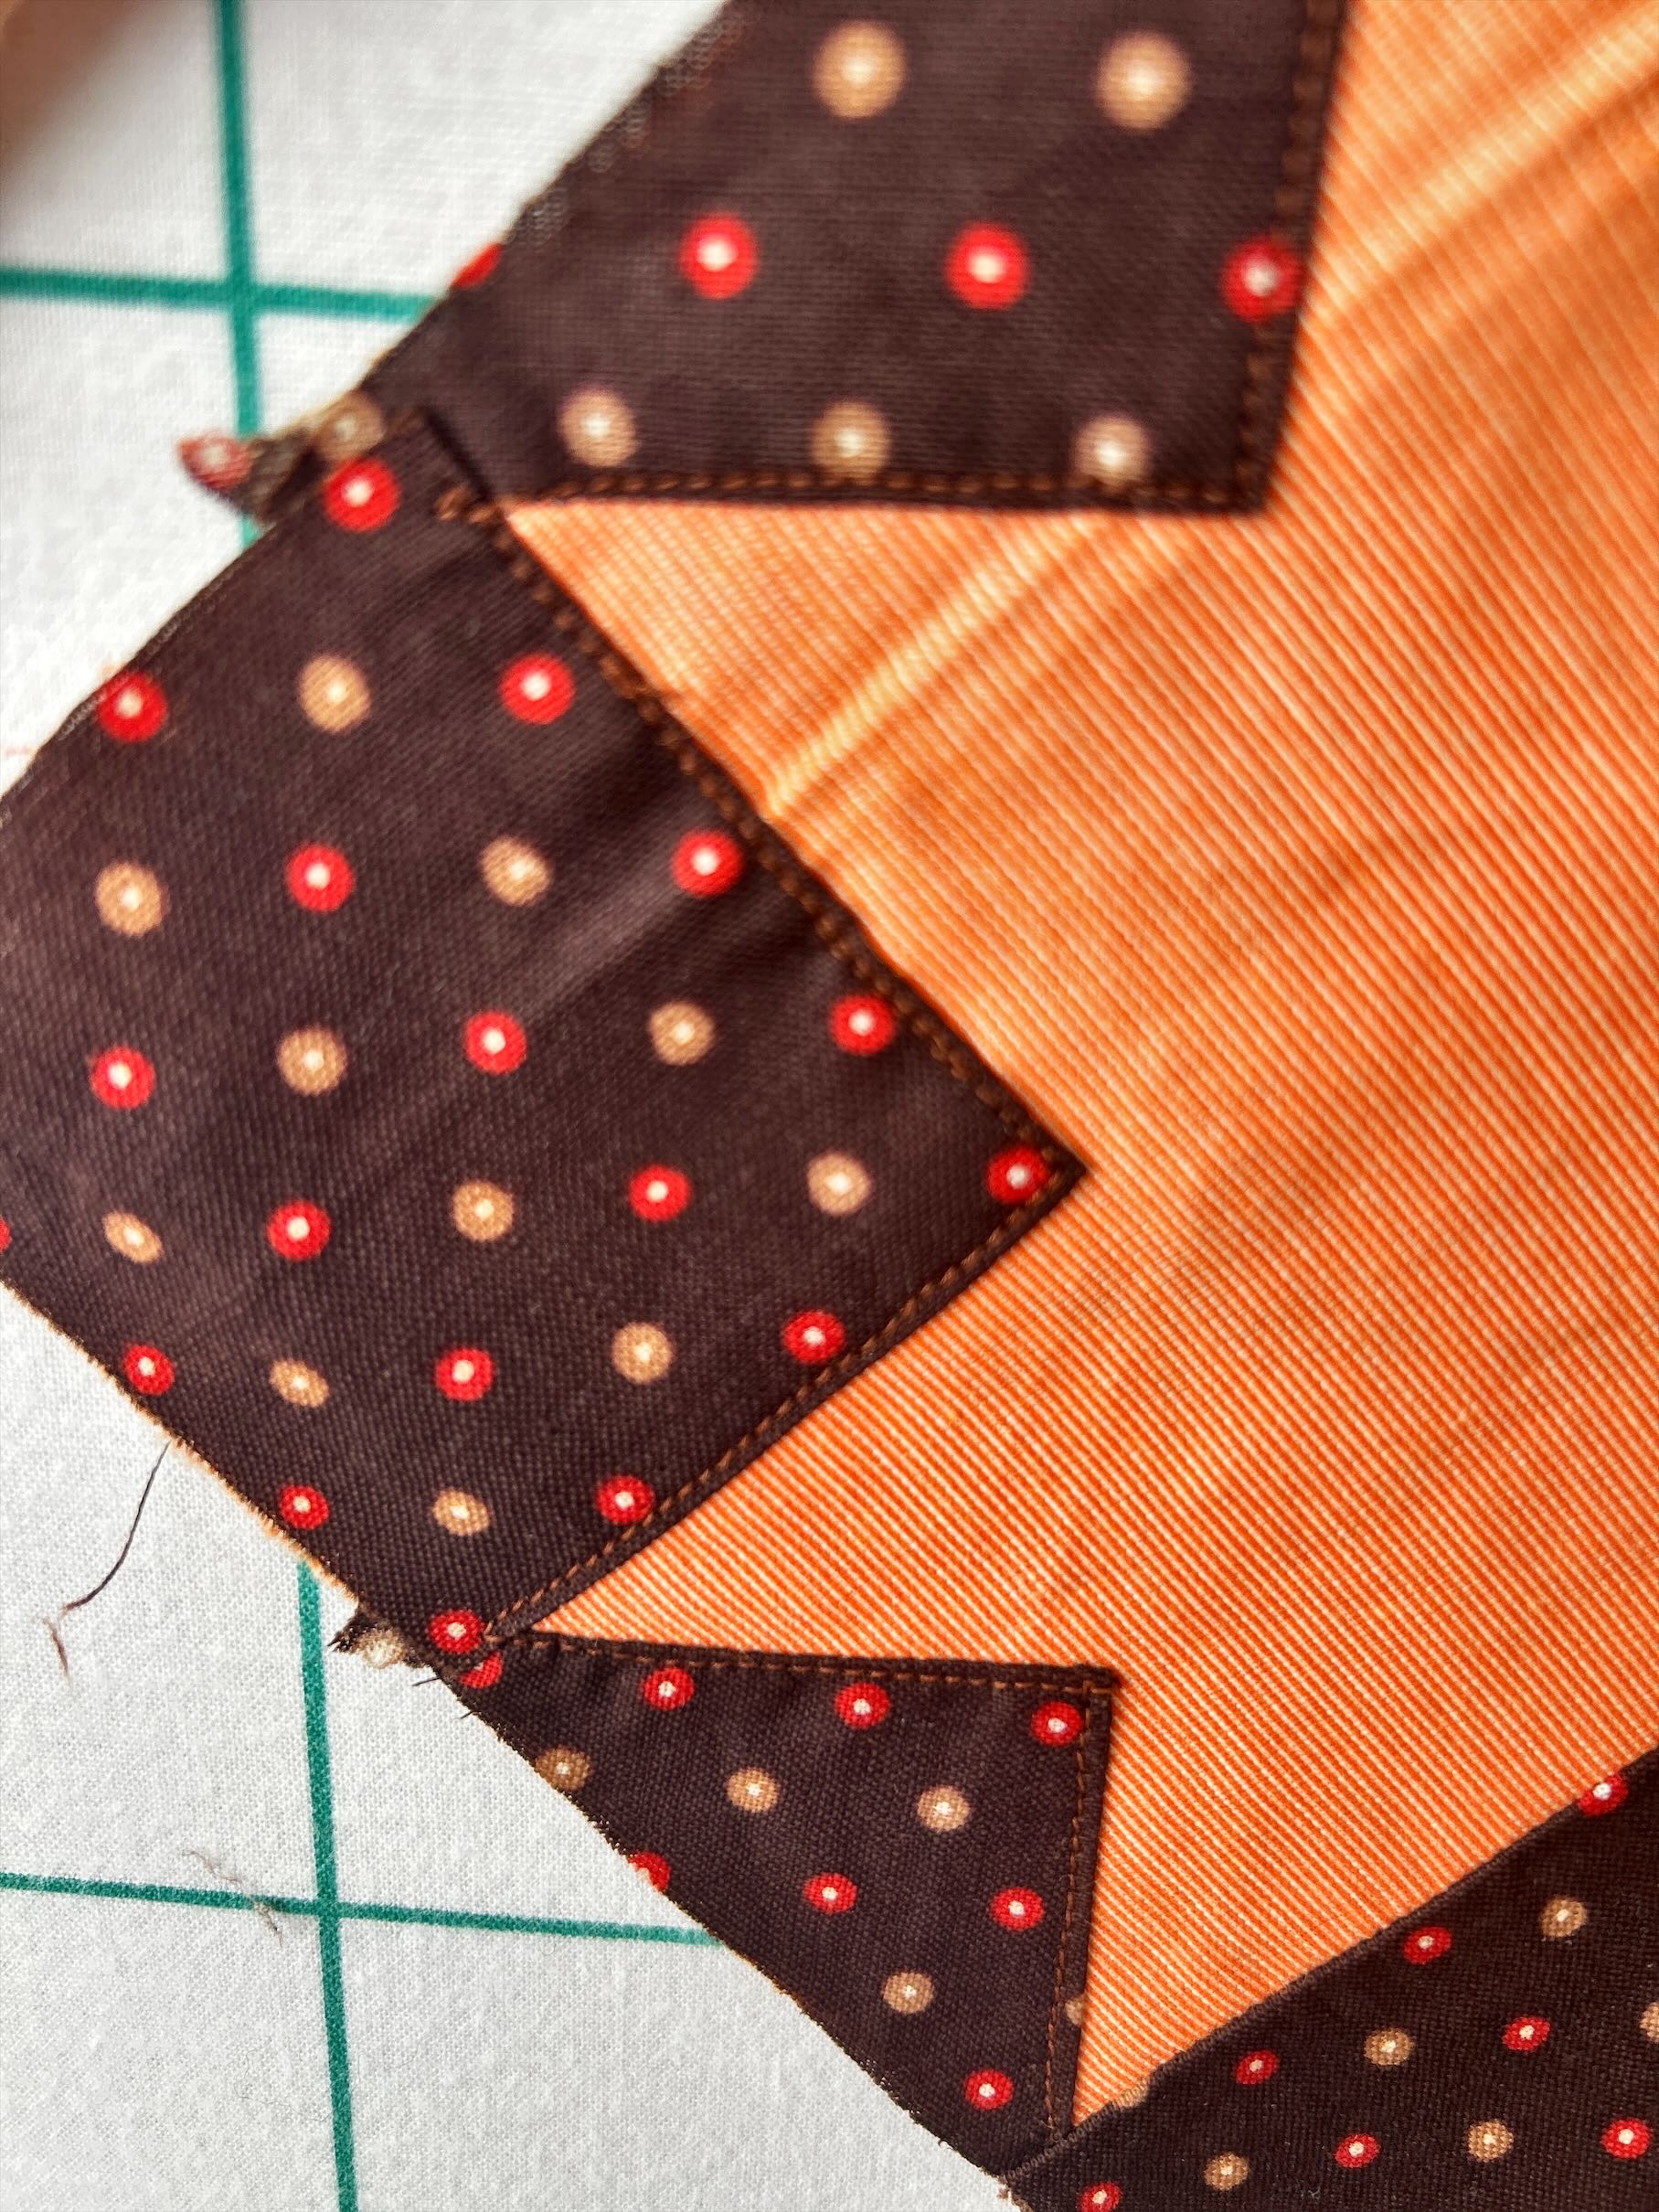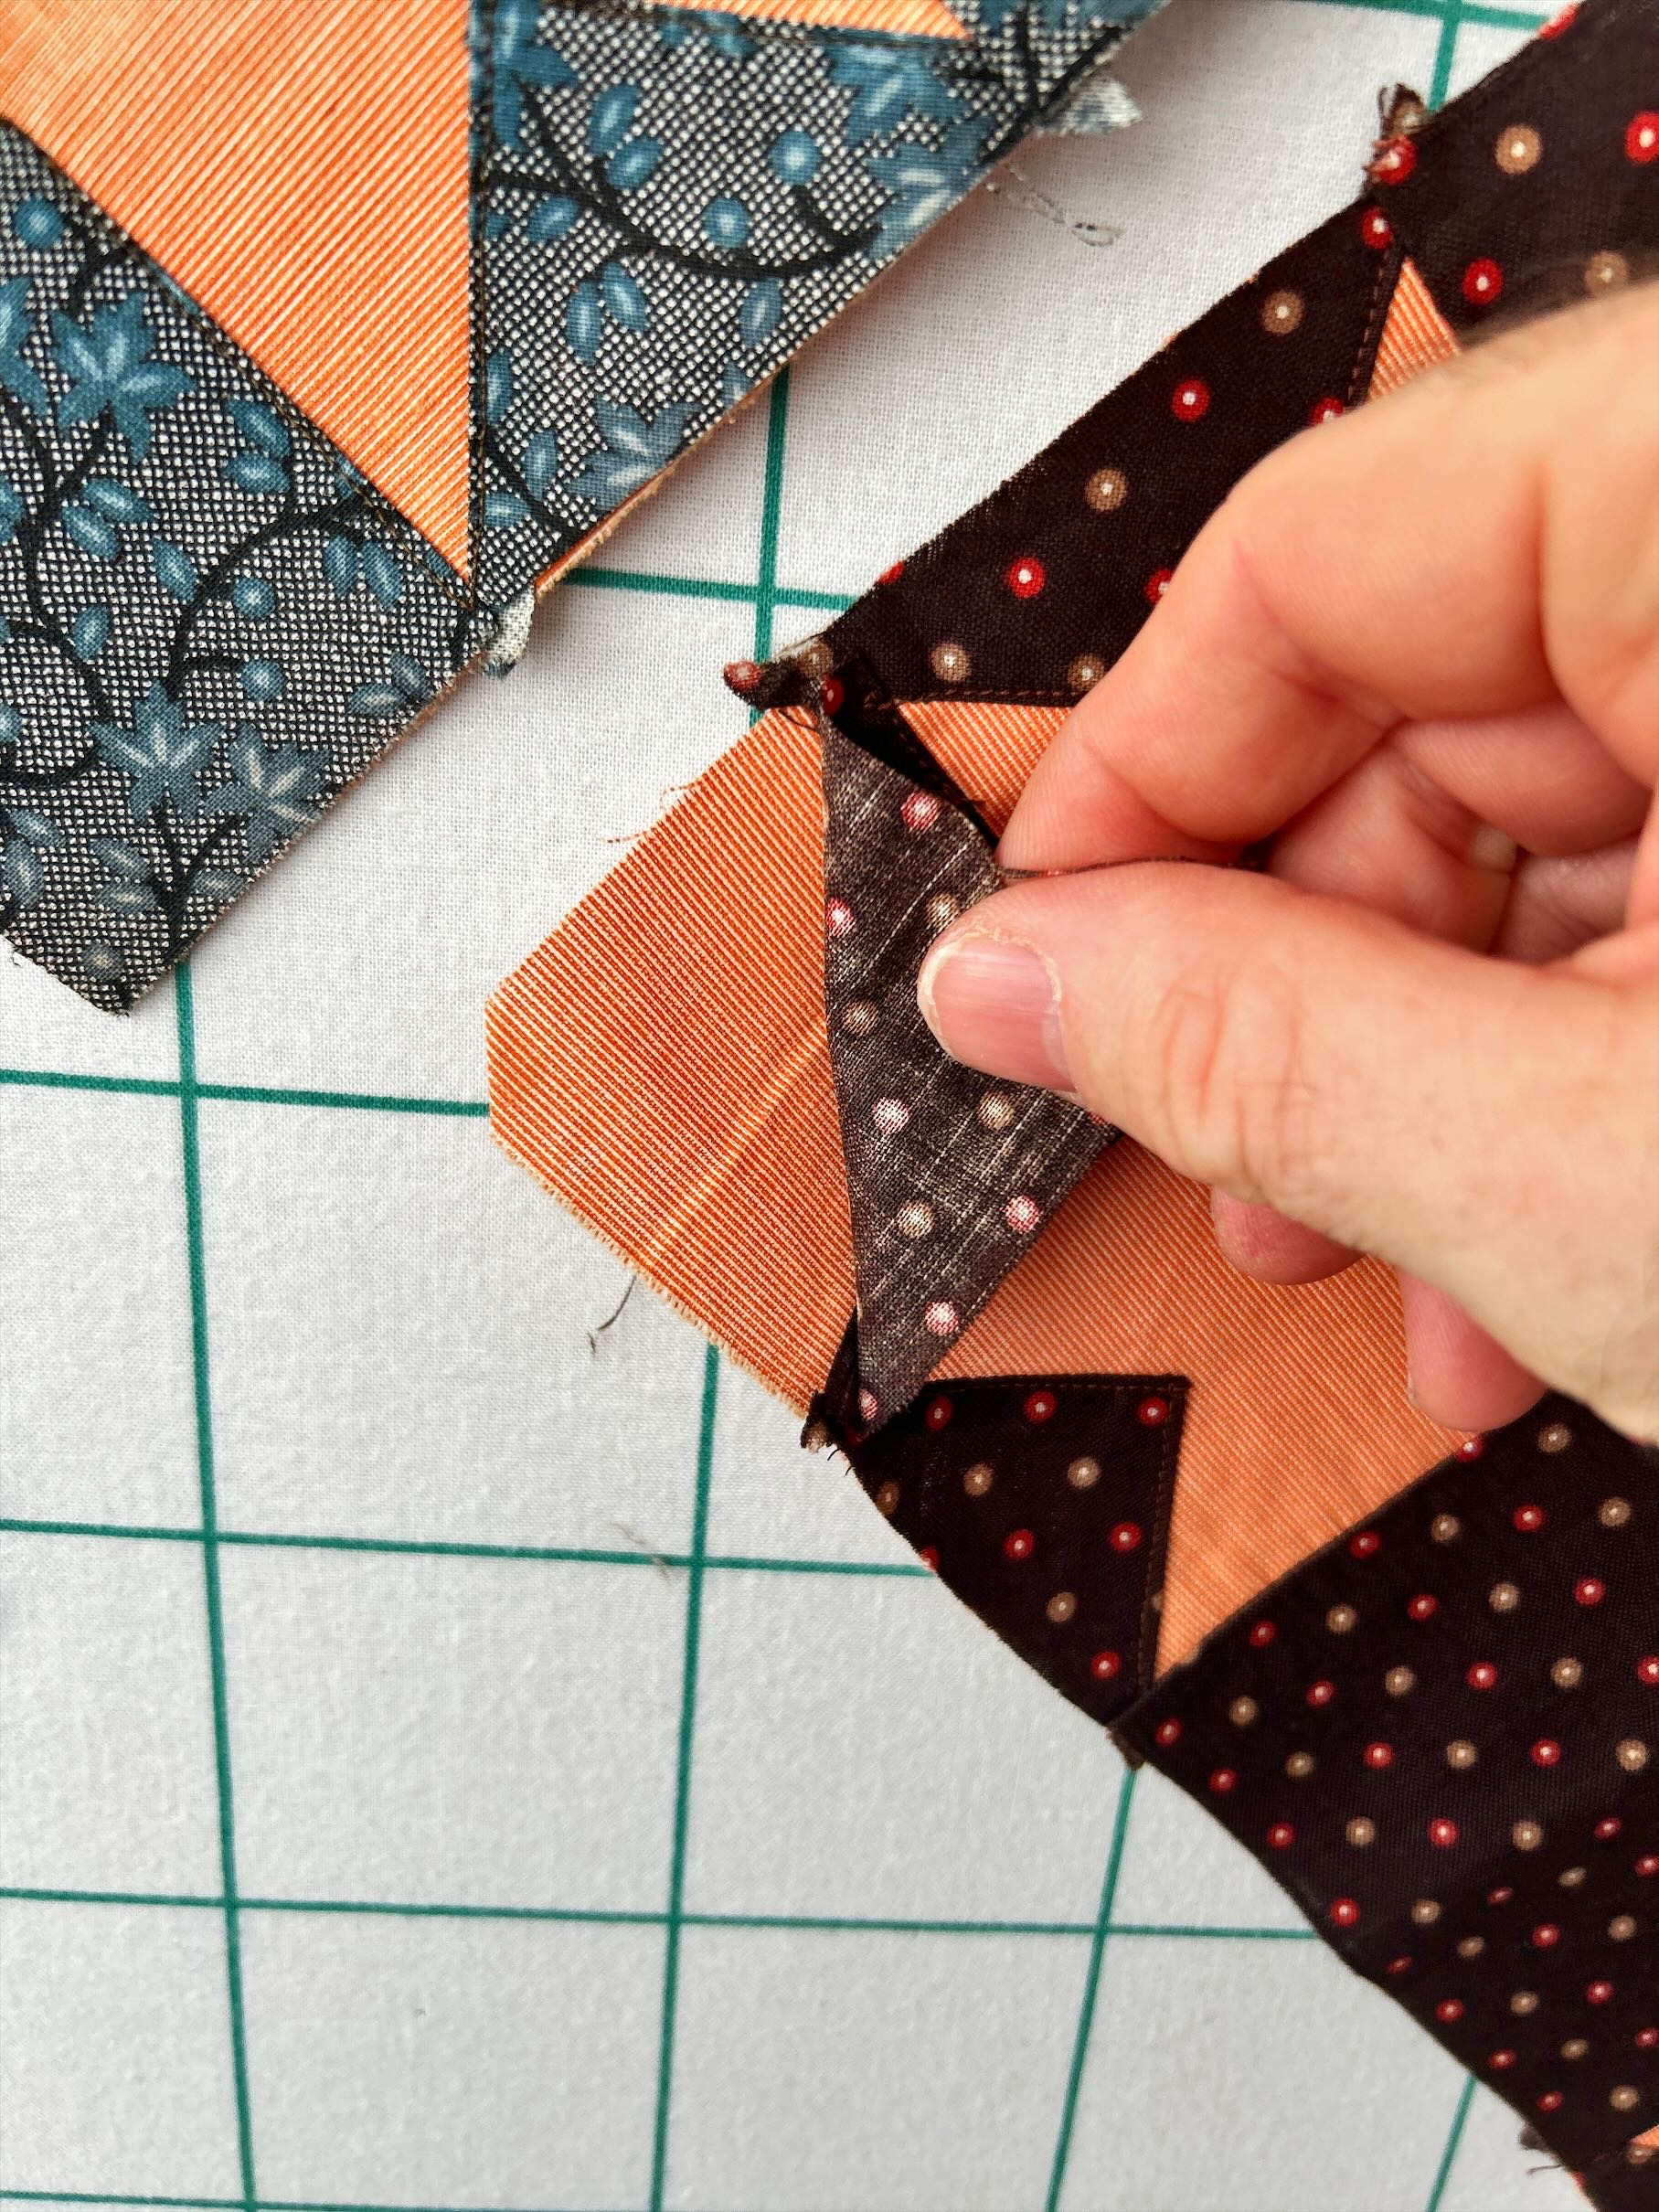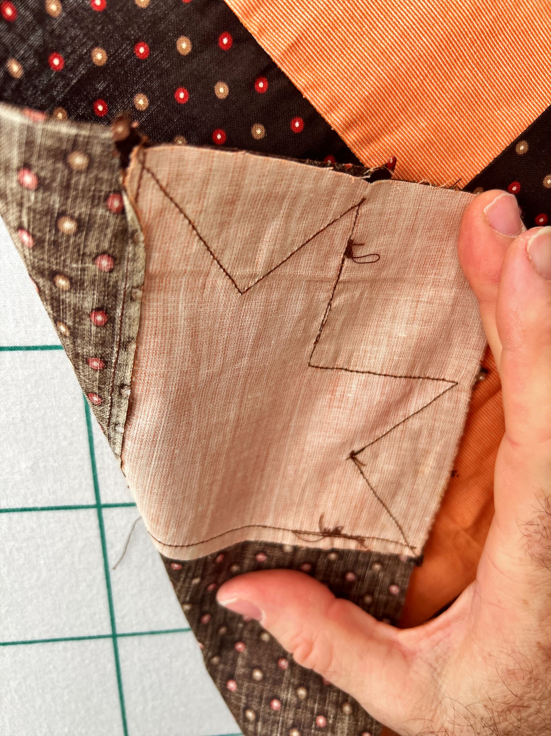

History

Known Owners
Owner | From Date | To Date | Acquired at: | Cost
David Bailey | 2025-10-18 | -- | AQSG Seminar - Portland, Maine | $30
Judy Roche |  | 2025-10-18
Made in:
--
 | If not purchased, the estimated cost for materials: $0

Display & Publication History
Date | Event | Location / Publication
-- | -- | --

General Description
Quilt Title or Name:  Stamped Inscribed Blocks | Fabric Date Range: 1875 ± 10 Years  Date Made: -- ± 0 Years  Method of Determination:
Item Type:  Items in Set: 4 | Size: Length: 13“ x Width: 13“
Appraisals:  Has this quilt been professionally appraised?  If so, when: --  ----------- | Other Related Information:  Quilt Index #:  Scanned Patterns  Images  EQ 8 Files  Research Notes
Additional Information: While the fabric is a good quality vintage, the sewing may be more recent. The construction process is odd here. Note that they corner fabric is appliqued not pieced as might be expected. Chris Moline agrees with this evaluation.

