Documentation Form

Overview

Images
Top | Back
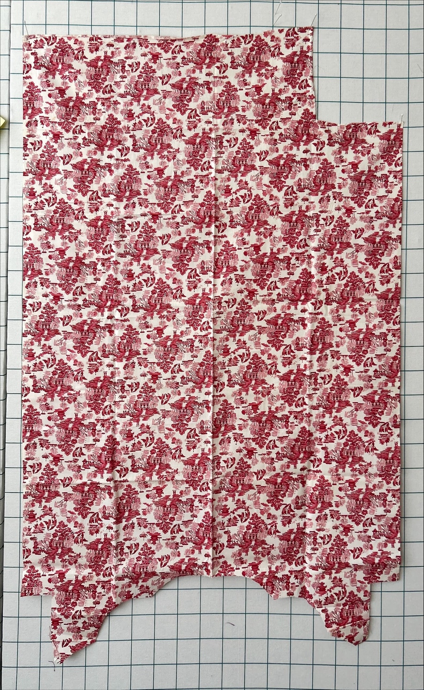

History

Known Owners
Owner | From Date | To Date | Acquired at: | Cost
David Bailey | June 21, 2025 | -- | Sherry Bronson  Libertyville, IL | $0
Made in:
--
 | If not purchased, the estimated cost for materials: $0

Display & Publication History
Date | Event | Location / Publication
-- | -- | --

General Description
Quilt Title or Name:  Japanese Momen Fabric | Fabric Date Range: 2000 ± 10 Years  Date Made: -- ± 0 Years  Method of Determination:
Item Type:  Items in Set: 1 | Size: Length: 46“ x Width: 34“
Appraisals:  Has this quilt been professionally appraised?  If so, when: --  ----------- | Other Related Information:  Quilt Index #:  Scanned Patterns  Images  EQ 8 Files  Research Notes
Additional Information: Chris Moline saw this fabric and said “Japanese Momen.” I am not sure what to make of this. The date range for Momen fabric is huge and this fabric does not feel like it is an antique or of particularly fine quality. Perhaps her reference was to a reproduction of a toile? I dunno.

