Documentation Form

Overview

Images
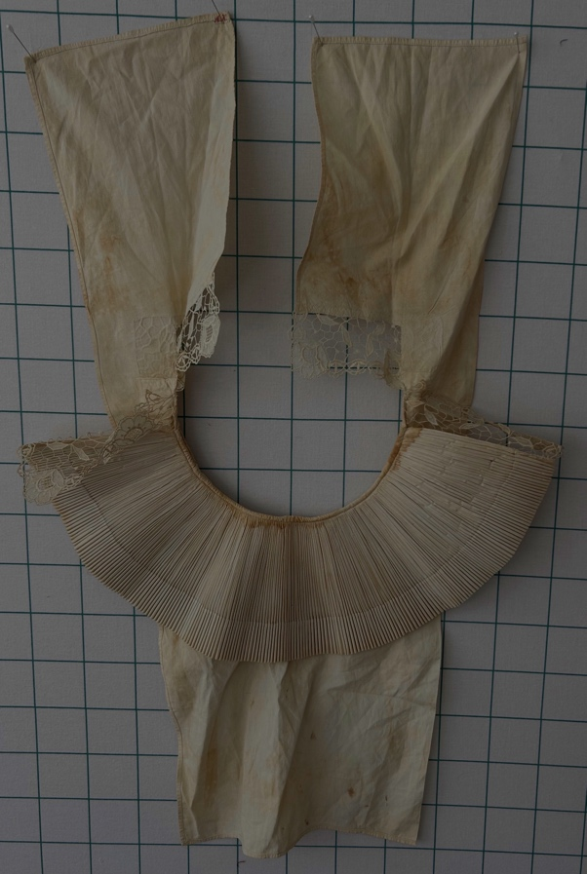 | 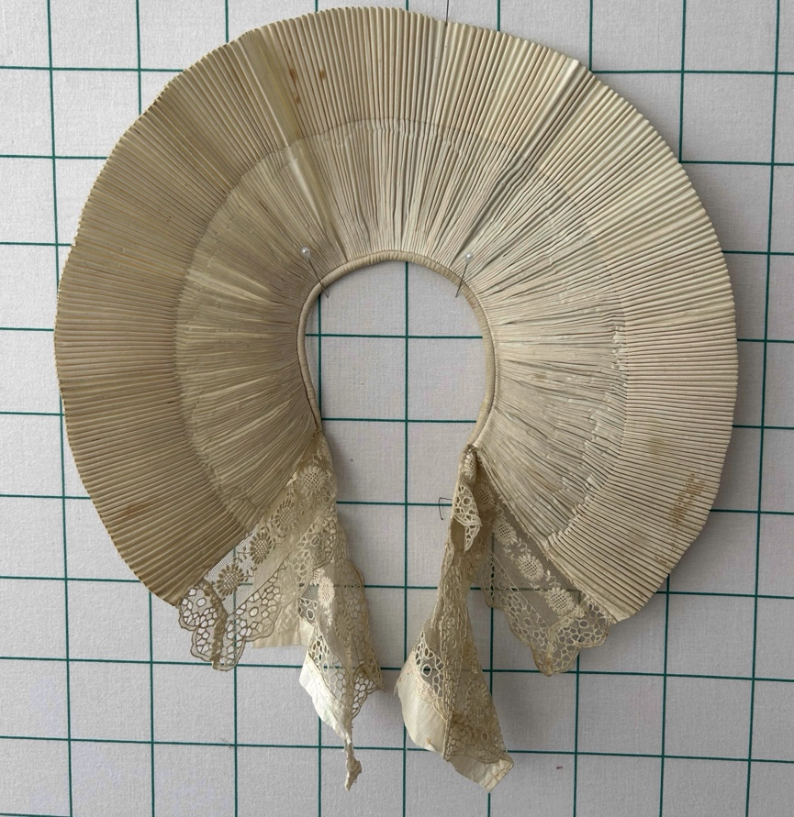

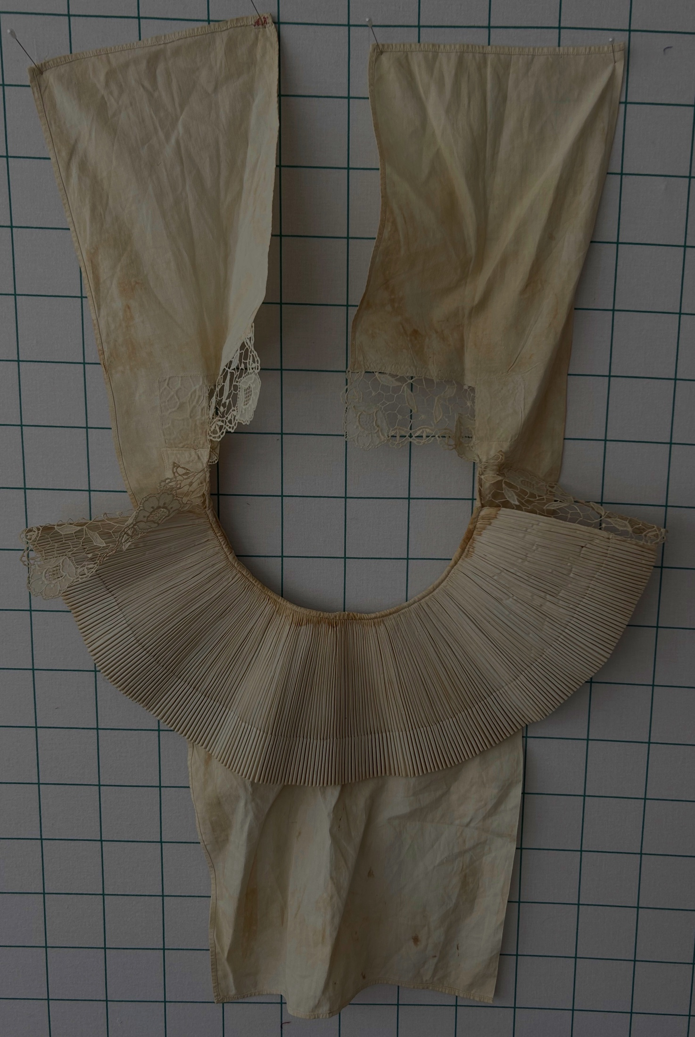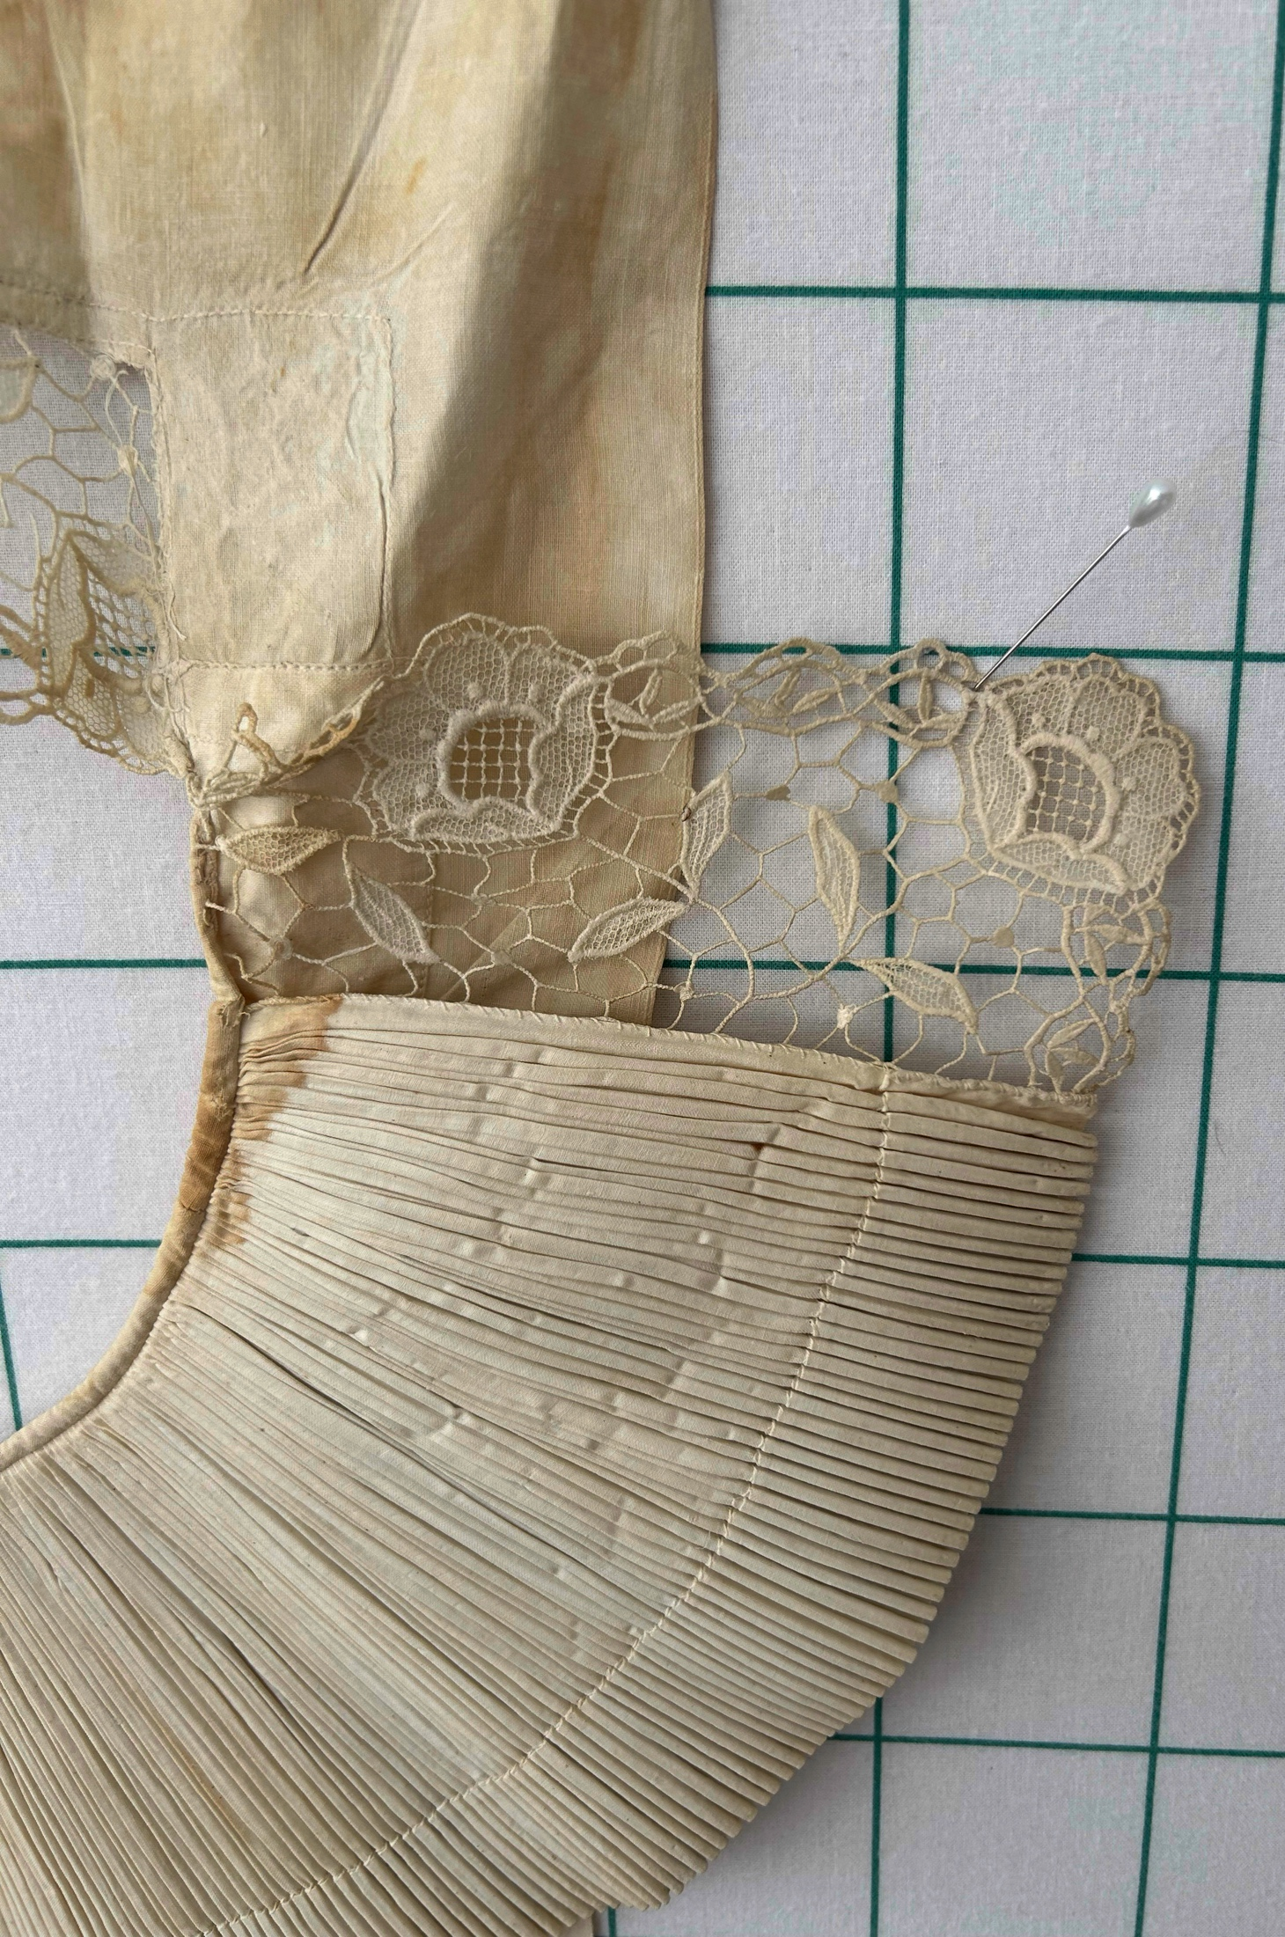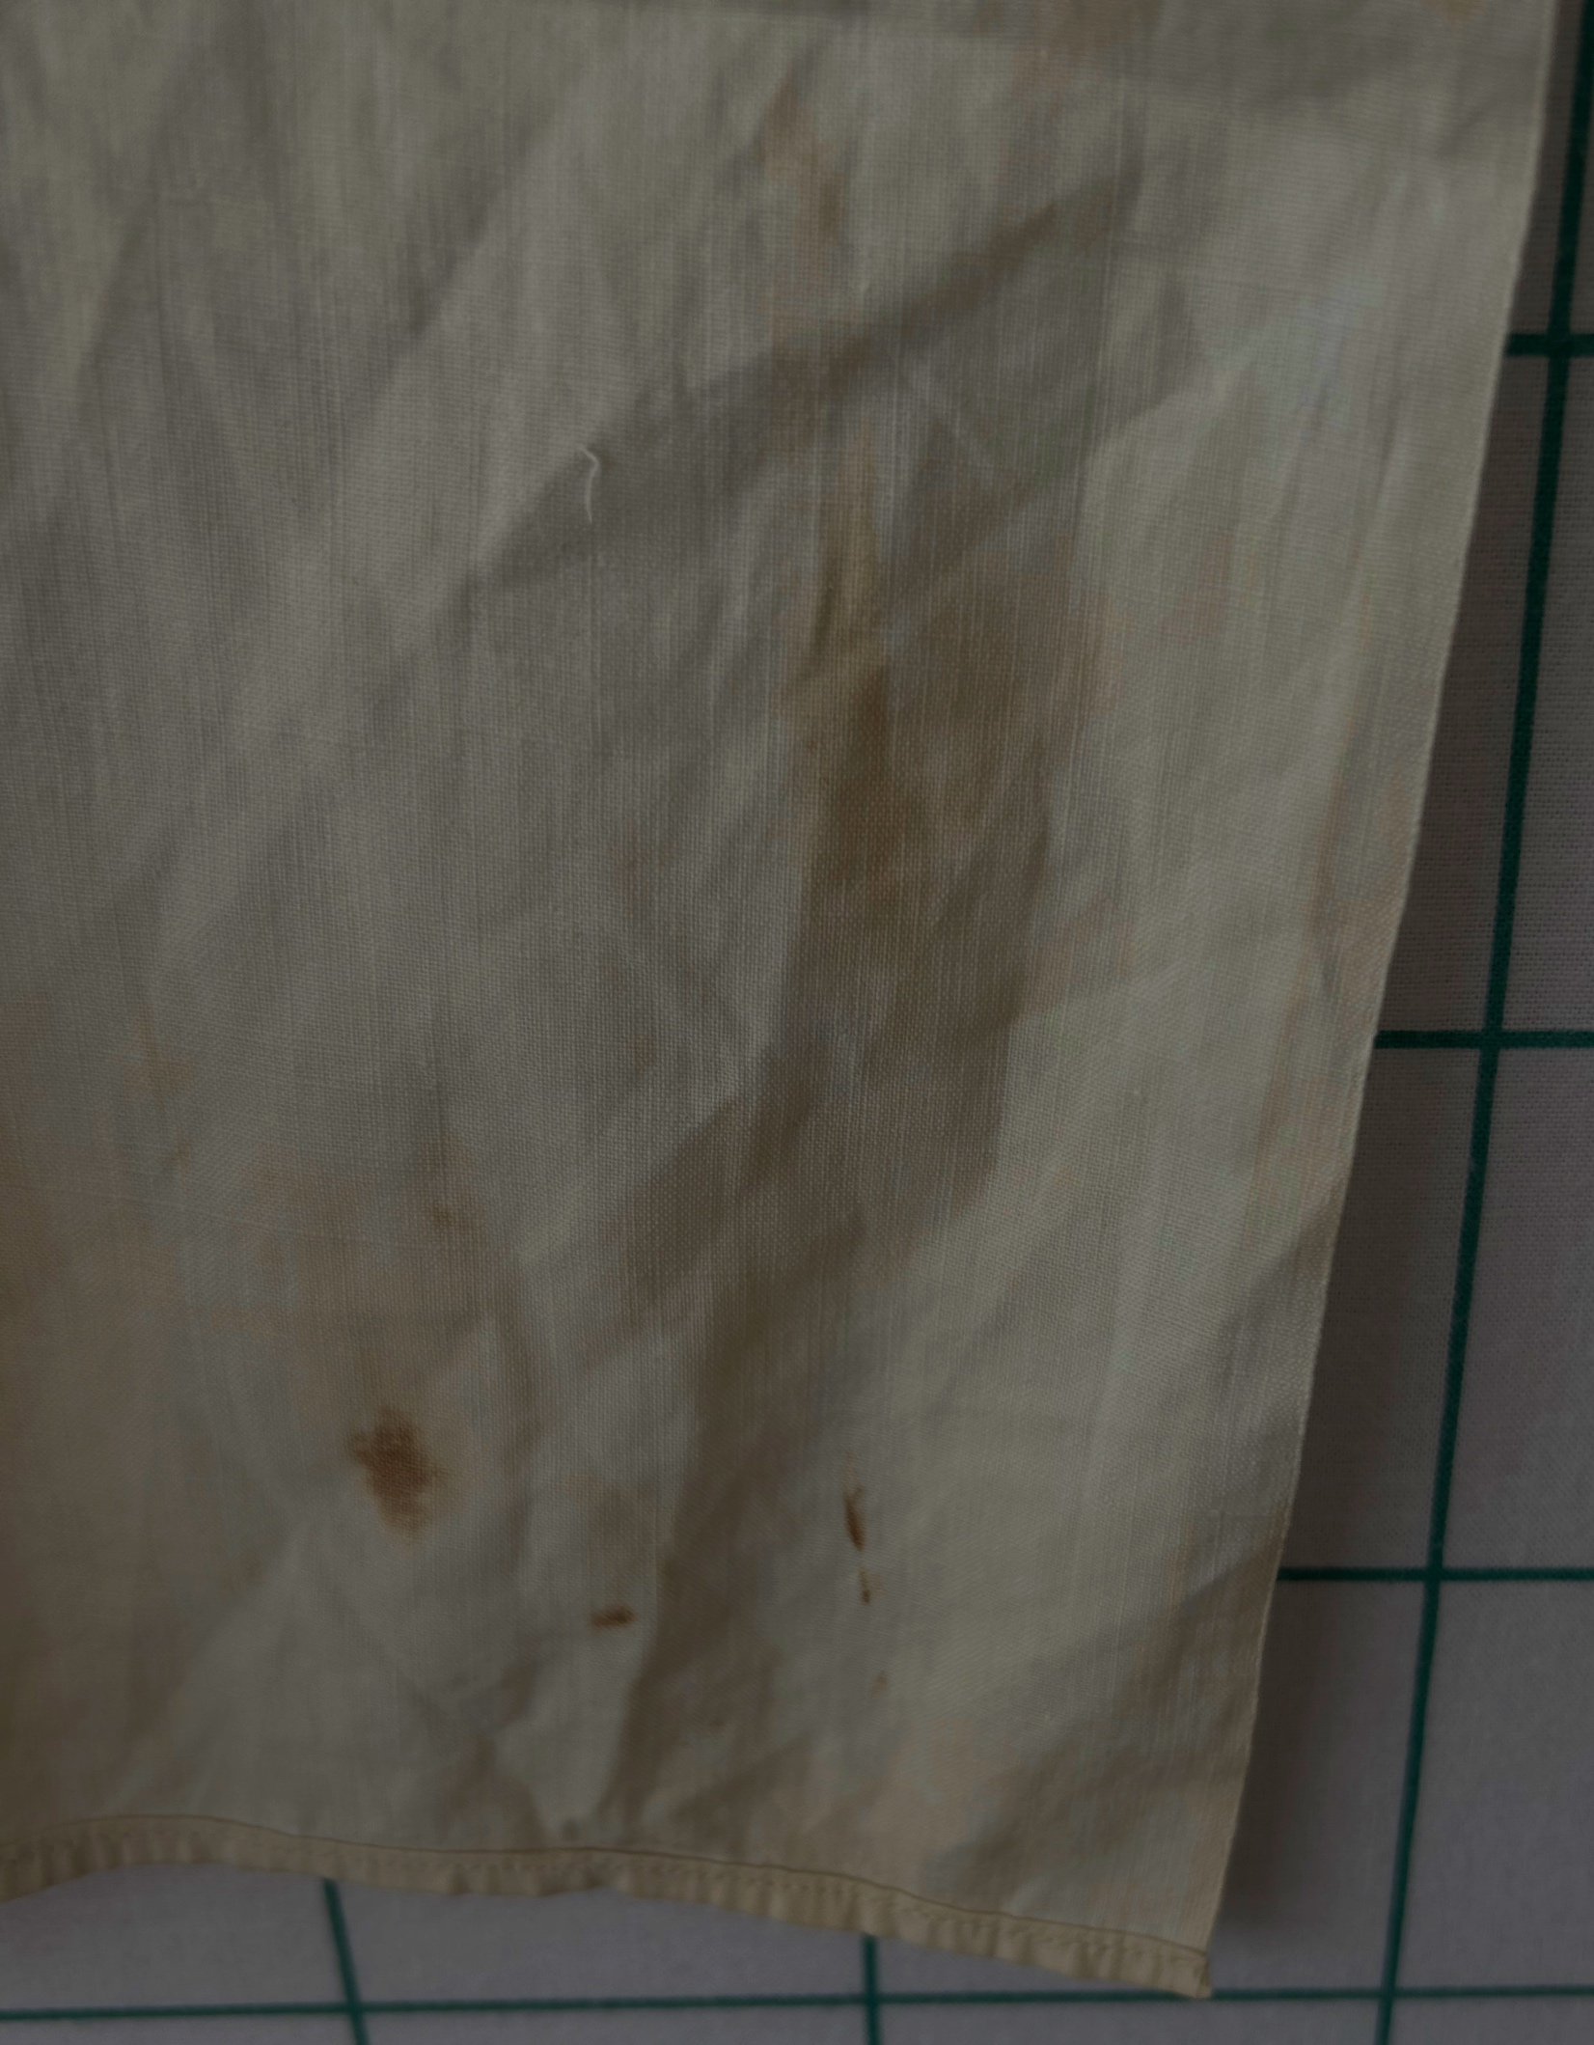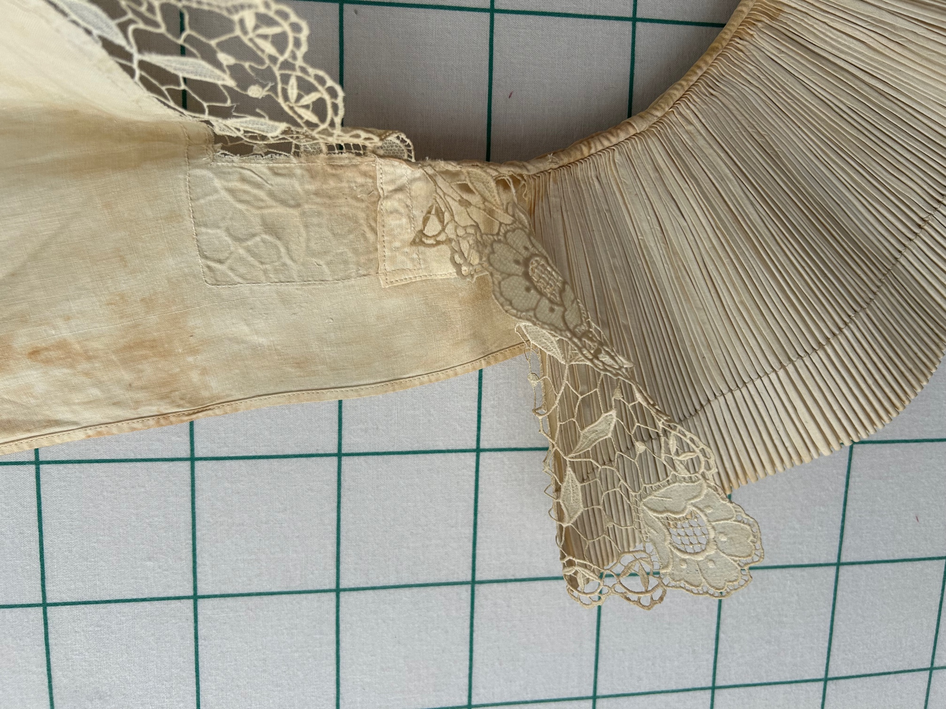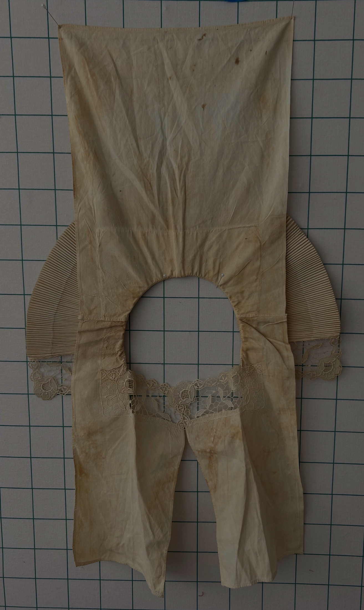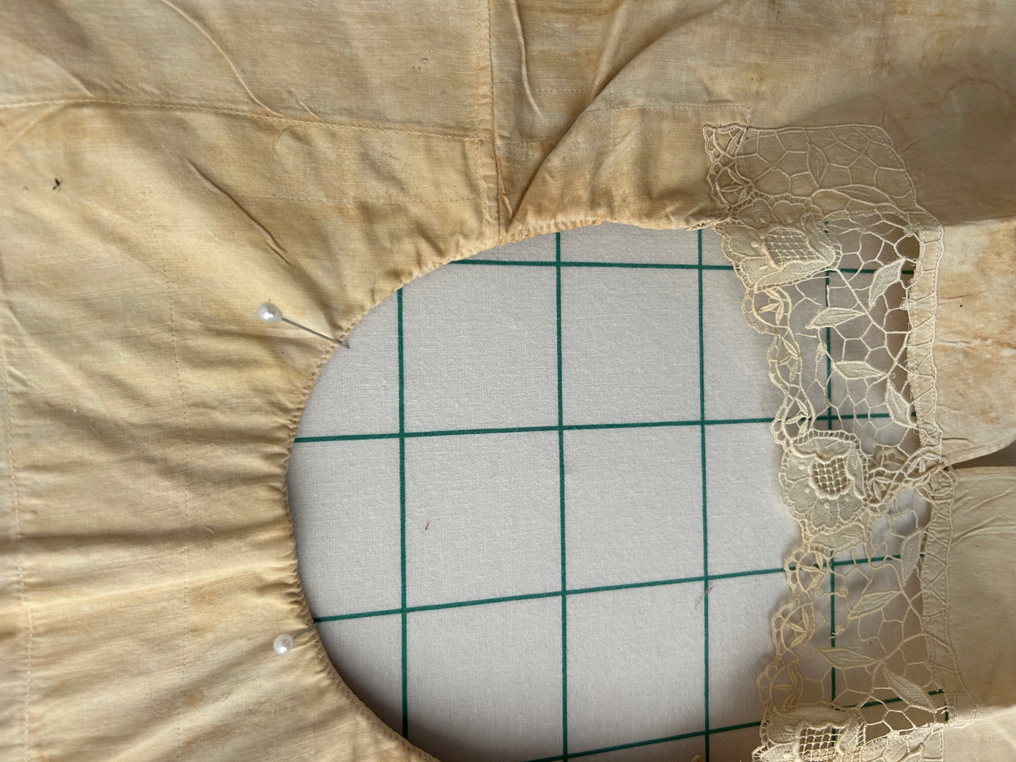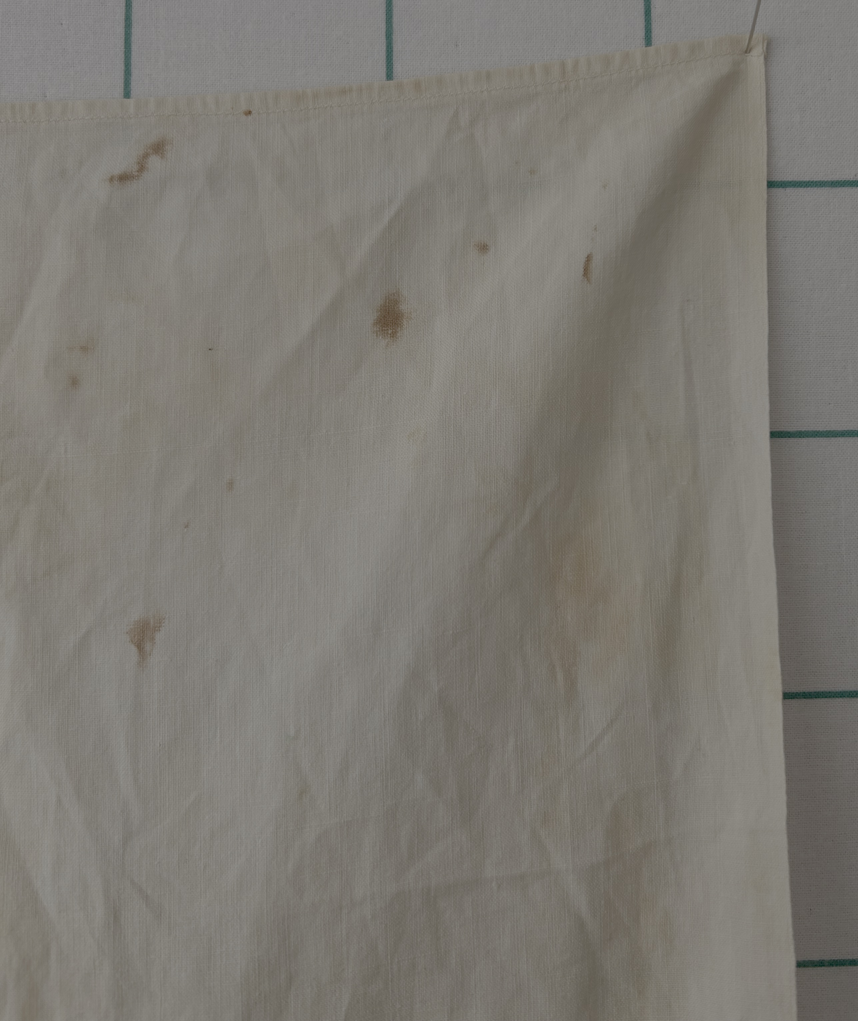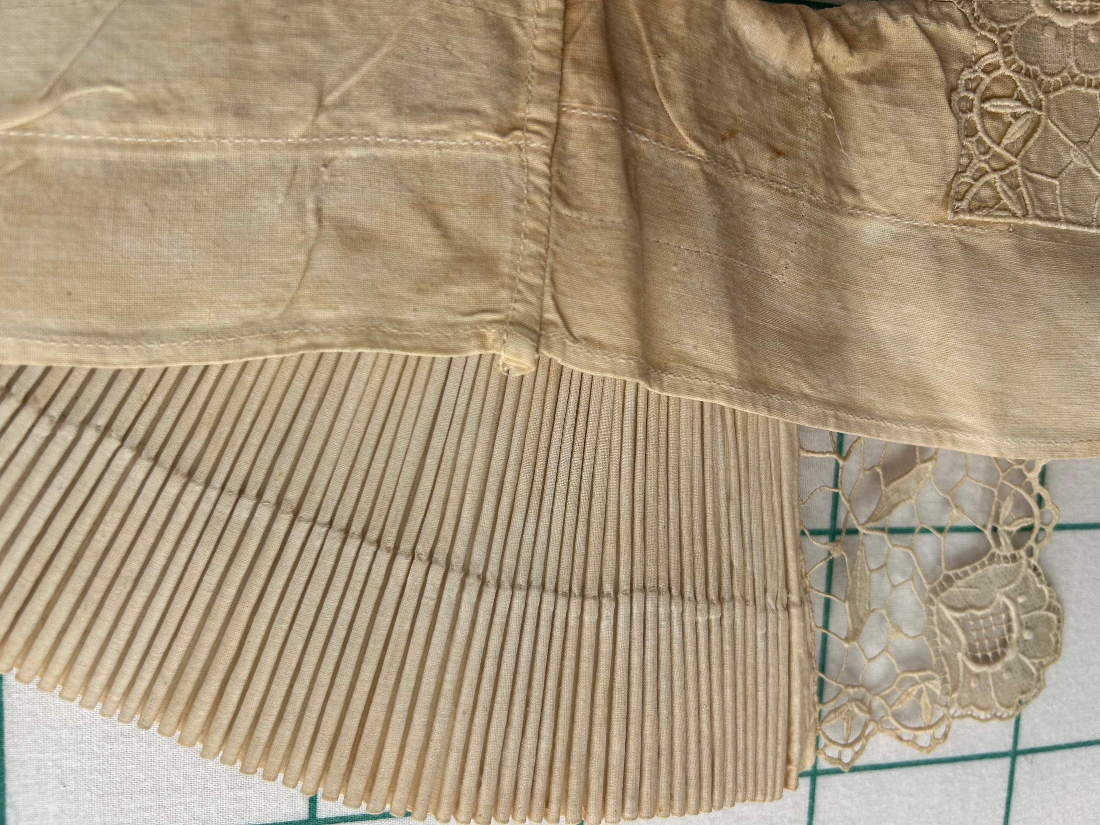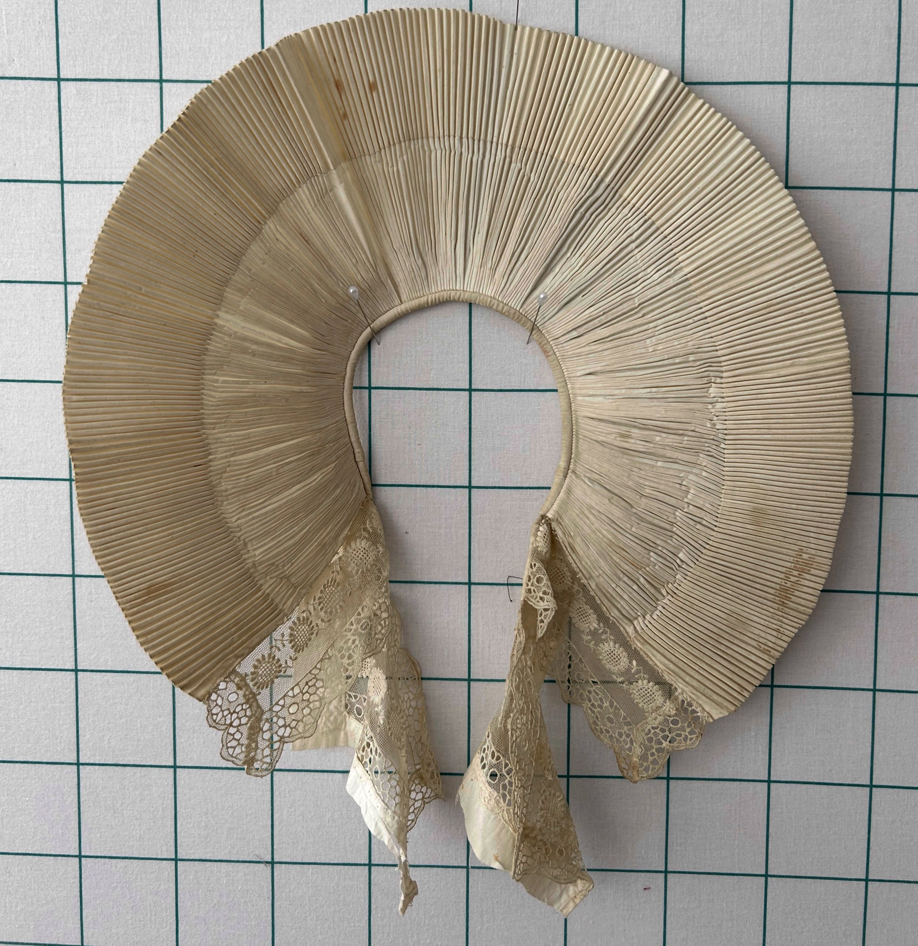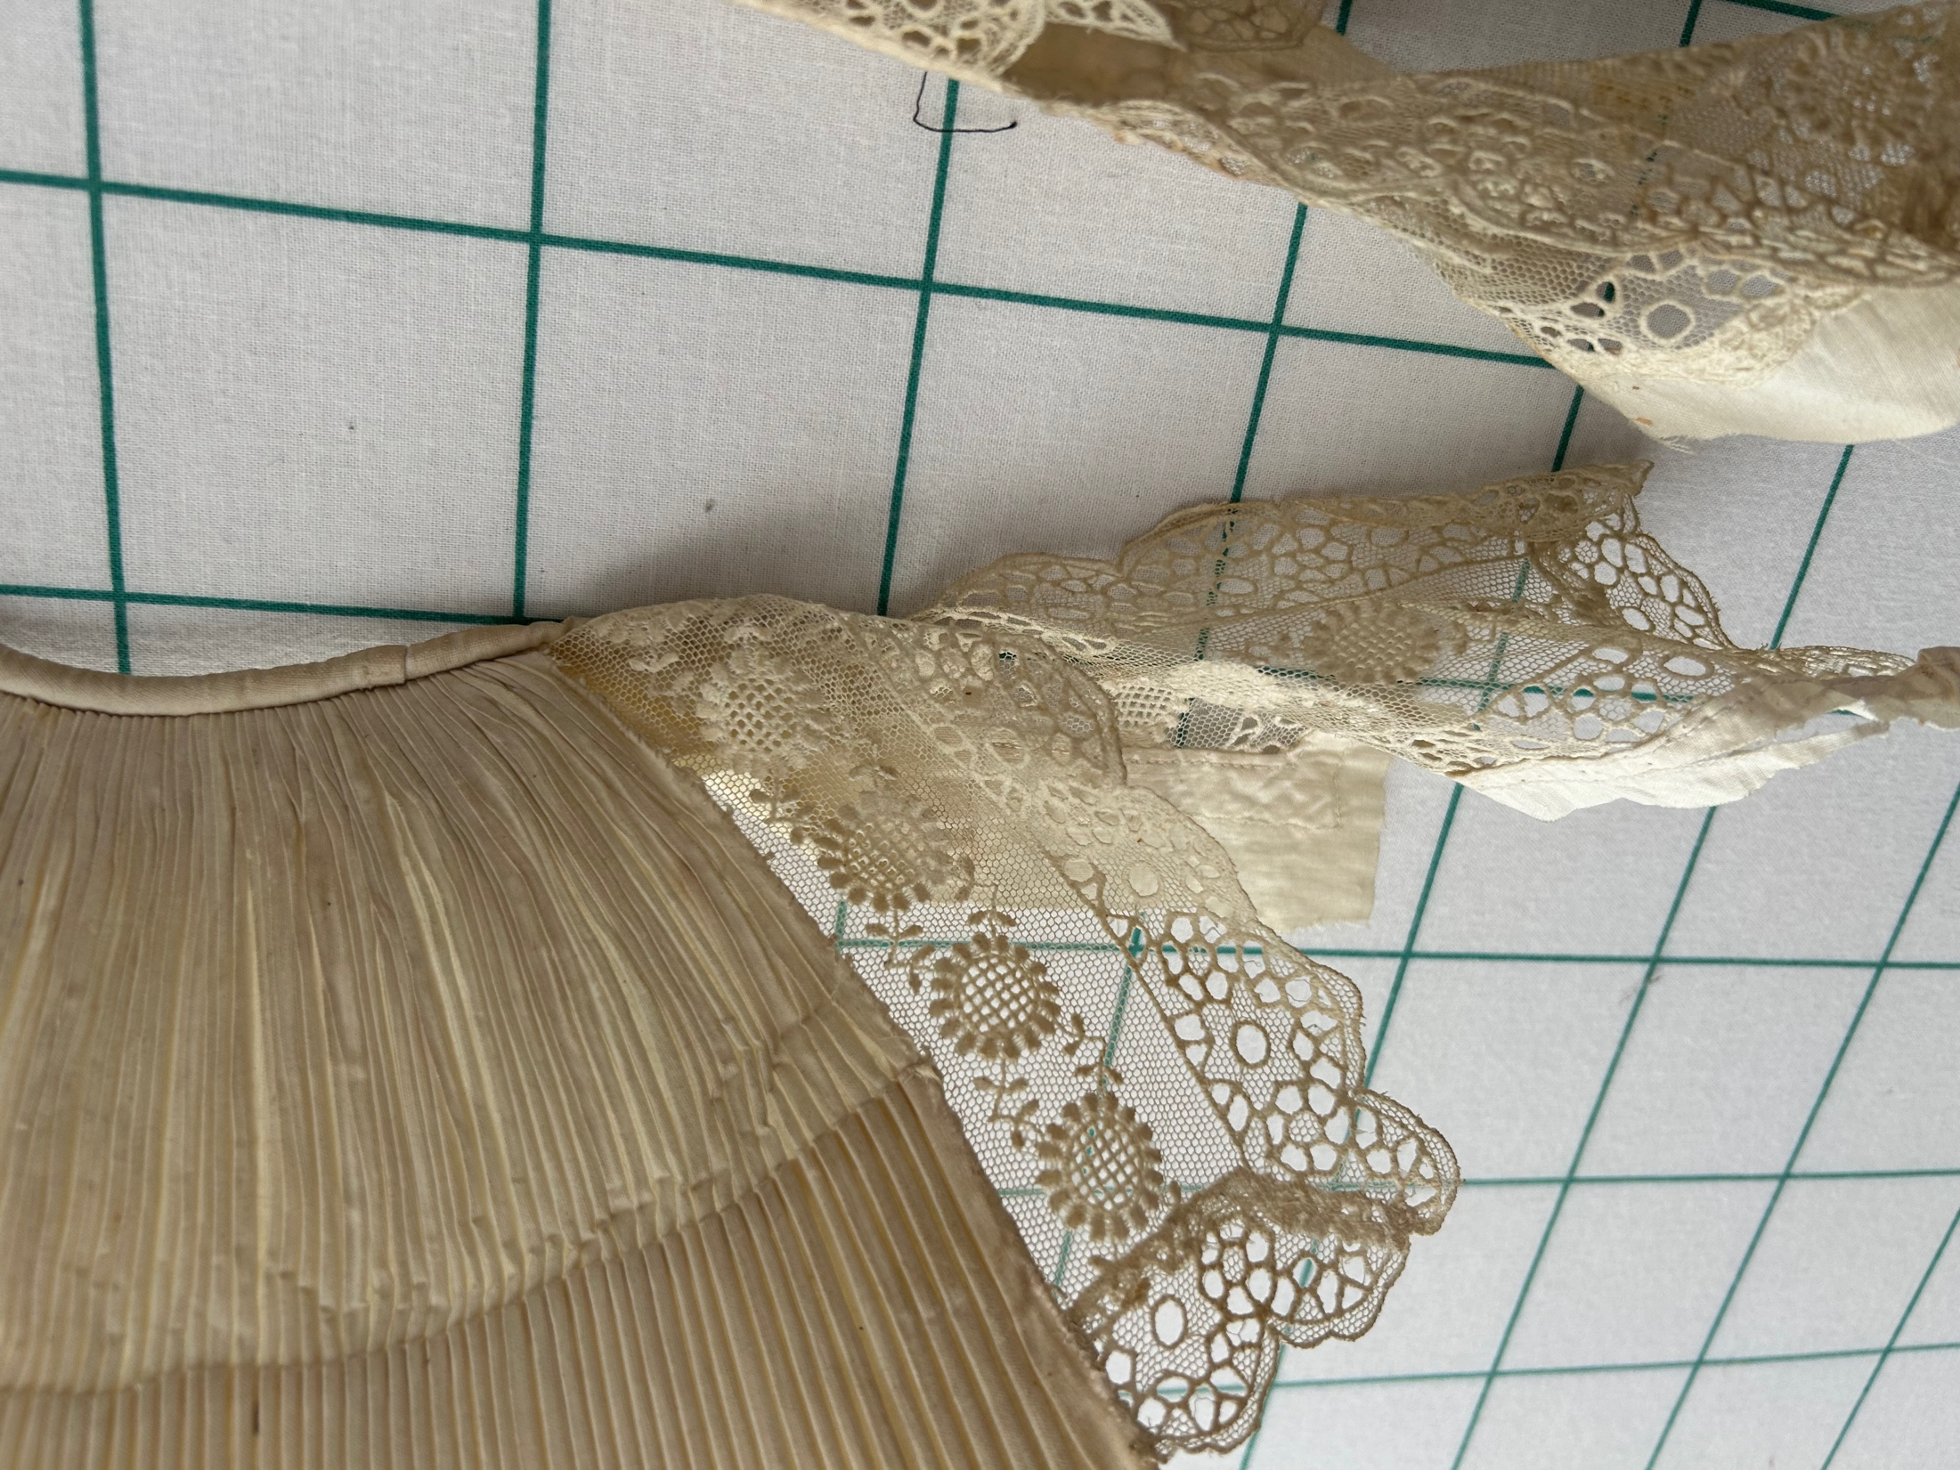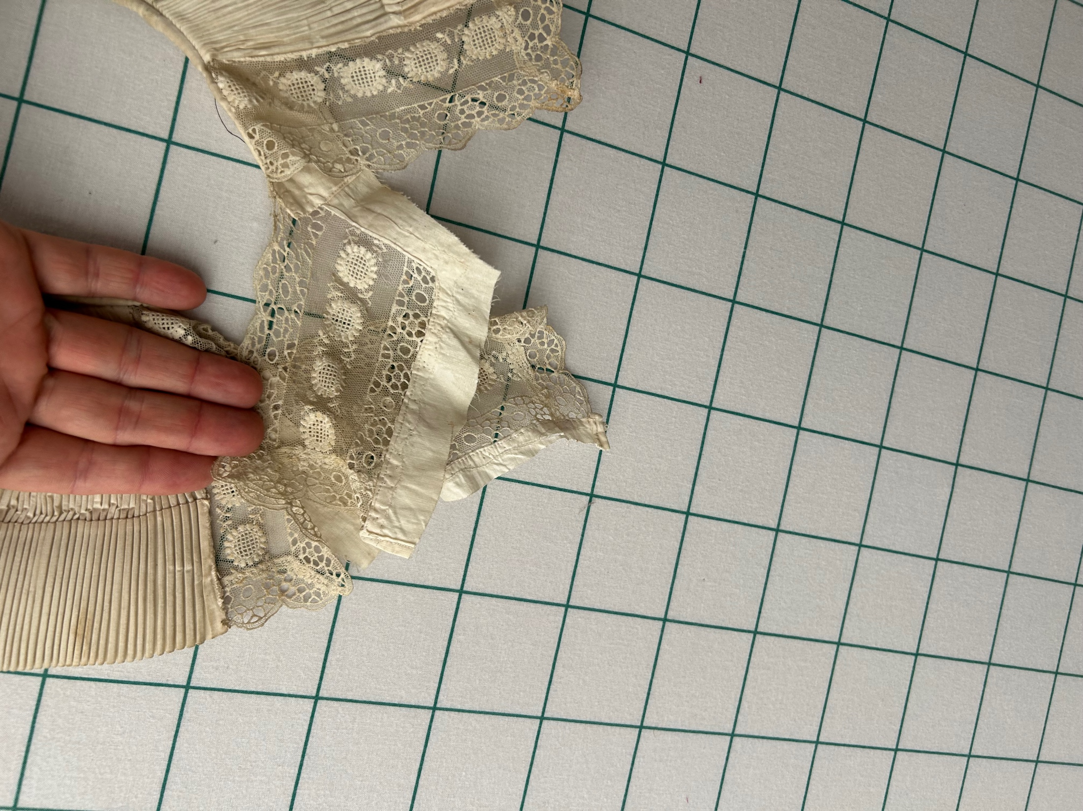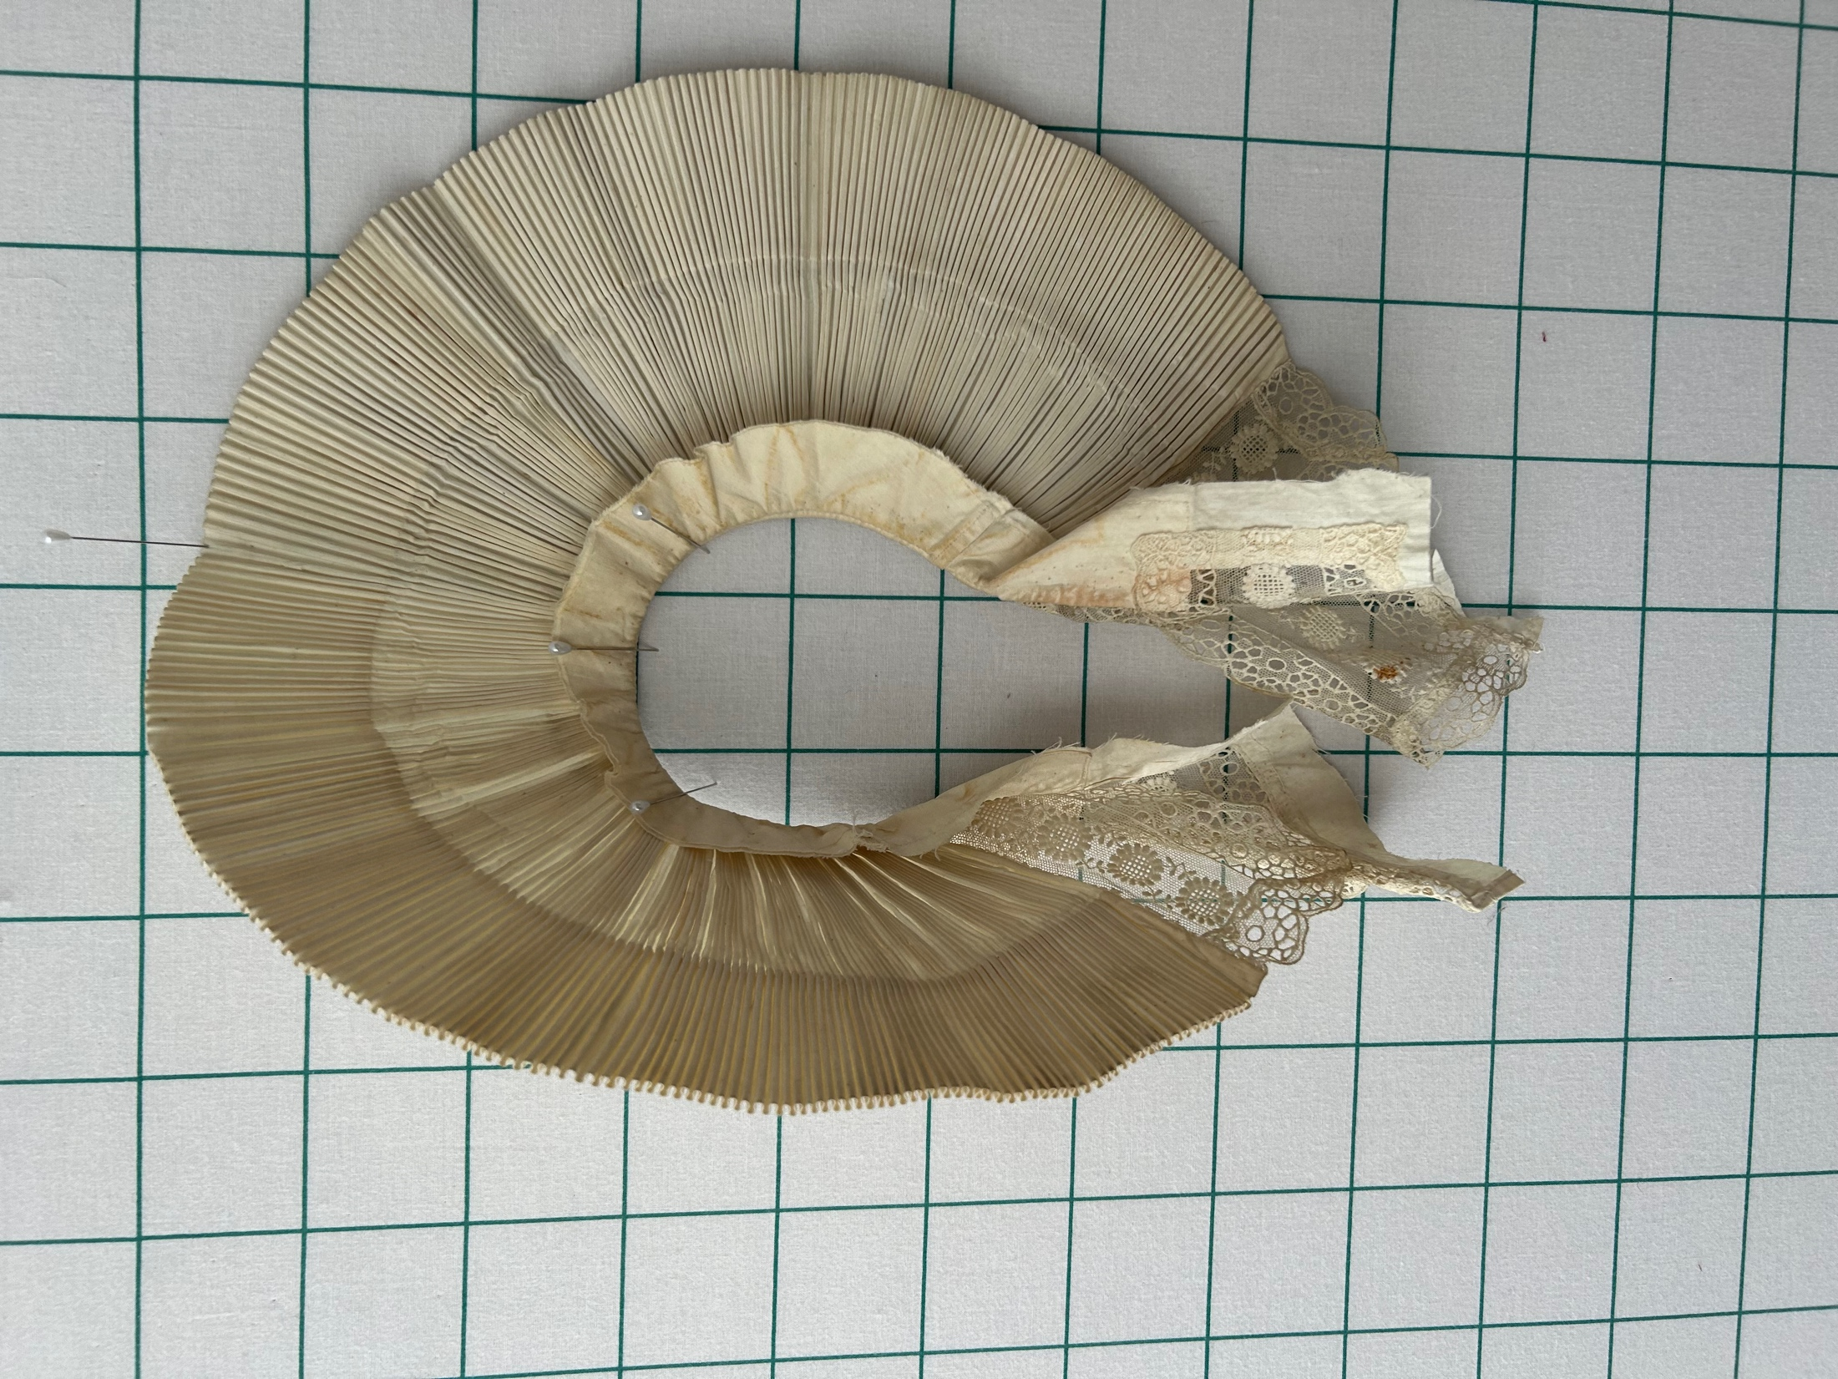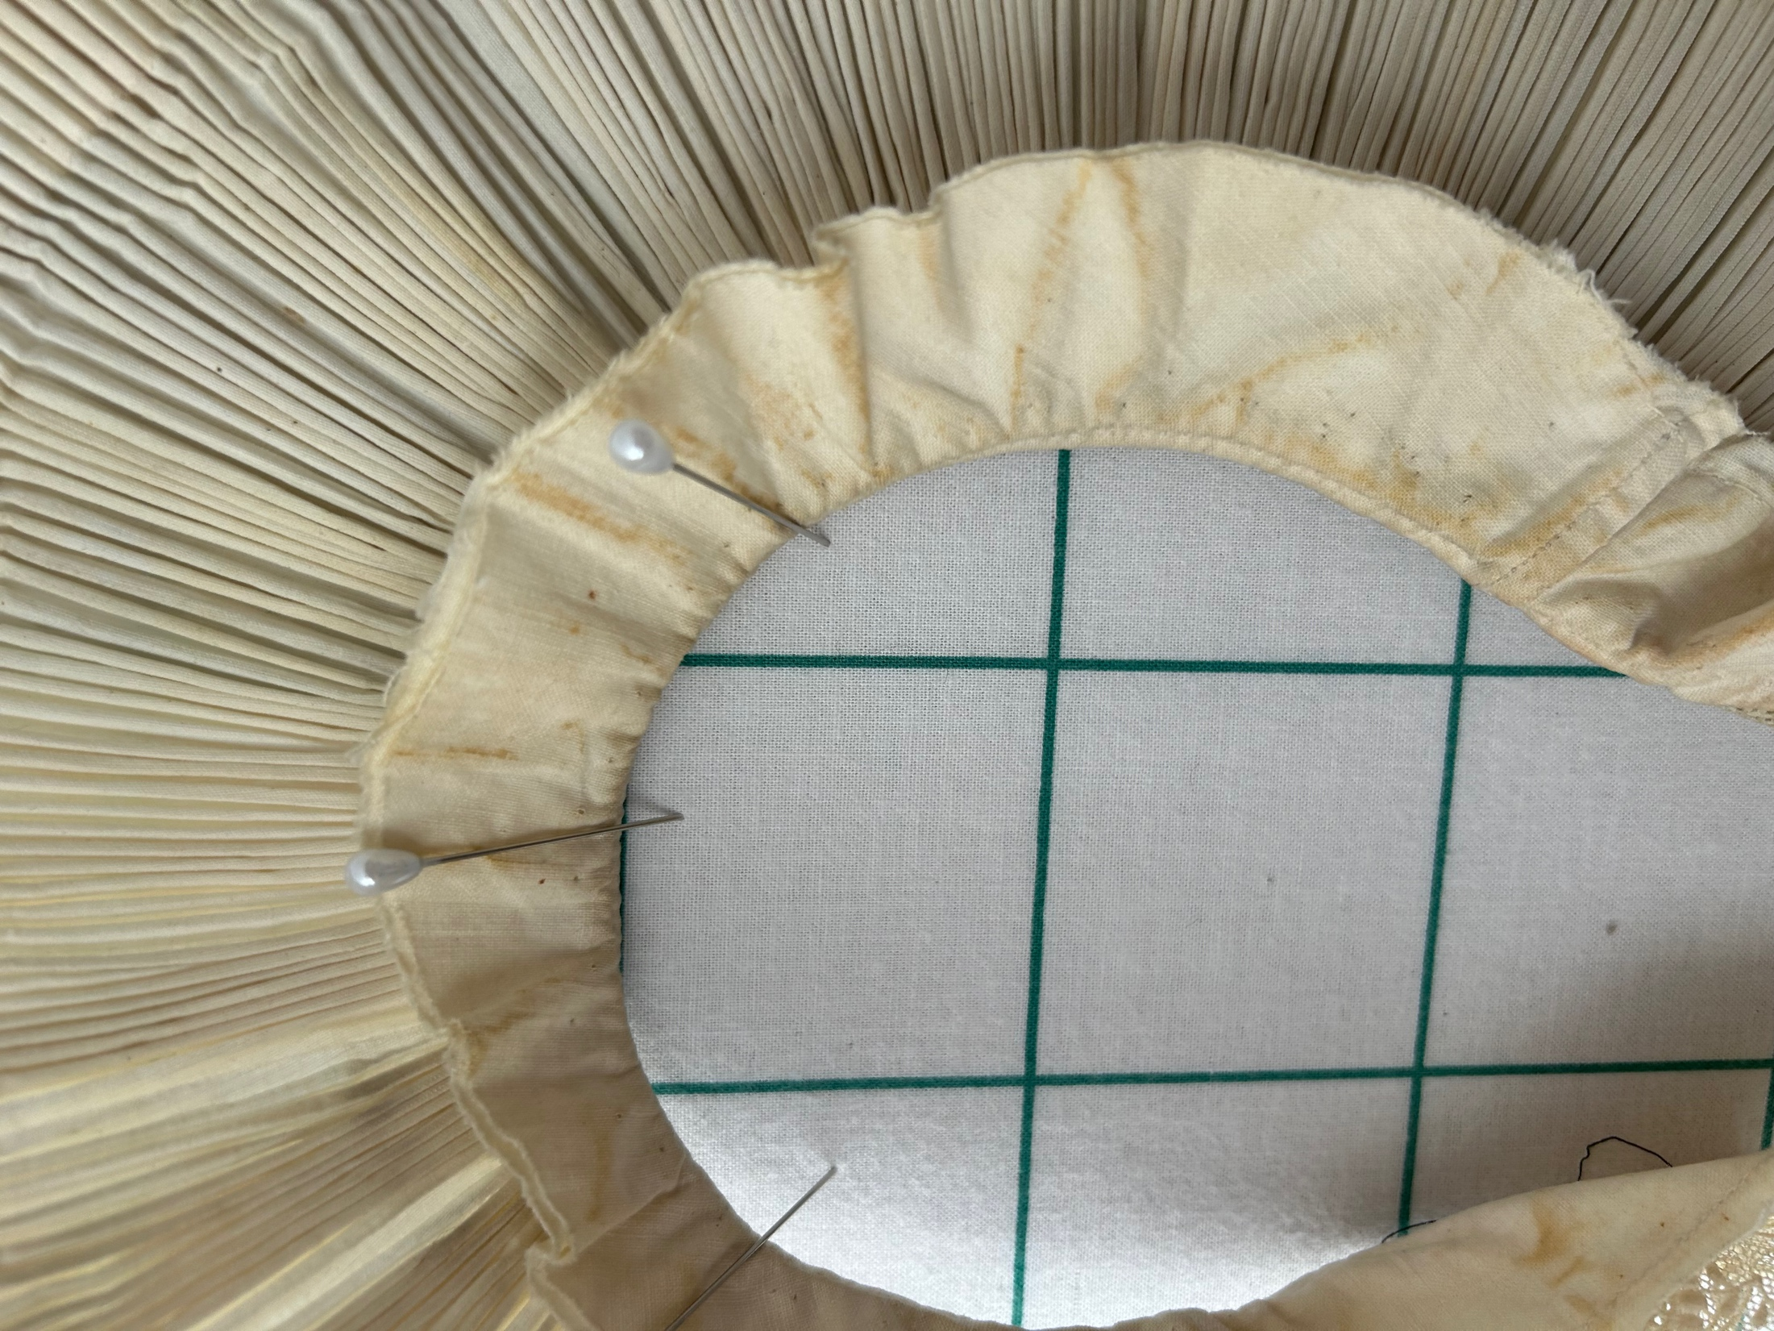

History

Known Owners
Owner | From Date | To Date | Acquired at: | Cost
David Bailey | 2025-10_18 | -- | AQSG Seminar Portland Maine | $30
Lenna Demarco
Made in:
--
 | If not purchased, the estimated cost for materials: $0

Display & Publication History
Date | Event | Location / Publication
-- | -- | --

General Description
Quilt Title or Name:  Pleated Collars | Fabric Date Range: 1890 ± 20 Years  Date Made: -- ± 0 Years  Method of Determination:
Item Type:  Items in Set: 2 | Size: Length: 32“ x Width: 21“  Length: 16“ x Width: 10“
Appraisals:  Has this quilt been professionally appraised?  If so, when: --  ----------- | Other Related Information:  Quilt Index #:  Scanned Patterns  Images  EQ 8 Files  Research Notes
Additional Information: Pleated collars like this went out of fashion in the 1600's. These collars seems to have an industrial fabric weave which places them after about 1770. There is machine stitching which places them after 1850, but more likely after the civil war.

