Documentation Form

Overview

Images
Top | Back
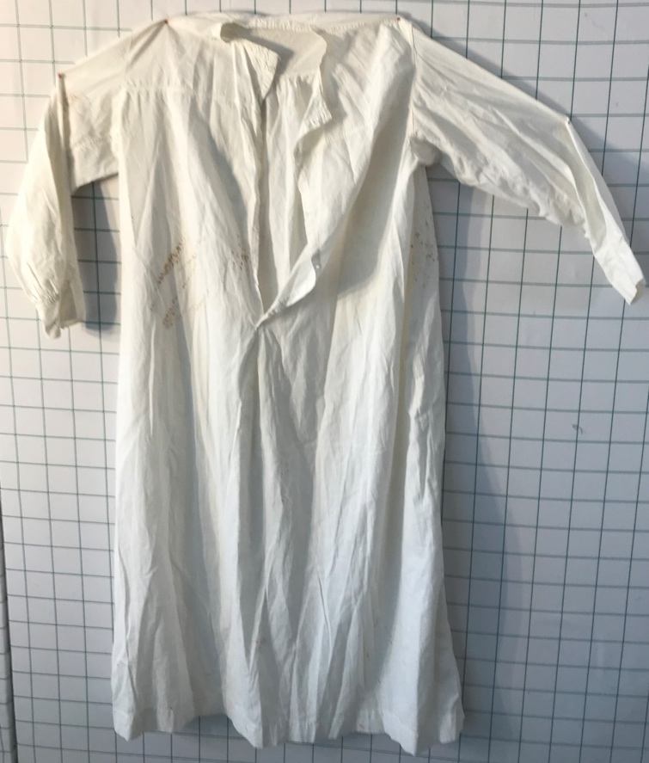 | 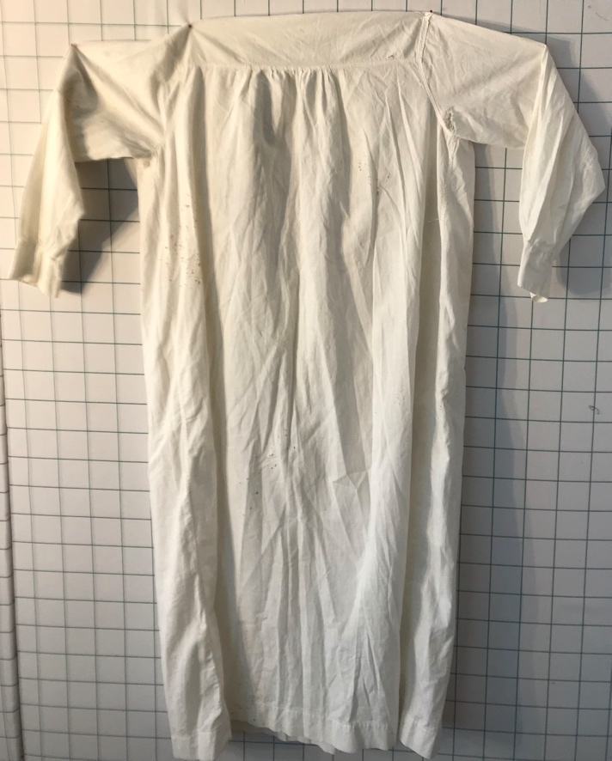

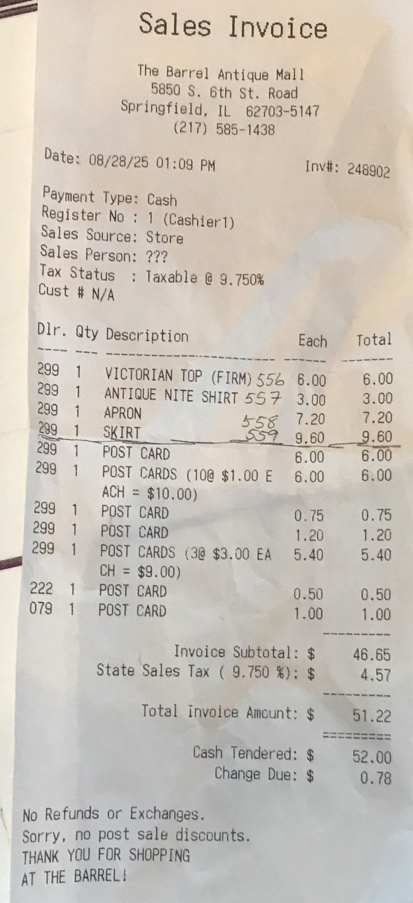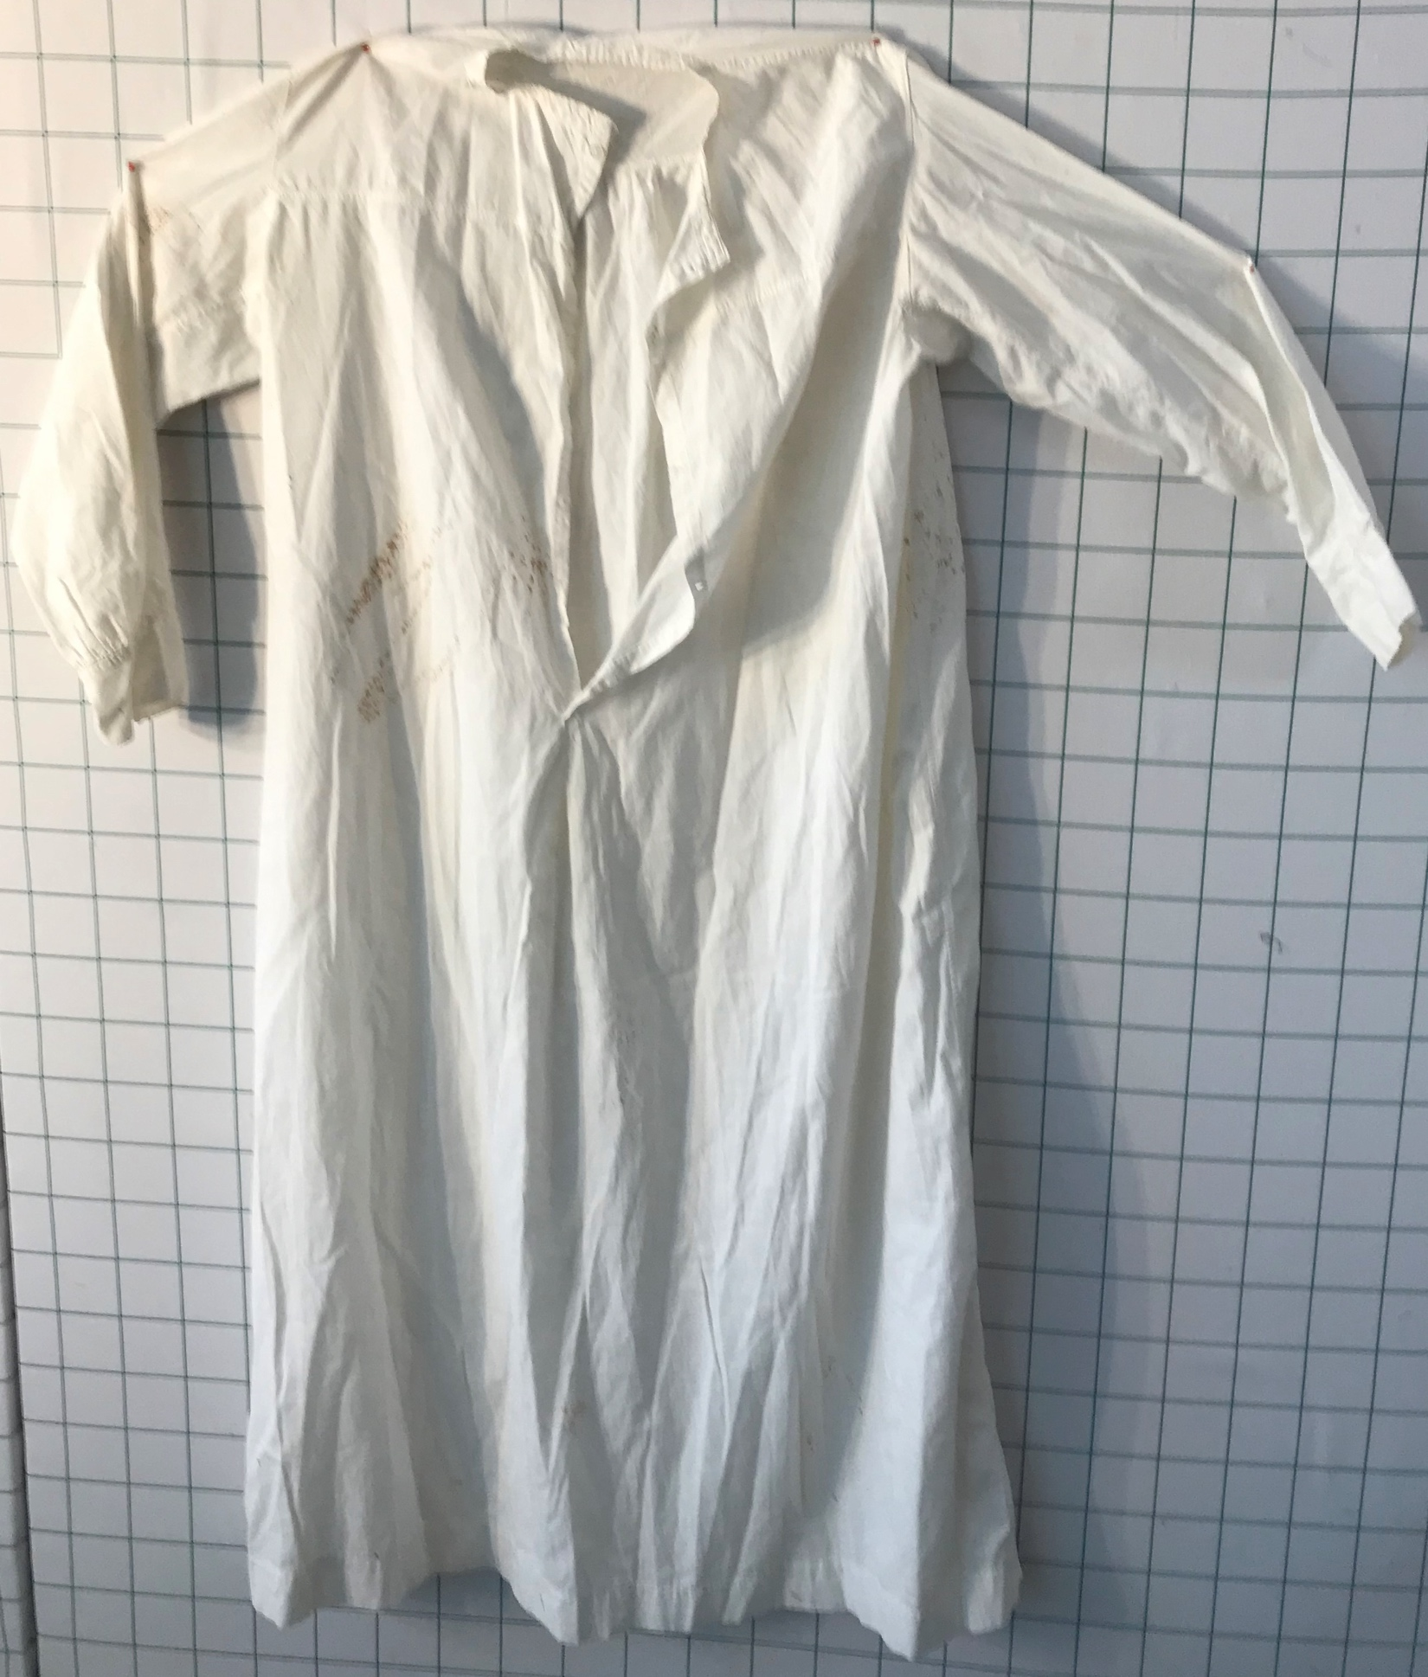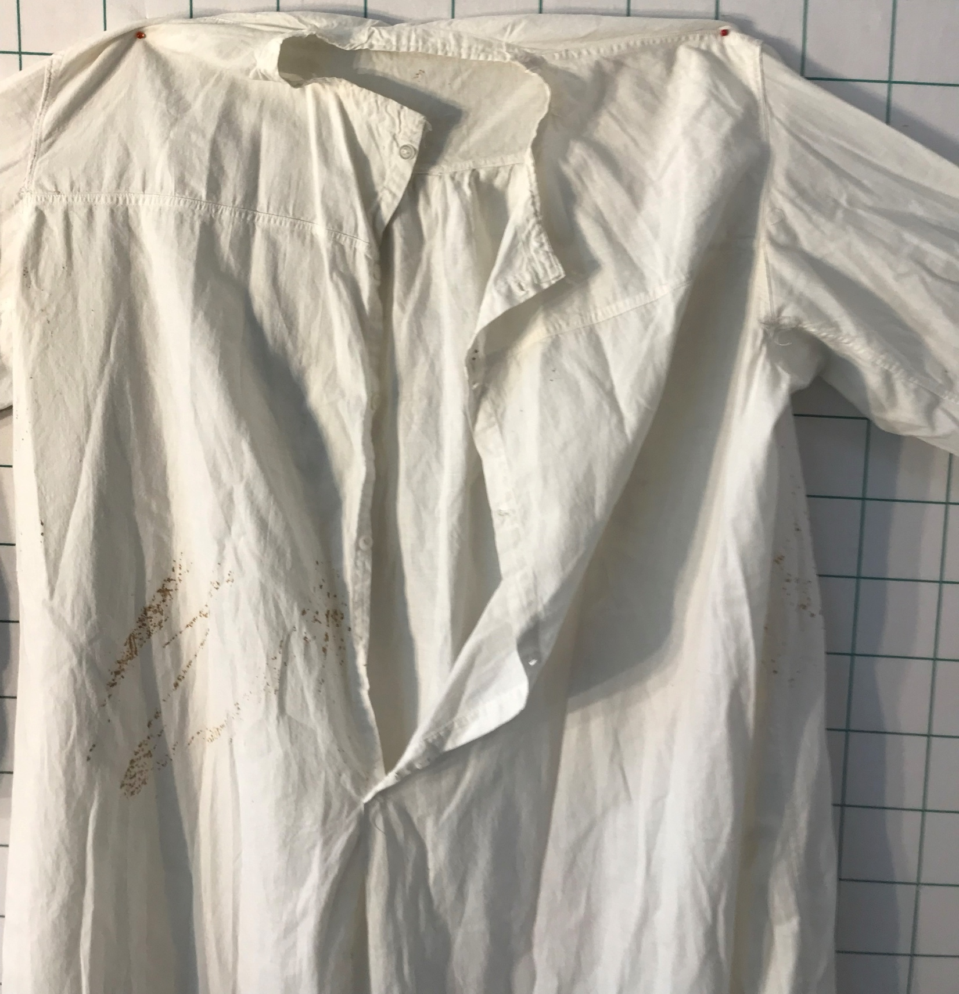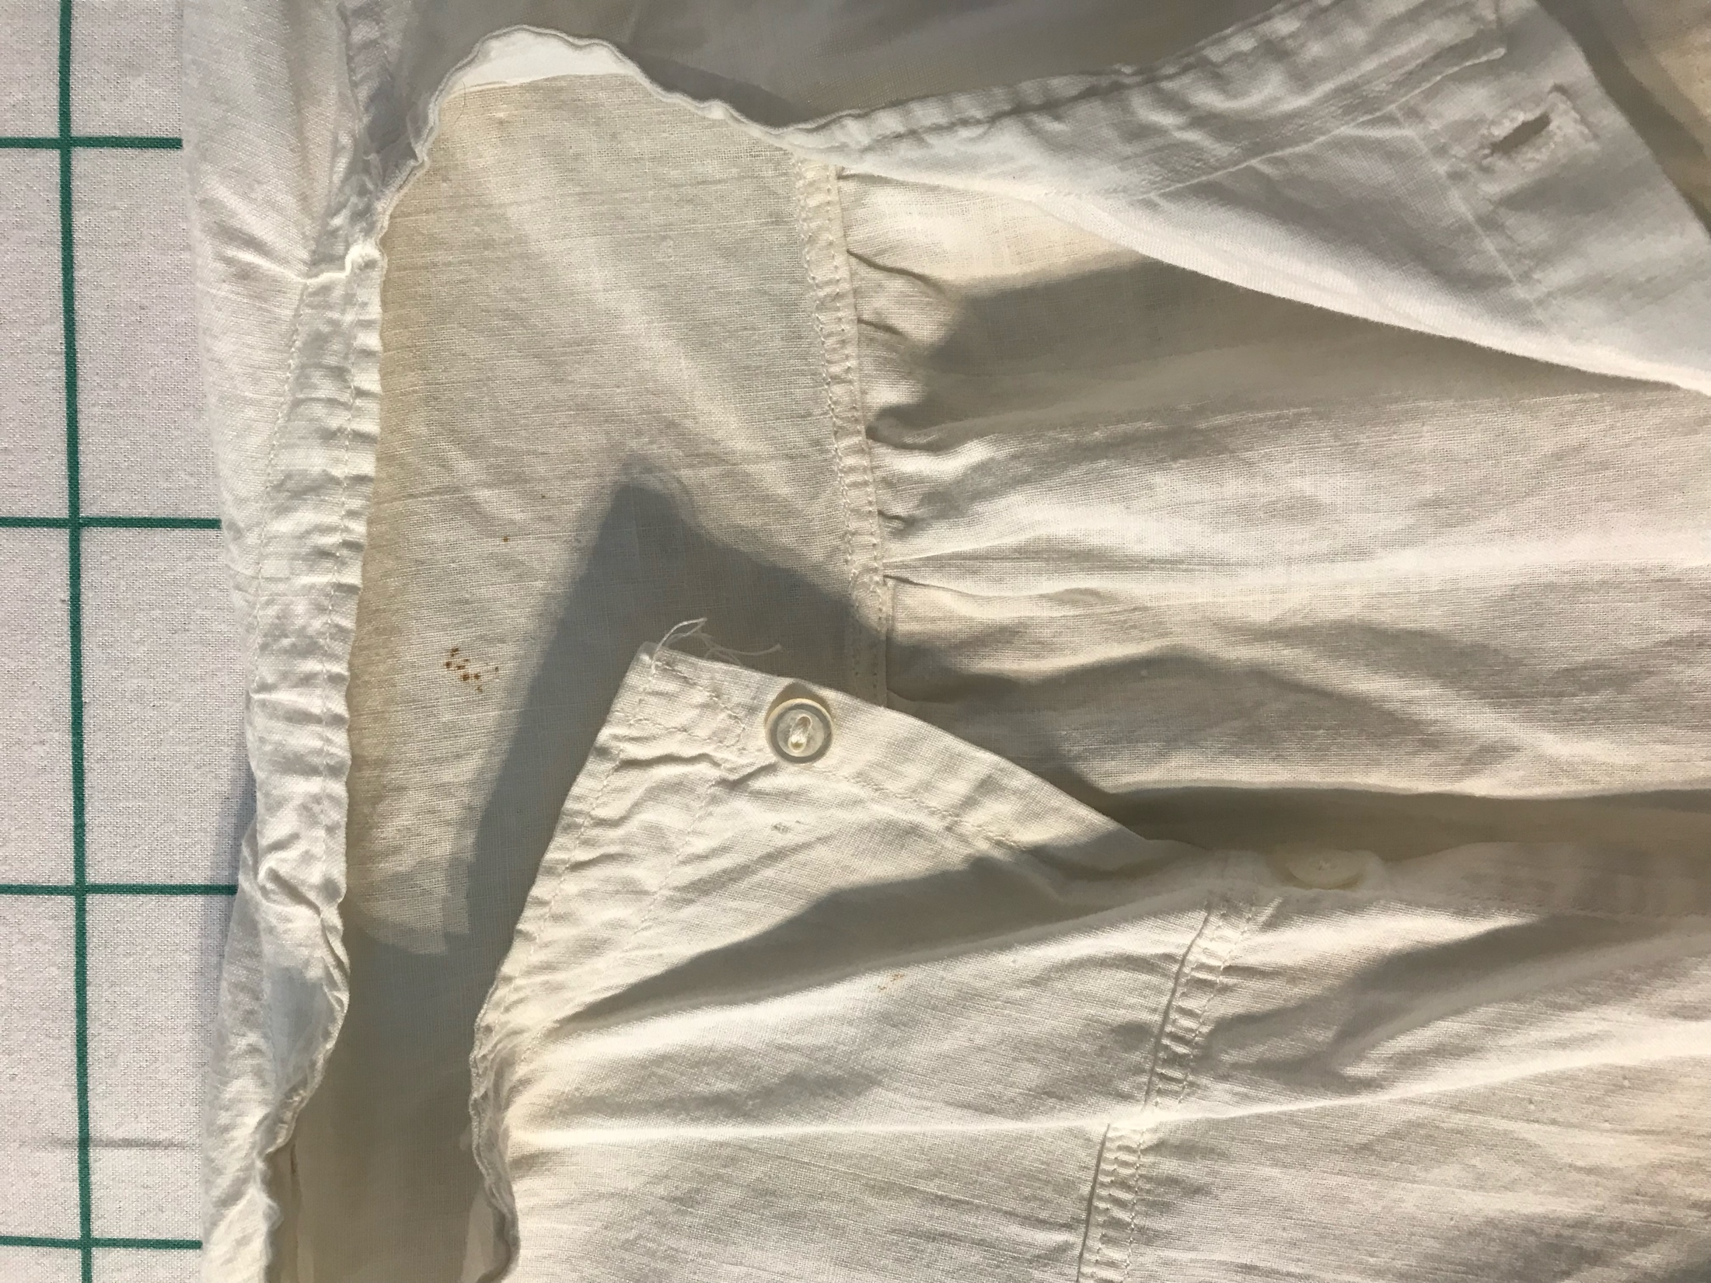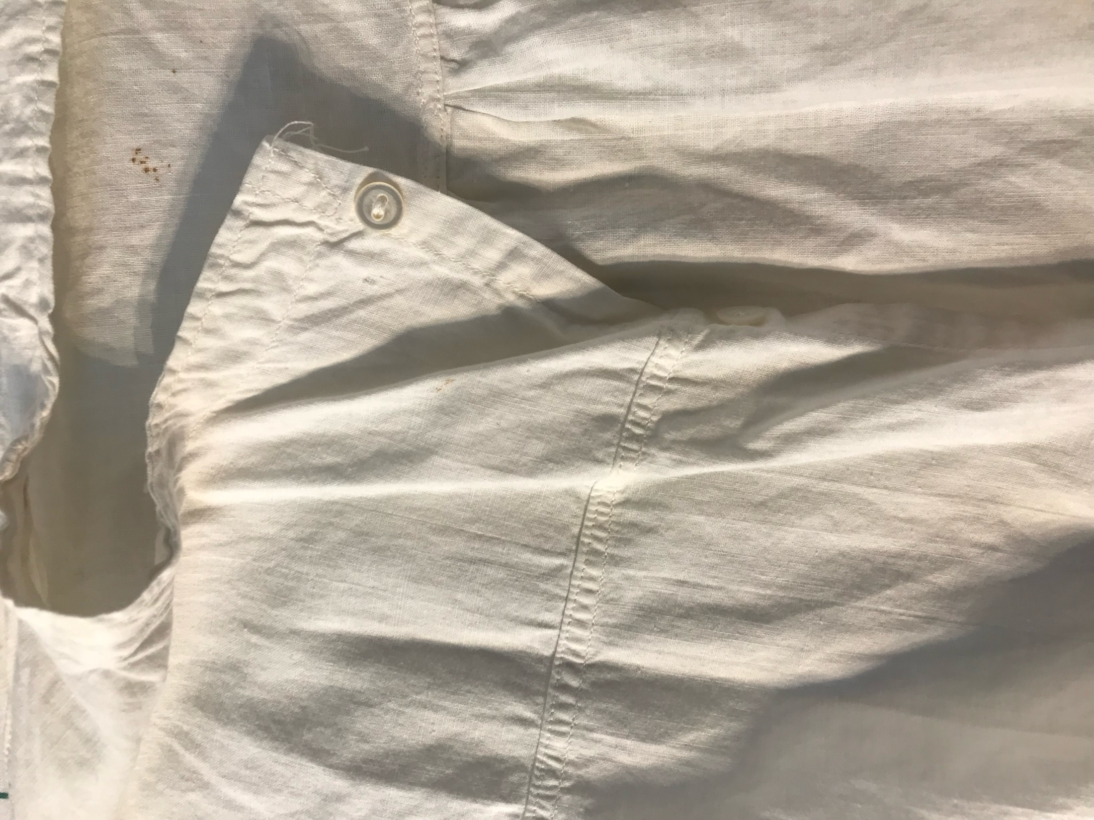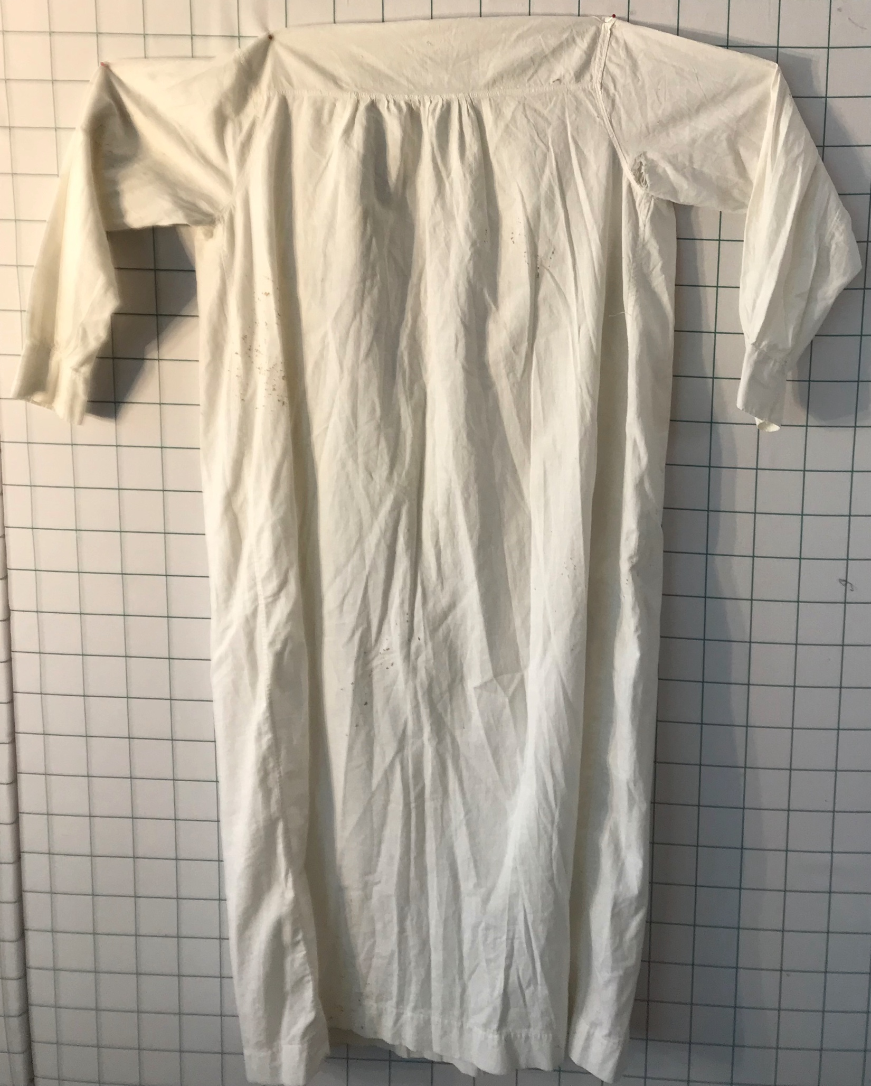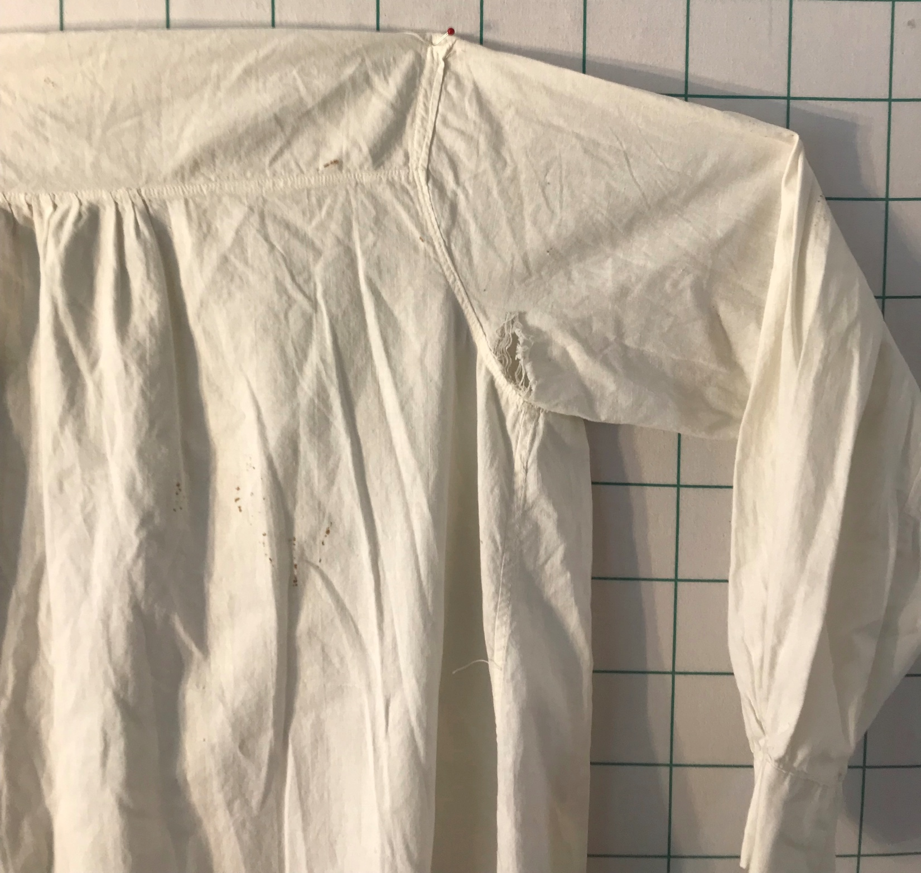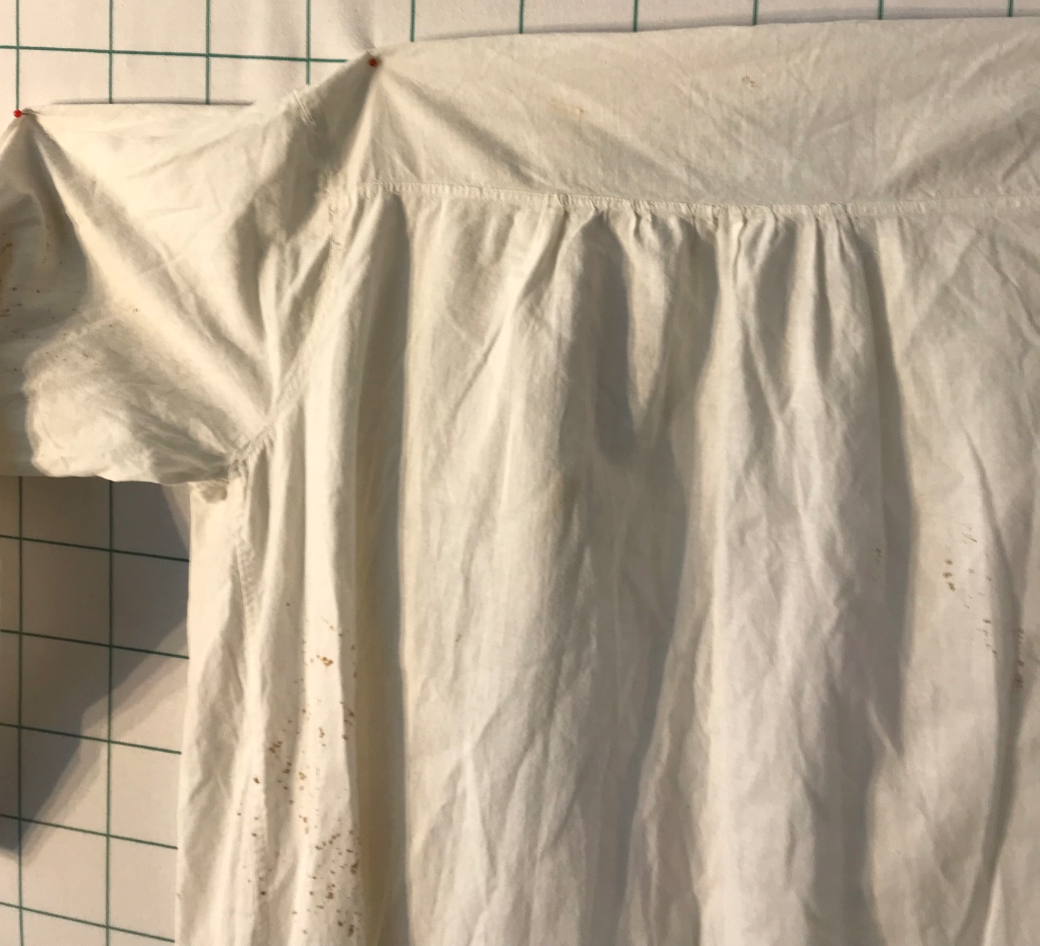

History

Known Owners
Owner | From Date | To Date | Acquired at: | Cost
David Bailey | Aug 28, 2025 | -- | The Barrel Antique Mall  5850 S. 6th Street Road  Springfield, IL 62703-5147  217 585 1438 | $3
Made in:
--
 | If not purchased, the estimated cost for materials: $0

Display & Publication History
Date | Event | Location / Publication
-- | -- | --

General Description
Quilt Title or Name:  Men’s Nightshirt | Fabric Date Range: 1910 ± 20 Years  Date Made: -- ± 0 Years  Method of Determination:
Item Type:  Items in Set: 1 | Size: Length: 55“ x Width: 0“
Appraisals:  Has this quilt been professionally appraised?  If so, when: --  ----------- | Other Related Information:  Quilt Index #:  Scanned Patterns  Images  EQ 8 Files  Research Notes
Additional Information: --

