Documentation Form

Overview

Images
Top
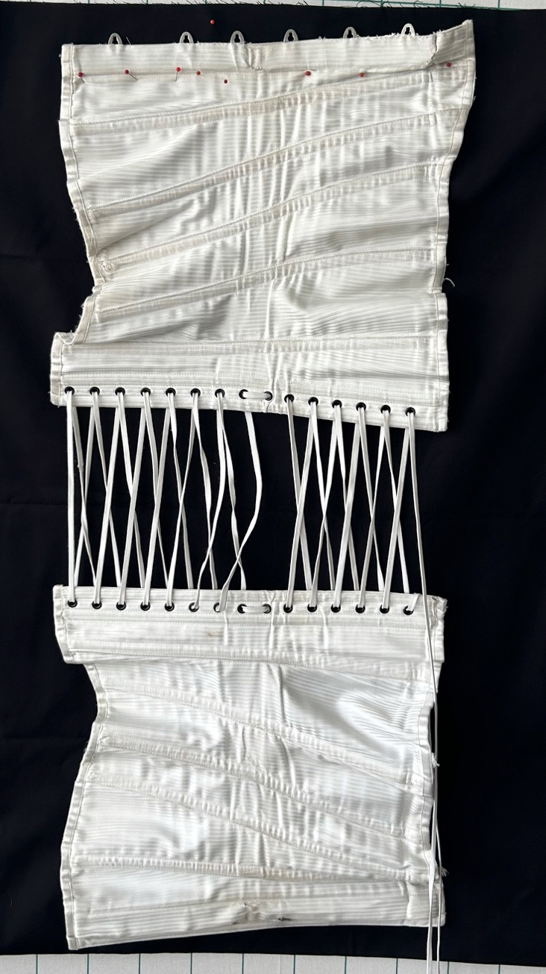 | 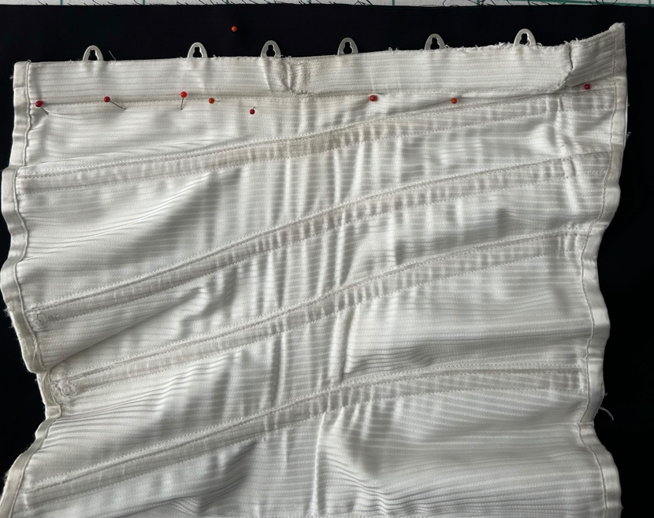
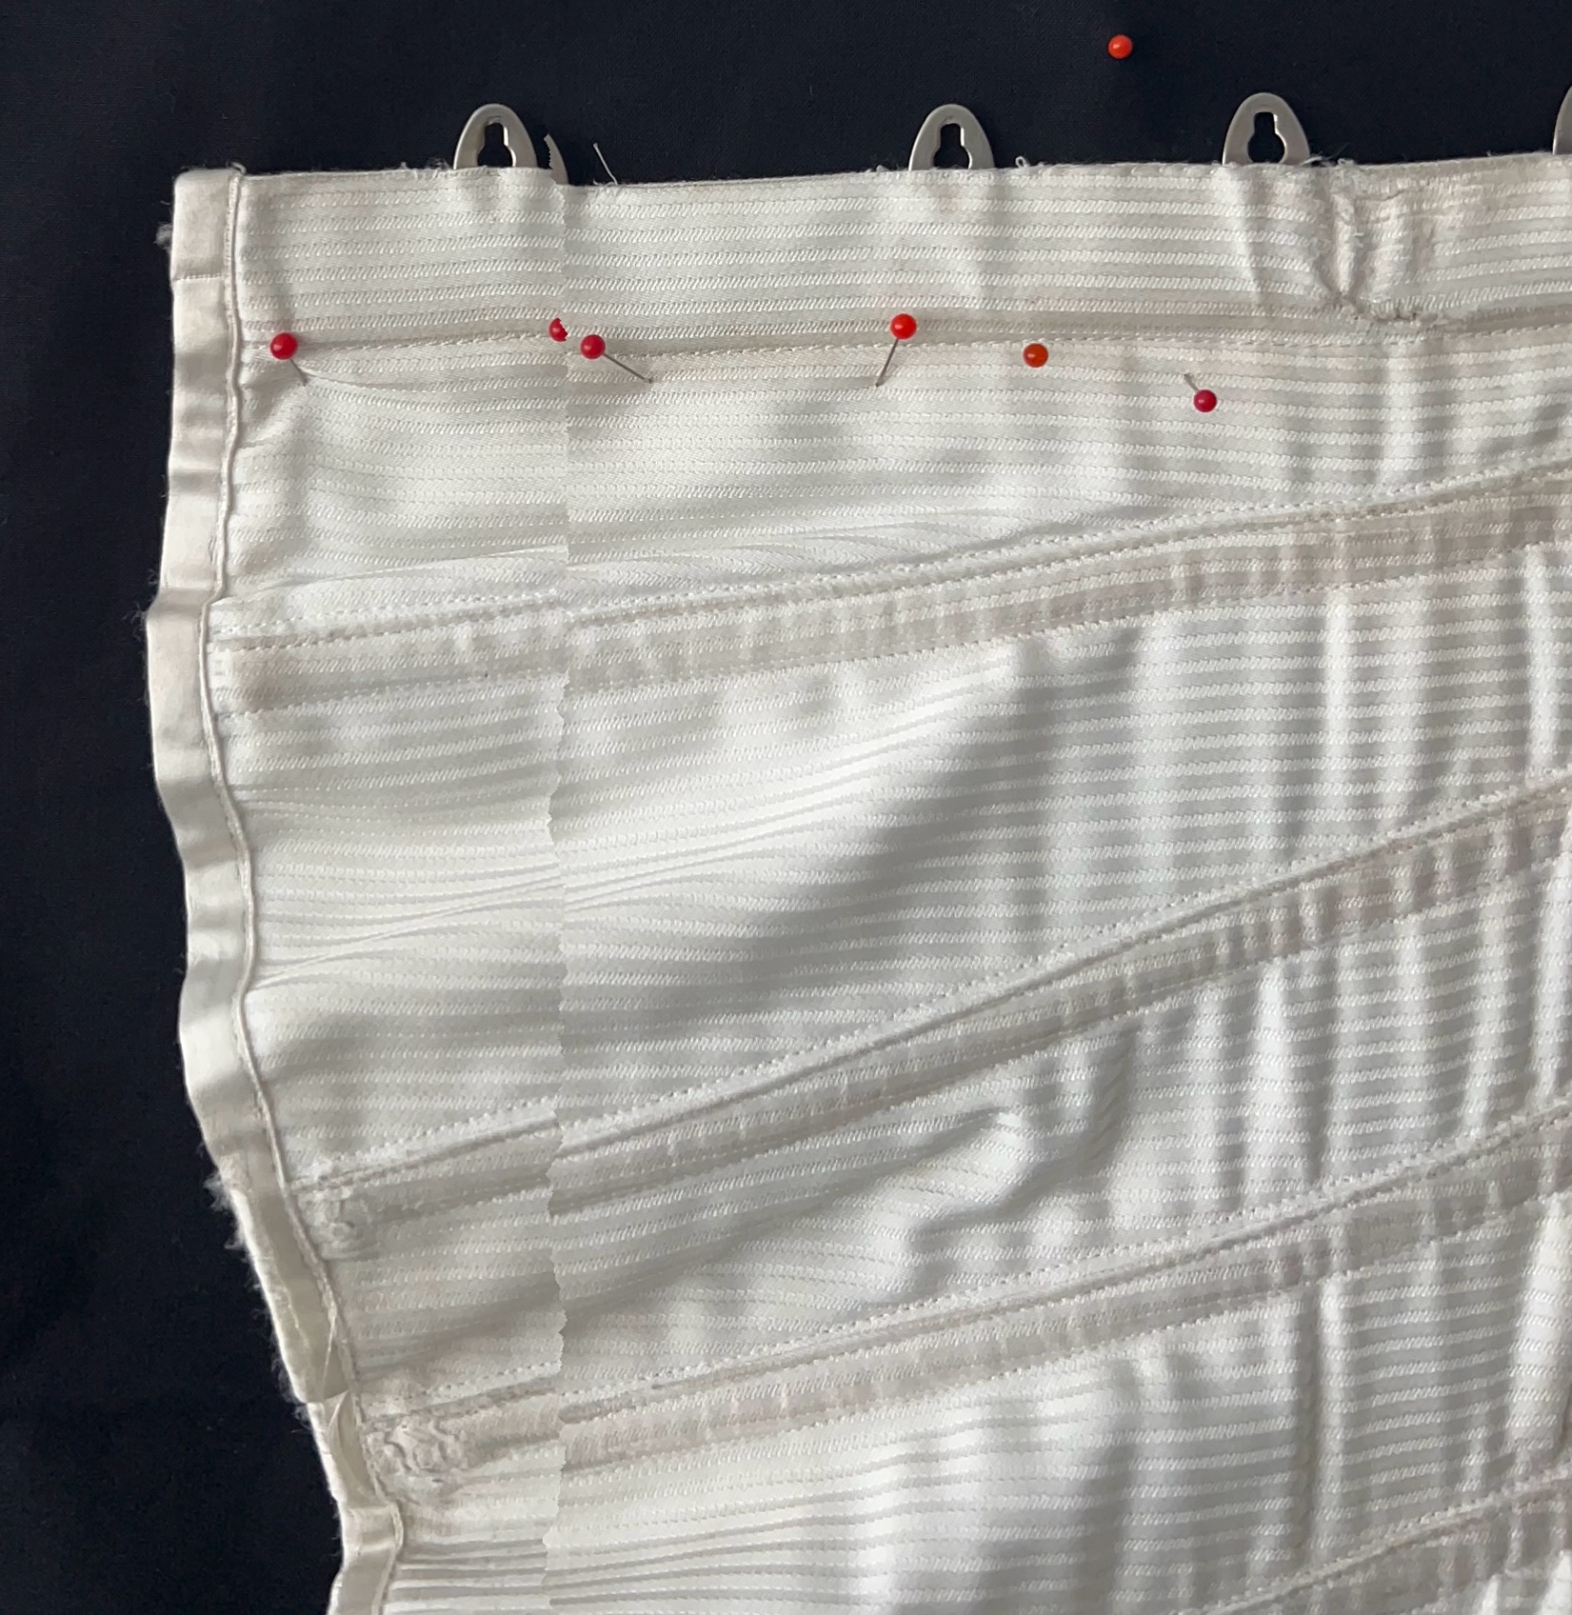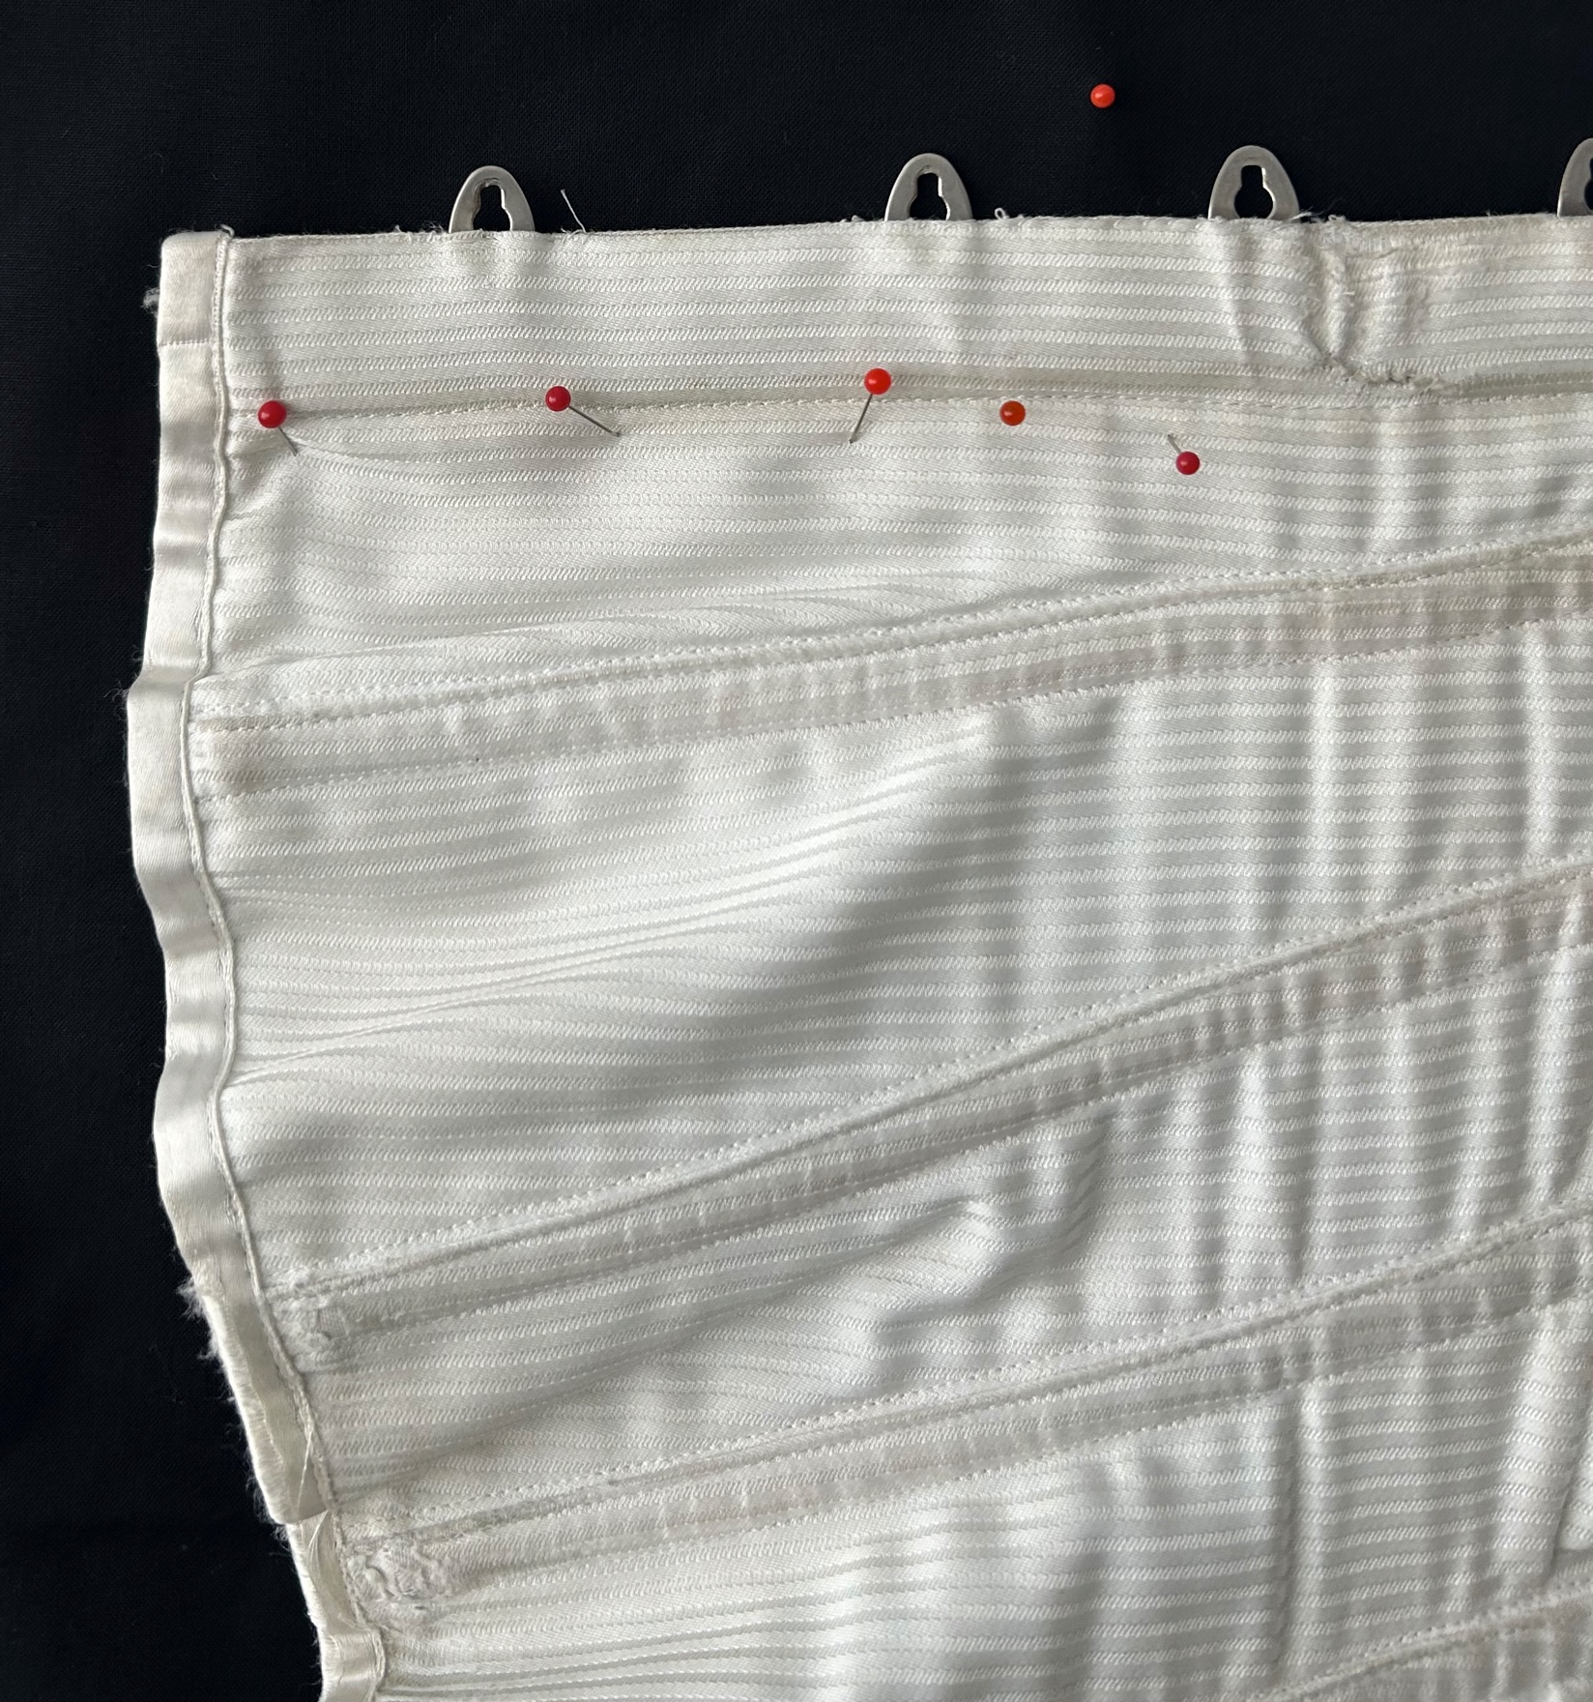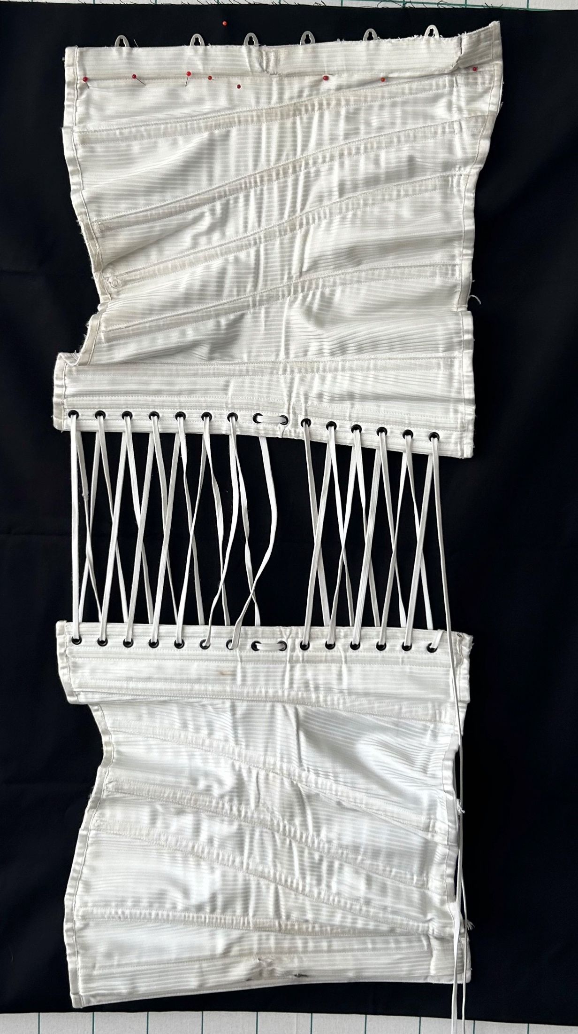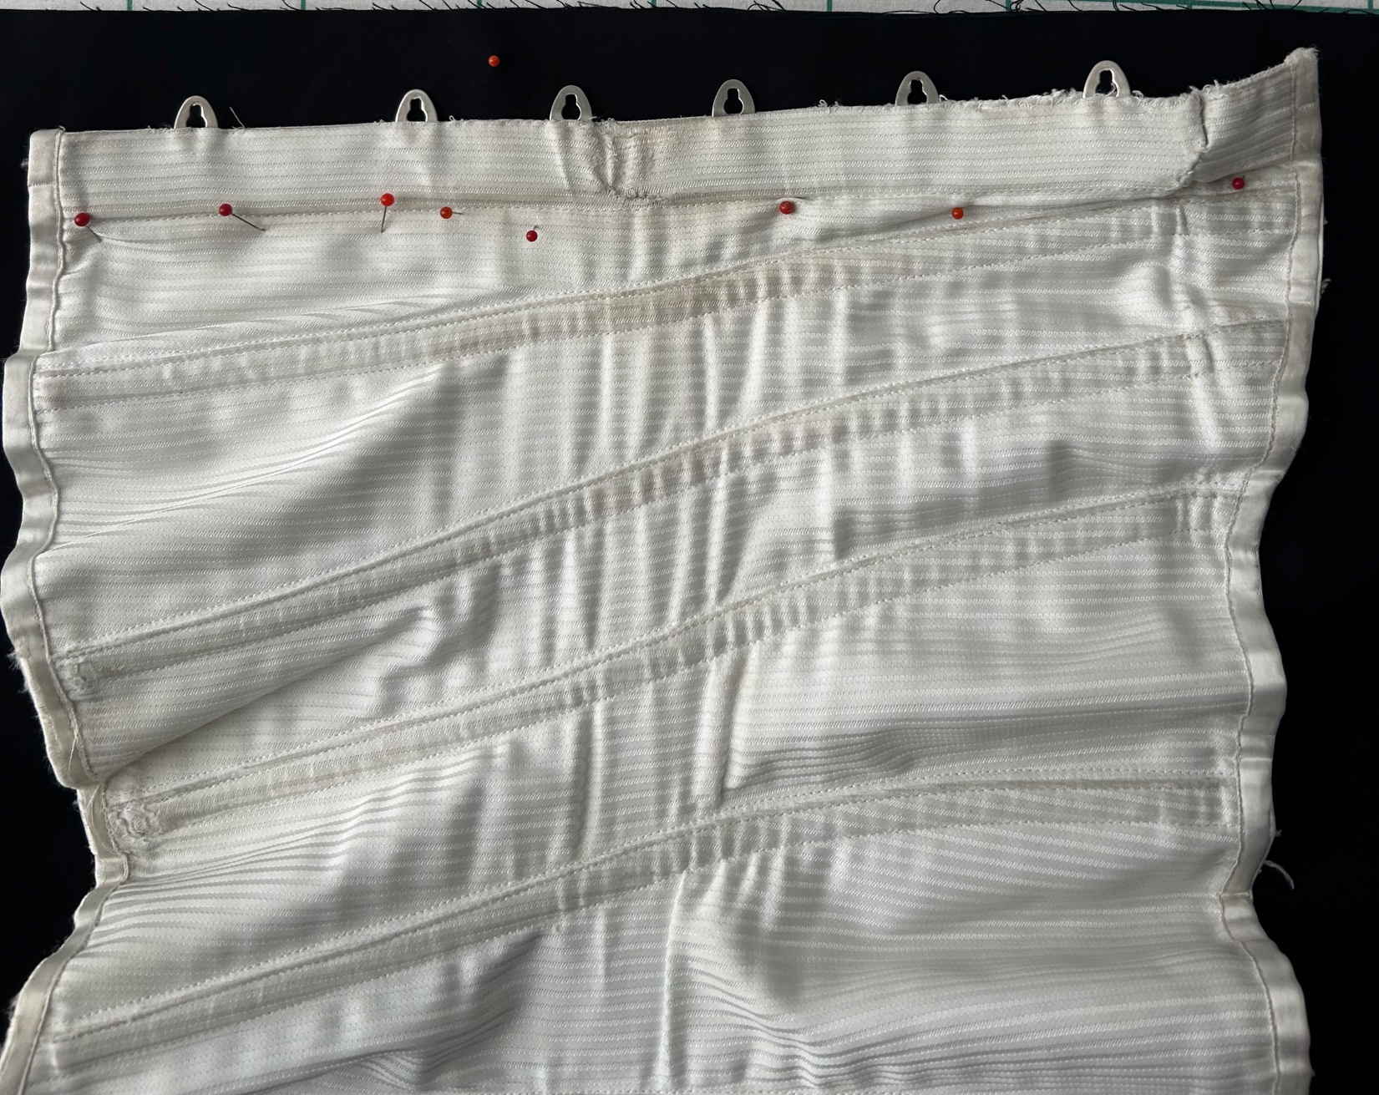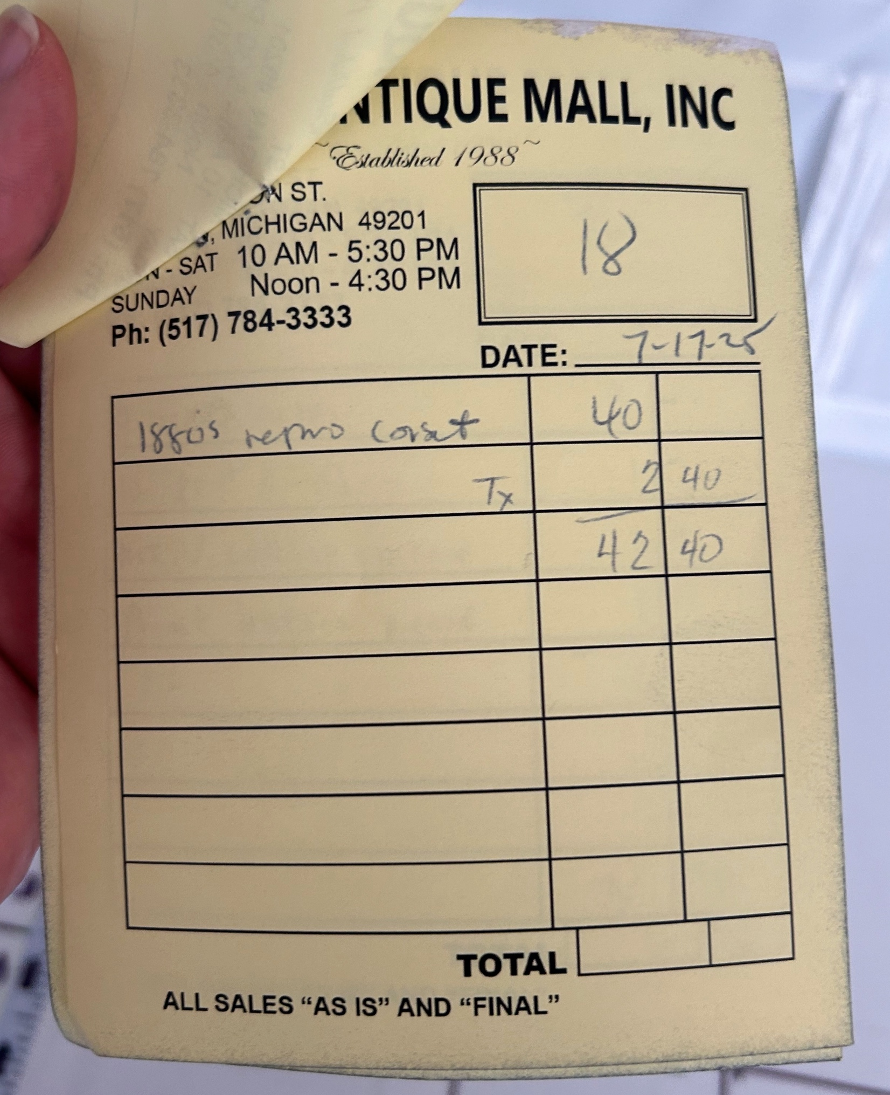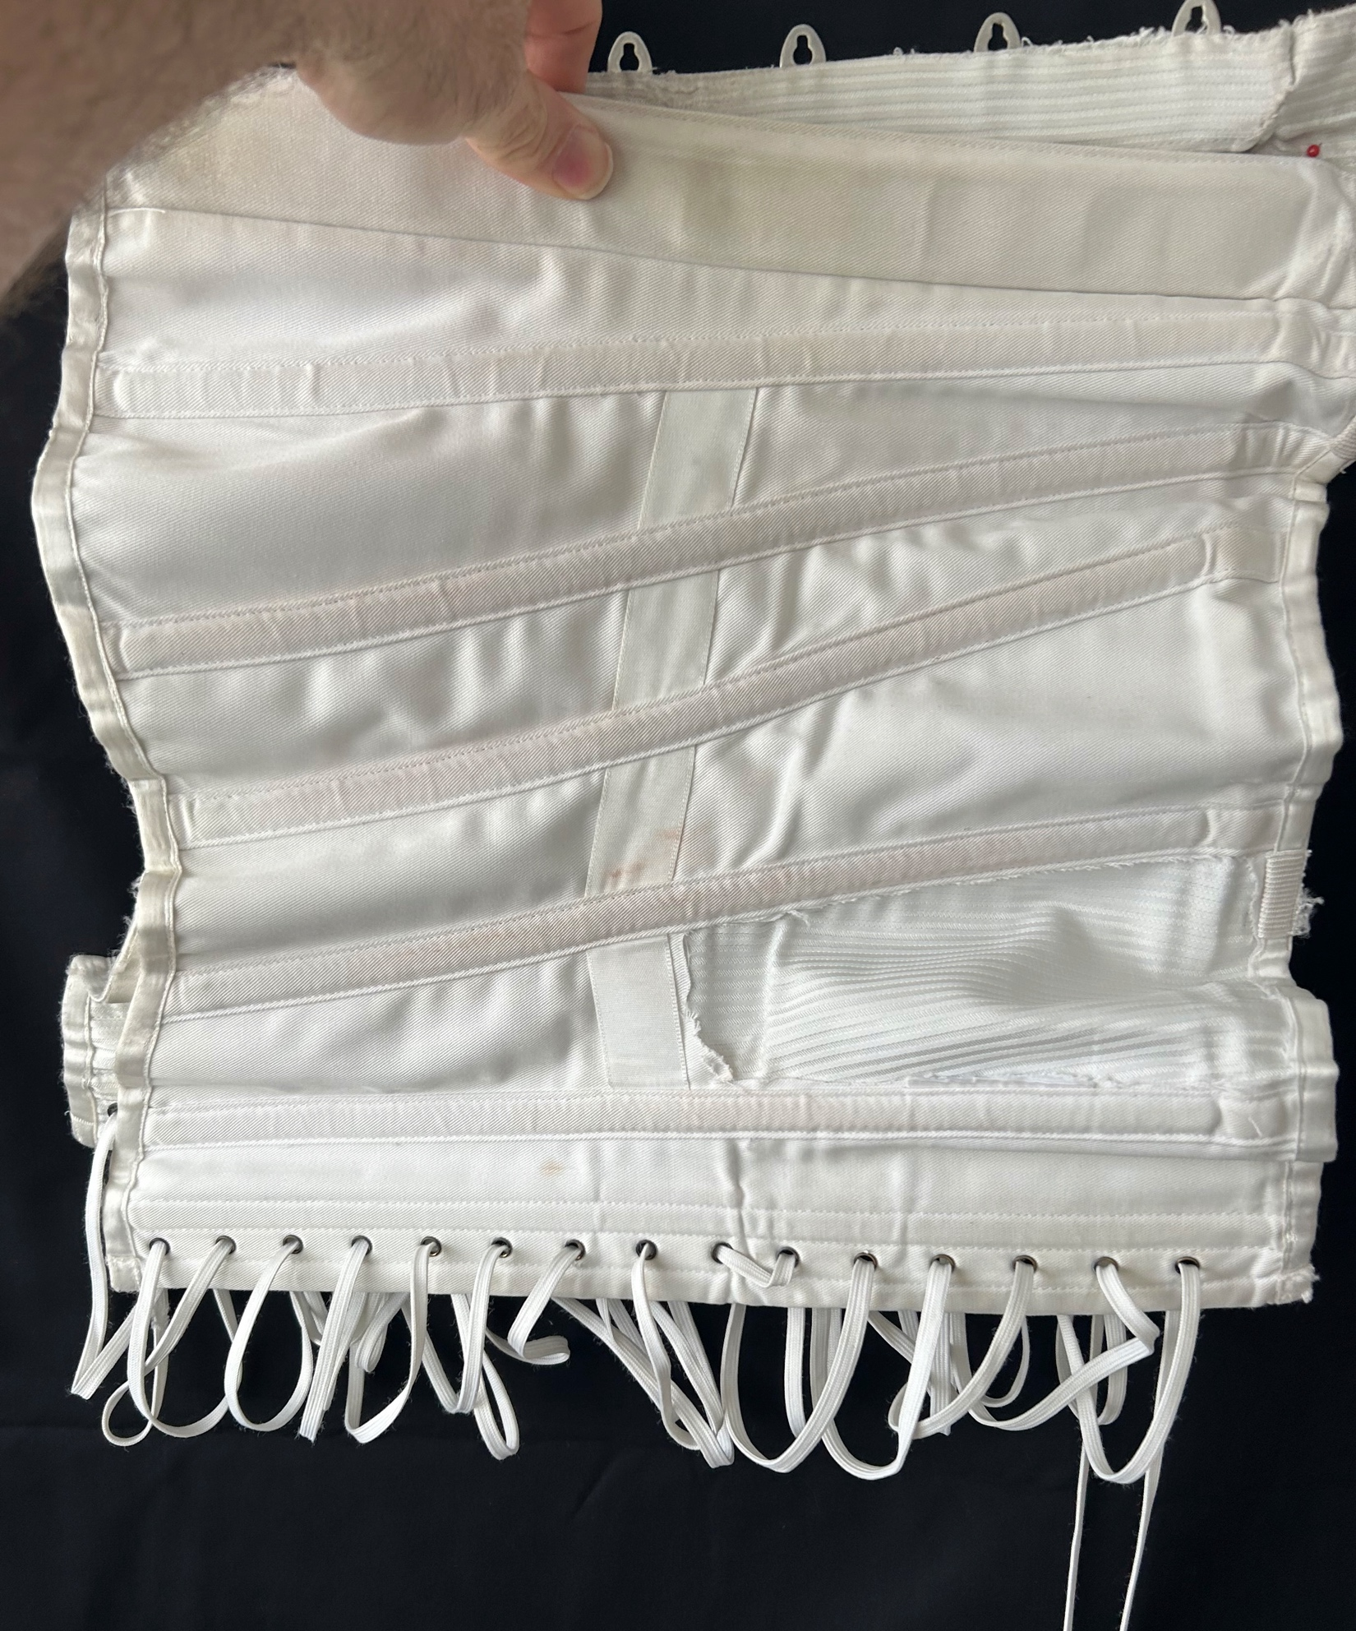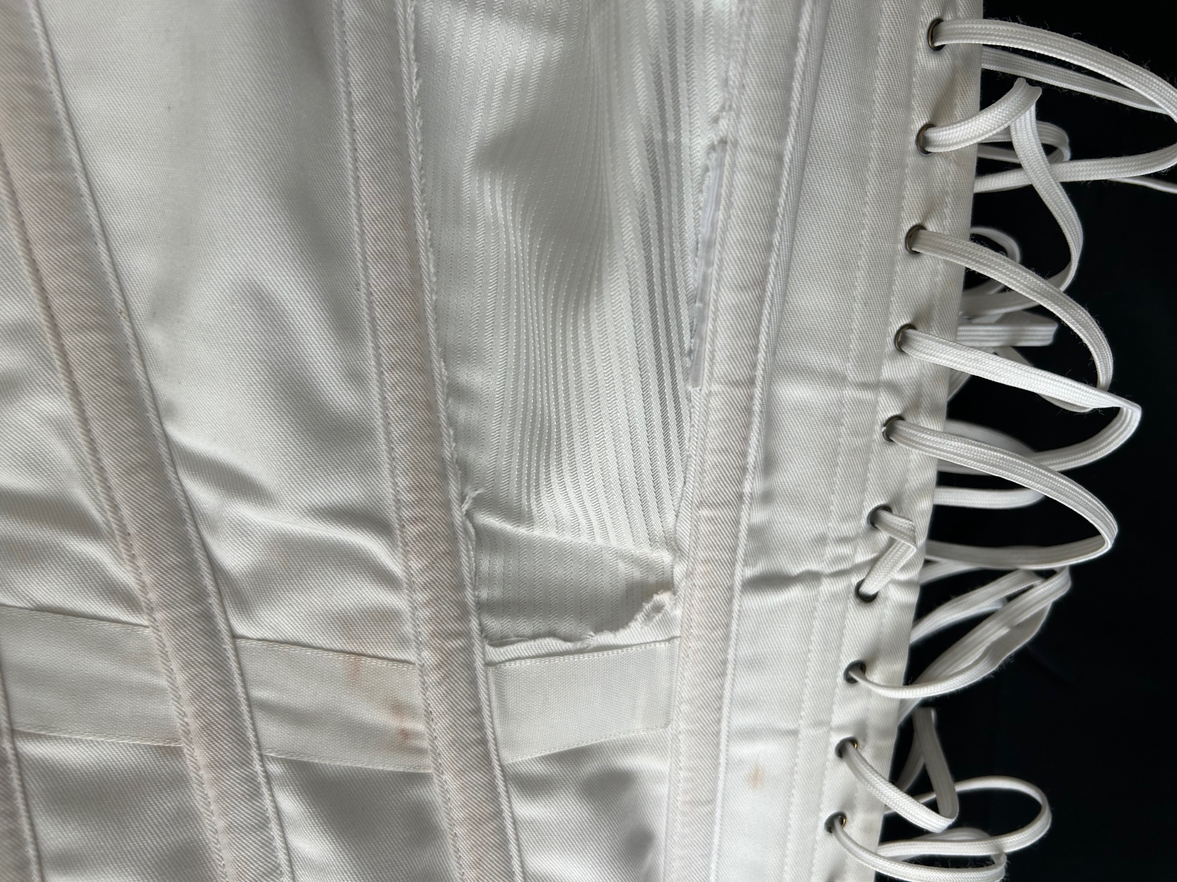

Owner History
Owner | From Date | To Date | Acquired at: | Cost
David Bailey | Juyly 17, 2025 | -- | Jackson Antique Mall  201 N Jackson St  Jackson, MI  517 784 3333 | $40
Made in:
--
 | If not purchased, the estimated cost for materials: $0

Display & Publication History
Date | Event | Location / Publication
-- | -- | --

General Description
Additional Information: Advertised as an reproduction 1880’s corsette. 28” x 15”

