Documentation Form

Overview

Images
Top | Back
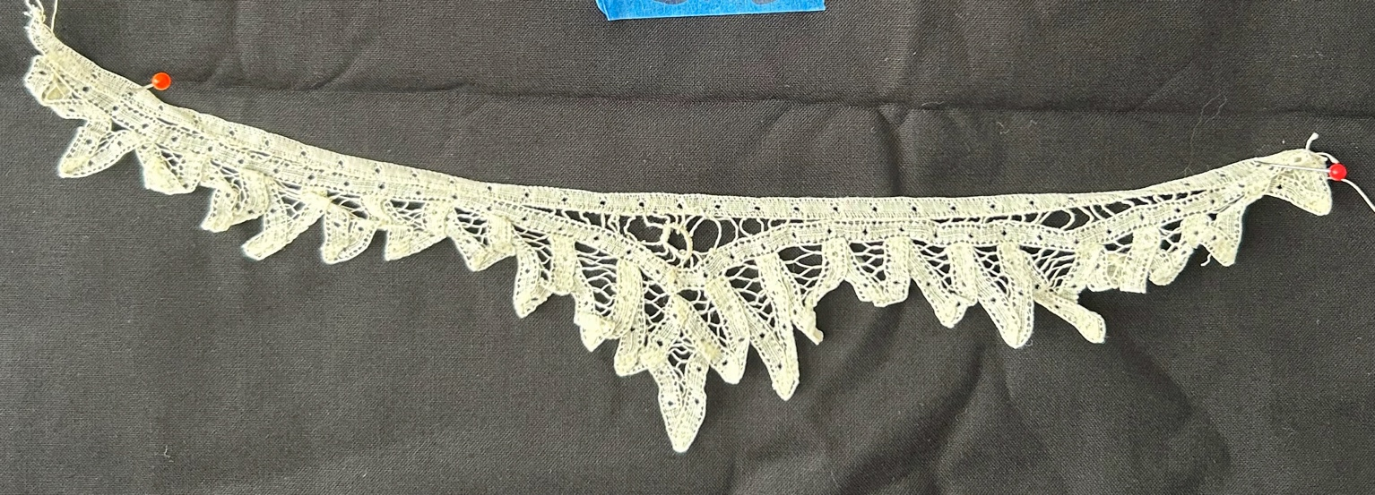
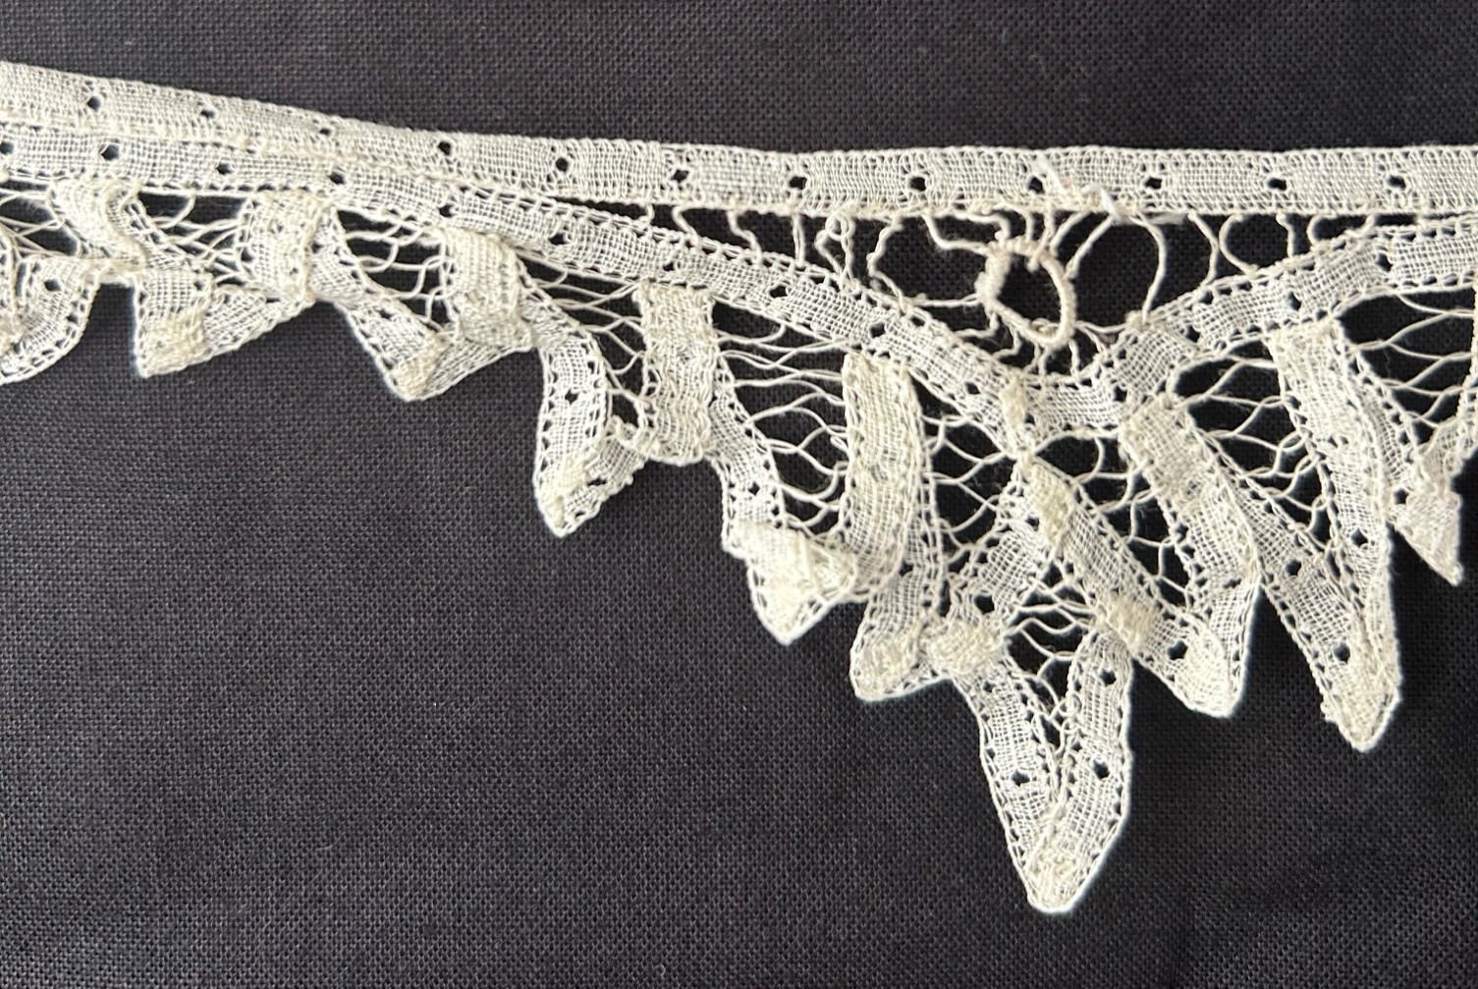

Owner History
Owner | From Date | To Date | Acquired at: | Cost
David Bailey | July 8, 2025 | -- | Naperville, IL | $0
Made in:
--
 | If not purchased, the estimated cost for materials: $0

Display & Publication History
Date | Event | Location / Publication
-- | -- | --

General Description
Quilt Title or Name:  Collar lace | Fabric Date Range: 1900 ± 20 Years  Date Made: -- ± 0 Years  Method of Determination:
Additional Information: Given to me by Chris Moline.
Length: 11.5”

