Documentation Form

Overview

Images
Top | Back
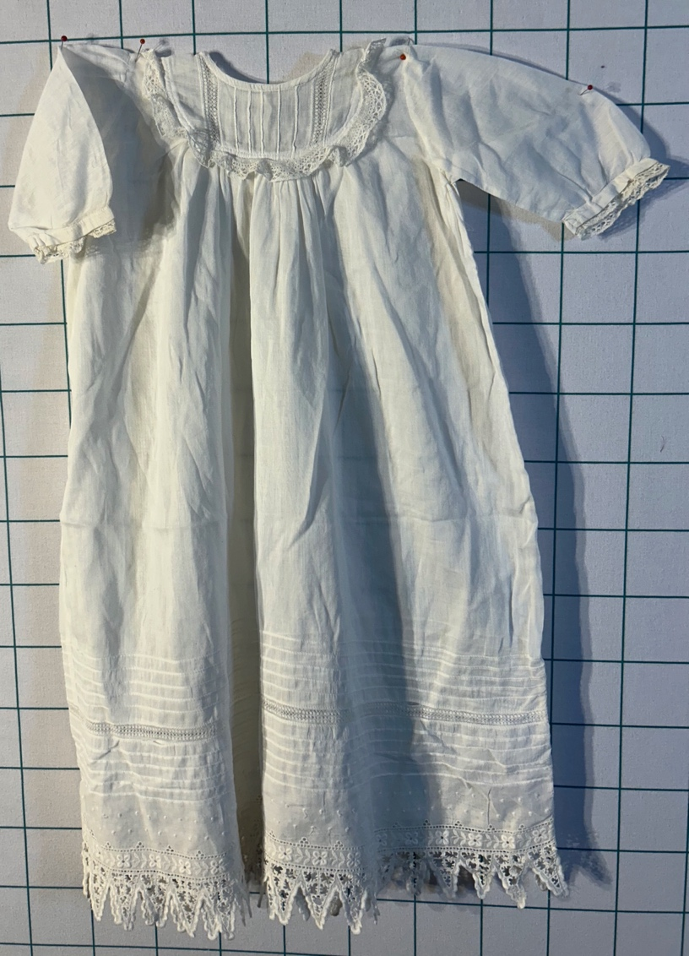 | 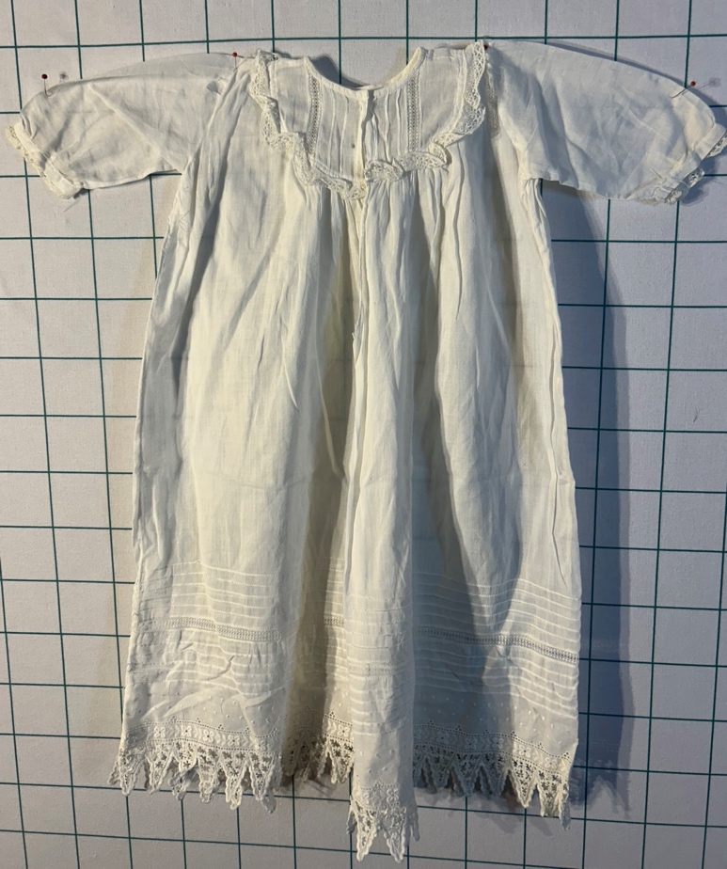

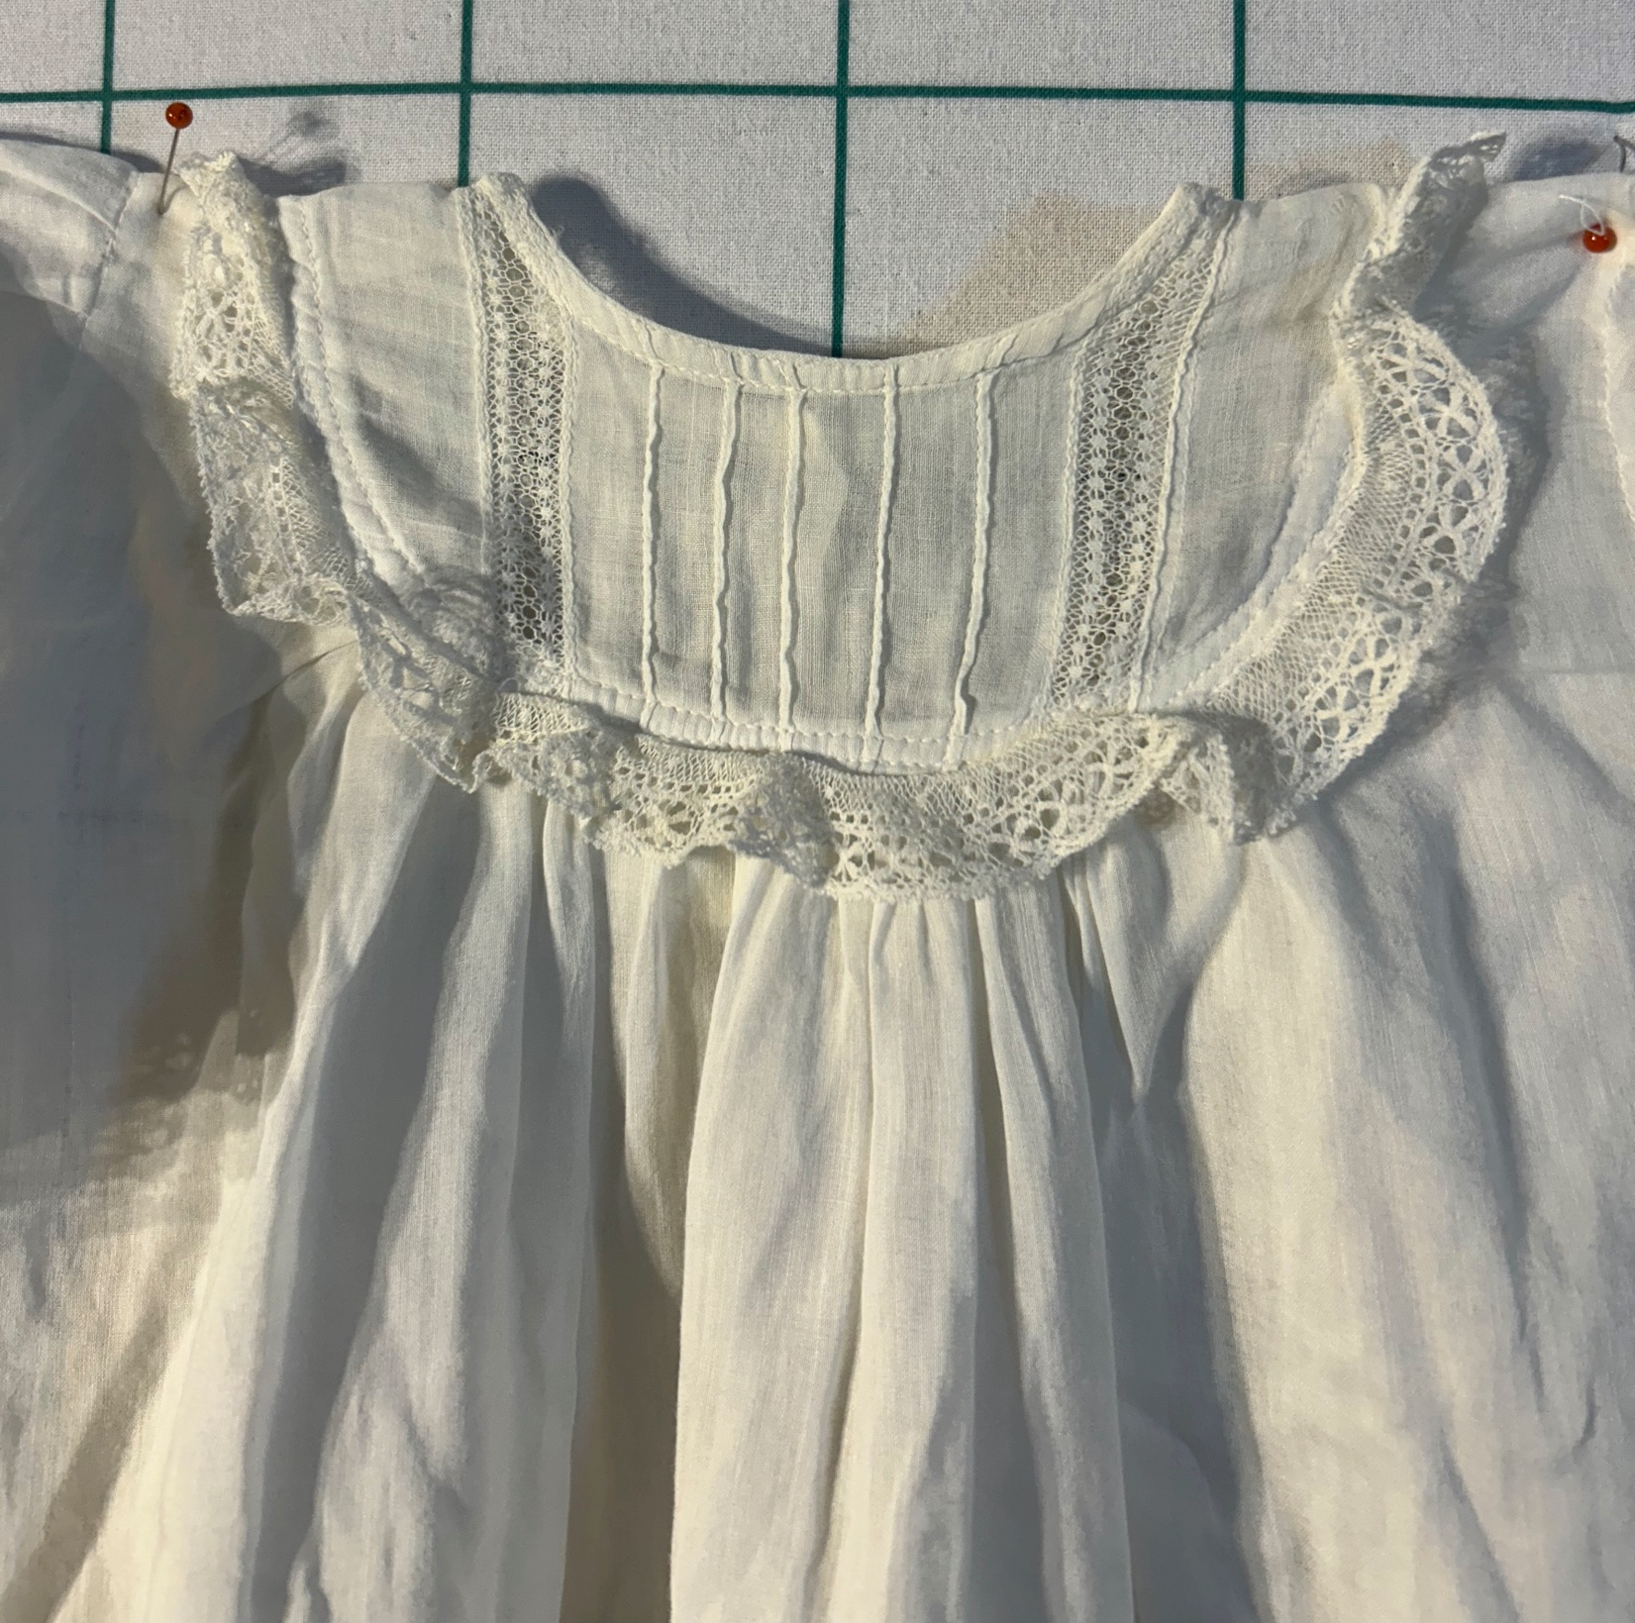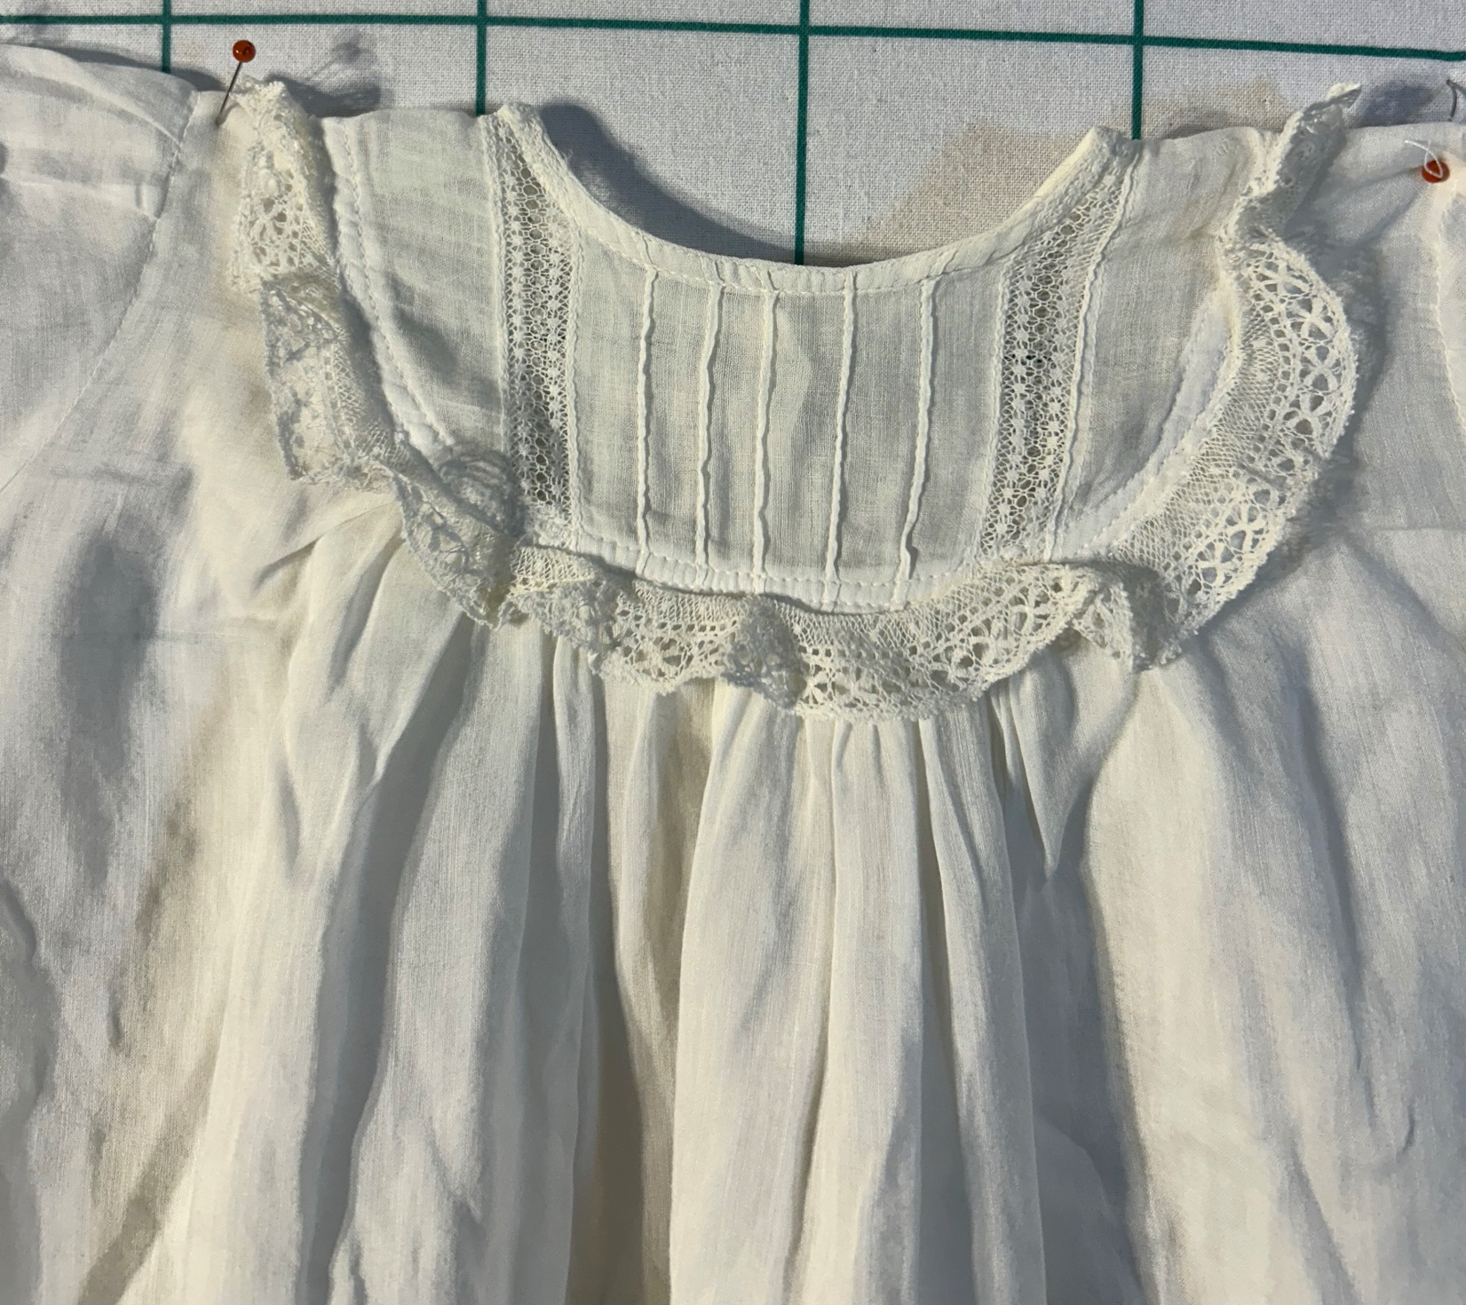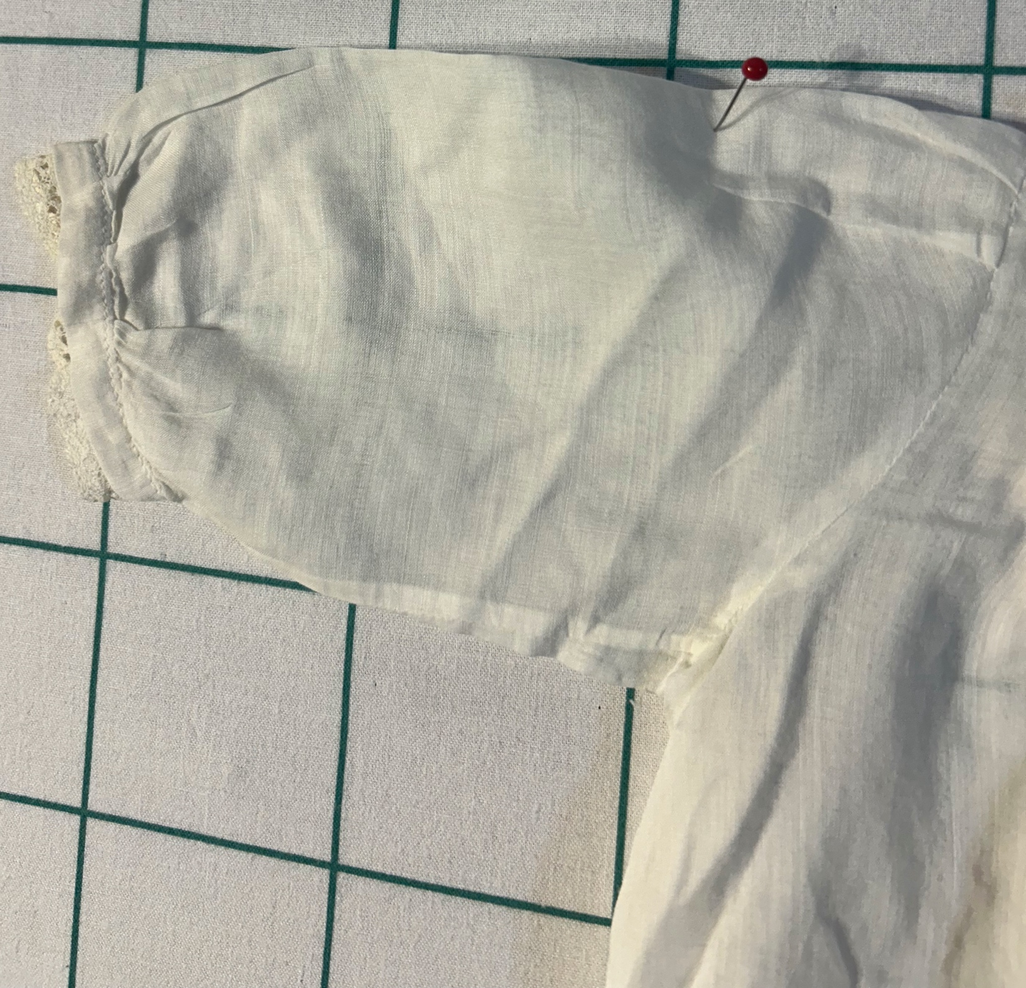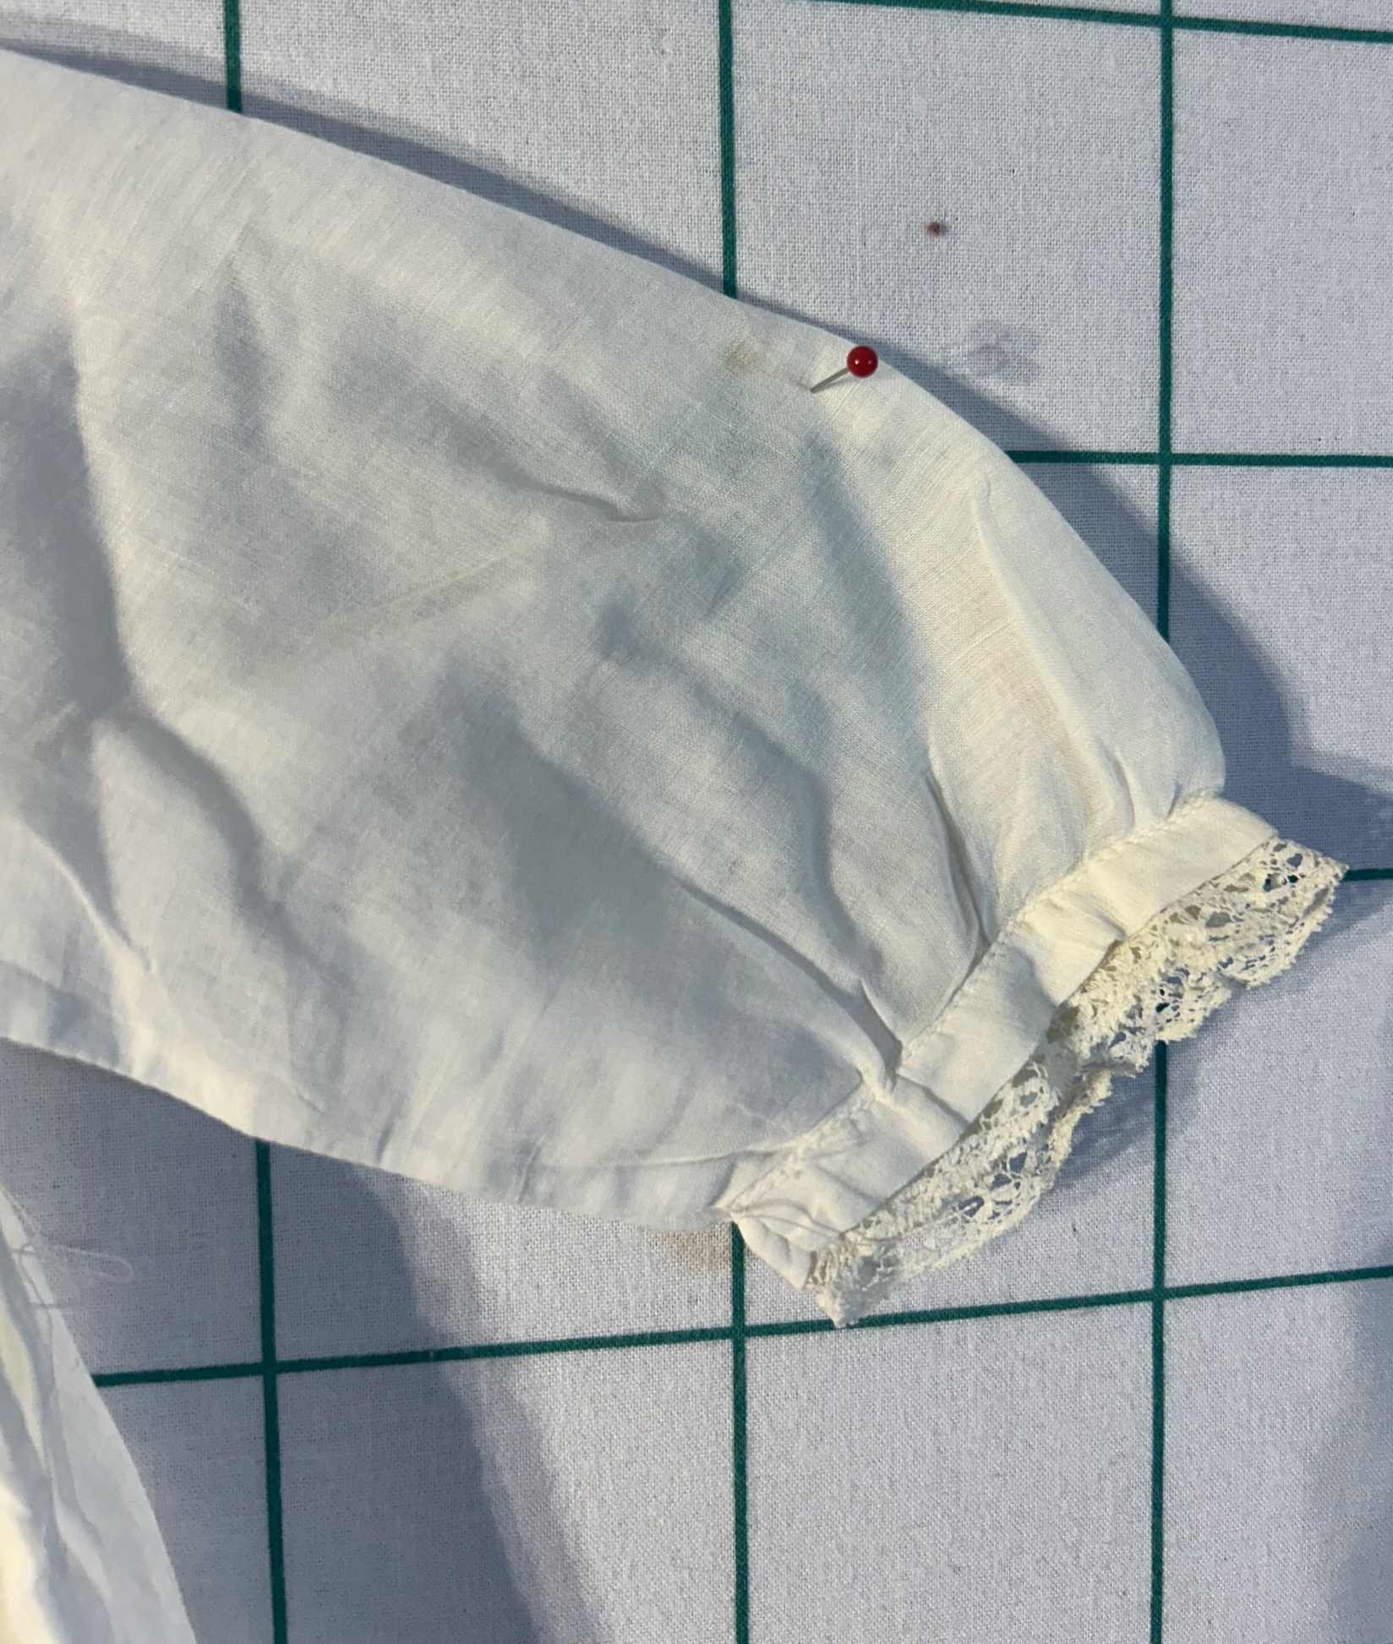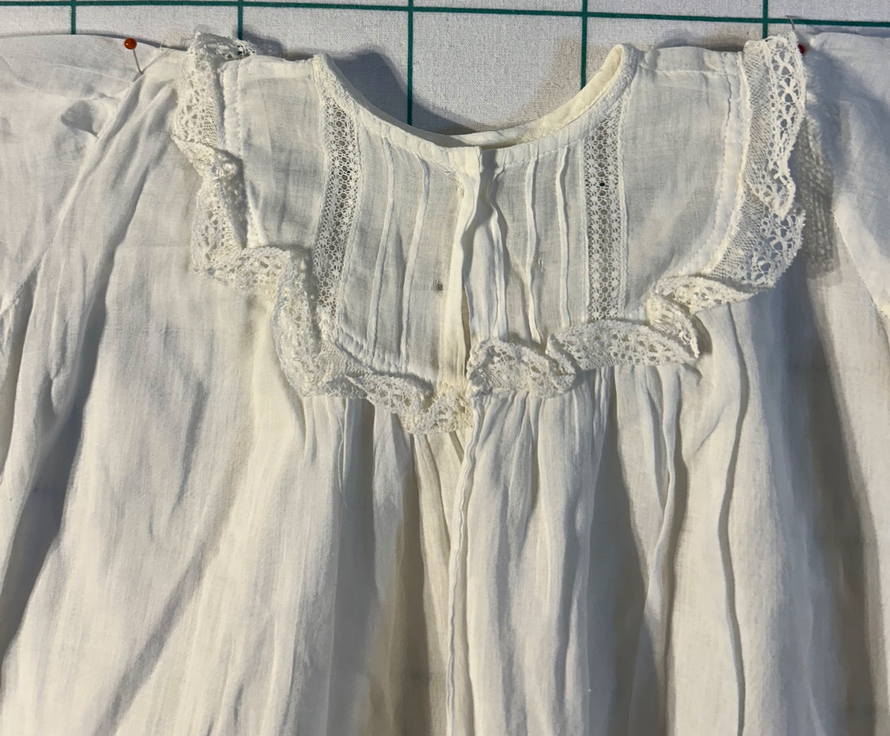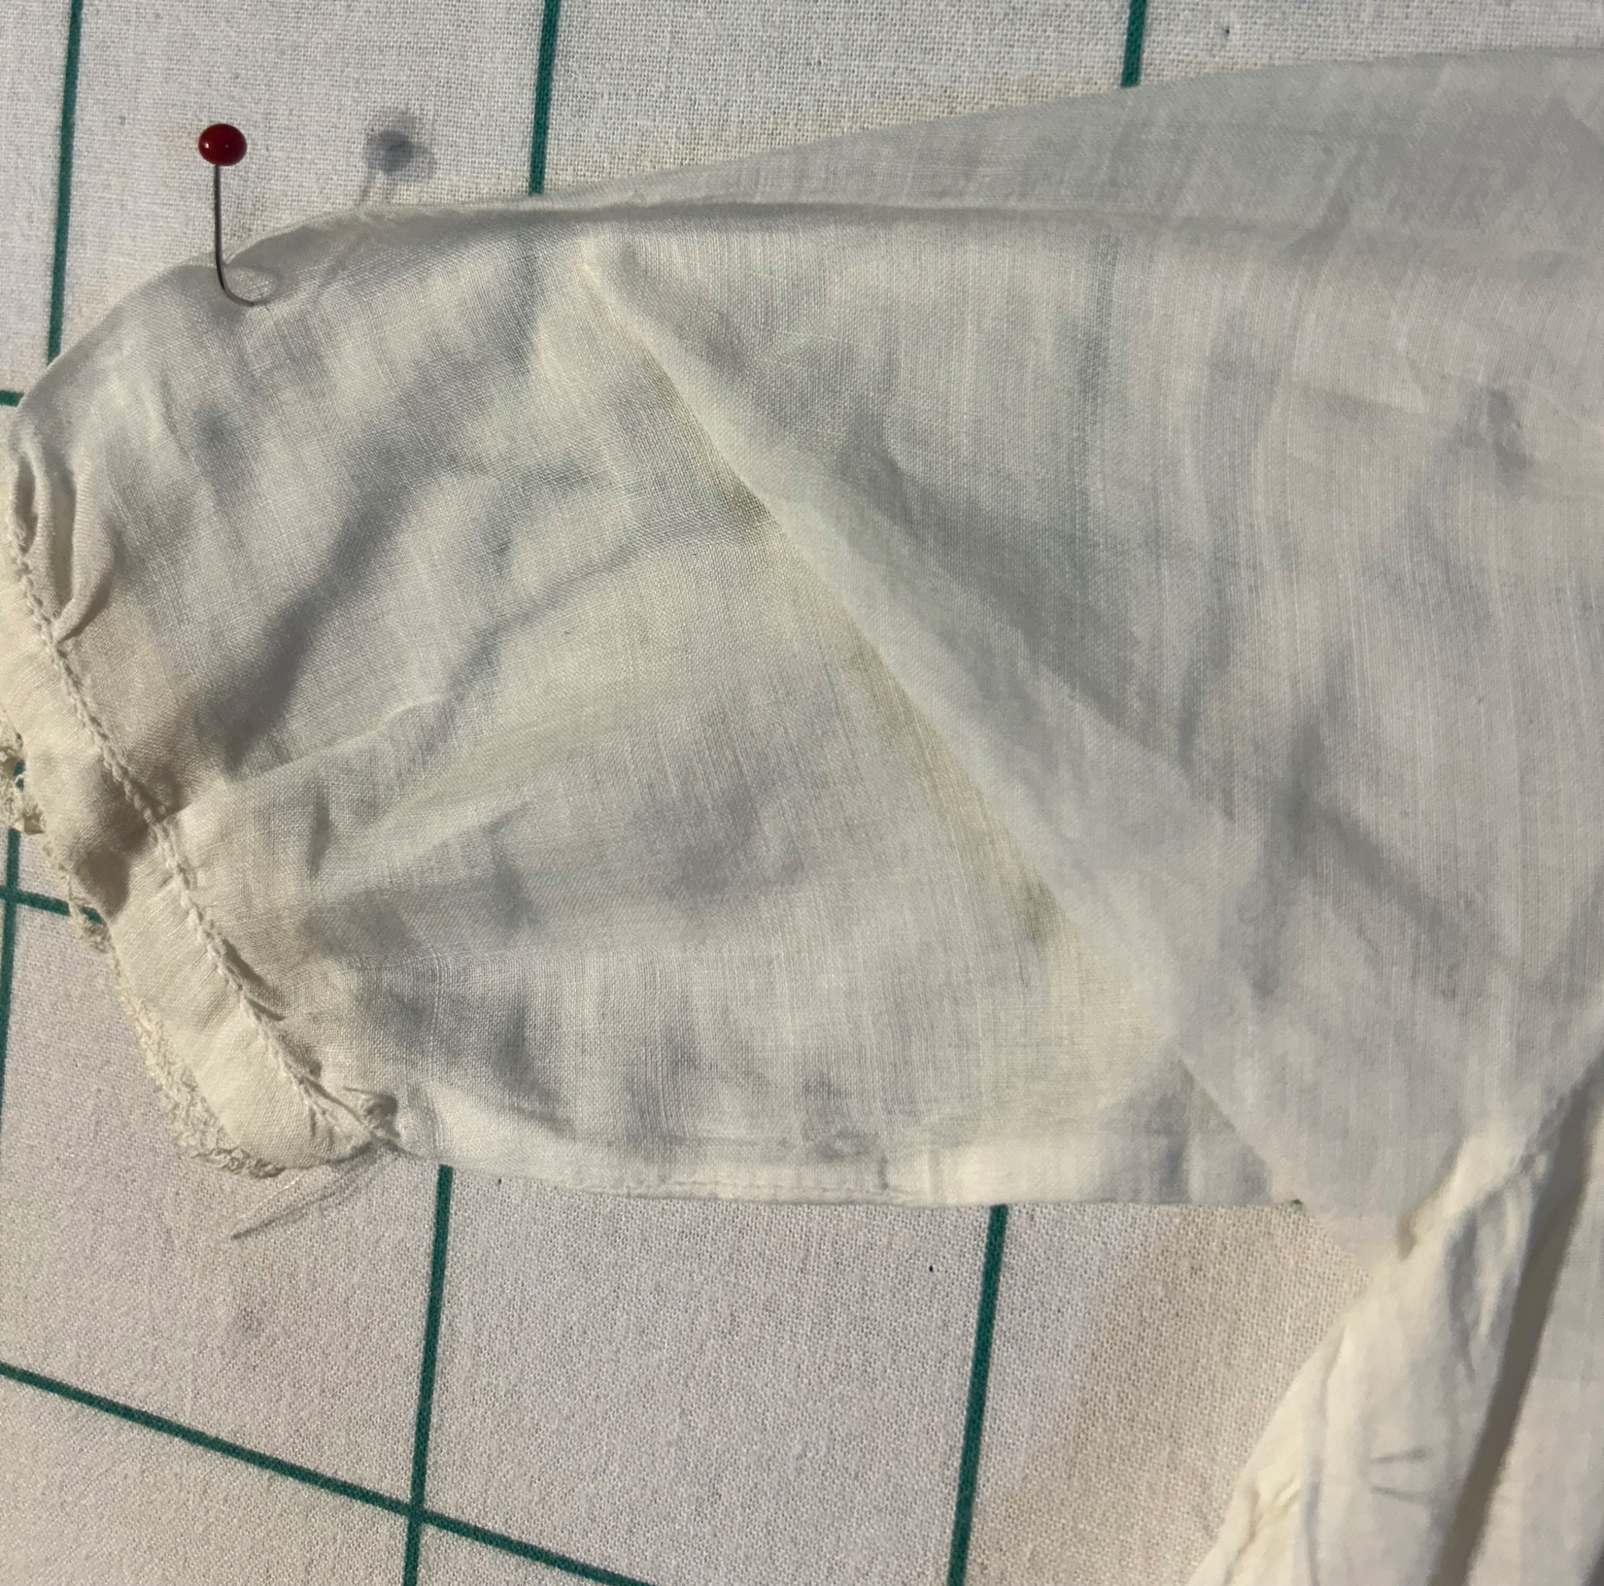

Owner History
Owner | From Date | To Date | Acquired at: | Cost
David Bailey | May 27, 2025 | -- | Naperville, IL | $4
Made in:
--
 | If not purchased, the estimated cost for materials: $0

Display & Publication History
Date | Event | Location / Publication
-- | -- | --

General Description
Quilt Title or Name:  Child's Dress | Fabric Date Range: 1910±20
This item was purchased as part of a set from Chris Moline. She used this as part of her Victorian Underwear lecture. The collection cost $4.25 / item. | Size: Length: 21“ x Width: 0“

