Documentation Form

Overview

Images
Top | Back
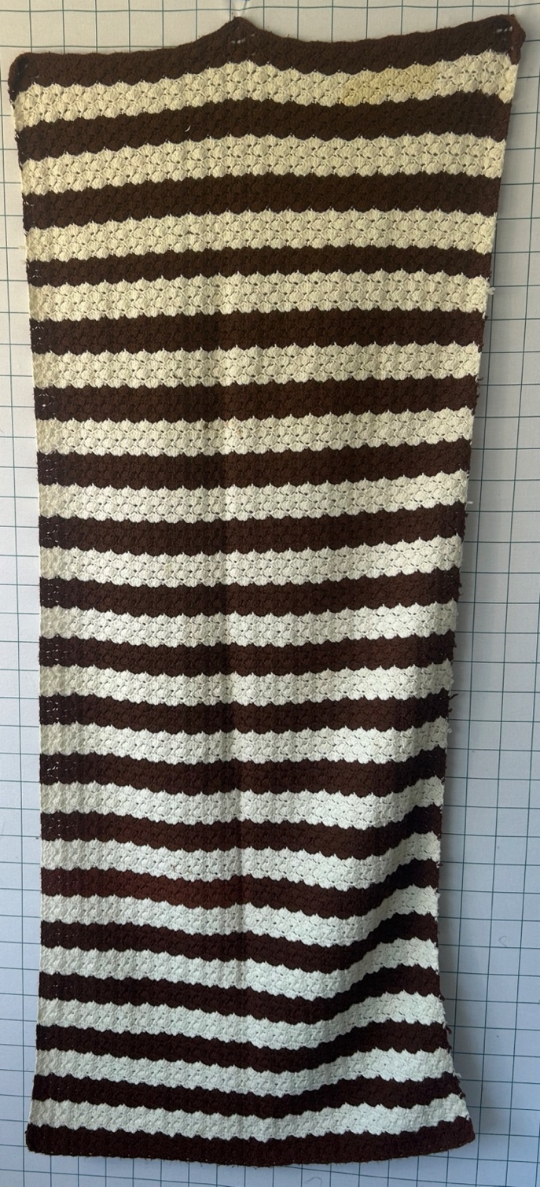 | 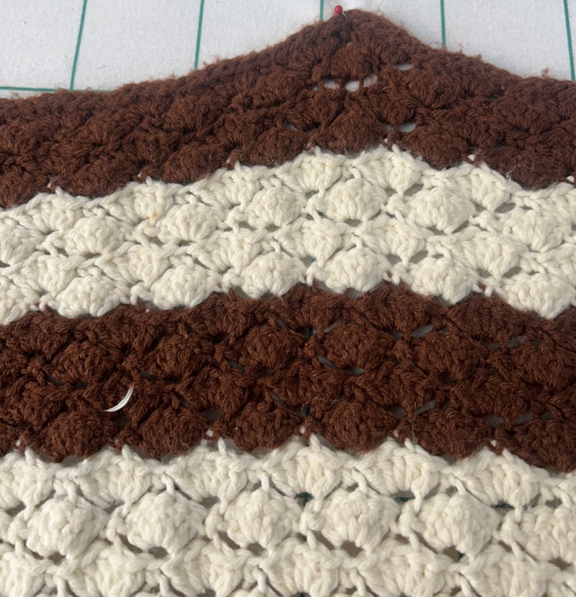

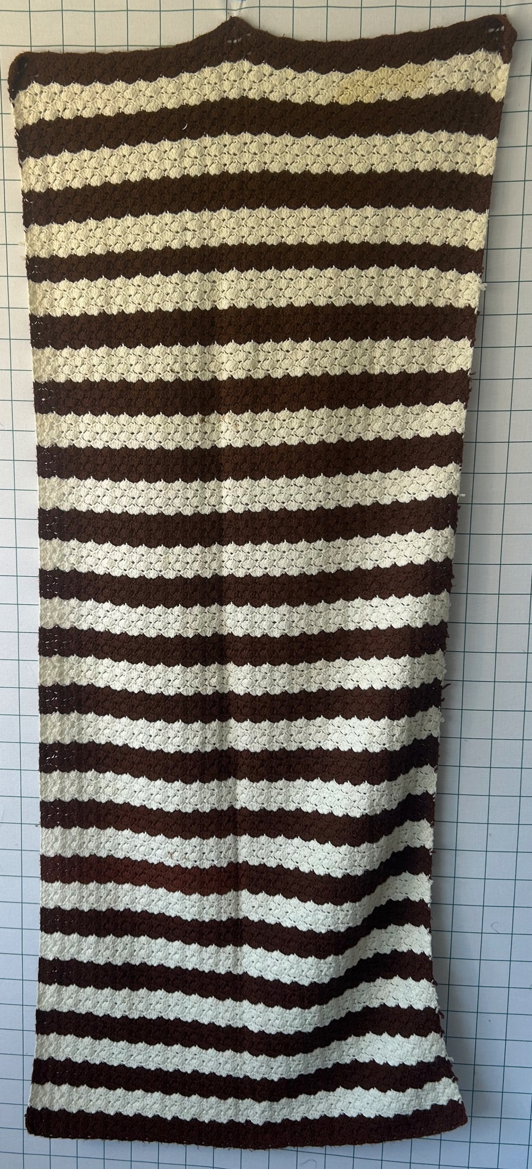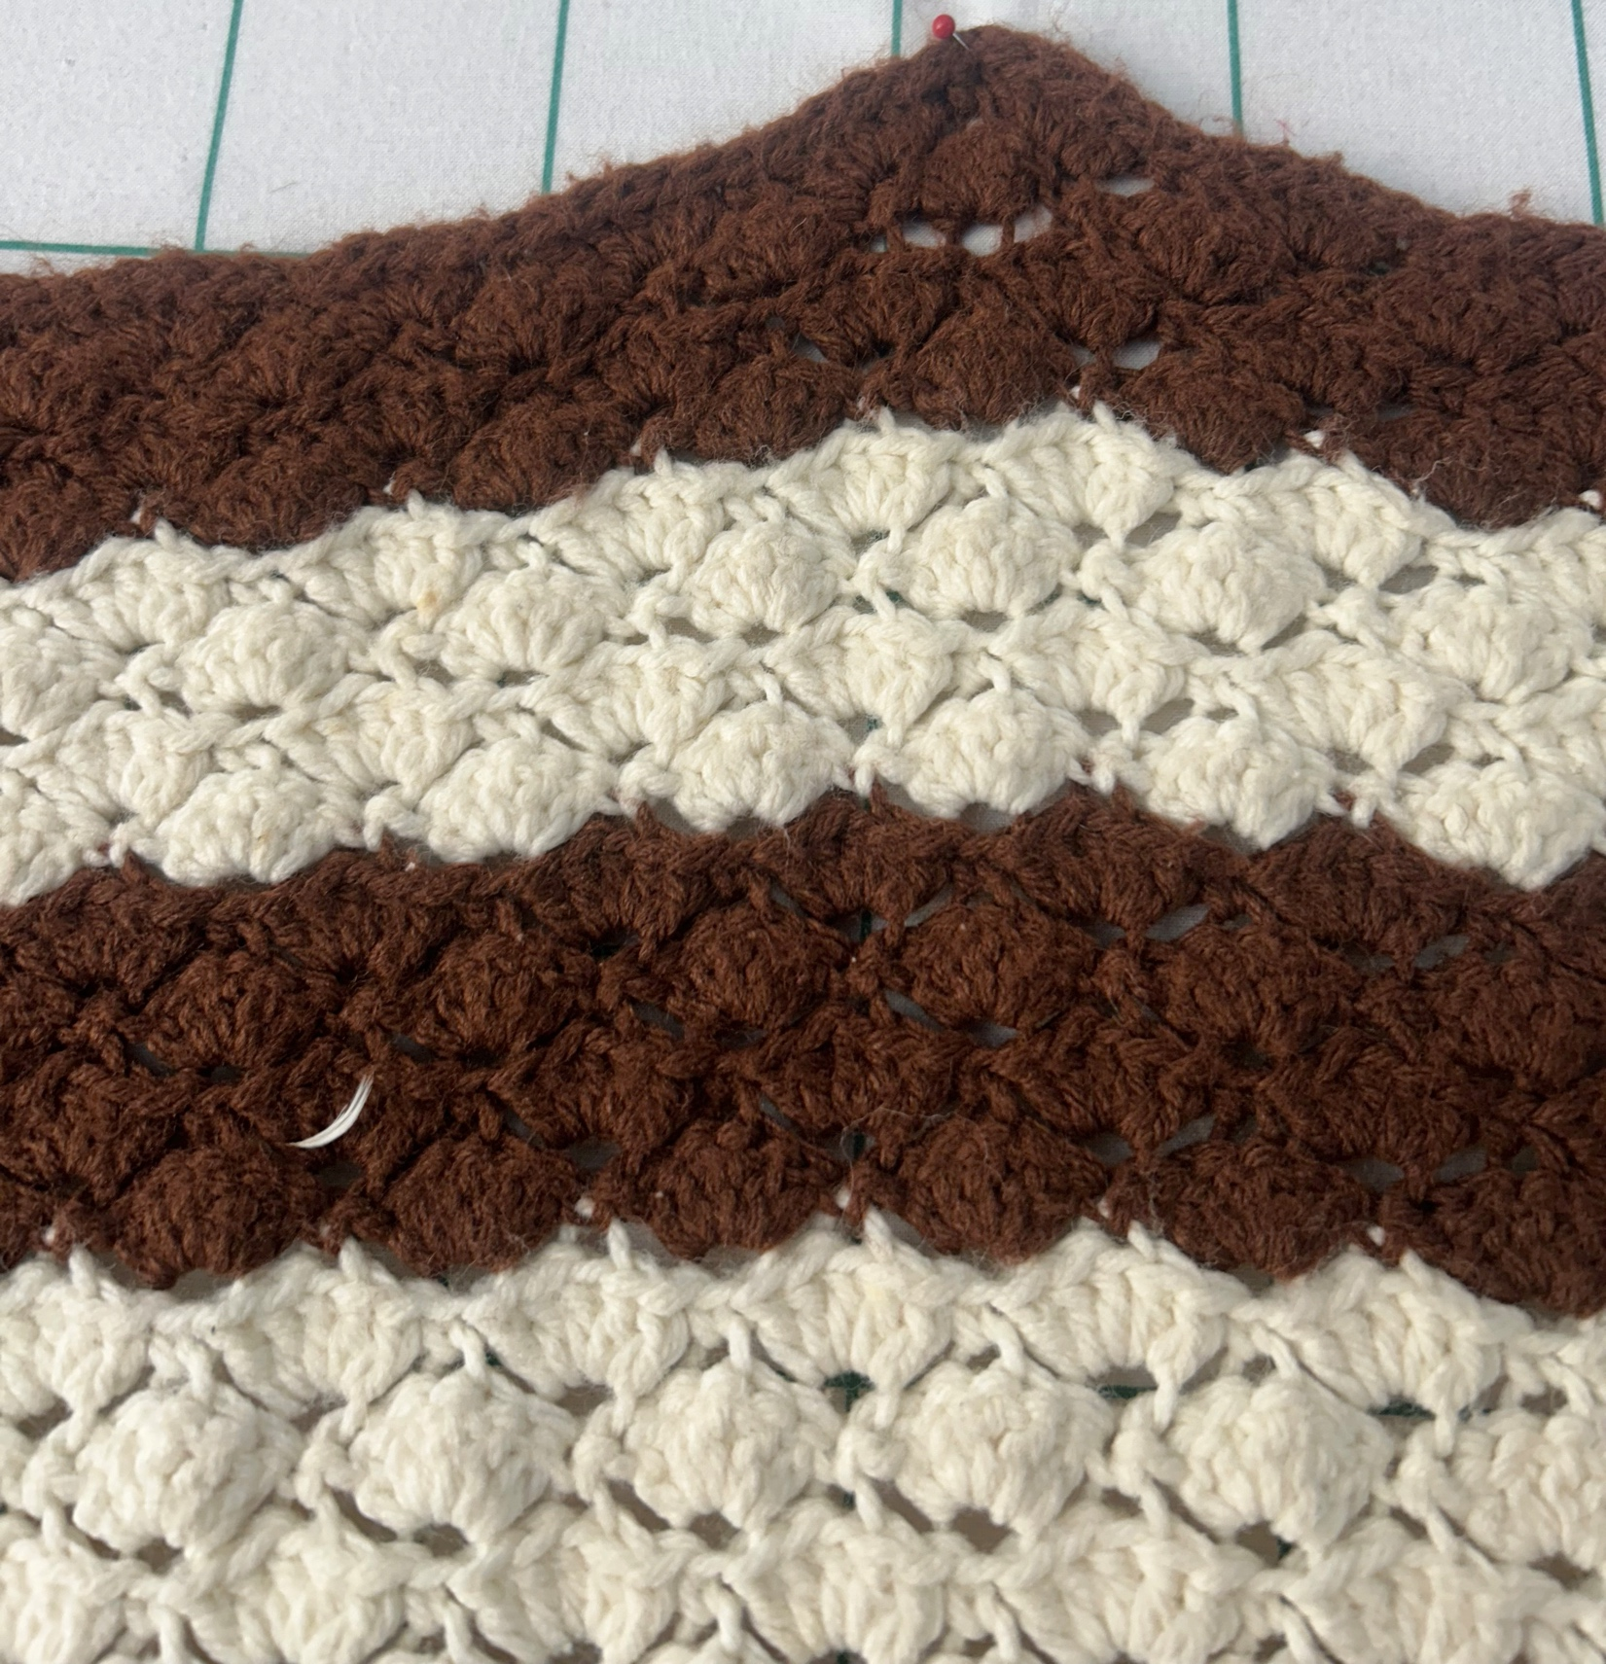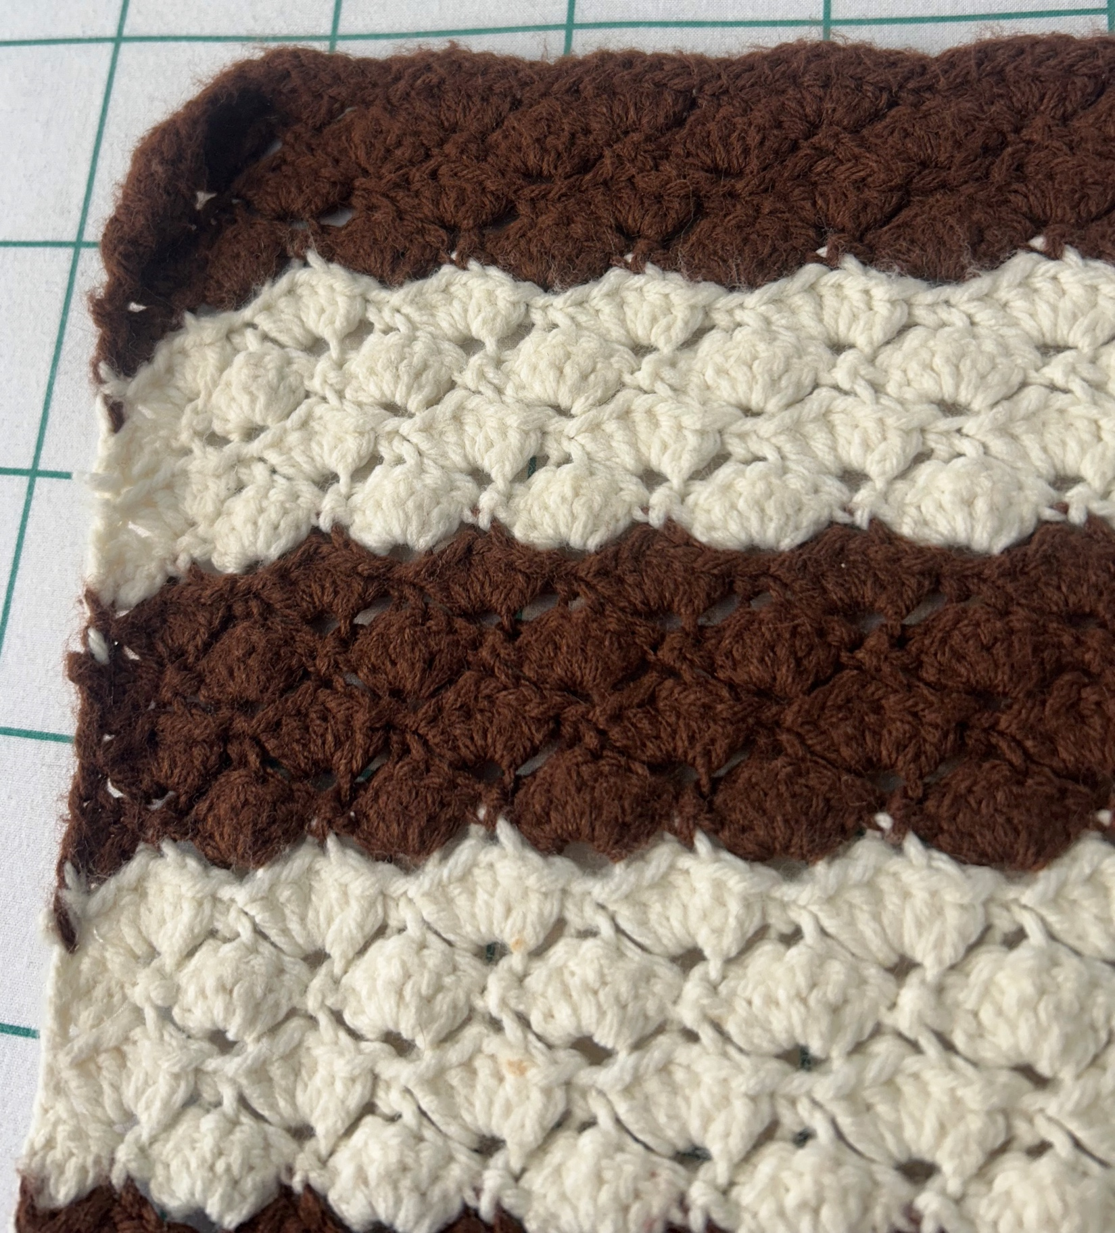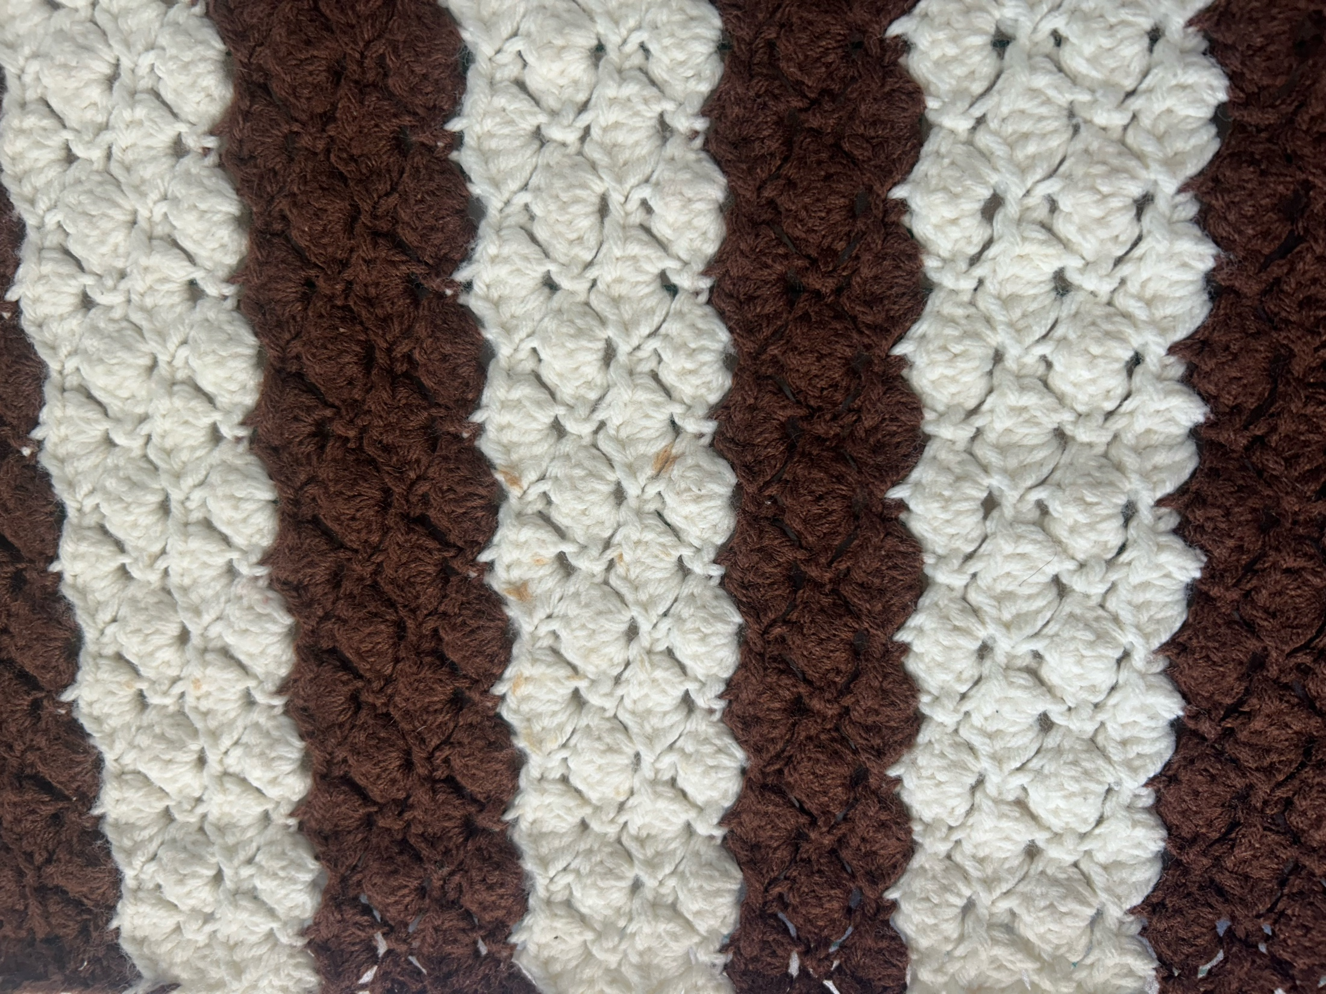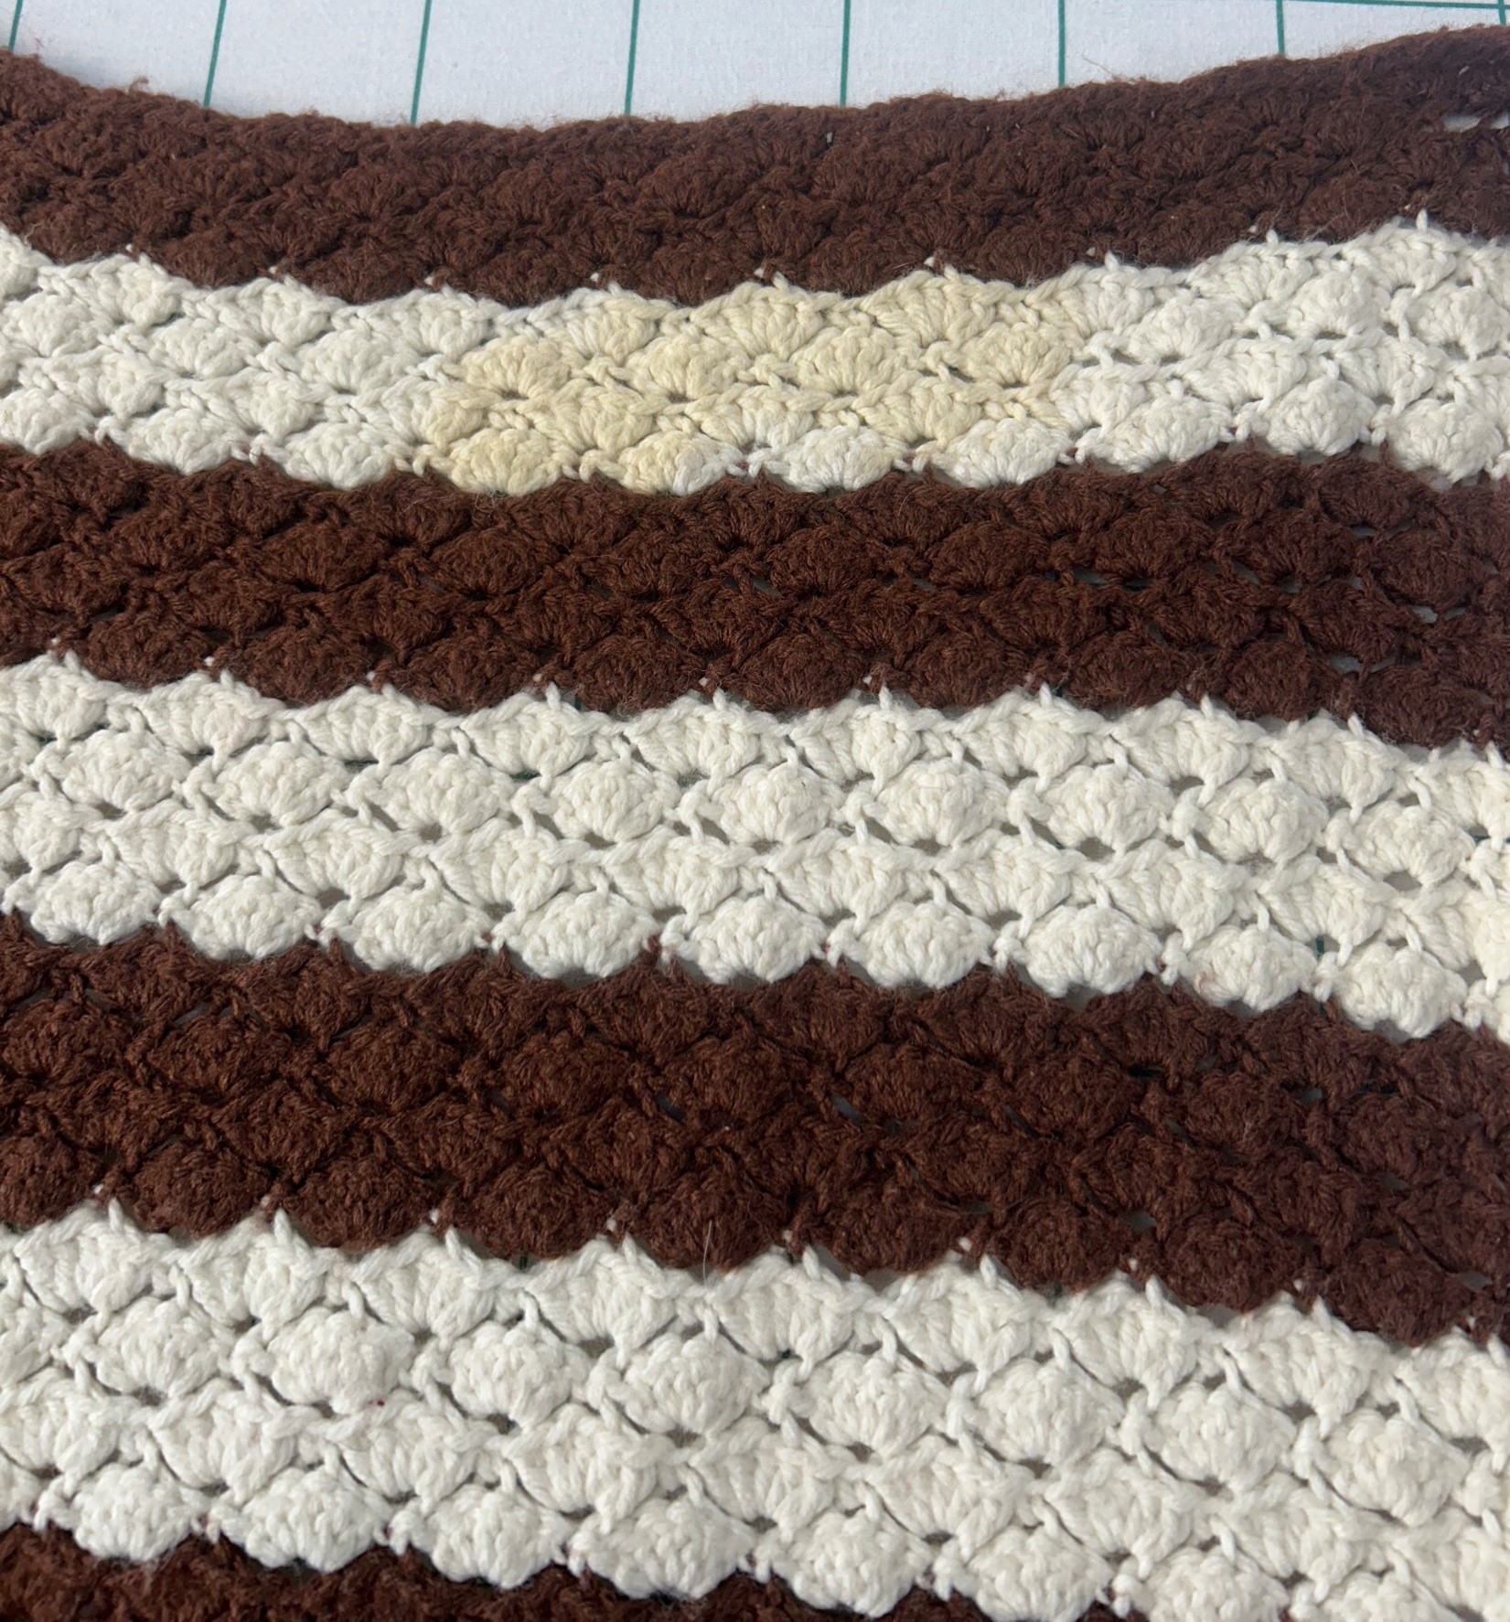

Owner History
Owner | From Date | To Date | Acquired at: | Cost
David Bailey | -- | -- | -- | $0
Made in:
--
 | If not purchased, the estimated cost for materials: $0

Display & Publication History
Date | Event | Location / Publication
-- | -- | --

General Description
Quilt Title or Name:  Afghan | Fabric Date Range: 1975 ± 5 Years  Date Made: -- ± 0 Years  Method of Determination:
Item Type:  Items in Set: 1 | Size: Length: 70“ x Width: 64“
Appraisals:  Has this quilt been professionally appraised?  If so, when: --  ----------- | Other related files:  Scanned Patterns  Images  EQ 8 Files  Research Notes
Additional Information: Made by DJ Trela’s mother – Ruby Trela. Probably in the 1970s. Yarn is acetate or wool / acetate blend.

History

Provenance
Describe: --

Quilt Maker
Maker: -- |  | Birth: -- |  | Death: --
 | Location: -- |  | Contributions: --

Purpose and Context
Expression
Art | Personal Enjoyment | Therapy
Income
Personal Income | Fundraising
Presentation
Anniversary | Wedding | Birth
Holiday | Birthday | Other gift
Charitable support
Relationships
Friendship | Commemorative | Memorial
Mourning | Reunion
Skill Building
Challenge / Contest | Learning / Teaching Sample
Use
Bed Quilt | Lap Quilt | Home Décor
Baby / Crib | Wall Hanging
Describe other purpose: --

Construction History
--

Coverlet Design & Construction

Coverlet Top
Warp strand count per inch: 0. | Design: --
Warp fiber: | Weaver: --
Weft strand count per inch: 0” | Location: --
Weft fiber: | Woven for: --
Additional Information: --

