Documentation Form

Overview

Images
Top | Back
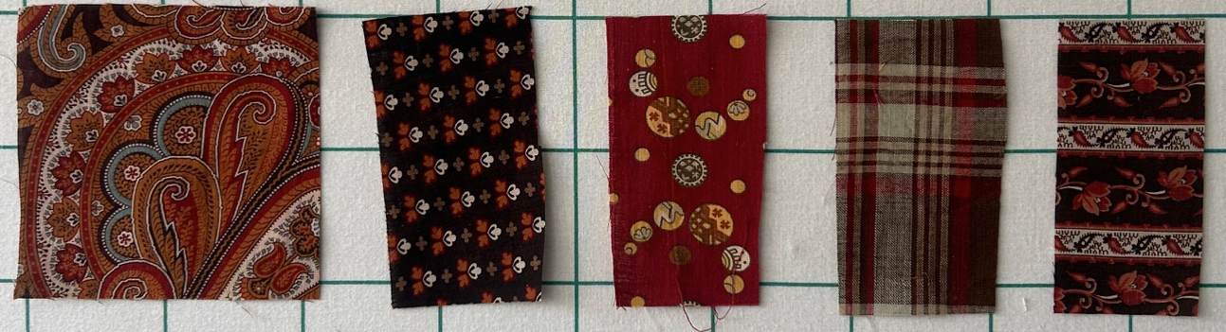 | 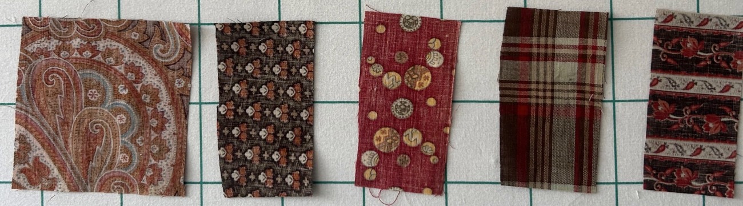

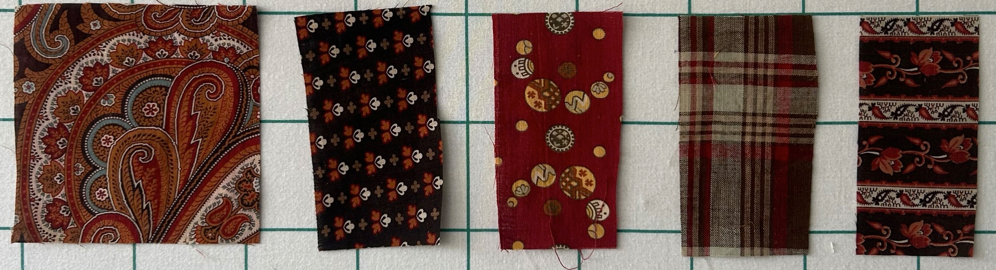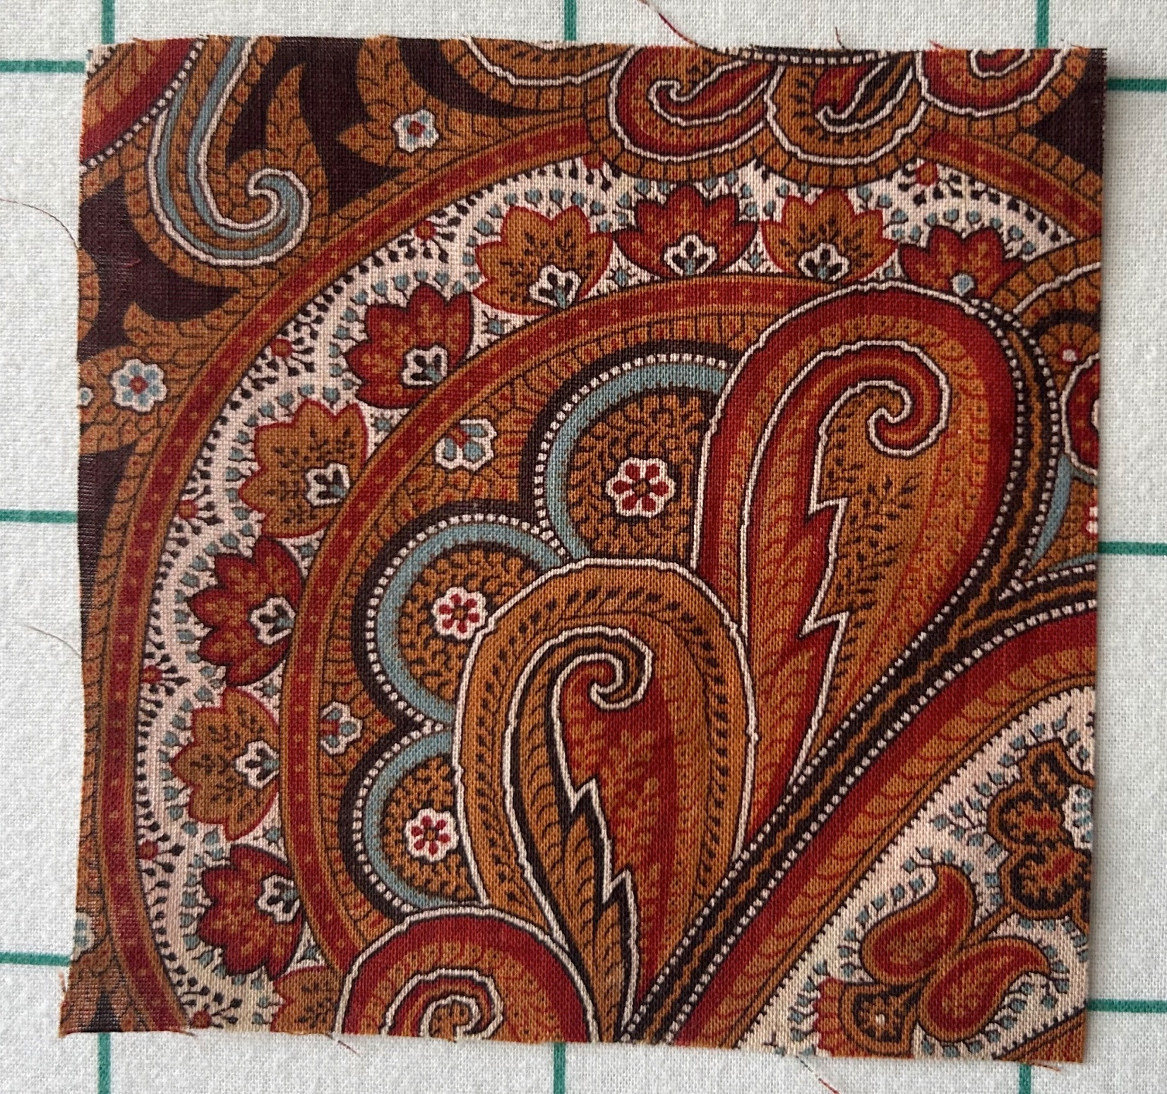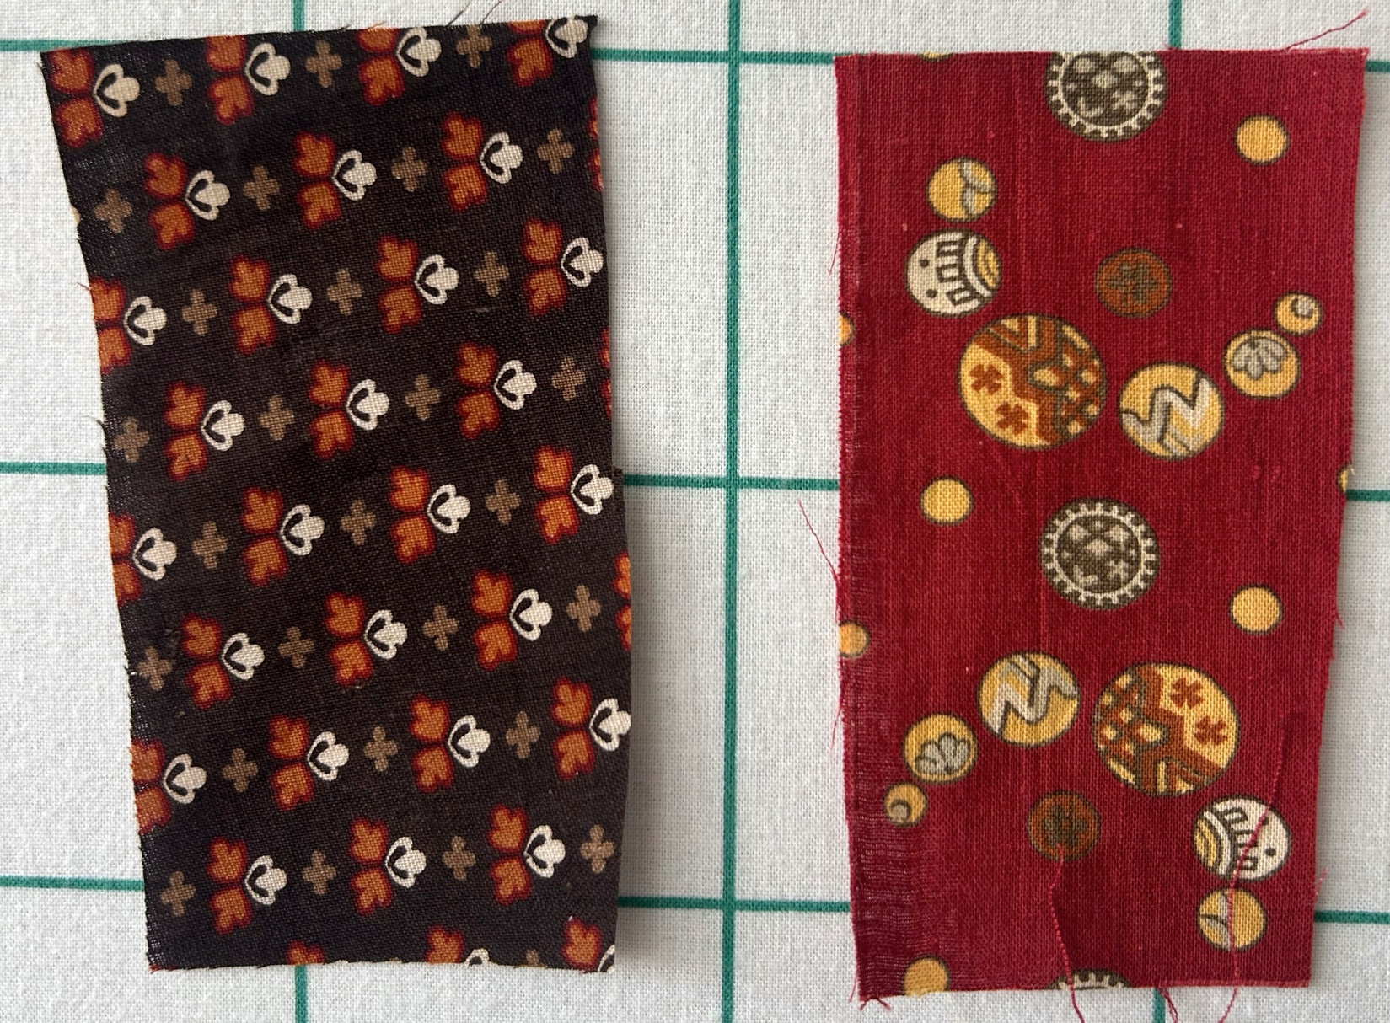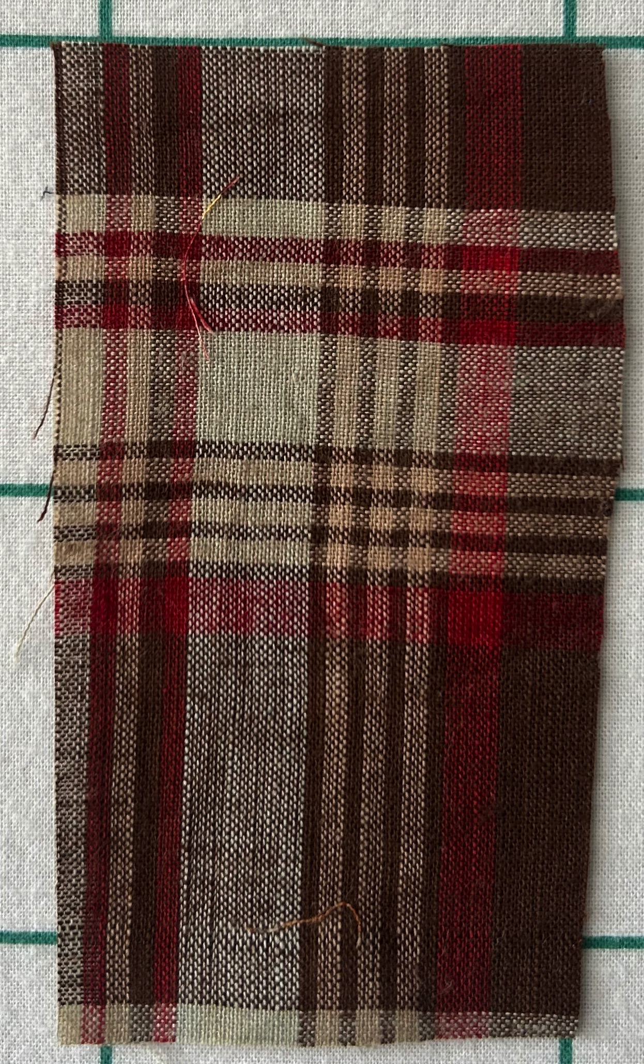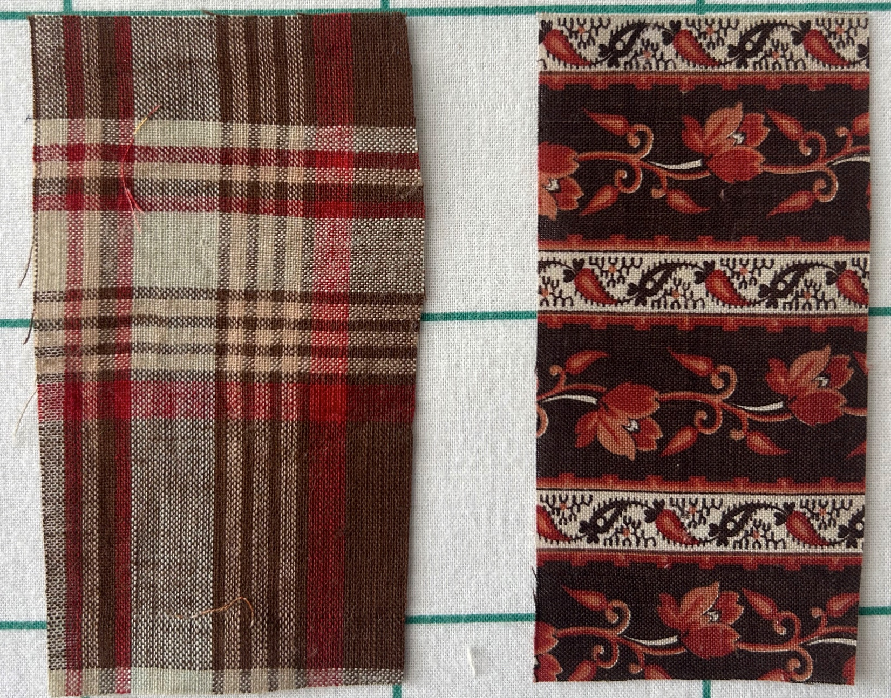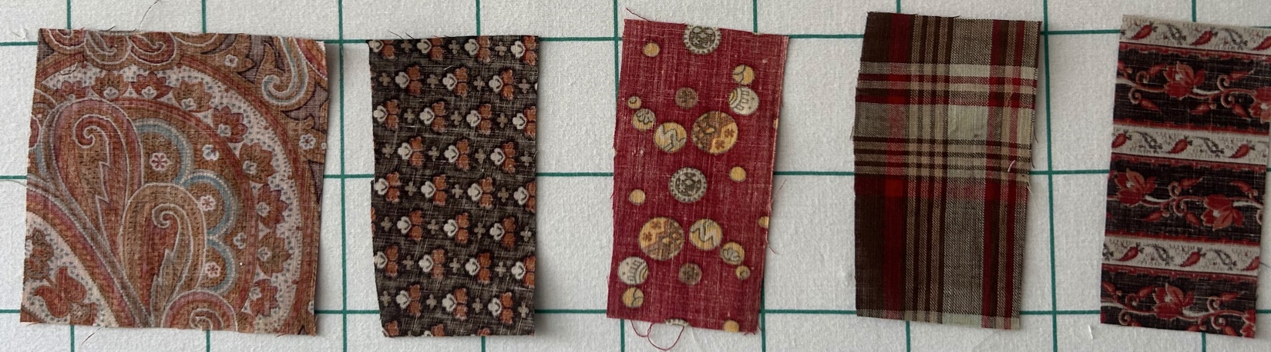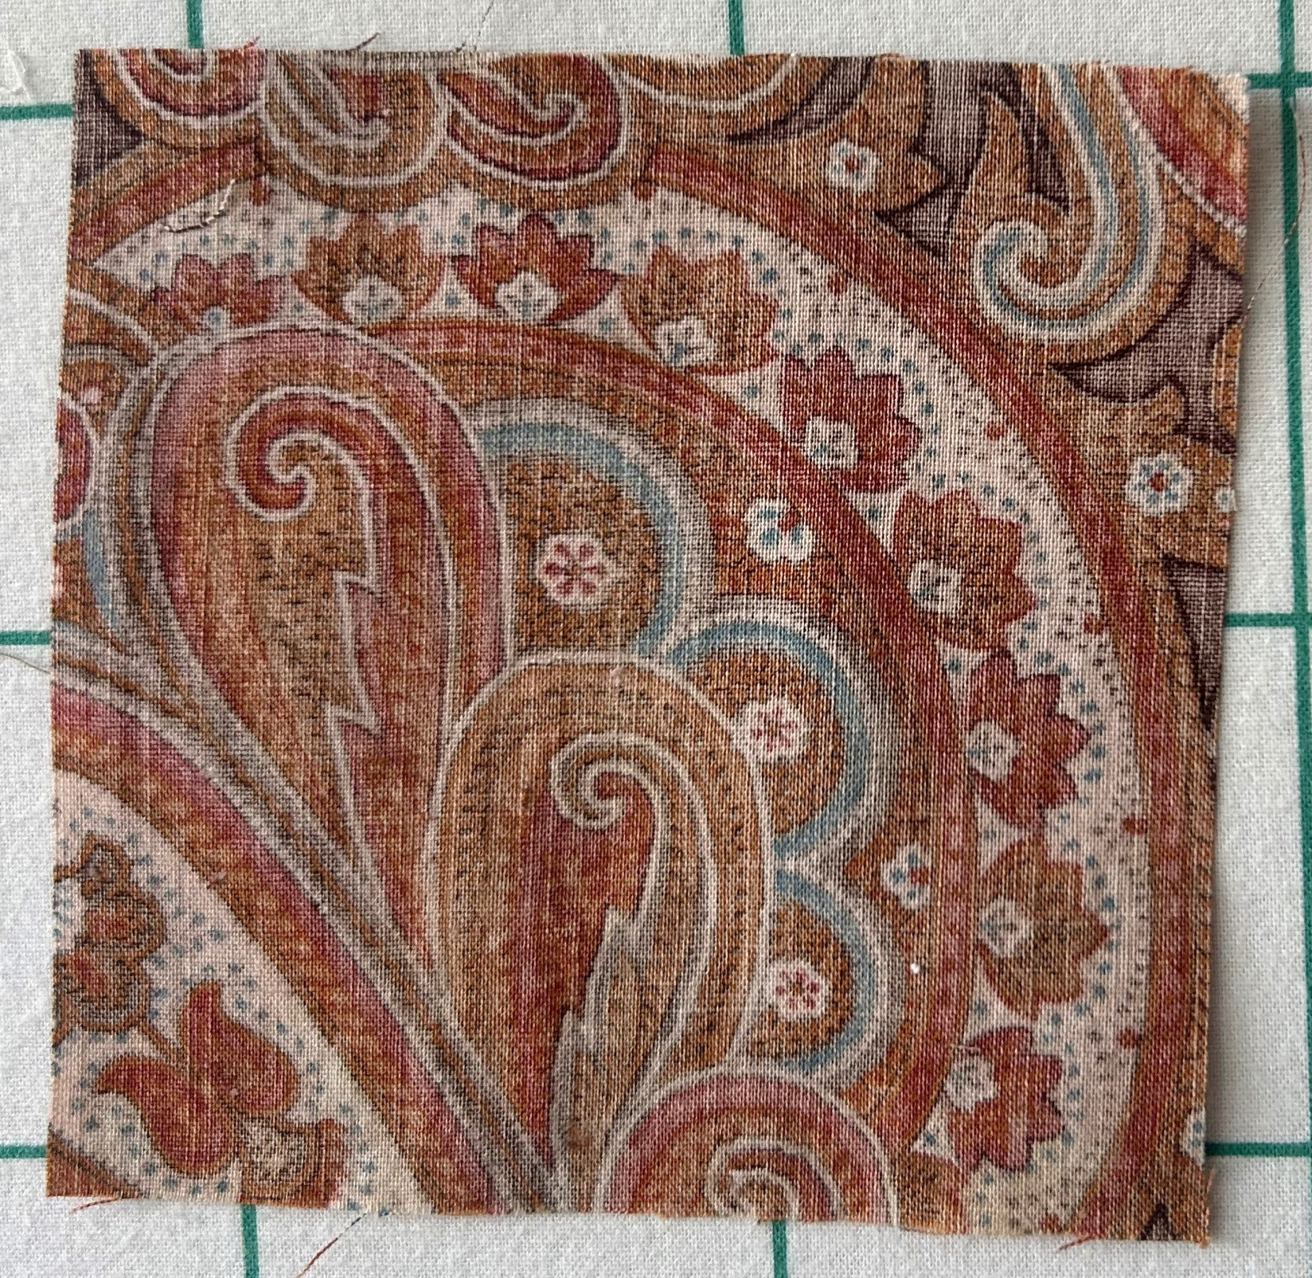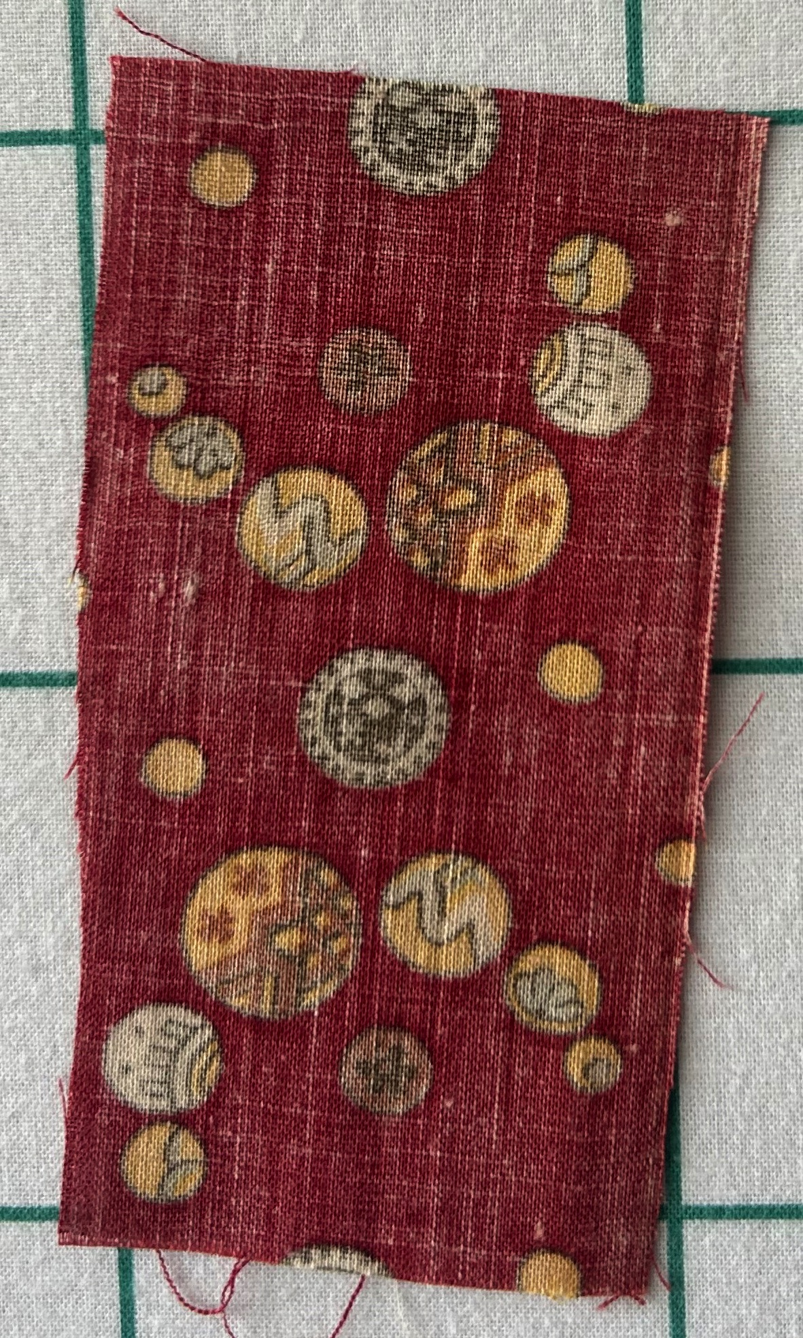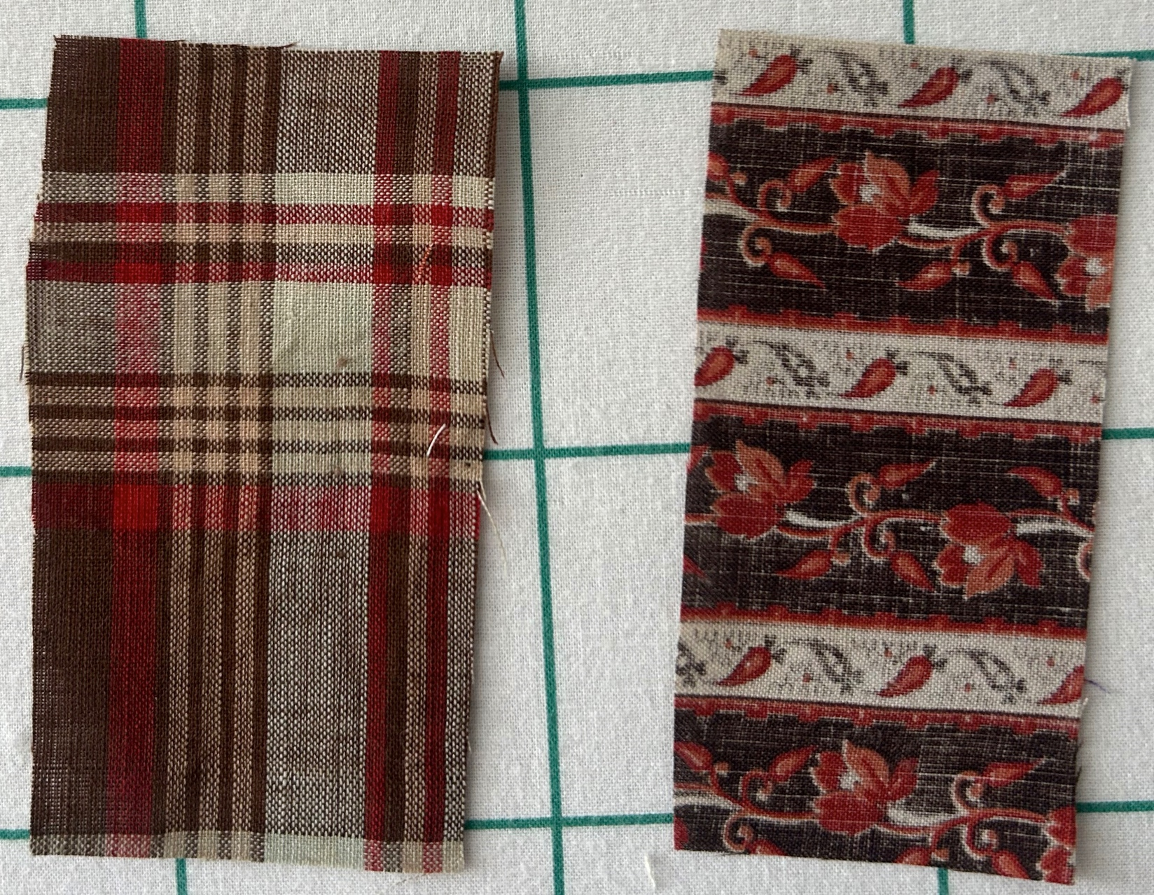

Owner History
Owner | From Date | To Date | Acquired at: | Cost
David Bailey | 2025, June 21 | -- | Sherry Branson  Belvidere, IL | $0
Made in:
--
 | If not purchased, the estimated cost for materials: $0

Display & Publication History
Date | Event | Location / Publication
-- | -- | --

General Description
Quilt Title or Name:  Madder Prints | Fabric Date Range: 1875 ± 10 Years  Date Made: -- ± 0 Years  Method of Determination:
Item Type:  Items in Set: 5 | Size: Length: 4“ x Width: -24“
Appraisals:  Has this quilt been professionally appraised?  If so, when: --  ----------- | Other related files:  Scanned Patterns  Images  EQ 8 Files  Research Notes
Additional Information: --

