Documentation Form

Overview

Images
Top | Back
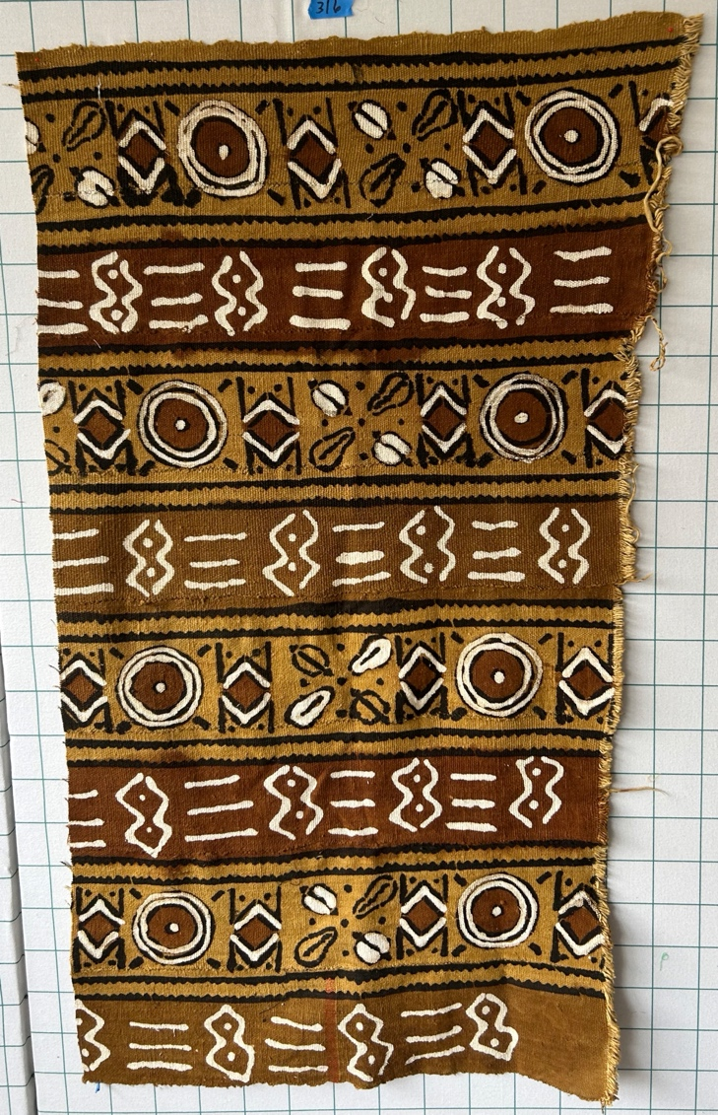 | 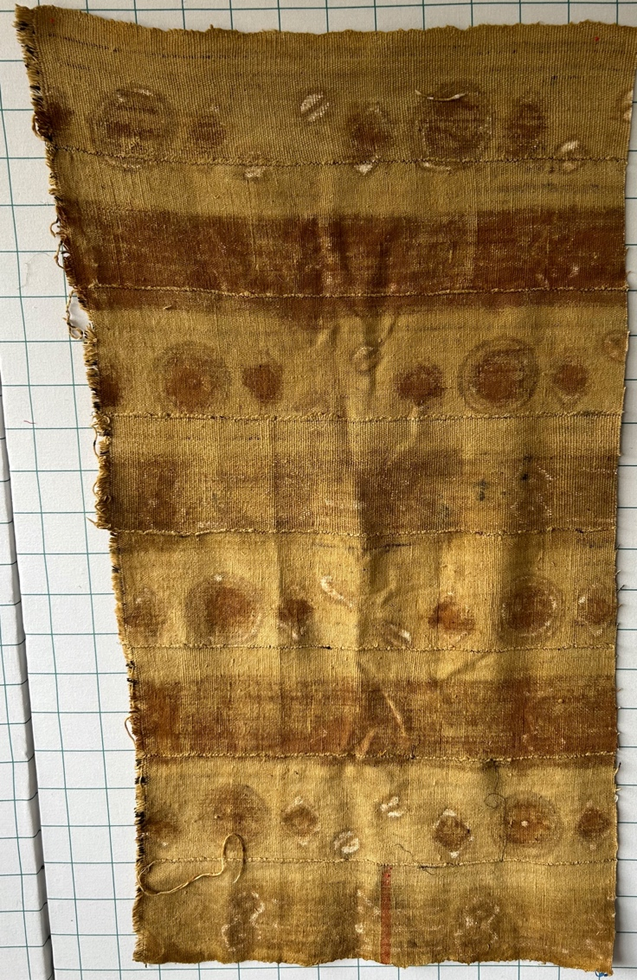

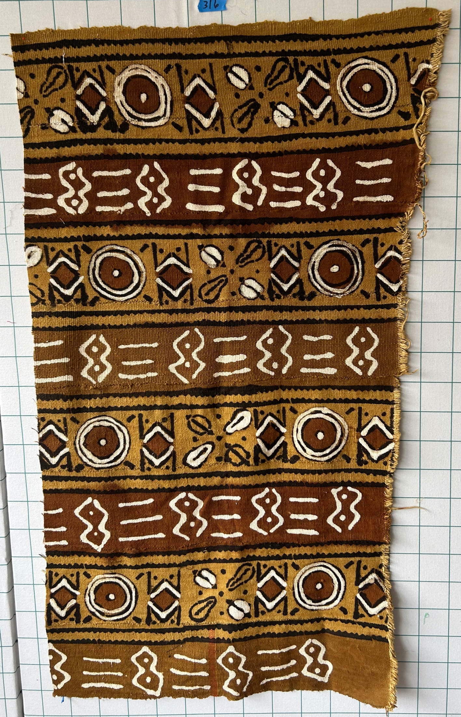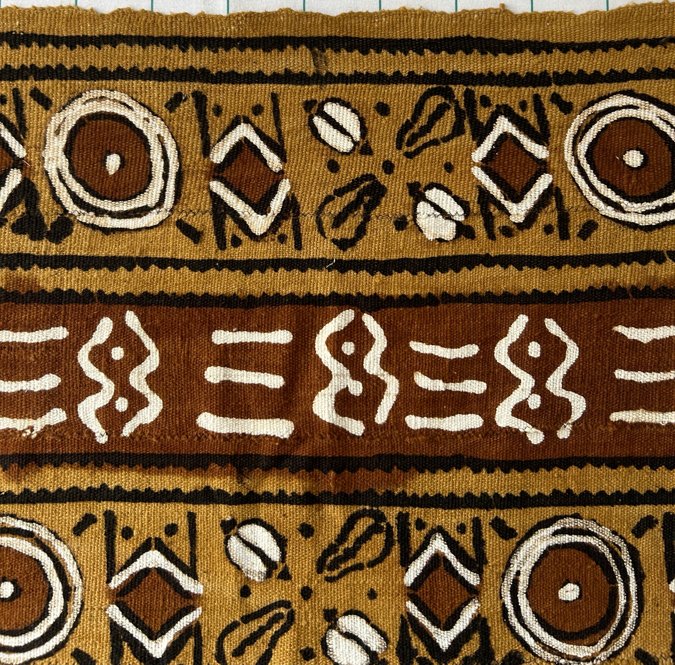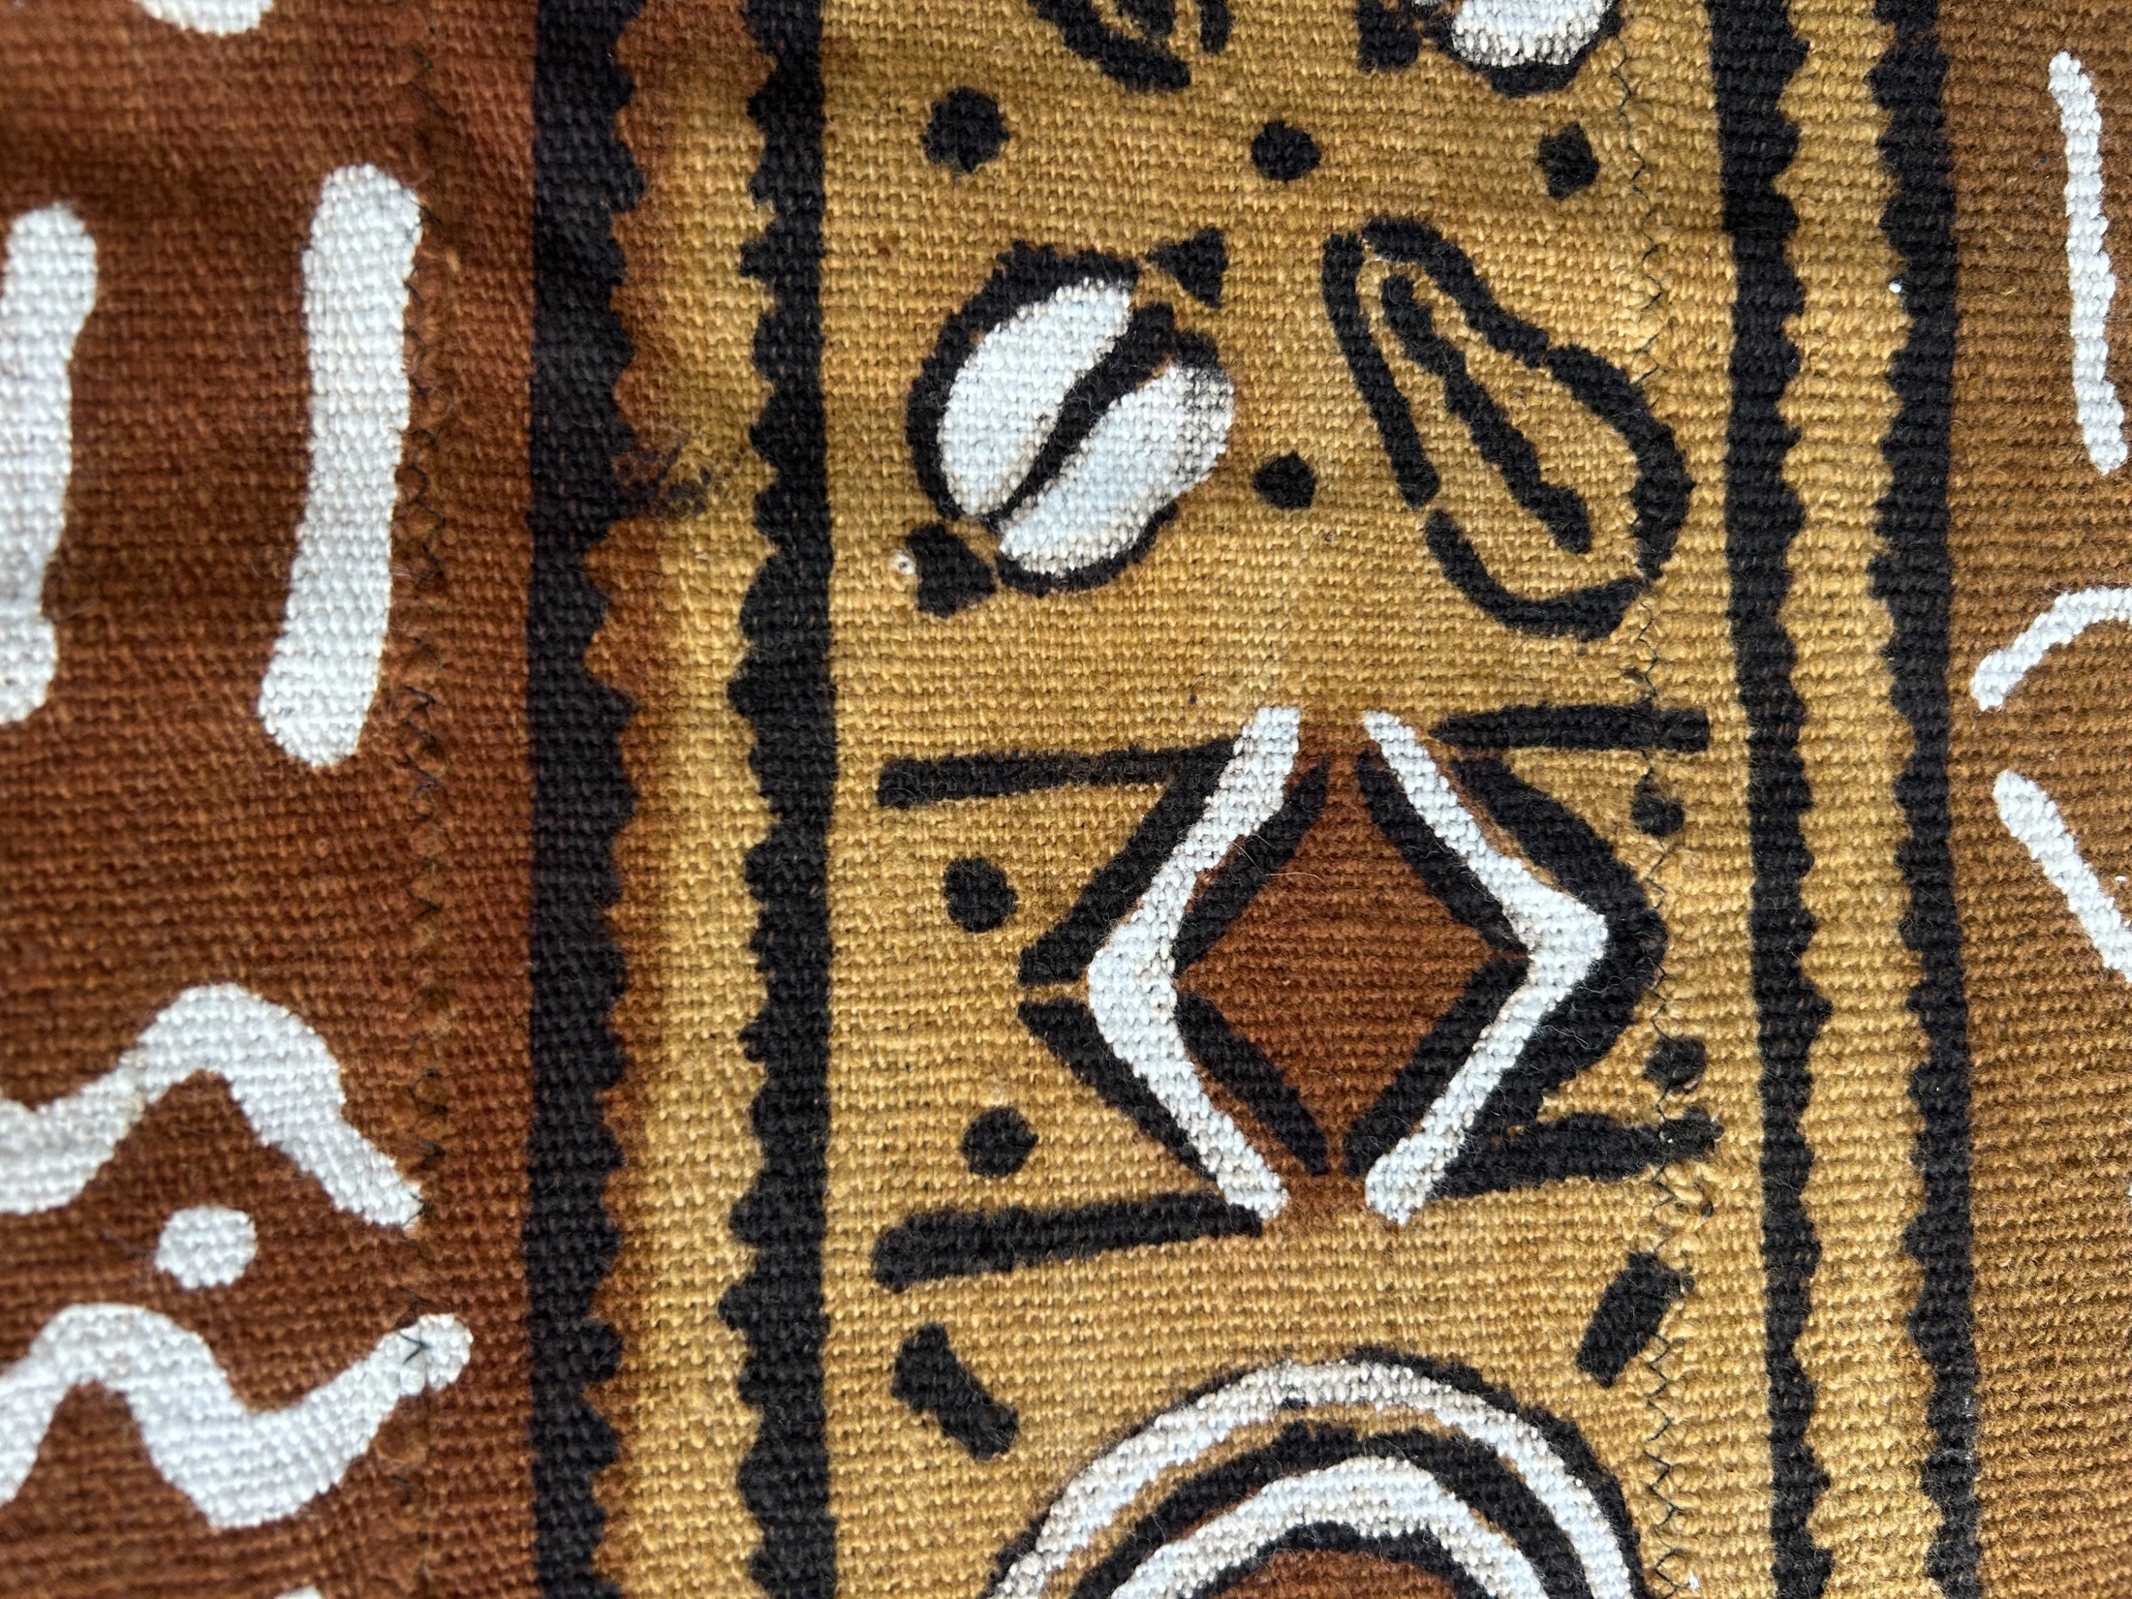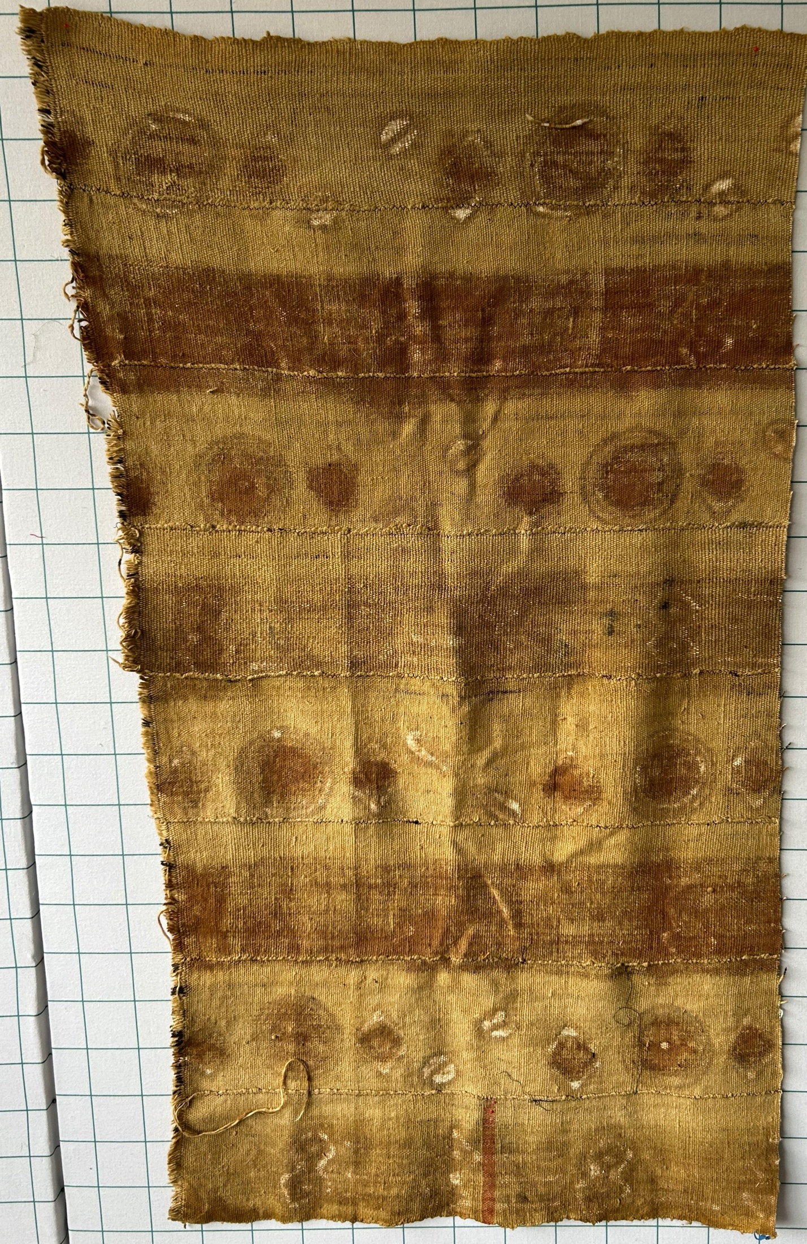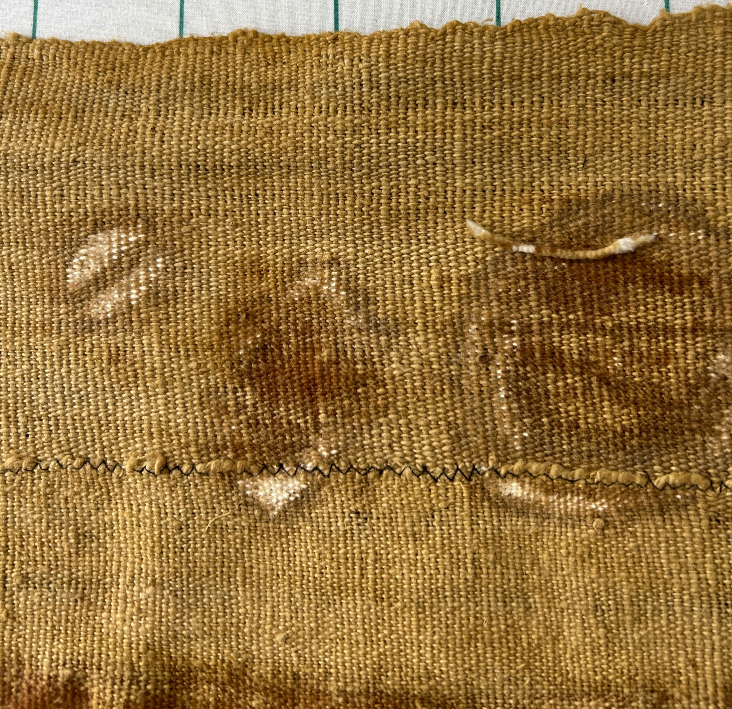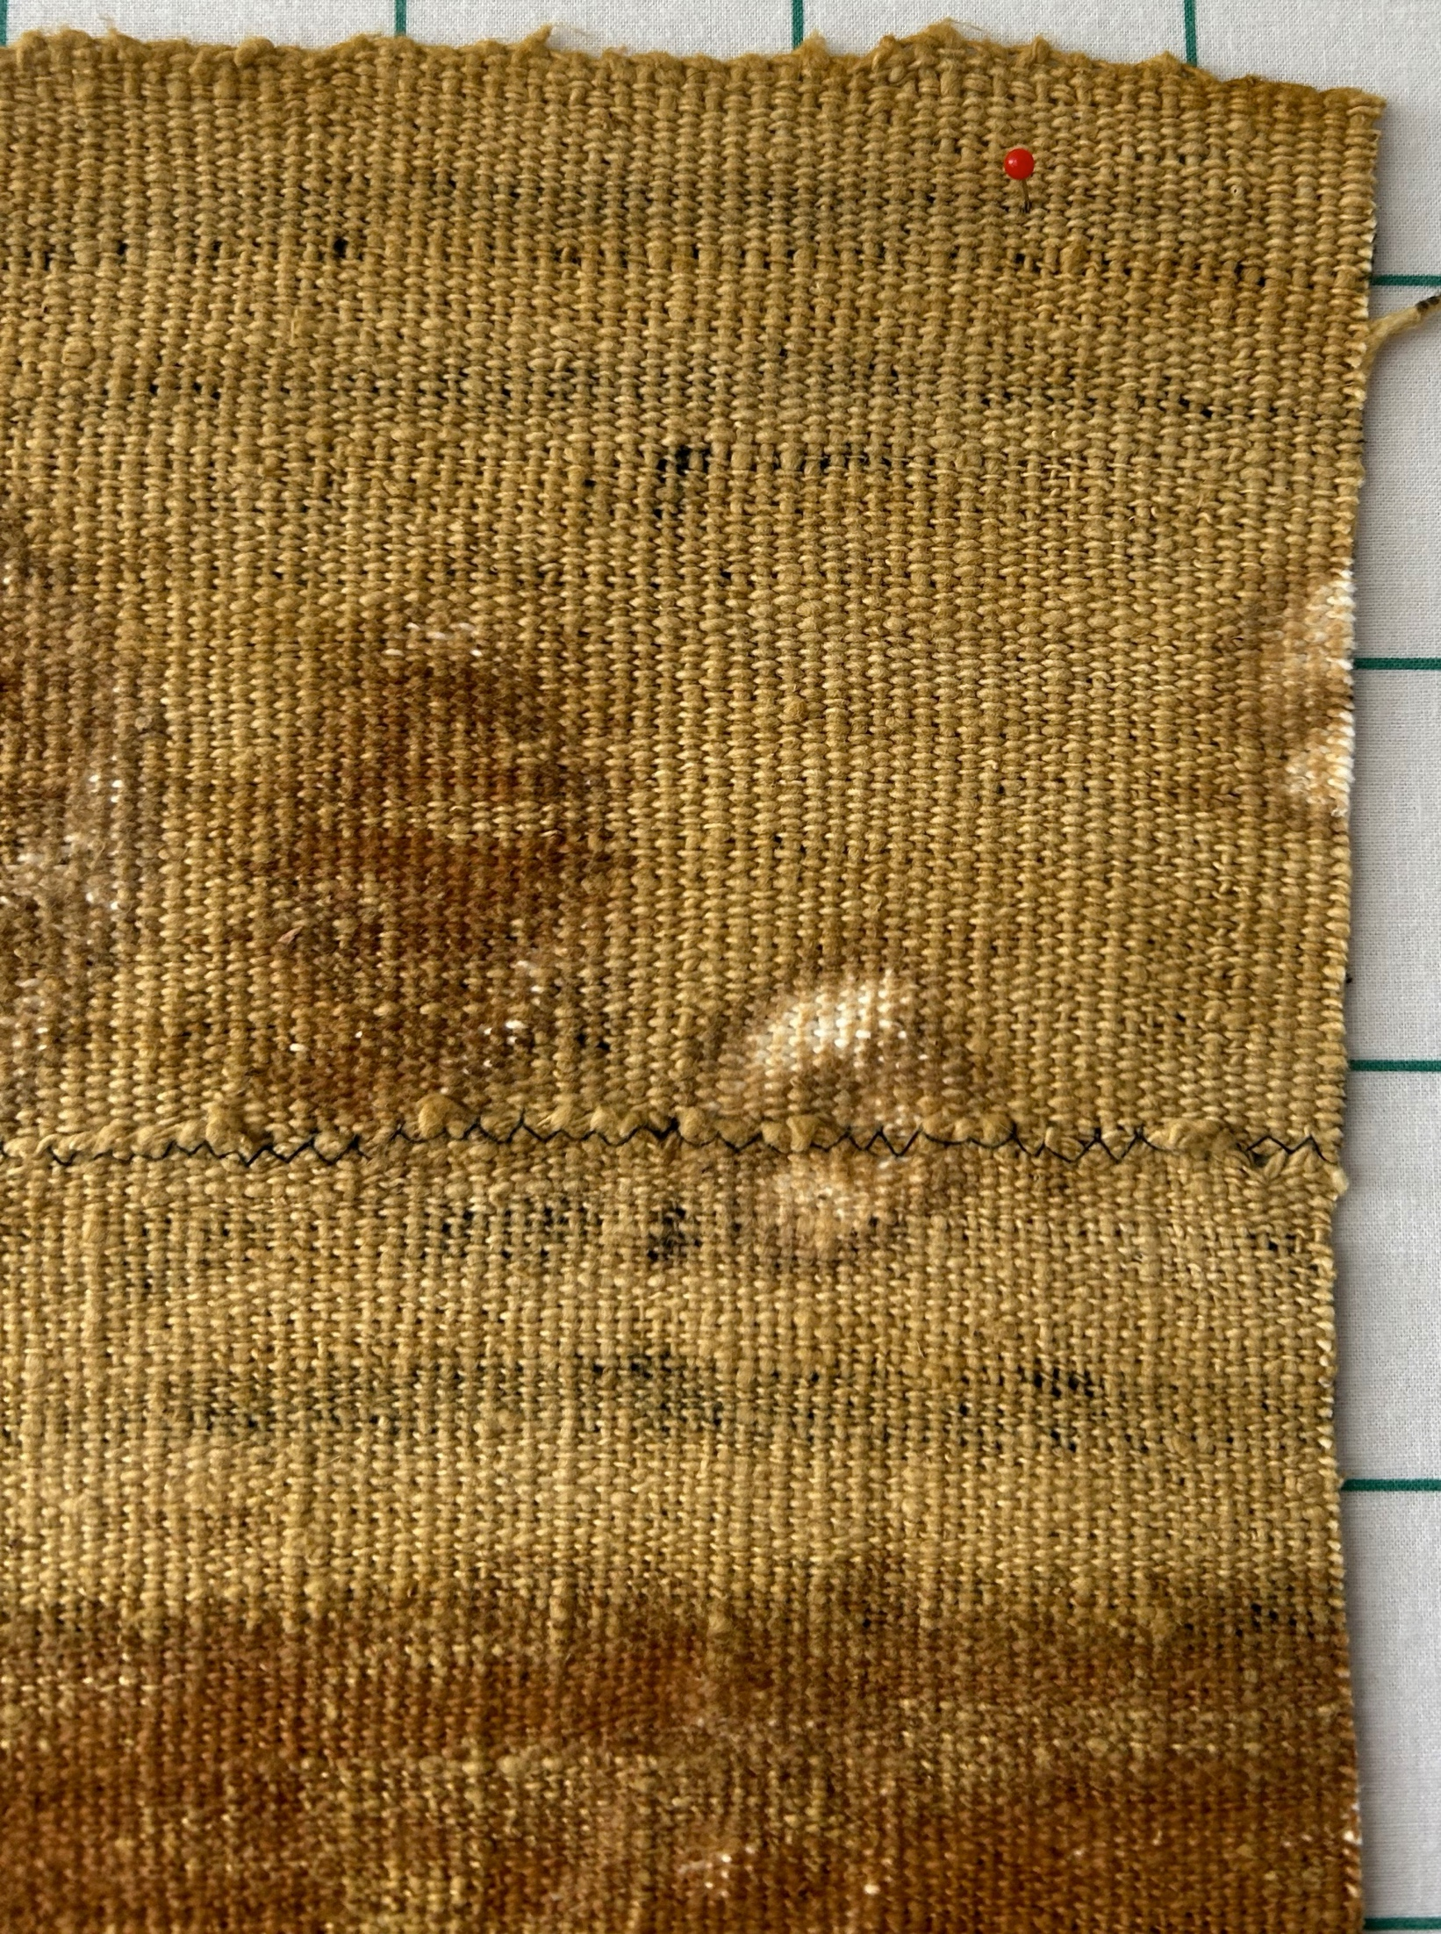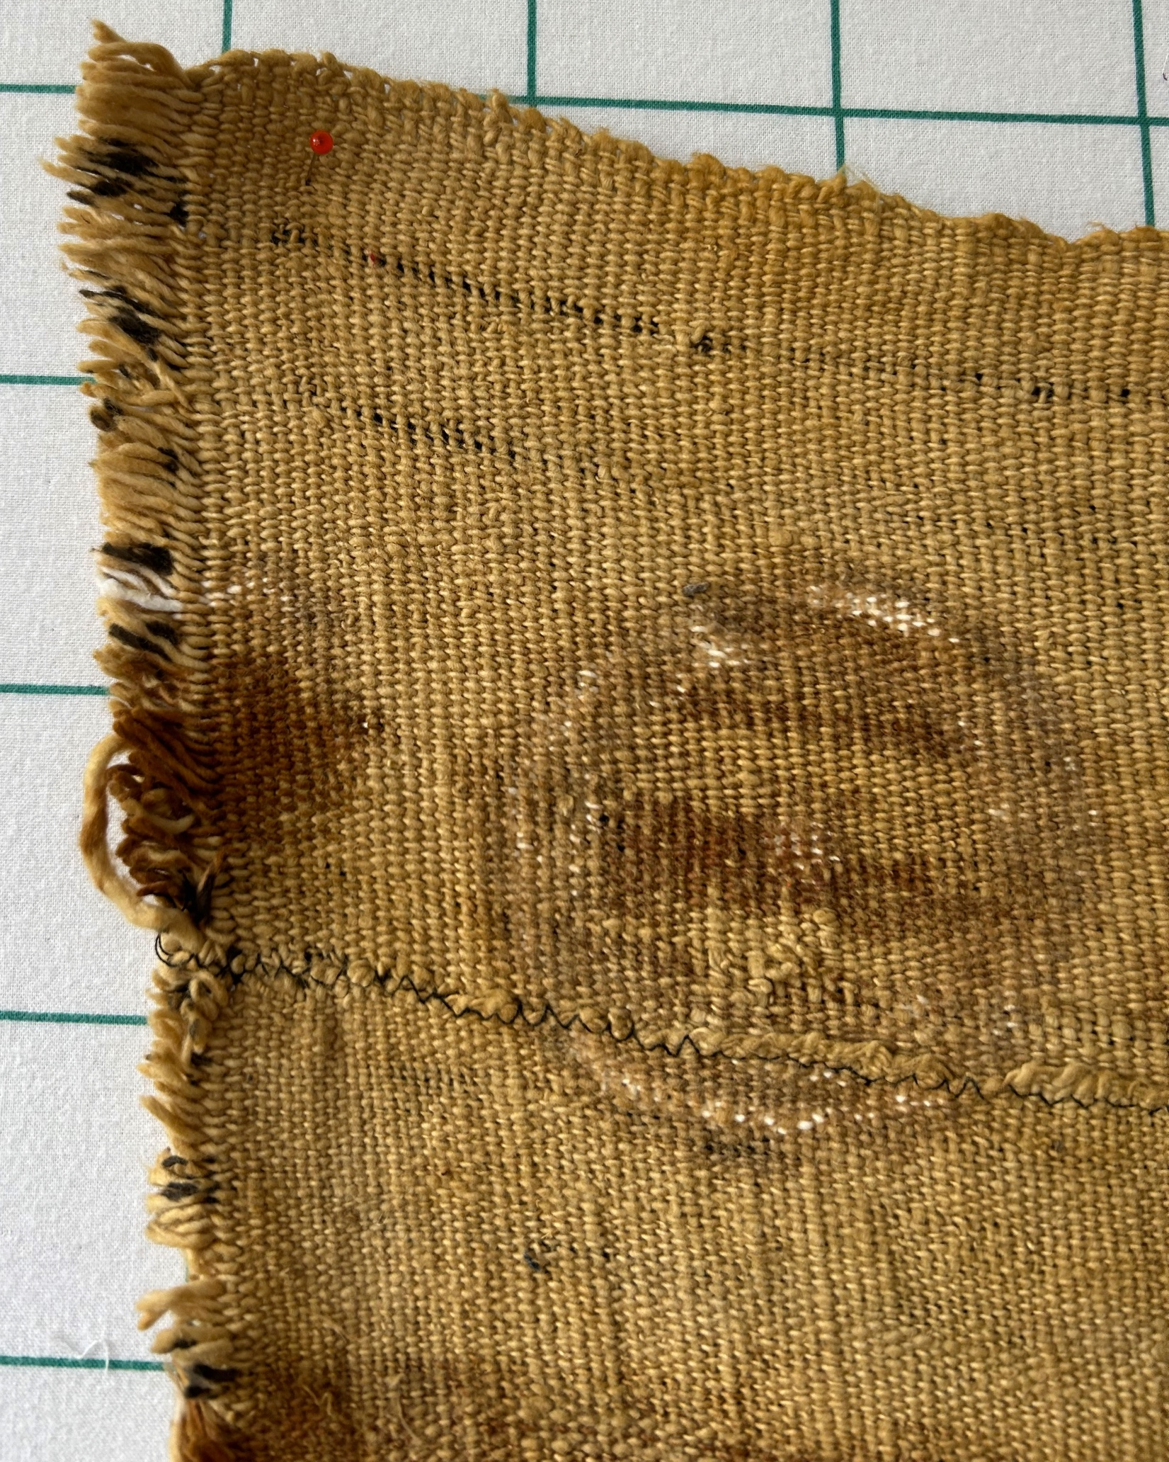

Owner History
Owner | From Date | To Date | Acquired at: | Cost
David Bailey | June 21, 2025 | -- | Sherry Branson  Belvidere, IL | $0
Made in:
--
 | If not purchased, the estimated cost for materials: $0

Display & Publication History
Date | Event | Location / Publication
-- | -- | --

General Description
Quilt Title or Name:  Mud Cloth | Fabric Date Range: 2000 ± 10 Years  Date Made: -- ± 0 Years  Method of Determination:
Item Type:  Items in Set: 1 | Size: Length: 47“ x Width: 28“
Appraisals:  Has this quilt been professionally appraised?  If so, when: --  ----------- | Other related files:  Scanned Patterns  Images  EQ 8 Files  Research Notes
Additional Information: -Notes on label reads:
Mali (W. Aftrican Mudd Cloth - first they weave the strips and then sew them together, then paint it with resist and then dye it repeatedly -. Chris Moline feels that this cloth was commercially made.

