Documentation Form

Overview

Images
Top | Back
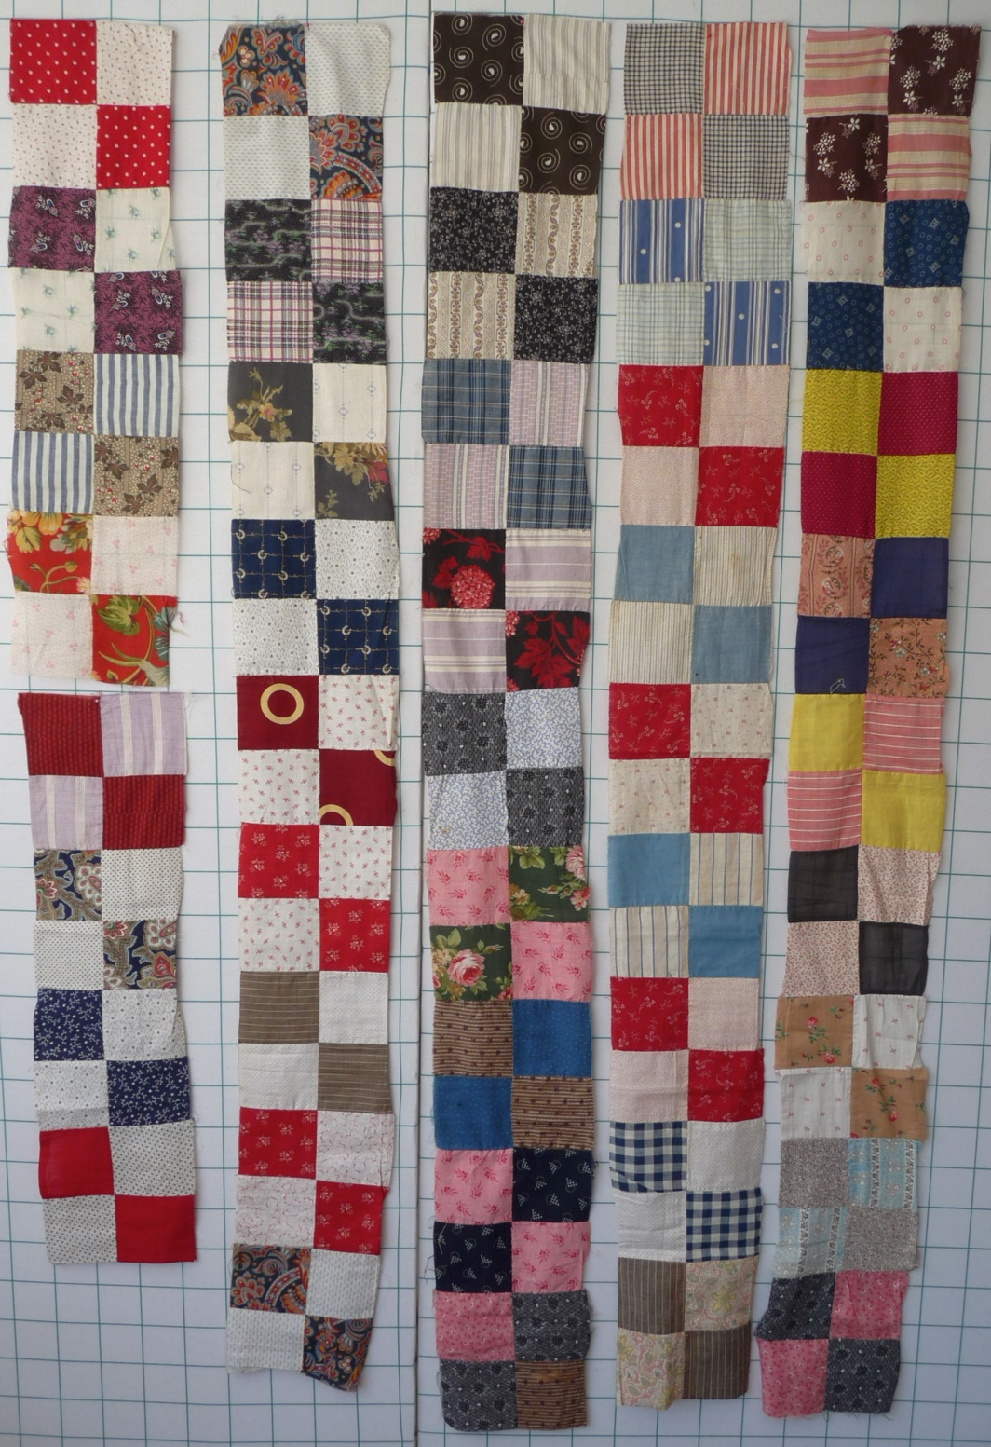
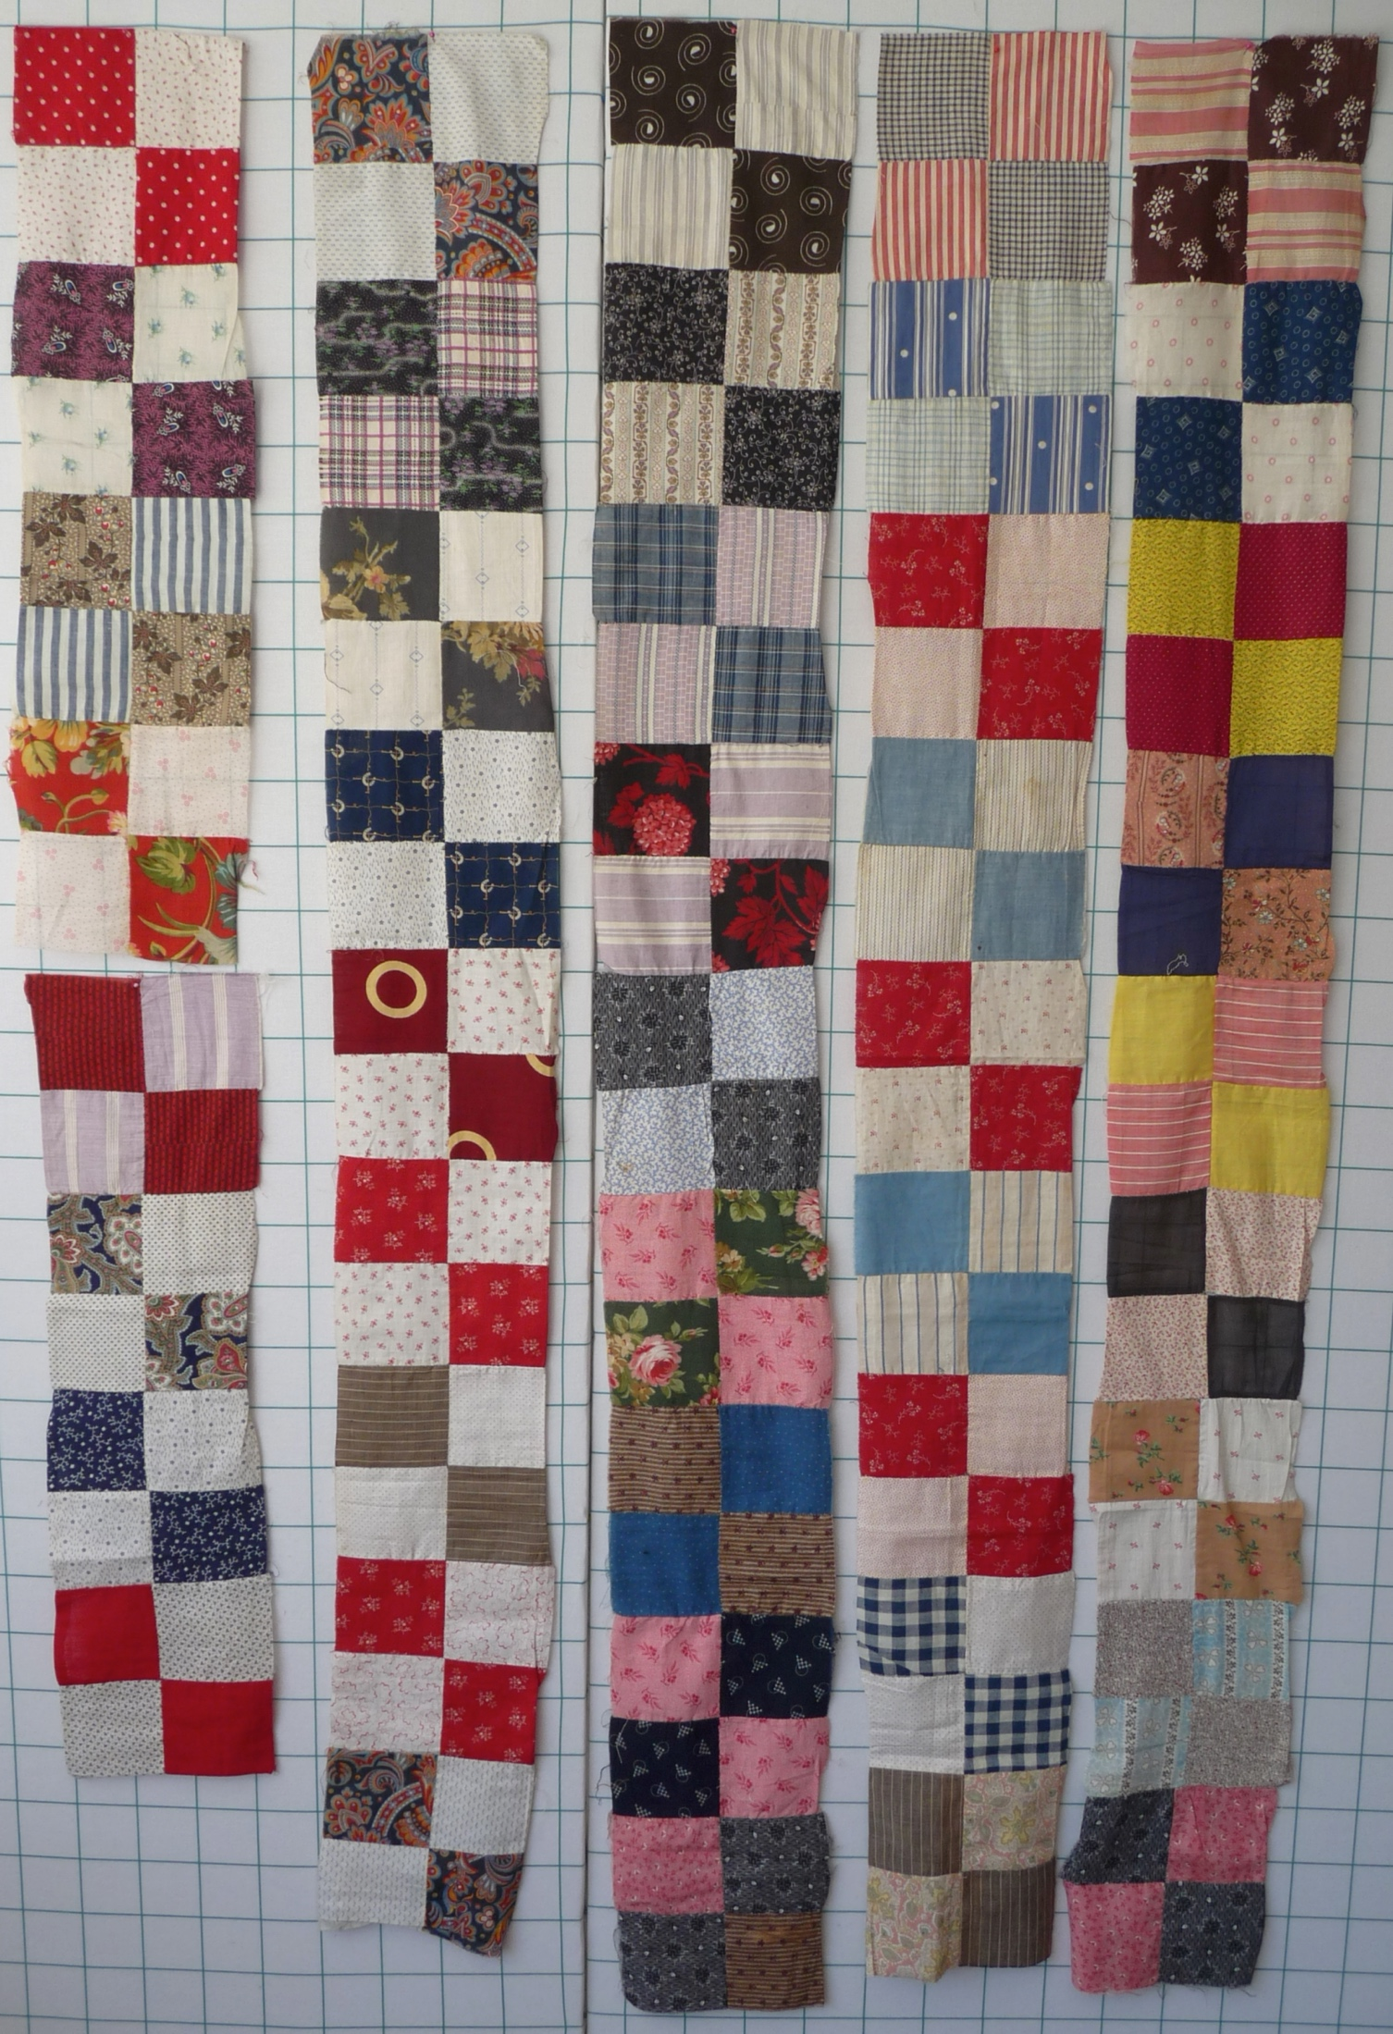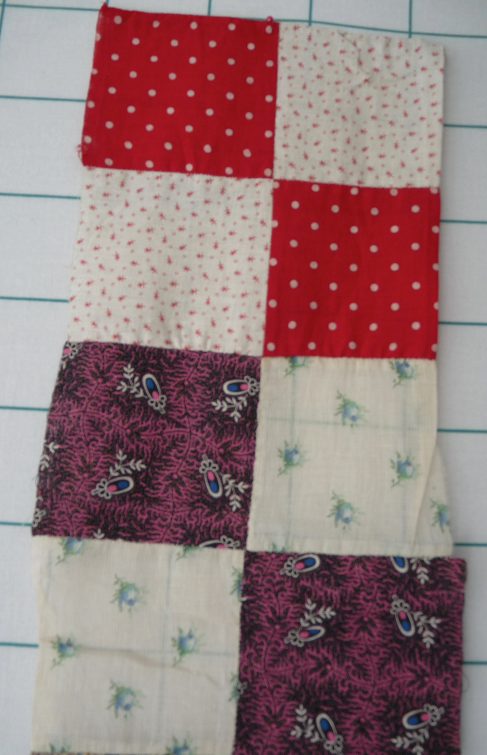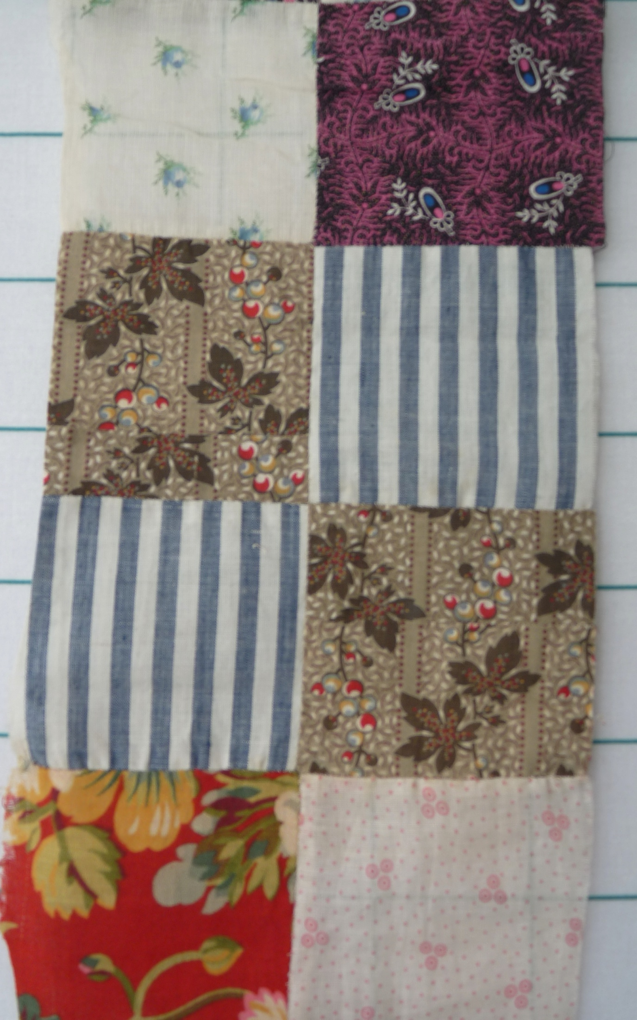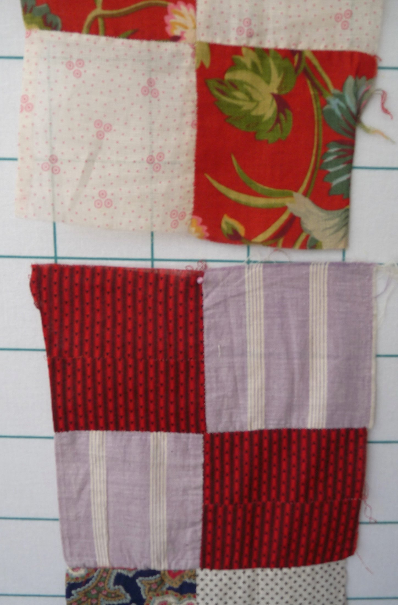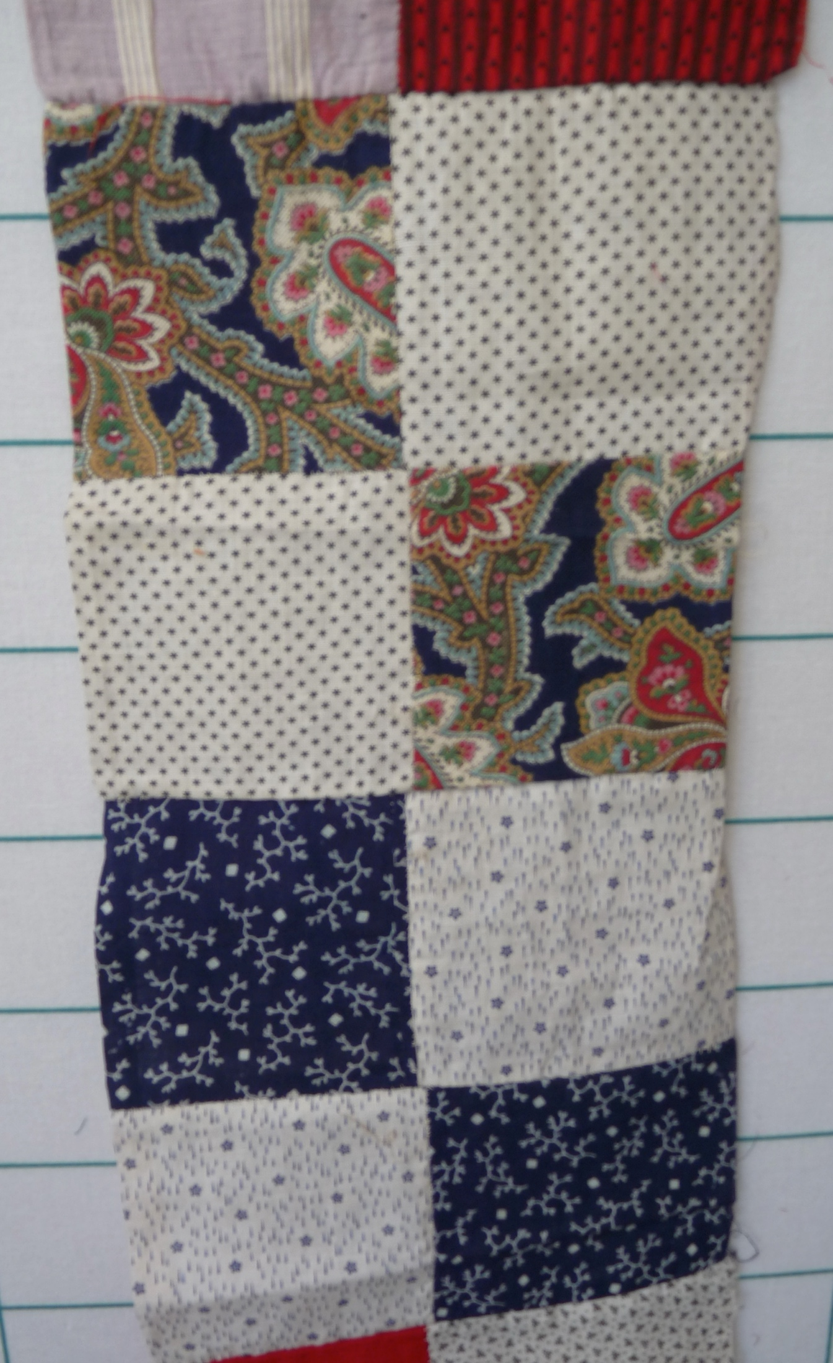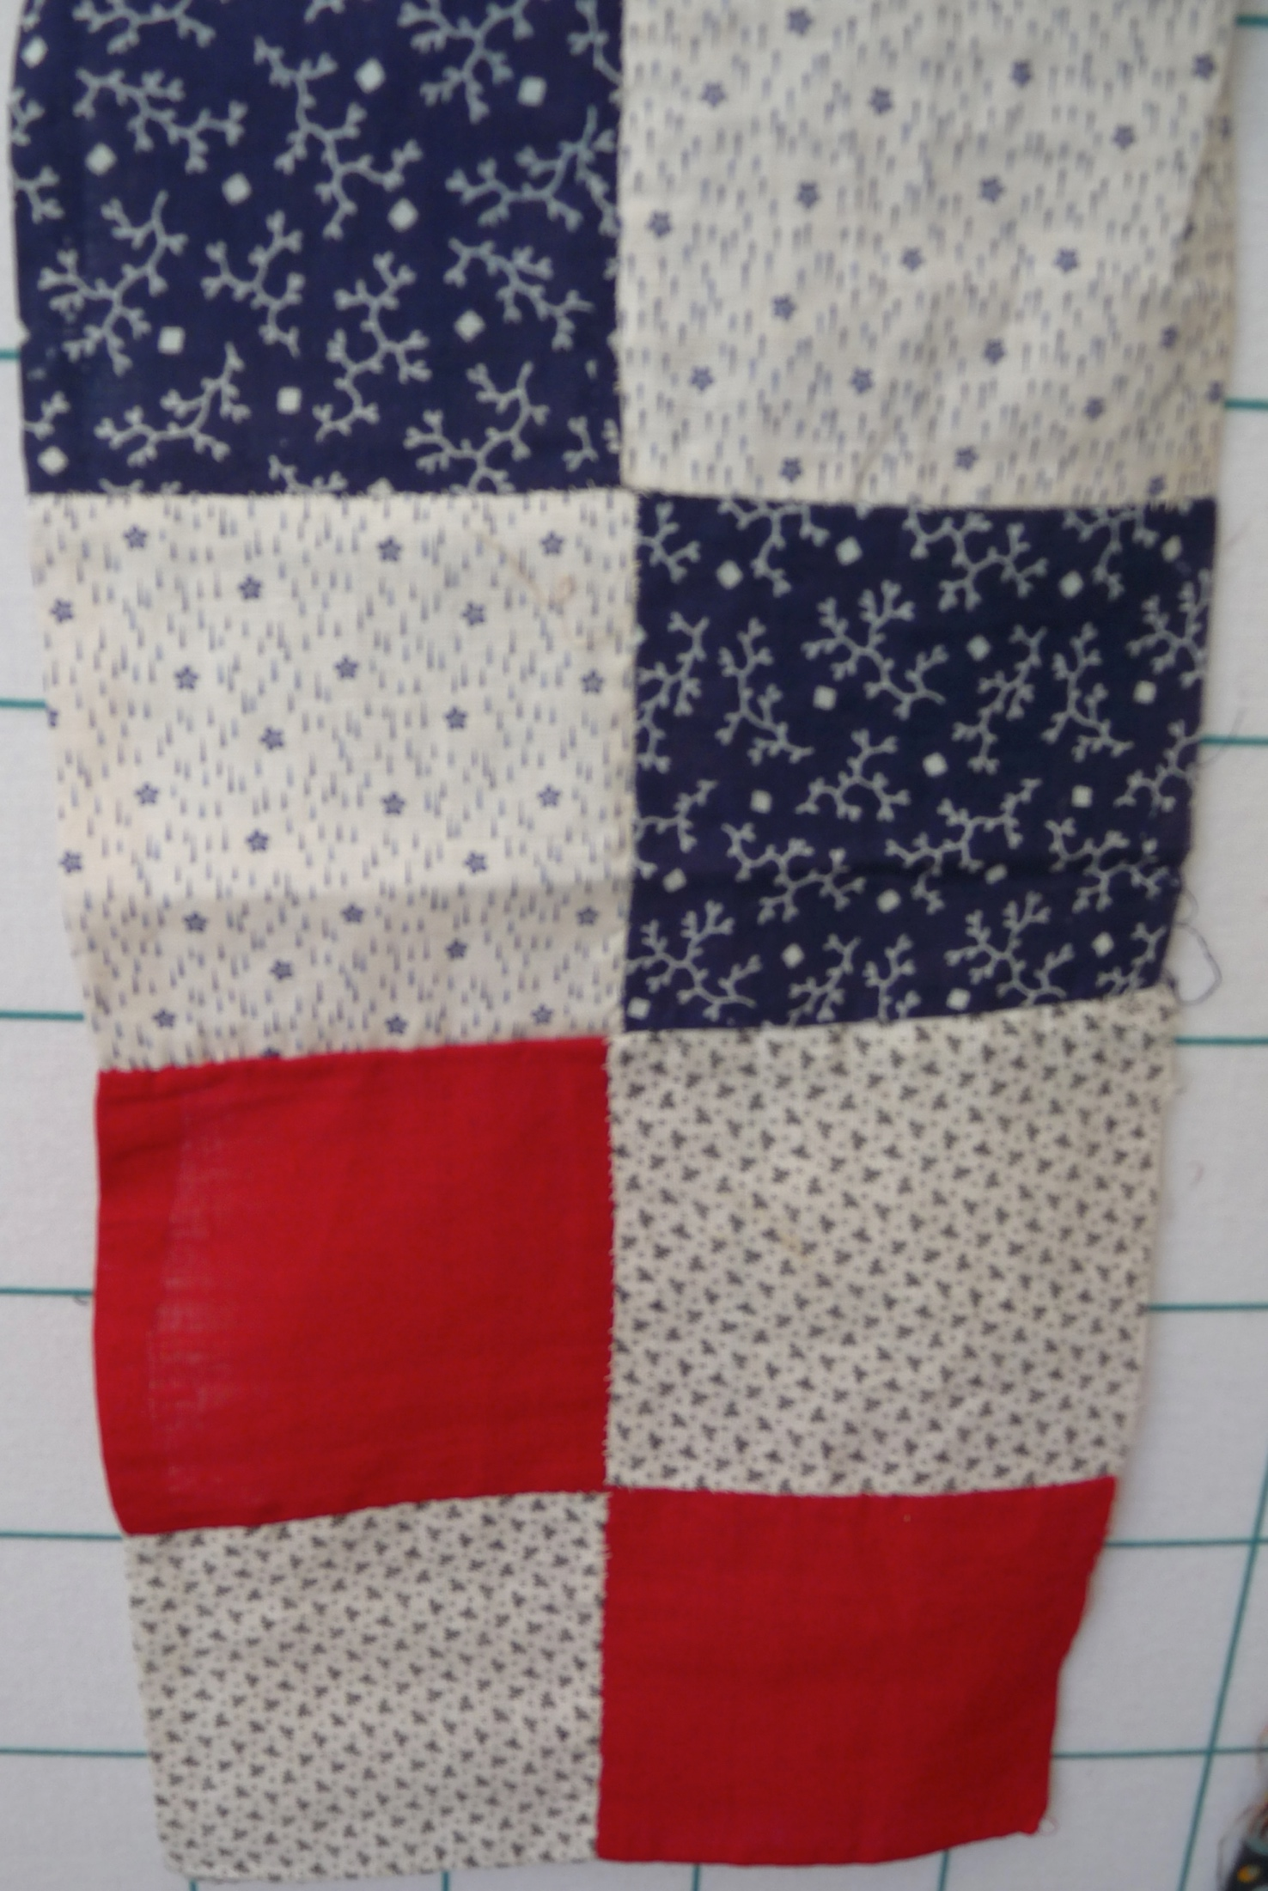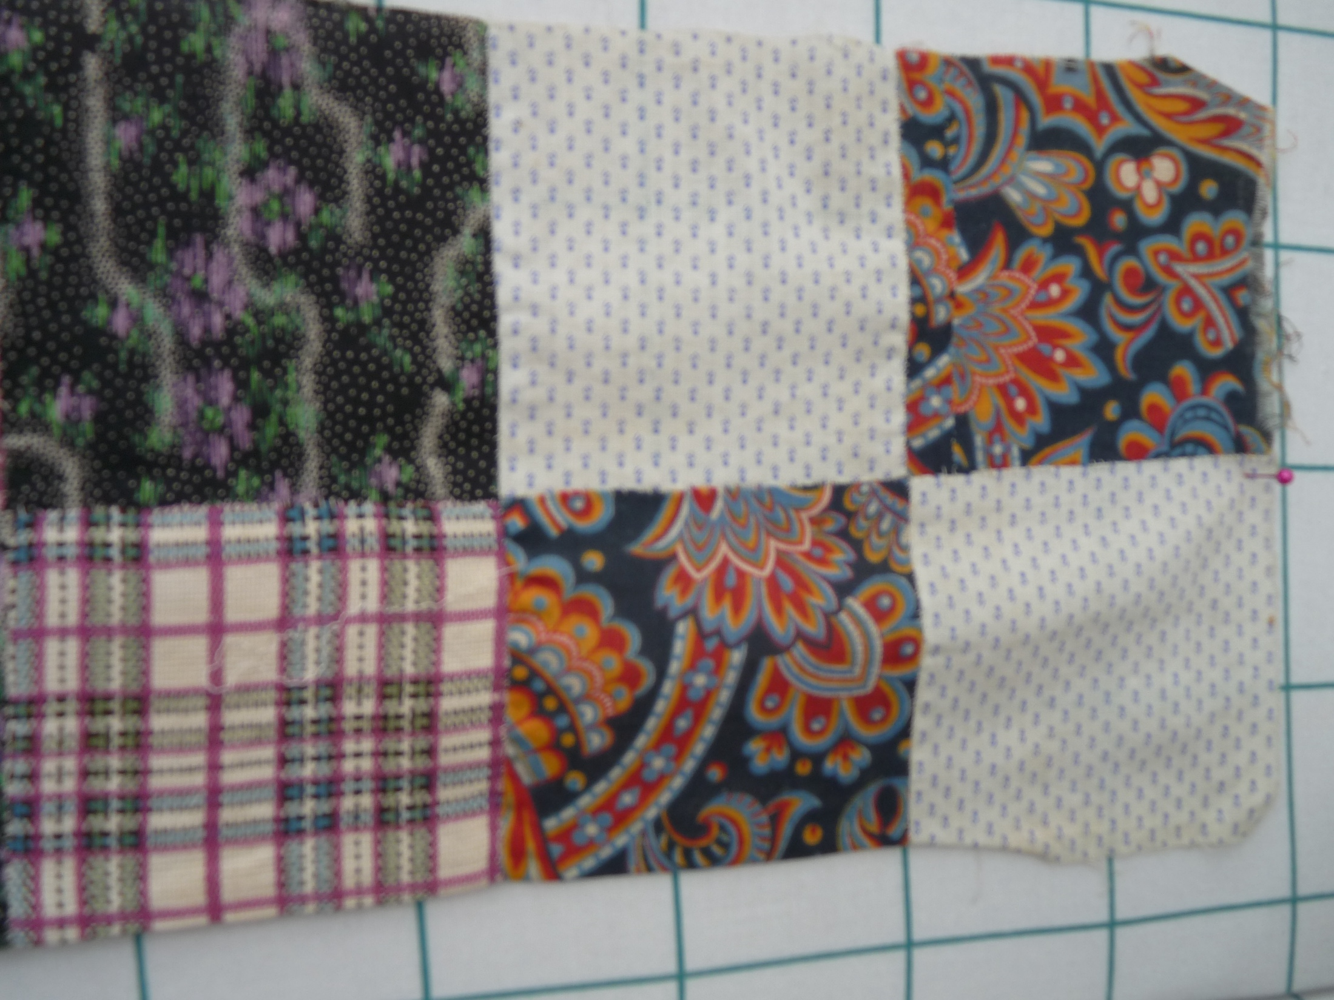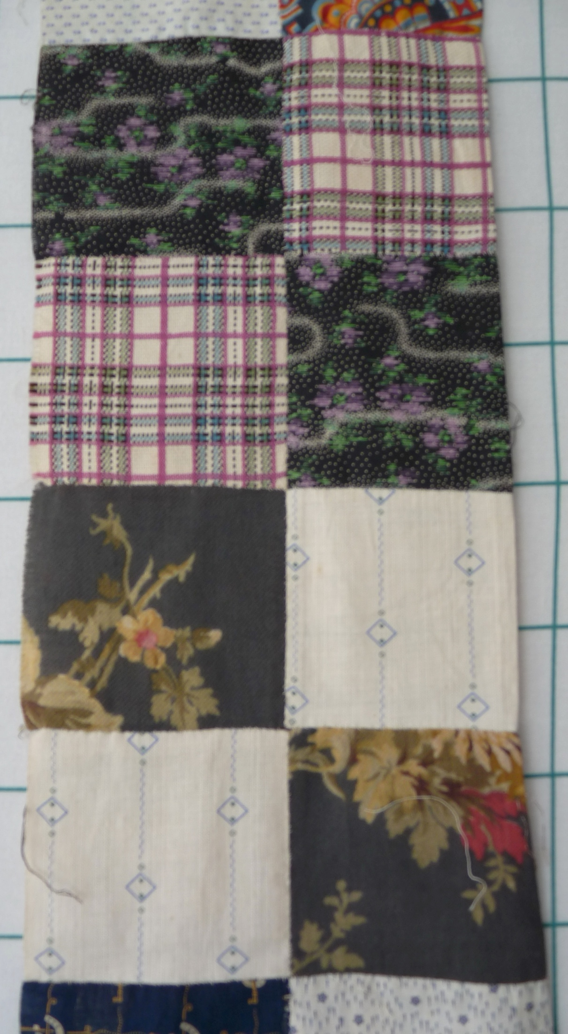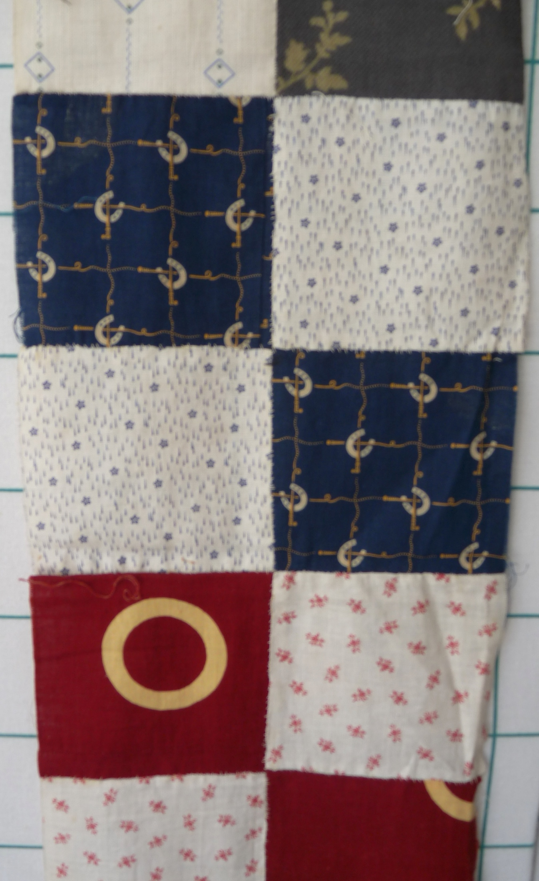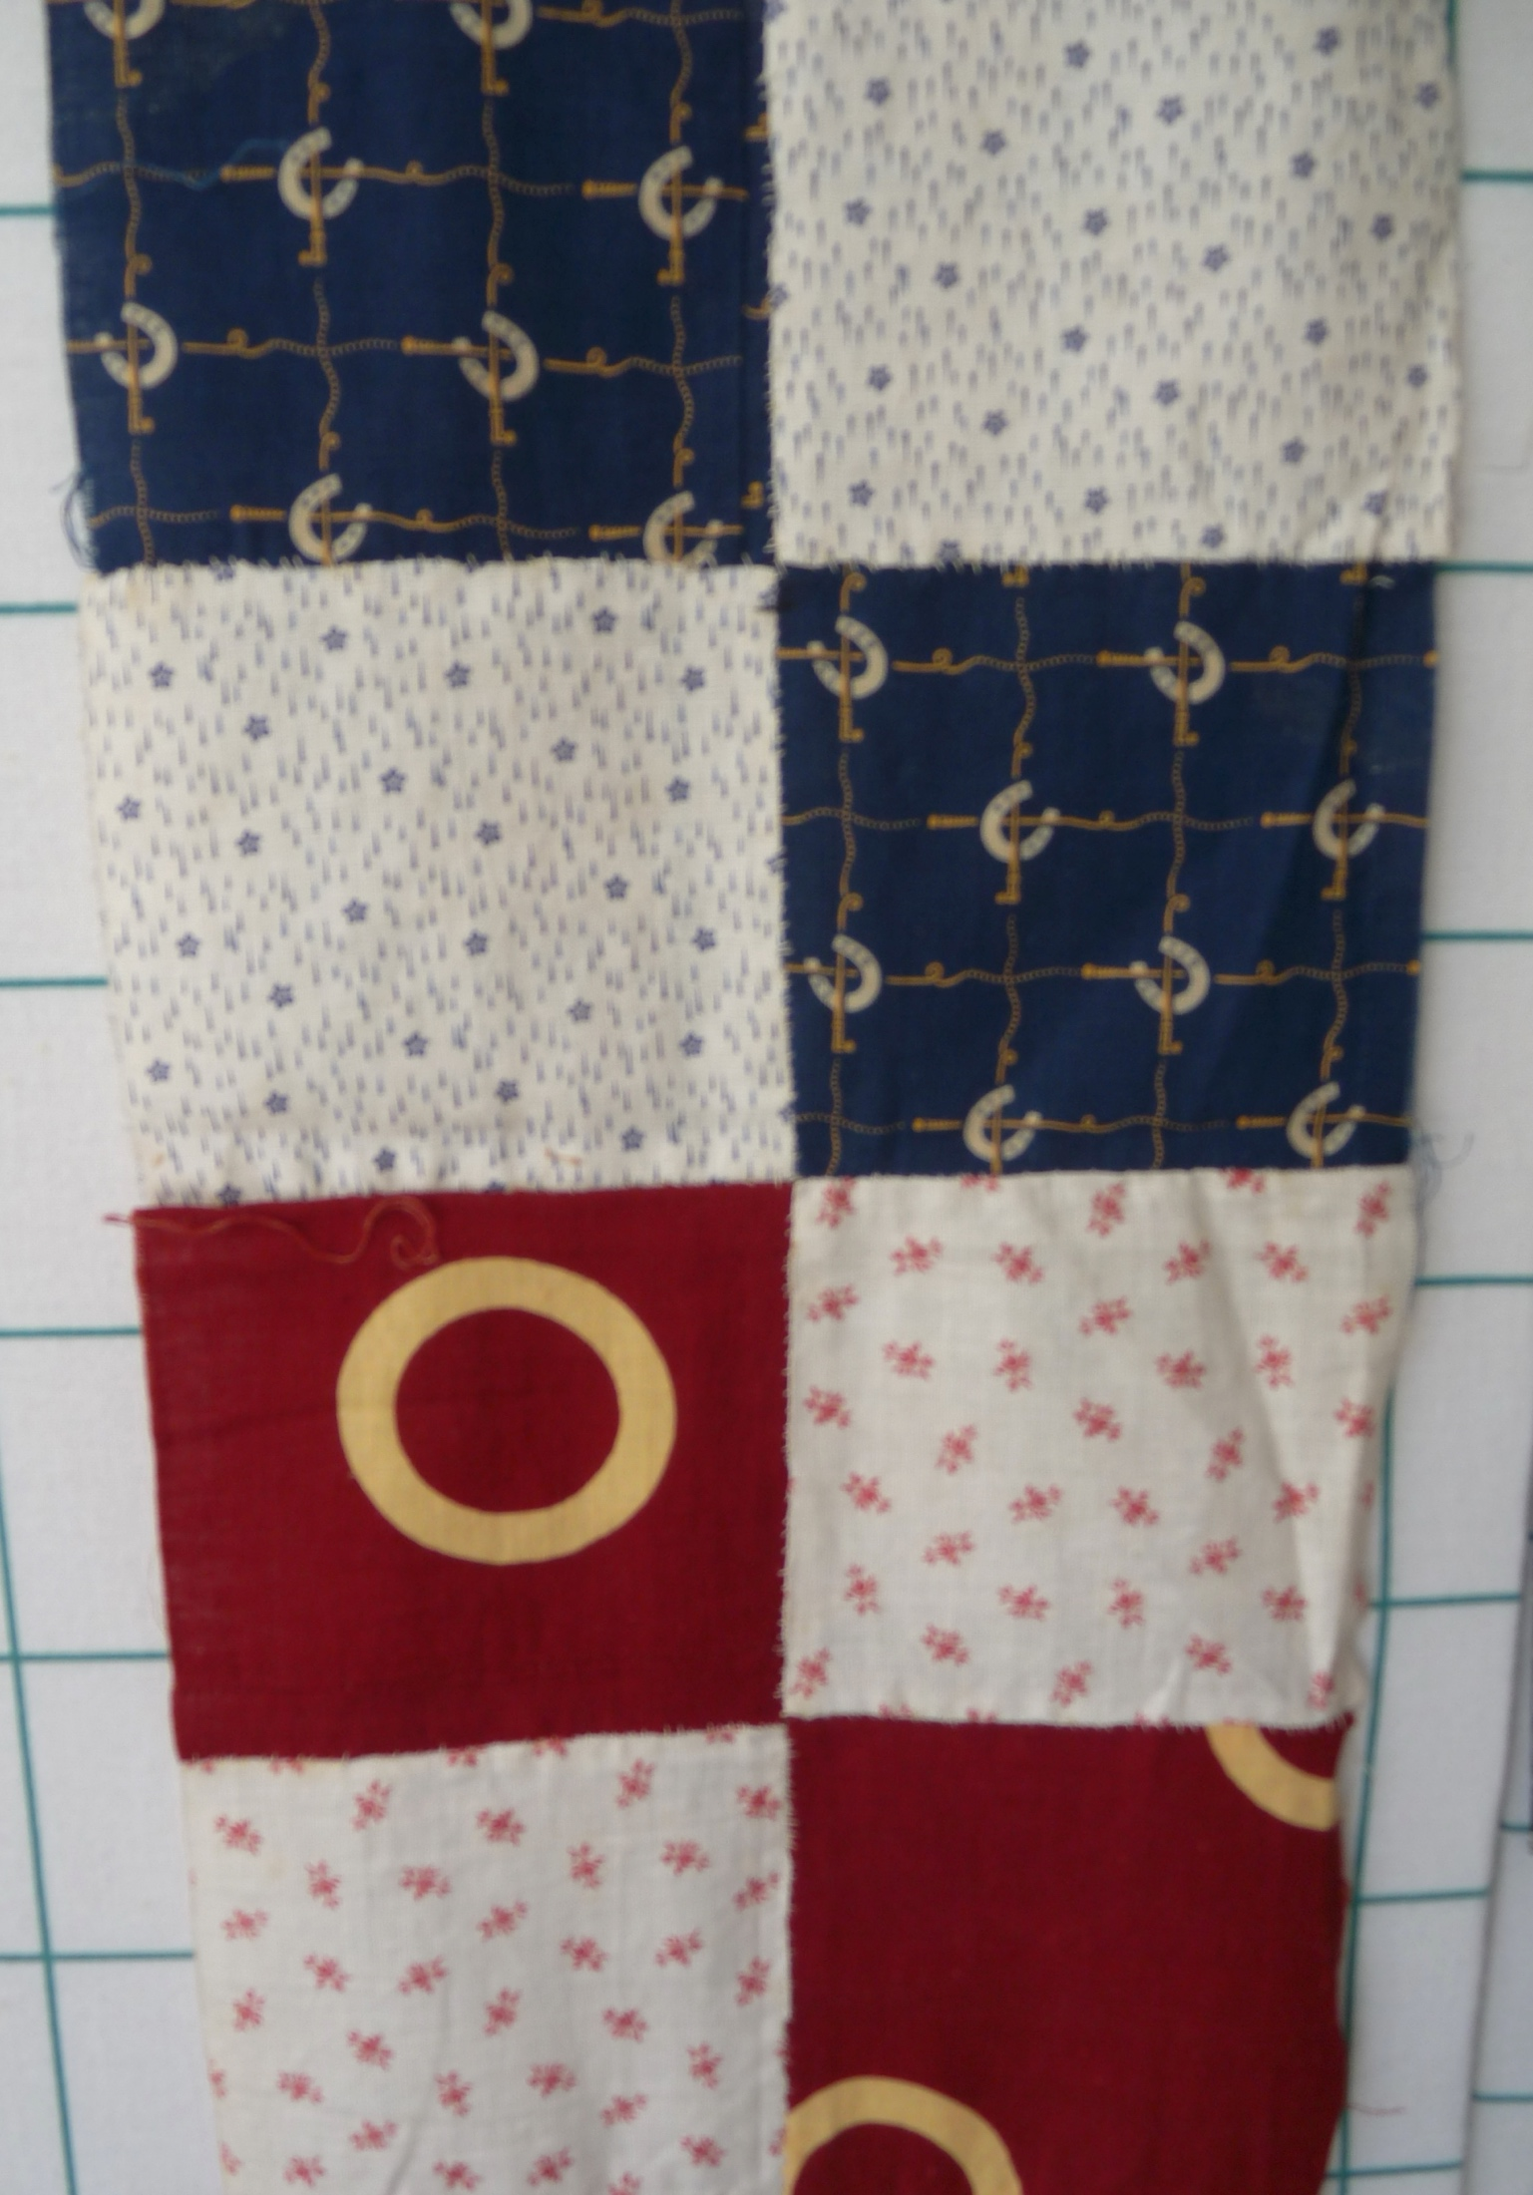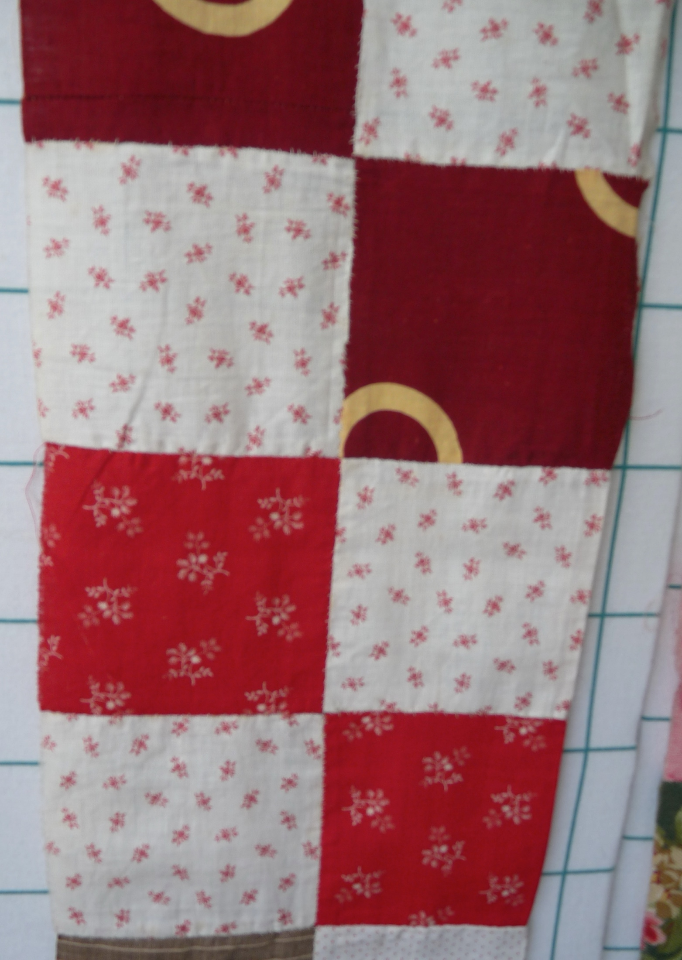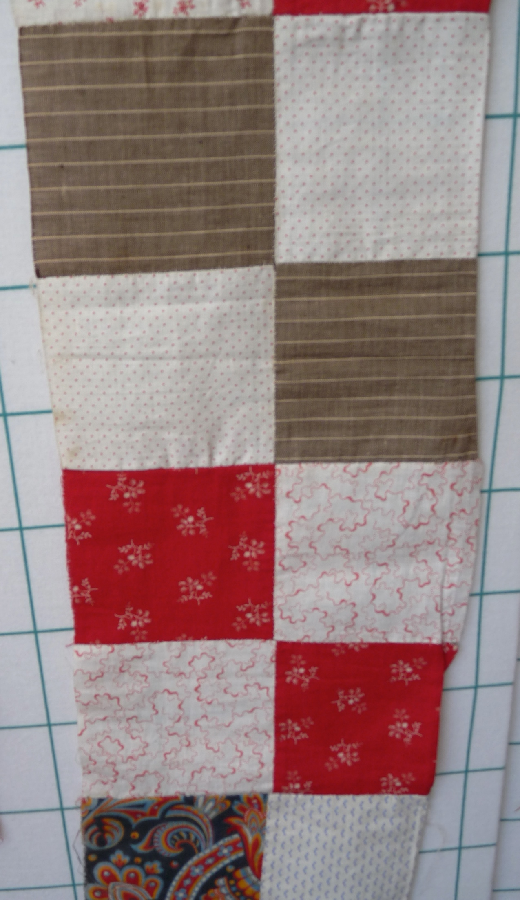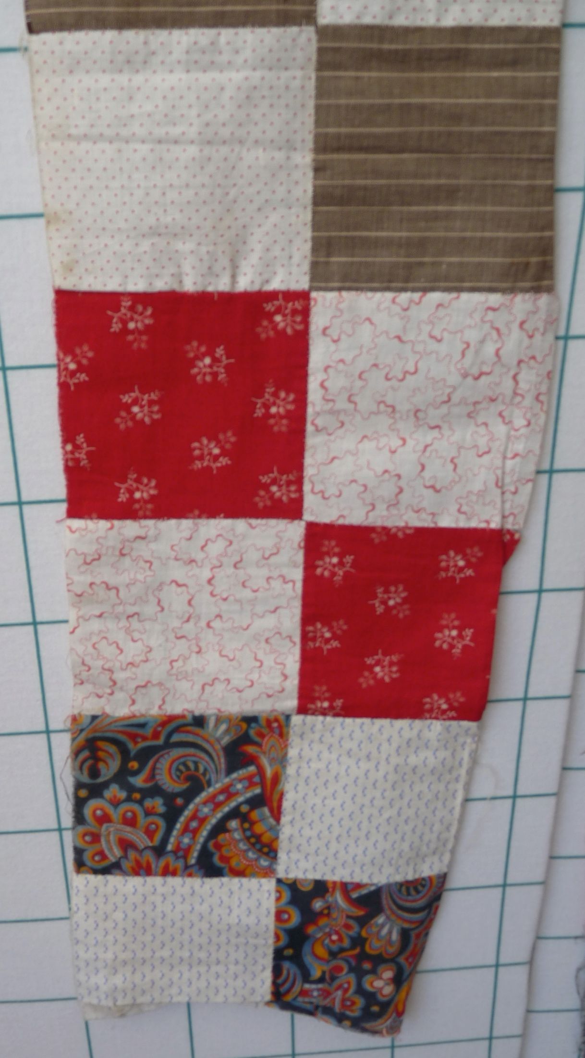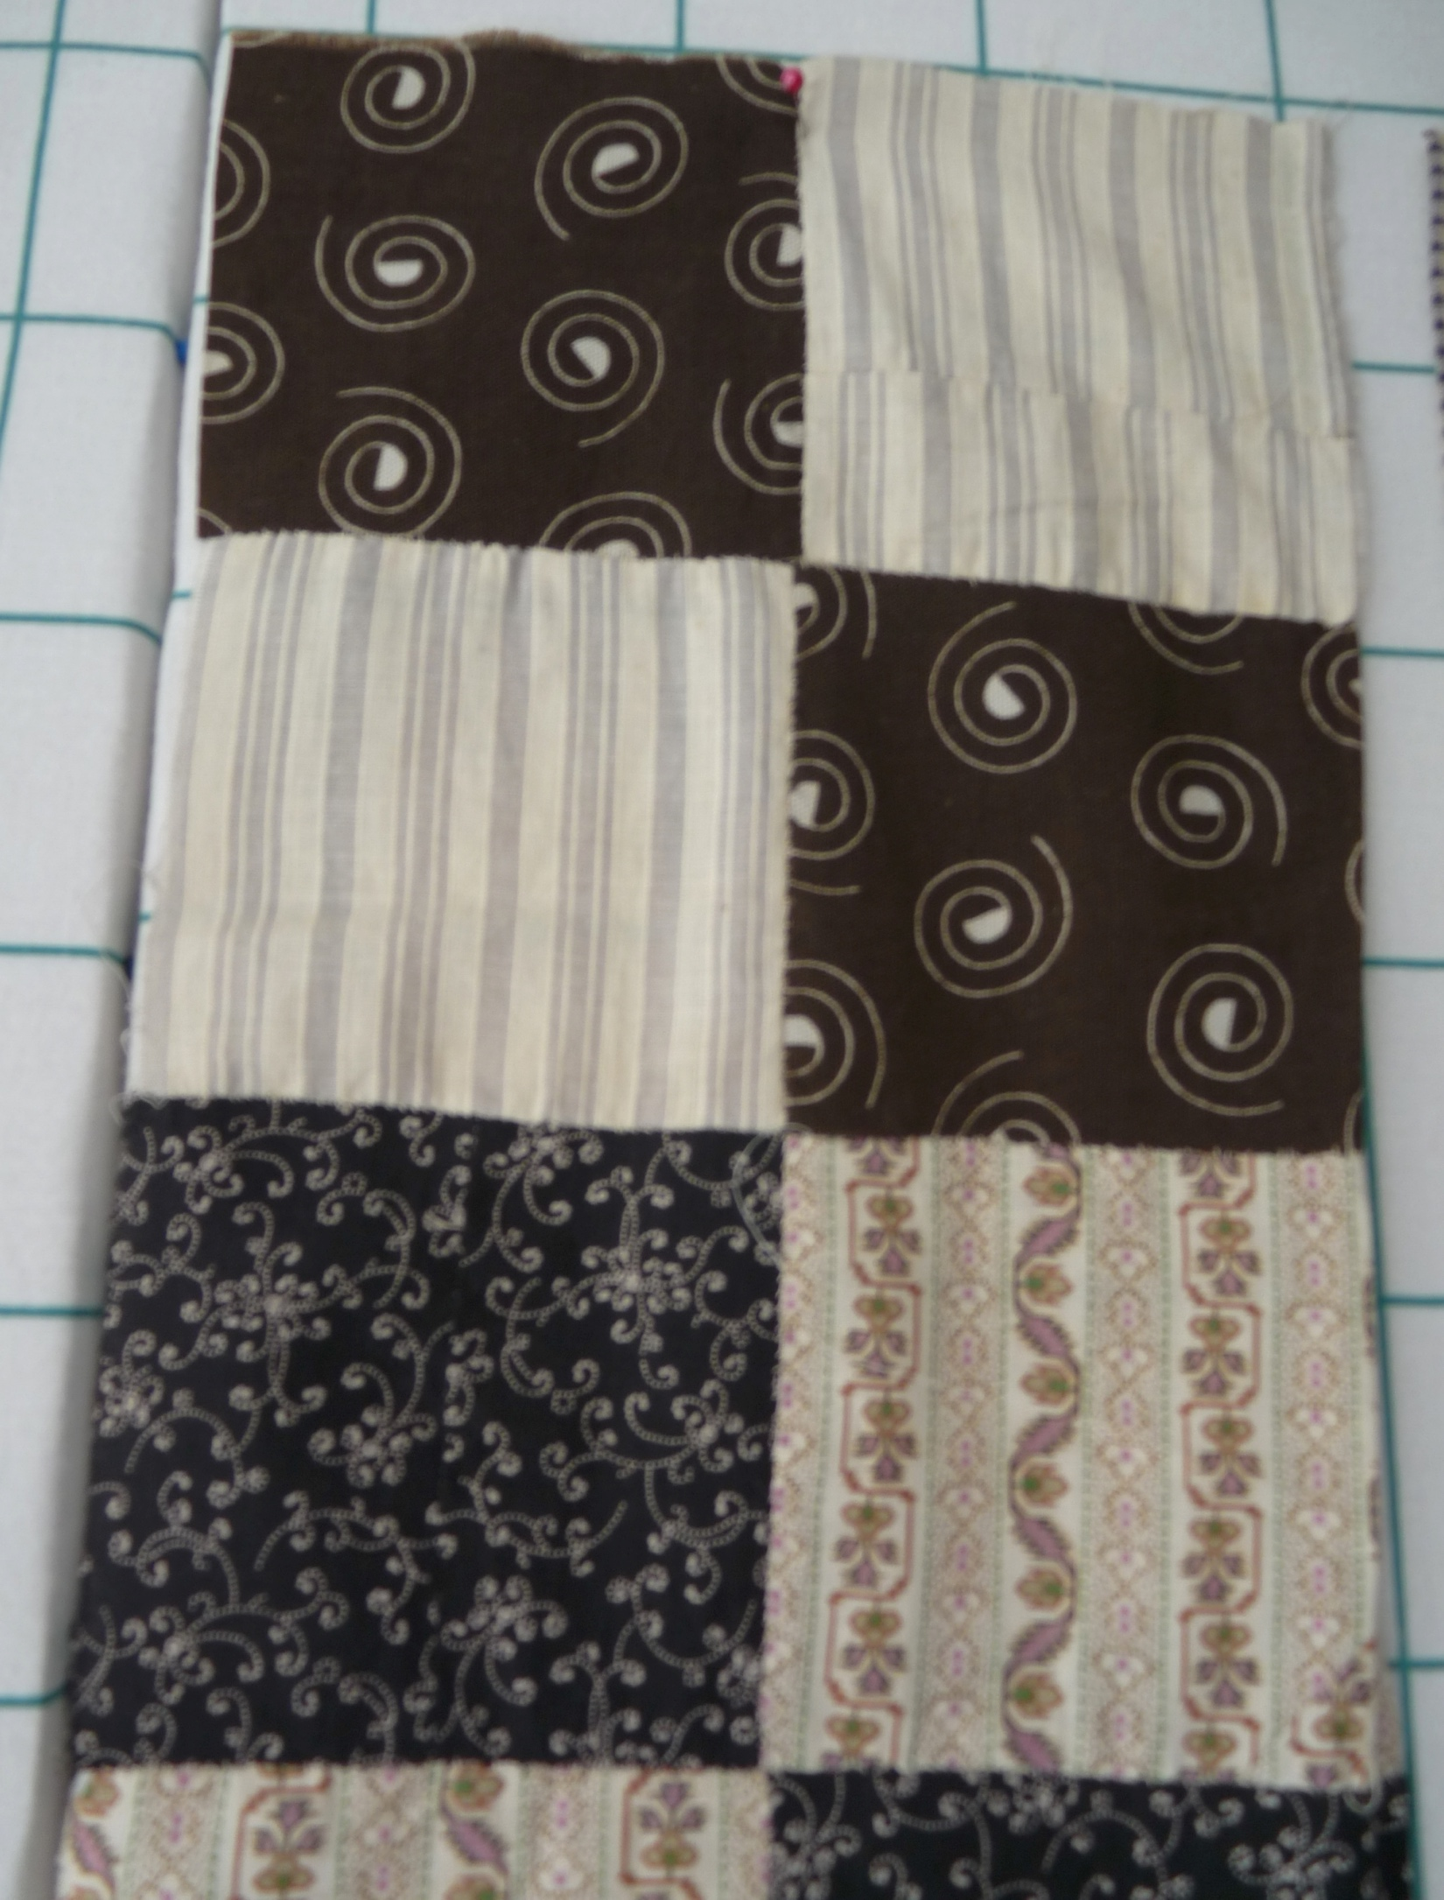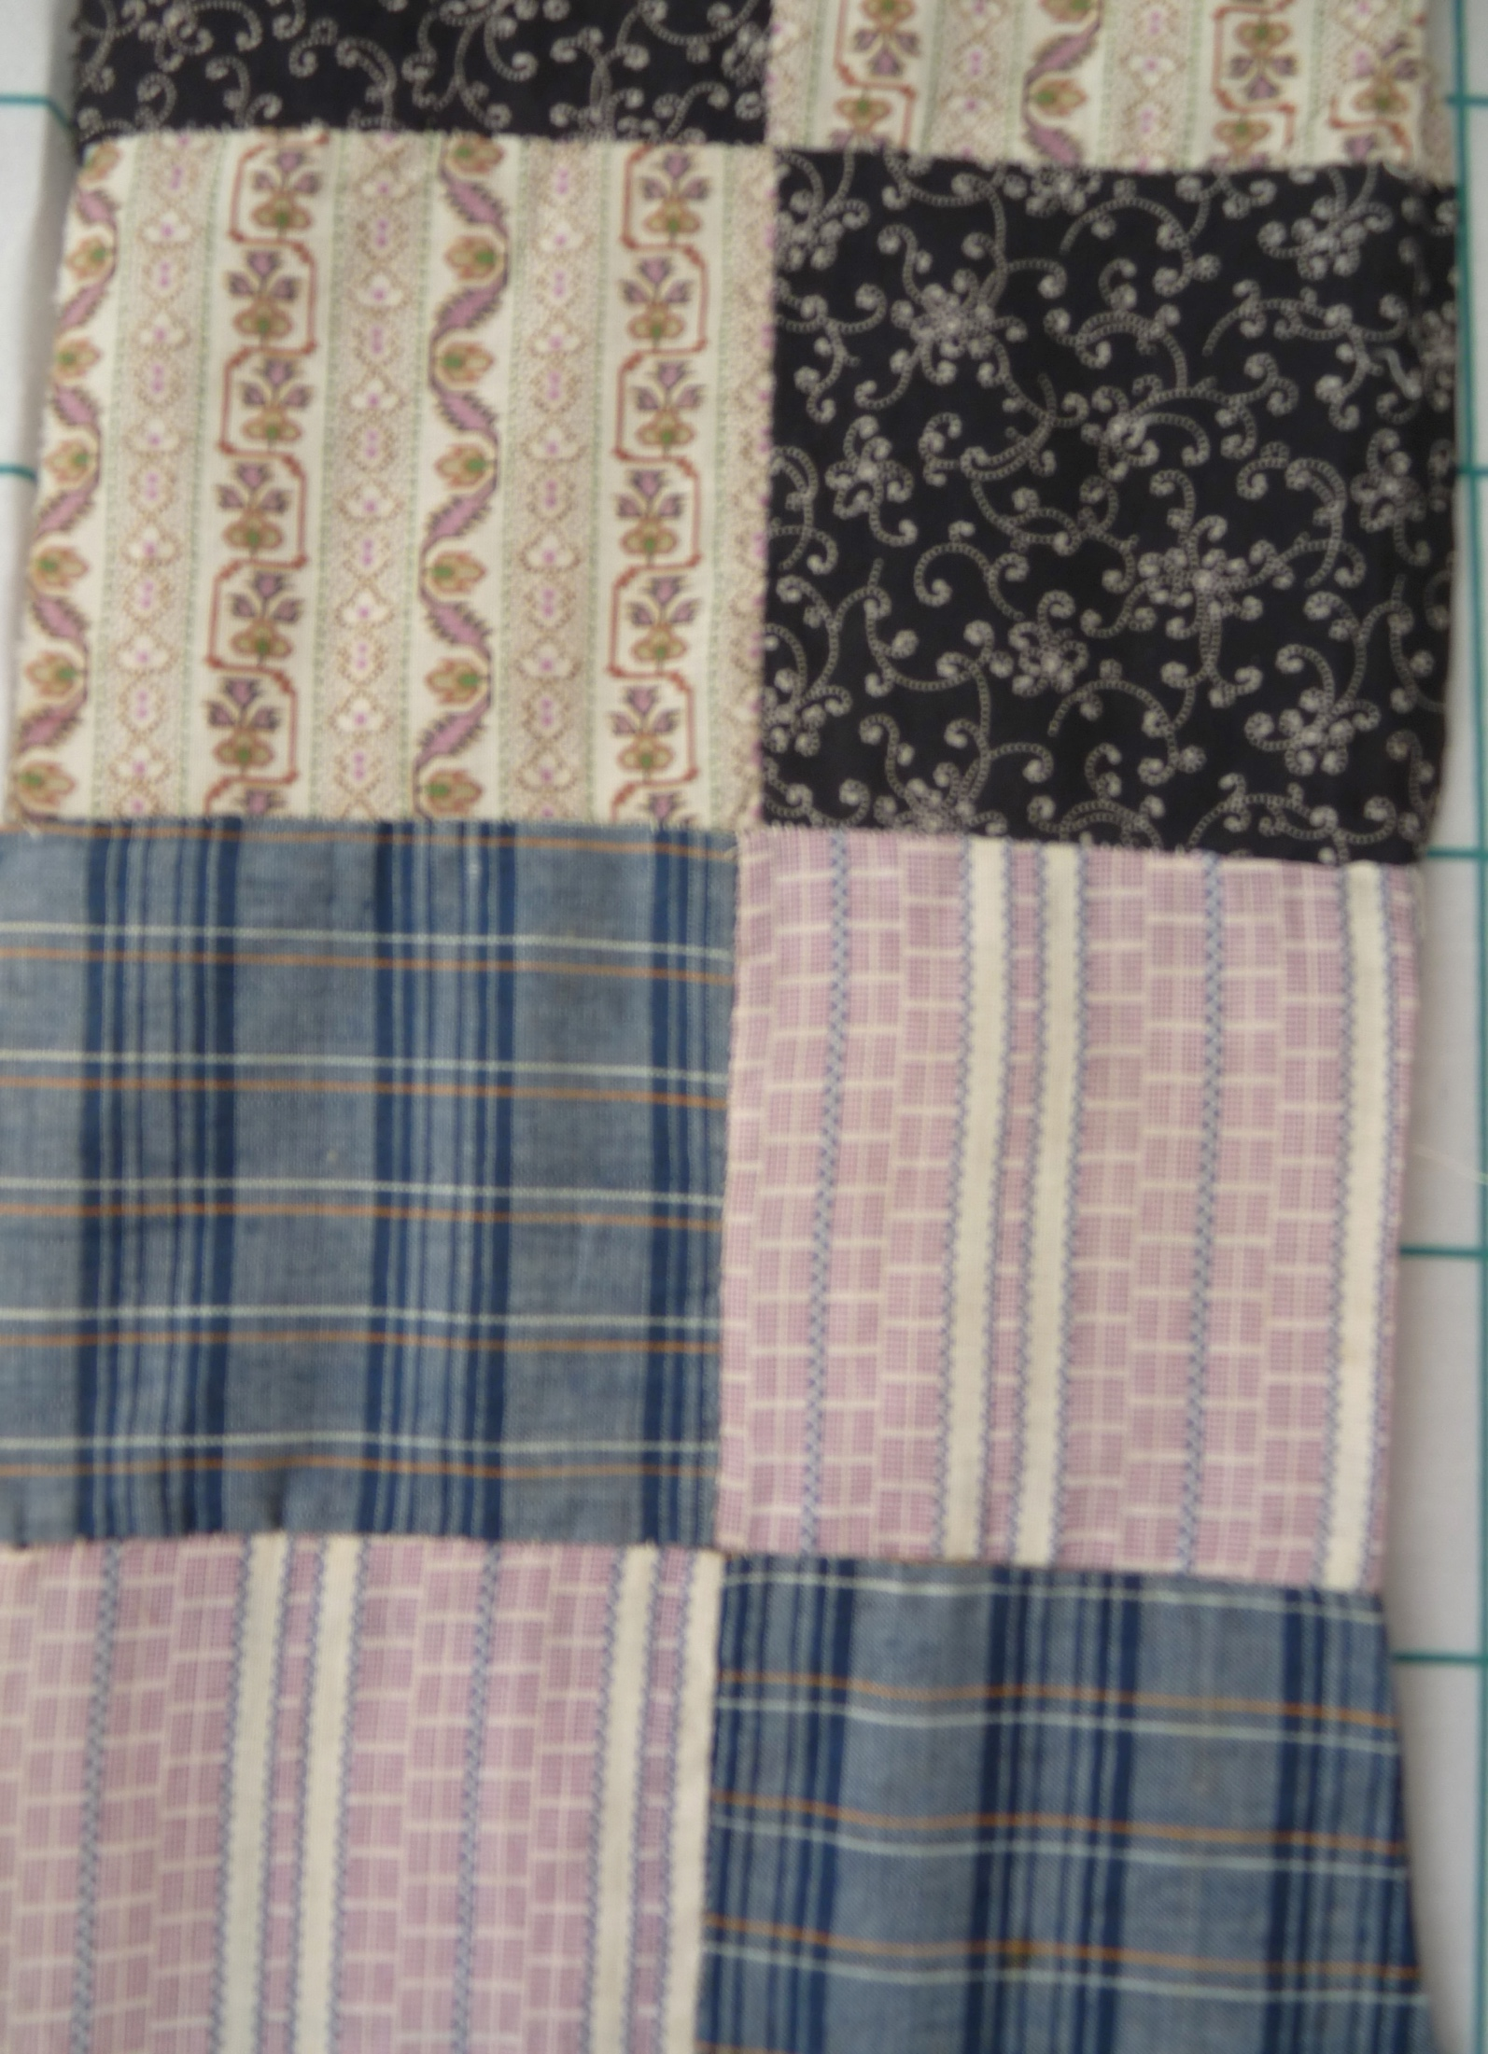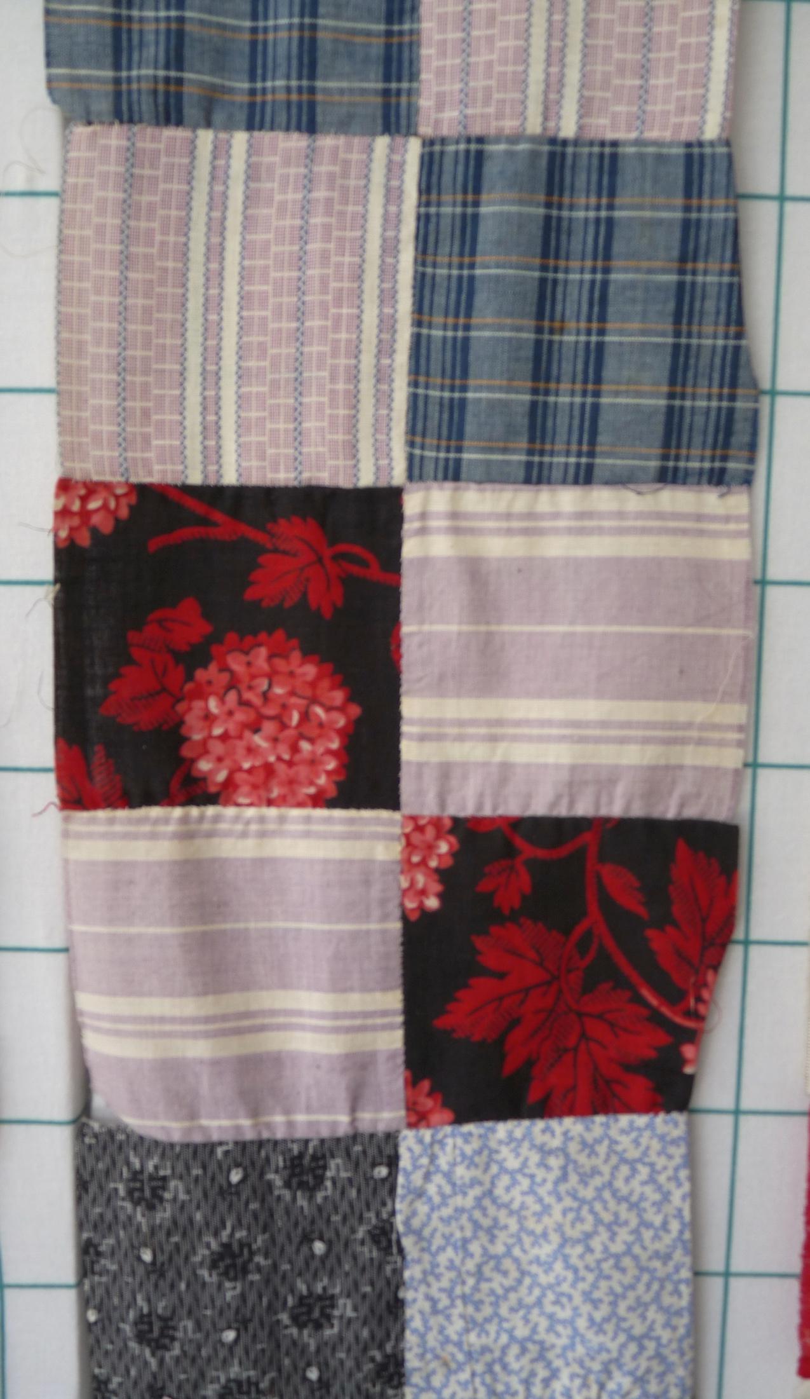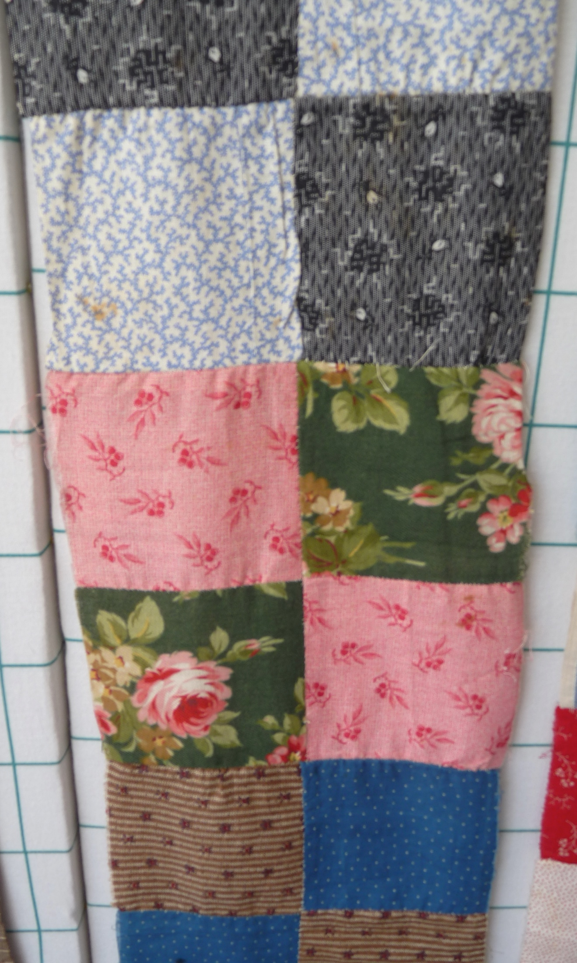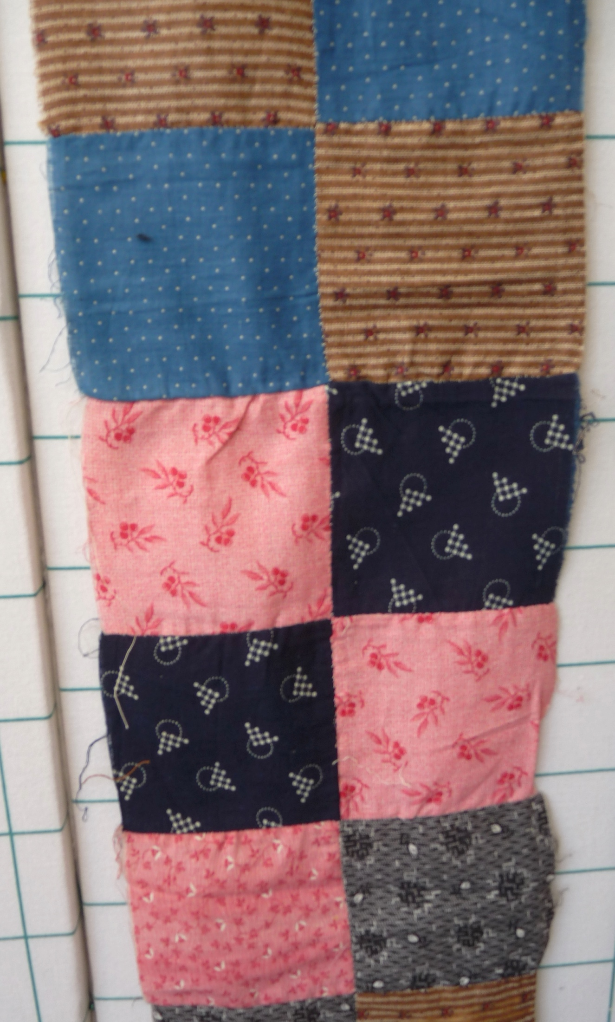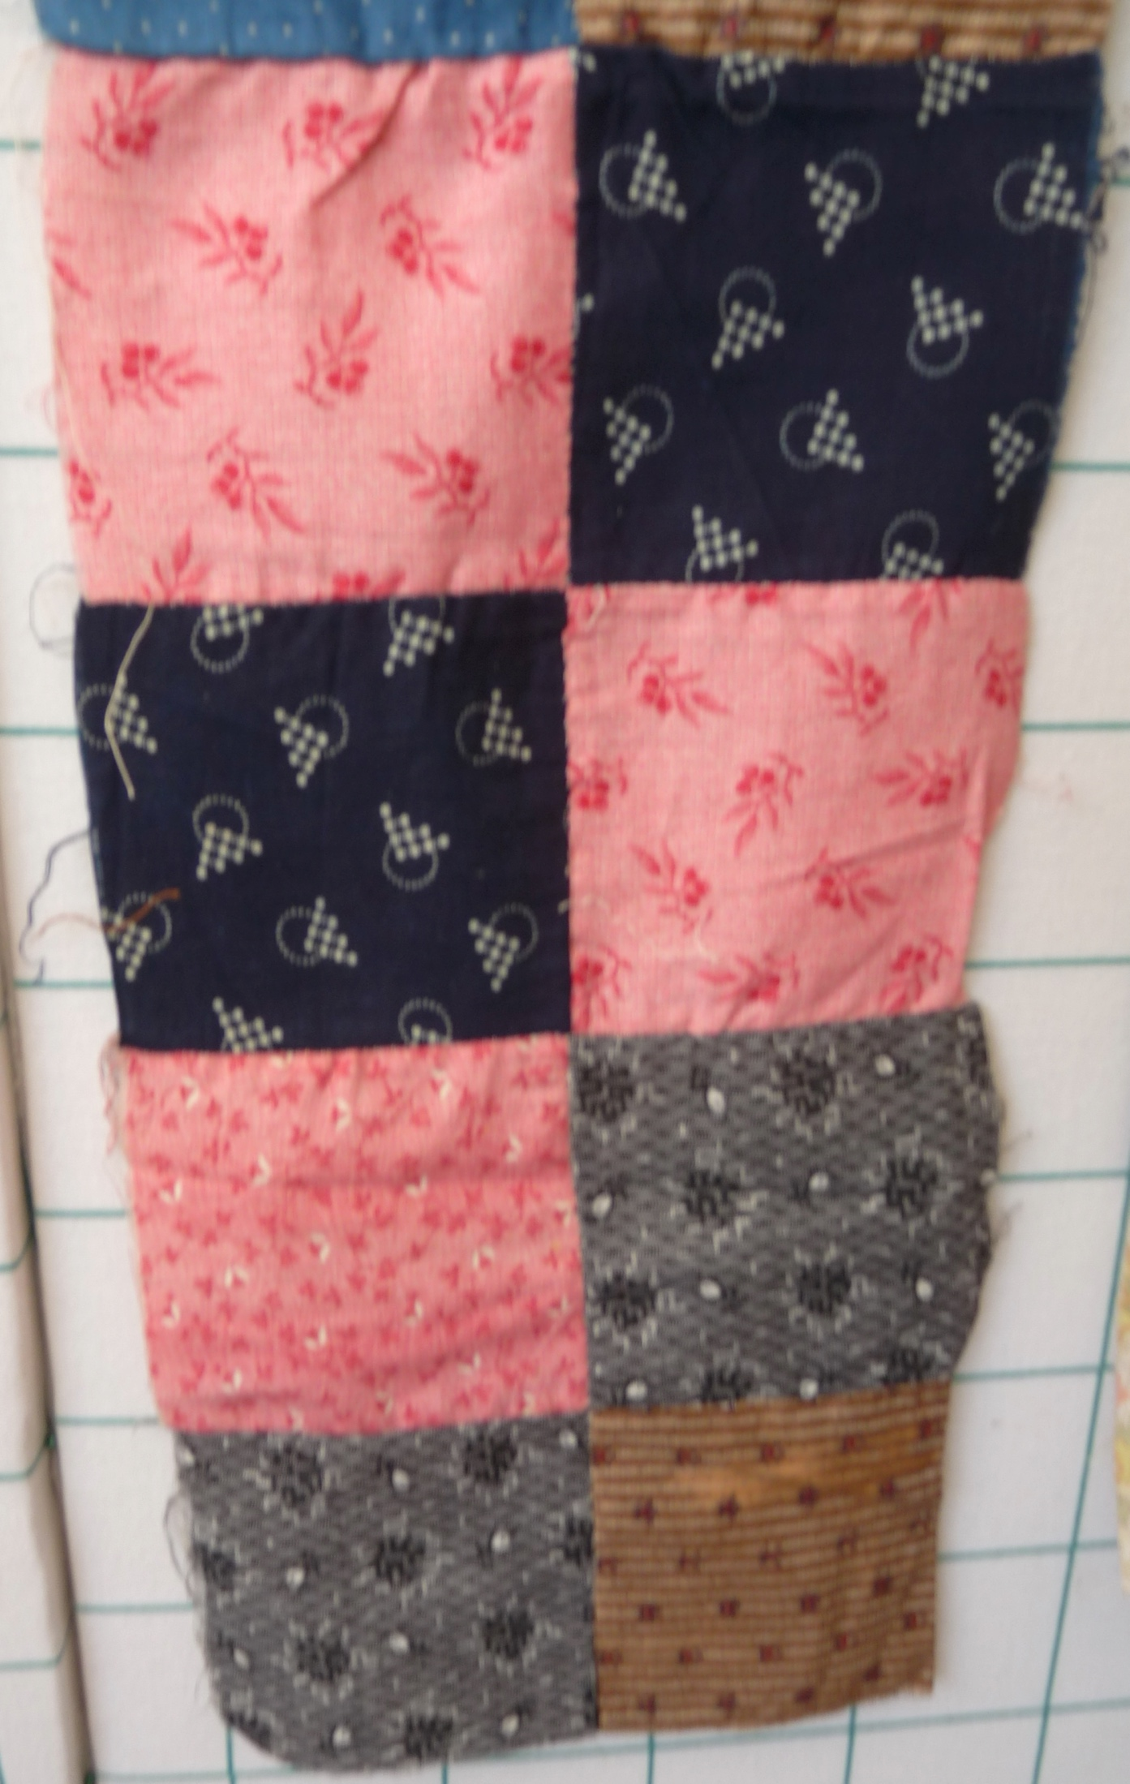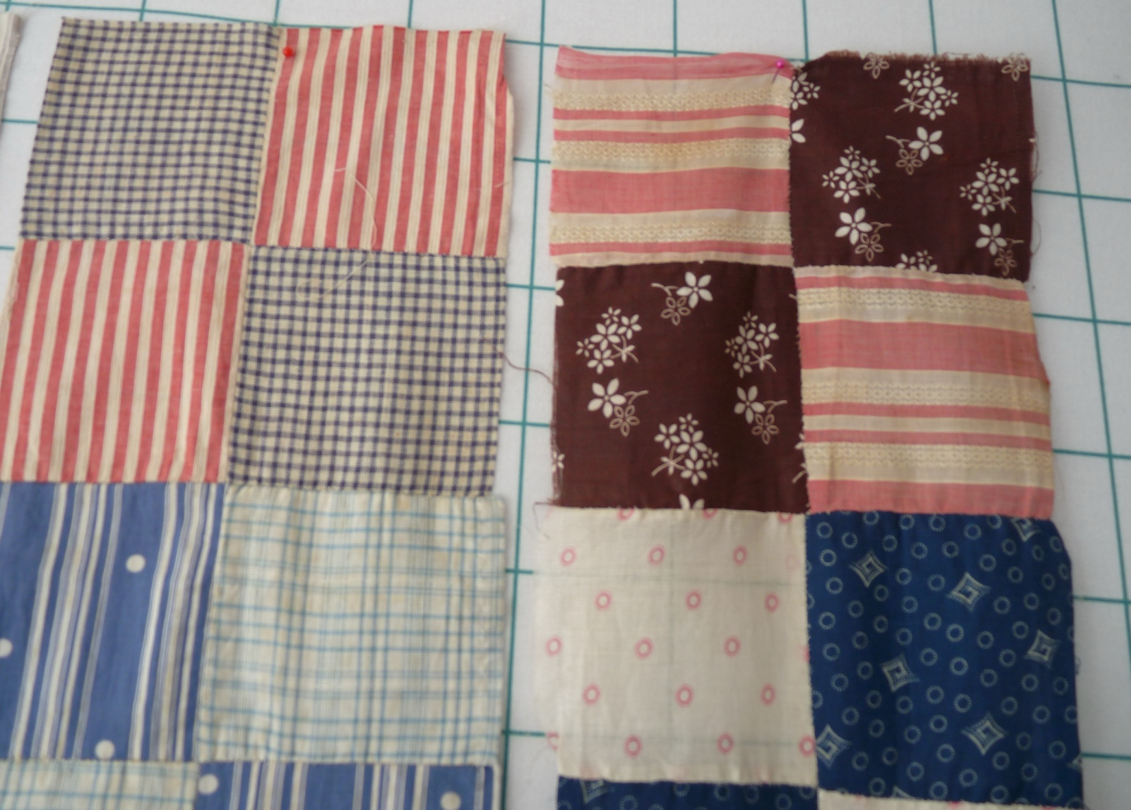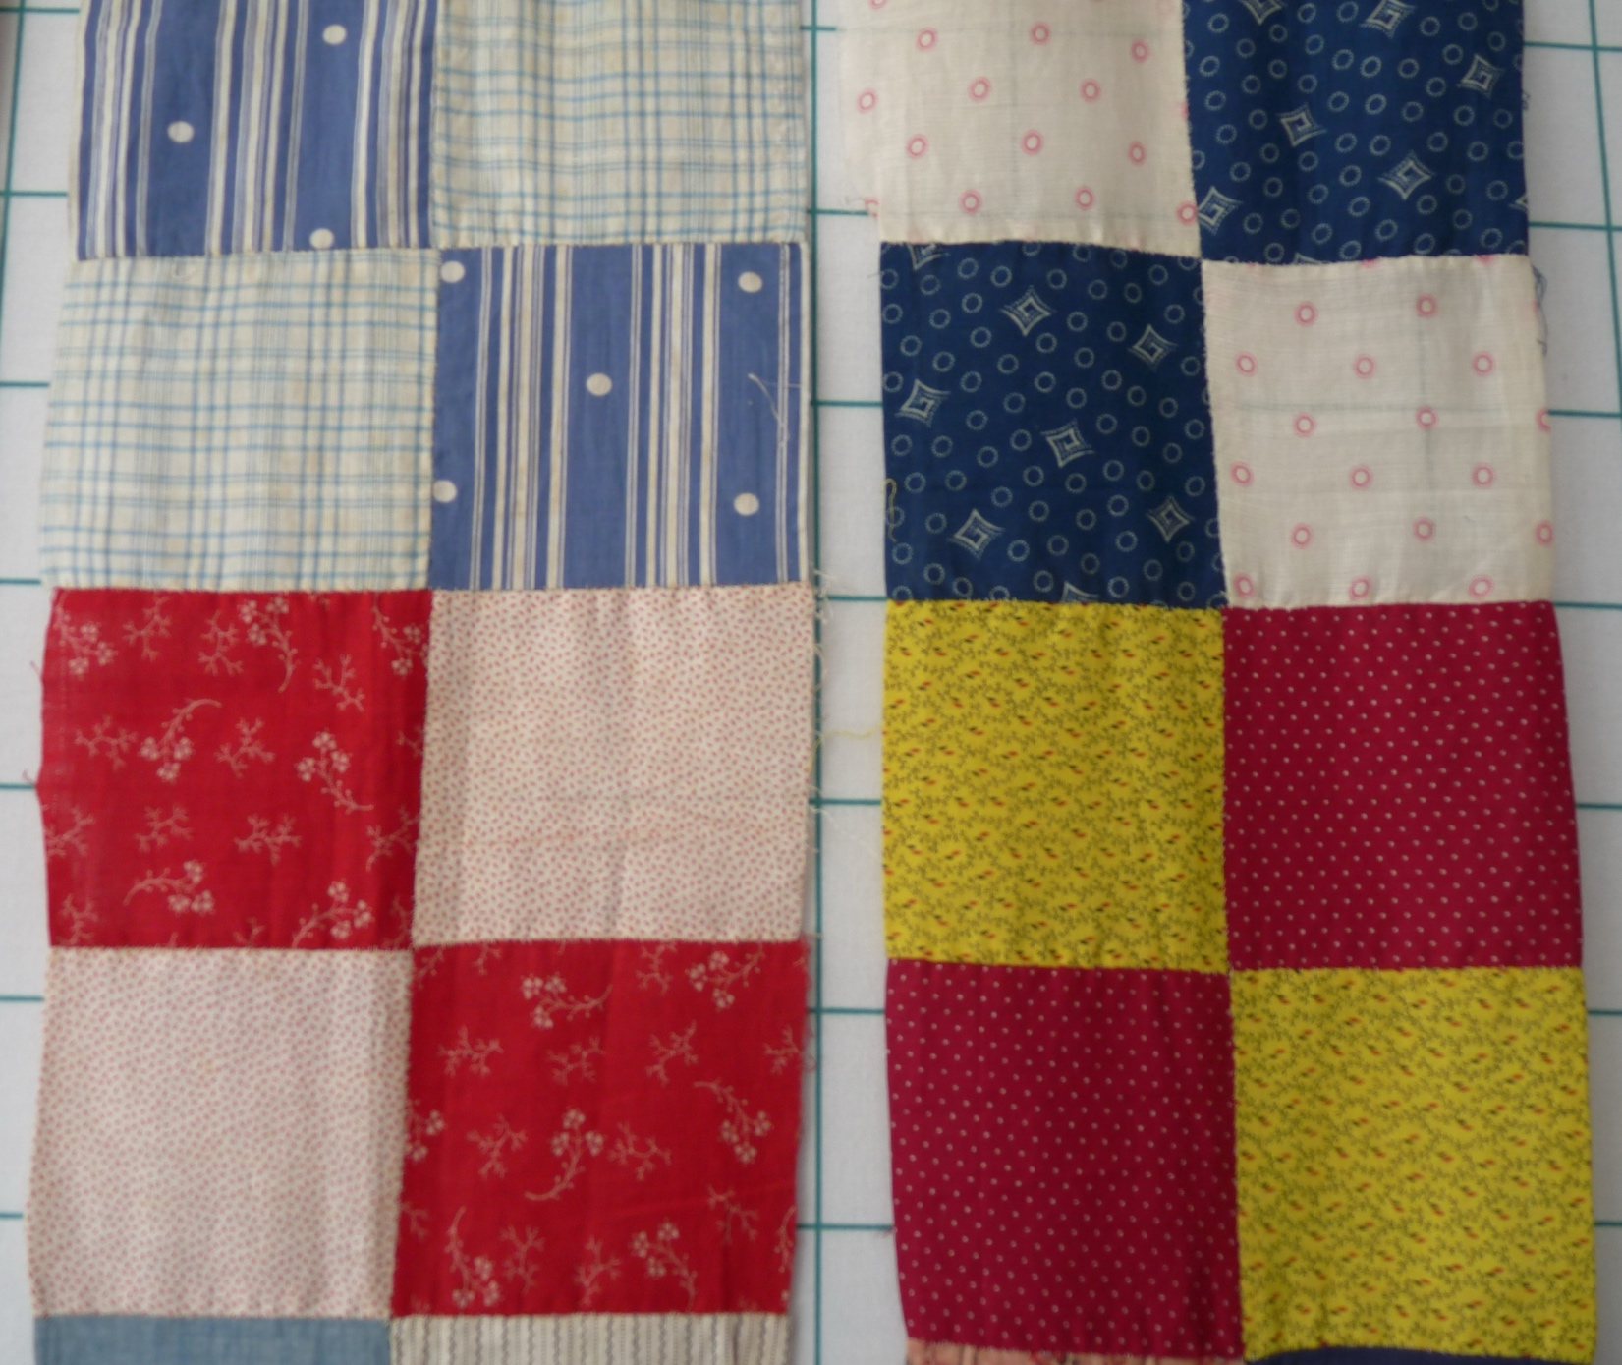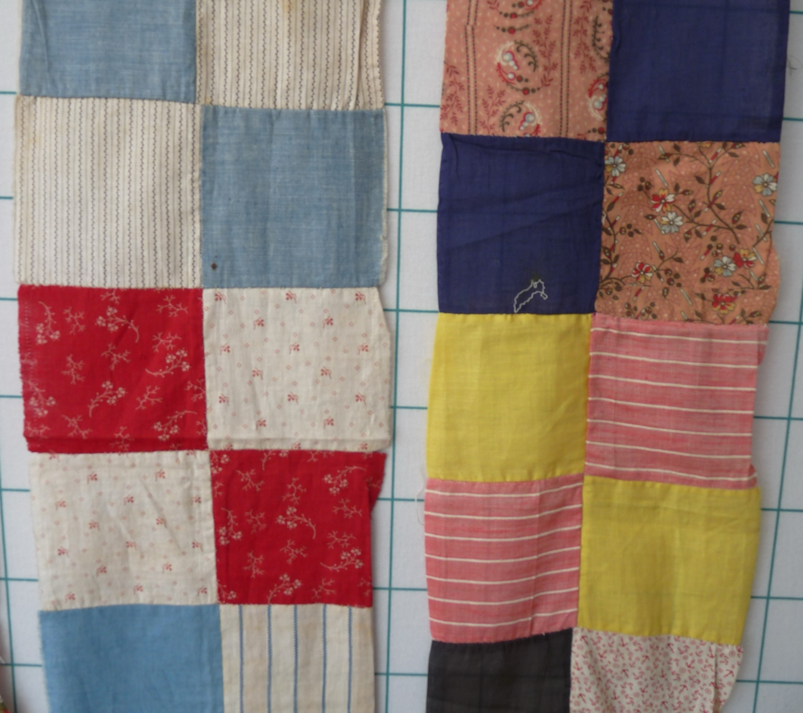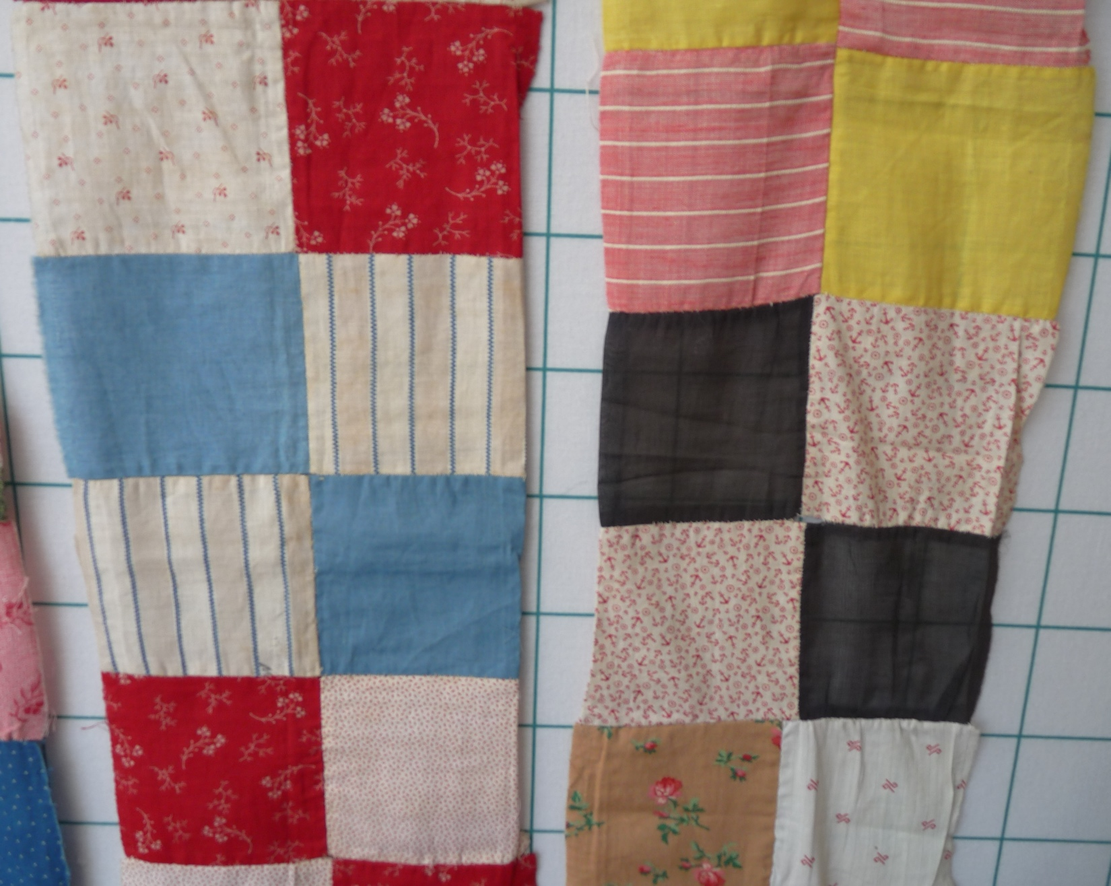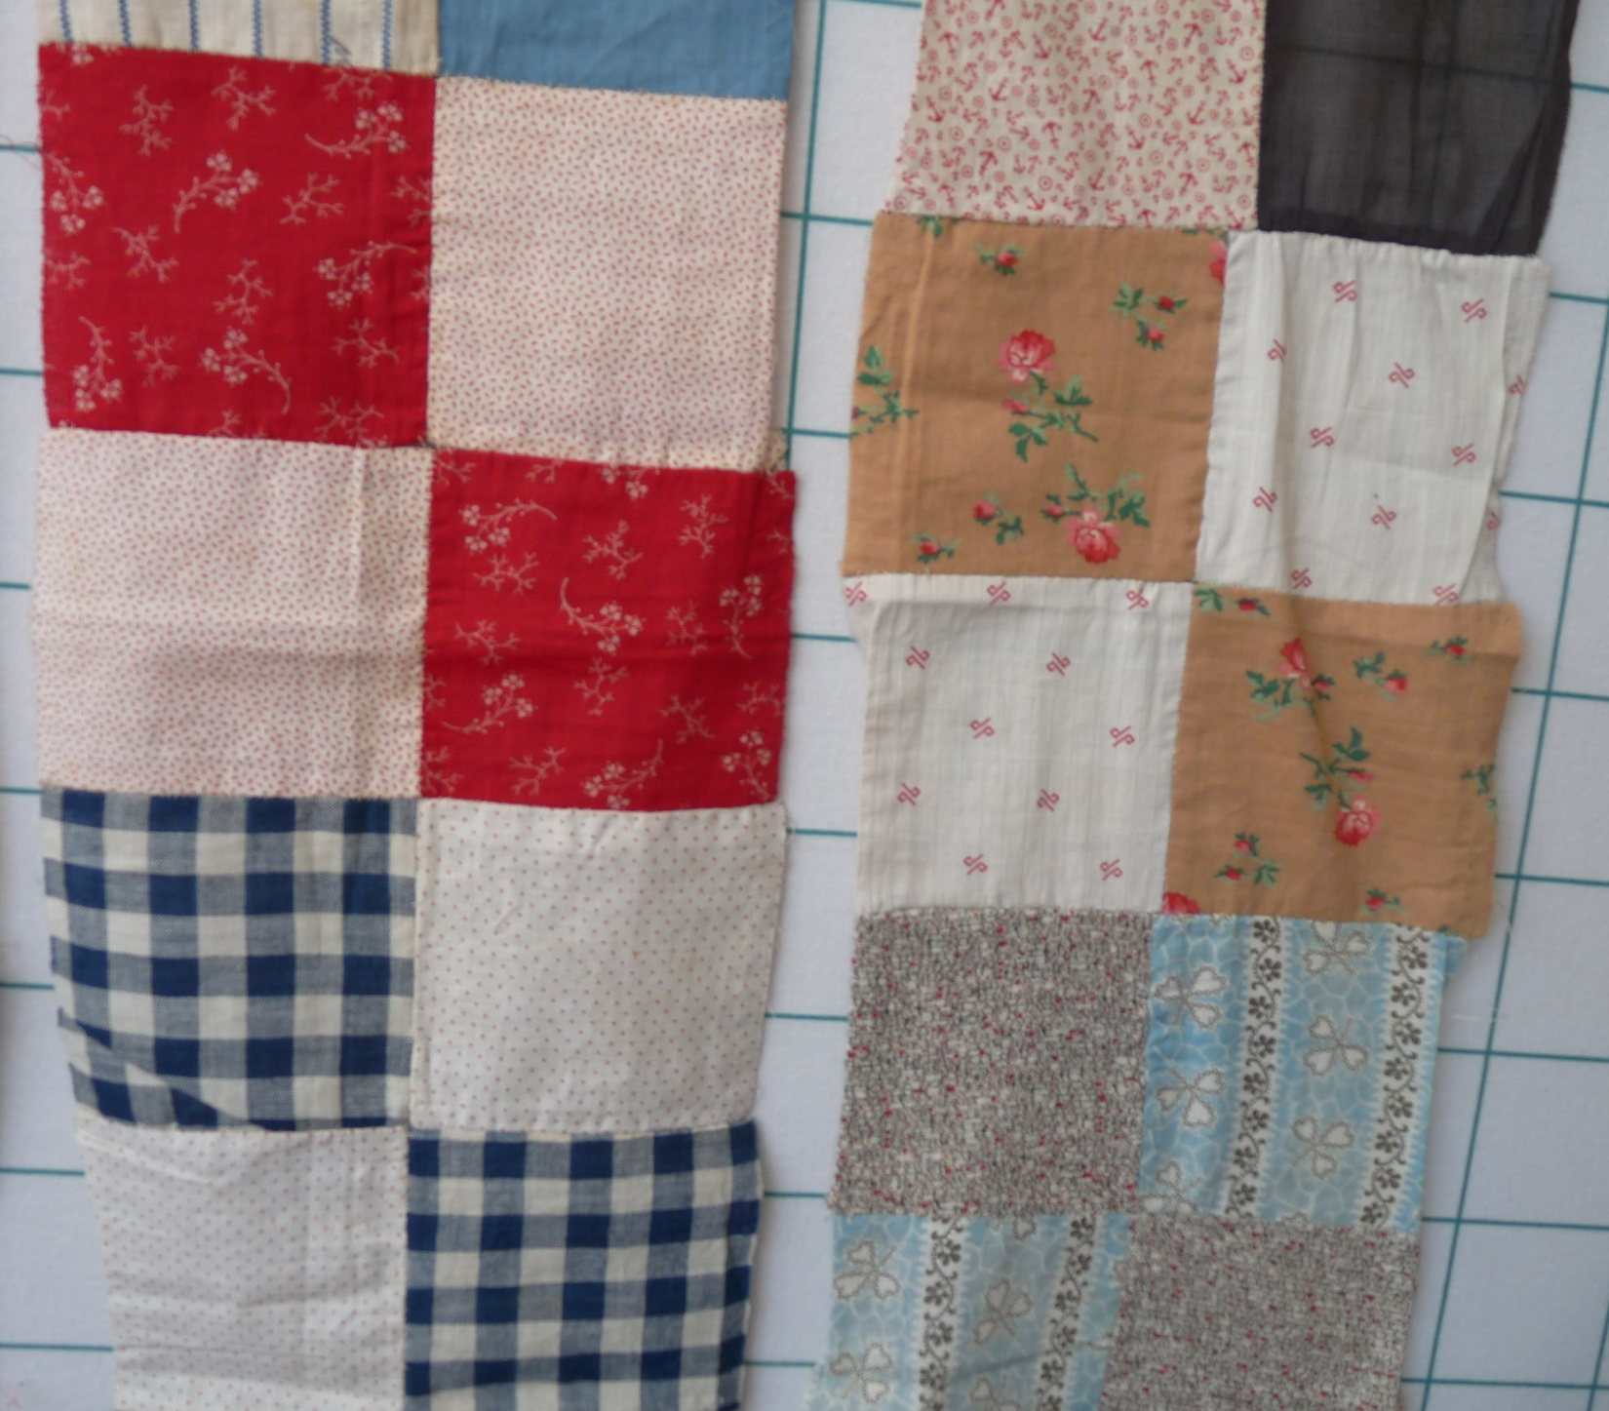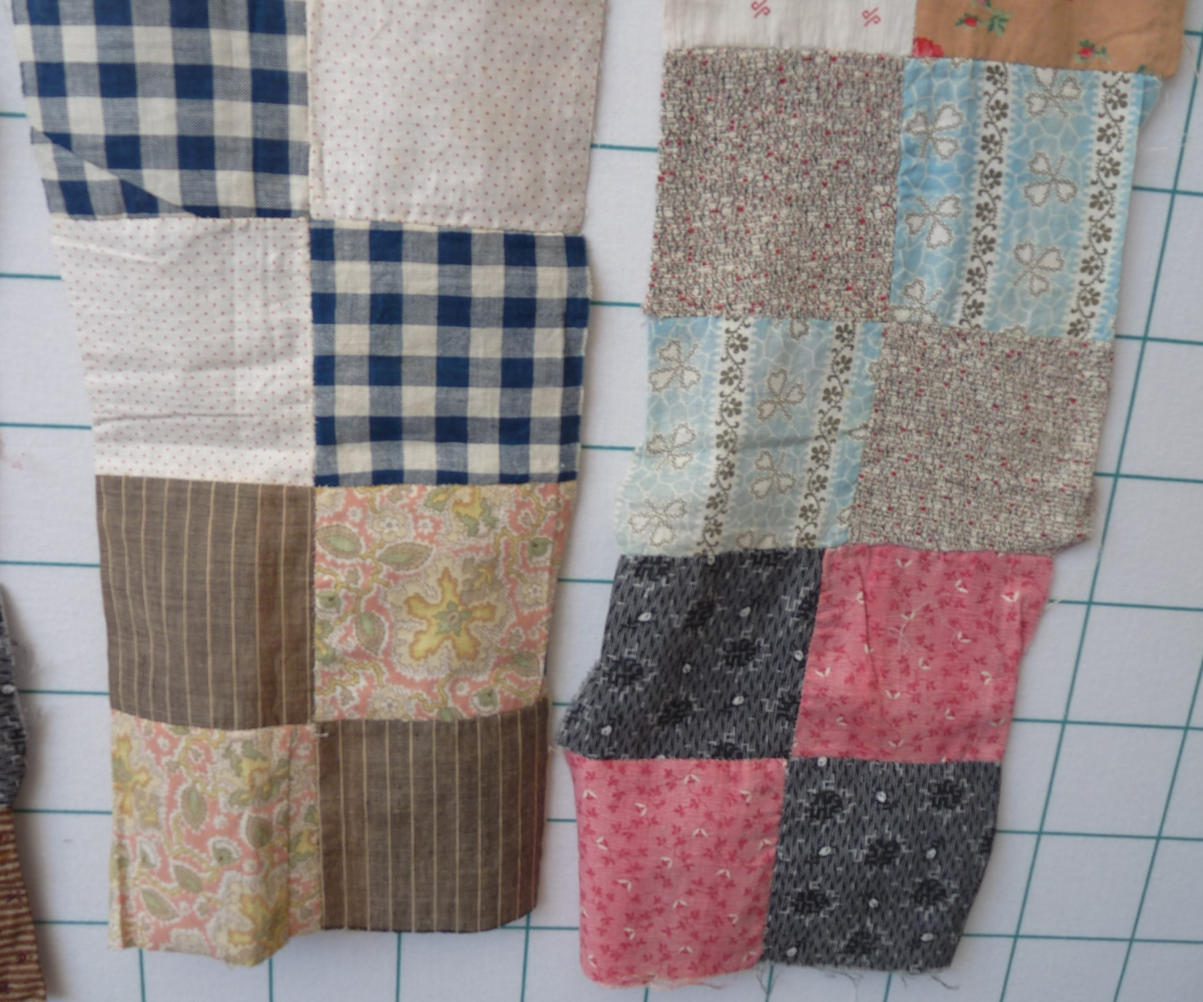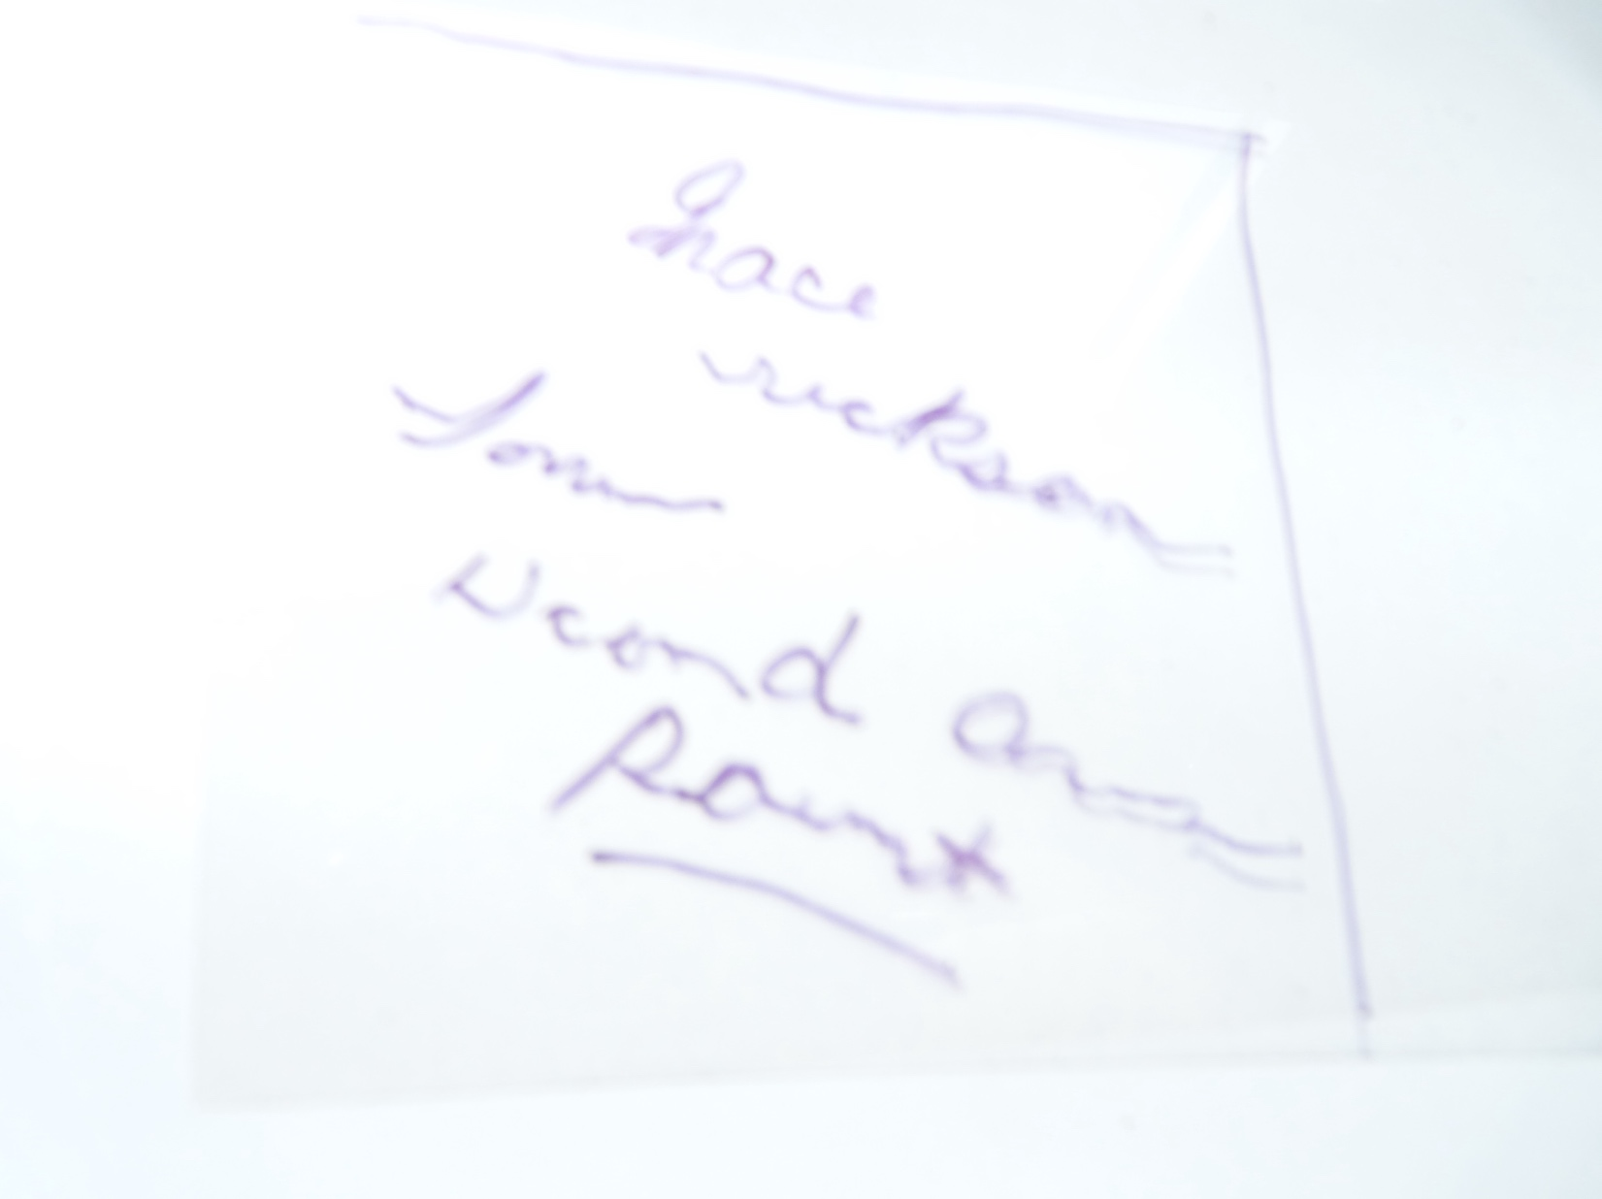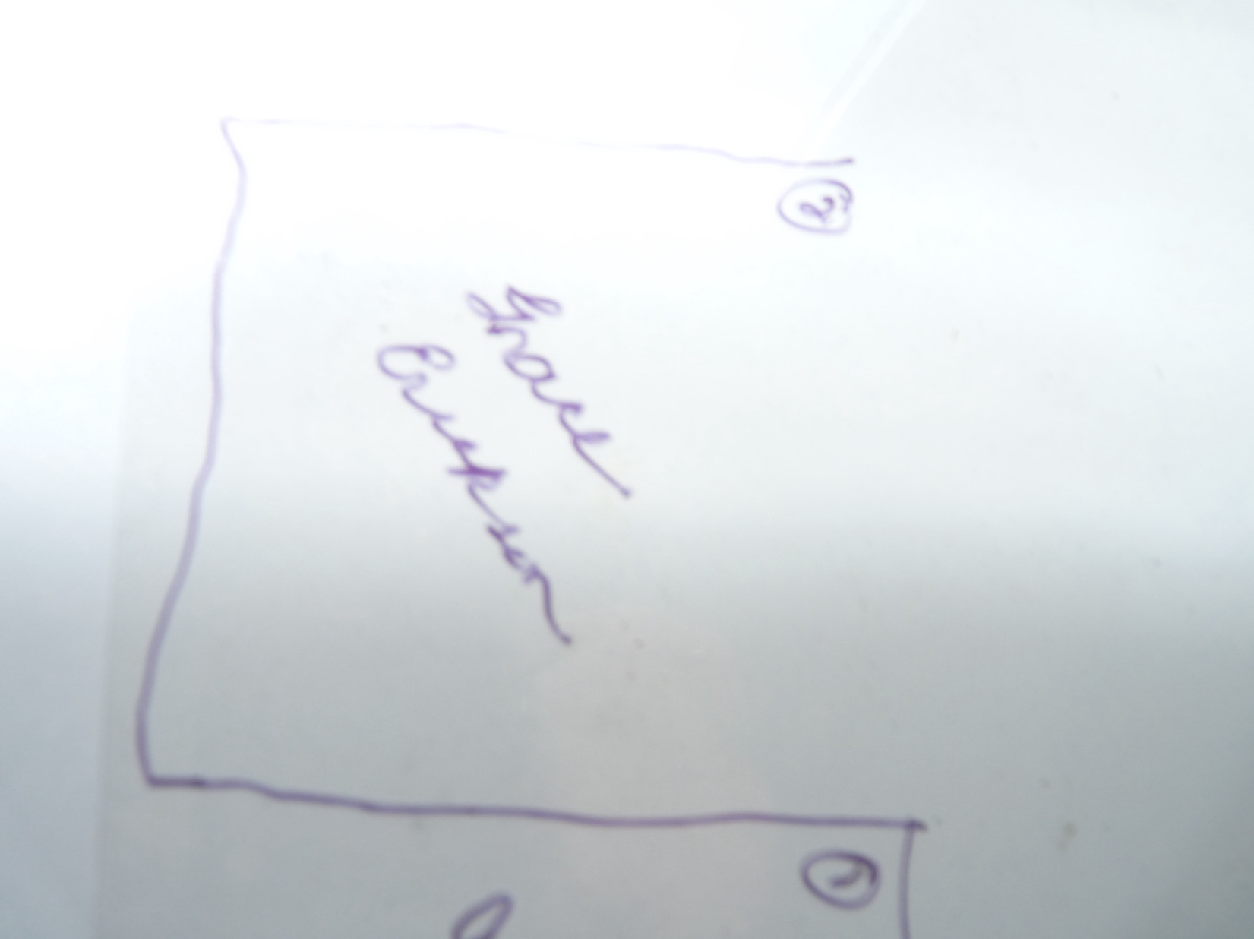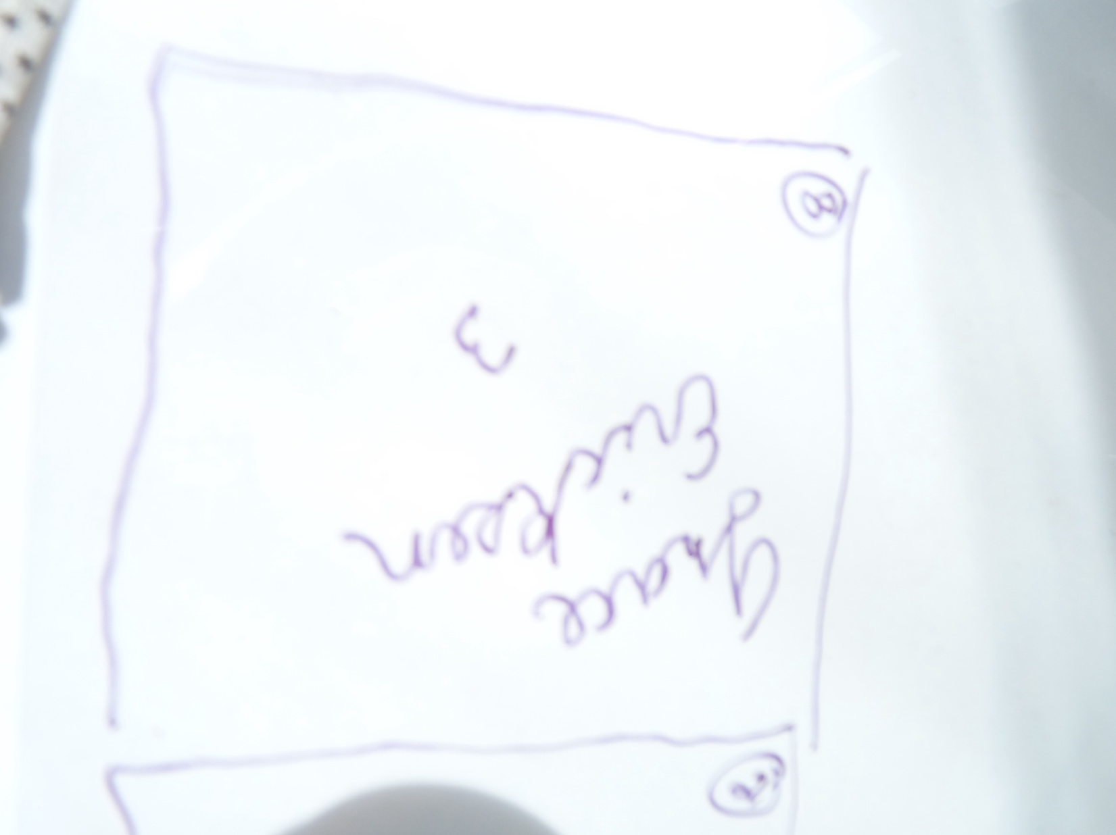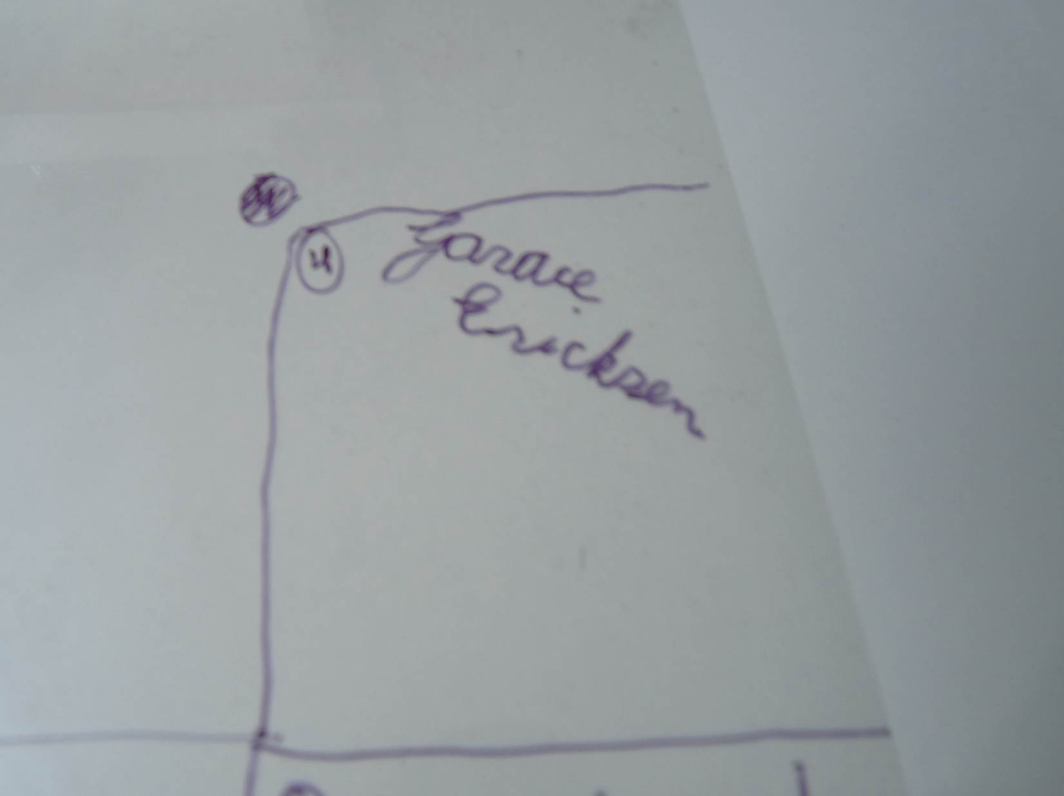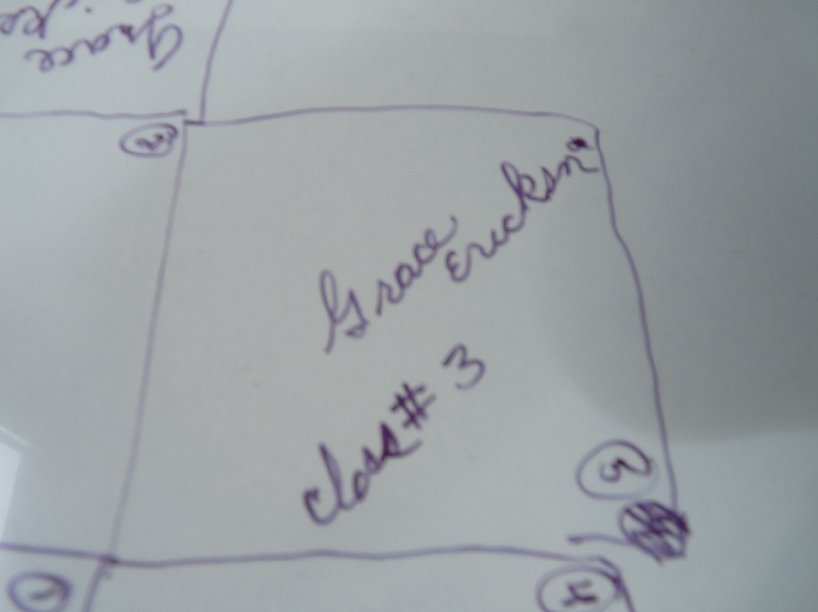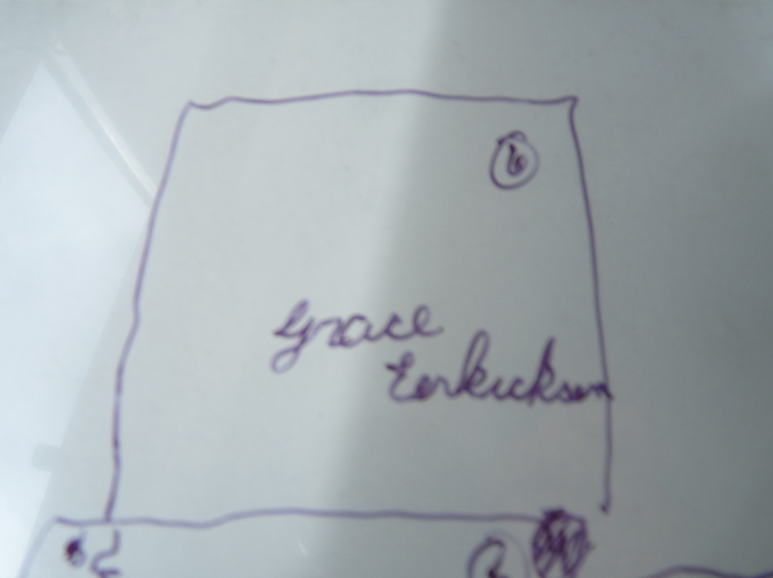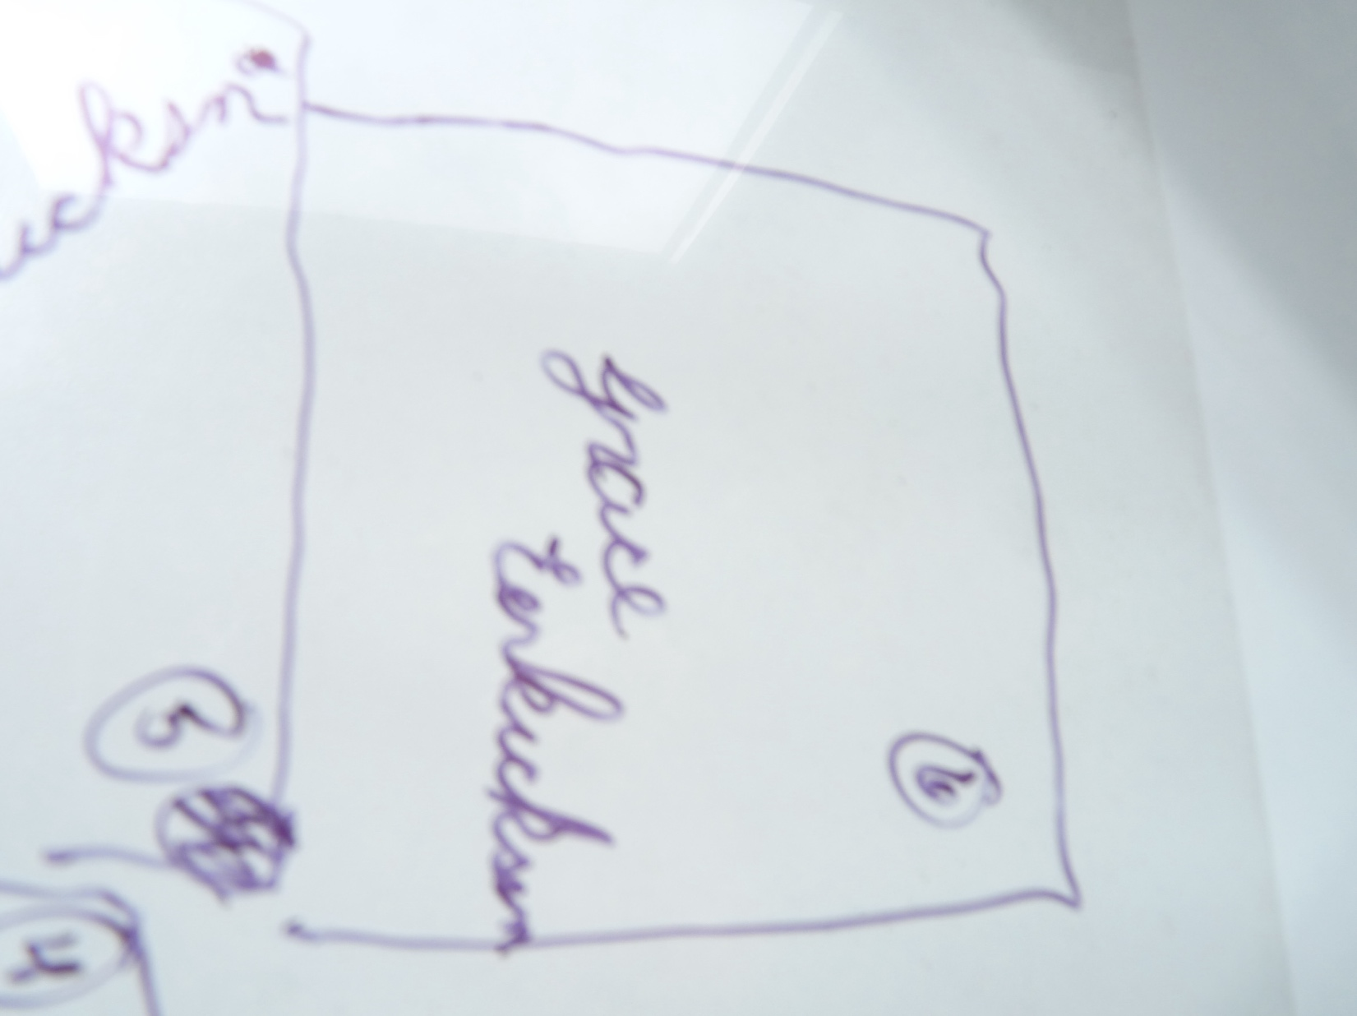

Owner History
Owner | From Date | To Date | Acquired at: | Cost
David Bailey | July 2024 | -- | Chris Moline  Naperville, IL  - from a retired appraiser | $0
Made in:
--
 | If not purchased, the estimated cost for materials: $0

Display & Publication History
Date | Event | Location / Publication
-- | -- | --

General Description
Quilt Title or Name:  4-Patch Strips | Fabric Date Range: 1880 ± 20 Years  Date Made: -- ± 0 Years  Method of Determination:
Item Type:  Items in Set: 5 | Size: Length: -2460“ x Width: 7“
Appraisals:  Has this quilt been professionally appraised?  If so, when: --  ----------- | Other related files:  Scanned Patterns  Images  EQ 8 Files  Research Notes
Additional Information: These strips have pencil inscribed names.

History

Provenance
Describe: --

Quilt Maker
Maker: -- |  | Birth: -- |  | Death: --
 | Location: -- |  | Contributions: --

Purpose and Context
Expression
Art | Personal Enjoyment | Therapy
Income
Personal Income | Fundraising
Presentation
Anniversary | Wedding | Birth
Holiday | Birthday | Other gift
Charitable support
Relationships
Friendship | Commemorative | Memorial
Mourning | Reunion
Skill Building
Challenge / Contest | Learning / Teaching Sample
Use
Bed Quilt | Lap Quilt | Home Décor
Baby / Crib | Wall Hanging
Describe other purpose: --

Construction History
--

Coverlet Design & Construction

Coverlet Top
Warp strand count per inch: 0. | Design: --
Warp fiber: | Weaver: --
Weft strand count per inch: 0” | Location: --
Weft fiber: | Woven for: --
Additional Information: --

Quilt Top Design & Construction

Quilt Top
Layout Design: .
Delete this & the following table rows as appropriate.
One Patch Shape Details
 |  |  | Describe: --
 | Techniques
 |  | Machine pieced | String / Improvisational piecing
 |  | Hand pieced | Foundation piecing
 |  | Strip piecing | English paper piecing
 |  | Describe: --
 | Workmanship
 |  | Seams are stable | Seams are appropriately aligned
 |  | Seams are flat | Points are sharp
 |  | Describe piecing workmanship
Medallion Details
 | Length 0.00” x Width: 0.00” |  | Describe: --
 | Describe: --
 | Techniques
 |  | Machine pieced | String / Improvisational piecing
 |  | Hand pieced | Foundation piecing
 |  | Strip piecing | English paper piecing
 |  | Describe: --
 | Workmanship
 |  | Seams are stable | Seams are appropriately aligned
 |  | Seams are flat | Points are sharp
 |  | Describe piecing workmanship
Blocks / Grid
 |  |  | Grid Dimensions: Length 0 x Width: 0
 |  |  | Block Size: Length: 0.00 “ x Width: 0.00 “
 | Describe: --
 | Pattern name & Brackman or other ID |  | <<Pattern Image>>
 | Techniques
 | Machine pieced |  | String / Improvisational piecing
 | Hand pieced |  | Foundation piecing
 | Strip piecing |  | English paper piecing
 | Describe: --
 | Workmanship
 | Seams are stable |  | Seams are appropriately aligned
 | Seams are flat |  | Points are sharp
 | Describe piecing workmanship

Embellishments
Delete this & the following table rows as appropriate.
Types:
 | Applique – Raw edge | Embroidery | Stuffed Work
 | Applique - Button-hole | Cording | Inking
 | Applique - Needle-turn | Beading | Painting
 | Applique - Reverse | Rhinestones / Gems | Marking lines noted
 | Applique - Other | Other: --
Workmanship
 | Stitches are appropriately small and even.
 | Edges are as design intends (straight, curved, pointed).
 | Work demonstrates appropriate skill for intended purpose.
 | Describe other techniques

Sashing
Delete this & the following table rows as appropriate.
 |  | Width: 0.00 “
Use of corner stones
Techniques
 | Machine pieced |  | String / Improvisational piecing
 | Hand pieced |  | Foundation piecing
 | Strip piecing |  | English paper piecing
 | Describe: --
Workmanship
 | Seams are stable |  | Seams are appropriately aligned
 | Seams are flat |  | Points are sharp
Describe: --
 | Describe piecing workmanship

Borders & Frames
Delete this & the following table rows as appropriate.
Describe borders and frames in order from center to edge.
1 | Width: 0.00“
 |  |  | Describe: --
Techniques
 |  | Machine pieced |  |  | String / Improvisational piecing
 |  | Hand pieced |  |  | Foundation piecing
 |  | Strip piecing |  |  | English paper piecing
 |  | Describe: --
Workmanship
 |  | Seams are stable |  |  | Seams are appropriately aligned
 |  | Seams are flat |  |  | Points are sharp
Describe: --
 |  | Describe piecing workmanship

Assembly
 | Seams are appropriately aligned
Seams are stable | Top has no inappropriate tucks or puckers
Seams are flat | Top lays flat with no overly full areas
Describe: --

Color
Predominant colors
 | Red | Blue | Black
 | Orange | Violet/Purple | Grey
 | Yellow | Brown | White
 | Green | Beige / Tan
Specific Antique Colors |  | NONE NOTED | Neon prints
 | Red – claret / wine | Yellow – chrome | Blue – Lancaster
 | Red – madder / cinnamon | Green - chrome | Blue – Prussian / Lafayette
 | Red – turkey | Green – Nile | Brown – madder
 | Pinks - double | Blue – Cadet | Butterscotch
 | Orange - madder | Blue - Indigo | Bronze
 | Orange – cheddar / antimony / chrome |  | Late 1800’s Purple
Describe: --

Materials
Sources of Fabric |  | NOT KNOWN
 | Companies | Fabric Name & Number | Designer
 | -- | -- | --
 | Describe other sources: --
Fiber Types |  | NOT YET IDENTIFIED
 | Cotton | Silk | Wool
 | Cotton Blend | Linen | Synthetic
 | Describe & Clarify: --
Fabric Types |  | NOT KNOWN
 | Broadcloth | Sateen | Upholstery
 | Flannel | Satin | Chintz
 | Shirting | Muslin | Glazed
 | Suiting | Velvet | Handwoven
 | Denim | Felt | Lindsey-Woolsey
 | Describe & Clarify: --
Print Types |  | NOT YET IDENTIFIED
 | Batik | Floral | Multiple scraps
 | Cheater Panel | Garibaldi Red Prints | Paisley
 | Checked / Gingham | Geometric | Plaid
 | Conversation / Novelty | Hand-dyed | Solid / Plain
 | Dotted | Victorian Mourning Prints | Stamped
 | Feed sack / Feed sack-like |  | Stripes
Describe & Clarify: --

Images

Inscriptions
None Found
Inscription is present. Describe location: --
Content
Makers names | Initials | Date
Single Name | Message | Place
Multiple Names
Transcription: --

Methods
Label | Ink – Ball point | Stencil
Printed onto fabric | Ink – Felt tip | Stamped
Quilted | Ink - Other | Pencil
Embroidery | Applique | Typewriter
Describe & Clarify: --

Images for Inscriptions

Quilt Back Design & Construction

Quilt Back
Layout Design: .
Delete this & the following table rows as appropriate.
One Patch Shape Details
 |  |  | Describe: --
 | Techniques
 |  | Machine pieced | String / Improvisational piecing
 |  | Hand pieced | Foundation piecing
 |  | Strip piecing | English paper piecing
 |  | Describe: --
 | Workmanship
 |  | Seams are stable | Seams are appropriately aligned
 |  | Seams are flat | Points are sharp
 |  | Describe piecing workmanship
Medallion Details
 | Length 0.00” x Width: 0.00” |  | Describe: --
 | Describe: --
 | Techniques
 |  | Machine pieced | String / Improvisational piecing
 |  | Hand pieced | Foundation piecing
 |  | Strip piecing | English paper piecing
 |  | Describe: --
 | Workmanship
 |  | Seams are stable | Seams are appropriately aligned
 |  | Seams are flat | Points are sharp
 |  | Describe piecing workmanship
Blocks / Grid
 |  |  | Grid Dimensions: Length 0 x Width: 0
 |  |  | Block Size: Length: 0.00 “ x Width: 0.00 “
 | Describe: --
 | Pattern name & Brackman or other ID |  | <<Pattern Image>>
 | Techniques
 | Machine pieced |  | String / Improvisational piecing
 | Hand pieced |  | Foundation piecing
 | Strip piecing |  | English paper piecing
 | Describe: --
 | Workmanship
 | Seams are stable |  | Seams are appropriately aligned
 | Seams are flat |  | Points are sharp
 | Describe piecing workmanship

Embellishments
Delete this & the following table rows as appropriate.
Types:
 | Applique – Raw edge | Embroidery | Stuffed Work
 | Applique - Button-hole | Cording | Inking
 | Applique - Needle-turn | Beading | Painting
 | Applique - Reverse | Rhinestones / Gems | Marking lines noted
 | Applique - Other | Other: --
Workmanship
 | Stitches are appropriately small and even.
 | Edges are as design intends (straight, curved, pointed).
 | Work demonstrates appropriate skill for intended purpose.
 | Describe other techniques

Sashing
Delete this & the following table rows as appropriate.
 |  | Width: 0.00 “
Use of corner stones
Techniques
 | Machine pieced |  | String / Improvisational piecing
 | Hand pieced |  | Foundation piecing
 | Strip piecing |  | English paper piecing
 | Describe: --
Workmanship
 | Seams are stable |  | Seams are appropriately aligned
 | Seams are flat |  | Points are sharp
Describe: --
 | Describe piecing workmanship

Borders & Frames
Delete this & the following table rows as appropriate.
Describe borders and frames in order from center to edge.
1 | Width: 0.00“
 |  |  | Describe: --
Techniques
 |  | Machine pieced |  |  | String / Improvisational piecing
 |  | Hand pieced |  |  | Foundation piecing
 |  | Strip piecing |  |  | English paper piecing
 |  | Describe: --
Workmanship
 |  | Seams are stable |  |  | Seams are appropriately aligned
 |  | Seams are flat |  |  | Points are sharp
Describe: --
 |  | Describe piecing workmanship

Assembly
 | Seams are appropriately aligned
Seams are stable | Top has no inappropriate tucks or puckers
Seams are flat | Top lays flat with no overly full areas
Describe: --

Color
Predominant colors
 | Red | Blue | Black
 | Orange | Violet/Purple | Grey
 | Yellow | Brown | White
 | Green | Beige / Tan
Specific Antique Colors |  | NONE NOTED | Neon prints
 | Red – claret / wine | Yellow – chrome | Blue – Lancaster
 | Red – madder / cinnamon | Green - chrome | Blue – Prussian / Lafayette
 | Red – turkey | Green – Nile | Brown – madder
 | Pinks - double | Blue – Cadet | Butterscotch
 | Orange - madder | Blue - Indigo | Bronze
 | Orange – cheddar / antimony / chrome |  | Late 1800’s Purple
Describe: --

Materials
Sources of Fabric |  | NOT KNOWN
 | Companies | Fabric Name & Number | Designer
 | -- | -- | --
 | Describe other sources: --
Fiber Types |  | NOT YET IDENTIFIED
 | Cotton | Silk | Wool
 | Cotton Blend | Linen | Synthetic
 | Describe & Clarify: --
Fabric Types |  | NOT KNOWN
 | Broadcloth | Sateen | Upholstery
 | Flannel | Satin | Chintz
 | Shirting | Muslin | Glazed
 | Suiting | Velvet | Handwoven
 | Denim | Felt | Lindsey-Woolsey
 | Describe & Clarify: --
Print Types |  | NOT YET IDENTIFIED
 | Batik | Floral | Multiple scraps
 | Cheater Panel | Garibaldi Red Prints | Paisley
 | Checked / Gingham | Geometric | Plaid
 | Conversation / Novelty | Hand-dyed | Solid / Plain
 | Dotted | Victorian Mourning Prints | Stamped
 | Feed sack / Feed sack-like |  | Stripes
Describe & Clarify: --

Images

Inscriptions
None Found
Inscription is present. Describe location: --
Content
Makers names | Initials | Date
Single Name | Message | Place
Multiple Names
Transcription: --

Methods
Label | Ink – Ball point | Stencil
Printed onto fabric | Ink – Felt tip | Stamped
Quilted | Ink - Other | Pencil
Embroidery | Applique | Typewriter
Describe & Clarify: --

Images for Inscriptions

Stabilization Method
Stabilization Method:
Delete this & the following table rows as appropriate.
Tied Details
 | Average Distance Between Knots: 0” |  | Placement:
 |  |  | Fiber Used:
Quilting Details
Batting
Quilting Techniques
 | Machine Quilted | Machine – sit-down |  | Corded
 | Machine – computer guided | Hand Quilted |  | Stuffed work
 | Machine – manual long-arm | Quilt-as-you-go
 | Describe: --
Quilting Patterns
 | Meander / Free motion | Lines – single parallel |  | Cables
 | In-the-ditch / To the piece | Lines – double parallel |  | Feathers
 | Echo / Outlined | Lines – triple parallel |  | Wreaths
 | Stipple | Grid – crosshatch |  | Vines
 | Clamshell | Grid – square |  | Floral
 | Elbow / Fan | Grid - diamond |  | Leaves
 | Describe other: --
Thread Choices
 | Brand | Weight |  | Number & Name
 | -- | -- |  | --
Describe: --
Images for Stabilization

Edge Finish
Edge Style:
Finishing Technique
Top Width: 0.00 “ | Binding | Rolled – top to back
Back Width: 0.00“ | Knife edge | Rolled – back to top
1/8 = 0.13, 3/8 = 0.38 | Turned with a closure
5/8 = 0.63, 7/8 = 0.88
Application Method: | Top: | Back:
Embellishments
Fringe | Ruffles | Cording
Lace | Ribbon
Describe: --

Images for Edge

Condition

Flaws
Soiling
Dirty | Stains
Mildew stains | Musty Smell
Discoloration
Running / fugitive color | Faded / bleached color | Crocking
Fabric Damage
Tears / holes | Disintegrating / fall out | Insect damage
Thread bare | Shattering
Sewing / Quilting Damage
Split / open seams | Ties / tufting missing | Embellishments missing
Quilting threads missing | Batting has shifted
Storage Issues
Discoloration from wood | Damage from acid | Fold marks / creases
Describe additional condition issues: --
Images for Condition Issues

Conservation, Restoration, Repairs
Describe Measures: --

Workmanship

Extension of Useful Life
Repair | Useful life of the item was extended.
Prevention of Damage
Conservation | All work is reversible.
Conservation | Further deterioration has been slowed, stabilized or prevented.
Maintaining Function & Integrity
Conservation | Work minimally interferes with the item’s overall appearance.
Restoration | Work blends well with the item’s overall appearance, style and age.
Restoration | Appropriate period reproductions were used.
Restoration | Vintage materials were used.
Restoration | Period appropriate techniques were used.
Restoration | Workmanship is of similar or better quality than original work.

Images for Conservation / Restoration / Repairs

