Documentation Form

Overview

Images
Top | Back
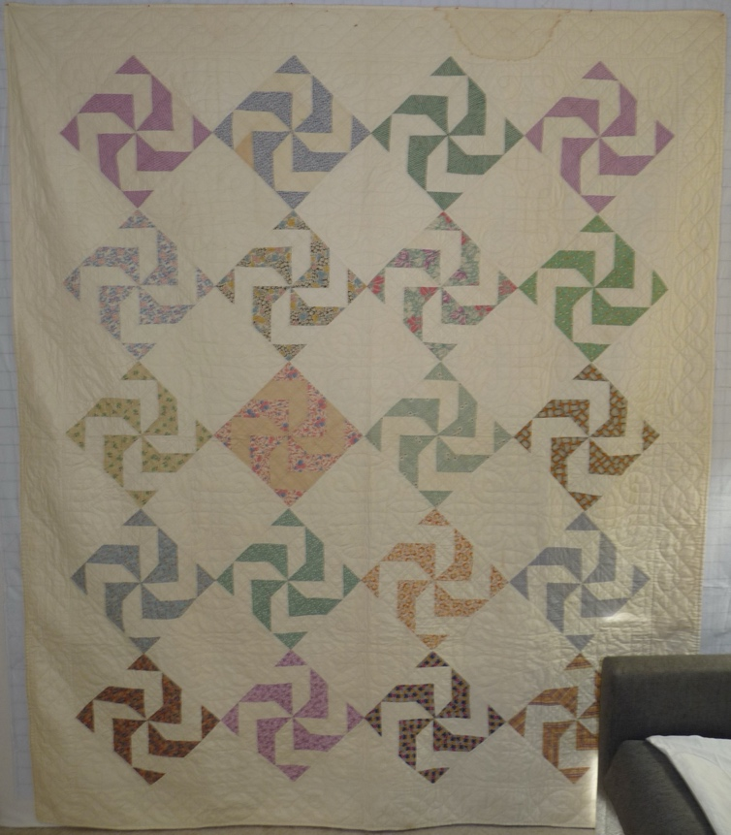 | 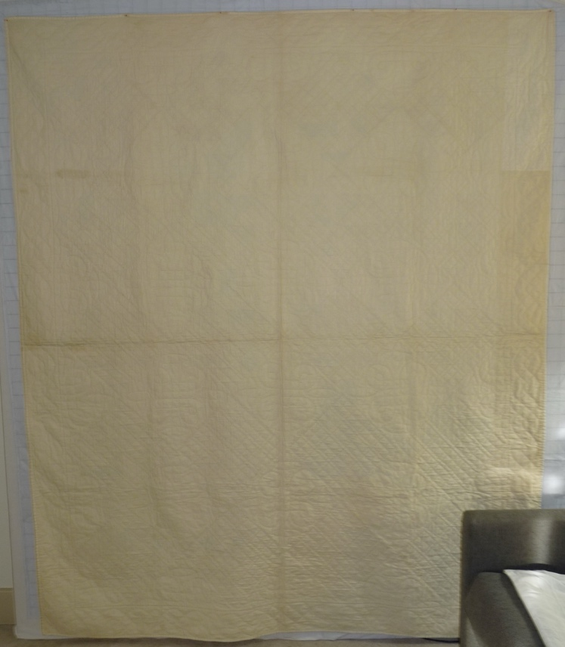

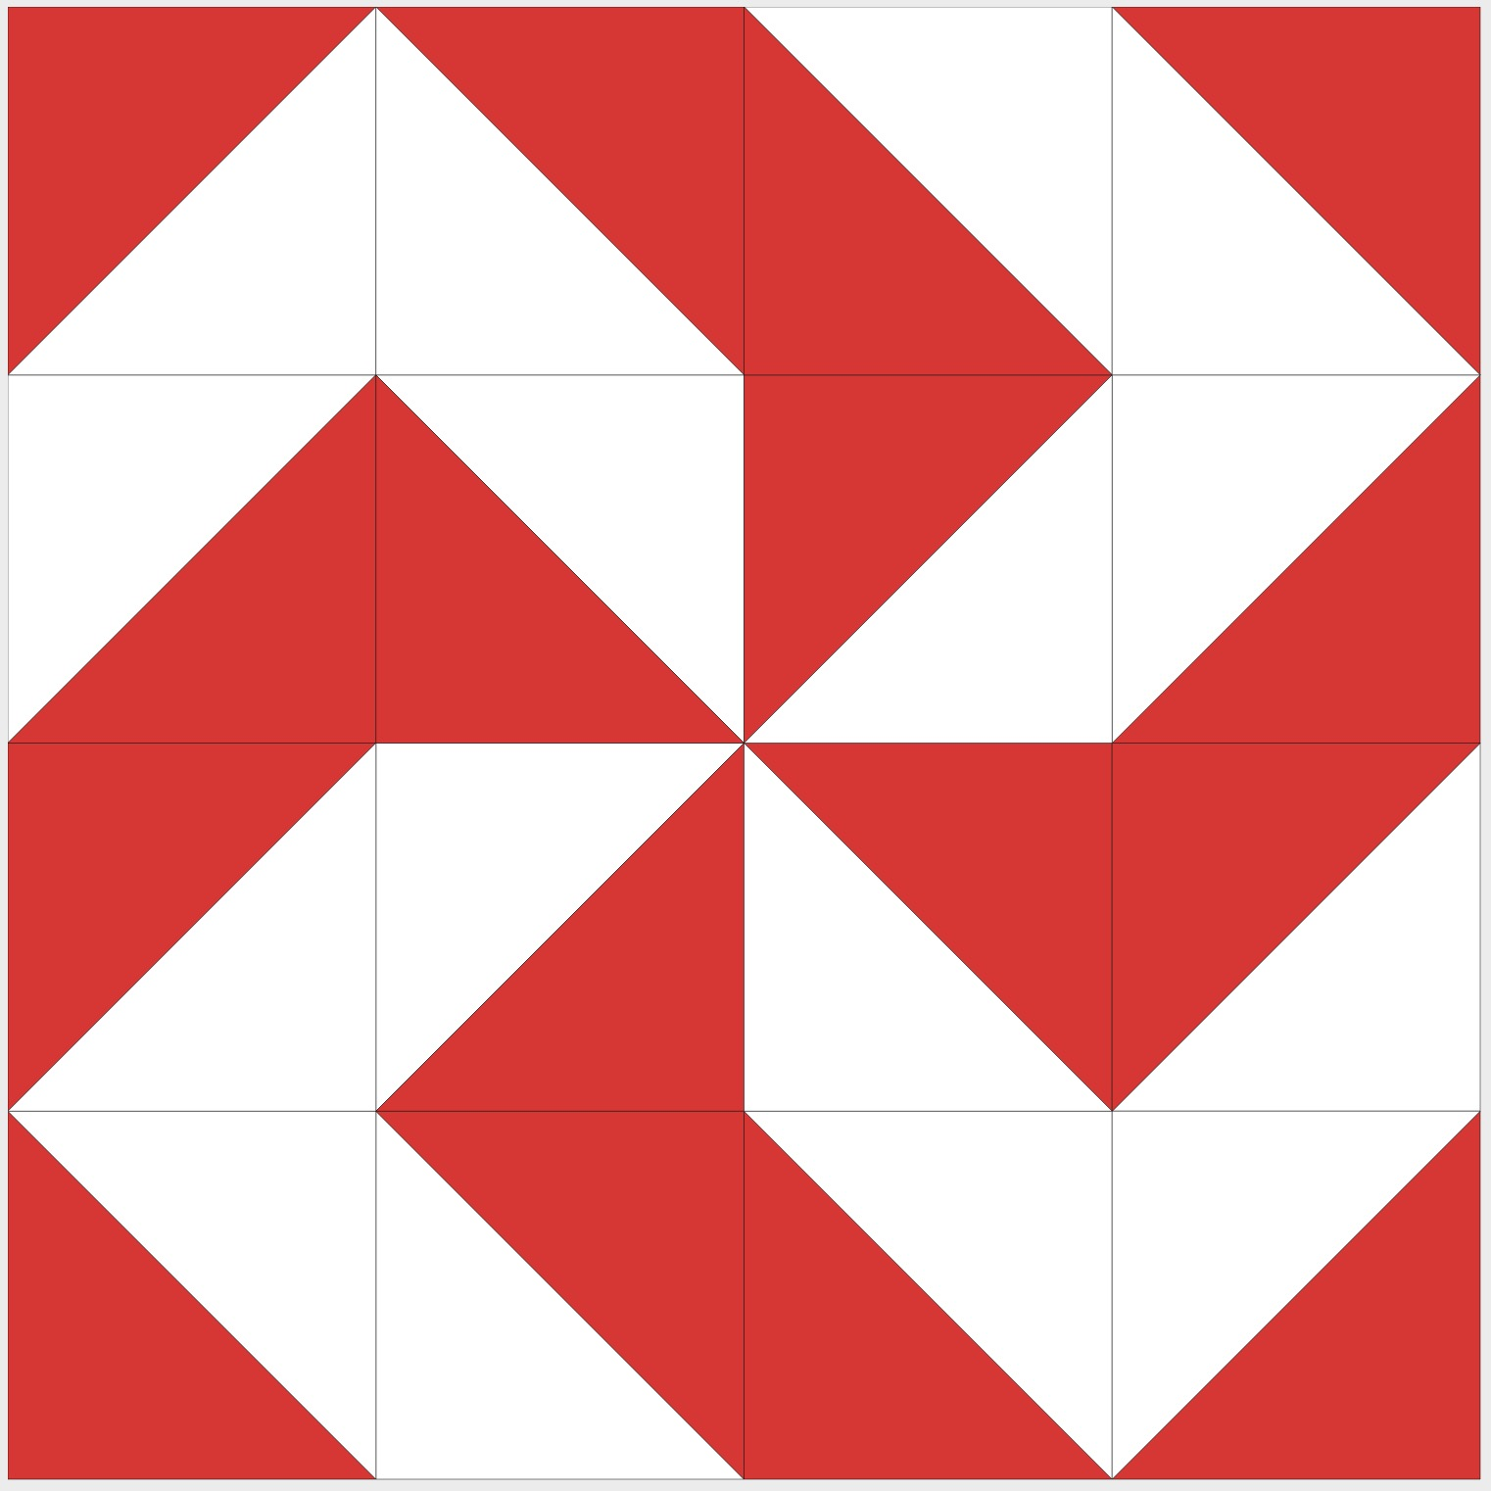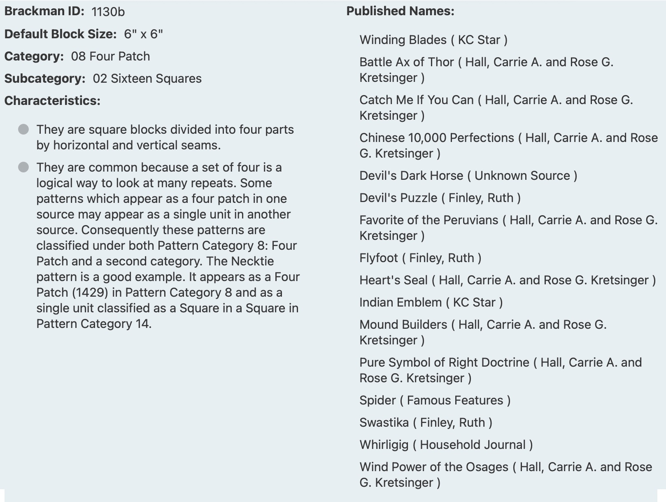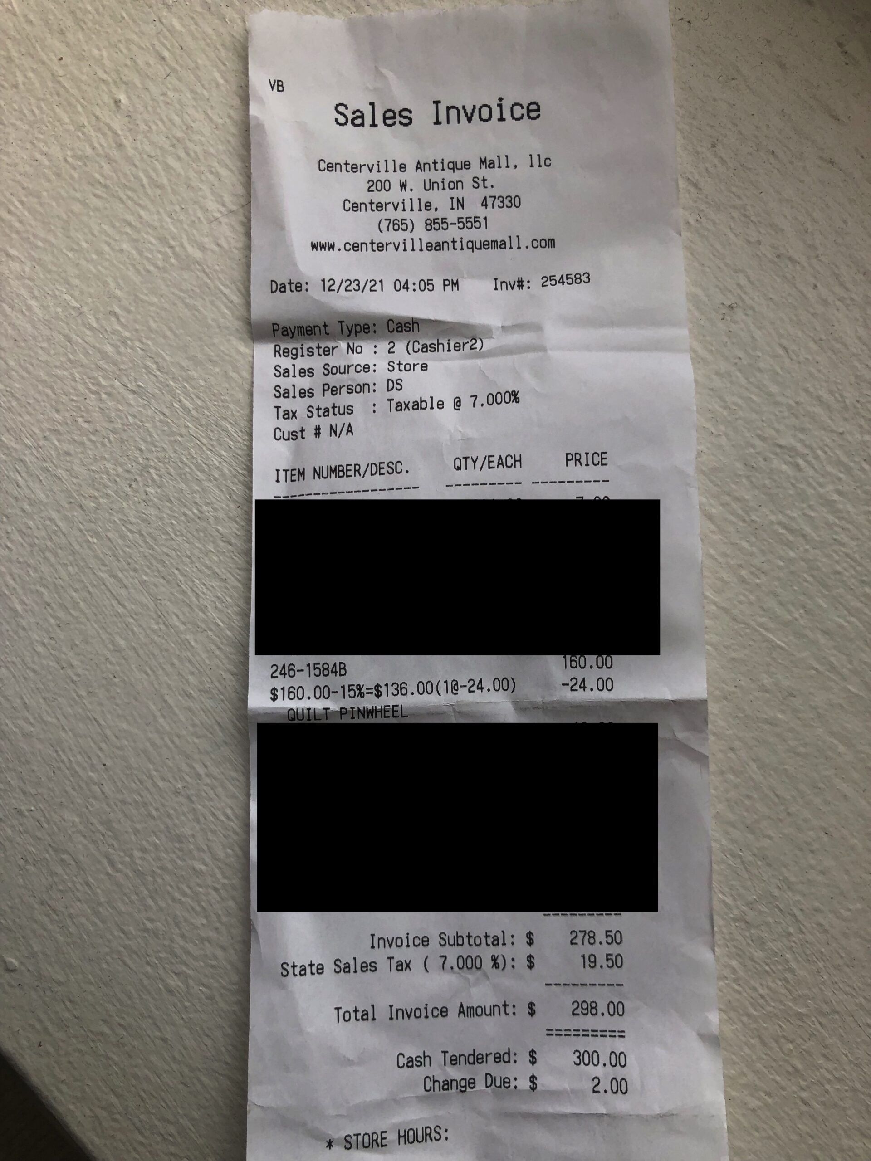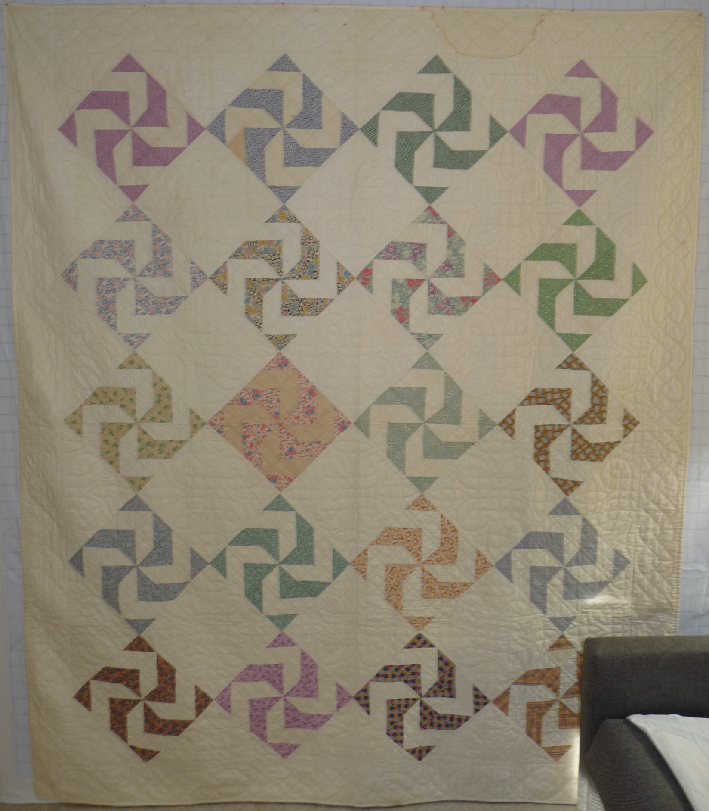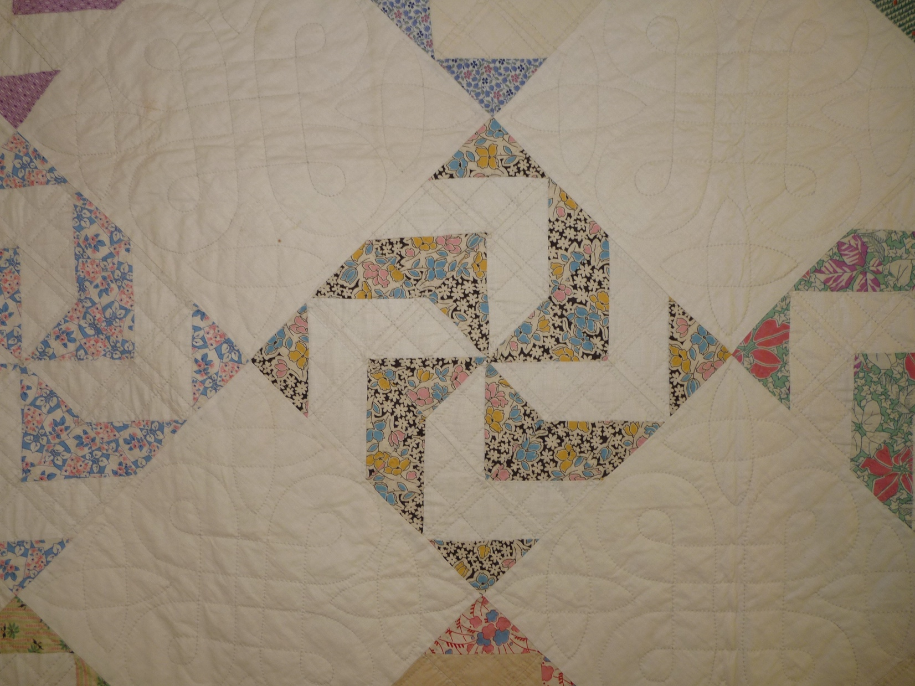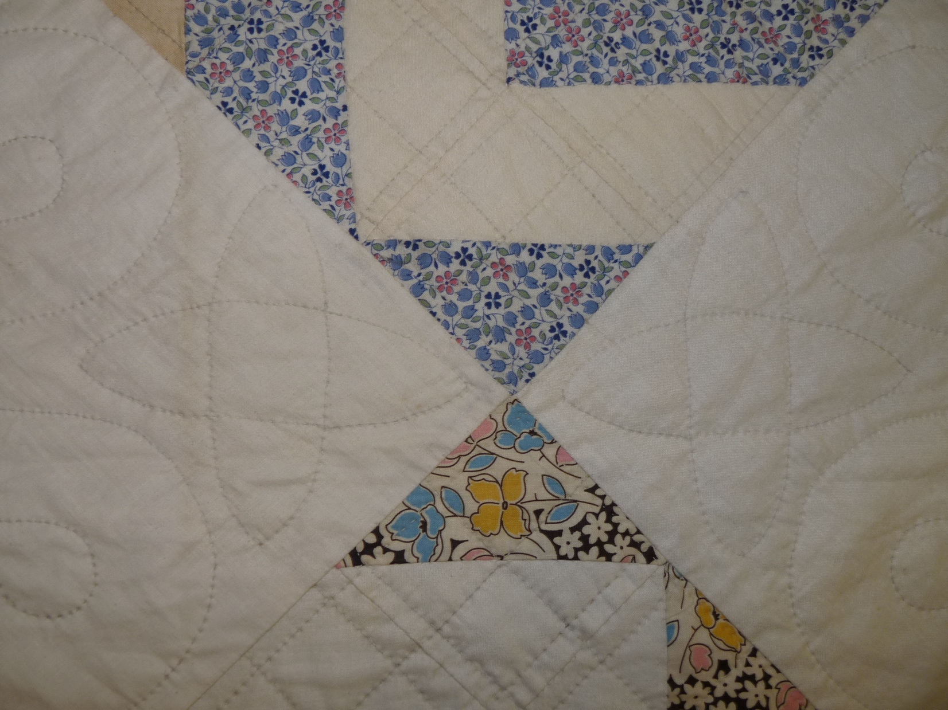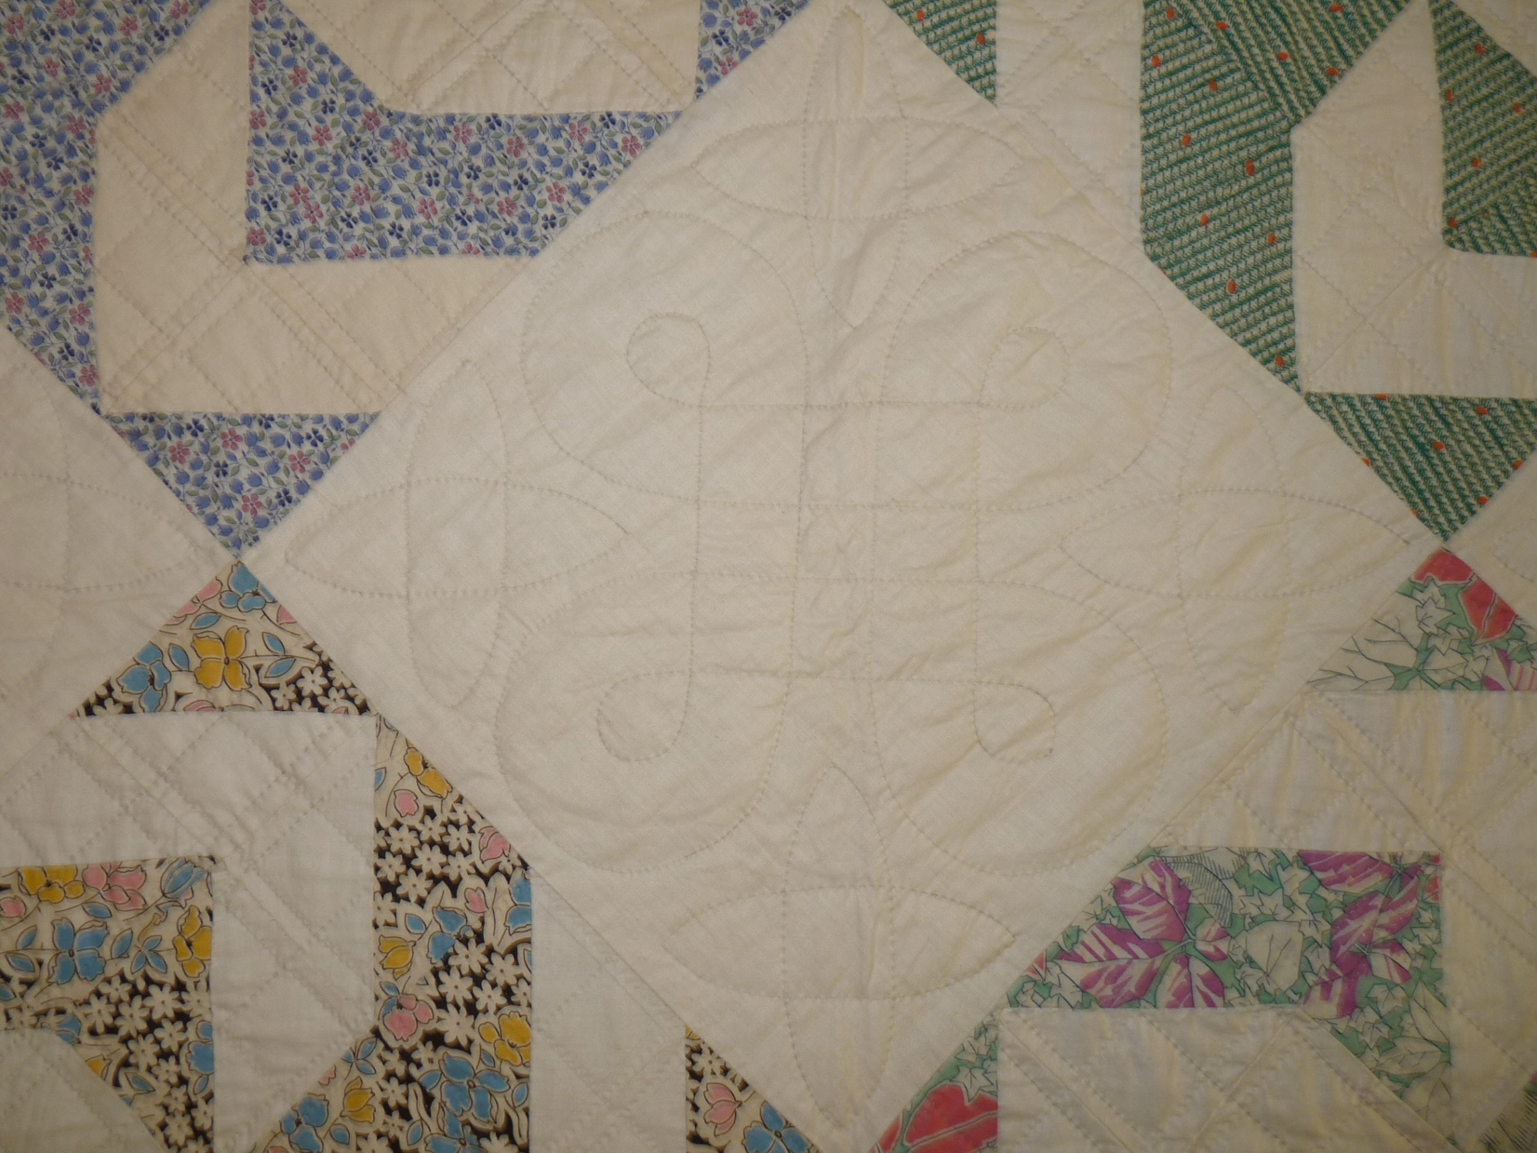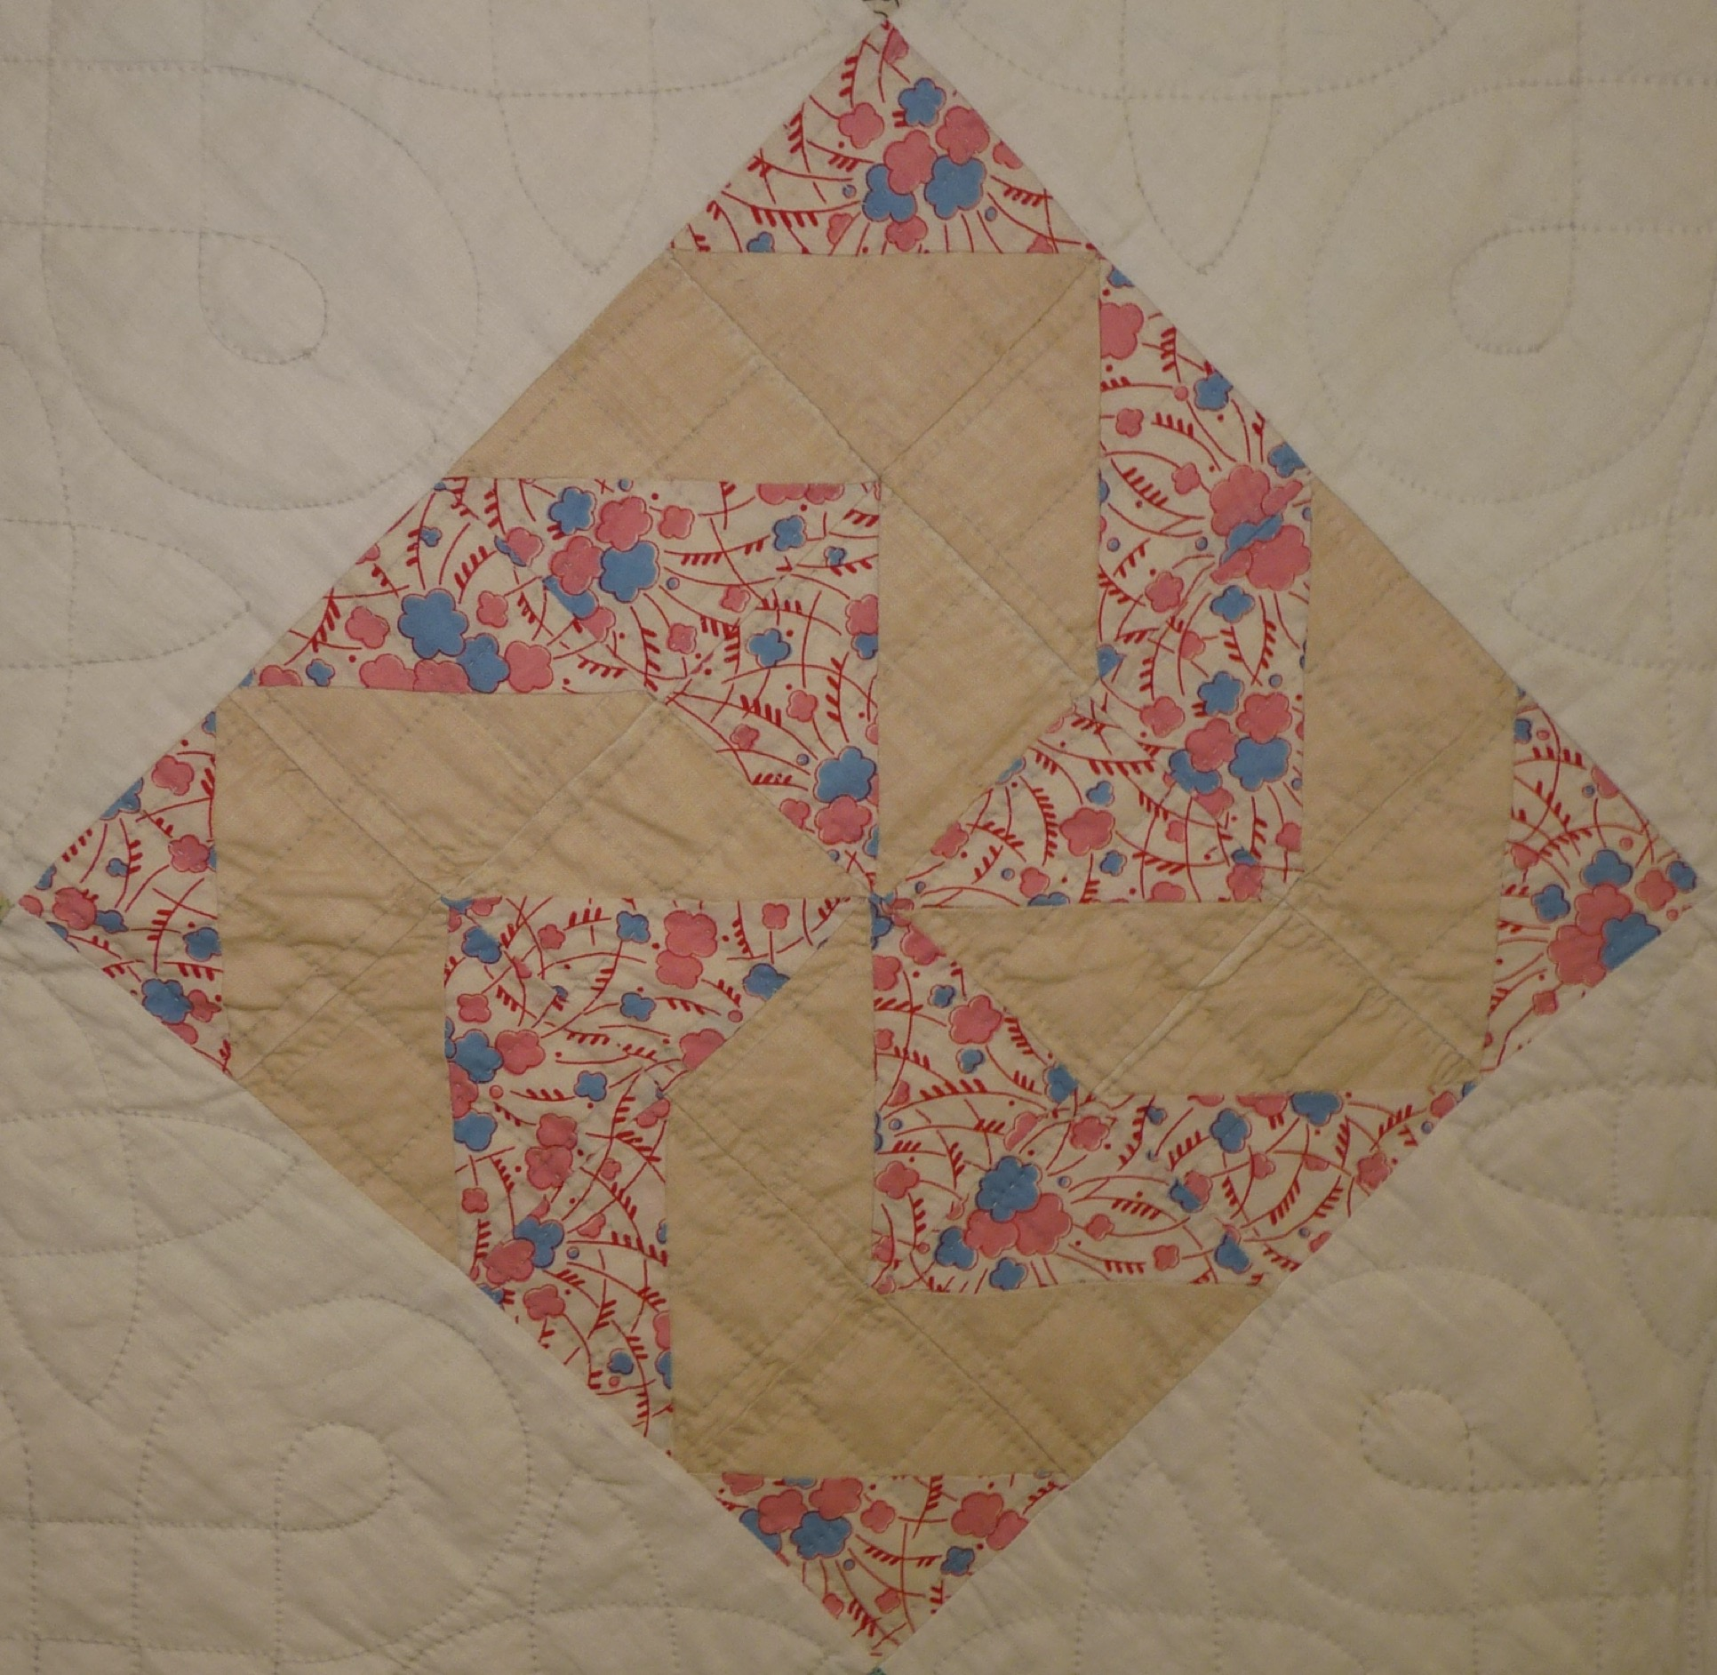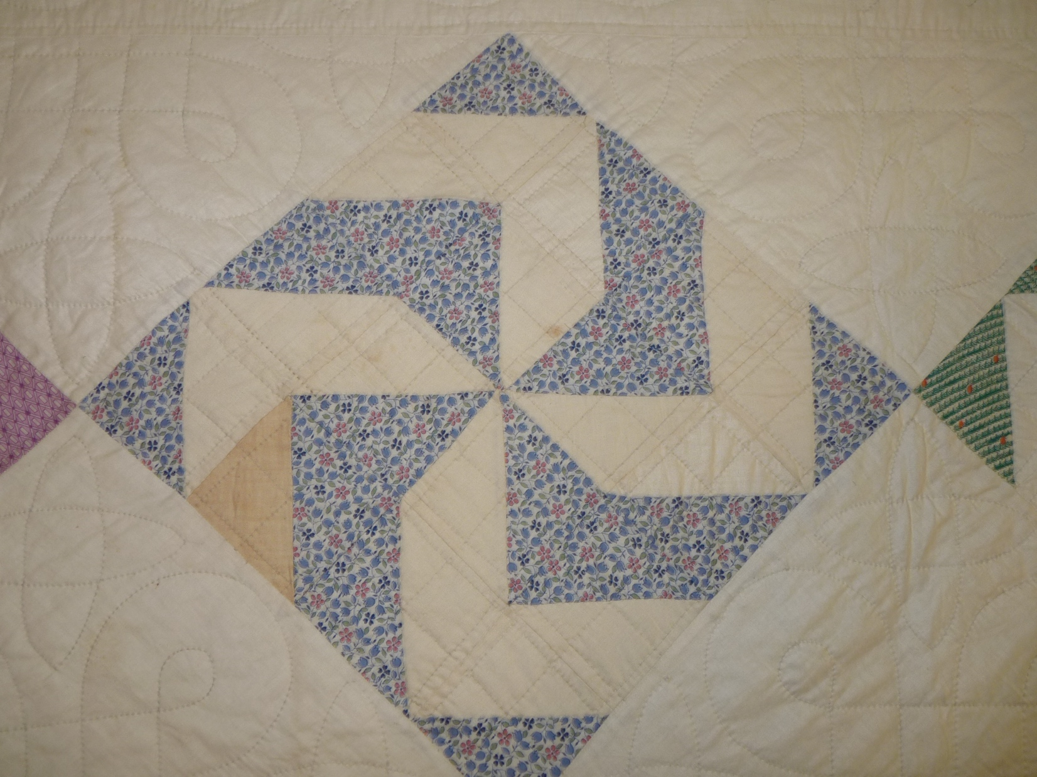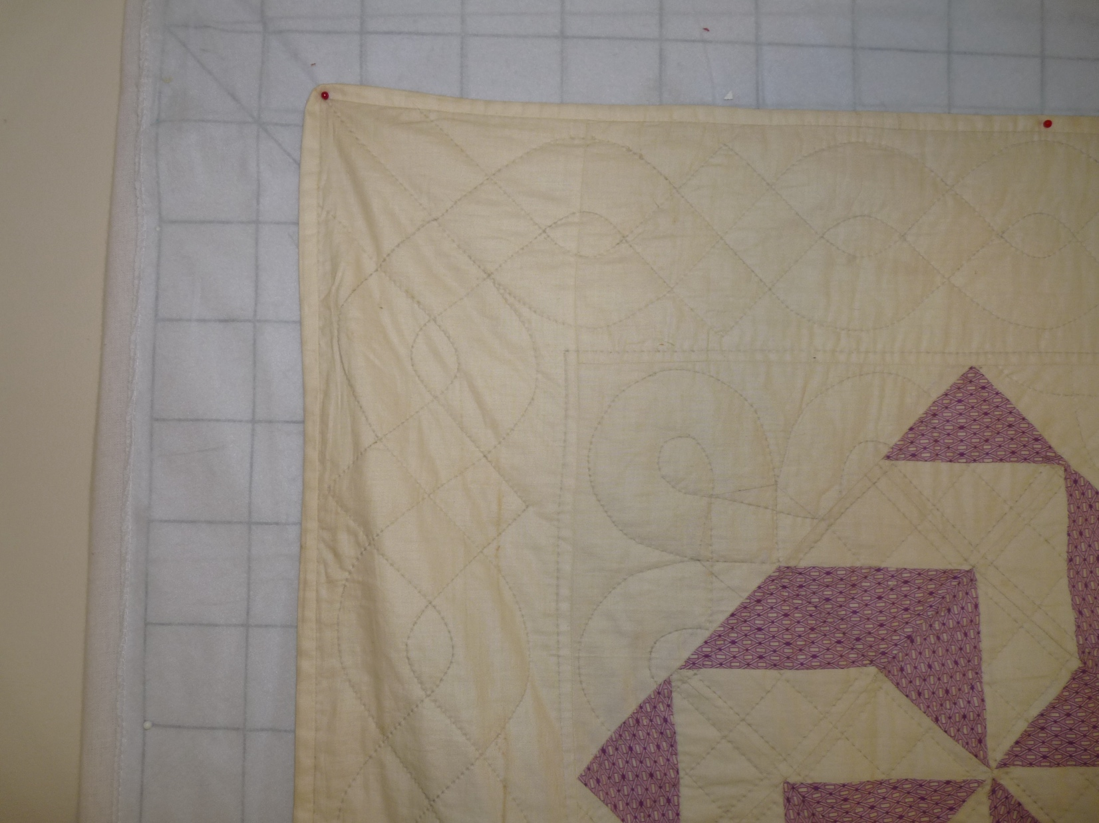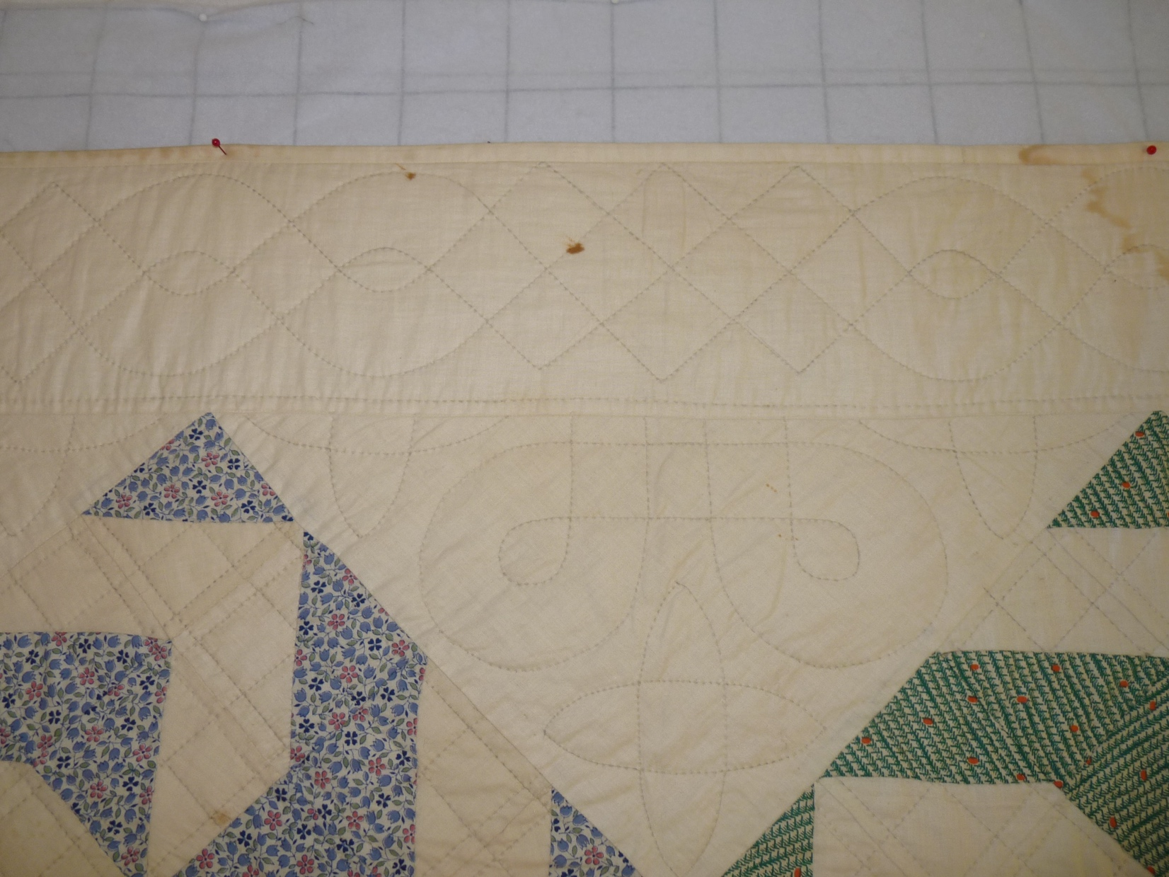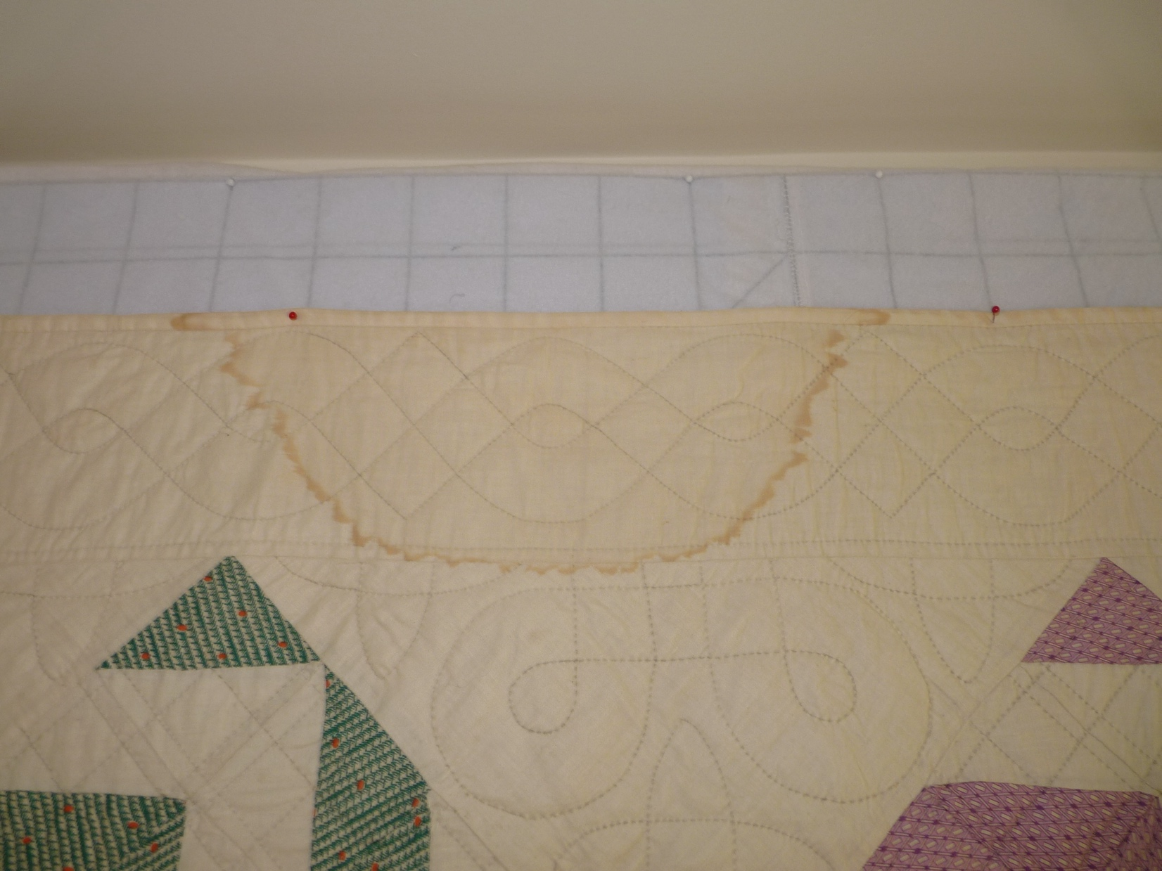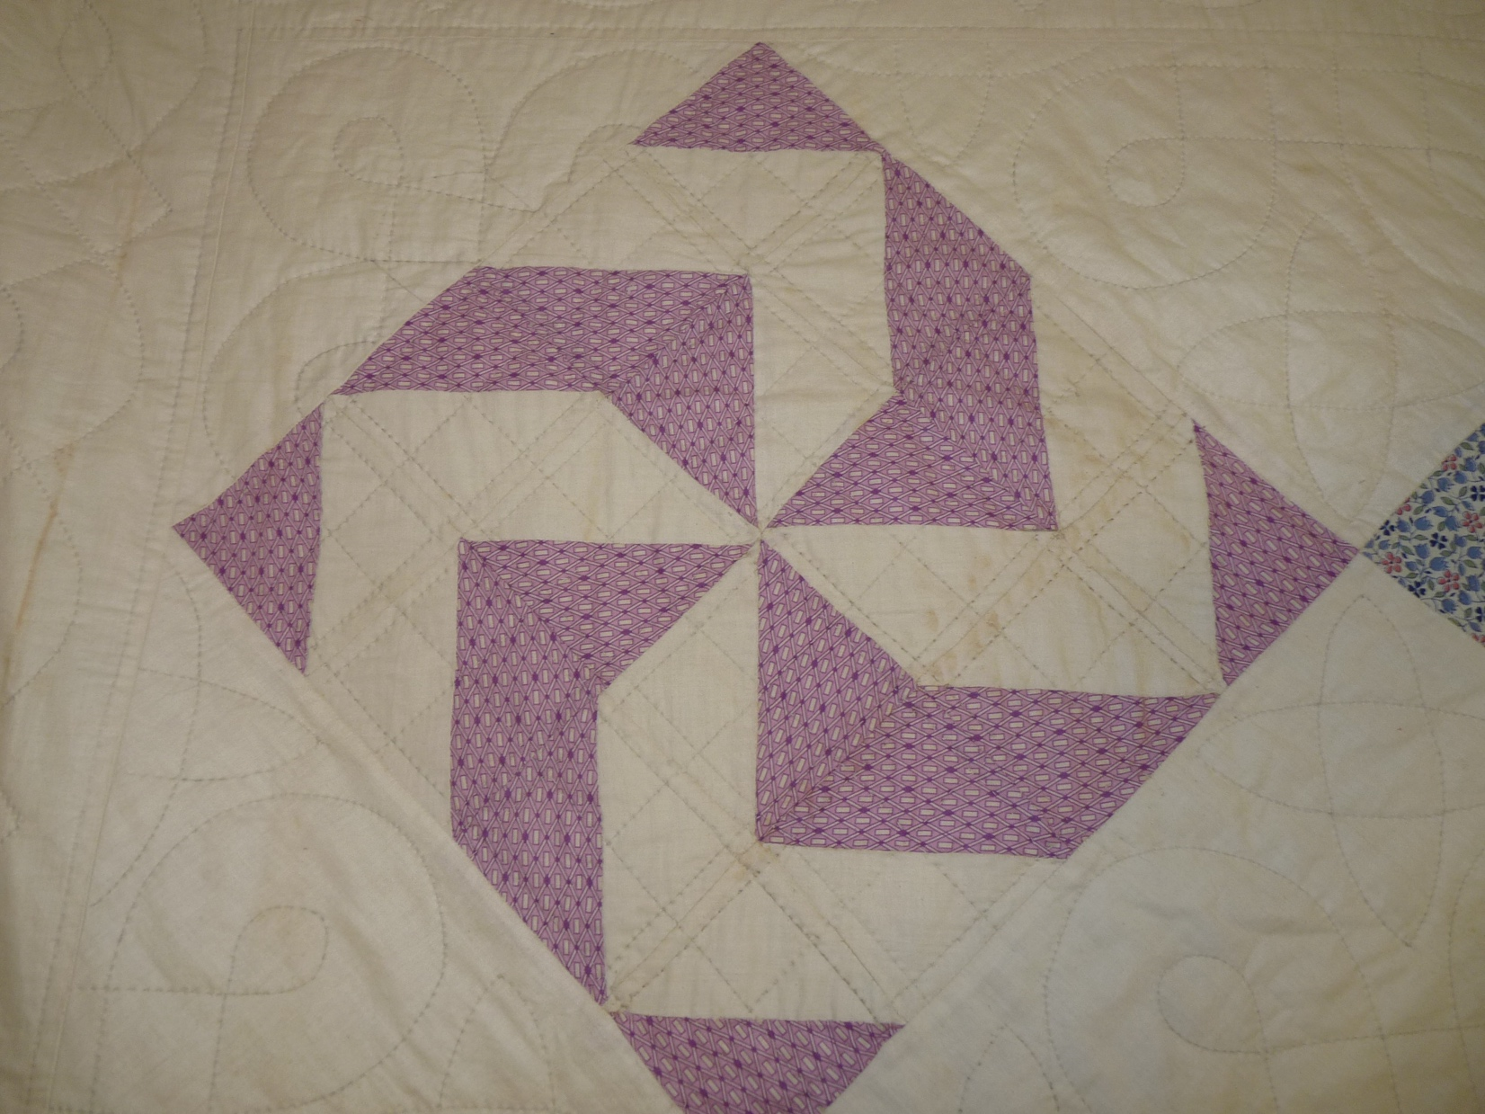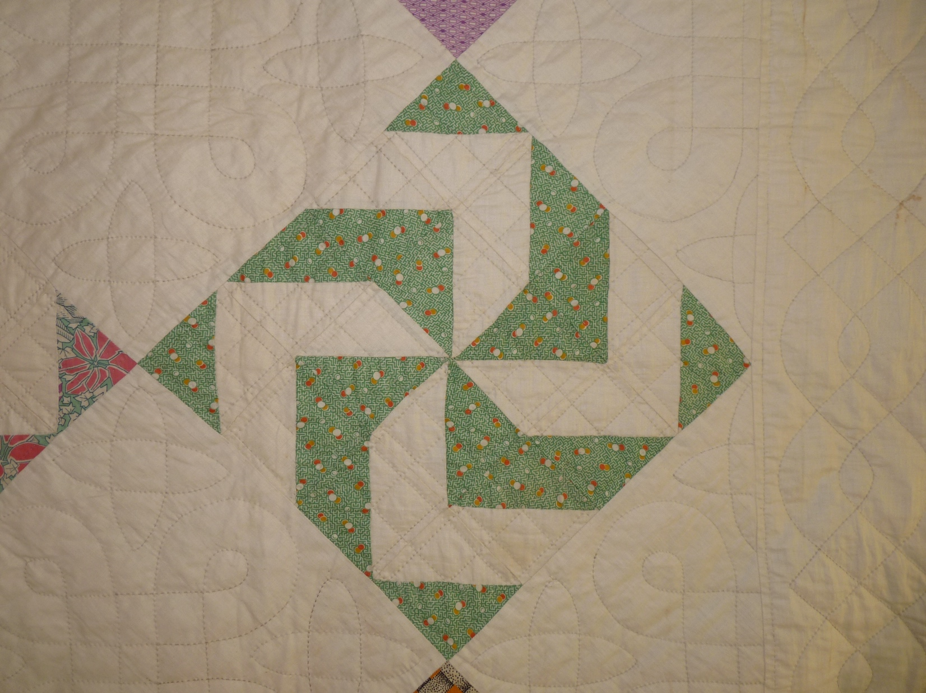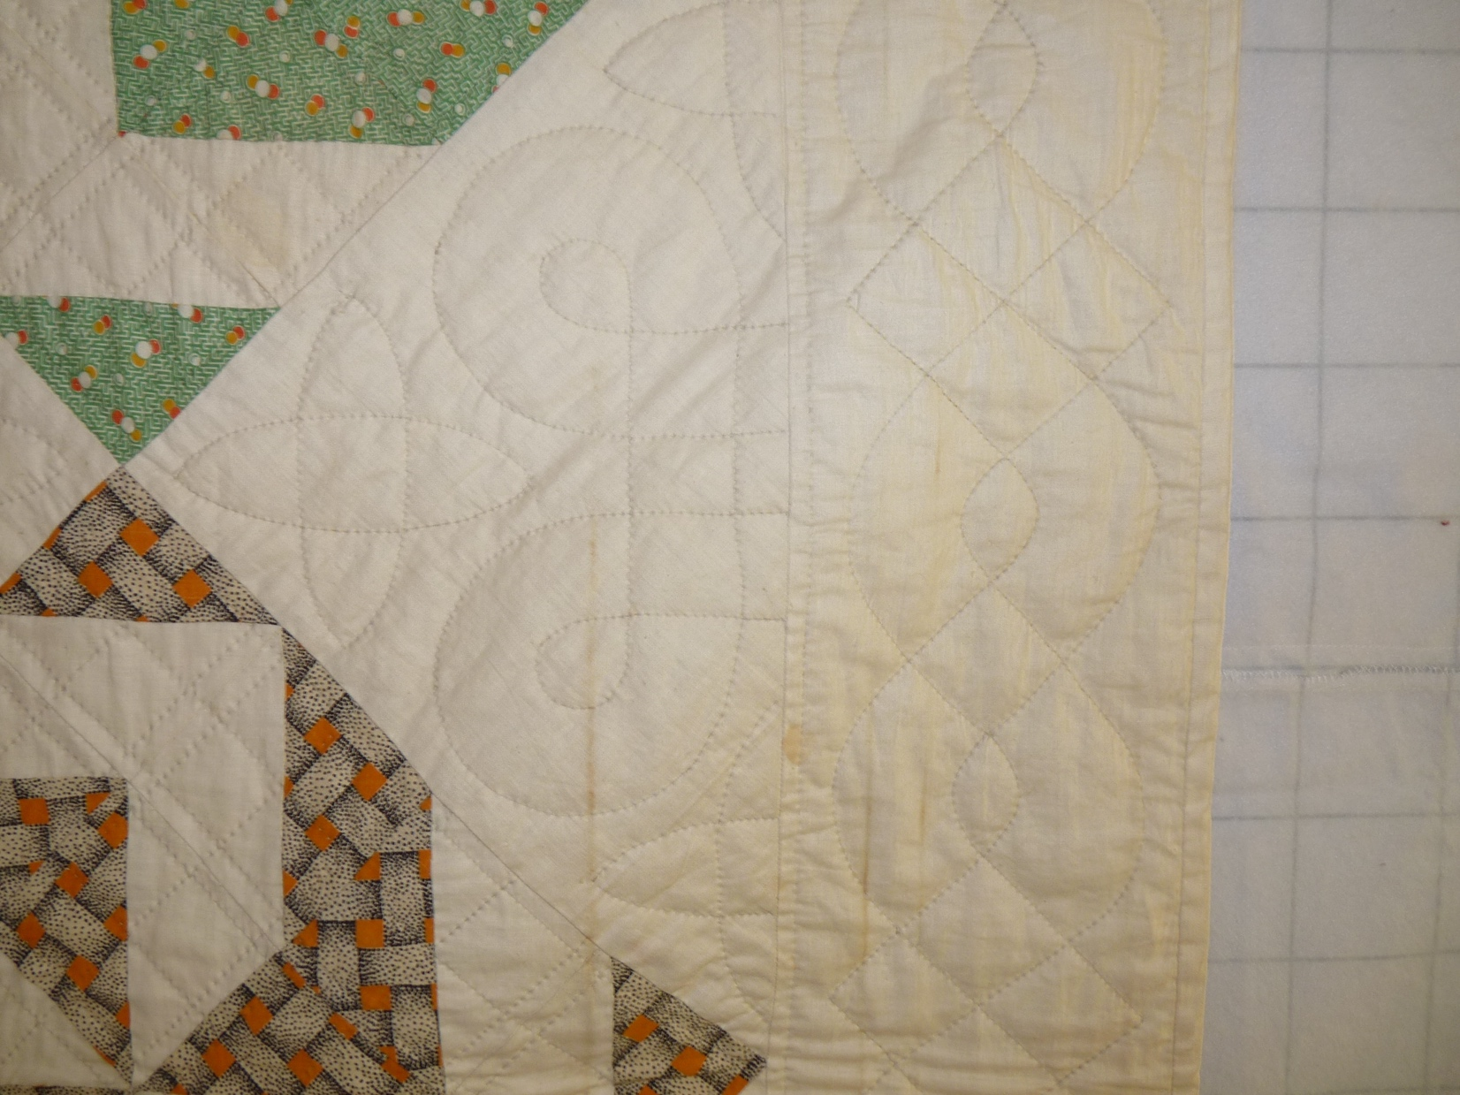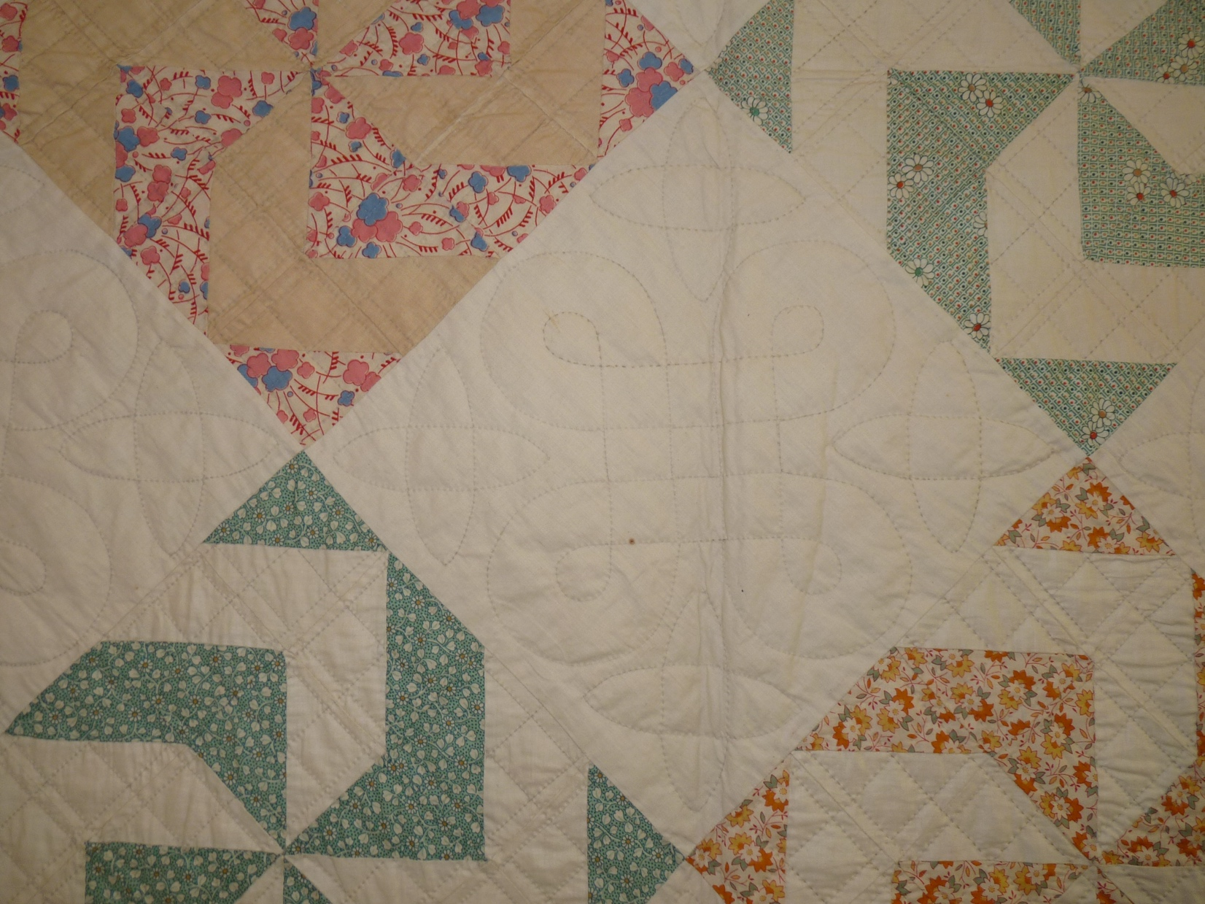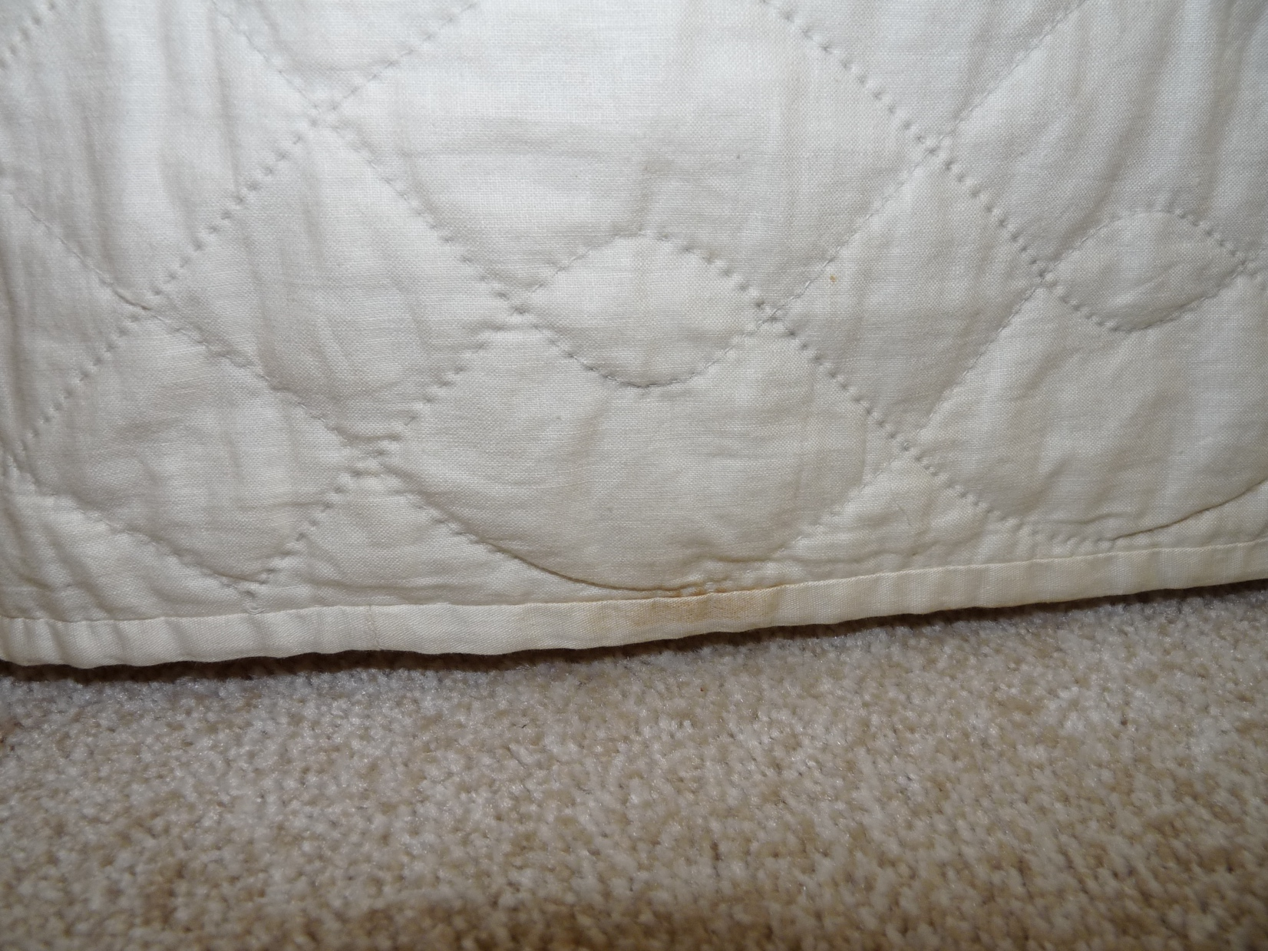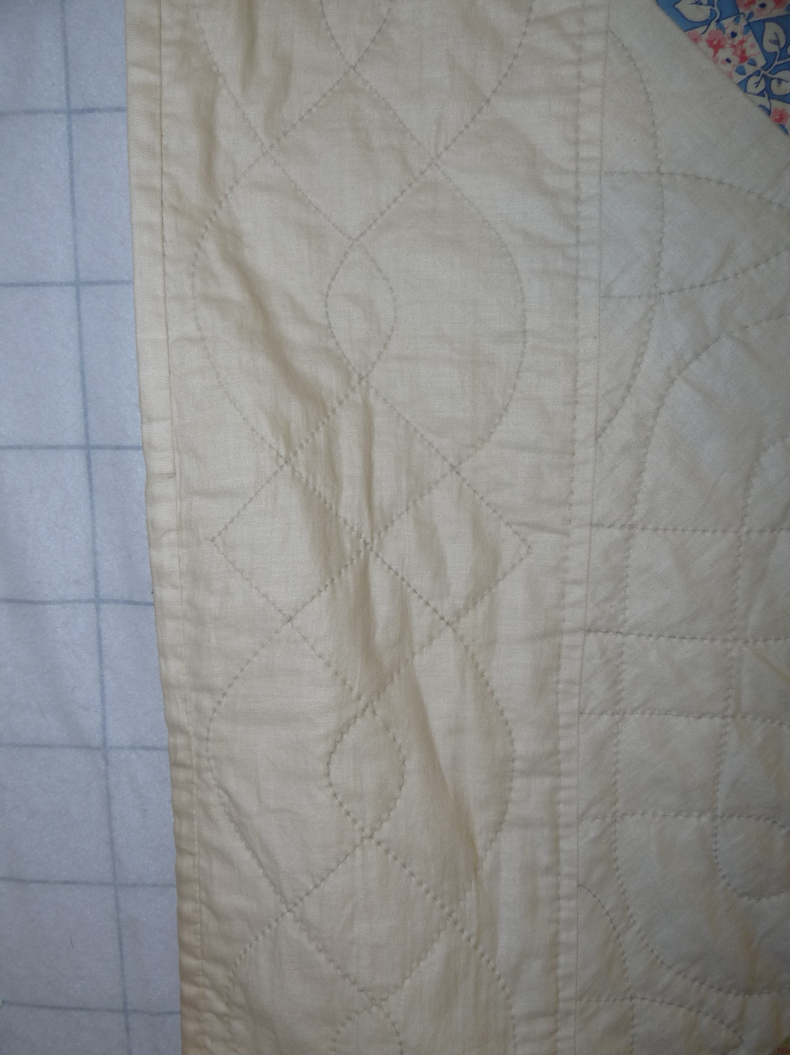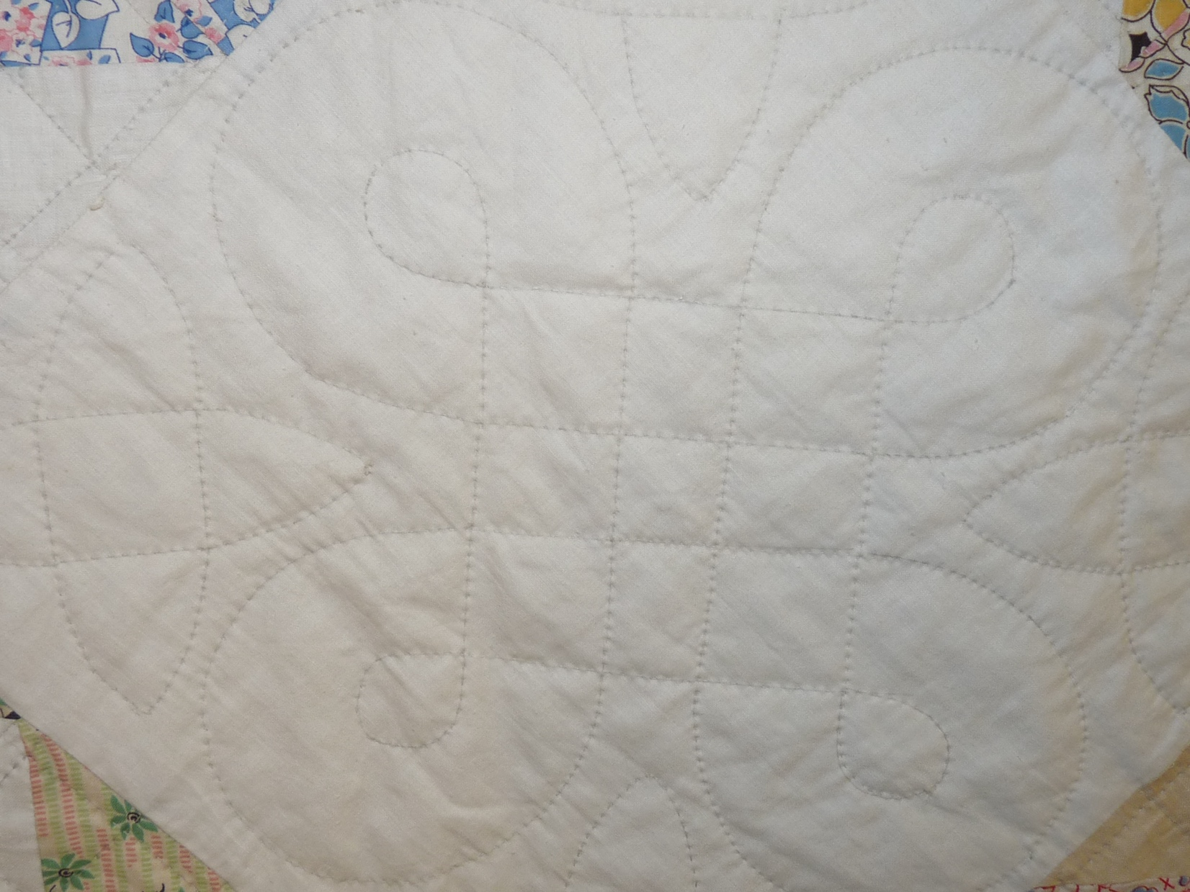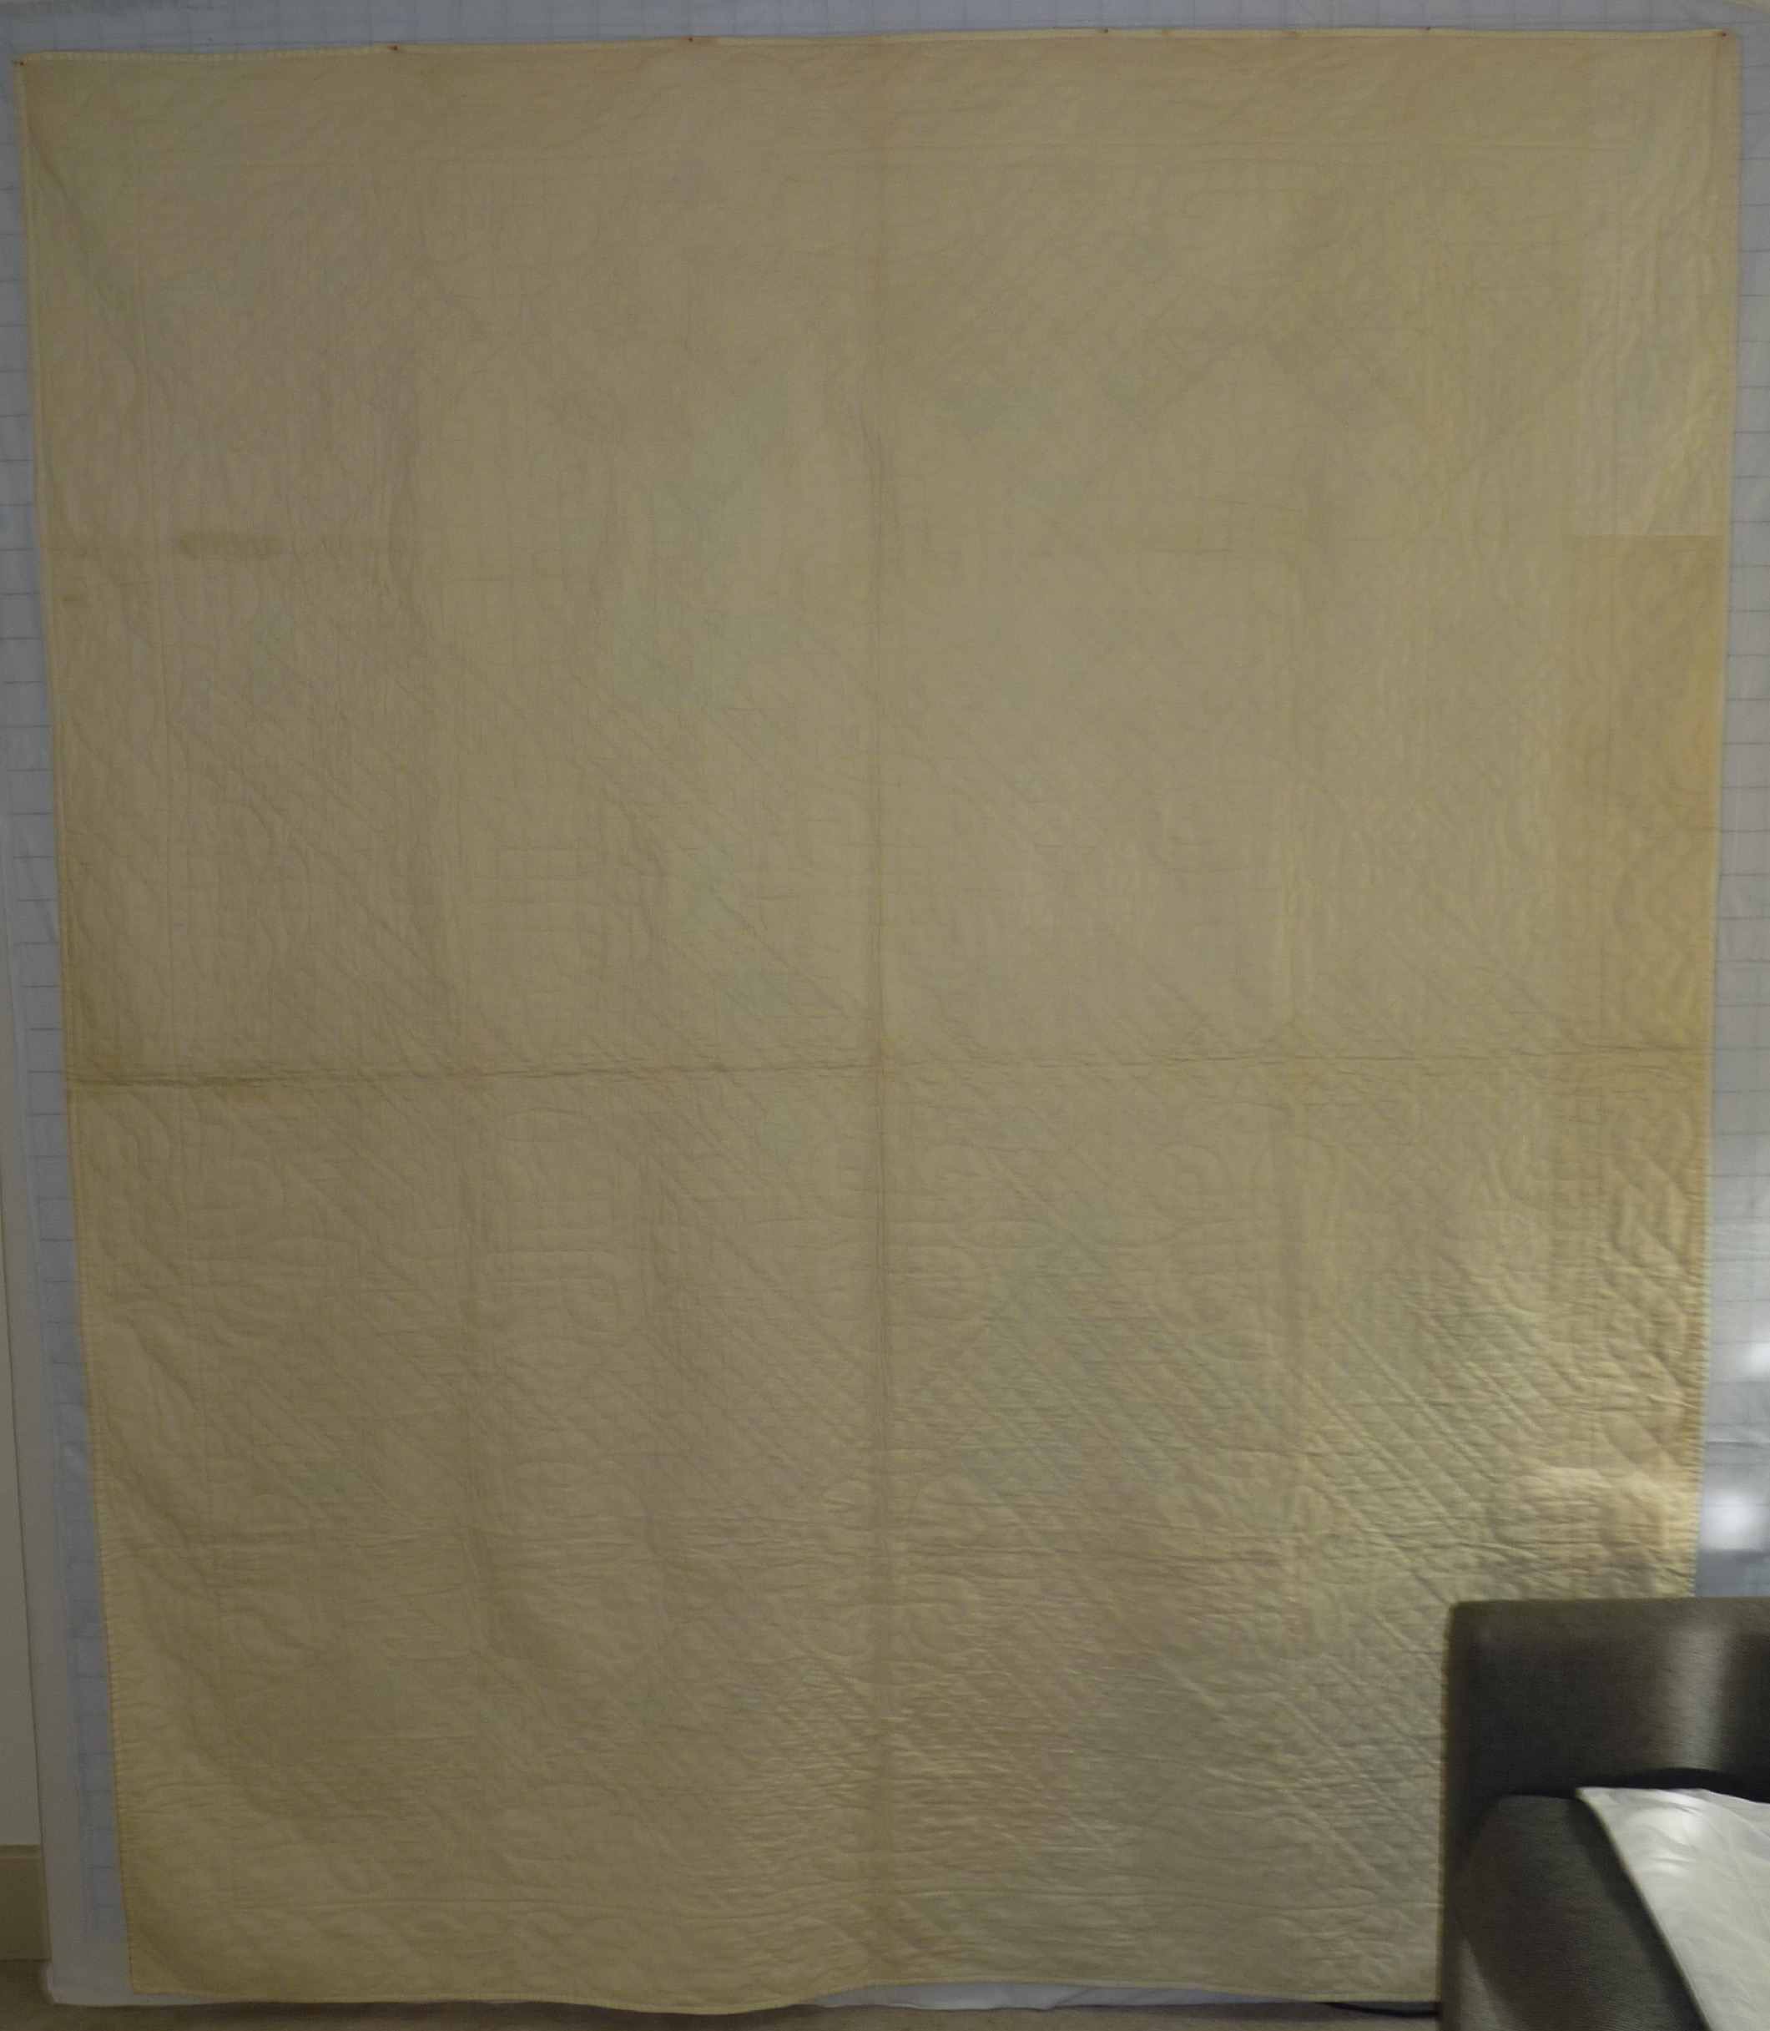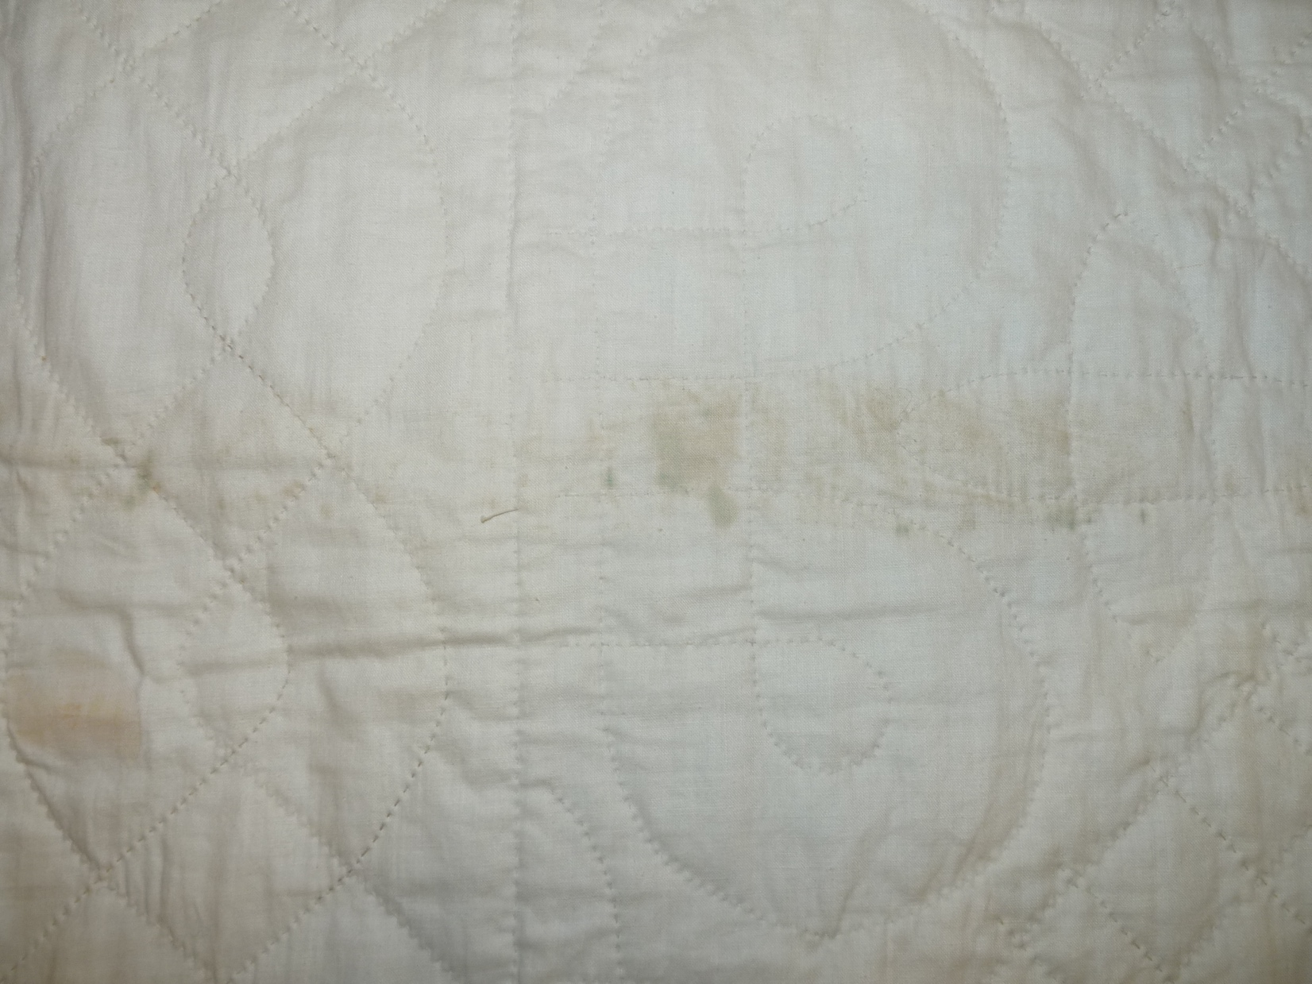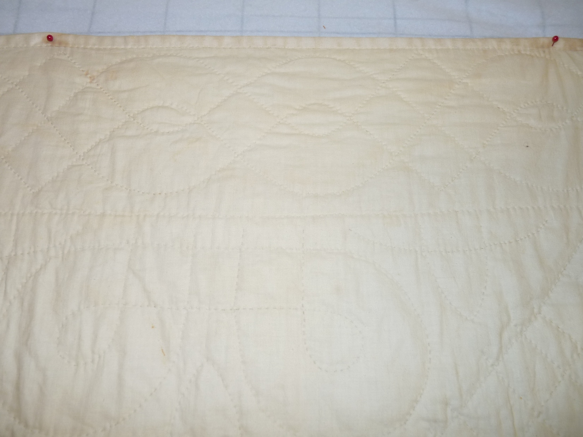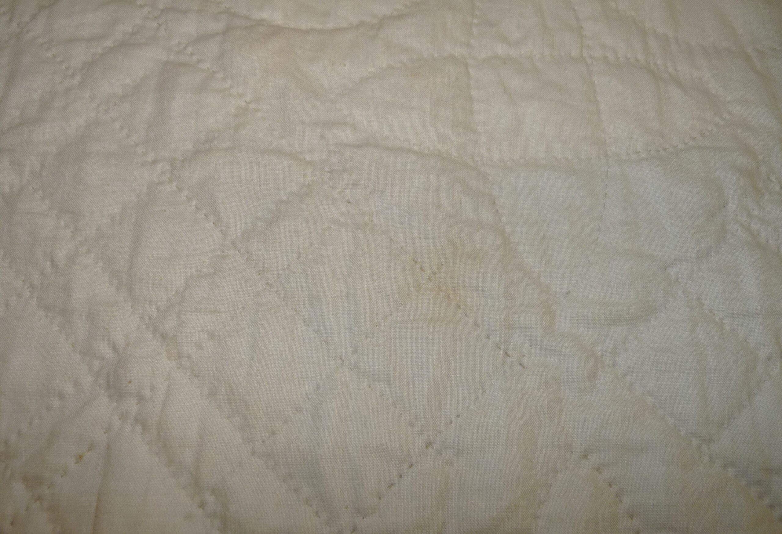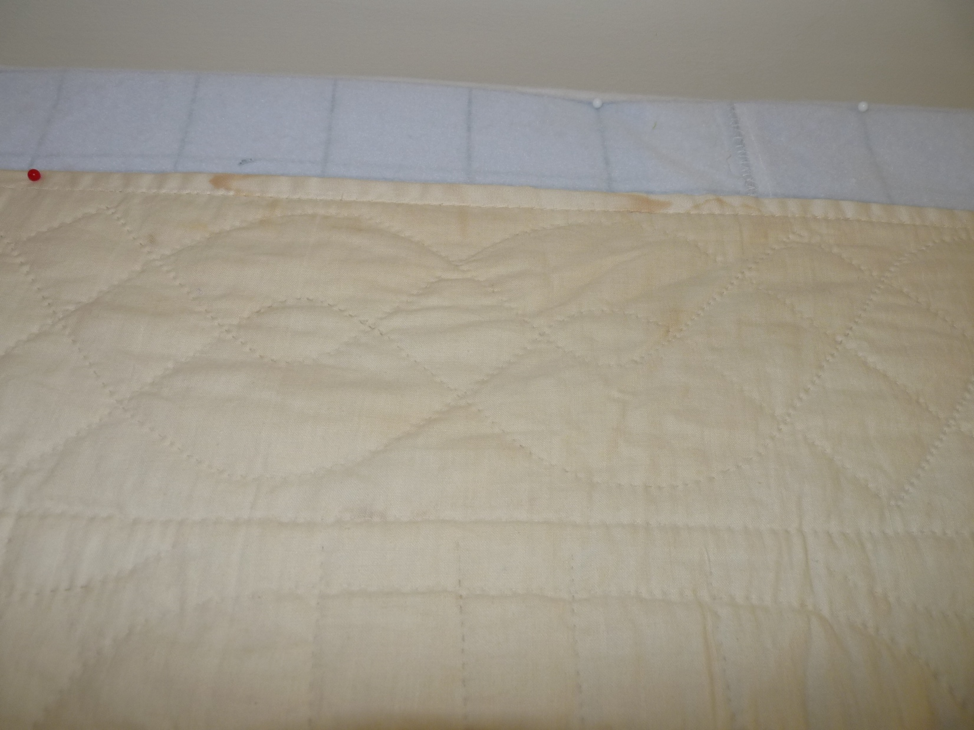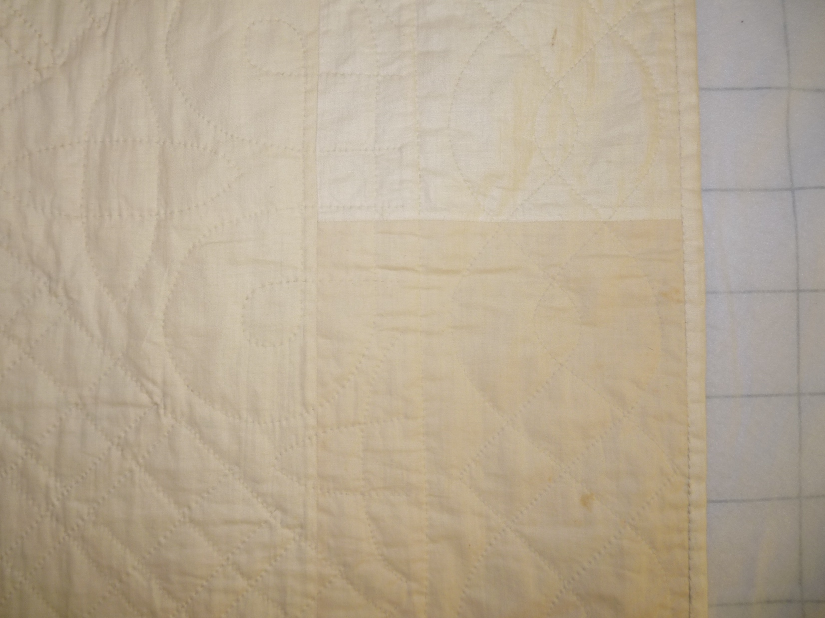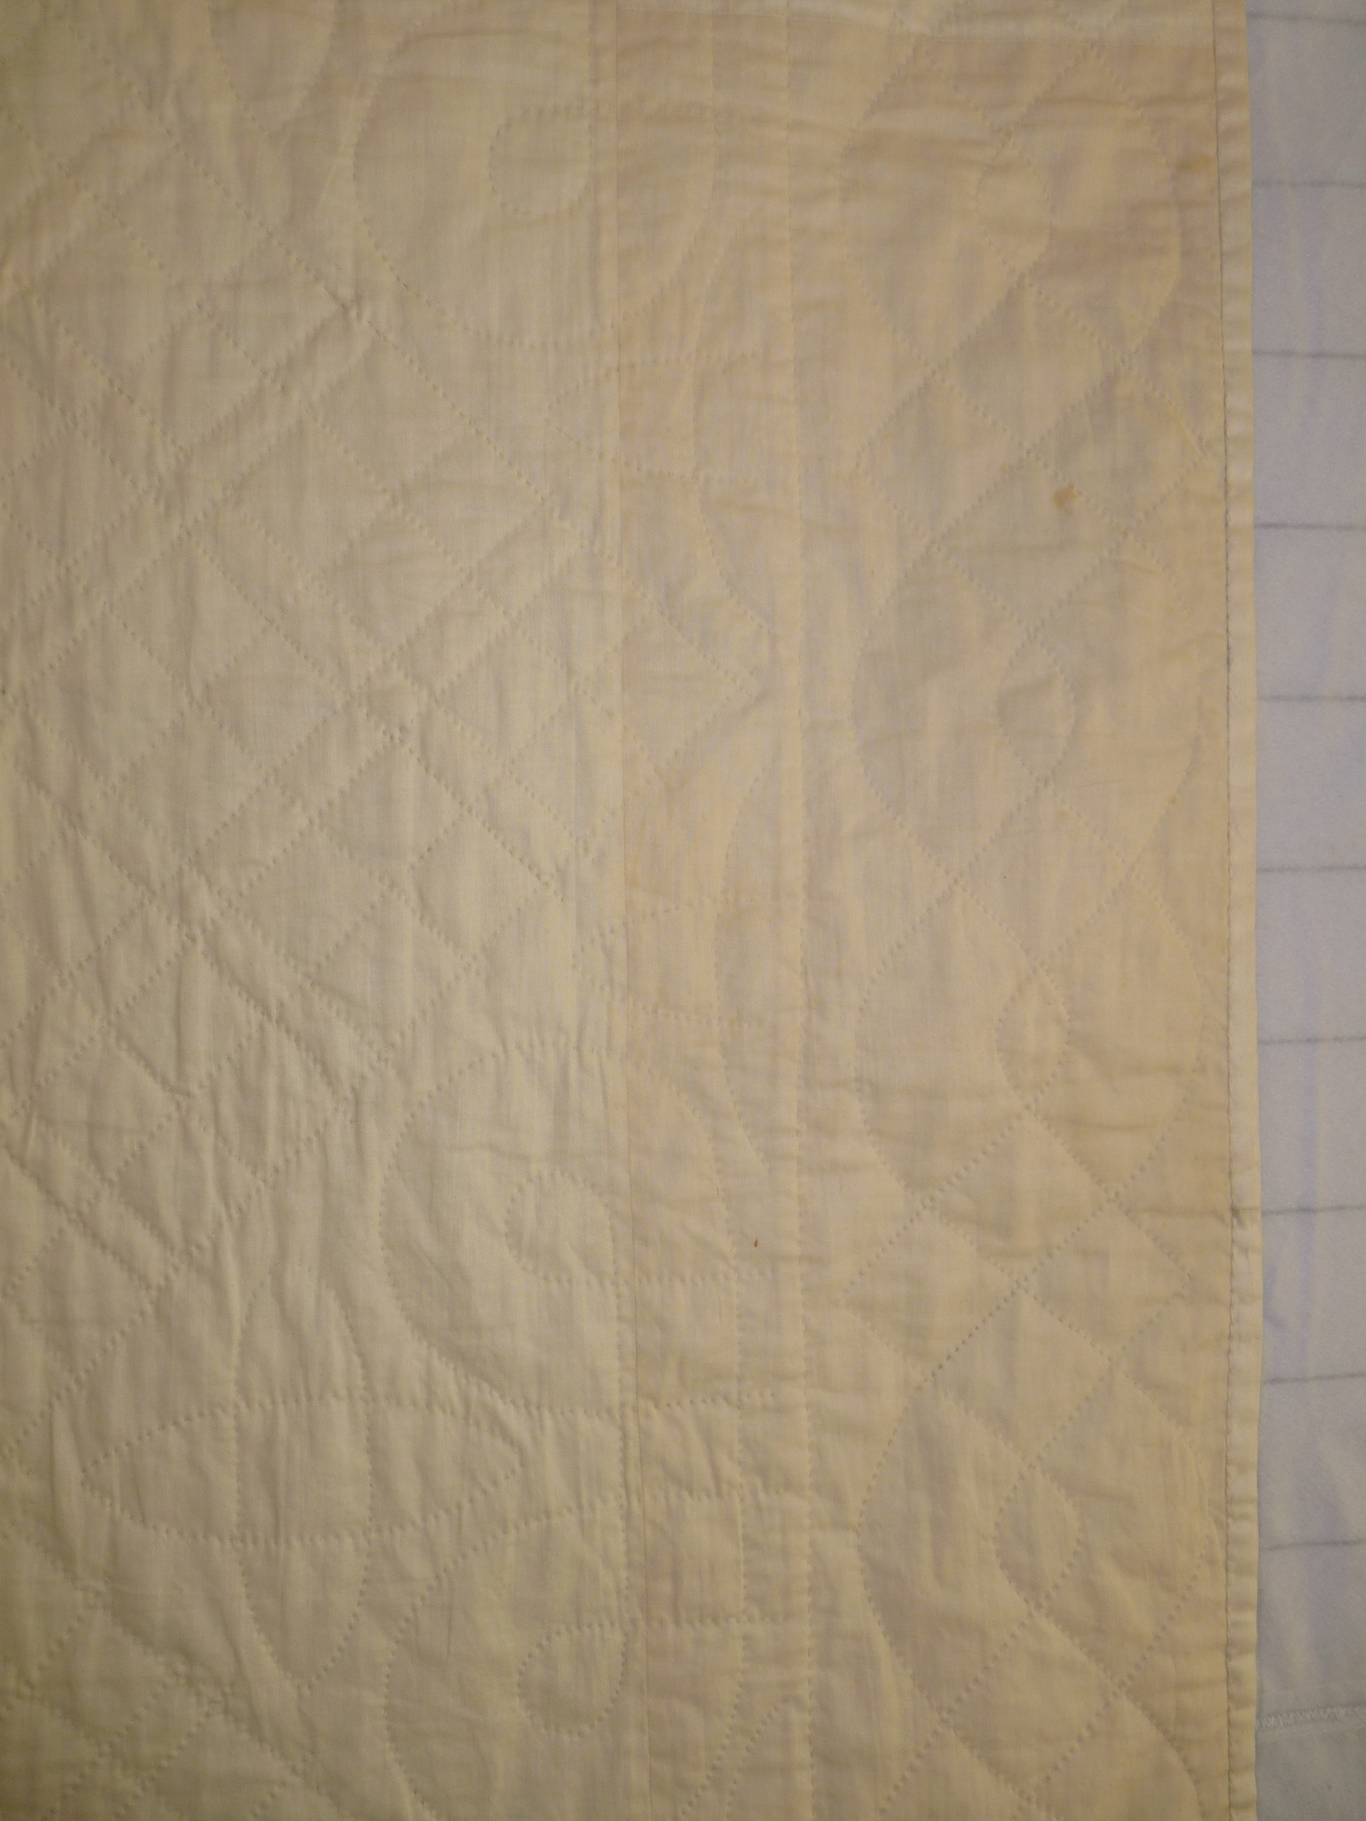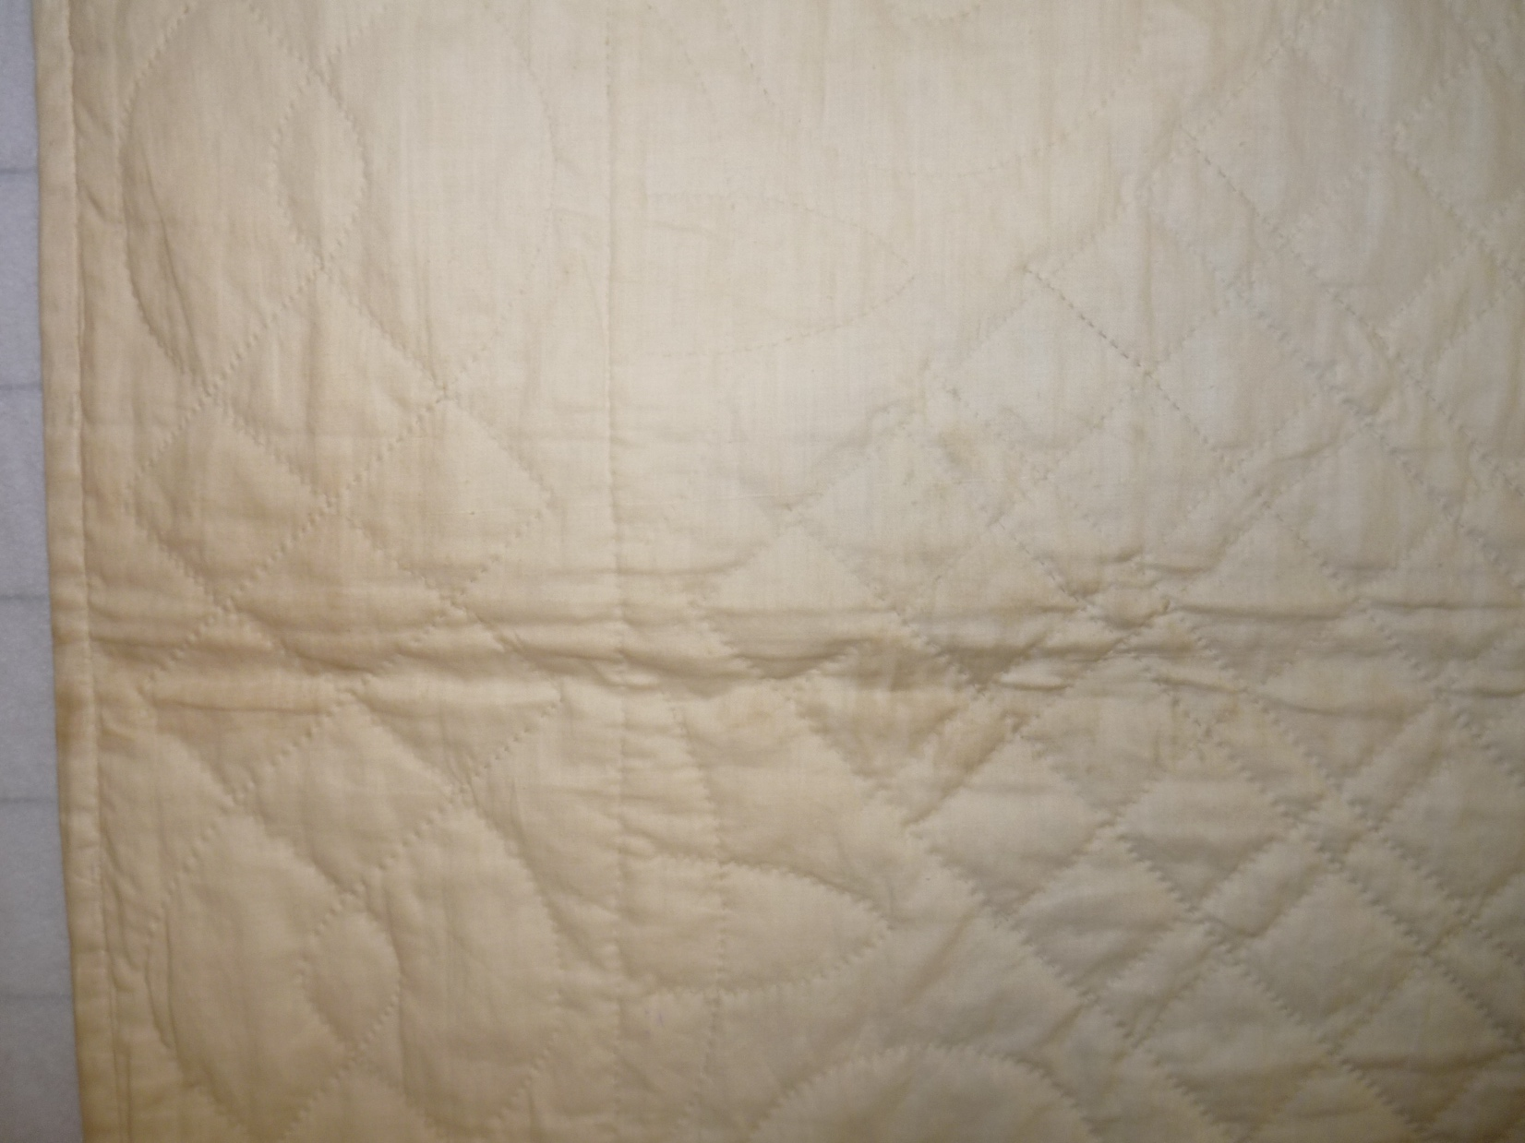

Owner History
Owner | From Date | To Date | Acquired at: | Cost
David Bailey | -- | -- | -- | $0
Made in:
--
 | If not purchased, the estimated cost for materials: $0

Display & Publication History
Date | Event | Location / Publication
-- | -- | --

General Description
Quilt Title or Name:  -- | Fabric Date Range: 1940 ± 10 Years  Date Made: 1940 ± 10 Years  Method of Determination:
Item Type:  Items in Set: 1 | Size: Length: 87“ x Width: 73“
Appraisals:  Has this quilt been professionally appraised?  If so, when: --  ----------- | Other related files:  Scanned Patterns  Images  EQ 8 Files  Research Notes
Additional Information: --

History

Provenance
Describe: --

Quilt Maker
Maker: -- |  | Birth: -- |  | Death: --
 | Location: -- |  | Contributions: --

Purpose and Context
Expression
Art | Personal Enjoyment | Therapy
Income
Personal Income | Fundraising
Presentation
Anniversary | Wedding | Birth
Holiday | Birthday | Other gift
Charitable support
Relationships
Friendship | Commemorative | Memorial
Mourning | Reunion
Skill Building
Challenge / Contest | Learning / Teaching Sample
Use
Bed Quilt | Lap Quilt | Home Décor
Baby / Crib | Wall Hanging
Describe other purpose: --

Construction History
--

Coverlet Design & Construction

Coverlet Top
Warp strand count per inch: 0. | Design: --
Warp fiber: | Weaver: --
Weft strand count per inch: 0” | Location: --
Weft fiber: | Woven for: --
Additional Information: --

Quilt Top Design & Construction

Quilt Top
Layout Design: .
Delete this & the following table rows as appropriate.
One Patch Shape Details
 |  |  | Describe: --
 | Techniques
 |  | Machine pieced | String / Improvisational piecing
 |  | Hand pieced | Foundation piecing
 |  | Strip piecing | English paper piecing
 |  | Describe: --
 | Workmanship
 |  | Seams are stable | Seams are appropriately aligned
 |  | Seams are flat | Points are sharp
 |  | Describe piecing workmanship
Medallion Details
 | Length 0.00” x Width: 0.00” |  | Describe: --
 | Describe: --
 | Techniques
 |  | Machine pieced | String / Improvisational piecing
 |  | Hand pieced | Foundation piecing
 |  | Strip piecing | English paper piecing
 |  | Describe: --
 | Workmanship
 |  | Seams are stable | Seams are appropriately aligned
 |  | Seams are flat | Points are sharp
 |  | Describe piecing workmanship
Blocks / Grid
 |  |  | Grid Dimensions: Length 0 x Width: 0
 |  |  | Block Size: Length: 0.00 “ x Width: 0.00 “
 | Describe: --
 | Pattern name & Brackman or other ID |  | <<Pattern Image>>
 | Techniques
 | Machine pieced |  | String / Improvisational piecing
 | Hand pieced |  | Foundation piecing
 | Strip piecing |  | English paper piecing
 | Describe: --
 | Workmanship
 | Seams are stable |  | Seams are appropriately aligned
 | Seams are flat |  | Points are sharp
 | Describe piecing workmanship

Embellishments
Delete this & the following table rows as appropriate.
Types:
 | Applique – Raw edge | Embroidery | Stuffed Work
 | Applique - Button-hole | Cording | Inking
 | Applique - Needle-turn | Beading | Painting
 | Applique - Reverse | Rhinestones / Gems | Marking lines noted
 | Applique - Other | Other: --
Workmanship
 | Stitches are appropriately small and even.
 | Edges are as design intends (straight, curved, pointed).
 | Work demonstrates appropriate skill for intended purpose.
 | Describe other techniques

Sashing
Delete this & the following table rows as appropriate.
 |  | Width: 0.00 “
Use of corner stones
Techniques
 | Machine pieced |  | String / Improvisational piecing
 | Hand pieced |  | Foundation piecing
 | Strip piecing |  | English paper piecing
 | Describe: --
Workmanship
 | Seams are stable |  | Seams are appropriately aligned
 | Seams are flat |  | Points are sharp
Describe: --
 | Describe piecing workmanship

Borders & Frames
Delete this & the following table rows as appropriate.
Describe borders and frames in order from center to edge.
1 | Width: 0.00“
 |  |  | Describe: --
Techniques
 |  | Machine pieced |  |  | String / Improvisational piecing
 |  | Hand pieced |  |  | Foundation piecing
 |  | Strip piecing |  |  | English paper piecing
 |  | Describe: --
Workmanship
 |  | Seams are stable |  |  | Seams are appropriately aligned
 |  | Seams are flat |  |  | Points are sharp
Describe: --
 |  | Describe piecing workmanship

Assembly
 | Seams are appropriately aligned
Seams are stable | Top has no inappropriate tucks or puckers
Seams are flat | Top lays flat with no overly full areas
Describe: --

Color
Predominant colors
 | Red | Blue | Black
 | Orange | Violet/Purple | Grey
 | Yellow | Brown | White
 | Green | Beige / Tan
Specific Antique Colors |  | NONE NOTED | Neon prints
 | Red – claret / wine | Yellow – chrome | Blue – Lancaster
 | Red – madder / cinnamon | Green - chrome | Blue – Prussian / Lafayette
 | Red – turkey | Green – Nile | Brown – madder
 | Pinks - double | Blue – Cadet | Butterscotch
 | Orange - madder | Blue - Indigo | Bronze
 | Orange – cheddar / antimony / chrome |  | Late 1800’s Purple
Describe: --

Materials
Sources of Fabric |  | NOT KNOWN
 | Companies | Fabric Name & Number | Designer
 | -- | -- | --
 | Describe other sources: --
Fiber Types |  | NOT YET IDENTIFIED
 | Cotton | Silk | Wool
 | Cotton Blend | Linen | Synthetic
 | Describe & Clarify: --
Fabric Types |  | NOT KNOWN
 | Broadcloth | Sateen | Upholstery
 | Flannel | Satin | Chintz
 | Shirting | Muslin | Glazed
 | Suiting | Velvet | Handwoven
 | Denim | Felt | Lindsey-Woolsey
 | Describe & Clarify: --
Print Types |  | NOT YET IDENTIFIED
 | Batik | Floral | Multiple scraps
 | Cheater Panel | Garibaldi Red Prints | Paisley
 | Checked / Gingham | Geometric | Plaid
 | Conversation / Novelty | Hand-dyed | Solid / Plain
 | Dotted | Victorian Mourning Prints | Stamped
 | Feed sack / Feed sack-like |  | Stripes
Describe & Clarify: --

Images

Inscriptions
None Found
Inscription is present. Describe location: --
Content
Makers names | Initials | Date
Single Name | Message | Place
Multiple Names
Transcription: --

Methods
Label | Ink – Ball point | Stencil
Printed onto fabric | Ink – Felt tip | Stamped
Quilted | Ink - Other | Pencil
Embroidery | Applique | Typewriter
Describe & Clarify: --

Images for Inscriptions

Quilt Back Design & Construction

Quilt Back
Layout Design: .
Delete this & the following table rows as appropriate.
One Patch Shape Details
 |  |  | Describe: --
 | Techniques
 |  | Machine pieced | String / Improvisational piecing
 |  | Hand pieced | Foundation piecing
 |  | Strip piecing | English paper piecing
 |  | Describe: --
 | Workmanship
 |  | Seams are stable | Seams are appropriately aligned
 |  | Seams are flat | Points are sharp
 |  | Describe piecing workmanship
Medallion Details
 | Length 0.00” x Width: 0.00” |  | Describe: --
 | Describe: --
 | Techniques
 |  | Machine pieced | String / Improvisational piecing
 |  | Hand pieced | Foundation piecing
 |  | Strip piecing | English paper piecing
 |  | Describe: --
 | Workmanship
 |  | Seams are stable | Seams are appropriately aligned
 |  | Seams are flat | Points are sharp
 |  | Describe piecing workmanship
Blocks / Grid
 |  |  | Grid Dimensions: Length 0 x Width: 0
 |  |  | Block Size: Length: 0.00 “ x Width: 0.00 “
 | Describe: --
 | Pattern name & Brackman or other ID |  | <<Pattern Image>>
 | Techniques
 | Machine pieced |  | String / Improvisational piecing
 | Hand pieced |  | Foundation piecing
 | Strip piecing |  | English paper piecing
 | Describe: --
 | Workmanship
 | Seams are stable |  | Seams are appropriately aligned
 | Seams are flat |  | Points are sharp
 | Describe piecing workmanship

Embellishments
Delete this & the following table rows as appropriate.
Types:
 | Applique – Raw edge | Embroidery | Stuffed Work
 | Applique - Button-hole | Cording | Inking
 | Applique - Needle-turn | Beading | Painting
 | Applique - Reverse | Rhinestones / Gems | Marking lines noted
 | Applique - Other | Other: --
Workmanship
 | Stitches are appropriately small and even.
 | Edges are as design intends (straight, curved, pointed).
 | Work demonstrates appropriate skill for intended purpose.
 | Describe other techniques

Sashing
Delete this & the following table rows as appropriate.
 |  | Width: 0.00 “
Use of corner stones
Techniques
 | Machine pieced |  | String / Improvisational piecing
 | Hand pieced |  | Foundation piecing
 | Strip piecing |  | English paper piecing
 | Describe: --
Workmanship
 | Seams are stable |  | Seams are appropriately aligned
 | Seams are flat |  | Points are sharp
Describe: --
 | Describe piecing workmanship

Borders & Frames
Delete this & the following table rows as appropriate.
Describe borders and frames in order from center to edge.
1 | Width: 0.00“
 |  |  | Describe: --
Techniques
 |  | Machine pieced |  |  | String / Improvisational piecing
 |  | Hand pieced |  |  | Foundation piecing
 |  | Strip piecing |  |  | English paper piecing
 |  | Describe: --
Workmanship
 |  | Seams are stable |  |  | Seams are appropriately aligned
 |  | Seams are flat |  |  | Points are sharp
Describe: --
 |  | Describe piecing workmanship

Assembly
 | Seams are appropriately aligned
Seams are stable | Top has no inappropriate tucks or puckers
Seams are flat | Top lays flat with no overly full areas
Describe: --

Color
Predominant colors
 | Red | Blue | Black
 | Orange | Violet/Purple | Grey
 | Yellow | Brown | White
 | Green | Beige / Tan
Specific Antique Colors |  | NONE NOTED | Neon prints
 | Red – claret / wine | Yellow – chrome | Blue – Lancaster
 | Red – madder / cinnamon | Green - chrome | Blue – Prussian / Lafayette
 | Red – turkey | Green – Nile | Brown – madder
 | Pinks - double | Blue – Cadet | Butterscotch
 | Orange - madder | Blue - Indigo | Bronze
 | Orange – cheddar / antimony / chrome |  | Late 1800’s Purple
Describe: --

Materials
Sources of Fabric |  | NOT KNOWN
 | Companies | Fabric Name & Number | Designer
 | -- | -- | --
 | Describe other sources: --
Fiber Types |  | NOT YET IDENTIFIED
 | Cotton | Silk | Wool
 | Cotton Blend | Linen | Synthetic
 | Describe & Clarify: --
Fabric Types |  | NOT KNOWN
 | Broadcloth | Sateen | Upholstery
 | Flannel | Satin | Chintz
 | Shirting | Muslin | Glazed
 | Suiting | Velvet | Handwoven
 | Denim | Felt | Lindsey-Woolsey
 | Describe & Clarify: --
Print Types |  | NOT YET IDENTIFIED
 | Batik | Floral | Multiple scraps
 | Cheater Panel | Garibaldi Red Prints | Paisley
 | Checked / Gingham | Geometric | Plaid
 | Conversation / Novelty | Hand-dyed | Solid / Plain
 | Dotted | Victorian Mourning Prints | Stamped
 | Feed sack / Feed sack-like |  | Stripes
Describe & Clarify: --

Images

Inscriptions
None Found
Inscription is present. Describe location: --
Content
Makers names | Initials | Date
Single Name | Message | Place
Multiple Names
Transcription: --

Methods
Label | Ink – Ball point | Stencil
Printed onto fabric | Ink – Felt tip | Stamped
Quilted | Ink - Other | Pencil
Embroidery | Applique | Typewriter
Describe & Clarify: --

Images for Inscriptions

Stabilization Method
Stabilization Method:
Delete this & the following table rows as appropriate.
Tied Details
 | Average Distance Between Knots: 0” |  | Placement:
 |  |  | Fiber Used:
Quilting Details
Batting
Quilting Techniques
 | Machine Quilted | Machine – sit-down |  | Corded
 | Machine – computer guided | Hand Quilted |  | Stuffed work
 | Machine – manual long-arm | Quilt-as-you-go
 | Describe: --
Quilting Patterns
 | Meander / Free motion | Lines – single parallel |  | Cables
 | In-the-ditch / To the piece | Lines – double parallel |  | Feathers
 | Echo / Outlined | Lines – triple parallel |  | Wreaths
 | Stipple | Grid – crosshatch |  | Vines
 | Clamshell | Grid – square |  | Floral
 | Elbow / Fan | Grid - diamond |  | Leaves
 | Describe other: --
Thread Choices
 | Brand | Weight |  | Number & Name
 | -- | -- |  | --
Describe: --
Images for Stabilization

Edge Finish
Edge Style:
Finishing Technique
Top Width: 0.00 “ | Binding | Rolled – top to back
Back Width: 0.00“ | Knife edge | Rolled – back to top
1/8 = 0.13, 3/8 = 0.38 | Turned with a closure
5/8 = 0.63, 7/8 = 0.88
Application Method: | Top: | Back:
Embellishments
Fringe | Ruffles | Cording
Lace | Ribbon
Describe: --

Images for Edge

Condition

Flaws
Soiling
Dirty | Stains
Mildew stains | Musty Smell
Discoloration
Running / fugitive color | Faded / bleached color | Crocking
Fabric Damage
Tears / holes | Disintegrating / fall out | Insect damage
Thread bare | Shattering
Sewing / Quilting Damage
Split / open seams | Ties / tufting missing | Embellishments missing
Quilting threads missing | Batting has shifted
Storage Issues
Discoloration from wood | Damage from acid | Fold marks / creases
Describe additional condition issues: --
Images for Condition Issues

Conservation, Restoration, Repairs
Describe Measures: --

Workmanship

Extension of Useful Life
Repair | Useful life of the item was extended.
Prevention of Damage
Conservation | All work is reversible.
Conservation | Further deterioration has been slowed, stabilized or prevented.
Maintaining Function & Integrity
Conservation | Work minimally interferes with the item’s overall appearance.
Restoration | Work blends well with the item’s overall appearance, style and age.
Restoration | Appropriate period reproductions were used.
Restoration | Vintage materials were used.
Restoration | Period appropriate techniques were used.
Restoration | Workmanship is of similar or better quality than original work.

Images for Conservation / Restoration / Repairs

History & Provenance
- Work Credit: unknown
- Date Made: circa 1940. Some fabric may be as early 1920’s.
- Ownership History:
  - David Bailey: From December 23, 2021.
  - Documented by David Bailey

Overall
Size
- Length: 89″
- Width: 75″
Condition
- Very Good
- Some stains. The largest one is at a distance from the pieced fabric.

Top
Fabric Description
- Cotton
- Prints / Solids
- Yardage
- Predominant Colors: White, Blues, Greens, some reds, yellows, pinks.
General Organization
- Grid
  - 4 x 5 grid of pieced blocks.
  - Unit Description
    - Unit Name: Winding Blade
    - Width: –“
    - Length: –“
  - Setting: Straight Setting, On-Point
    - Setting Triangles: –” x — “
    - Setting Blocks: –” x — “
    - Corner Triangles: –” x — “
- Borders
  - 1 border on each side. – Same color as background fabric.
  - Describe: work from innermost frame to outermost frame.
    - Width
    - Strips
    - Full Across Length (Vertical)
- Techniques: Patchwork
- Stitching Method: Machine / Hand
- Workmanship of Piecing: Very Good
- Workmanship of Setting: Very Good
- Other Descriptions: Different background fabric is used in two locations. The most prominent location is the pinwheel in the second column and third row. The less obvious one is the single triangle in the pinwheel of the second column, top row.
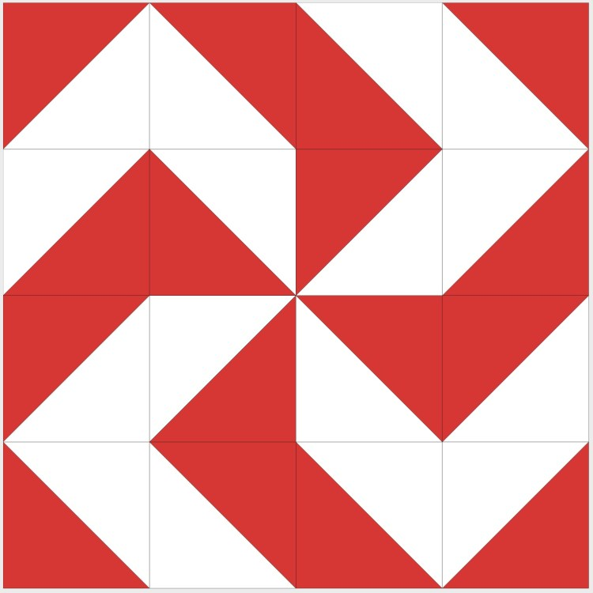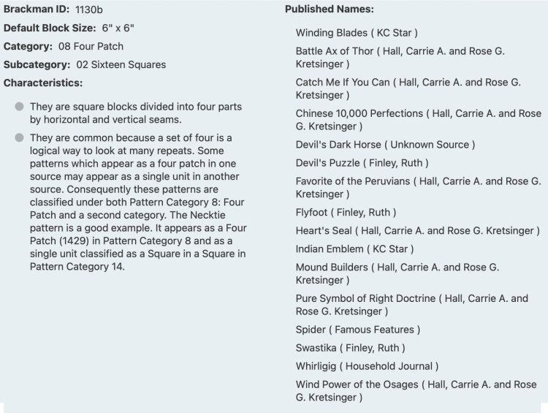Block ID: Encyclopedia of Pieced Quilt Patterns, 3rd ed. Barbara Brackman.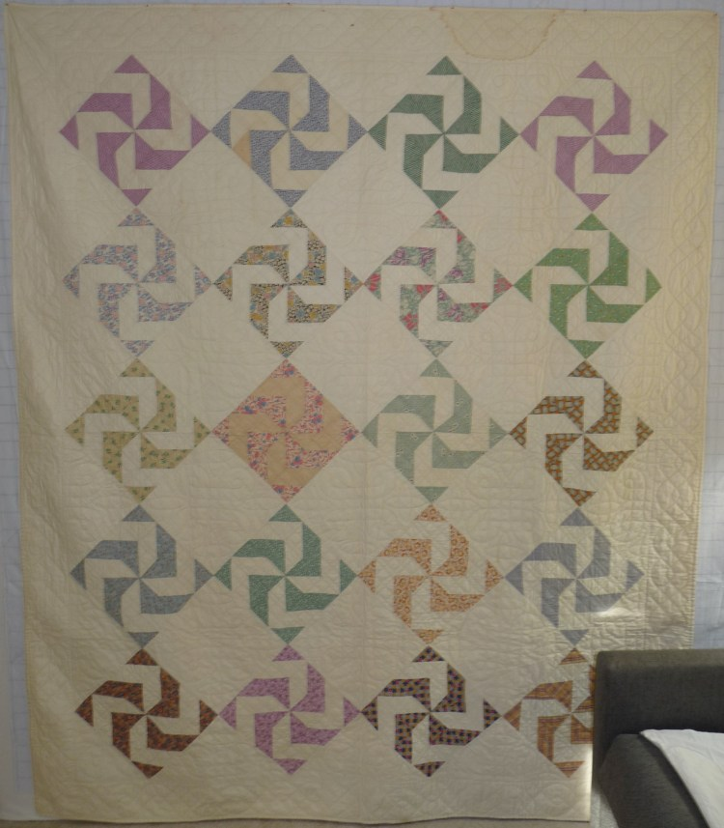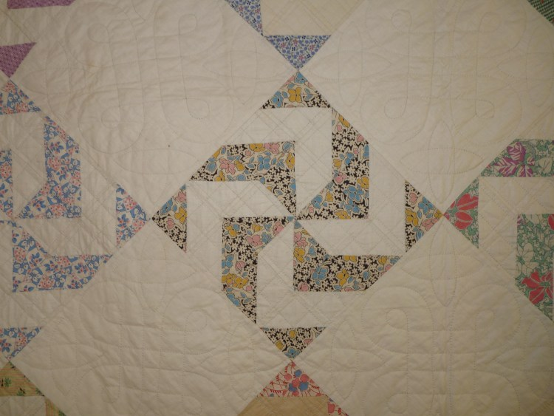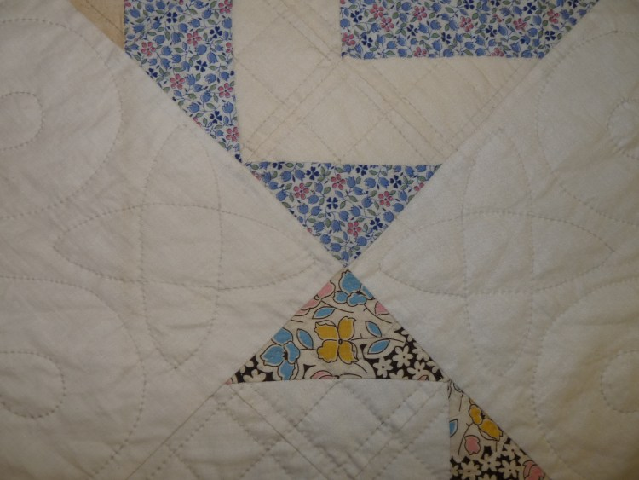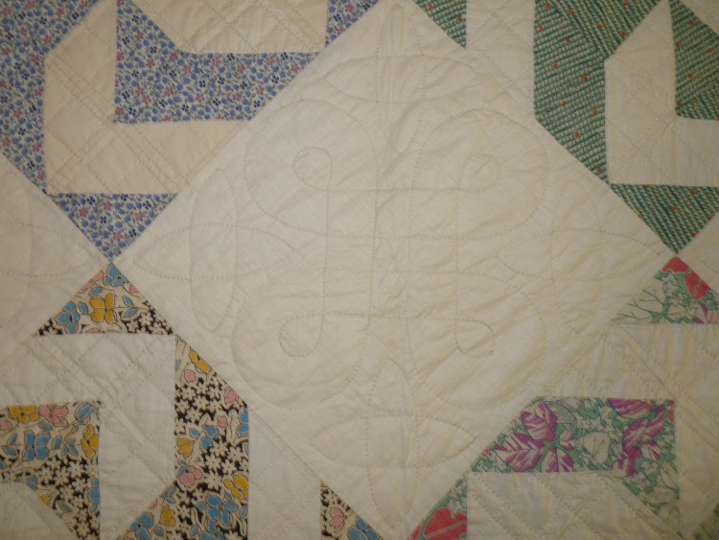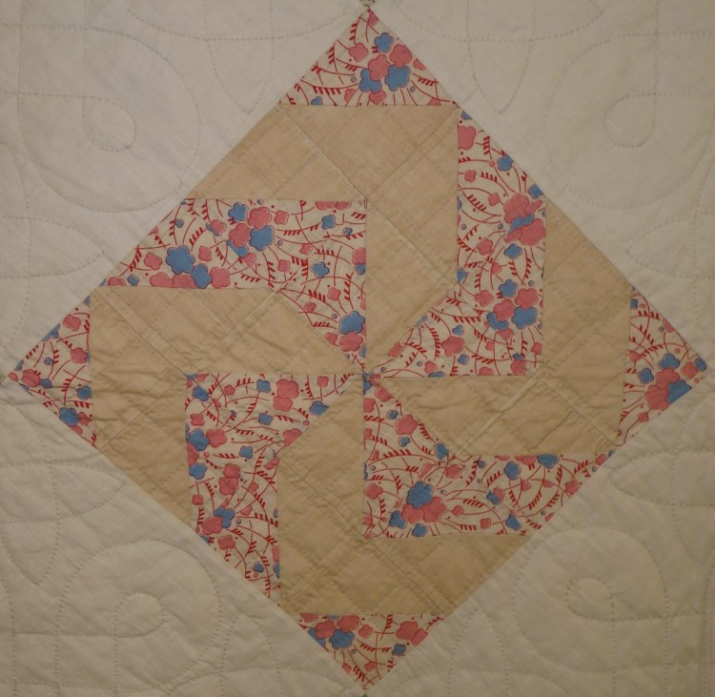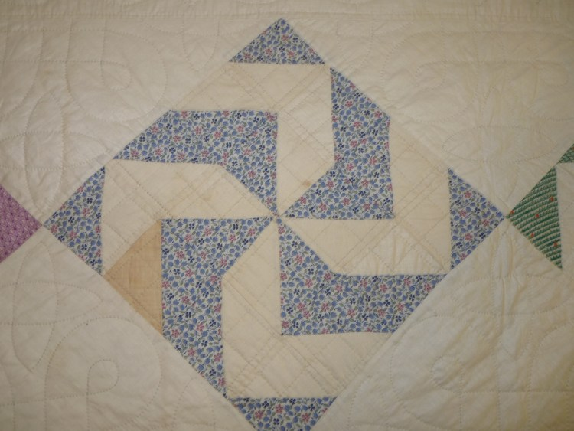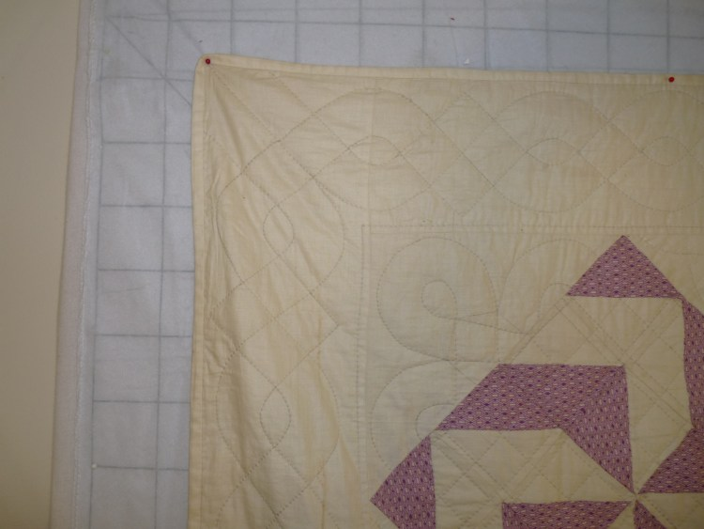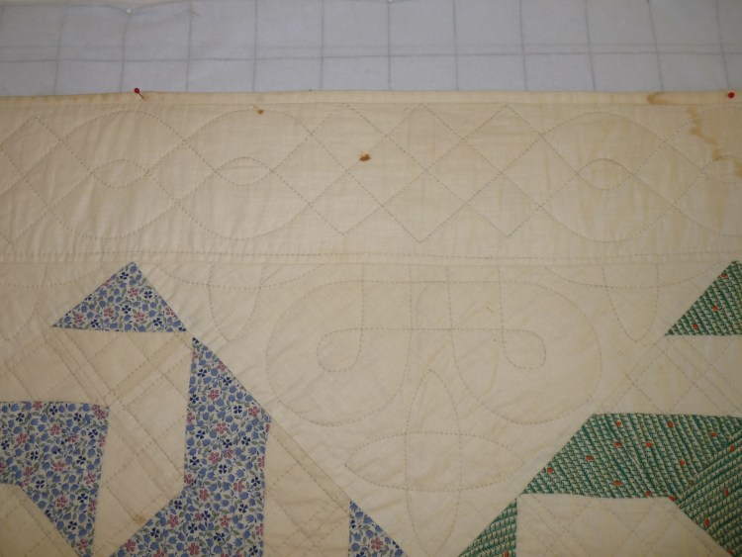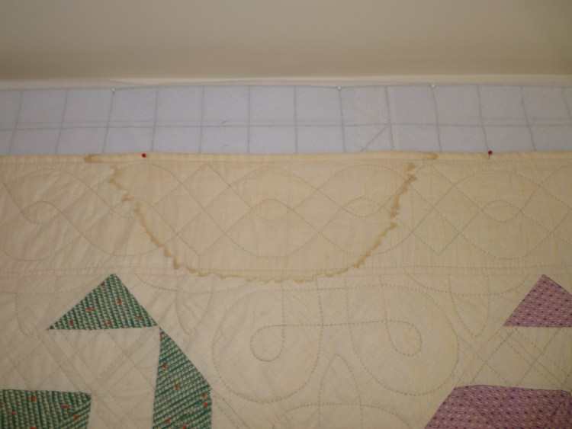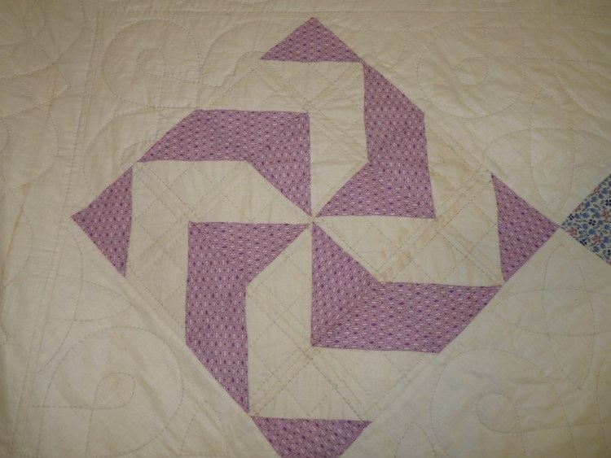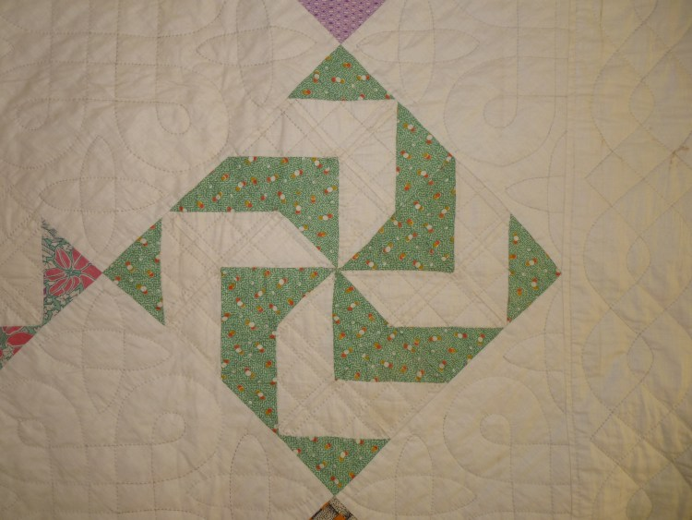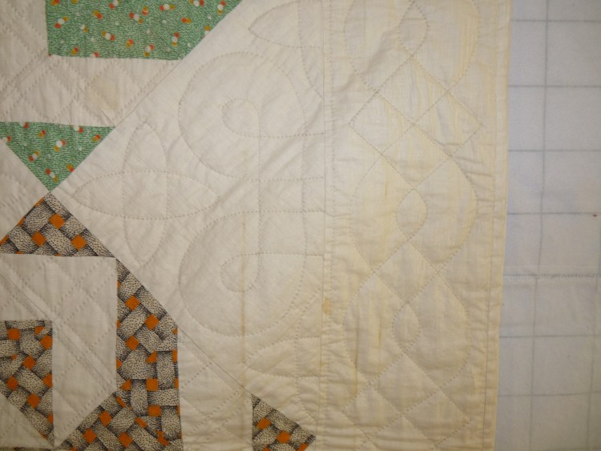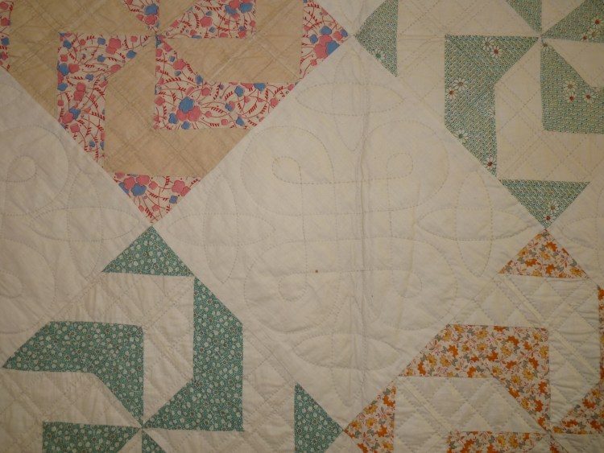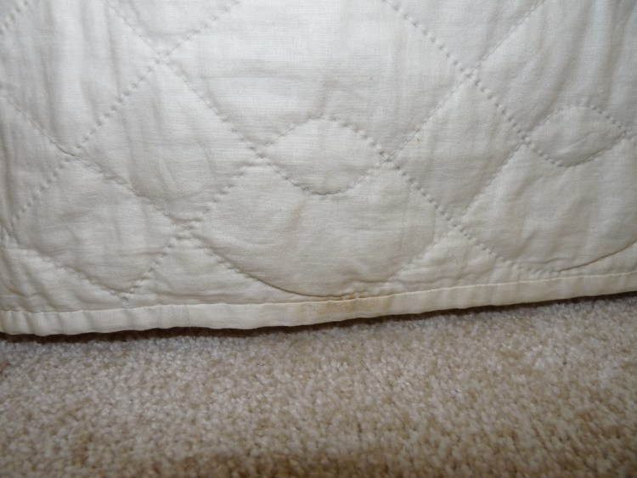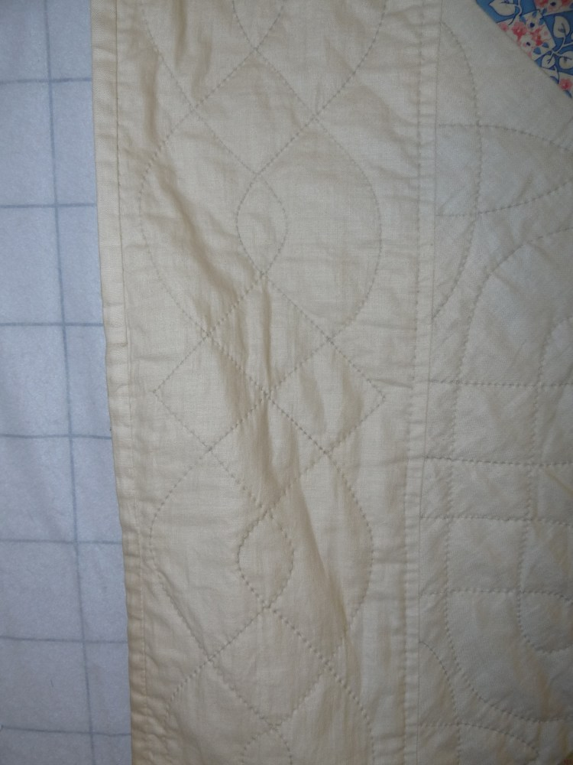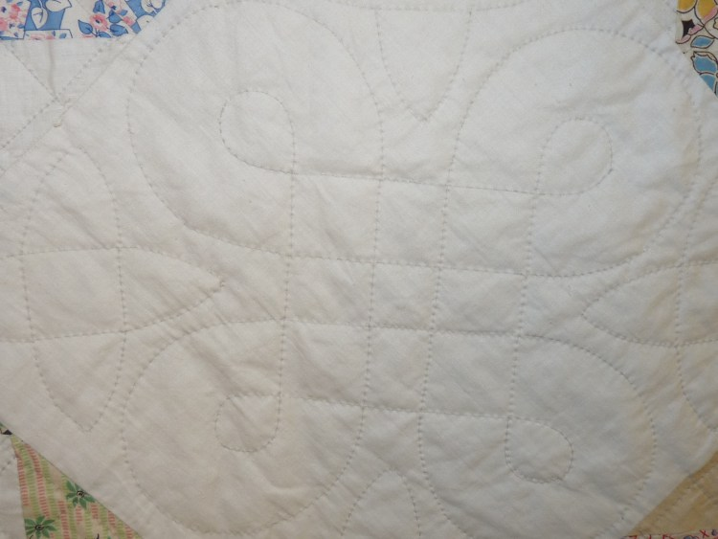

Back
Fabric Description
- Cotton
- Solids
- Predominant Colors: White
General Organization
- Whole Cloth / Panel
- Seamed Yardage
  - Describe seam positions
- Stitching Method: Machine / Hand
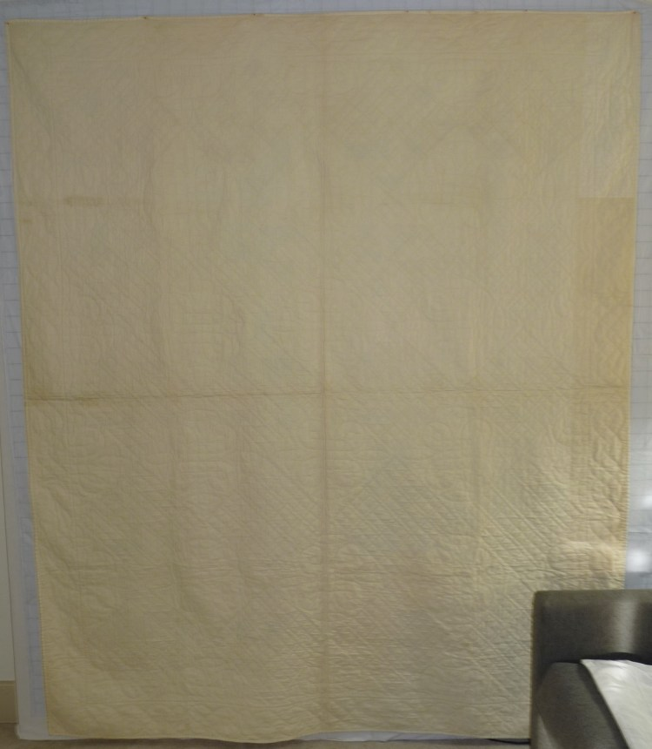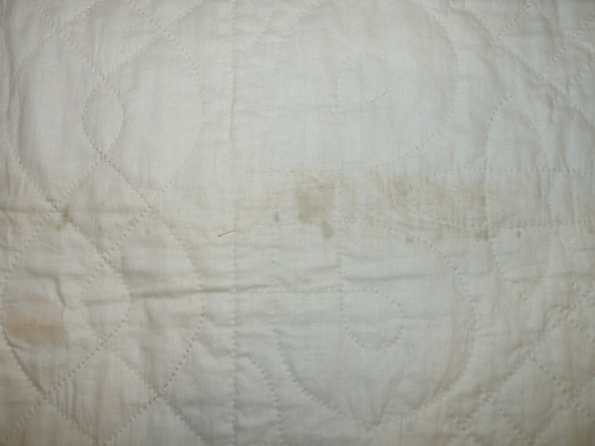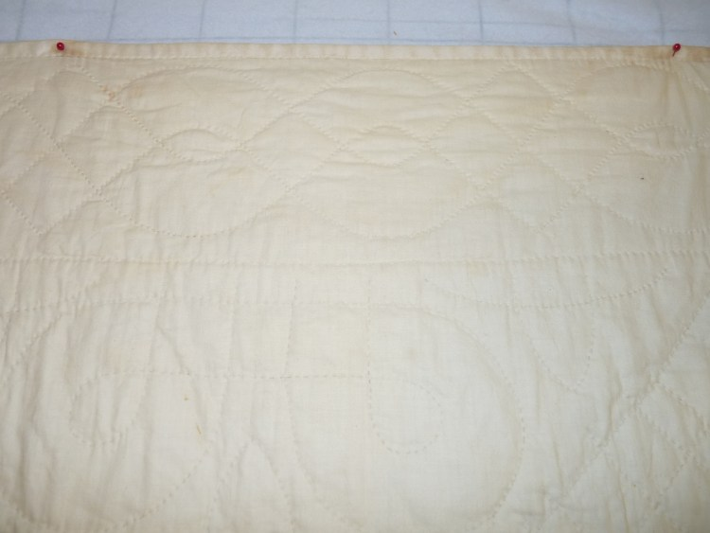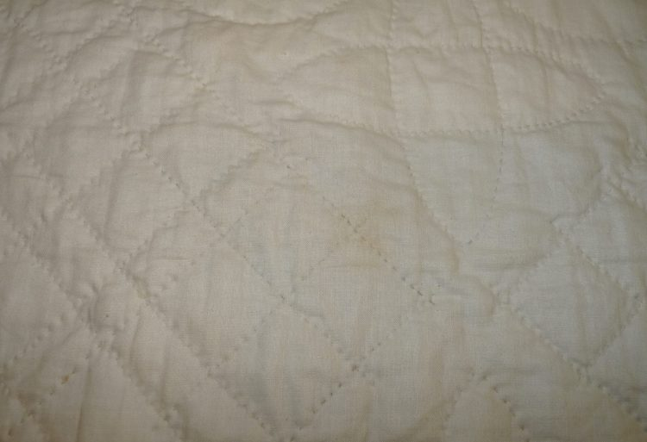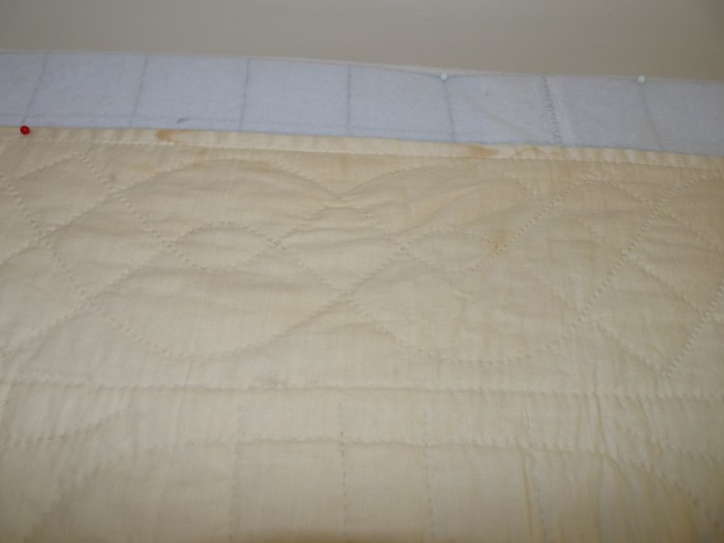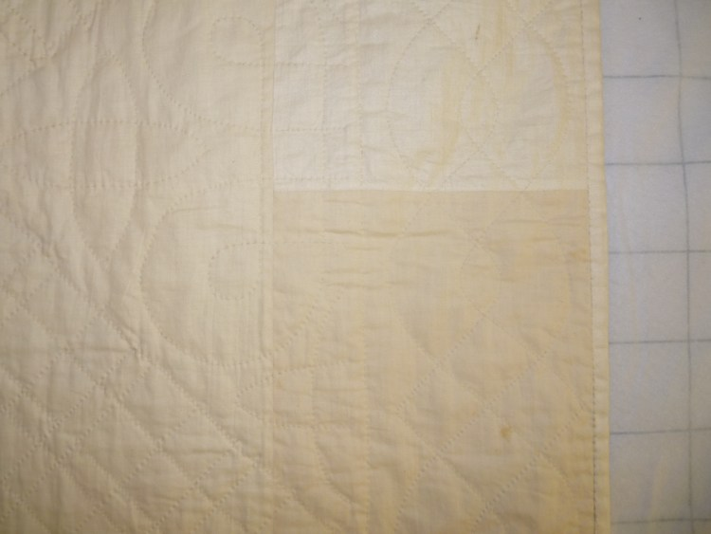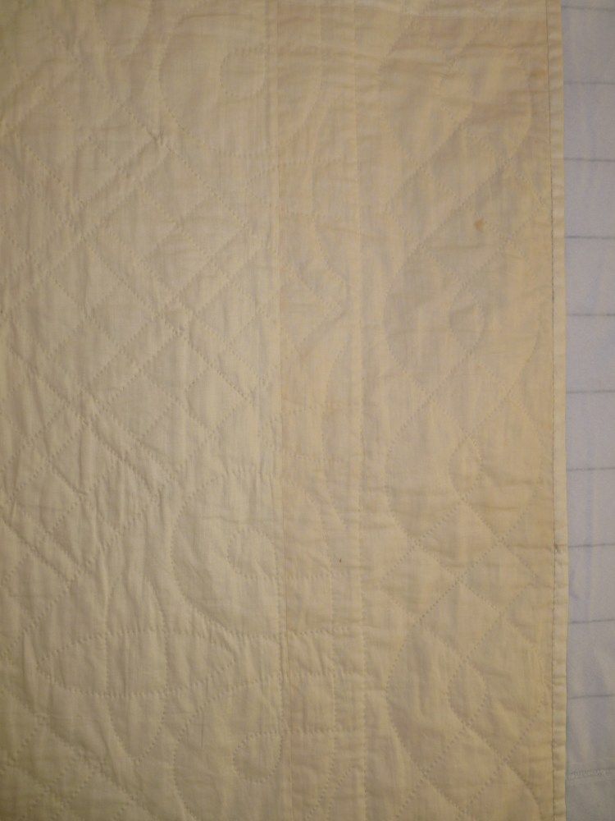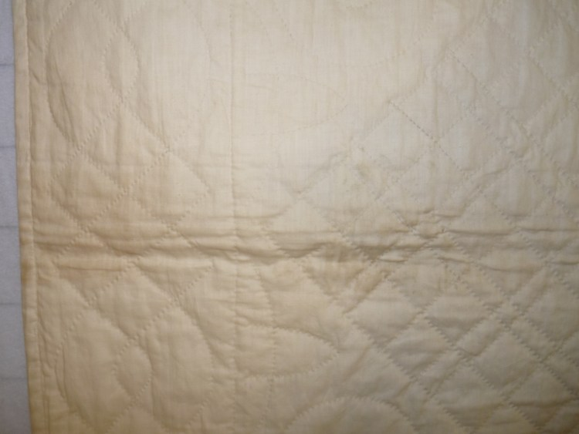

Layering and Stabilization
Batting Type
- Cotton / Wool / Silk / Polyester / Blend / Unknown / Other
- Low Loft
Stitching
- Hand
- Density: moderate
Stitching Patterns
- Cables
- Pumpkin Seeds
Workmanship of Quilting: Very Good

Edging
Size
- Front: –“
- Back: –“
Binding Style
- Front-to-Back / Back-to-Front
  - Front applied by machine / hand
  - Back applied by machine / hand

Restoration & Repair Measures
Repair & Restoration:
No signs of restoration or repair. The biggest condition issues are fabric discoloration.

Appraisal
No.

Purchase Information
- Vintage quilt: $ 136
  - Date of Purchase: December 23, 2021
  - Vendor
    - Vendor Comments
    - Contact Information
Centerville Antique Mall
200 Union Street
Centerville, Indiana 47330
Sales Receipt
