Documentation Form

Overview

Images
Top | Back
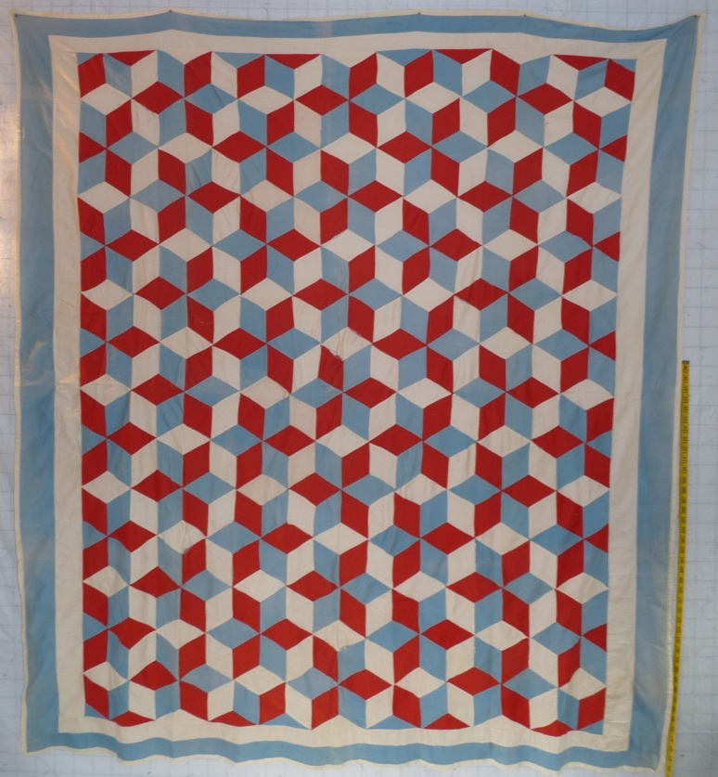 | 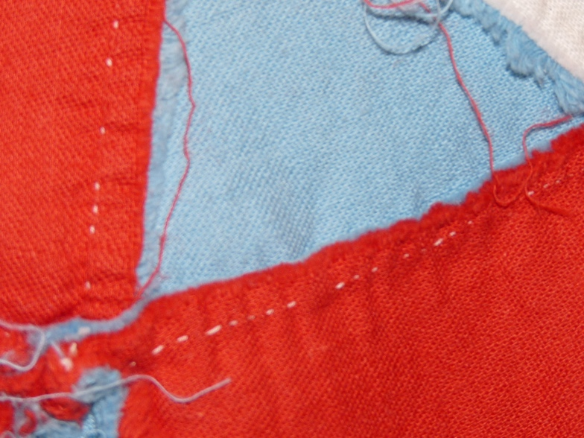

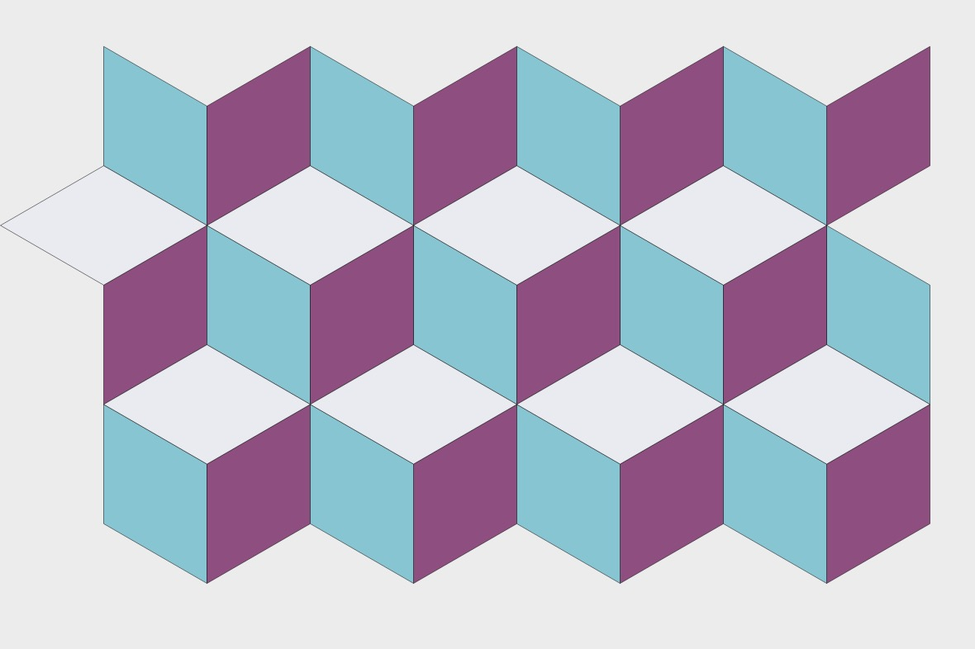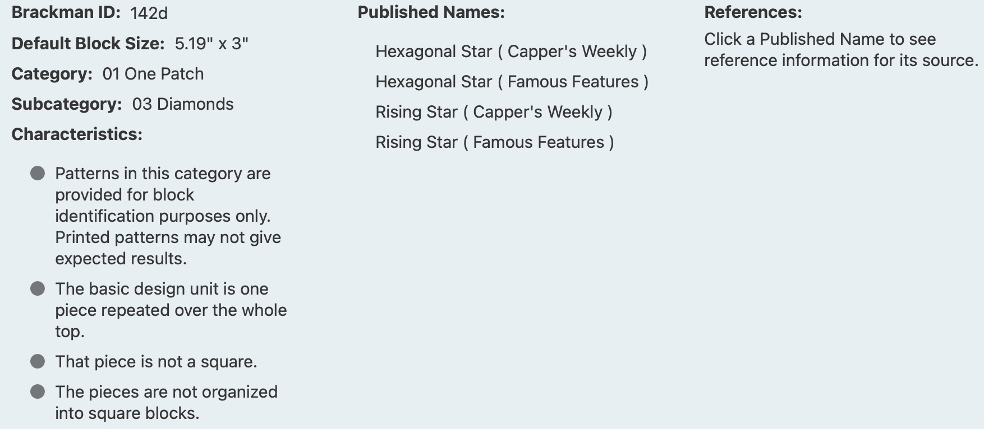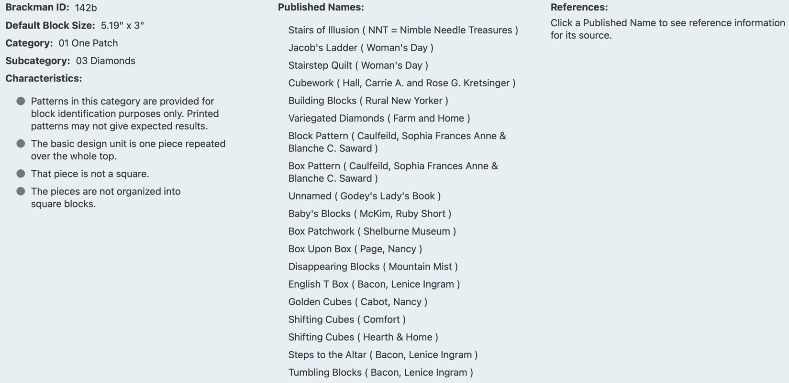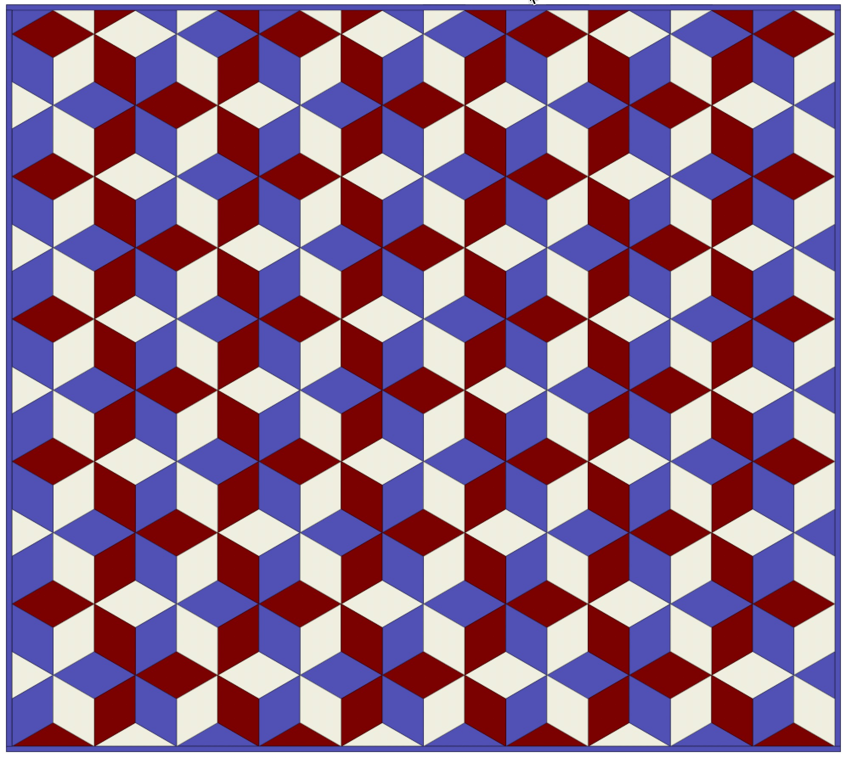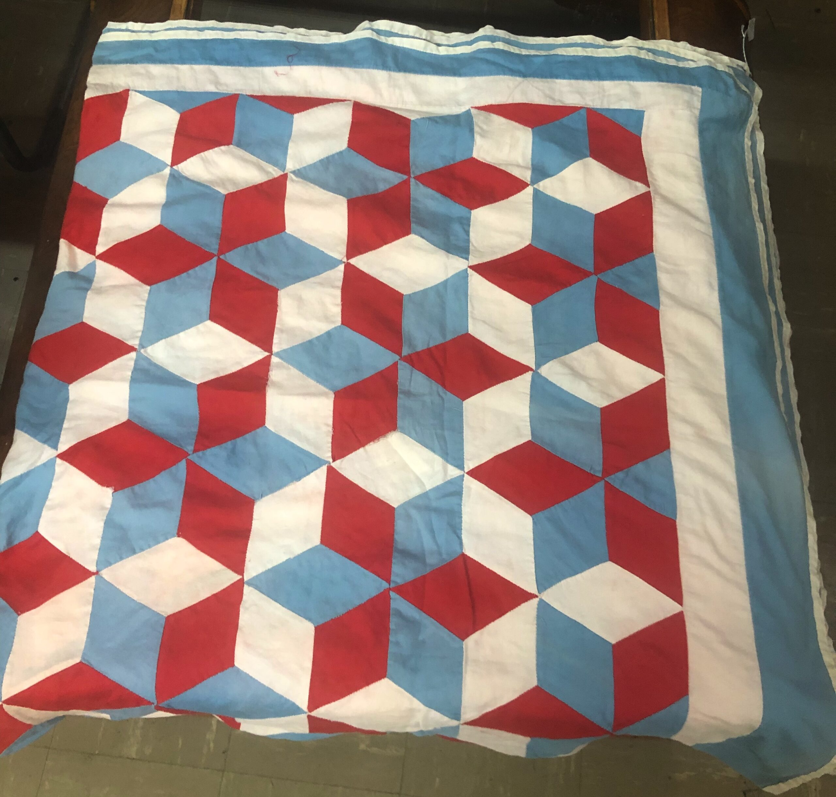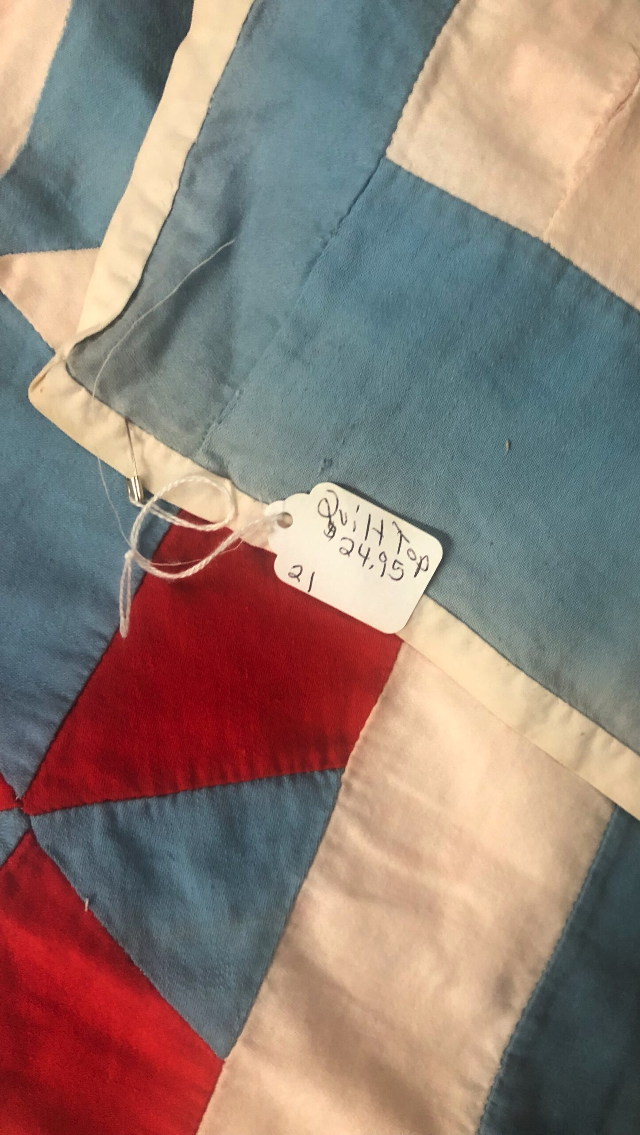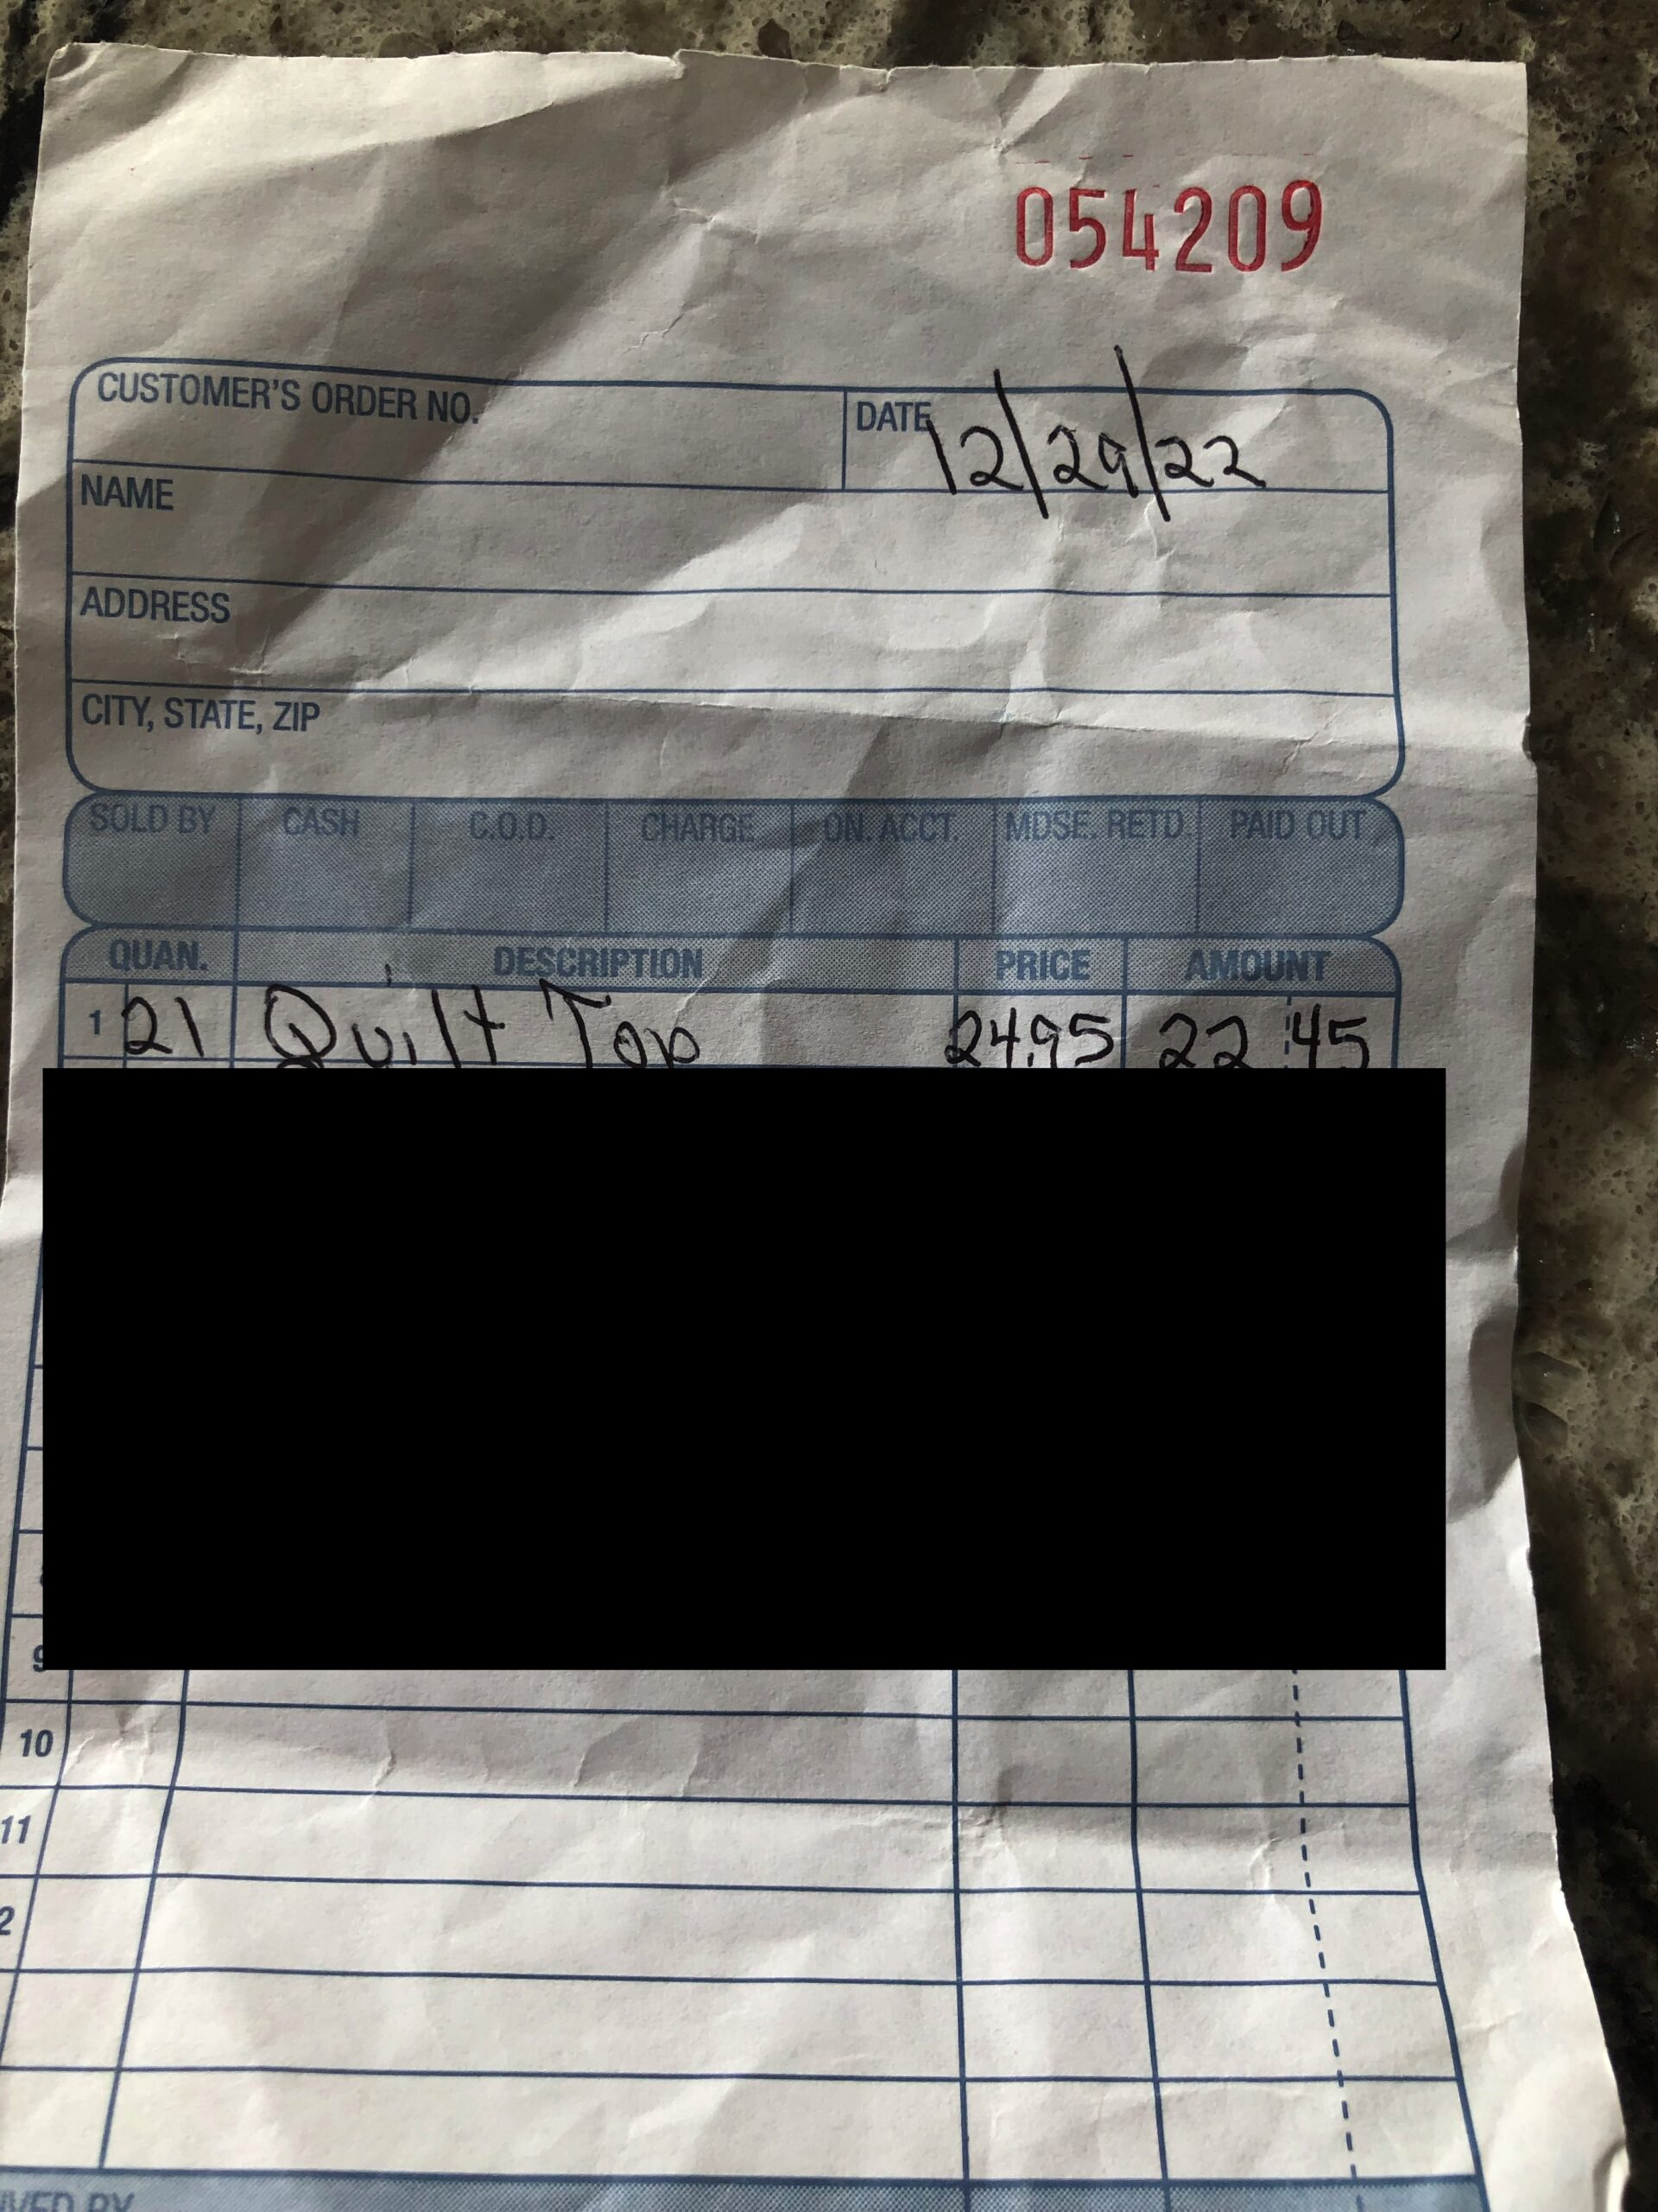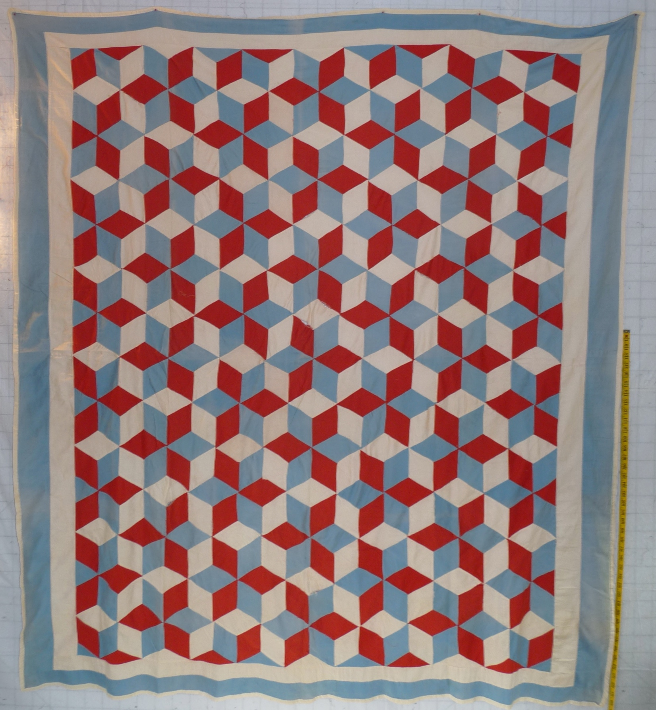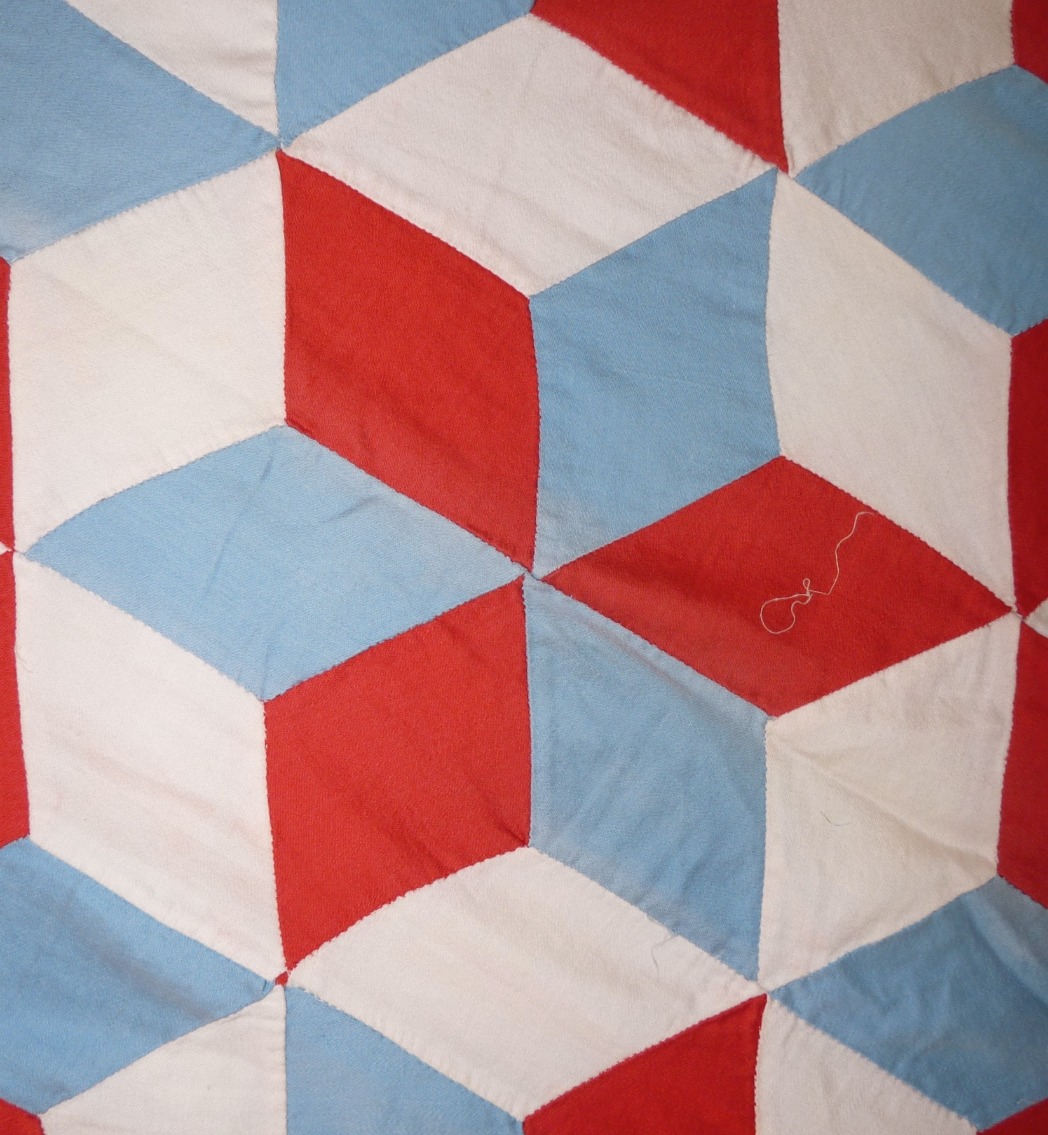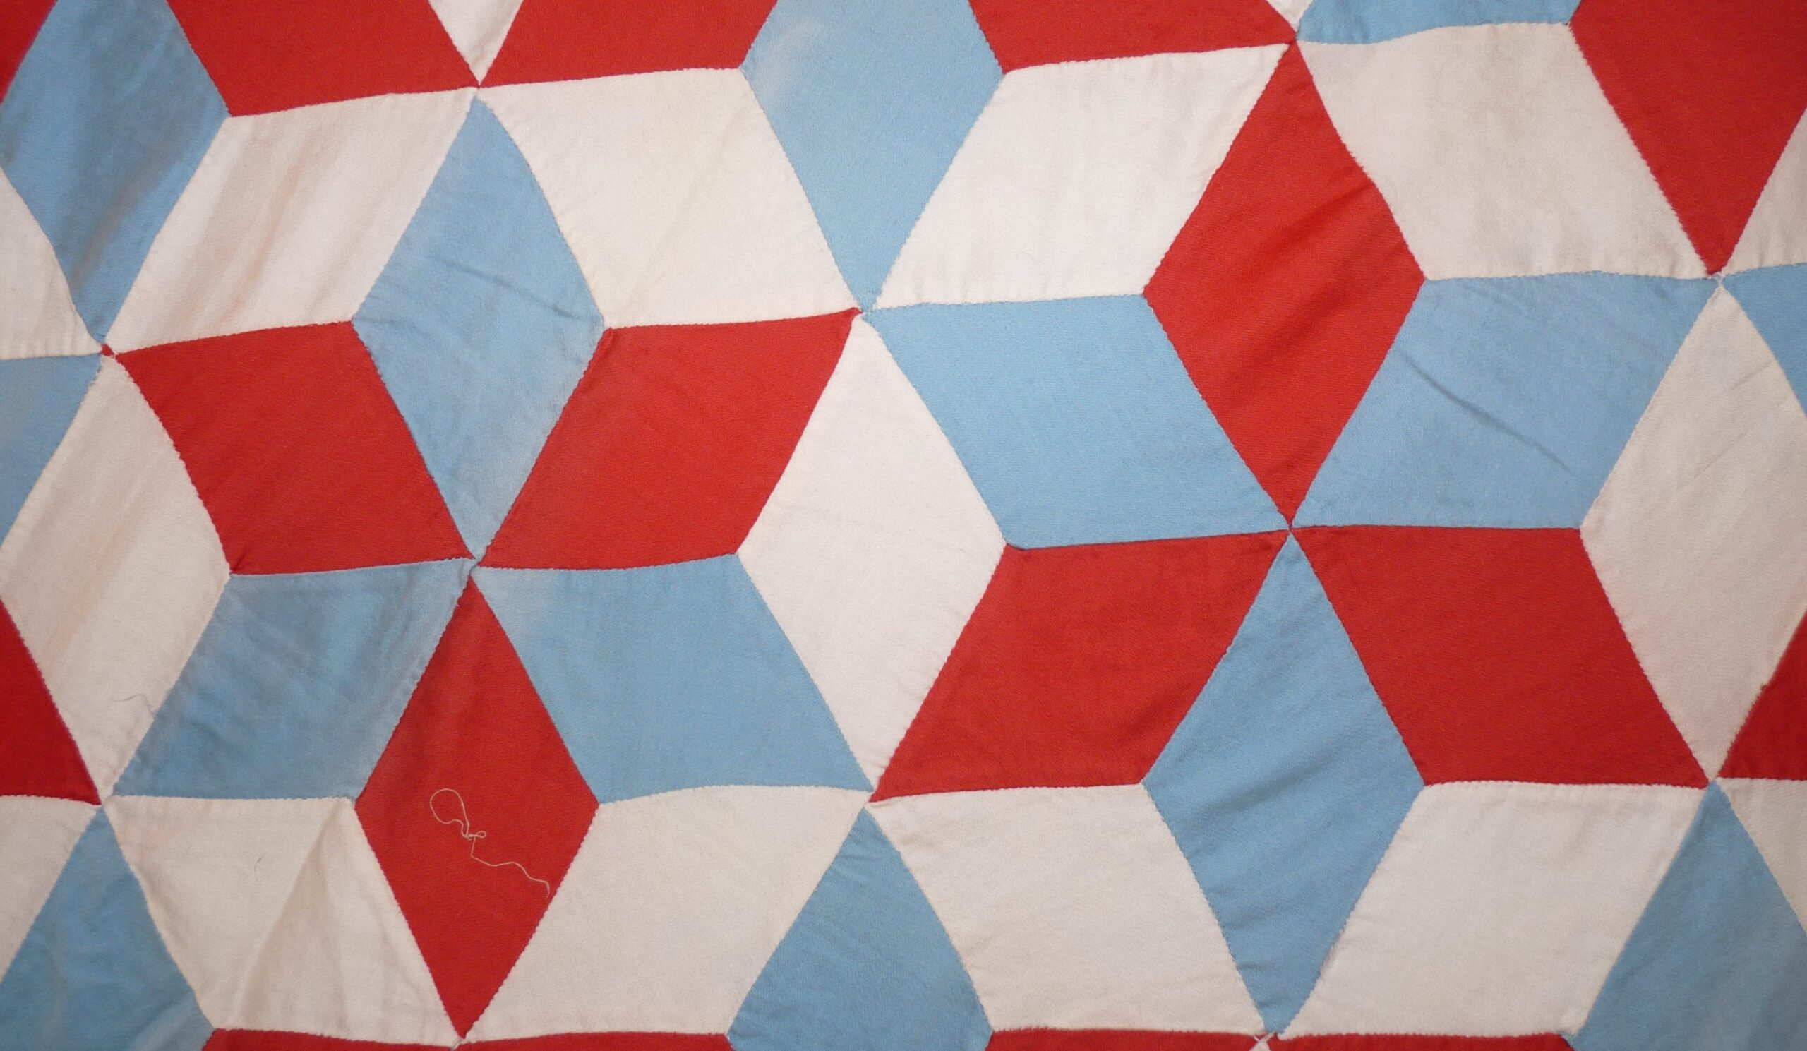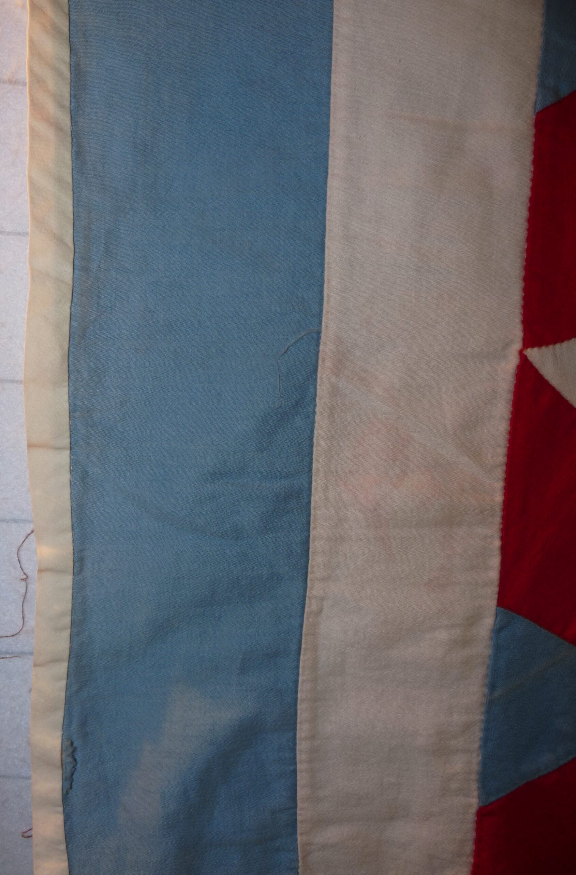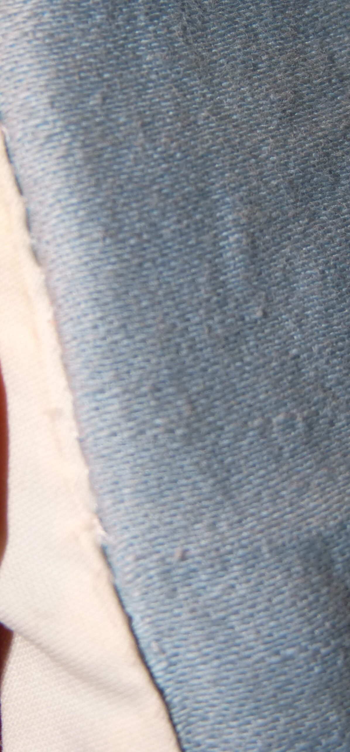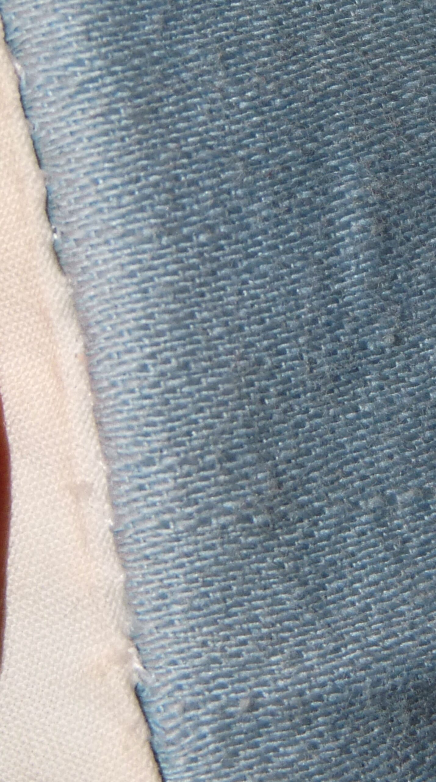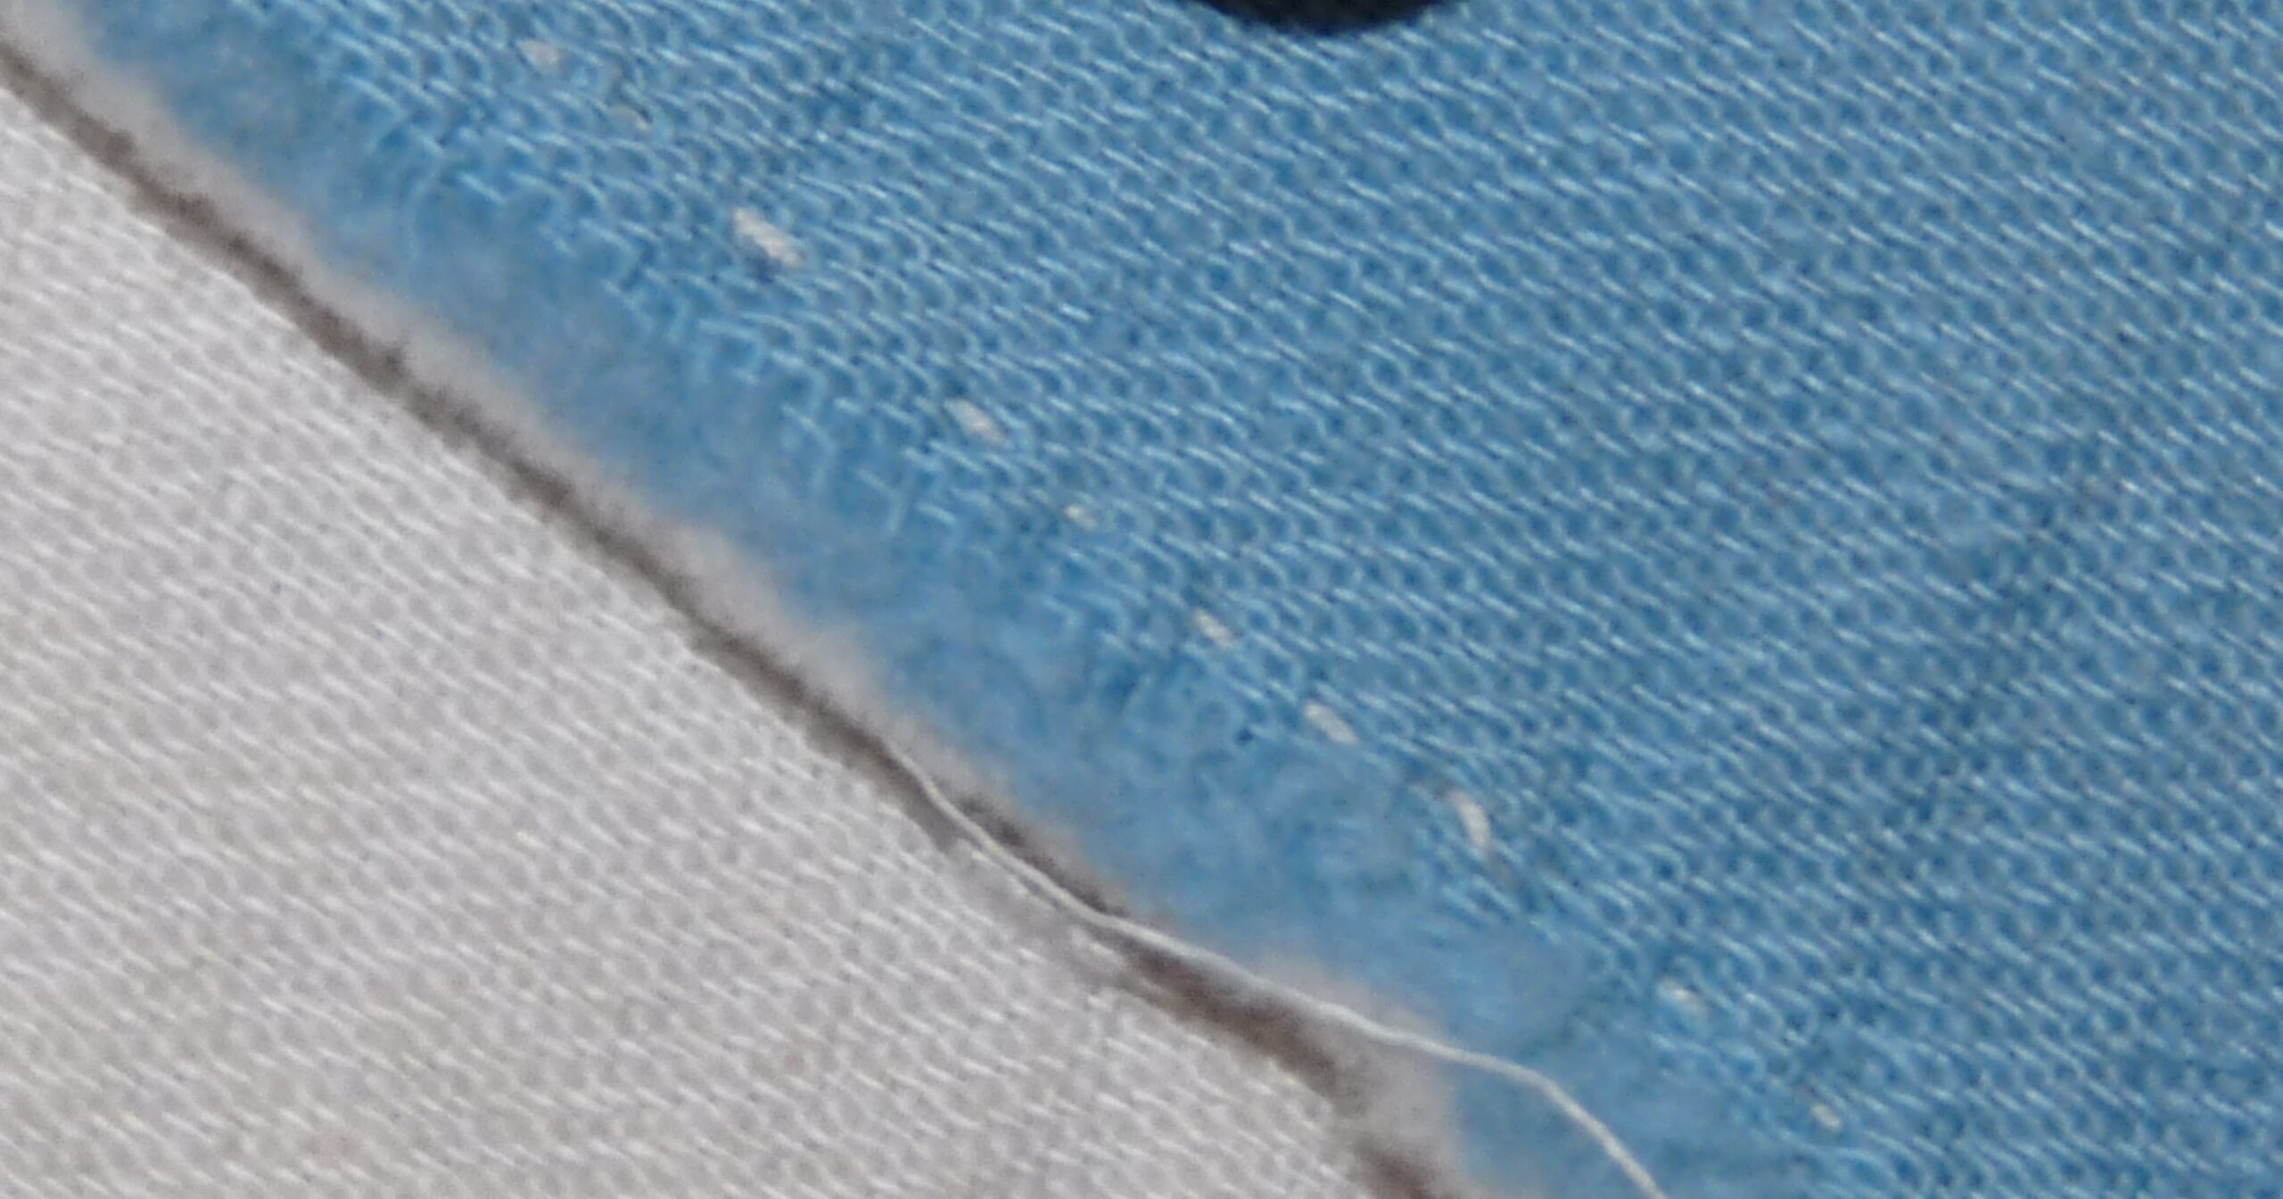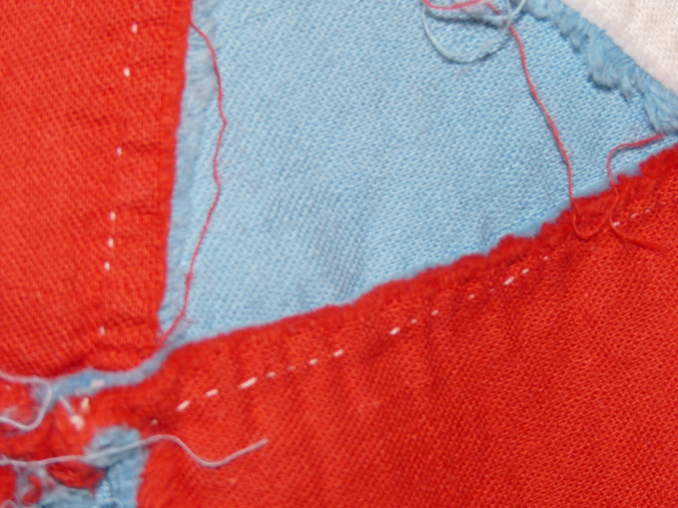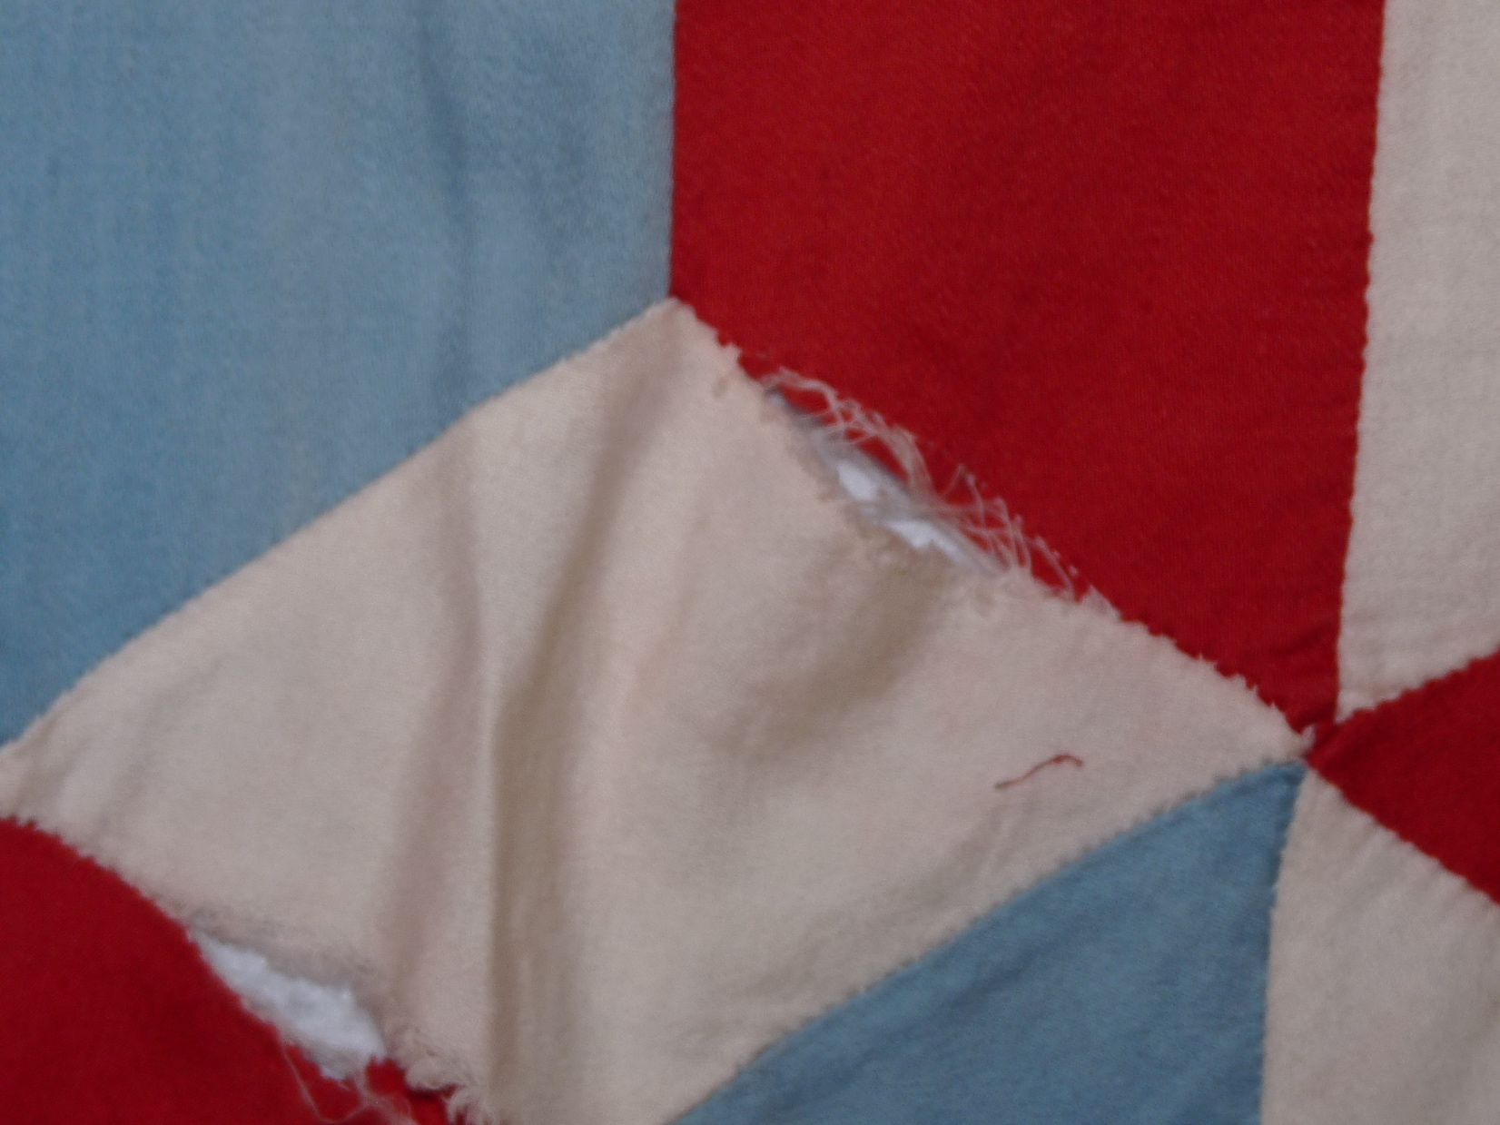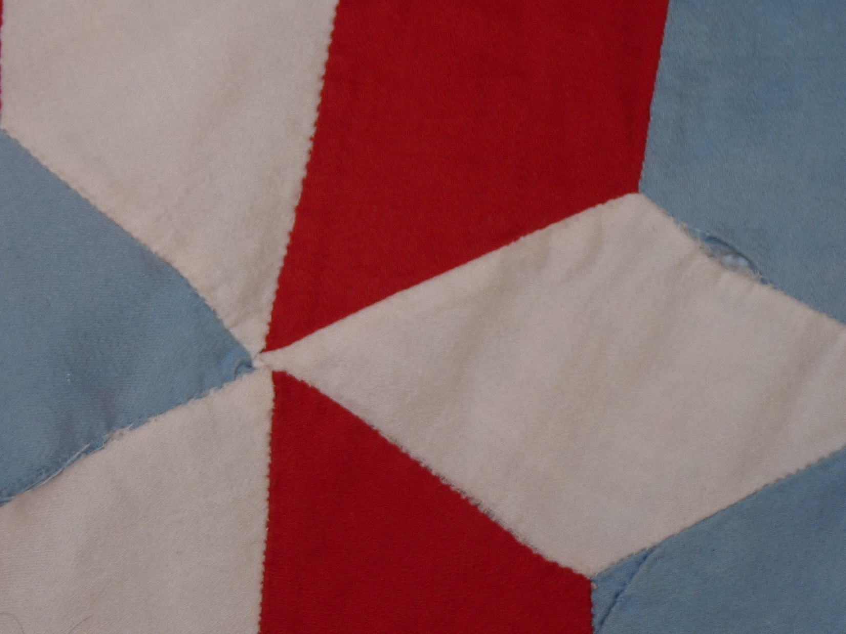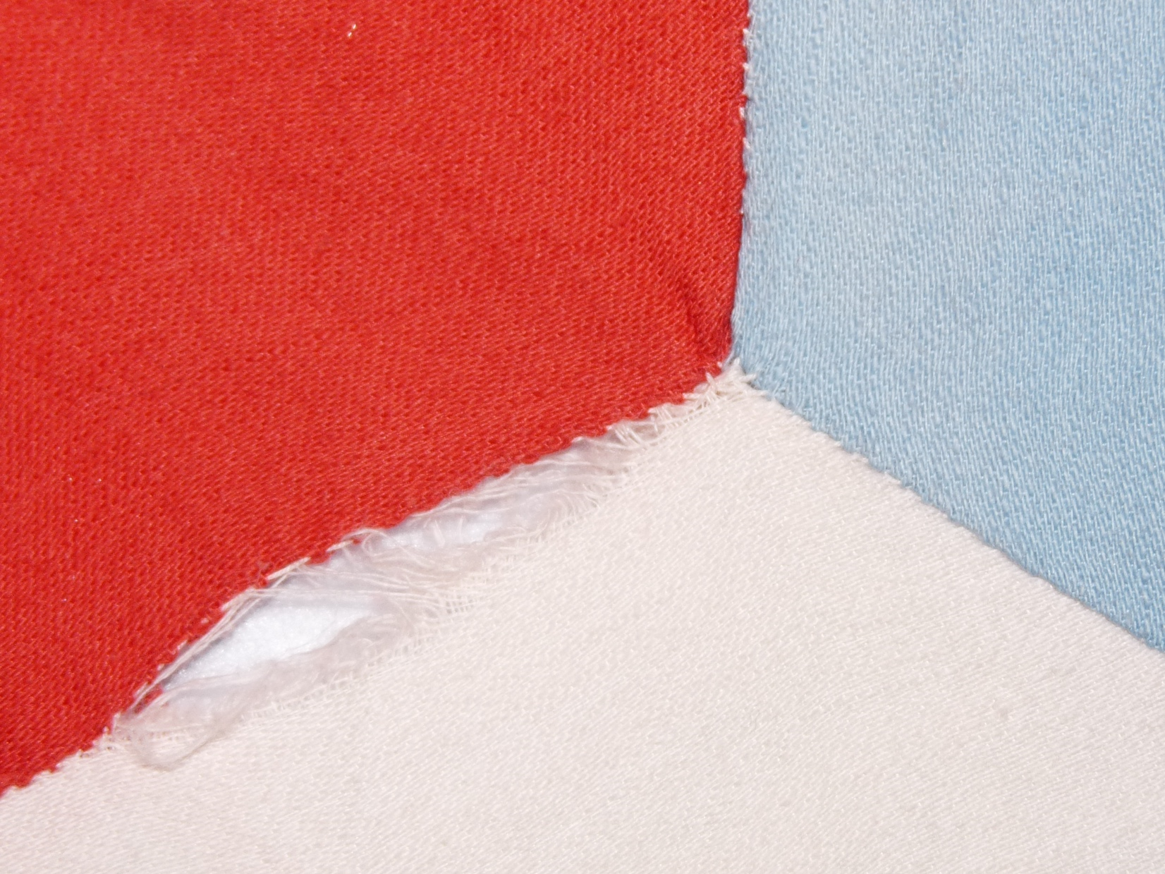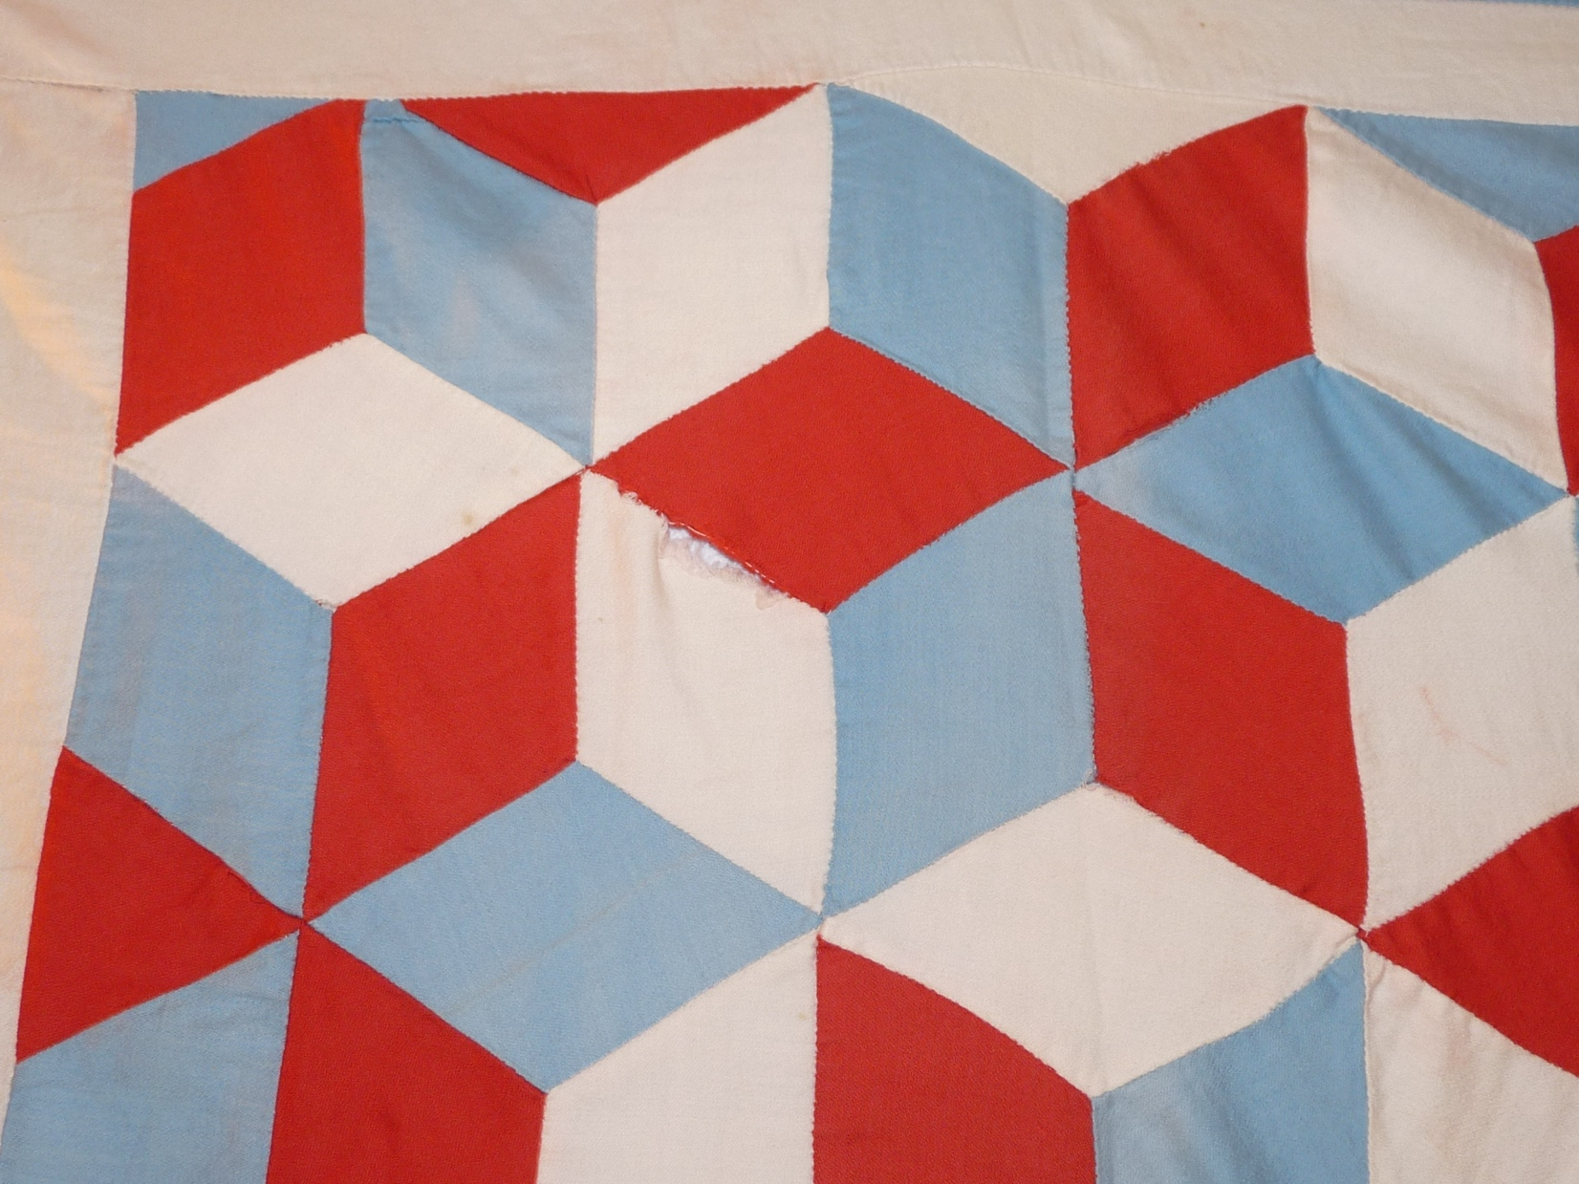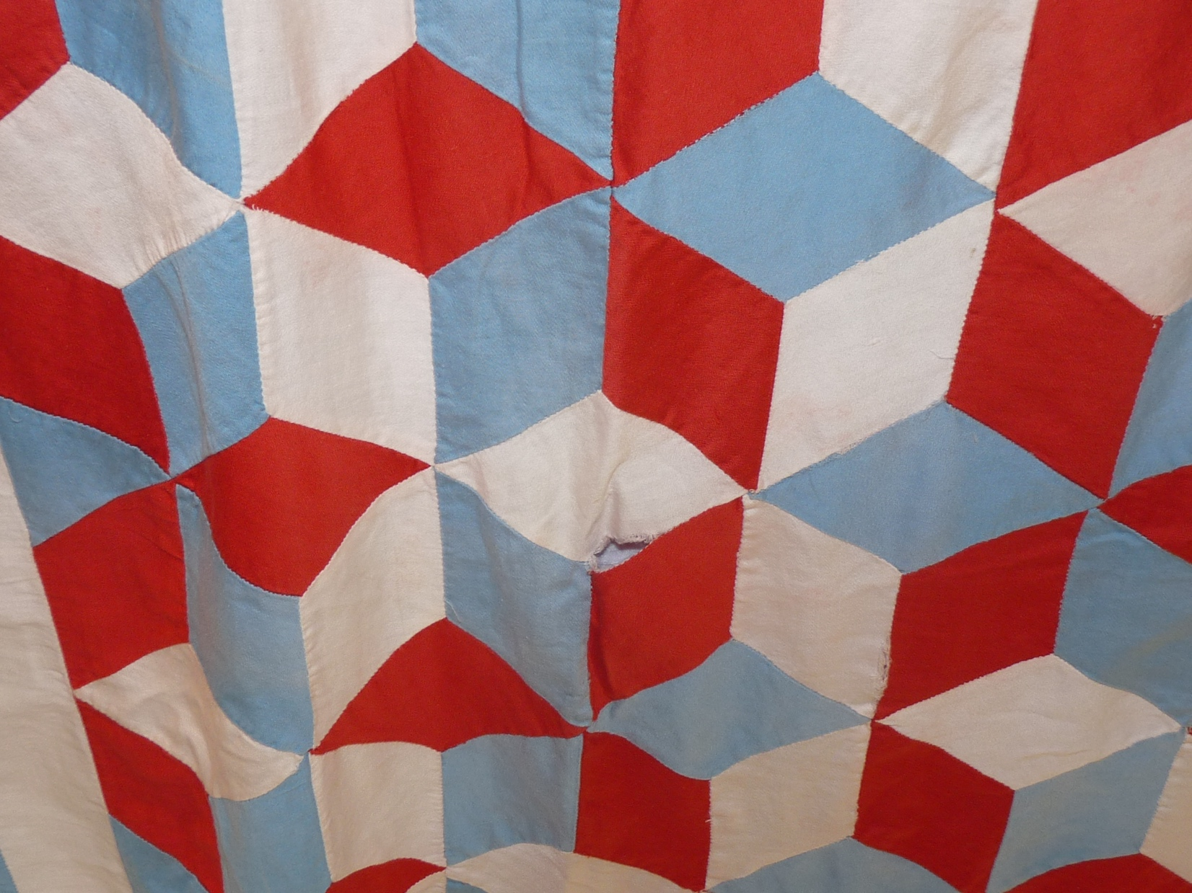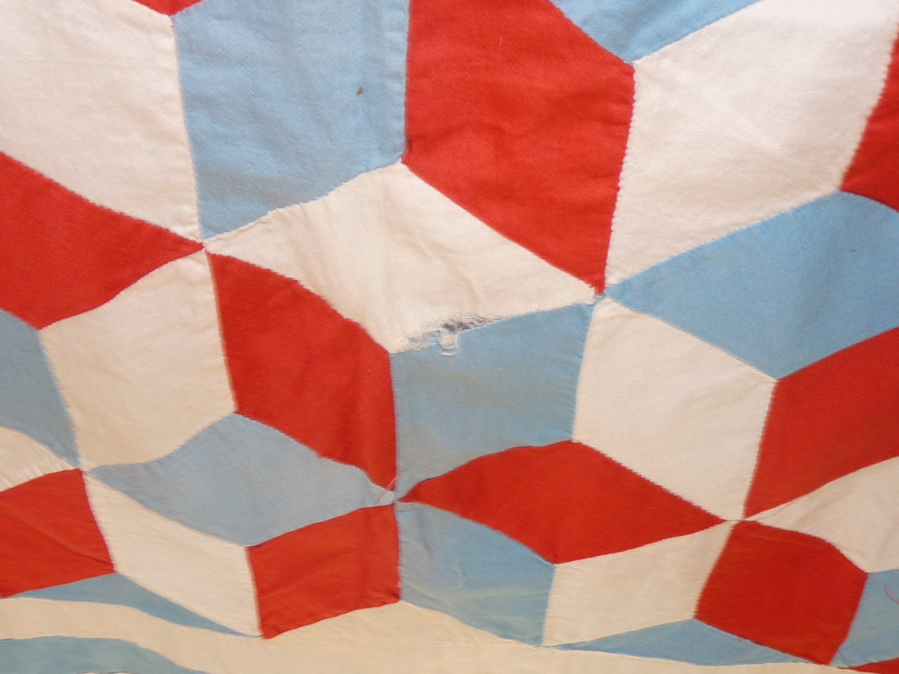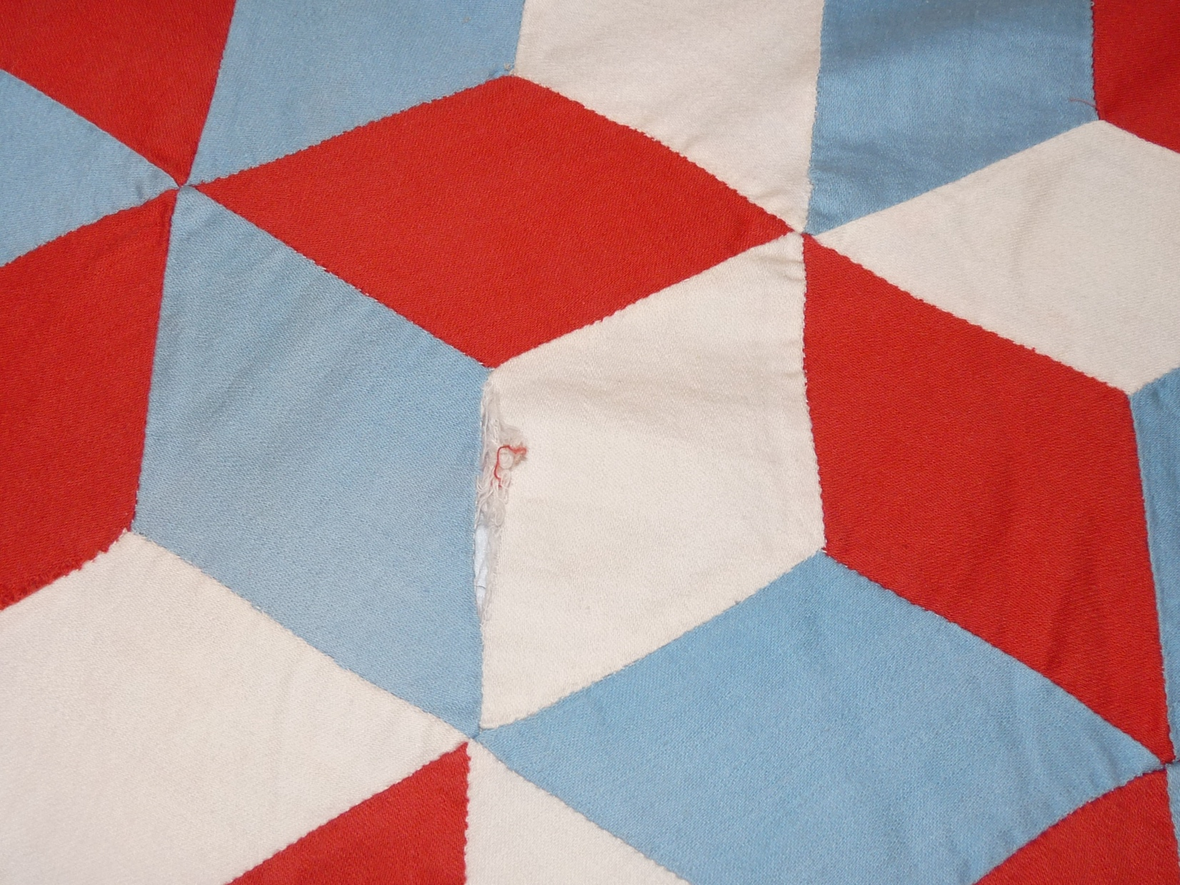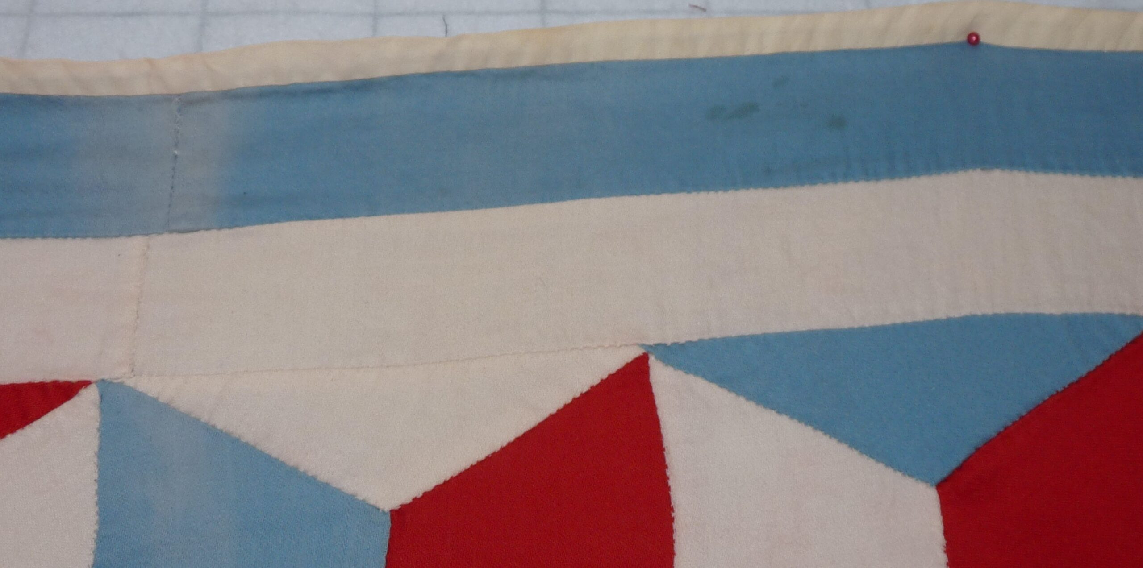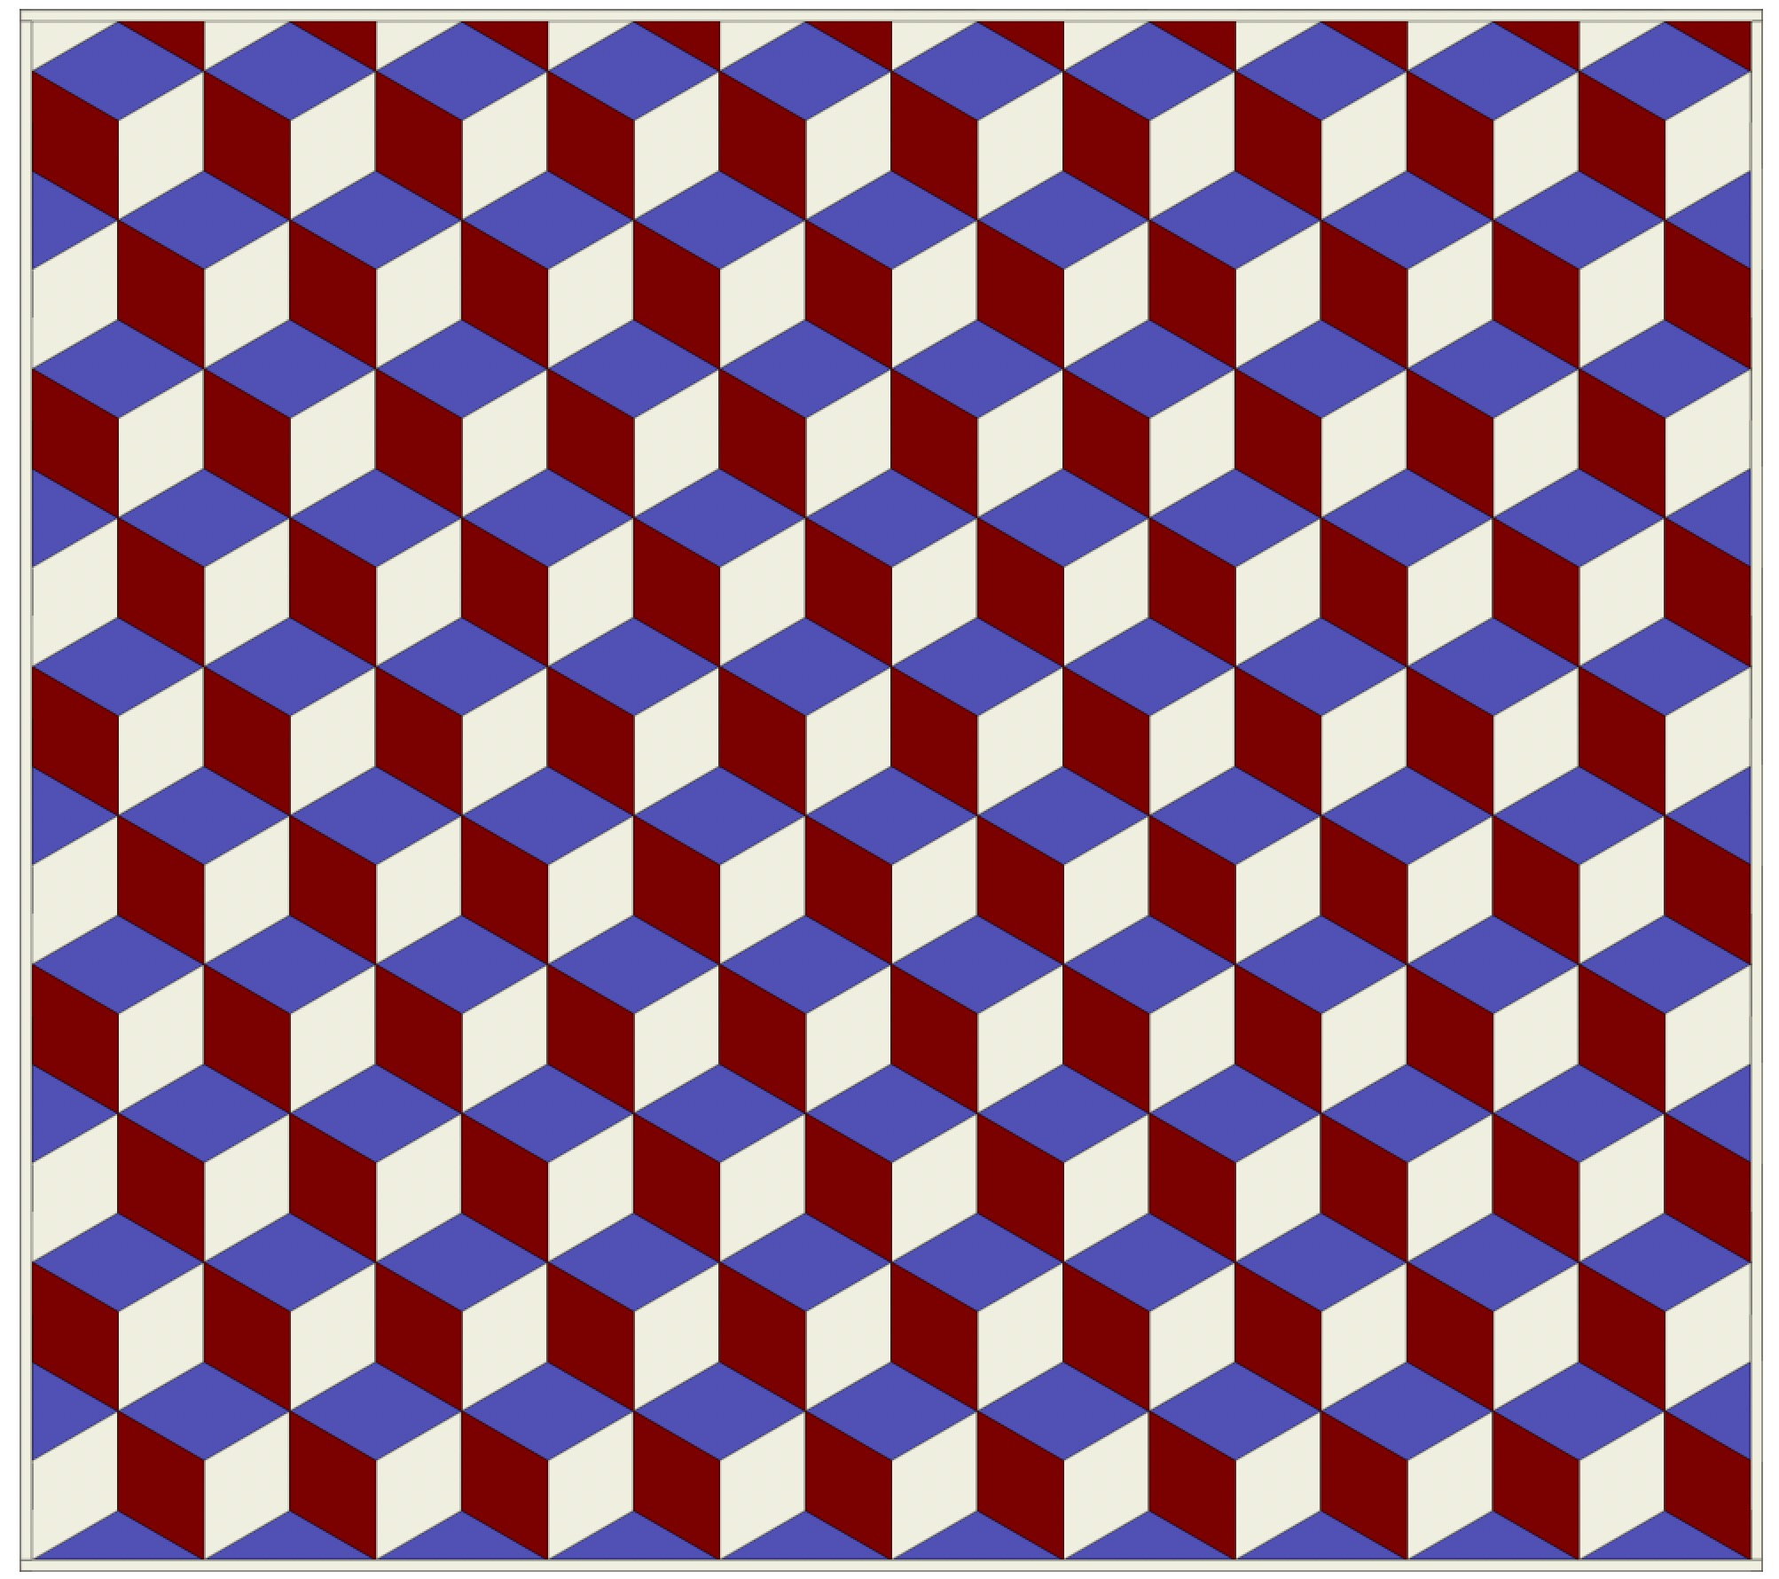

Owner History
Owner | From Date | To Date | Acquired at: | Cost
David Bailey | -- | -- | -- | $0
Made in:
--
 | If not purchased, the estimated cost for materials: $0

Display & Publication History
Date | Event | Location / Publication
-- | -- | --

General Description
Quilt Title or Name:  -- | Fabric Date Range: 1935 ± 10 Years  Date Made: -- ± 0 Years  Method of Determination:
Item Type:  Items in Set: 1 | Size: Length: 74“ x Width: 66“
Appraisals:  Has this quilt been professionally appraised?  If so, when: --  ----------- | Other related files:  Scanned Patterns  Images  EQ 8 Files  Research Notes
Additional Information: --

History

Provenance
Describe: --

Quilt Maker
Maker: -- |  | Birth: -- |  | Death: --
 | Location: -- |  | Contributions: --

Purpose and Context
Expression
Art | Personal Enjoyment | Therapy
Income
Personal Income | Fundraising
Presentation
Anniversary | Wedding | Birth
Holiday | Birthday | Other gift
Charitable support
Relationships
Friendship | Commemorative | Memorial
Mourning | Reunion
Skill Building
Challenge / Contest | Learning / Teaching Sample
Use
Bed Quilt | Lap Quilt | Home Décor
Baby / Crib | Wall Hanging
Describe other purpose: --

Construction History
--

Coverlet Design & Construction

Coverlet Top
Warp strand count per inch: 0. | Design: --
Warp fiber: | Weaver: --
Weft strand count per inch: 0” | Location: --
Weft fiber: | Woven for: --
Additional Information: --

Quilt Top Design & Construction

Quilt Top
Layout Design: .
Delete this & the following table rows as appropriate.
One Patch Shape Details
 |  |  | Describe: --
 | Techniques
 |  | Machine pieced | String / Improvisational piecing
 |  | Hand pieced | Foundation piecing
 |  | Strip piecing | English paper piecing
 |  | Describe: --
 | Workmanship
 |  | Seams are stable | Seams are appropriately aligned
 |  | Seams are flat | Points are sharp
 |  | Describe piecing workmanship
Medallion Details
 | Length 0.00” x Width: 0.00” |  | Describe: --
 | Describe: --
 | Techniques
 |  | Machine pieced | String / Improvisational piecing
 |  | Hand pieced | Foundation piecing
 |  | Strip piecing | English paper piecing
 |  | Describe: --
 | Workmanship
 |  | Seams are stable | Seams are appropriately aligned
 |  | Seams are flat | Points are sharp
 |  | Describe piecing workmanship
Blocks / Grid
 |  |  | Grid Dimensions: Length 0 x Width: 0
 |  |  | Block Size: Length: 0.00 “ x Width: 0.00 “
 | Describe: --
 | Pattern name & Brackman or other ID |  | <<Pattern Image>>
 | Techniques
 | Machine pieced |  | String / Improvisational piecing
 | Hand pieced |  | Foundation piecing
 | Strip piecing |  | English paper piecing
 | Describe: --
 | Workmanship
 | Seams are stable |  | Seams are appropriately aligned
 | Seams are flat |  | Points are sharp
 | Describe piecing workmanship

Embellishments
Delete this & the following table rows as appropriate.
Types:
 | Applique – Raw edge | Embroidery | Stuffed Work
 | Applique - Button-hole | Cording | Inking
 | Applique - Needle-turn | Beading | Painting
 | Applique - Reverse | Rhinestones / Gems | Marking lines noted
 | Applique - Other | Other: --
Workmanship
 | Stitches are appropriately small and even.
 | Edges are as design intends (straight, curved, pointed).
 | Work demonstrates appropriate skill for intended purpose.
 | Describe other techniques

Sashing
Delete this & the following table rows as appropriate.
 |  | Width: 0.00 “
Use of corner stones
Techniques
 | Machine pieced |  | String / Improvisational piecing
 | Hand pieced |  | Foundation piecing
 | Strip piecing |  | English paper piecing
 | Describe: --
Workmanship
 | Seams are stable |  | Seams are appropriately aligned
 | Seams are flat |  | Points are sharp
Describe: --
 | Describe piecing workmanship

Borders & Frames
Delete this & the following table rows as appropriate.
Describe borders and frames in order from center to edge.
1 | Width: 0.00“
 |  |  | Describe: --
Techniques
 |  | Machine pieced |  |  | String / Improvisational piecing
 |  | Hand pieced |  |  | Foundation piecing
 |  | Strip piecing |  |  | English paper piecing
 |  | Describe: --
Workmanship
 |  | Seams are stable |  |  | Seams are appropriately aligned
 |  | Seams are flat |  |  | Points are sharp
Describe: --
 |  | Describe piecing workmanship

Assembly
 | Seams are appropriately aligned
Seams are stable | Top has no inappropriate tucks or puckers
Seams are flat | Top lays flat with no overly full areas
Describe: --

Color
Predominant colors
 | Red | Blue | Black
 | Orange | Violet/Purple | Grey
 | Yellow | Brown | White
 | Green | Beige / Tan
Specific Antique Colors |  | NONE NOTED | Neon prints
 | Red – claret / wine | Yellow – chrome | Blue – Lancaster
 | Red – madder / cinnamon | Green - chrome | Blue – Prussian / Lafayette
 | Red – turkey | Green – Nile | Brown – madder
 | Pinks - double | Blue – Cadet | Butterscotch
 | Orange - madder | Blue - Indigo | Bronze
 | Orange – cheddar / antimony / chrome |  | Late 1800’s Purple
Describe: --

Materials
Sources of Fabric |  | NOT KNOWN
 | Companies | Fabric Name & Number | Designer
 | -- | -- | --
 | Describe other sources: --
Fiber Types |  | NOT YET IDENTIFIED
 | Cotton | Silk | Wool
 | Cotton Blend | Linen | Synthetic
 | Describe & Clarify: --
Fabric Types |  | NOT KNOWN
 | Broadcloth | Sateen | Upholstery
 | Flannel | Satin | Chintz
 | Shirting | Muslin | Glazed
 | Suiting | Velvet | Handwoven
 | Denim | Felt | Lindsey-Woolsey
 | Describe & Clarify: --
Print Types |  | NOT YET IDENTIFIED
 | Batik | Floral | Multiple scraps
 | Cheater Panel | Garibaldi Red Prints | Paisley
 | Checked / Gingham | Geometric | Plaid
 | Conversation / Novelty | Hand-dyed | Solid / Plain
 | Dotted | Victorian Mourning Prints | Stamped
 | Feed sack / Feed sack-like |  | Stripes
Describe & Clarify: --

Images

Inscriptions
None Found
Inscription is present. Describe location: --
Content
Makers names | Initials | Date
Single Name | Message | Place
Multiple Names
Transcription: --

Methods
Label | Ink – Ball point | Stencil
Printed onto fabric | Ink – Felt tip | Stamped
Quilted | Ink - Other | Pencil
Embroidery | Applique | Typewriter
Describe & Clarify: --

Images for Inscriptions

Quilt Back Design & Construction

Quilt Back
Layout Design: .
Delete this & the following table rows as appropriate.
One Patch Shape Details
 |  |  | Describe: --
 | Techniques
 |  | Machine pieced | String / Improvisational piecing
 |  | Hand pieced | Foundation piecing
 |  | Strip piecing | English paper piecing
 |  | Describe: --
 | Workmanship
 |  | Seams are stable | Seams are appropriately aligned
 |  | Seams are flat | Points are sharp
 |  | Describe piecing workmanship
Medallion Details
 | Length 0.00” x Width: 0.00” |  | Describe: --
 | Describe: --
 | Techniques
 |  | Machine pieced | String / Improvisational piecing
 |  | Hand pieced | Foundation piecing
 |  | Strip piecing | English paper piecing
 |  | Describe: --
 | Workmanship
 |  | Seams are stable | Seams are appropriately aligned
 |  | Seams are flat | Points are sharp
 |  | Describe piecing workmanship
Blocks / Grid
 |  |  | Grid Dimensions: Length 0 x Width: 0
 |  |  | Block Size: Length: 0.00 “ x Width: 0.00 “
 | Describe: --
 | Pattern name & Brackman or other ID |  | <<Pattern Image>>
 | Techniques
 | Machine pieced |  | String / Improvisational piecing
 | Hand pieced |  | Foundation piecing
 | Strip piecing |  | English paper piecing
 | Describe: --
 | Workmanship
 | Seams are stable |  | Seams are appropriately aligned
 | Seams are flat |  | Points are sharp
 | Describe piecing workmanship

Embellishments
Delete this & the following table rows as appropriate.
Types:
 | Applique – Raw edge | Embroidery | Stuffed Work
 | Applique - Button-hole | Cording | Inking
 | Applique - Needle-turn | Beading | Painting
 | Applique - Reverse | Rhinestones / Gems | Marking lines noted
 | Applique - Other | Other: --
Workmanship
 | Stitches are appropriately small and even.
 | Edges are as design intends (straight, curved, pointed).
 | Work demonstrates appropriate skill for intended purpose.
 | Describe other techniques

Sashing
Delete this & the following table rows as appropriate.
 |  | Width: 0.00 “
Use of corner stones
Techniques
 | Machine pieced |  | String / Improvisational piecing
 | Hand pieced |  | Foundation piecing
 | Strip piecing |  | English paper piecing
 | Describe: --
Workmanship
 | Seams are stable |  | Seams are appropriately aligned
 | Seams are flat |  | Points are sharp
Describe: --
 | Describe piecing workmanship

Borders & Frames
Delete this & the following table rows as appropriate.
Describe borders and frames in order from center to edge.
1 | Width: 0.00“
 |  |  | Describe: --
Techniques
 |  | Machine pieced |  |  | String / Improvisational piecing
 |  | Hand pieced |  |  | Foundation piecing
 |  | Strip piecing |  |  | English paper piecing
 |  | Describe: --
Workmanship
 |  | Seams are stable |  |  | Seams are appropriately aligned
 |  | Seams are flat |  |  | Points are sharp
Describe: --
 |  | Describe piecing workmanship

Assembly
 | Seams are appropriately aligned
Seams are stable | Top has no inappropriate tucks or puckers
Seams are flat | Top lays flat with no overly full areas
Describe: --

Color
Predominant colors
 | Red | Blue | Black
 | Orange | Violet/Purple | Grey
 | Yellow | Brown | White
 | Green | Beige / Tan
Specific Antique Colors |  | NONE NOTED | Neon prints
 | Red – claret / wine | Yellow – chrome | Blue – Lancaster
 | Red – madder / cinnamon | Green - chrome | Blue – Prussian / Lafayette
 | Red – turkey | Green – Nile | Brown – madder
 | Pinks - double | Blue – Cadet | Butterscotch
 | Orange - madder | Blue - Indigo | Bronze
 | Orange – cheddar / antimony / chrome |  | Late 1800’s Purple
Describe: --

Materials
Sources of Fabric |  | NOT KNOWN
 | Companies | Fabric Name & Number | Designer
 | -- | -- | --
 | Describe other sources: --
Fiber Types |  | NOT YET IDENTIFIED
 | Cotton | Silk | Wool
 | Cotton Blend | Linen | Synthetic
 | Describe & Clarify: --
Fabric Types |  | NOT KNOWN
 | Broadcloth | Sateen | Upholstery
 | Flannel | Satin | Chintz
 | Shirting | Muslin | Glazed
 | Suiting | Velvet | Handwoven
 | Denim | Felt | Lindsey-Woolsey
 | Describe & Clarify: --
Print Types |  | NOT YET IDENTIFIED
 | Batik | Floral | Multiple scraps
 | Cheater Panel | Garibaldi Red Prints | Paisley
 | Checked / Gingham | Geometric | Plaid
 | Conversation / Novelty | Hand-dyed | Solid / Plain
 | Dotted | Victorian Mourning Prints | Stamped
 | Feed sack / Feed sack-like |  | Stripes
Describe & Clarify: --

Images

Inscriptions
None Found
Inscription is present. Describe location: --
Content
Makers names | Initials | Date
Single Name | Message | Place
Multiple Names
Transcription: --

Methods
Label | Ink – Ball point | Stencil
Printed onto fabric | Ink – Felt tip | Stamped
Quilted | Ink - Other | Pencil
Embroidery | Applique | Typewriter
Describe & Clarify: --

Images for Inscriptions

Stabilization Method
Stabilization Method:
Delete this & the following table rows as appropriate.
Tied Details
 | Average Distance Between Knots: 0” |  | Placement:
 |  |  | Fiber Used:
Quilting Details
Batting
Quilting Techniques
 | Machine Quilted | Machine – sit-down |  | Corded
 | Machine – computer guided | Hand Quilted |  | Stuffed work
 | Machine – manual long-arm | Quilt-as-you-go
 | Describe: --
Quilting Patterns
 | Meander / Free motion | Lines – single parallel |  | Cables
 | In-the-ditch / To the piece | Lines – double parallel |  | Feathers
 | Echo / Outlined | Lines – triple parallel |  | Wreaths
 | Stipple | Grid – crosshatch |  | Vines
 | Clamshell | Grid – square |  | Floral
 | Elbow / Fan | Grid - diamond |  | Leaves
 | Describe other: --
Thread Choices
 | Brand | Weight |  | Number & Name
 | -- | -- |  | --
Describe: --
Images for Stabilization

Edge Finish
Edge Style:
Finishing Technique
Top Width: 0.00 “ | Binding | Rolled – top to back
Back Width: 0.00“ | Knife edge | Rolled – back to top
1/8 = 0.13, 3/8 = 0.38 | Turned with a closure
5/8 = 0.63, 7/8 = 0.88
Application Method: | Top: | Back:
Embellishments
Fringe | Ruffles | Cording
Lace | Ribbon
Describe: --

Images for Edge

Condition

Flaws
Soiling
Dirty | Stains
Mildew stains | Musty Smell
Discoloration
Running / fugitive color | Faded / bleached color | Crocking
Fabric Damage
Tears / holes | Disintegrating / fall out | Insect damage
Thread bare | Shattering
Sewing / Quilting Damage
Split / open seams | Ties / tufting missing | Embellishments missing
Quilting threads missing | Batting has shifted
Storage Issues
Discoloration from wood | Damage from acid | Fold marks / creases
Describe additional condition issues: --
Images for Condition Issues

Conservation, Restoration, Repairs
Describe Measures: --

Workmanship

Extension of Useful Life
Repair | Useful life of the item was extended.
Prevention of Damage
Conservation | All work is reversible.
Conservation | Further deterioration has been slowed, stabilized or prevented.
Maintaining Function & Integrity
Conservation | Work minimally interferes with the item’s overall appearance.
Restoration | Work blends well with the item’s overall appearance, style and age.
Restoration | Appropriate period reproductions were used.
Restoration | Vintage materials were used.
Restoration | Period appropriate techniques were used.
Restoration | Workmanship is of similar or better quality than original work.

Images for Conservation / Restoration / Repairs

History & Provenance
- Work Credit: unknown
- Date Made: circa 1940 inferred by fabric
- Ownership History:
  - David Bailey from December 29, 2022
- Documented by David Bailey

Overall
Size
- Length: 75″
- Width: 66.25″
General Condition Issues
- Some seams have opened. There is some bleaching (sun) of the fabric and a few smaller stains.
- This is a quilt top with a binding, but not back or batting.
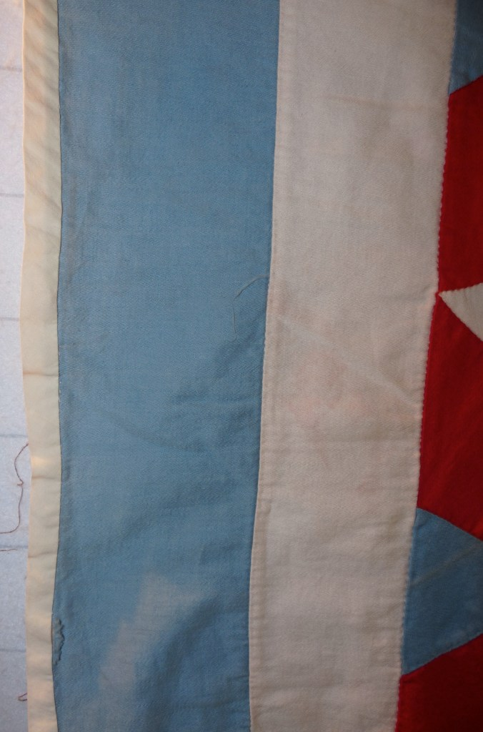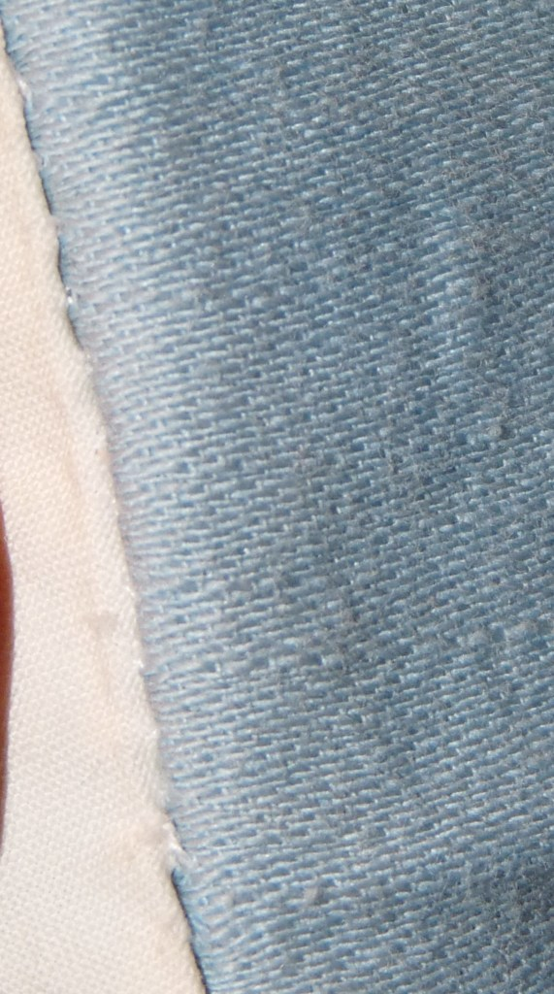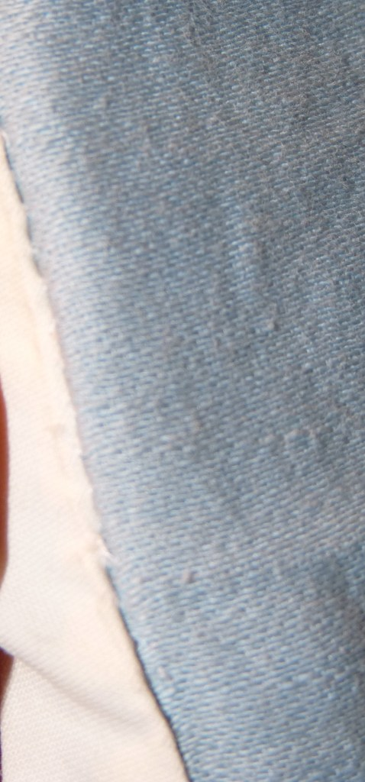

Top
Fabric Description
- Cotton – very soft, maybe flannel
- Solids – red, white and a soft blue
General Organization
- The basic repeating unit in this grid a hexagon made of 3 diamonds – one red, one white and one blue. This the Tumbling Block (BB ID 142b). The tumbling block hexagon is 3 3/8″ from tip to tip.
The tumbling blocks are assembled into a setting that forms the Rising Star (BB ID 142d). Here the Rising Star is created from the alternating red and white diamonds to form a six pointed star on a white background. The white diamond background for one star is shared with adjacent stars. The stars are 5 1/4″ from one red tip to one blue tip. The white background for a star is 6 3/4″ from tip to tip.
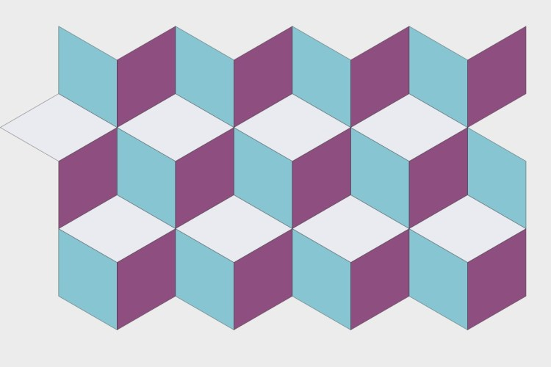142b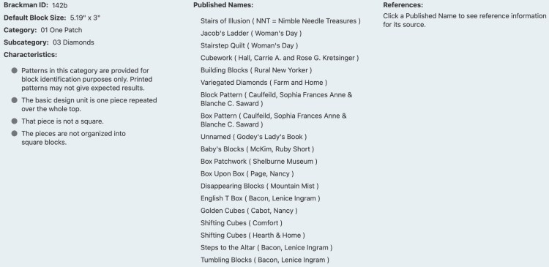142d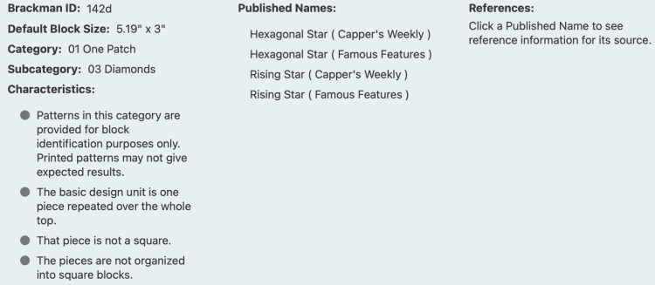Encyclopedia of Pieced Quilt Patterns, 3rd ed. Barbara Brackman.
The setting of the Idaho Stars is not consistent in this quilt top. Some stars are rotated by 60 degrees compared to others. A comparison of the settings is provided here.
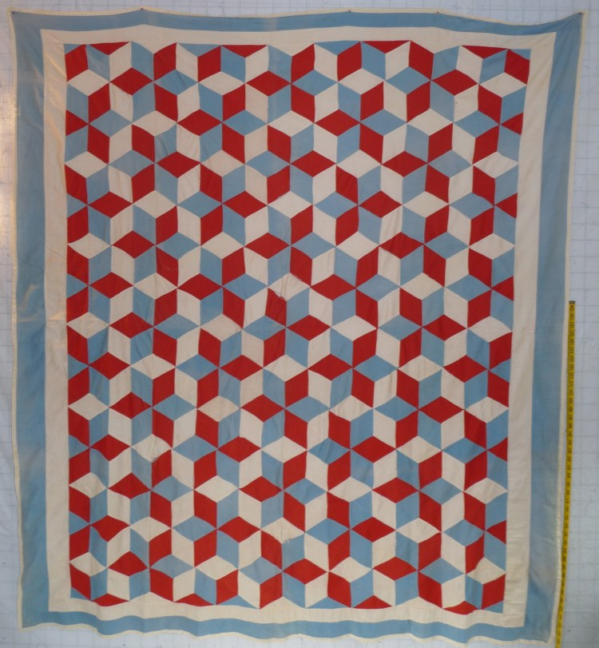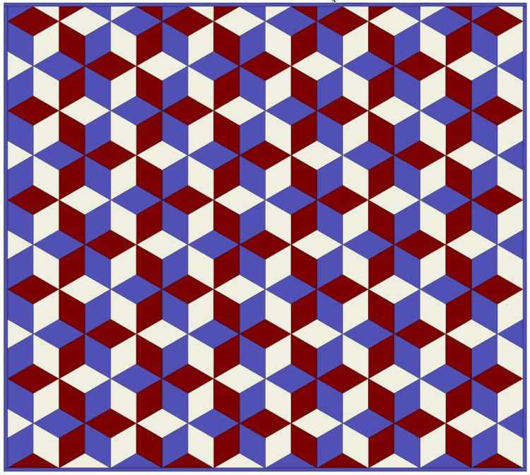Consistent Idaho Star Setting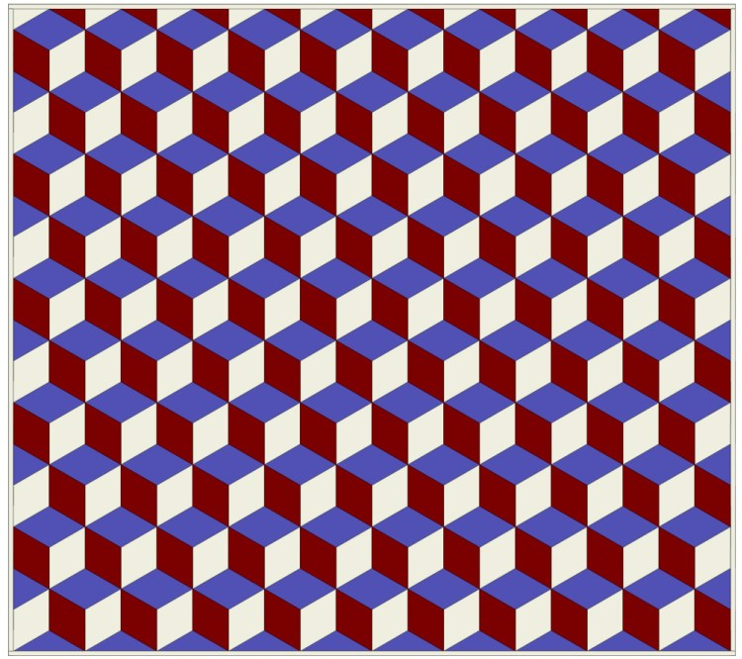Tumbling Block Setting
- Sashing: None
- Borders
There are 2 borders. The inner border is solid white (2 3/4″) and the outer border is solid blue (4″). Neither are pieced, but strips were created with blunt-end seams, not biased seams.
Other
- Techniques Used: Patchwork
- Stitching Methods:
  - Blocks: Hand
  - Top Assembly: Hand
- Workmanship: Hand-piecing and top assembly is very good.
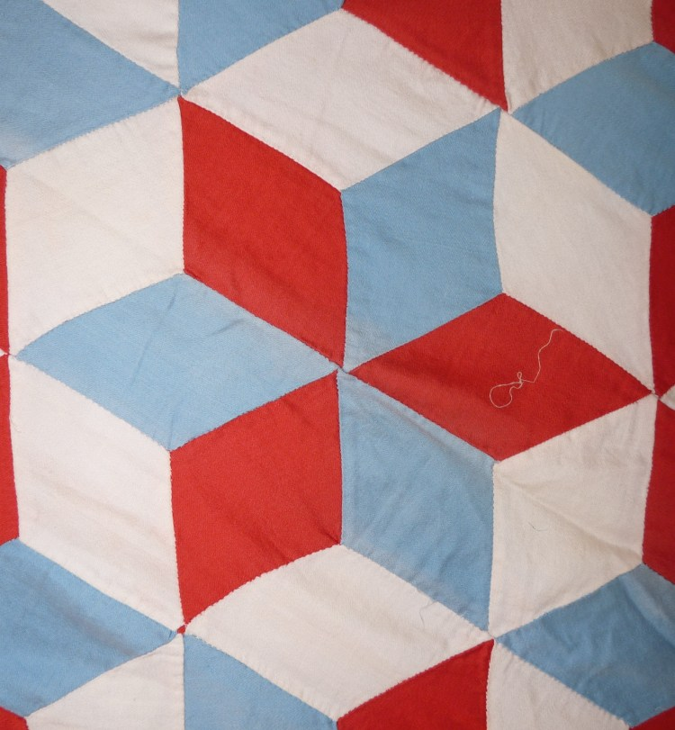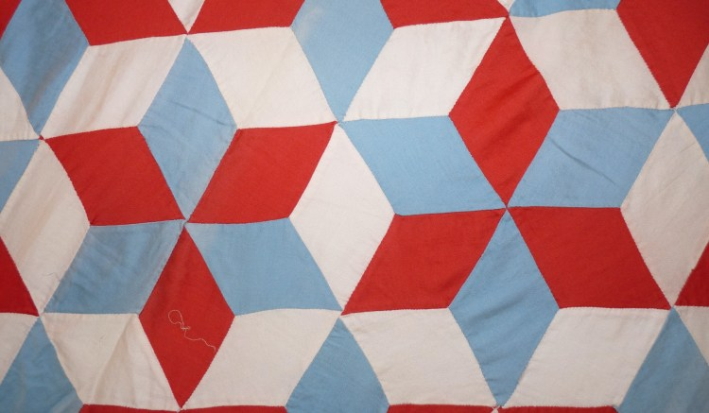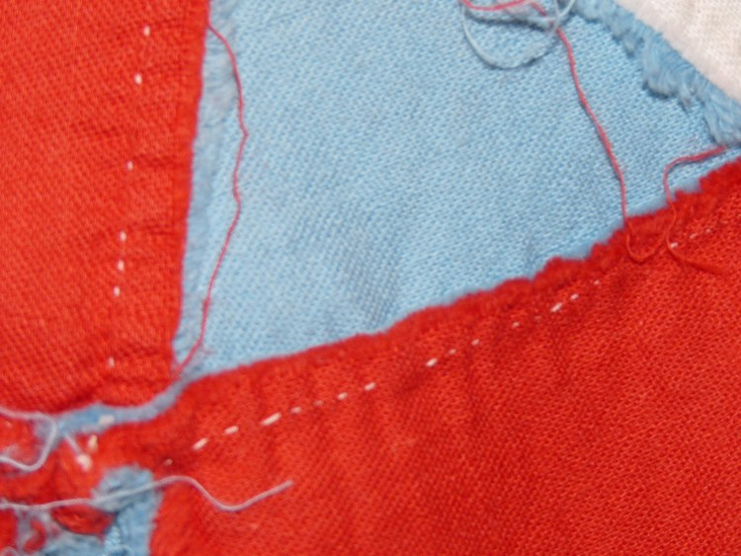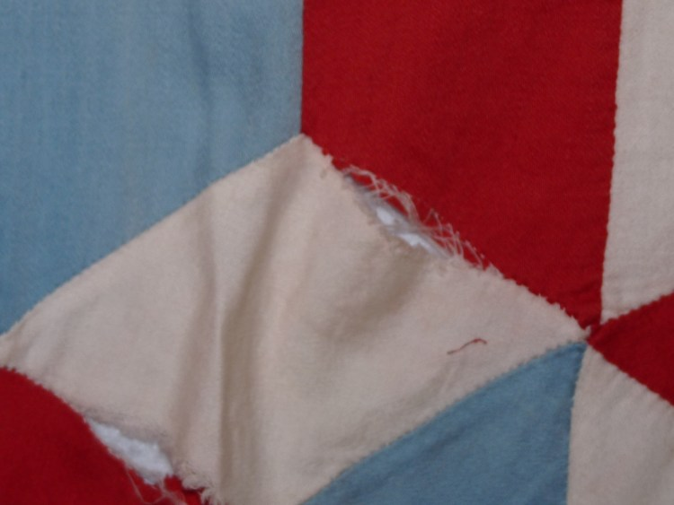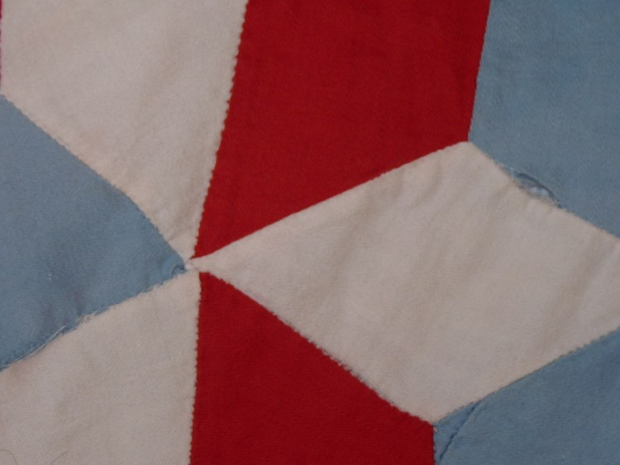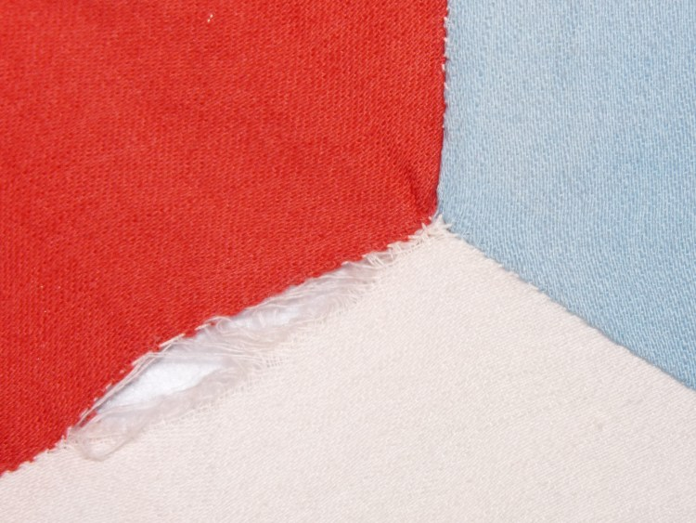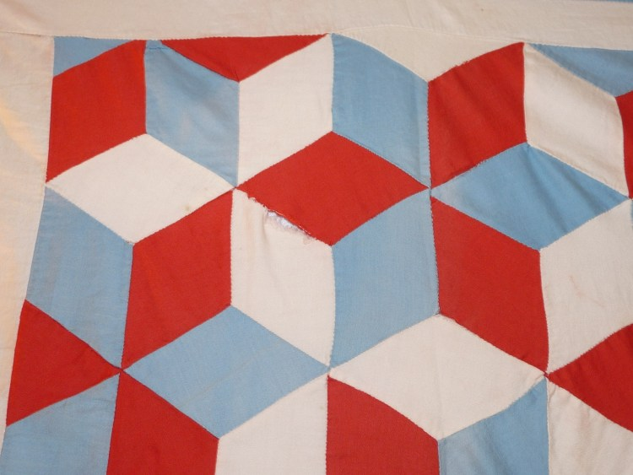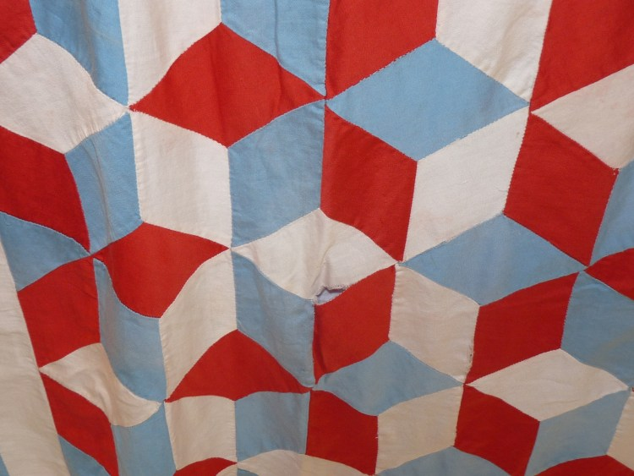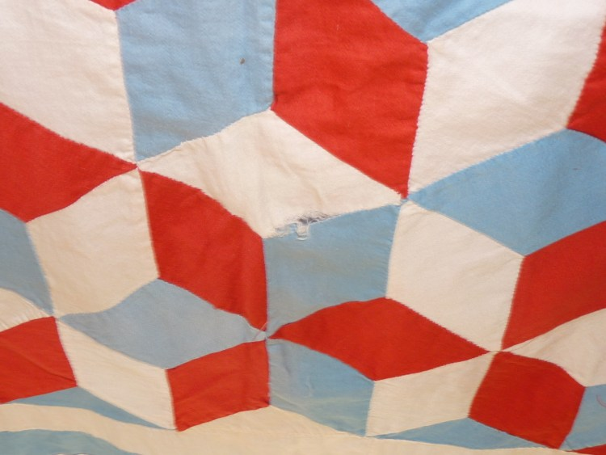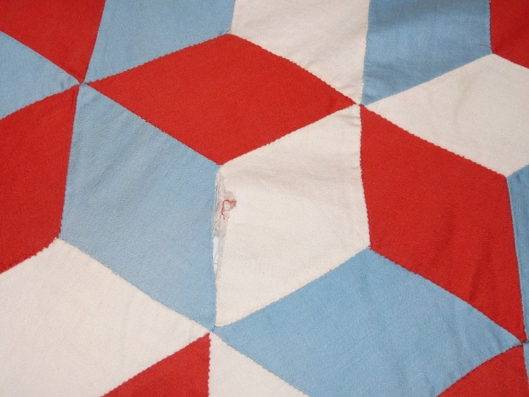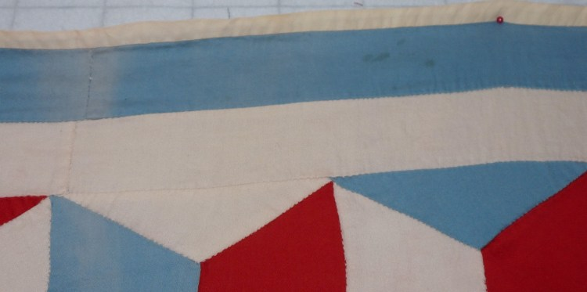

Edge Treatment
Style
- The binding is white and may have been applied after the original construction of the top because it was not done by hand – like the rest of the piece. This may have been done to prevent fraying.
The hand work used to apply the binding to the back of the top is much coarser than the hand work used for piecing seams.
- Straight edge.
- Front-to-Back
  - Front applied by machine
  - Back applied by hand
- Size of binding:
  - Width on Front: 3/8″
  - Width on Back: 3/8″

Appraisal
No
- Vintage Pieces $ 22.45
  - Tops
  - Price for Original Set: $ 22.45
    - Number of Units in Original Set: 1
    - Price per unit: $ 22.45
  - Vendor Contact Information:
Cadiz Antique Mall
24 Main Street
Cadiz KY 42211
270 522 7880
- 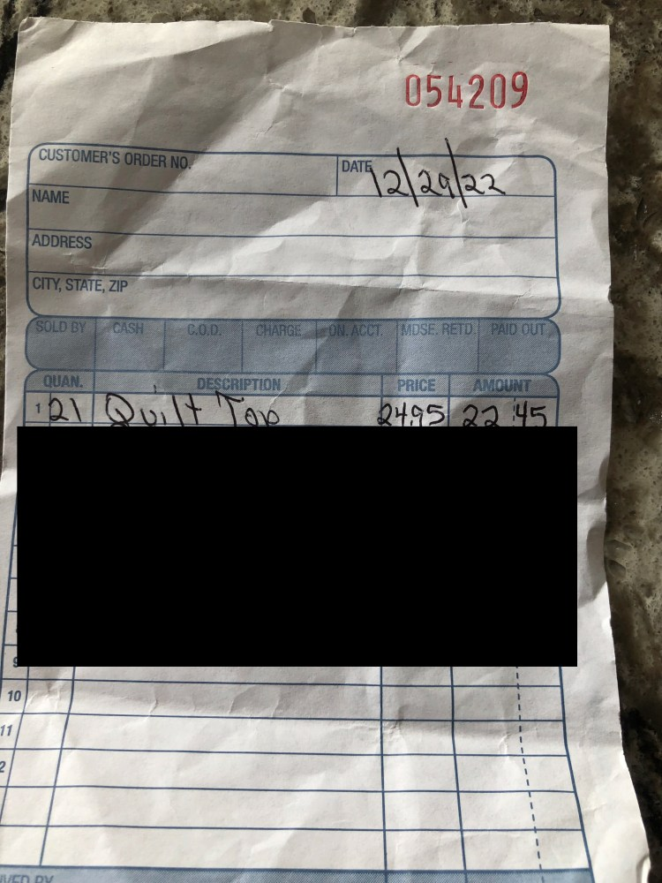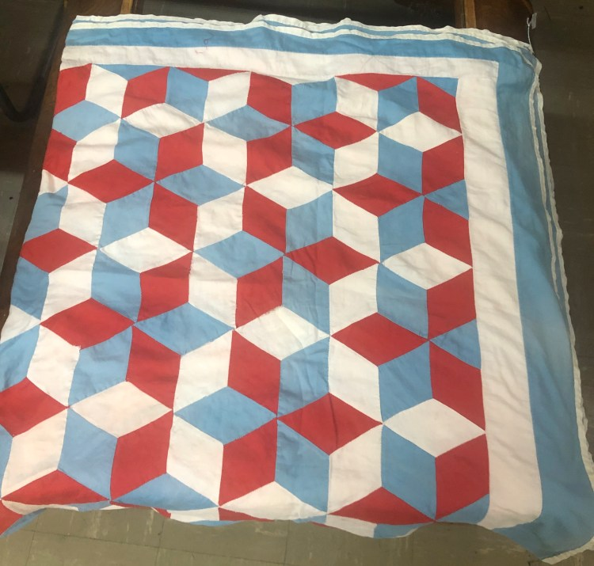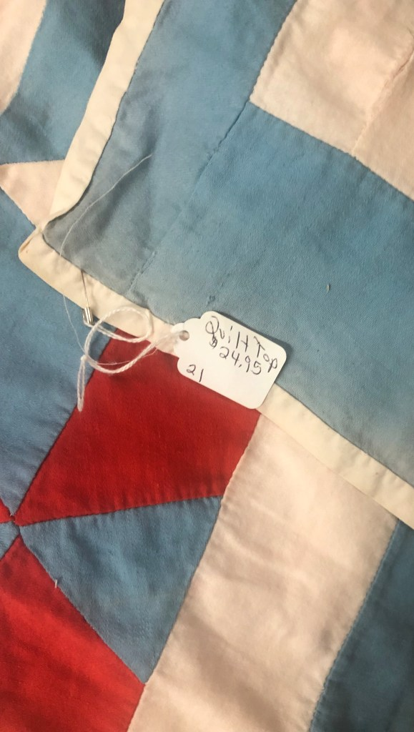Vintage Pieces $ 22.45
  - Tops
  - Price for Original Set: $ 22.45
    - Number of Units in Original Set: 1
    - Price per unit: $ 22.45
  - Vendor Contact Information:
Cadiz Antique Mall
24 Main Street
Cadiz KY 42211
270 522 7880

