Documentation Form

Overview

Images
Top | Back
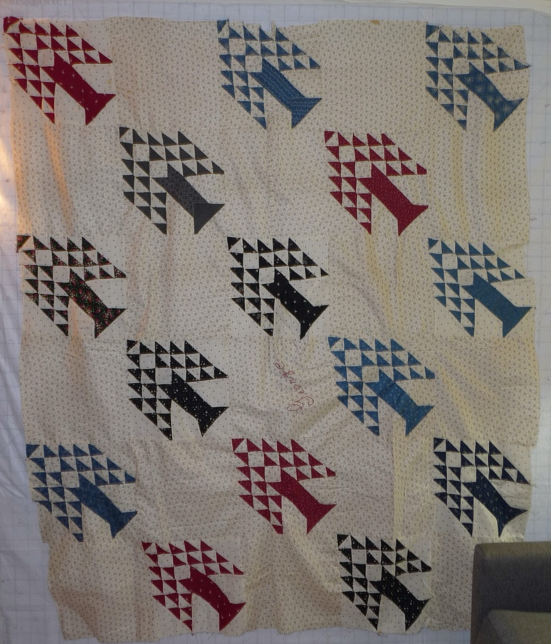 | 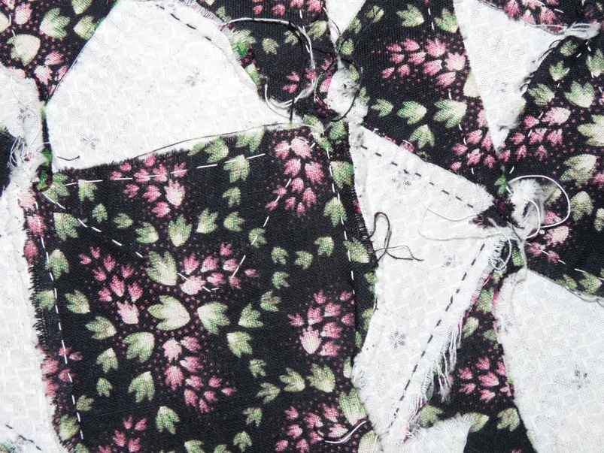

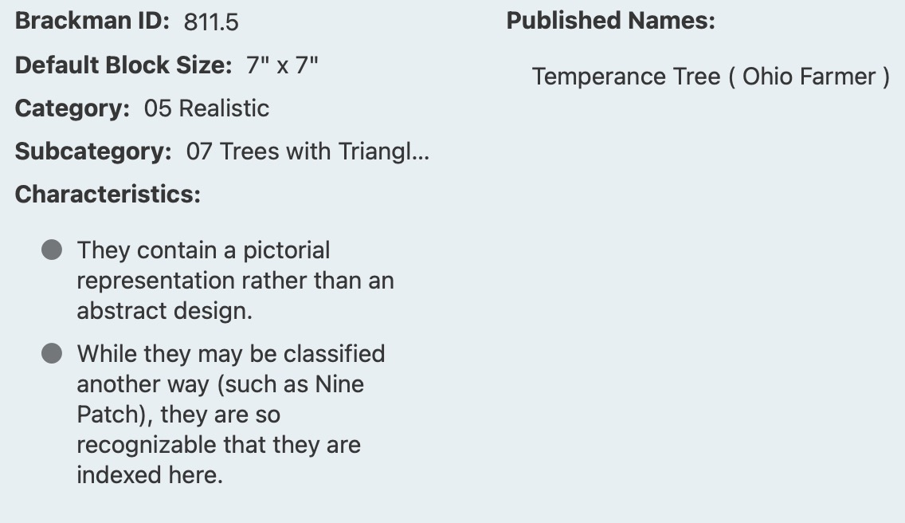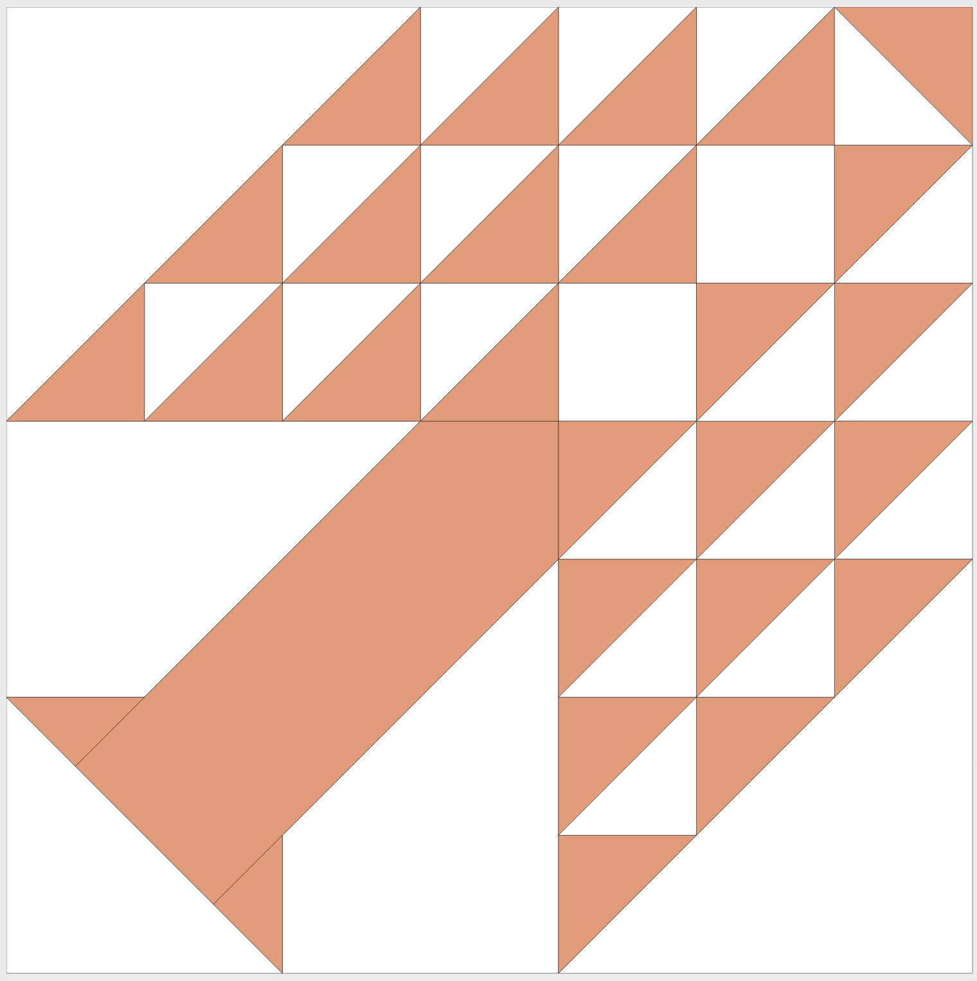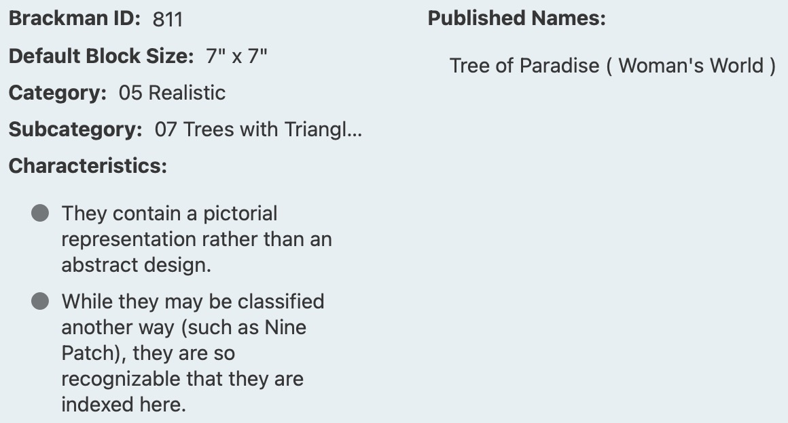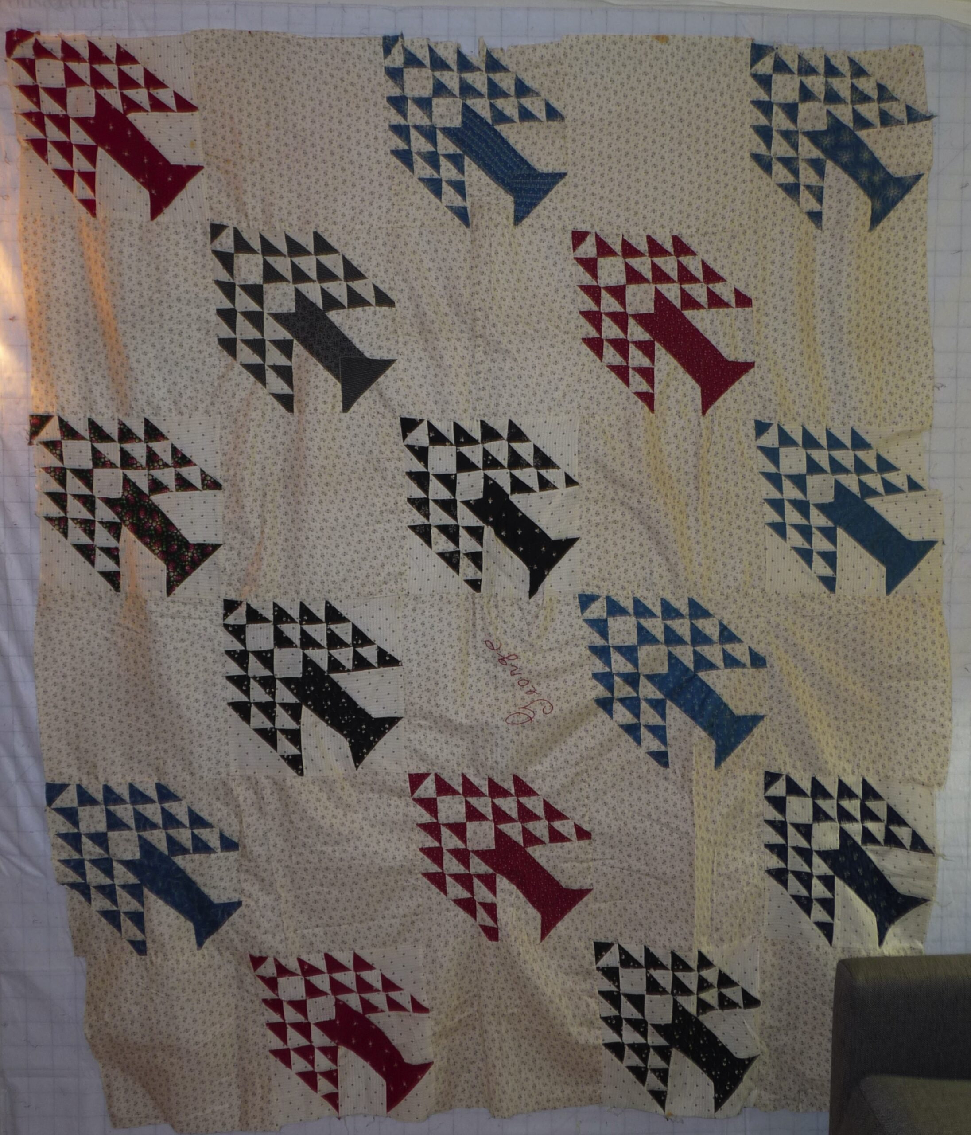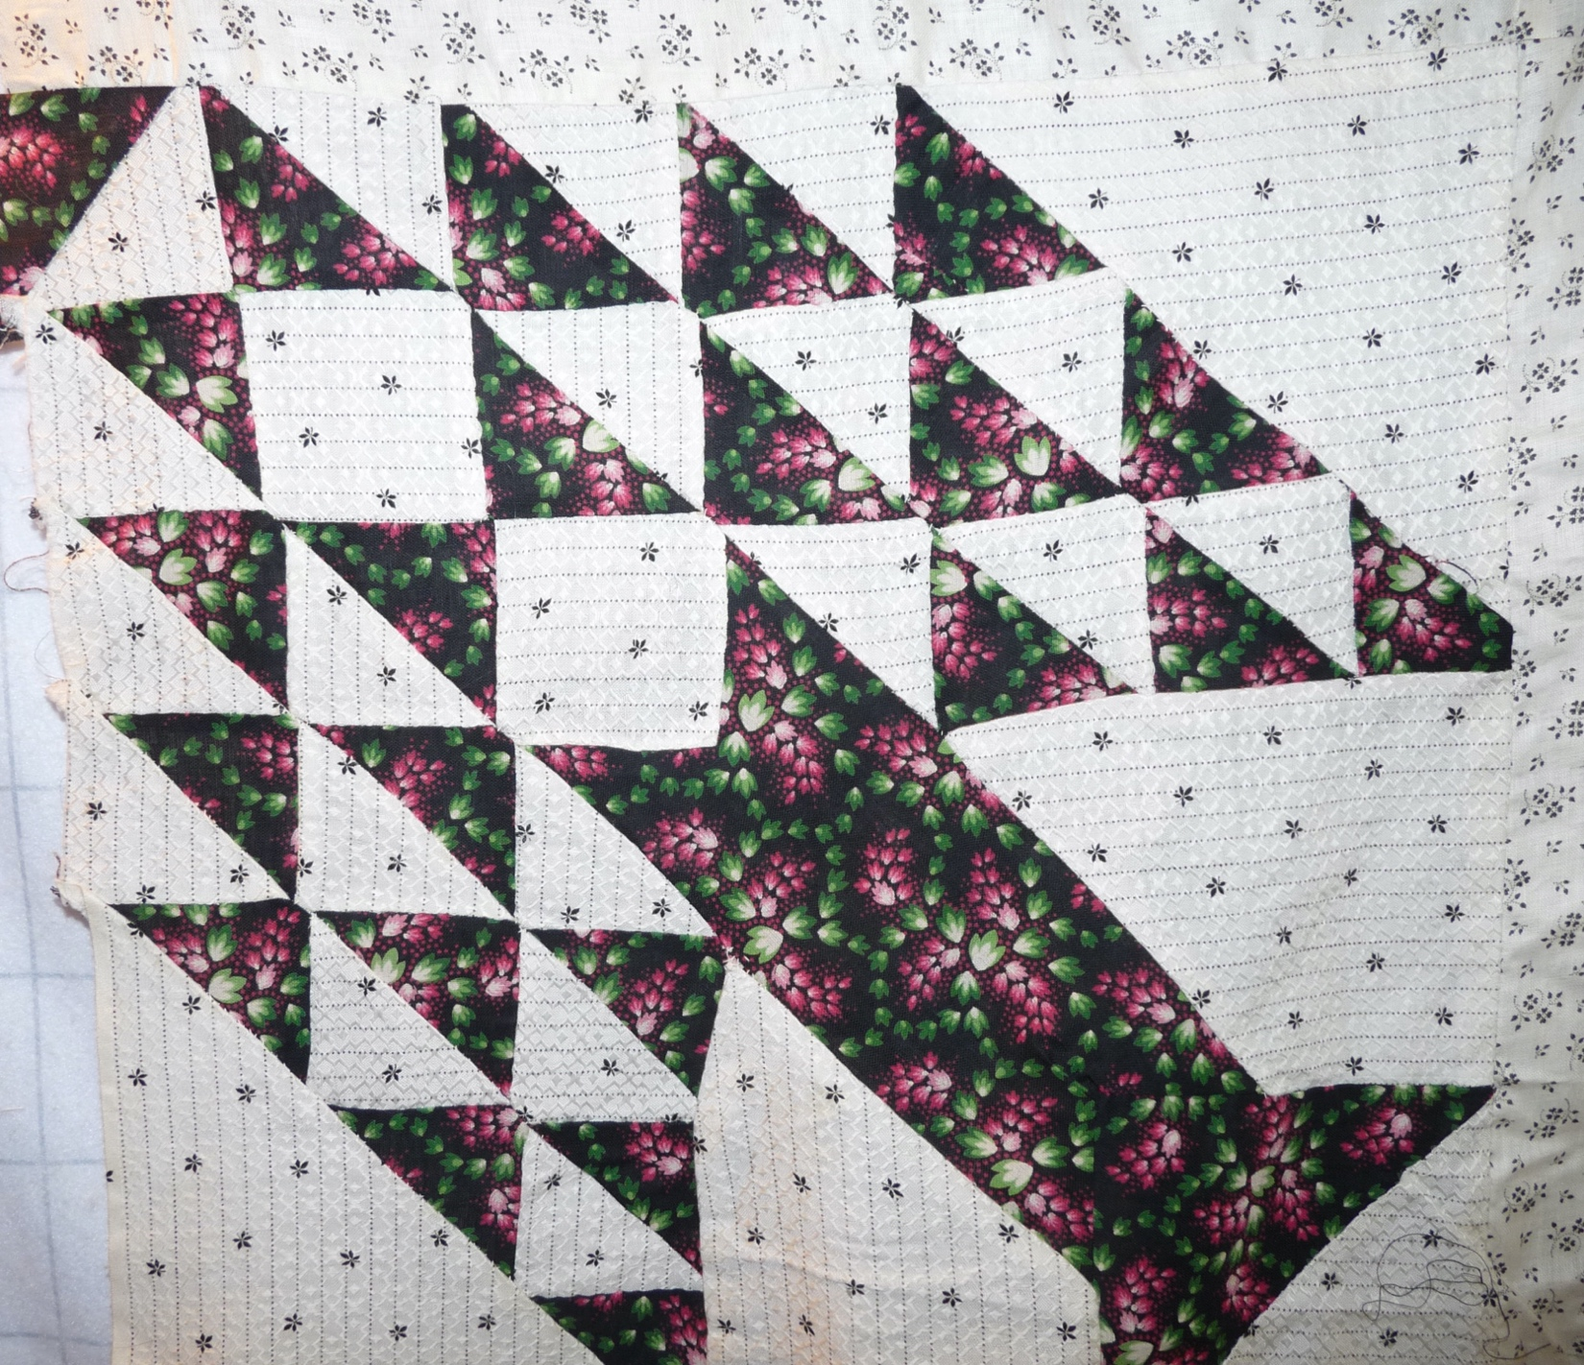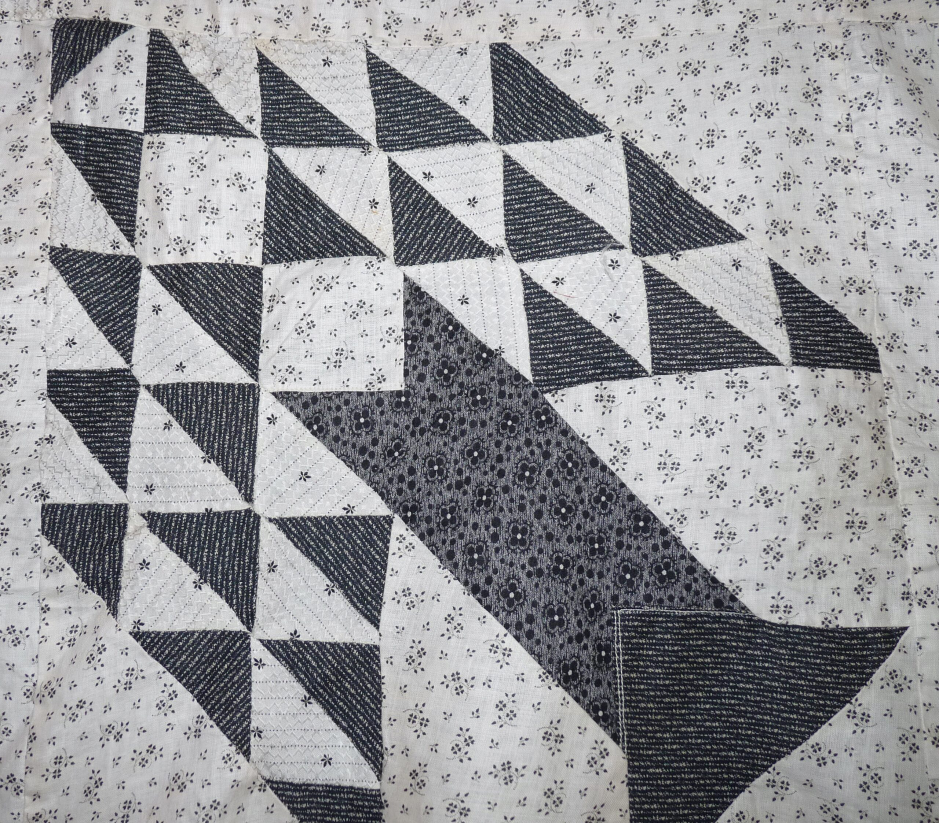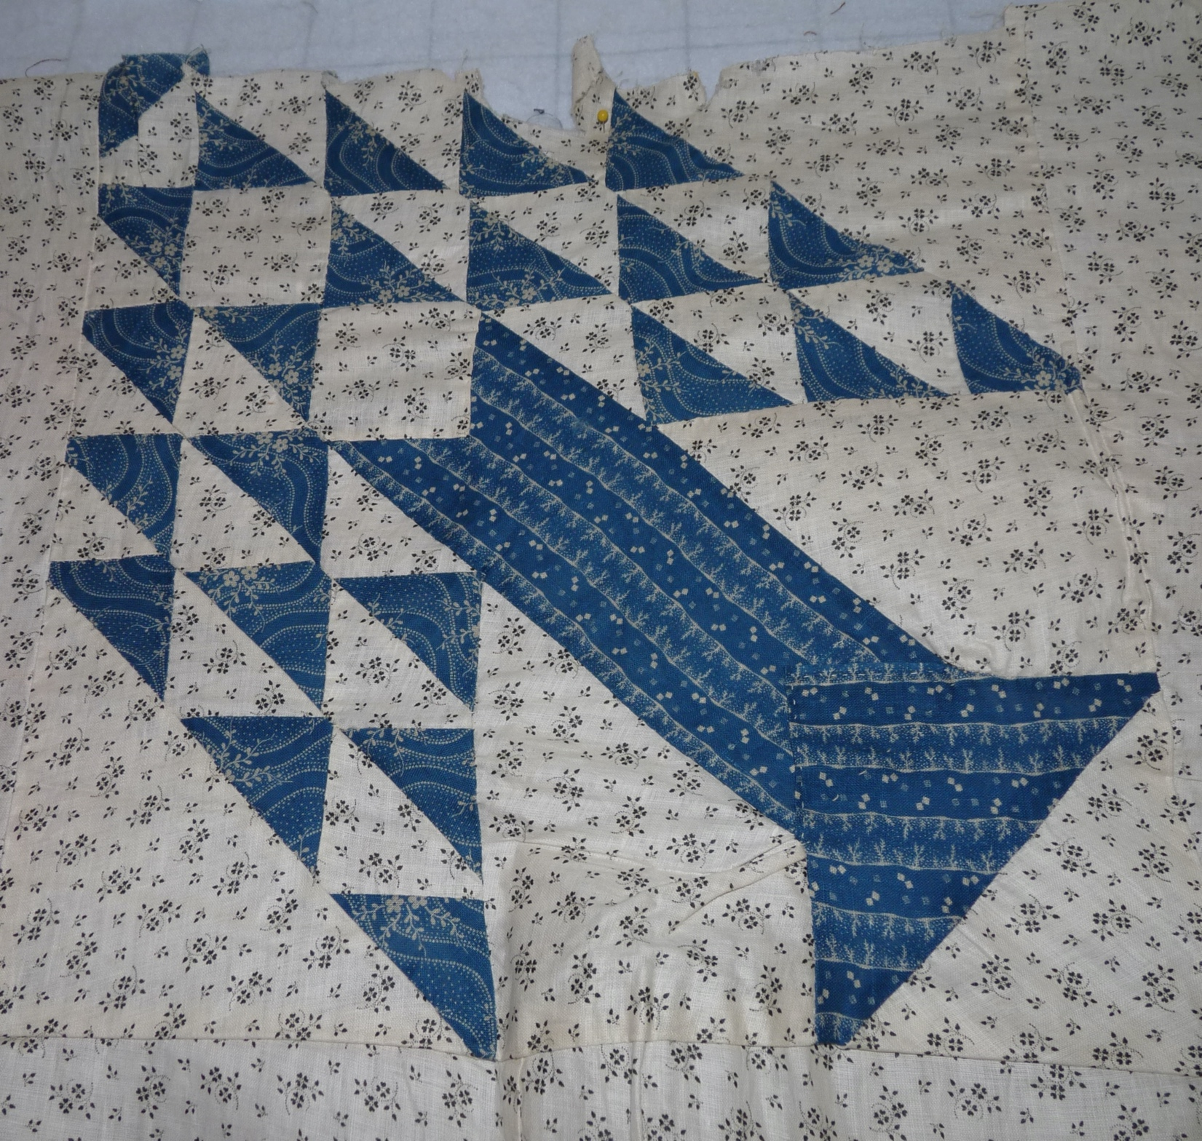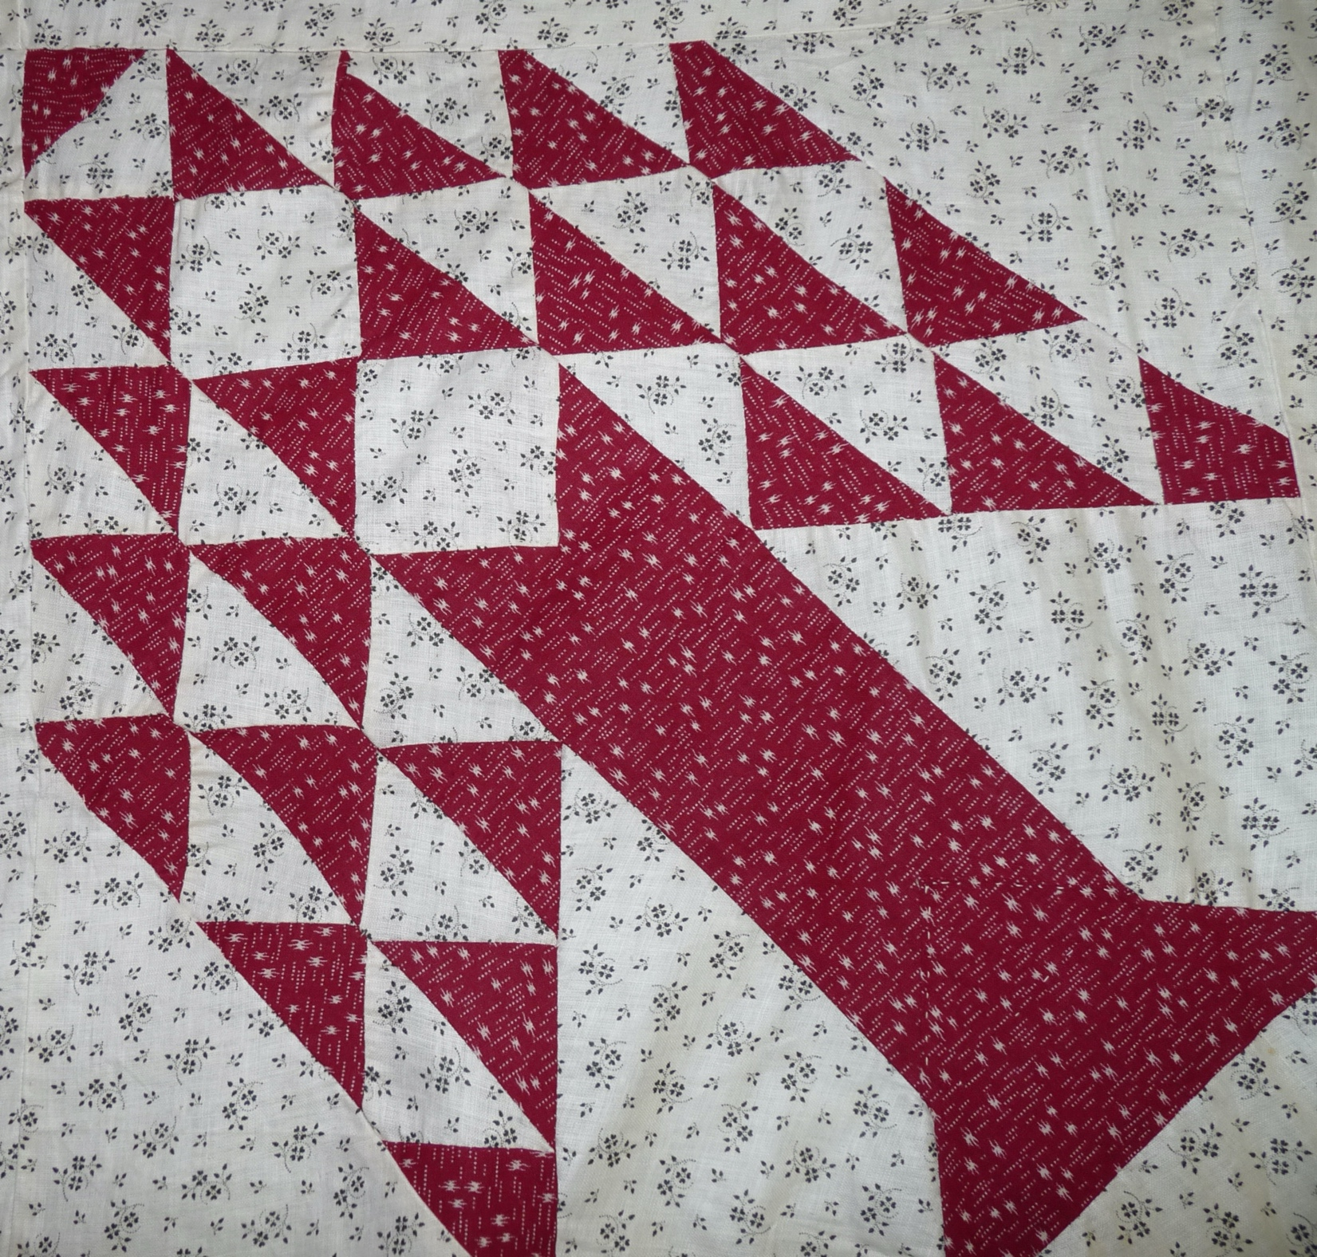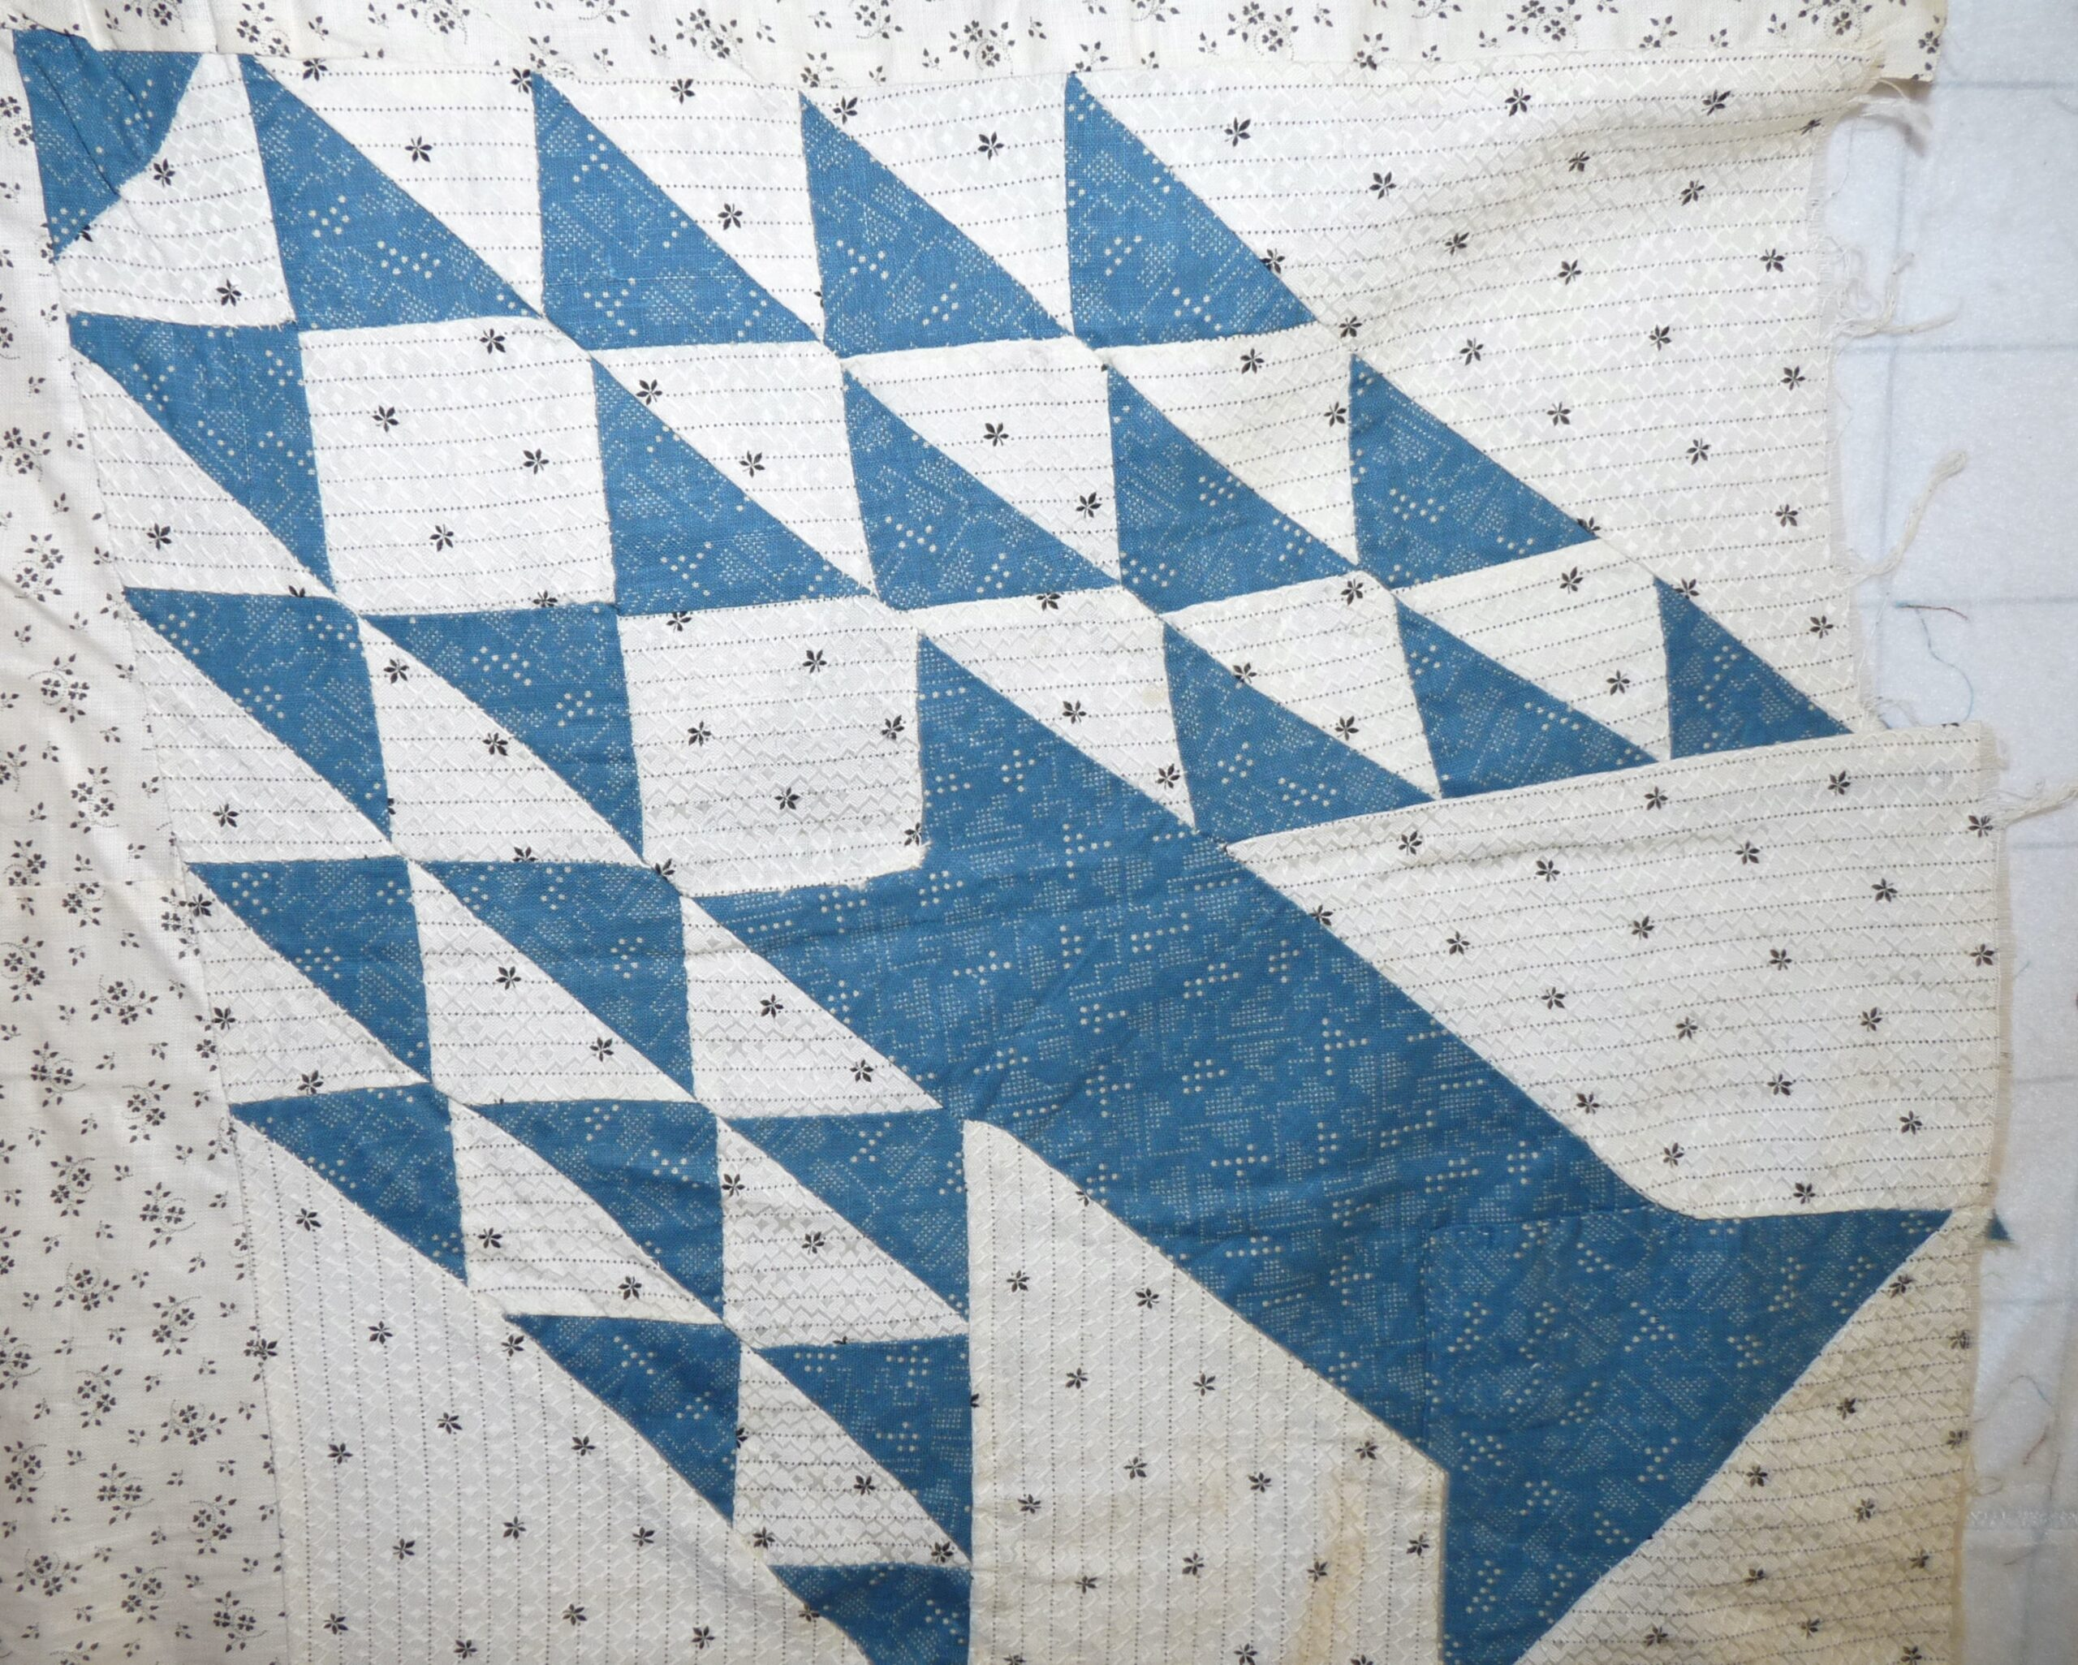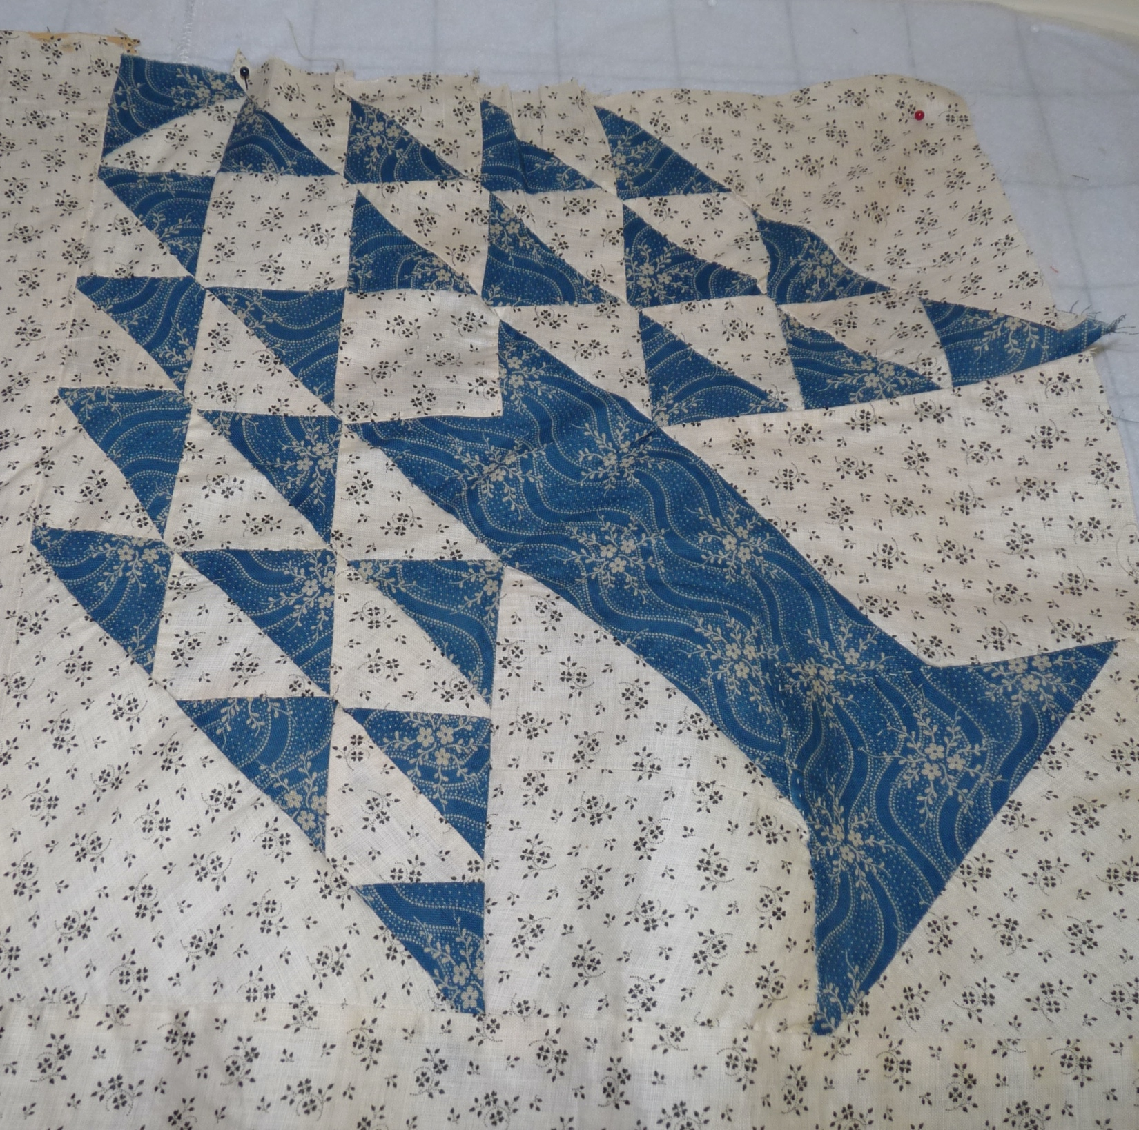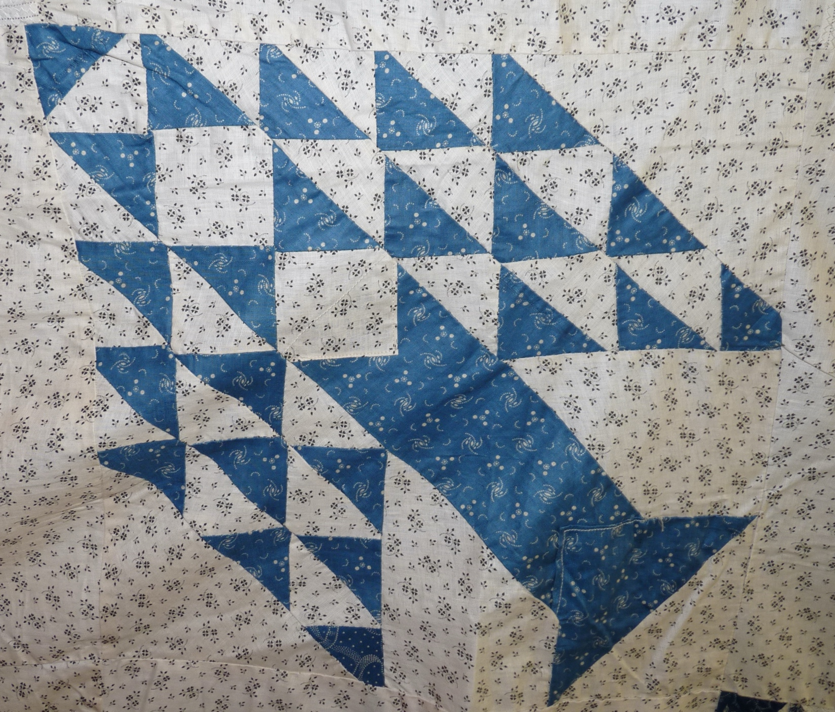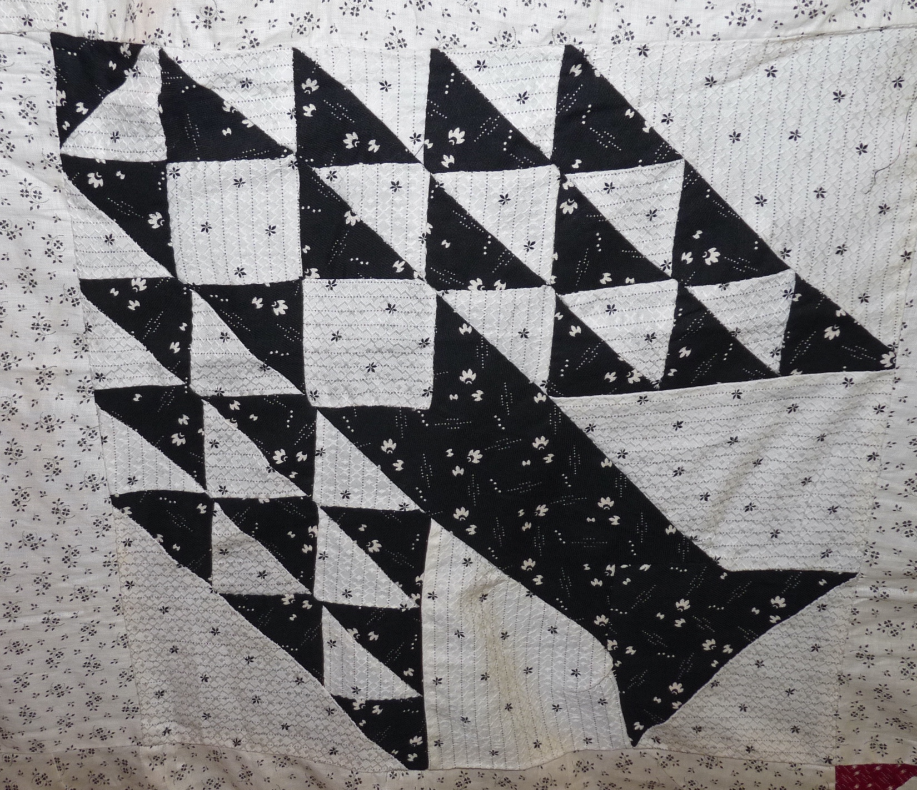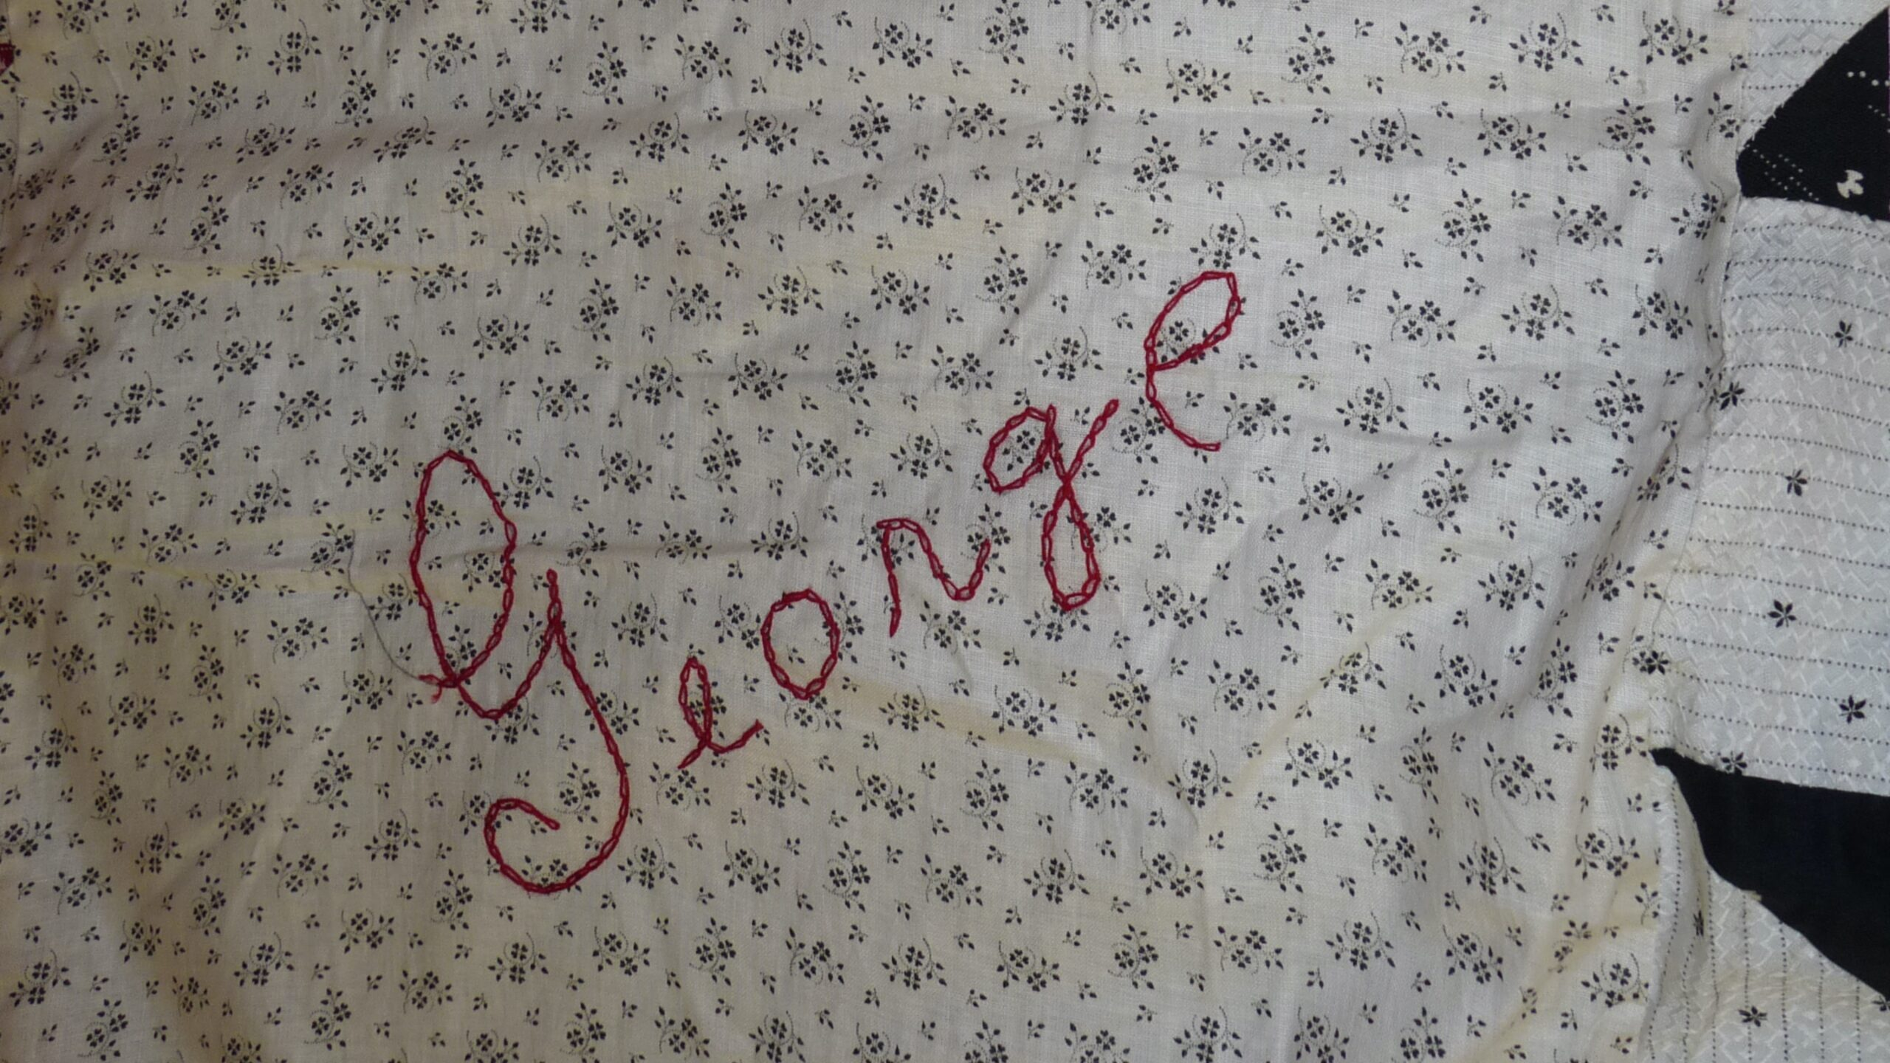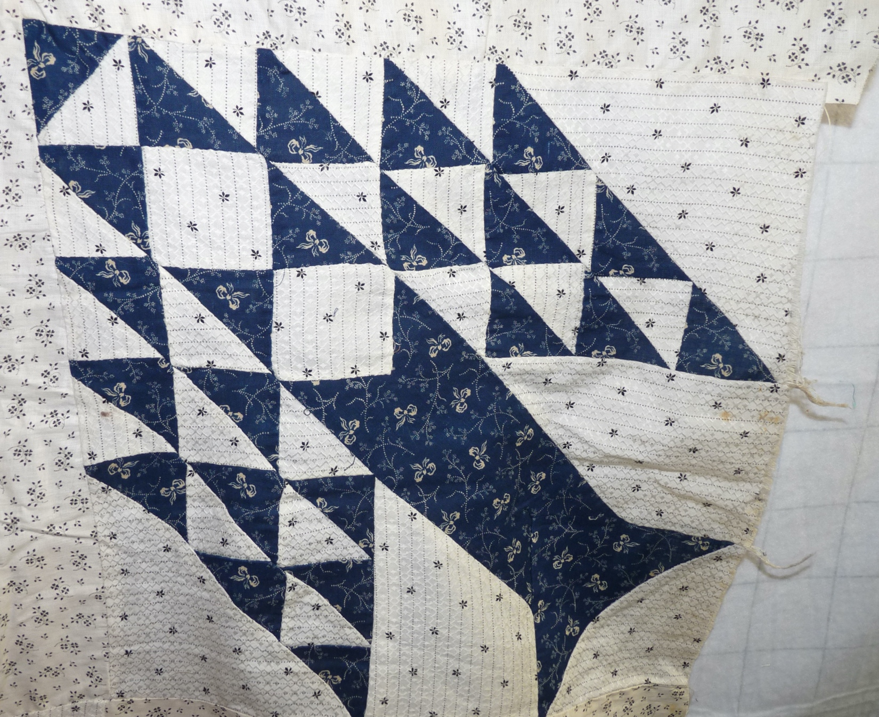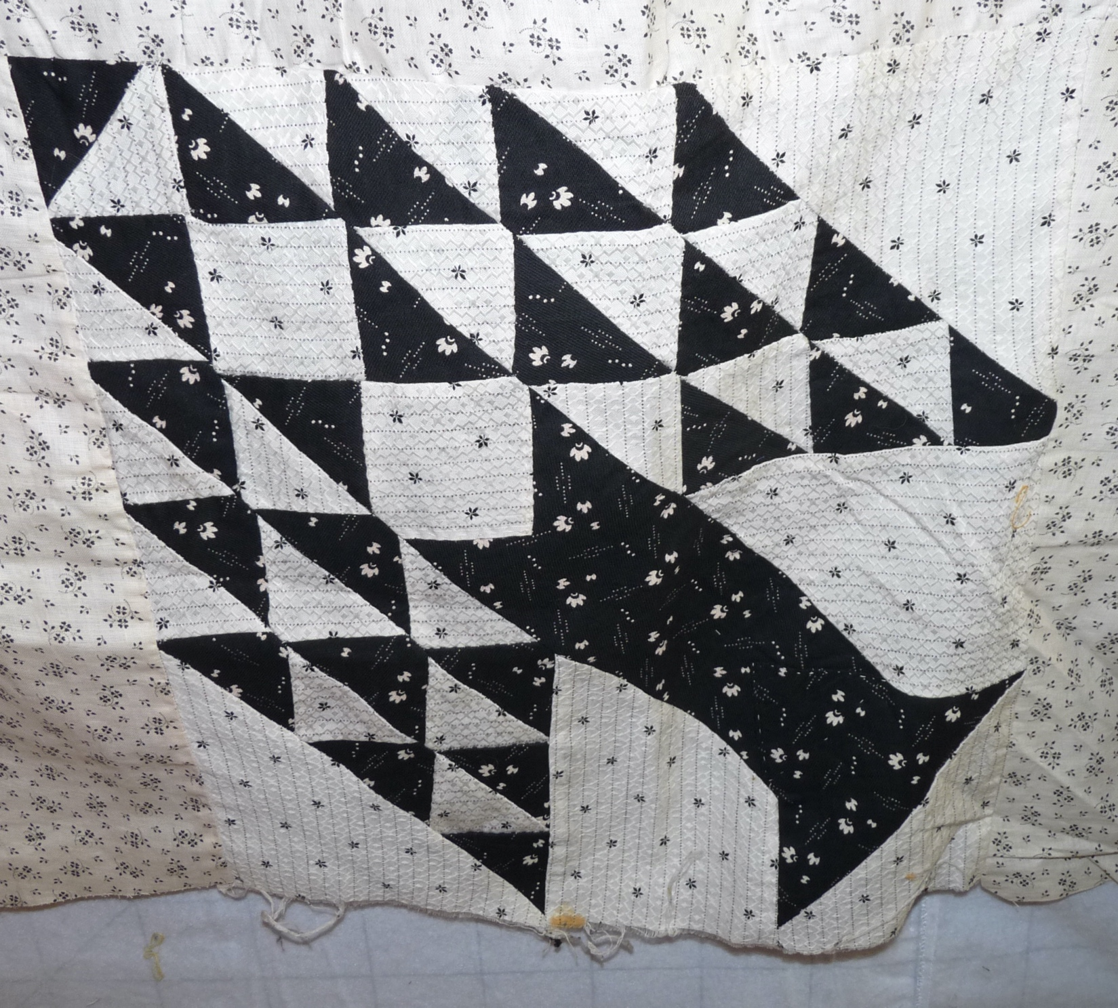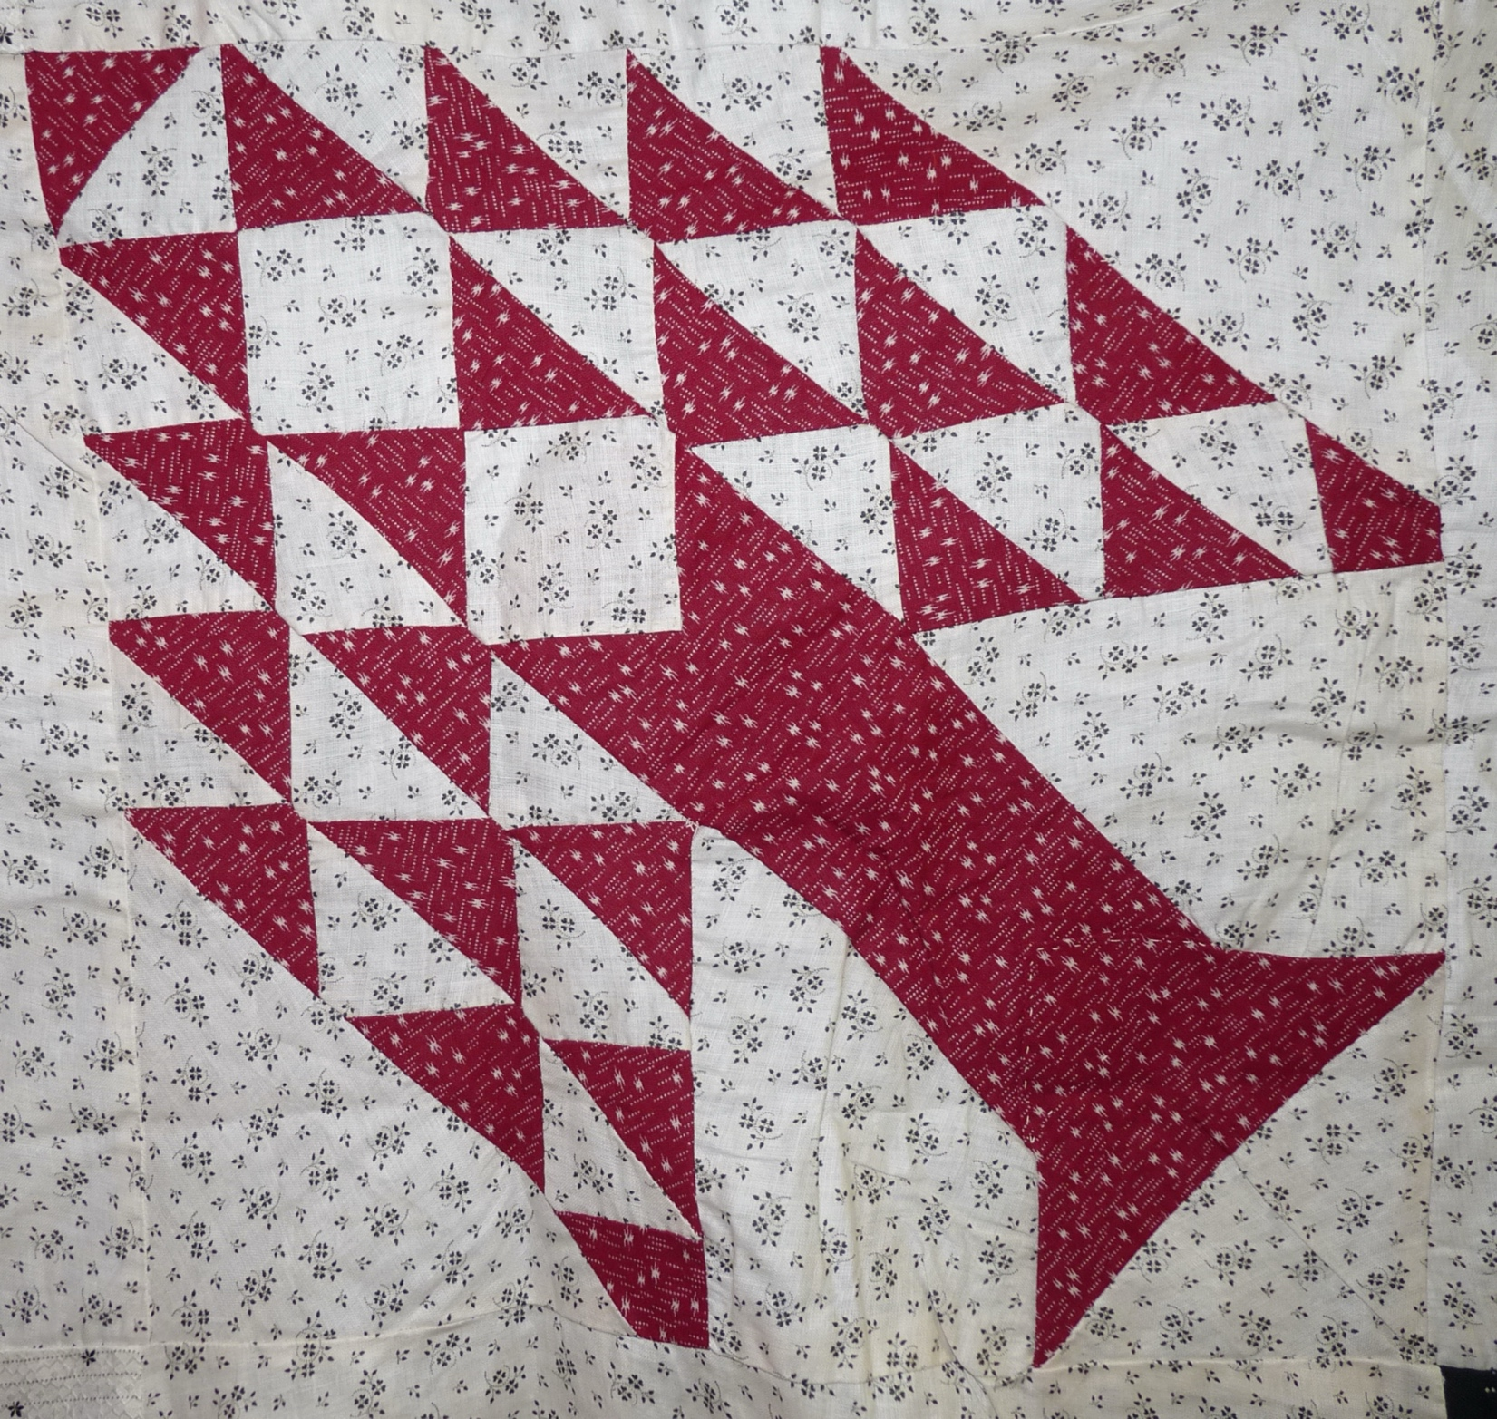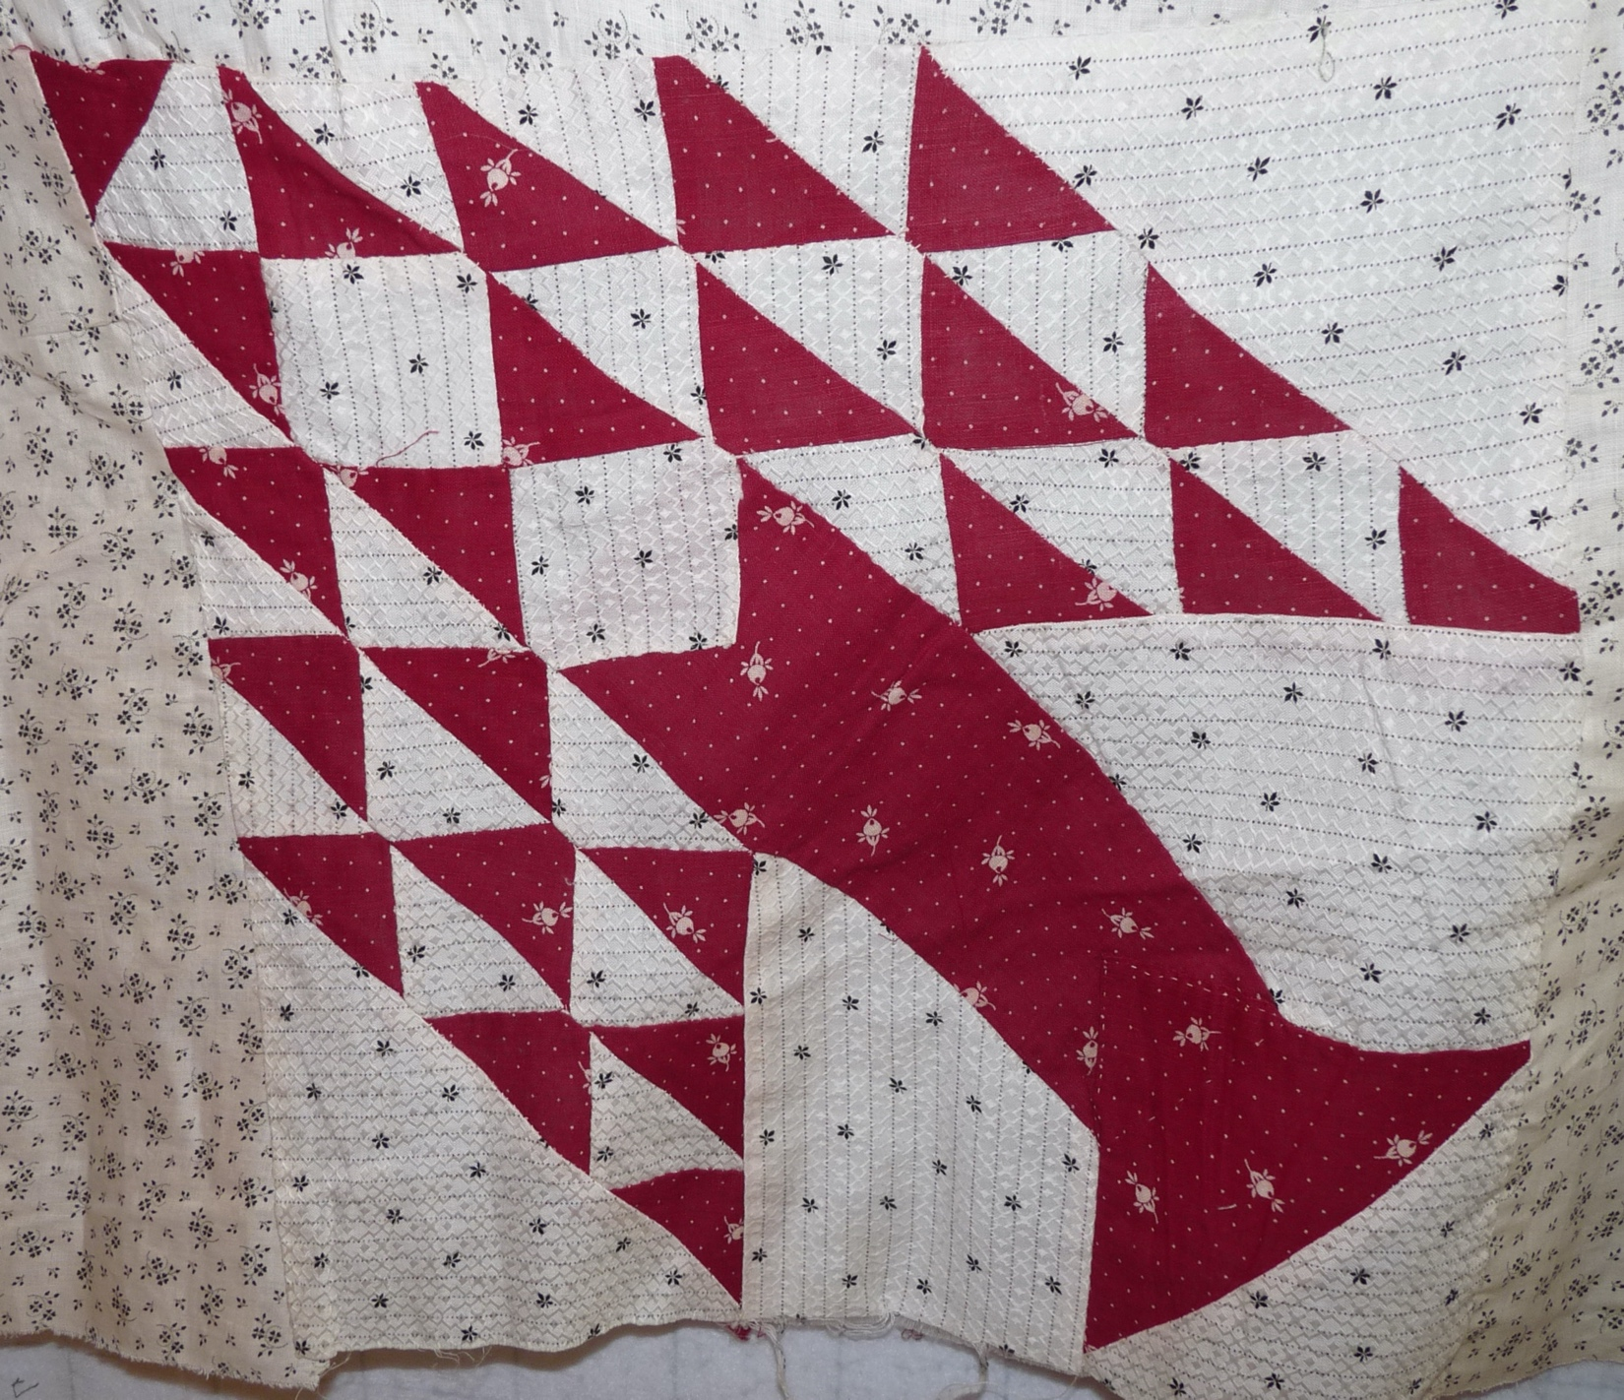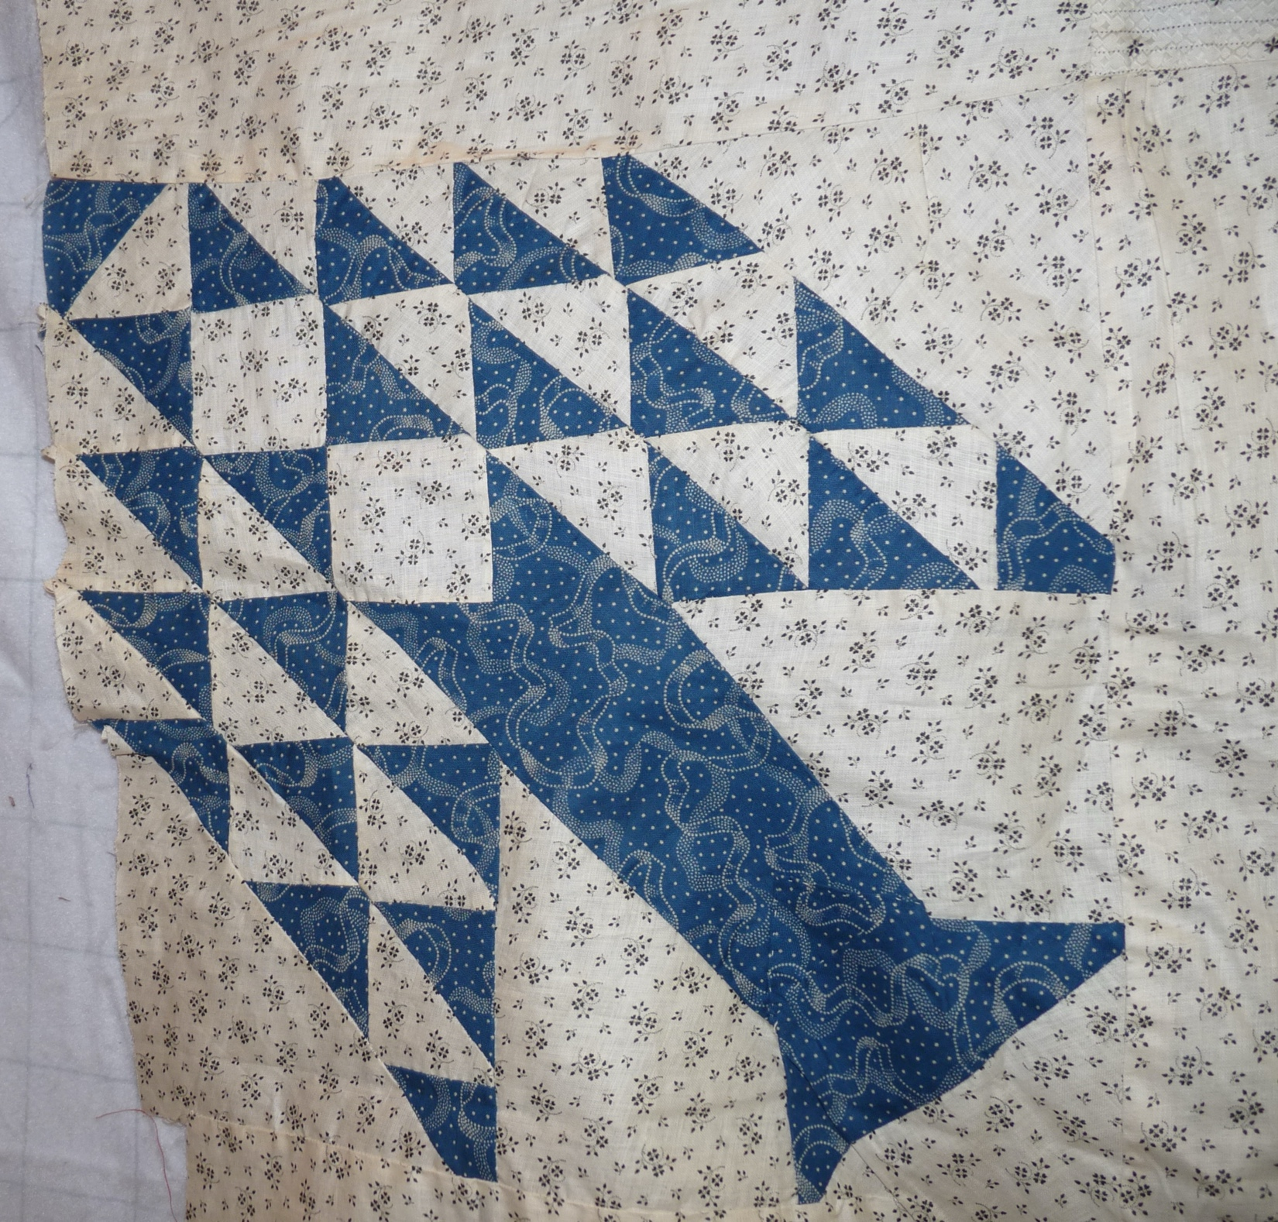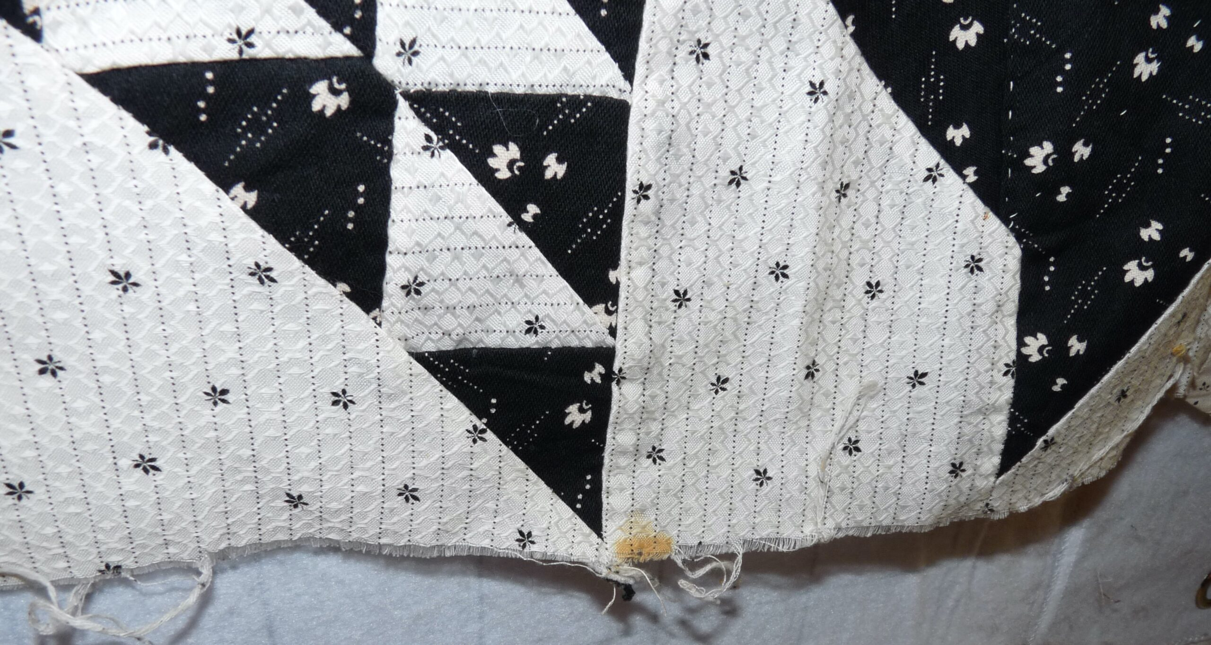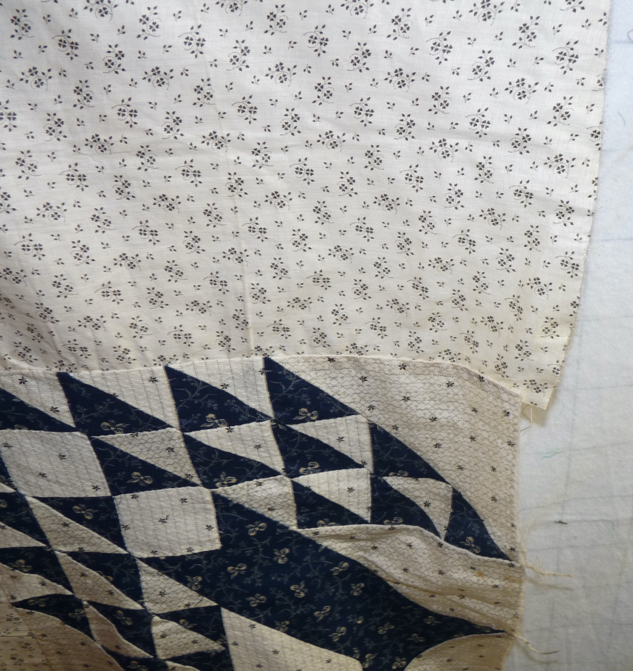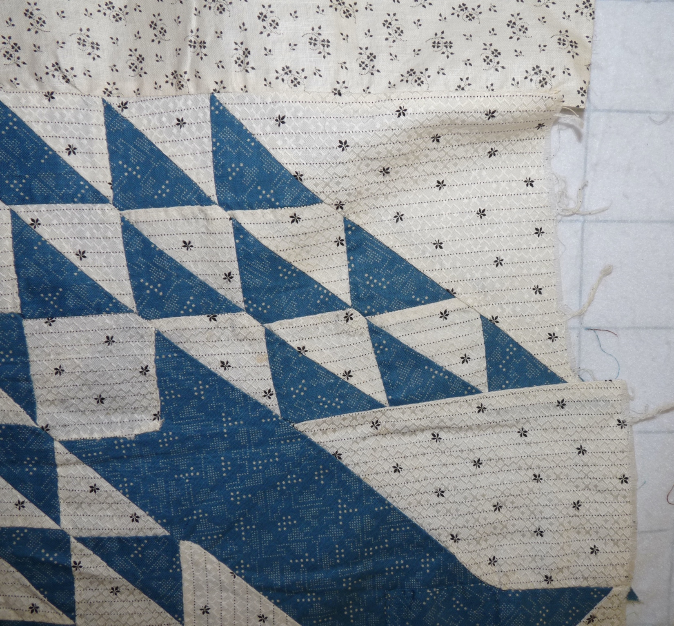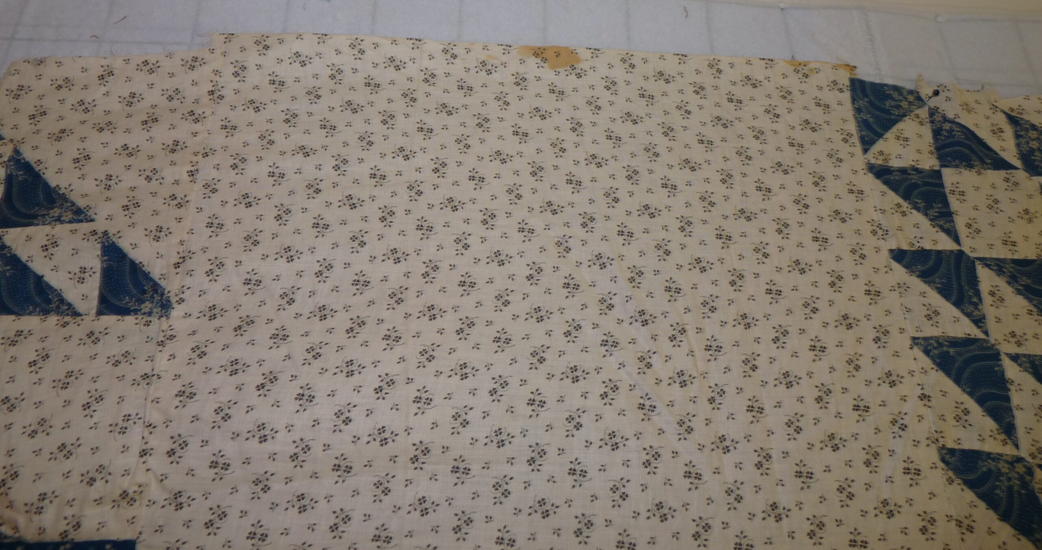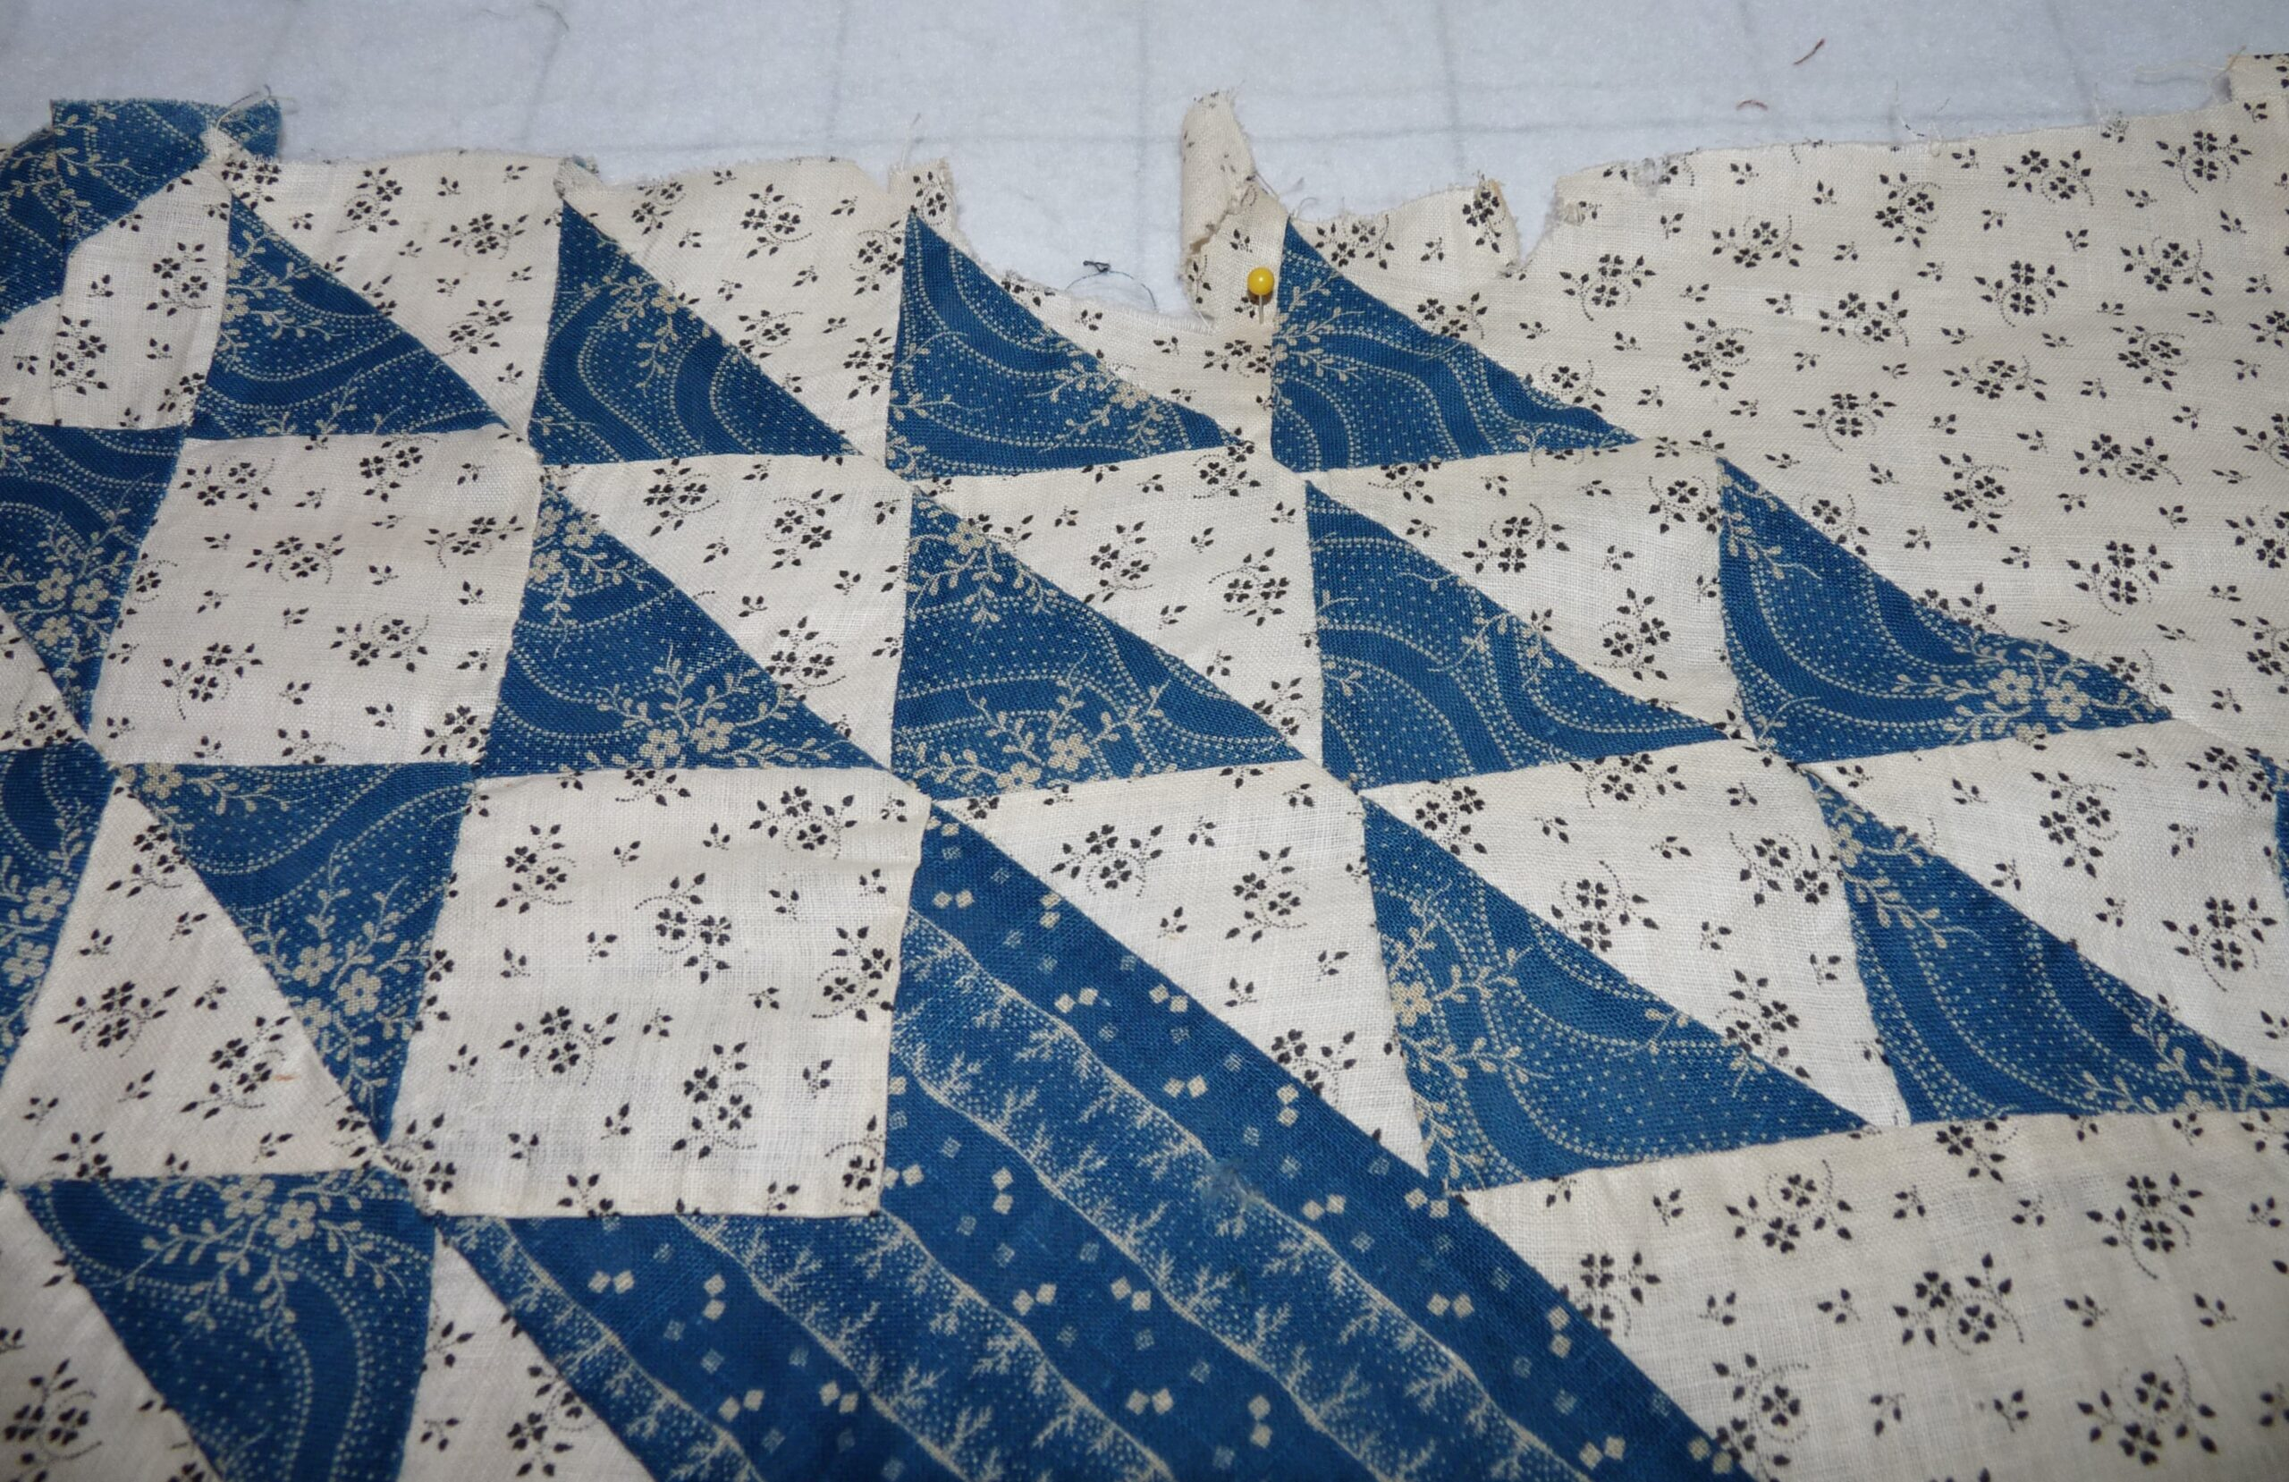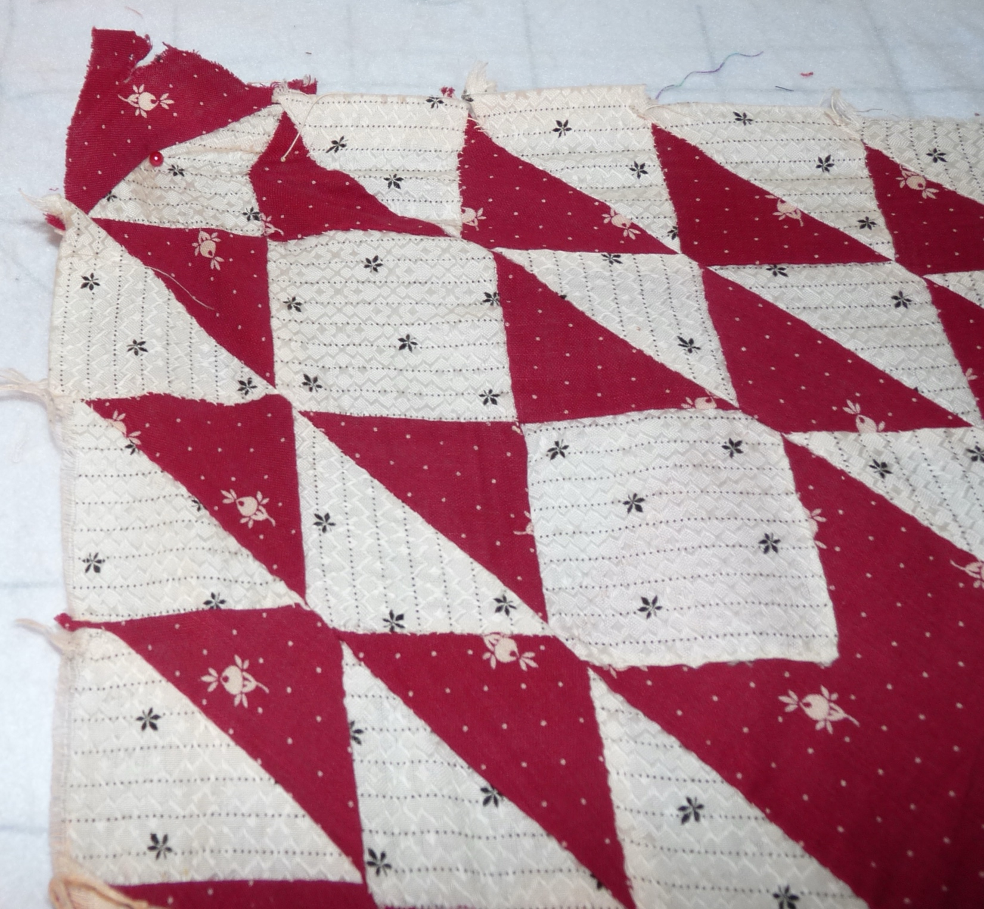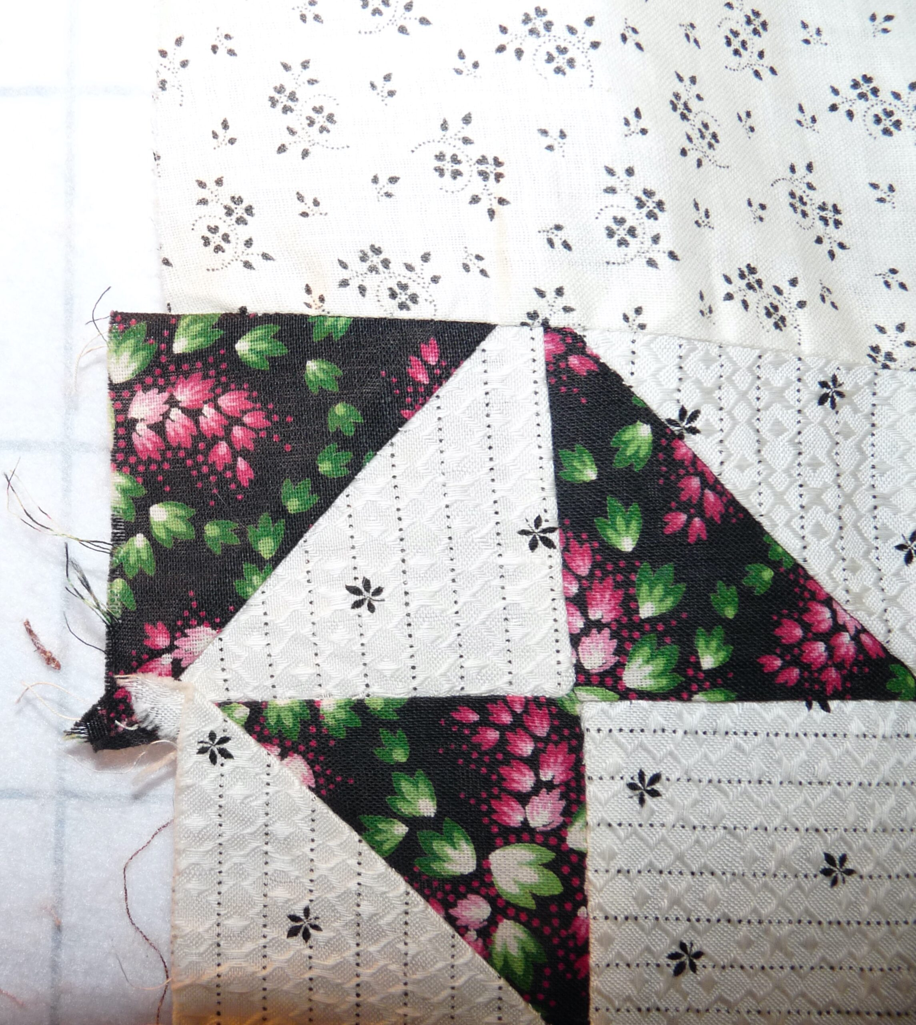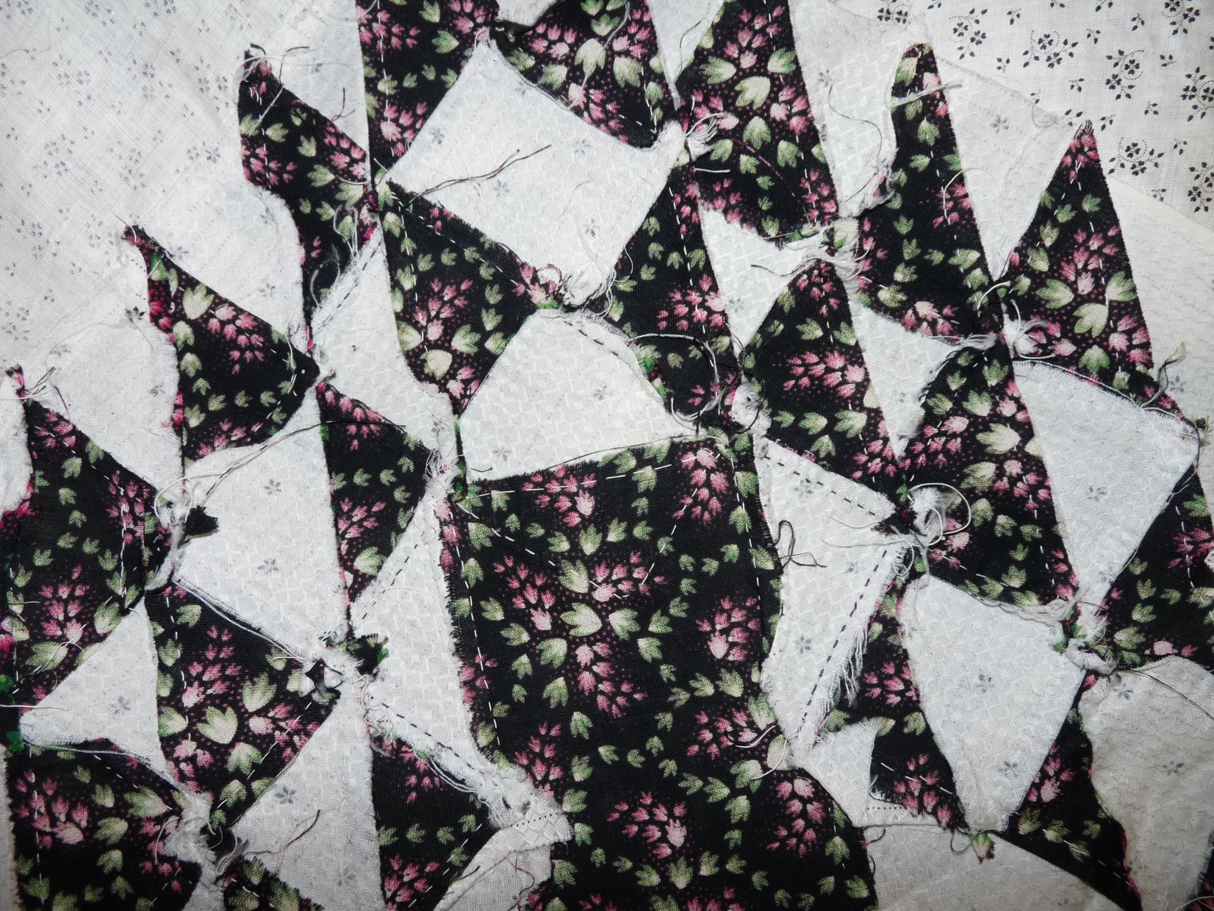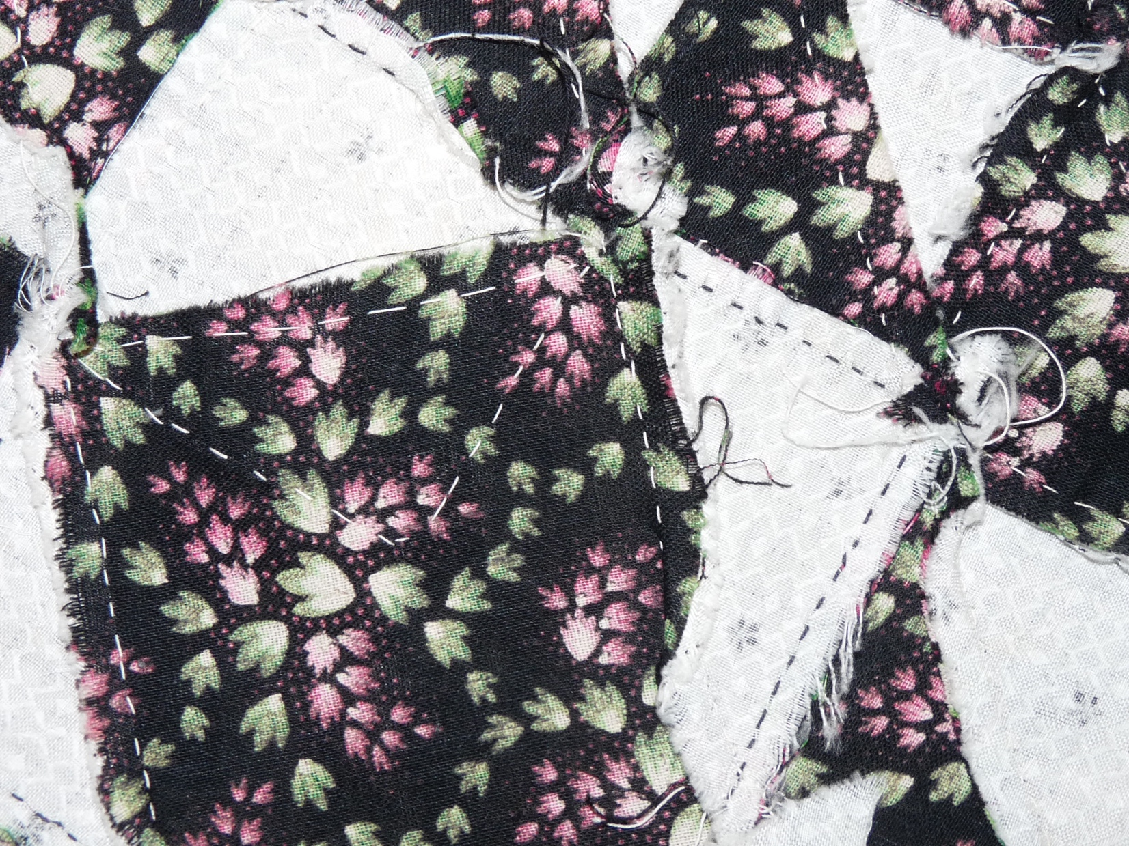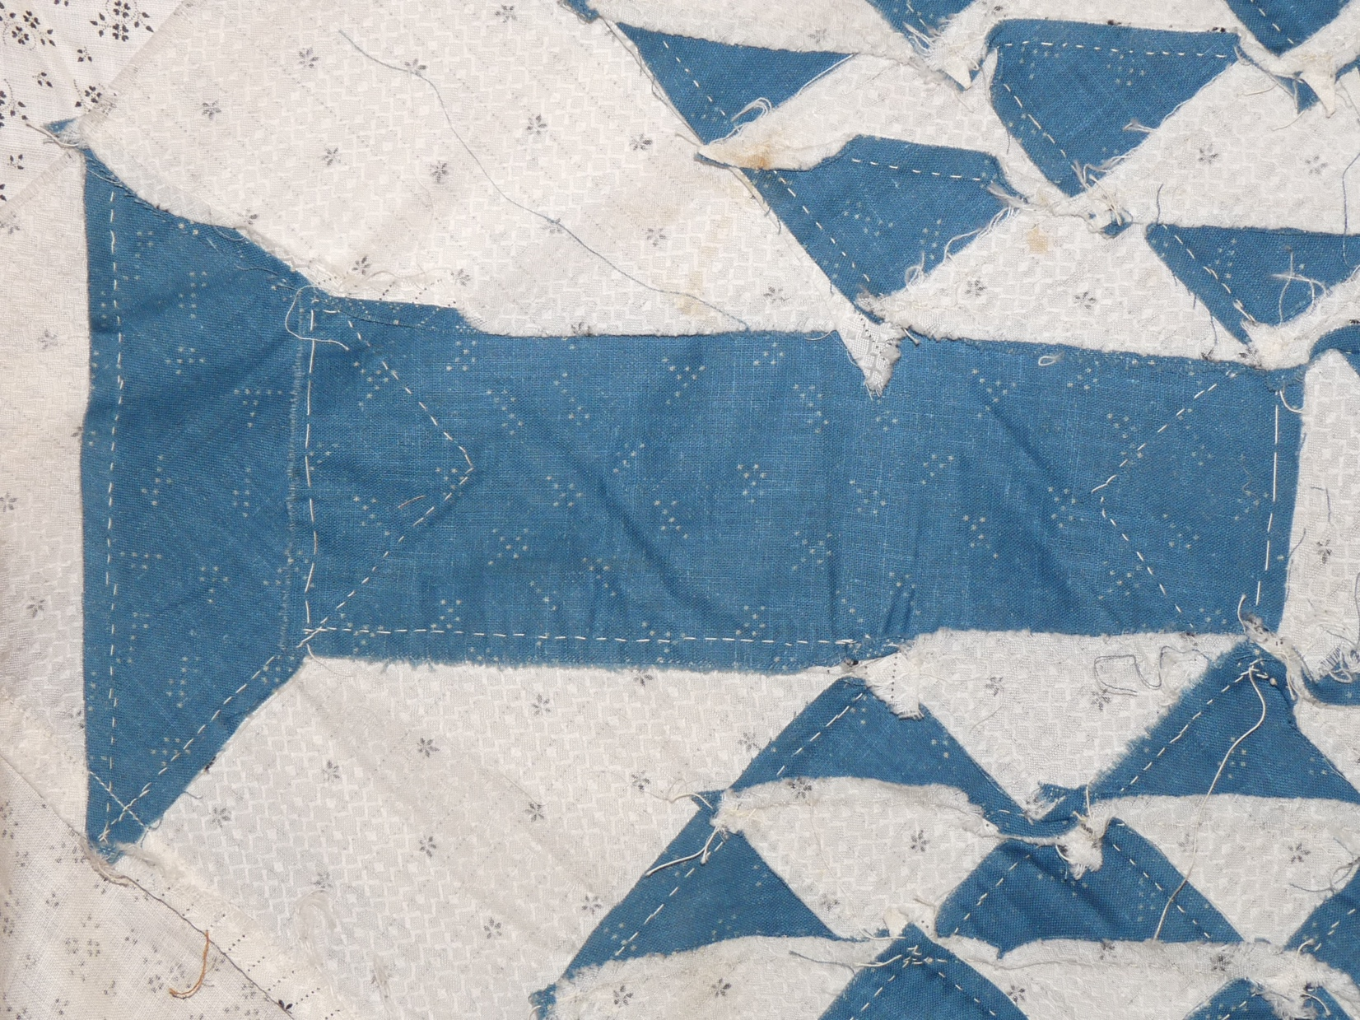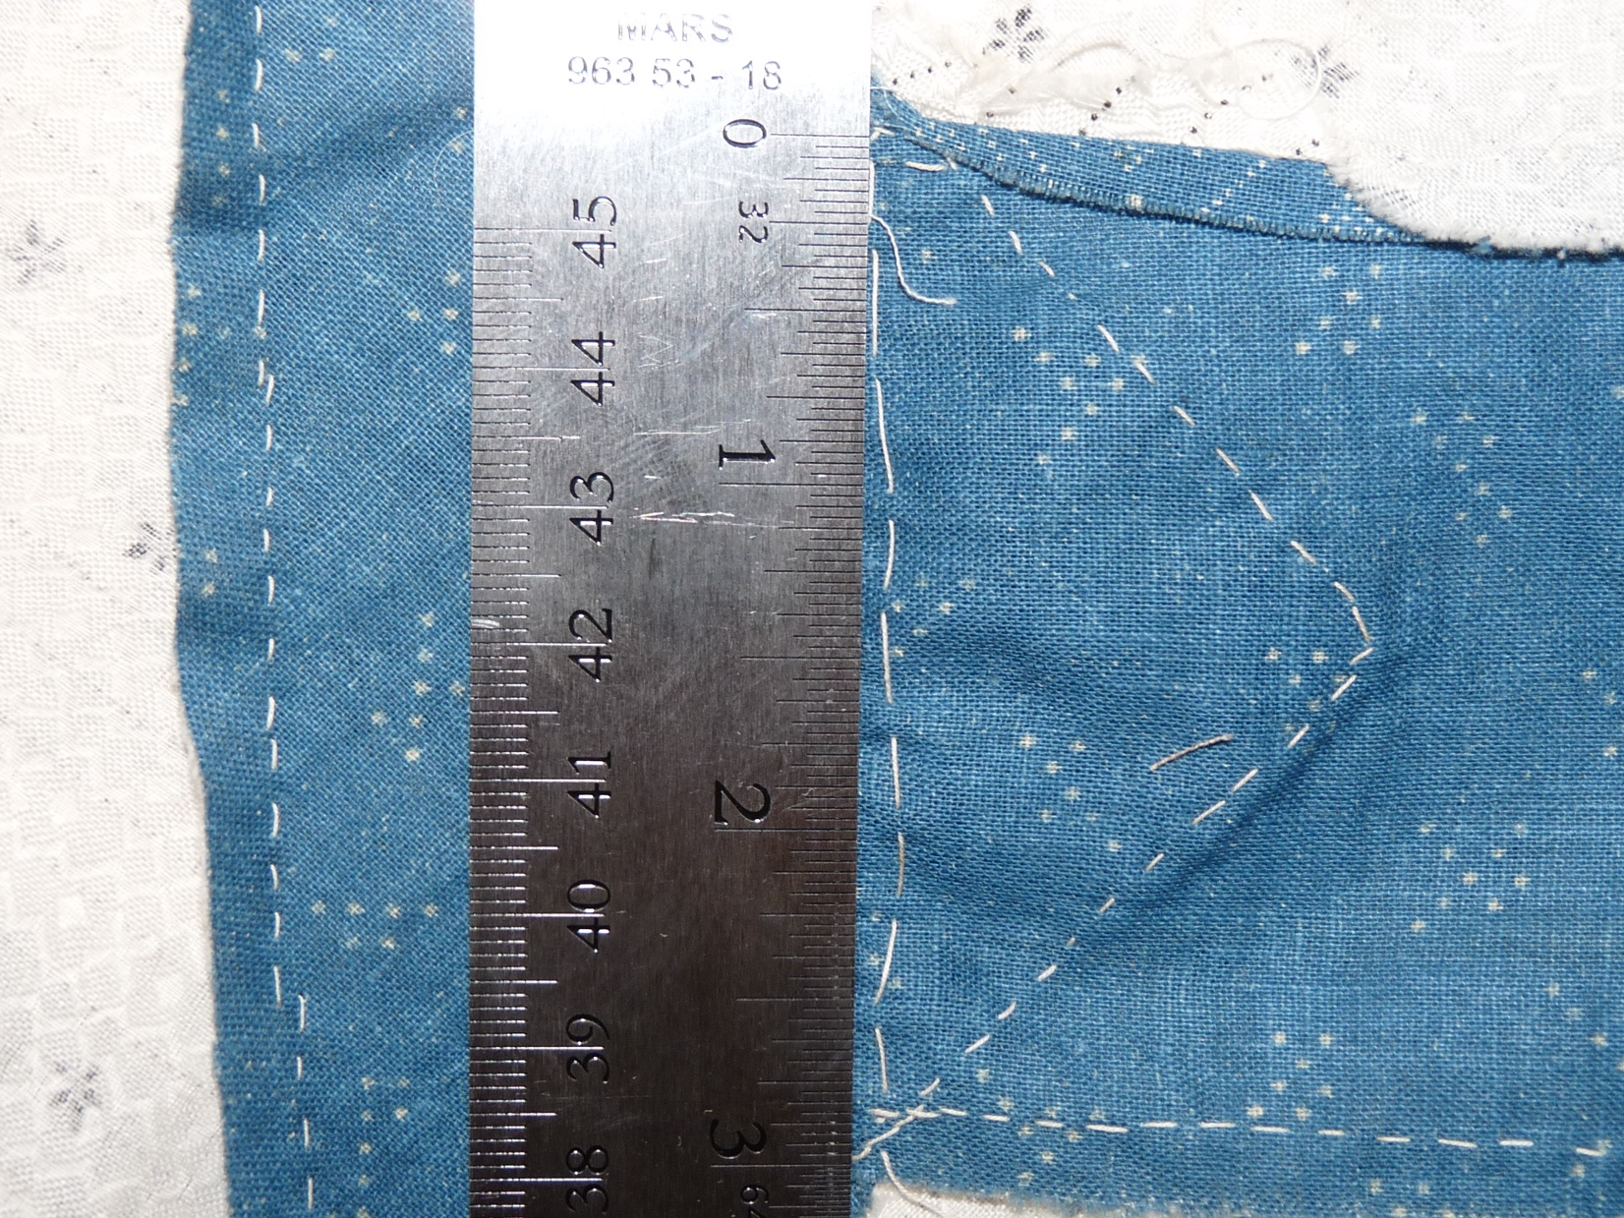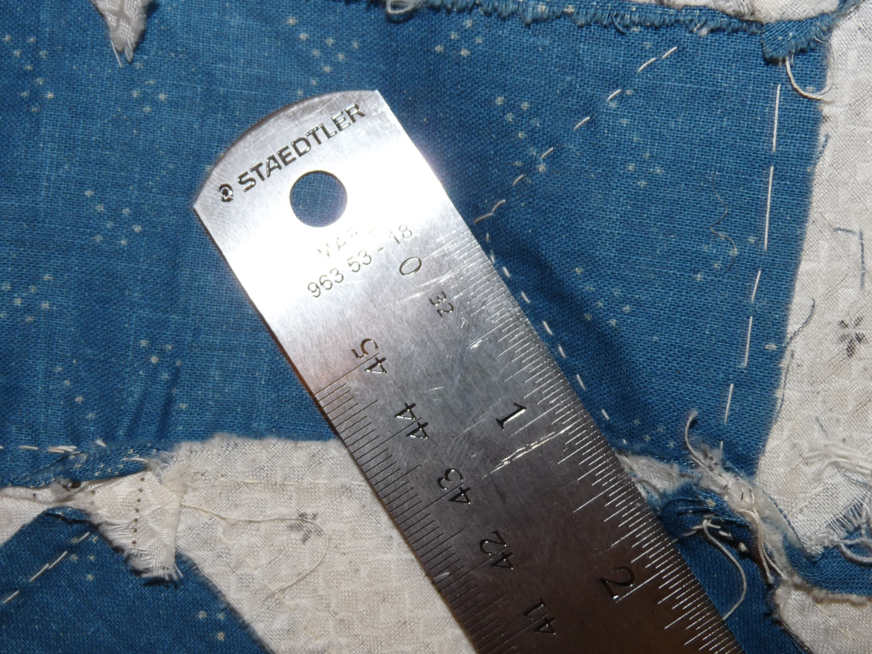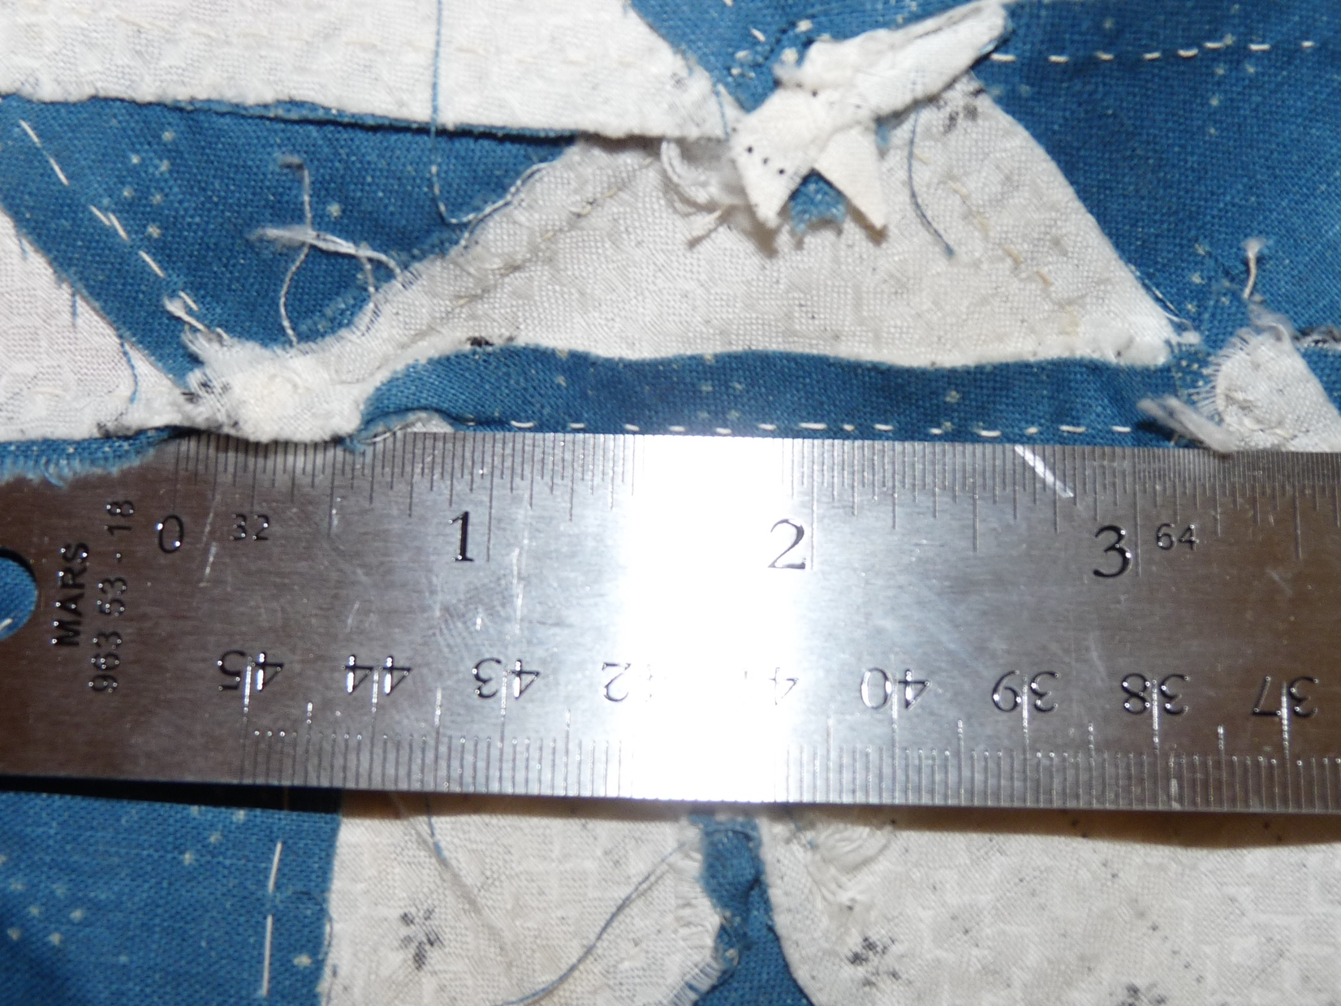

Owner History
Owner | From Date | To Date | Acquired at: | Cost
David Bailey | -- | -- | -- | $0
Made in:
--
 | If not purchased, the estimated cost for materials: $0

Display & Publication History
Date | Event | Location / Publication
-- | -- | --

General Description
Quilt Title or Name:  -- | Fabric Date Range: 1885 ± 10 Years  Date Made: -- ± 0 Years  Method of Determination:
Item Type:  Items in Set: 1 | Size: Length: 84“ x Width: 72“
Appraisals:  Has this quilt been professionally appraised?  If so, when: --  ----------- | Other related files:  Scanned Patterns  Images  EQ 8 Files  Research Notes
Additional Information: --

History

Provenance
Describe: --

Quilt Maker
Maker: -- |  | Birth: -- |  | Death: --
 | Location: -- |  | Contributions: --

Purpose and Context
Expression
Art | Personal Enjoyment | Therapy
Income
Personal Income | Fundraising
Presentation
Anniversary | Wedding | Birth
Holiday | Birthday | Other gift
Charitable support
Relationships
Friendship | Commemorative | Memorial
Mourning | Reunion
Skill Building
Challenge / Contest | Learning / Teaching Sample
Use
Bed Quilt | Lap Quilt | Home Décor
Baby / Crib | Wall Hanging
Describe other purpose: --

Construction History
--

Coverlet Design & Construction

Coverlet Top
Warp strand count per inch: 0. | Design: --
Warp fiber: | Weaver: --
Weft strand count per inch: 0” | Location: --
Weft fiber: | Woven for: --
Additional Information: --

Quilt Top Design & Construction

Quilt Top
Layout Design: .
Delete this & the following table rows as appropriate.
One Patch Shape Details
 |  |  | Describe: --
 | Techniques
 |  | Machine pieced | String / Improvisational piecing
 |  | Hand pieced | Foundation piecing
 |  | Strip piecing | English paper piecing
 |  | Describe: --
 | Workmanship
 |  | Seams are stable | Seams are appropriately aligned
 |  | Seams are flat | Points are sharp
 |  | Describe piecing workmanship
Medallion Details
 | Length 0.00” x Width: 0.00” |  | Describe: --
 | Describe: --
 | Techniques
 |  | Machine pieced | String / Improvisational piecing
 |  | Hand pieced | Foundation piecing
 |  | Strip piecing | English paper piecing
 |  | Describe: --
 | Workmanship
 |  | Seams are stable | Seams are appropriately aligned
 |  | Seams are flat | Points are sharp
 |  | Describe piecing workmanship
Blocks / Grid
 |  |  | Grid Dimensions: Length 0 x Width: 0
 |  |  | Block Size: Length: 0.00 “ x Width: 0.00 “
 | Describe: --
 | Pattern name & Brackman or other ID |  | <<Pattern Image>>
 | Techniques
 | Machine pieced |  | String / Improvisational piecing
 | Hand pieced |  | Foundation piecing
 | Strip piecing |  | English paper piecing
 | Describe: --
 | Workmanship
 | Seams are stable |  | Seams are appropriately aligned
 | Seams are flat |  | Points are sharp
 | Describe piecing workmanship

Embellishments
Delete this & the following table rows as appropriate.
Types:
 | Applique – Raw edge | Embroidery | Stuffed Work
 | Applique - Button-hole | Cording | Inking
 | Applique - Needle-turn | Beading | Painting
 | Applique - Reverse | Rhinestones / Gems | Marking lines noted
 | Applique - Other | Other: --
Workmanship
 | Stitches are appropriately small and even.
 | Edges are as design intends (straight, curved, pointed).
 | Work demonstrates appropriate skill for intended purpose.
 | Describe other techniques

Sashing
Delete this & the following table rows as appropriate.
 |  | Width: 0.00 “
Use of corner stones
Techniques
 | Machine pieced |  | String / Improvisational piecing
 | Hand pieced |  | Foundation piecing
 | Strip piecing |  | English paper piecing
 | Describe: --
Workmanship
 | Seams are stable |  | Seams are appropriately aligned
 | Seams are flat |  | Points are sharp
Describe: --
 | Describe piecing workmanship

Borders & Frames
Delete this & the following table rows as appropriate.
Describe borders and frames in order from center to edge.
1 | Width: 0.00“
 |  |  | Describe: --
Techniques
 |  | Machine pieced |  |  | String / Improvisational piecing
 |  | Hand pieced |  |  | Foundation piecing
 |  | Strip piecing |  |  | English paper piecing
 |  | Describe: --
Workmanship
 |  | Seams are stable |  |  | Seams are appropriately aligned
 |  | Seams are flat |  |  | Points are sharp
Describe: --
 |  | Describe piecing workmanship

Assembly
 | Seams are appropriately aligned
Seams are stable | Top has no inappropriate tucks or puckers
Seams are flat | Top lays flat with no overly full areas
Describe: --

Color
Predominant colors
 | Red | Blue | Black
 | Orange | Violet/Purple | Grey
 | Yellow | Brown | White
 | Green | Beige / Tan
Specific Antique Colors |  | NONE NOTED | Neon prints
 | Red – claret / wine | Yellow – chrome | Blue – Lancaster
 | Red – madder / cinnamon | Green - chrome | Blue – Prussian / Lafayette
 | Red – turkey | Green – Nile | Brown – madder
 | Pinks - double | Blue – Cadet | Butterscotch
 | Orange - madder | Blue - Indigo | Bronze
 | Orange – cheddar / antimony / chrome |  | Late 1800’s Purple
Describe: --

Materials
Sources of Fabric |  | NOT KNOWN
 | Companies | Fabric Name & Number | Designer
 | -- | -- | --
 | Describe other sources: --
Fiber Types |  | NOT YET IDENTIFIED
 | Cotton | Silk | Wool
 | Cotton Blend | Linen | Synthetic
 | Describe & Clarify: --
Fabric Types |  | NOT KNOWN
 | Broadcloth | Sateen | Upholstery
 | Flannel | Satin | Chintz
 | Shirting | Muslin | Glazed
 | Suiting | Velvet | Handwoven
 | Denim | Felt | Lindsey-Woolsey
 | Describe & Clarify: --
Print Types |  | NOT YET IDENTIFIED
 | Batik | Floral | Multiple scraps
 | Cheater Panel | Garibaldi Red Prints | Paisley
 | Checked / Gingham | Geometric | Plaid
 | Conversation / Novelty | Hand-dyed | Solid / Plain
 | Dotted | Victorian Mourning Prints | Stamped
 | Feed sack / Feed sack-like |  | Stripes
Describe & Clarify: --

Images

Inscriptions
None Found
Inscription is present. Describe location: --
Content
Makers names | Initials | Date
Single Name | Message | Place
Multiple Names
Transcription: --

Methods
Label | Ink – Ball point | Stencil
Printed onto fabric | Ink – Felt tip | Stamped
Quilted | Ink - Other | Pencil
Embroidery | Applique | Typewriter
Describe & Clarify: --

Images for Inscriptions

Quilt Back Design & Construction

Quilt Back
Layout Design: .
Delete this & the following table rows as appropriate.
One Patch Shape Details
 |  |  | Describe: --
 | Techniques
 |  | Machine pieced | String / Improvisational piecing
 |  | Hand pieced | Foundation piecing
 |  | Strip piecing | English paper piecing
 |  | Describe: --
 | Workmanship
 |  | Seams are stable | Seams are appropriately aligned
 |  | Seams are flat | Points are sharp
 |  | Describe piecing workmanship
Medallion Details
 | Length 0.00” x Width: 0.00” |  | Describe: --
 | Describe: --
 | Techniques
 |  | Machine pieced | String / Improvisational piecing
 |  | Hand pieced | Foundation piecing
 |  | Strip piecing | English paper piecing
 |  | Describe: --
 | Workmanship
 |  | Seams are stable | Seams are appropriately aligned
 |  | Seams are flat | Points are sharp
 |  | Describe piecing workmanship
Blocks / Grid
 |  |  | Grid Dimensions: Length 0 x Width: 0
 |  |  | Block Size: Length: 0.00 “ x Width: 0.00 “
 | Describe: --
 | Pattern name & Brackman or other ID |  | <<Pattern Image>>
 | Techniques
 | Machine pieced |  | String / Improvisational piecing
 | Hand pieced |  | Foundation piecing
 | Strip piecing |  | English paper piecing
 | Describe: --
 | Workmanship
 | Seams are stable |  | Seams are appropriately aligned
 | Seams are flat |  | Points are sharp
 | Describe piecing workmanship

Embellishments
Delete this & the following table rows as appropriate.
Types:
 | Applique – Raw edge | Embroidery | Stuffed Work
 | Applique - Button-hole | Cording | Inking
 | Applique - Needle-turn | Beading | Painting
 | Applique - Reverse | Rhinestones / Gems | Marking lines noted
 | Applique - Other | Other: --
Workmanship
 | Stitches are appropriately small and even.
 | Edges are as design intends (straight, curved, pointed).
 | Work demonstrates appropriate skill for intended purpose.
 | Describe other techniques

Sashing
Delete this & the following table rows as appropriate.
 |  | Width: 0.00 “
Use of corner stones
Techniques
 | Machine pieced |  | String / Improvisational piecing
 | Hand pieced |  | Foundation piecing
 | Strip piecing |  | English paper piecing
 | Describe: --
Workmanship
 | Seams are stable |  | Seams are appropriately aligned
 | Seams are flat |  | Points are sharp
Describe: --
 | Describe piecing workmanship

Borders & Frames
Delete this & the following table rows as appropriate.
Describe borders and frames in order from center to edge.
1 | Width: 0.00“
 |  |  | Describe: --
Techniques
 |  | Machine pieced |  |  | String / Improvisational piecing
 |  | Hand pieced |  |  | Foundation piecing
 |  | Strip piecing |  |  | English paper piecing
 |  | Describe: --
Workmanship
 |  | Seams are stable |  |  | Seams are appropriately aligned
 |  | Seams are flat |  |  | Points are sharp
Describe: --
 |  | Describe piecing workmanship

Assembly
 | Seams are appropriately aligned
Seams are stable | Top has no inappropriate tucks or puckers
Seams are flat | Top lays flat with no overly full areas
Describe: --

Color
Predominant colors
 | Red | Blue | Black
 | Orange | Violet/Purple | Grey
 | Yellow | Brown | White
 | Green | Beige / Tan
Specific Antique Colors |  | NONE NOTED | Neon prints
 | Red – claret / wine | Yellow – chrome | Blue – Lancaster
 | Red – madder / cinnamon | Green - chrome | Blue – Prussian / Lafayette
 | Red – turkey | Green – Nile | Brown – madder
 | Pinks - double | Blue – Cadet | Butterscotch
 | Orange - madder | Blue - Indigo | Bronze
 | Orange – cheddar / antimony / chrome |  | Late 1800’s Purple
Describe: --

Materials
Sources of Fabric |  | NOT KNOWN
 | Companies | Fabric Name & Number | Designer
 | -- | -- | --
 | Describe other sources: --
Fiber Types |  | NOT YET IDENTIFIED
 | Cotton | Silk | Wool
 | Cotton Blend | Linen | Synthetic
 | Describe & Clarify: --
Fabric Types |  | NOT KNOWN
 | Broadcloth | Sateen | Upholstery
 | Flannel | Satin | Chintz
 | Shirting | Muslin | Glazed
 | Suiting | Velvet | Handwoven
 | Denim | Felt | Lindsey-Woolsey
 | Describe & Clarify: --
Print Types |  | NOT YET IDENTIFIED
 | Batik | Floral | Multiple scraps
 | Cheater Panel | Garibaldi Red Prints | Paisley
 | Checked / Gingham | Geometric | Plaid
 | Conversation / Novelty | Hand-dyed | Solid / Plain
 | Dotted | Victorian Mourning Prints | Stamped
 | Feed sack / Feed sack-like |  | Stripes
Describe & Clarify: --

Images

Inscriptions
None Found
Inscription is present. Describe location: --
Content
Makers names | Initials | Date
Single Name | Message | Place
Multiple Names
Transcription: --

Methods
Label | Ink – Ball point | Stencil
Printed onto fabric | Ink – Felt tip | Stamped
Quilted | Ink - Other | Pencil
Embroidery | Applique | Typewriter
Describe & Clarify: --

Images for Inscriptions

Stabilization Method
Stabilization Method:
Delete this & the following table rows as appropriate.
Tied Details
 | Average Distance Between Knots: 0” |  | Placement:
 |  |  | Fiber Used:
Quilting Details
Batting
Quilting Techniques
 | Machine Quilted | Machine – sit-down |  | Corded
 | Machine – computer guided | Hand Quilted |  | Stuffed work
 | Machine – manual long-arm | Quilt-as-you-go
 | Describe: --
Quilting Patterns
 | Meander / Free motion | Lines – single parallel |  | Cables
 | In-the-ditch / To the piece | Lines – double parallel |  | Feathers
 | Echo / Outlined | Lines – triple parallel |  | Wreaths
 | Stipple | Grid – crosshatch |  | Vines
 | Clamshell | Grid – square |  | Floral
 | Elbow / Fan | Grid - diamond |  | Leaves
 | Describe other: --
Thread Choices
 | Brand | Weight |  | Number & Name
 | -- | -- |  | --
Describe: --
Images for Stabilization

Edge Finish
Edge Style:
Finishing Technique
Top Width: 0.00 “ | Binding | Rolled – top to back
Back Width: 0.00“ | Knife edge | Rolled – back to top
1/8 = 0.13, 3/8 = 0.38 | Turned with a closure
5/8 = 0.63, 7/8 = 0.88
Application Method: | Top: | Back:
Embellishments
Fringe | Ruffles | Cording
Lace | Ribbon
Describe: --

Images for Edge

Condition

Flaws
Soiling
Dirty | Stains
Mildew stains | Musty Smell
Discoloration
Running / fugitive color | Faded / bleached color | Crocking
Fabric Damage
Tears / holes | Disintegrating / fall out | Insect damage
Thread bare | Shattering
Sewing / Quilting Damage
Split / open seams | Ties / tufting missing | Embellishments missing
Quilting threads missing | Batting has shifted
Storage Issues
Discoloration from wood | Damage from acid | Fold marks / creases
Describe additional condition issues: --
Images for Condition Issues

Conservation, Restoration, Repairs
Describe Measures: --

Workmanship

Extension of Useful Life
Repair | Useful life of the item was extended.
Prevention of Damage
Conservation | All work is reversible.
Conservation | Further deterioration has been slowed, stabilized or prevented.
Maintaining Function & Integrity
Conservation | Work minimally interferes with the item’s overall appearance.
Restoration | Work blends well with the item’s overall appearance, style and age.
Restoration | Appropriate period reproductions were used.
Restoration | Vintage materials were used.
Restoration | Period appropriate techniques were used.
Restoration | Workmanship is of similar or better quality than original work.

Images for Conservation / Restoration / Repairs

History & Provenance
- Work Credit
  - Piecing: unknown
  - Top Assembly: unknown
- Date Made: circa 1890
- Ownership History:
  - David Bailey: From August 19, 2022
  - Vendor: To August 19, 2022
  - Documented by David Bailey

Overall
Size
- Length: 82.5″
- Width: 68.5″
Condition
- Very Good

Top
Fabric Description
- Cotton
- Prints
- Yardage
- Predominant Colors: White, Burgundy, Black, Blue
General Organization
- Grid
  - 5 x 6 grid with every other block piece to form a checkerboard. There are a total of 15 pieced blocks and 15 blocks of unpieced yardage.
  - Unit Description
    - Unit Name: Tree of Paradise (BB ID: 811) or Temperance Tree (BB ID: 811.5).
      - The Tree of Temperance Pattern was published in 1894.
      - While the foreground and background patterns of this quilt top’s blocks the the Tree of Paradise and Temperance Tree, this quilt’s blocks are not an exact match to the piecing pattern. The variations are found in the tree trunks. This quilt’s trunks are solid, not split along their length. In this quilt, the root flair at the bottom of the trunk is a single piece of fabric that is pieced to the background and appliqued to the narrow portion of the trunk.
    - Width: –“
    - Length: –“
  - Straight setting
- Techniques: Patchwork / Applique / Embroidery
  - Embroidery of name with chain stitch.
- Stitching Method: Mostly by Hand, some machine applique/top stitching
- Workmanship of Piecing: Good
- Workmanship of Setting: Very Good
- Other Descriptions
  - The quilt blocks were mostly stitched by hand. The hand-stitching was not terribly skilled. The stitch length is uneven and there is a great deal of extra or stretched fabric across the field of the quilt top.
  - Many points were lost. This seems to run against what I would expect from someone who aspired to this block. Lost points are a beginner’s issue when piecing by hand. This is not a beginner’s block.
  - The assembled tree blocks were sewn into the top with a machine. The background fabric of the tree blocks varies. In some cases the background fabric matches the fabric used in the setting squares. In any case, the trees are hand pieced and the assembled blocks sewn to the top by machine.
  - The fabrics are mourning prints. This may have been used as a coffin cover. George’s coffin?
811.5 Temperance Tree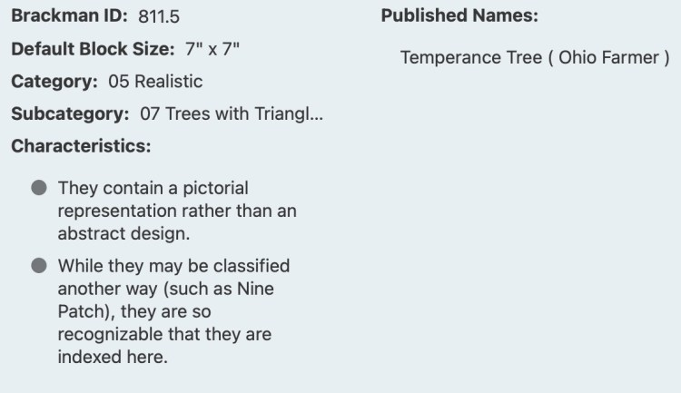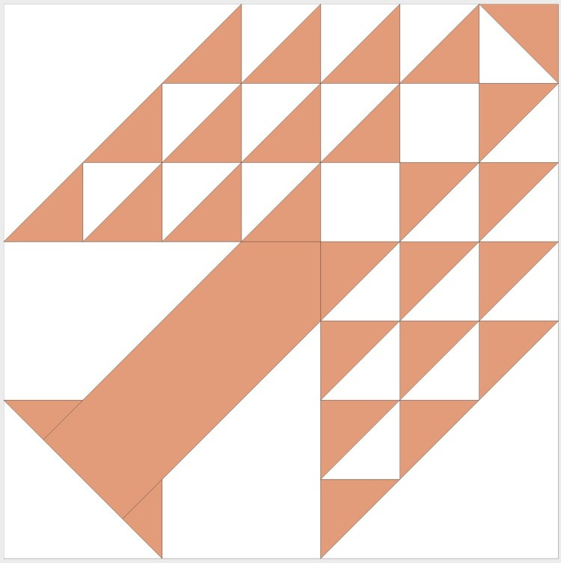811 Tree of Paradise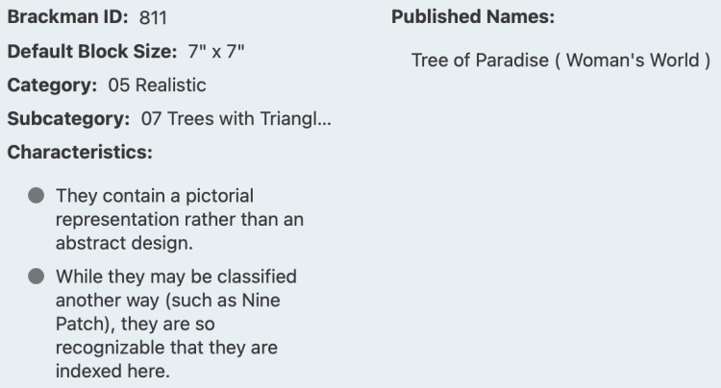Block ID: Encyclopedia of Pieced Quilt Patterns, 3rd ed. Barbara Brackman.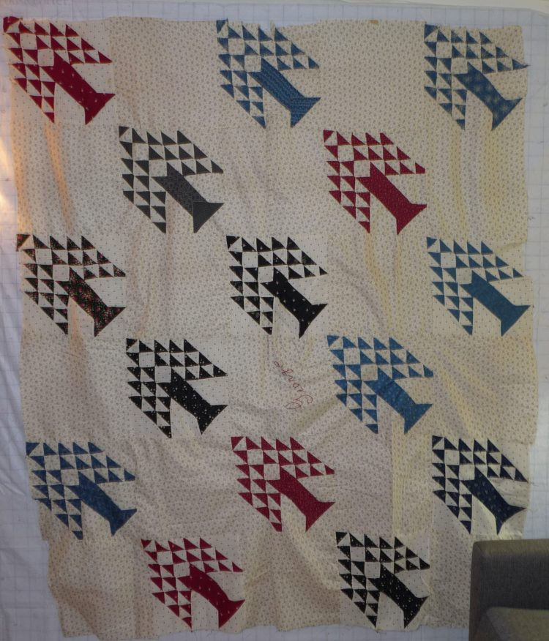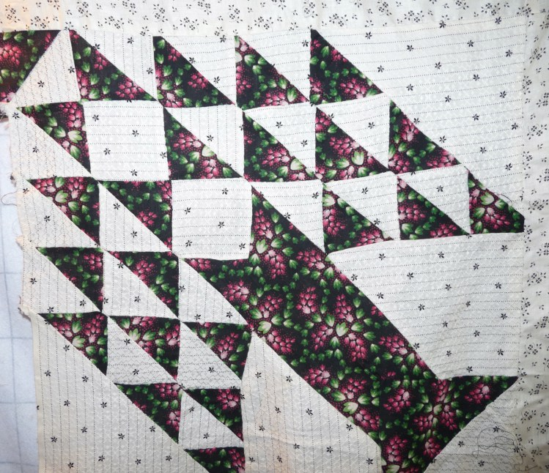Neon Print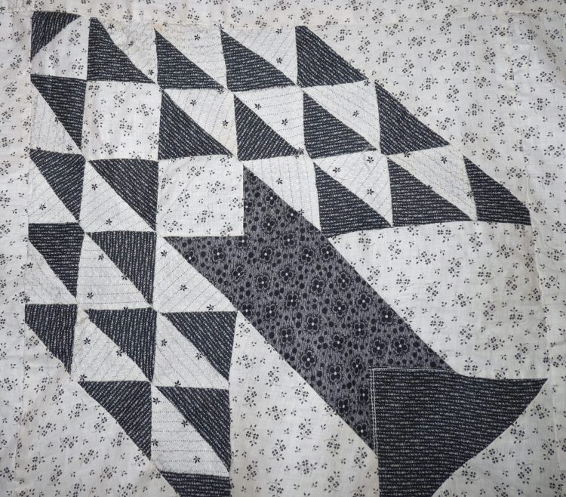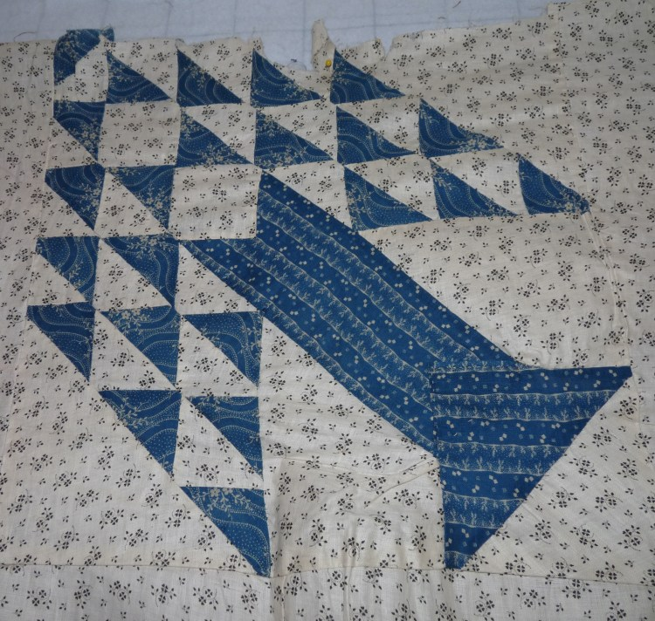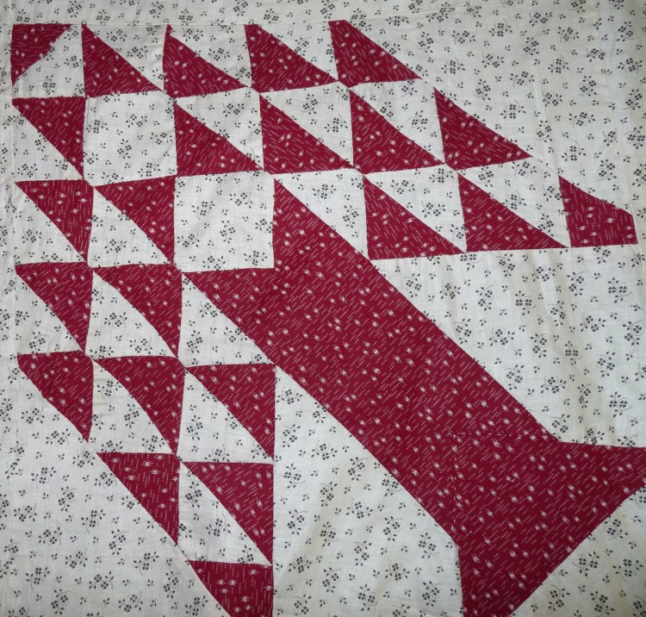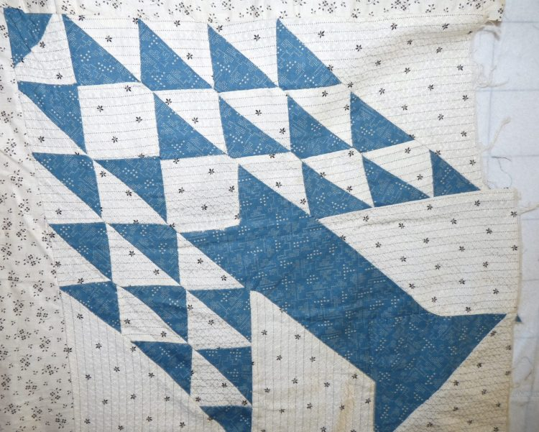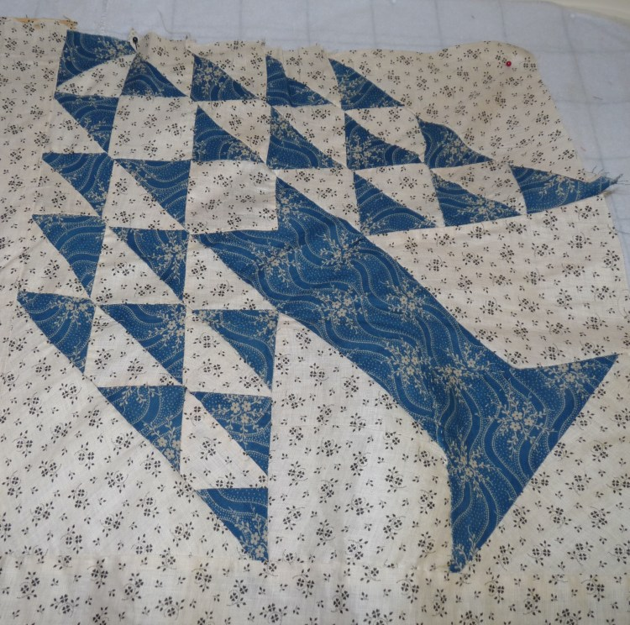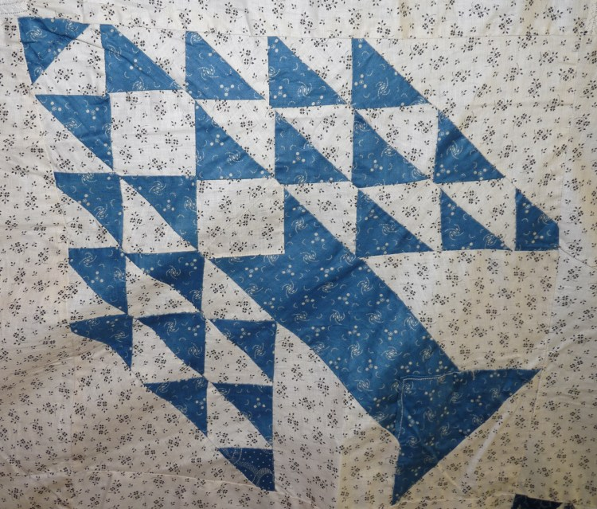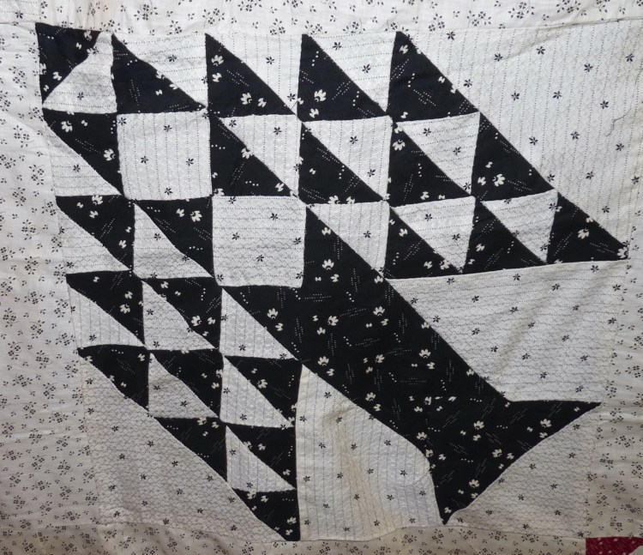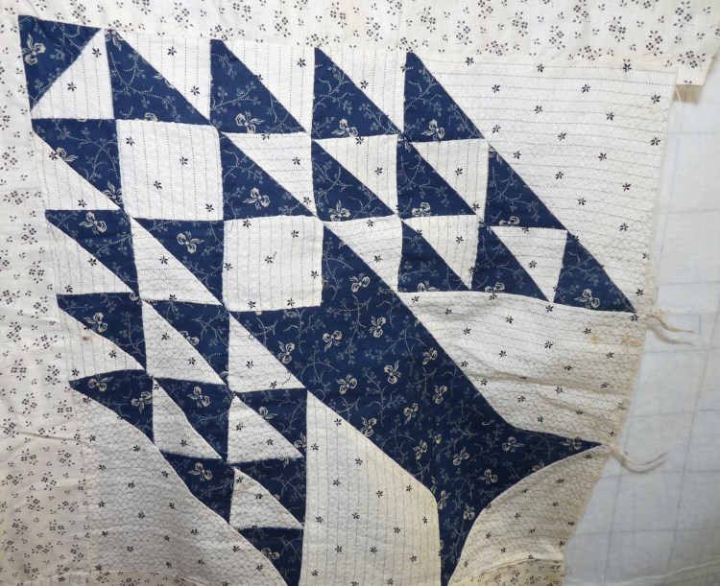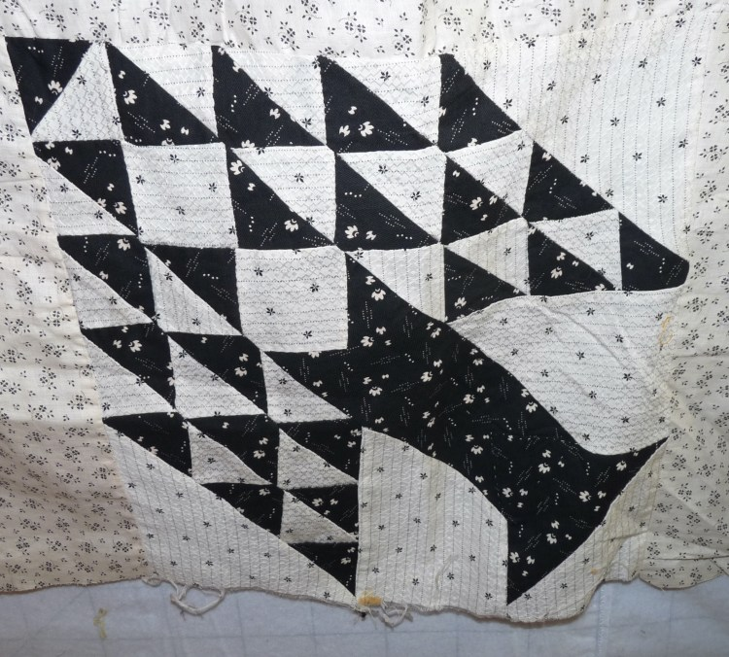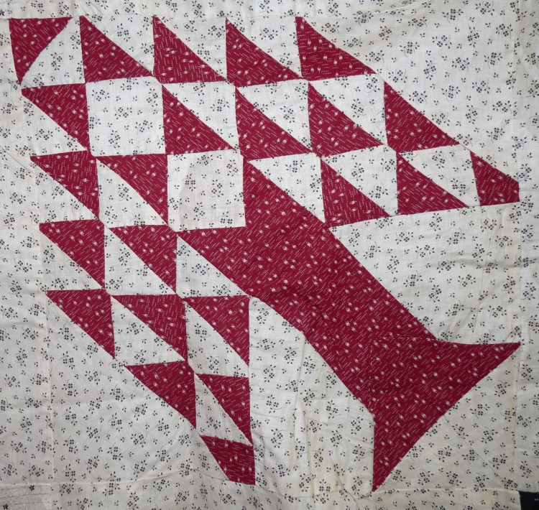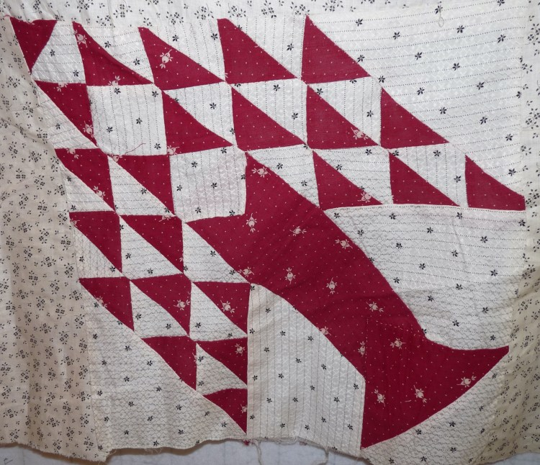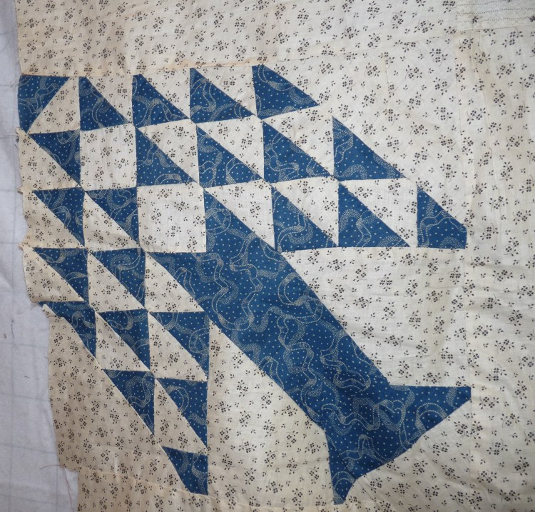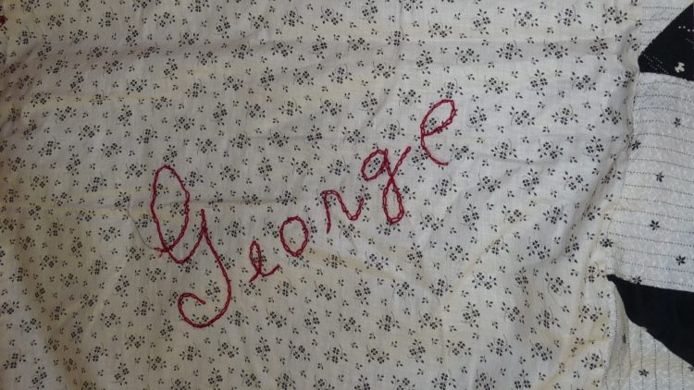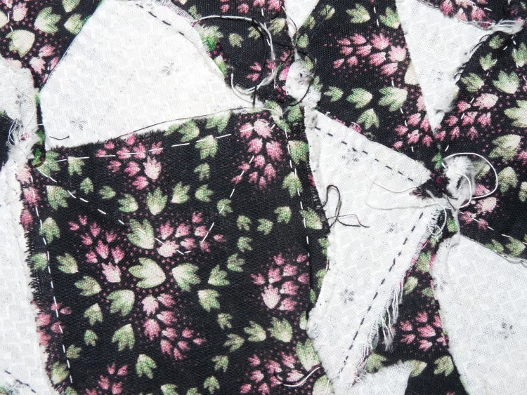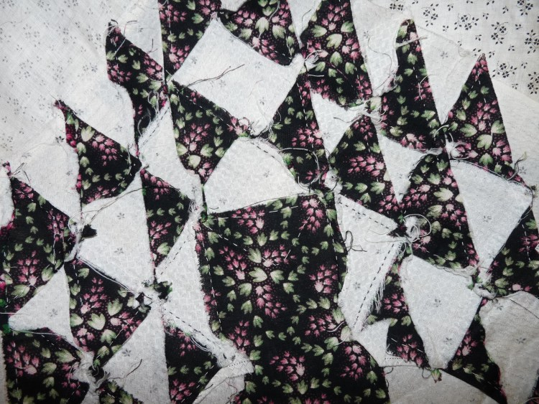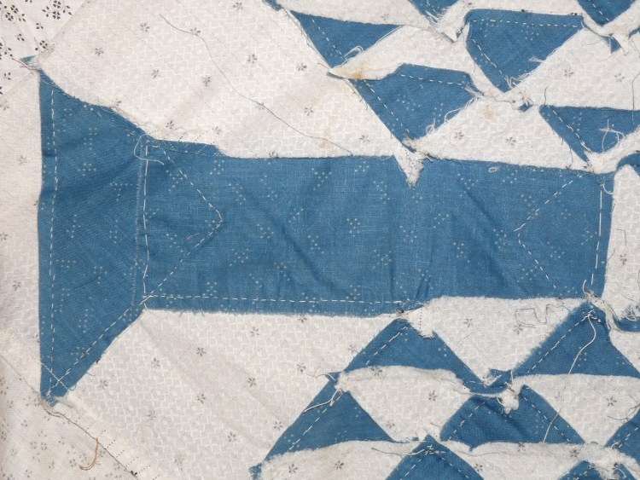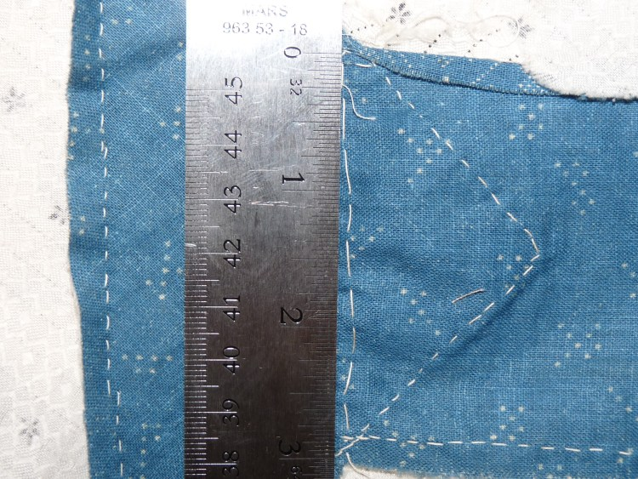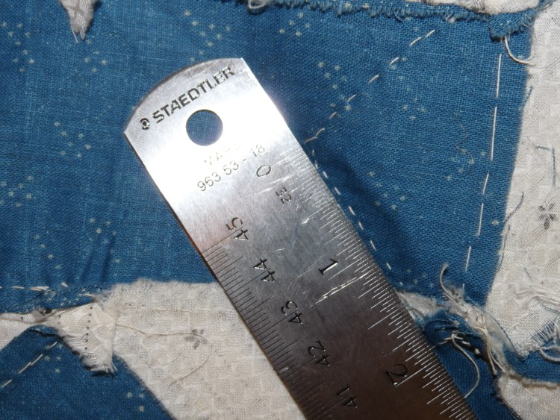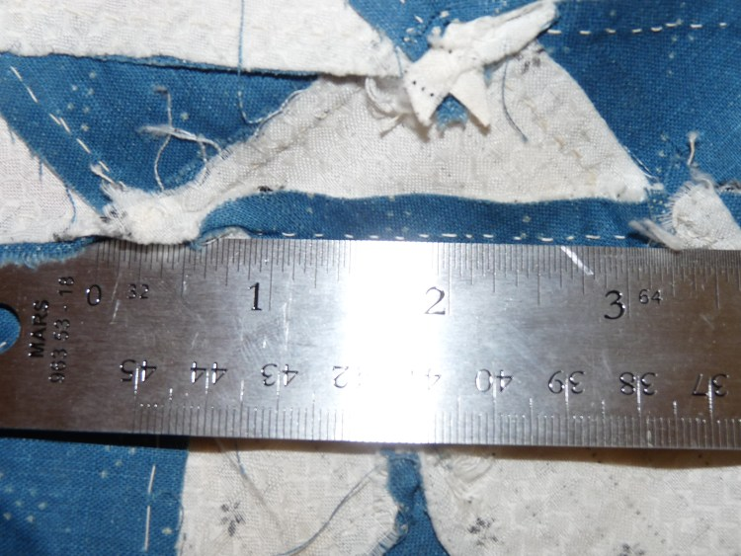

Restoration & Repair Measures
Repair & Restoration:
No signs of repair or restoration other than those described to assemble the quilt top as top stitching.
There is some torn fabric and a few stains.
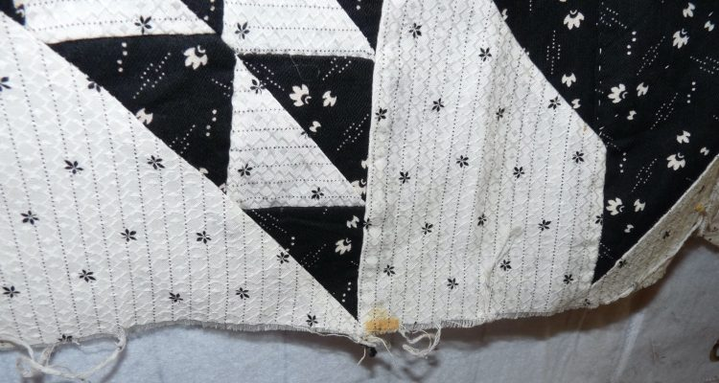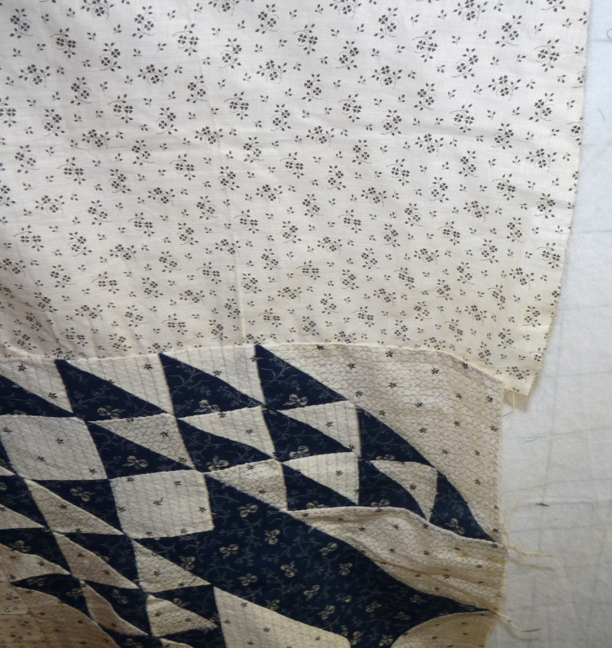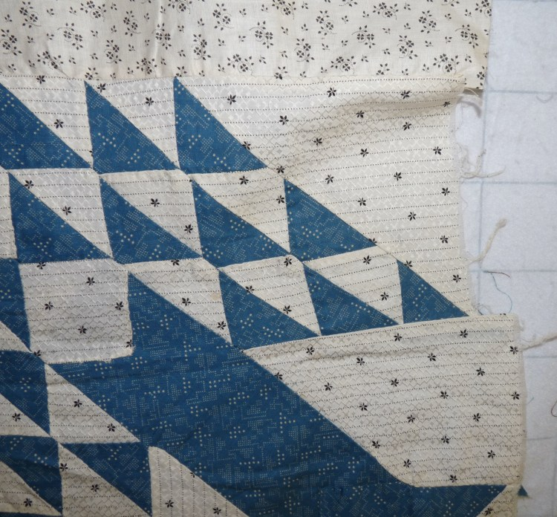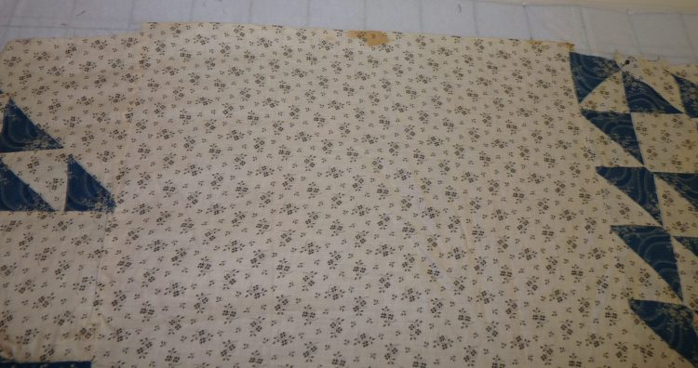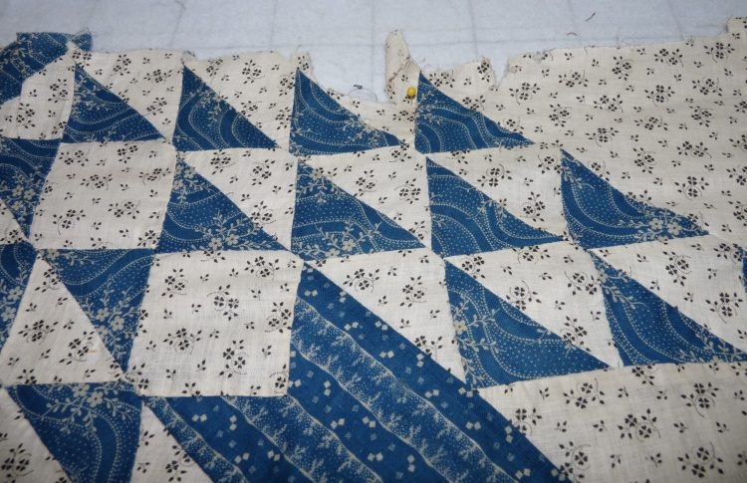

Appraisal
No.

Purchase Information
Supplies
- Vintage top: $ 75
  - Date of Purchase: August 19, 2022
  - Vendor Contact Information
Vendor at Wally’s Castle
3637 Clyde Park Ave
Wyoming, MI
Phone: 616 330 0530

