Documentation Form

Overview

Images
Top | Back
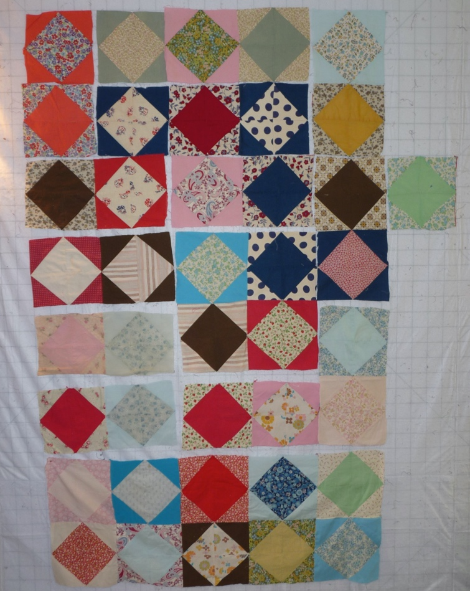 | 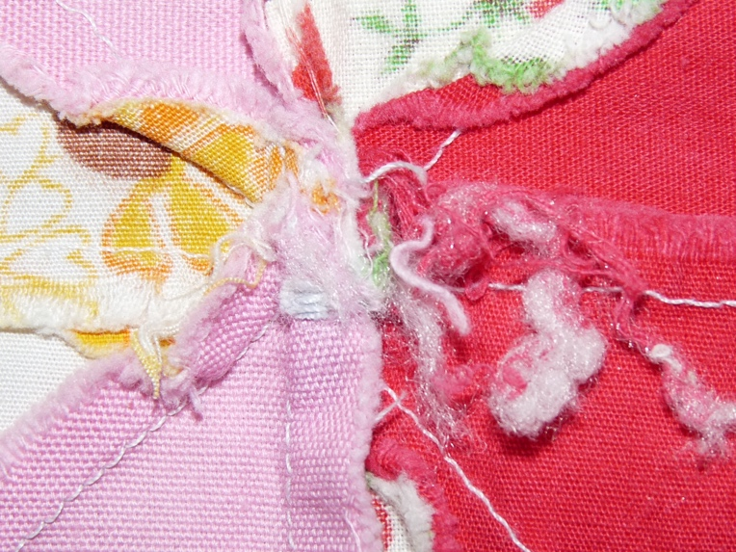

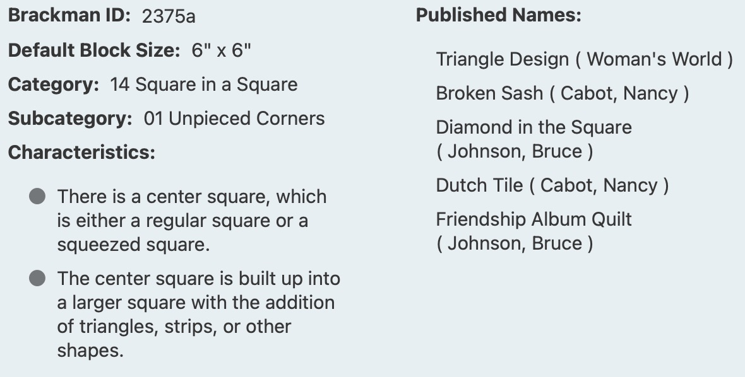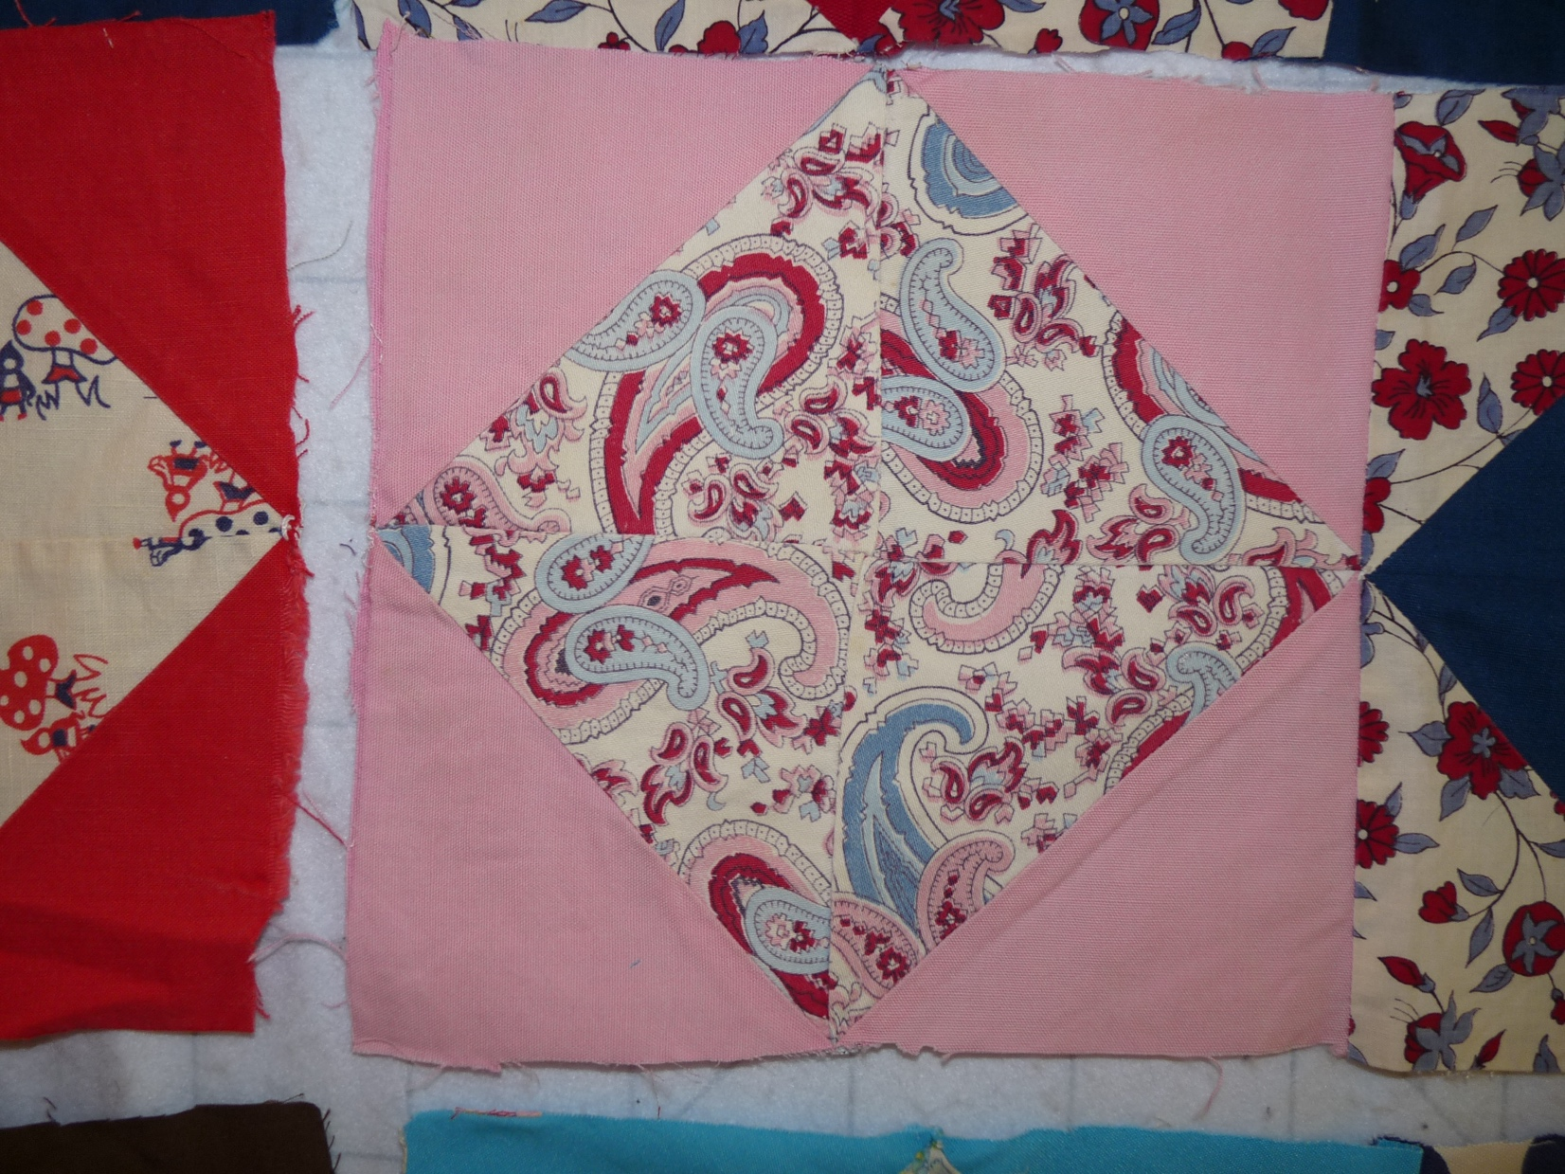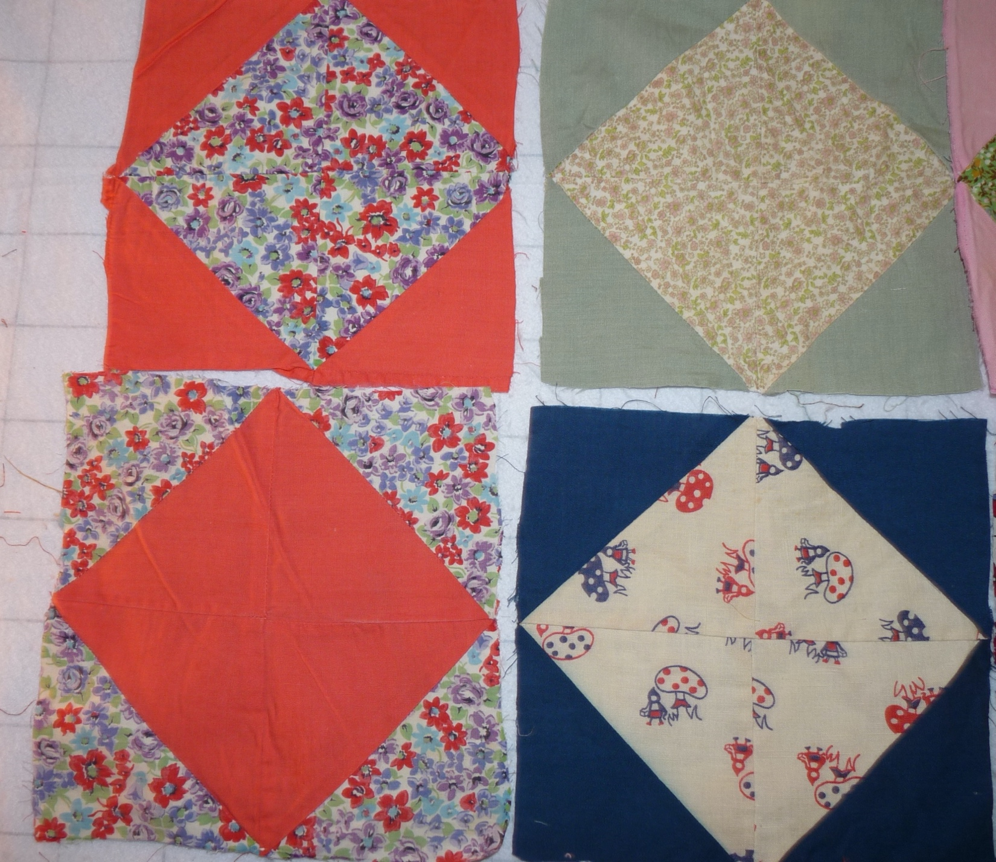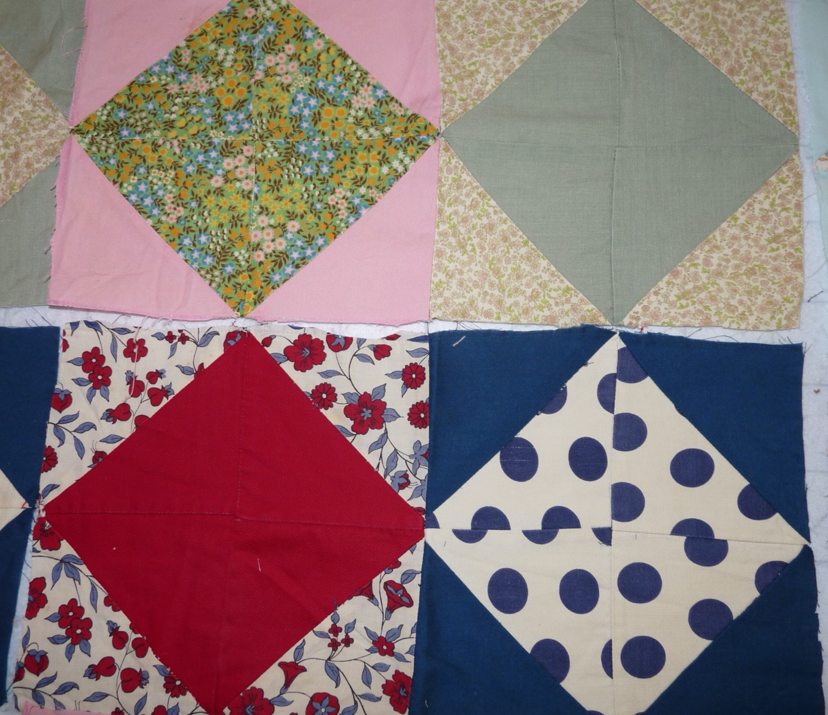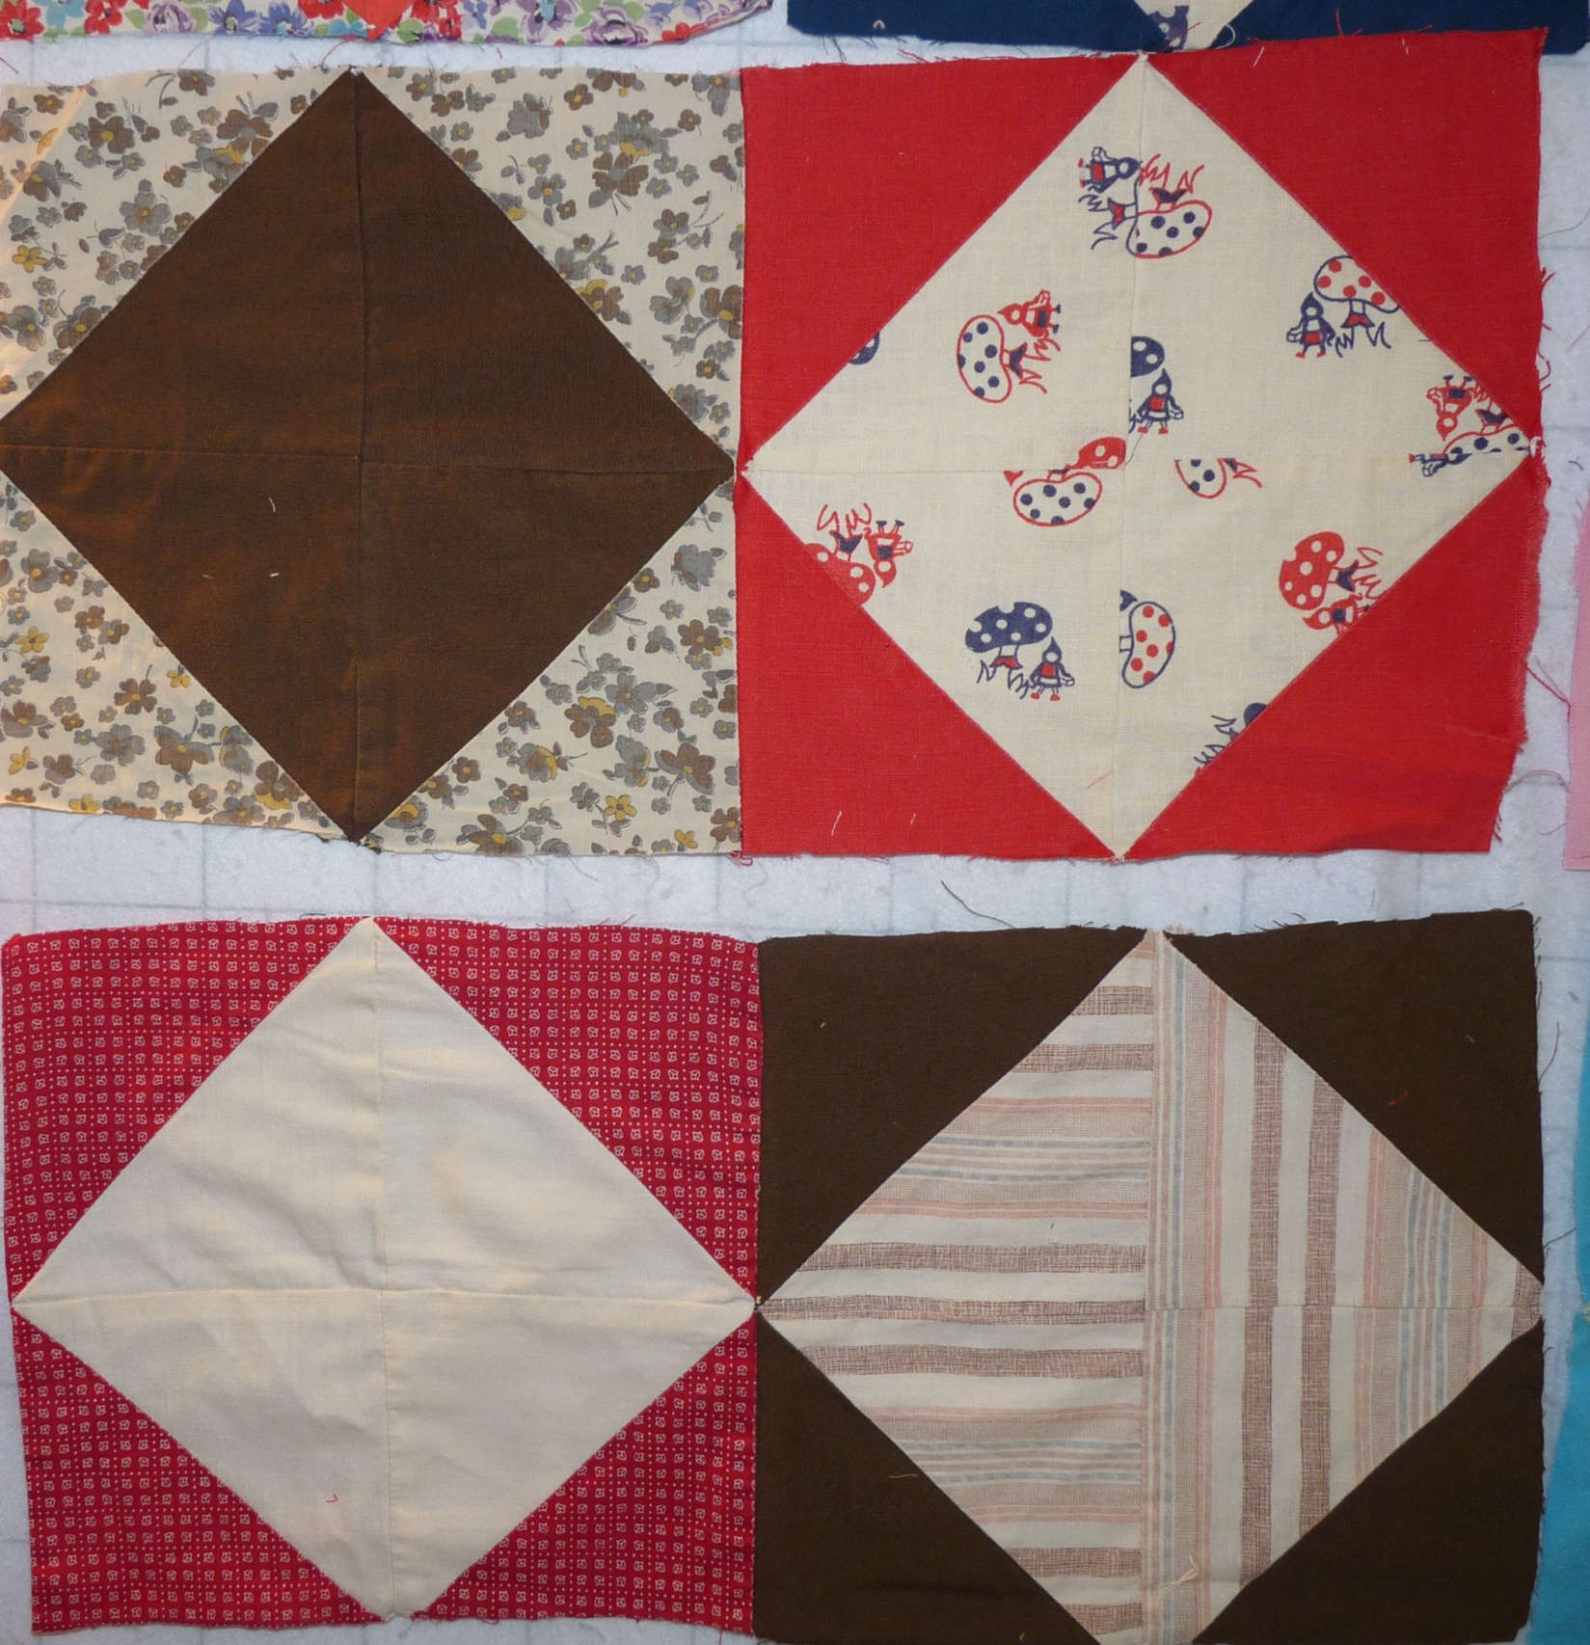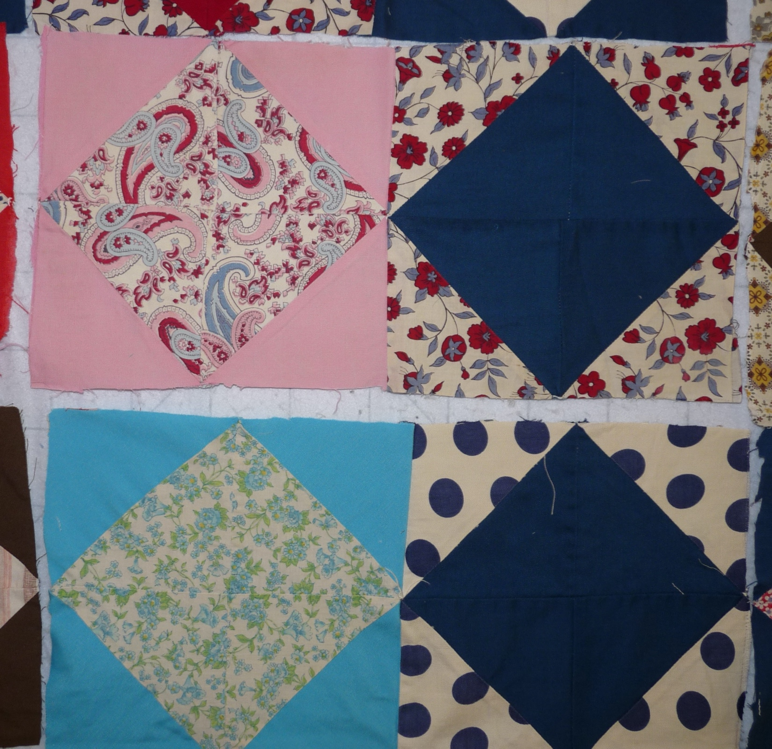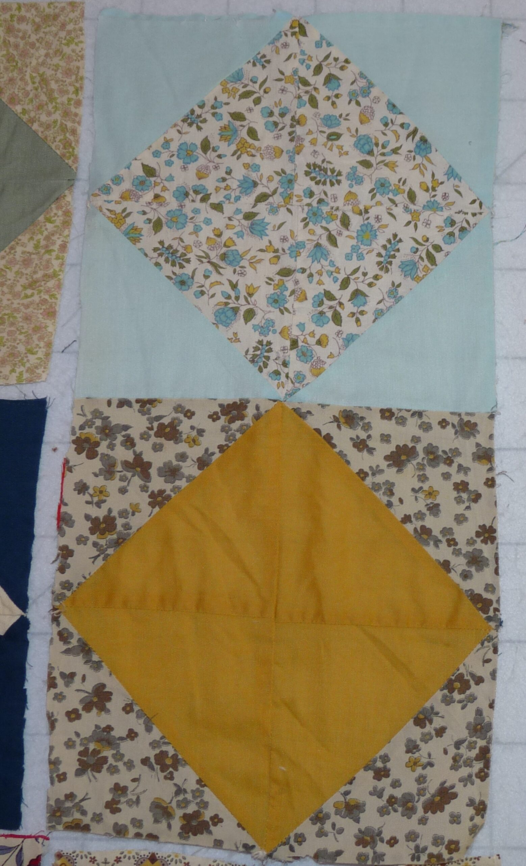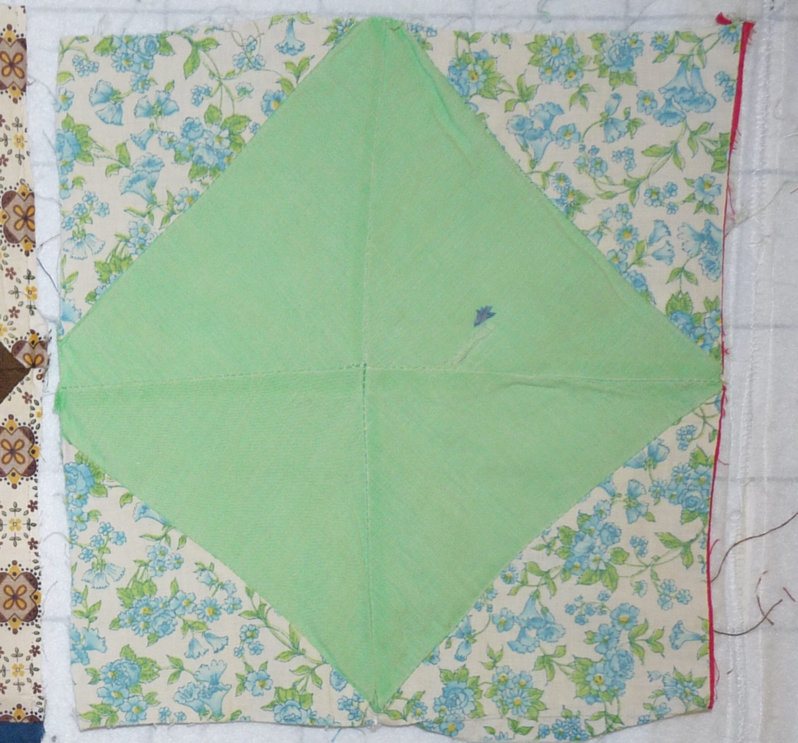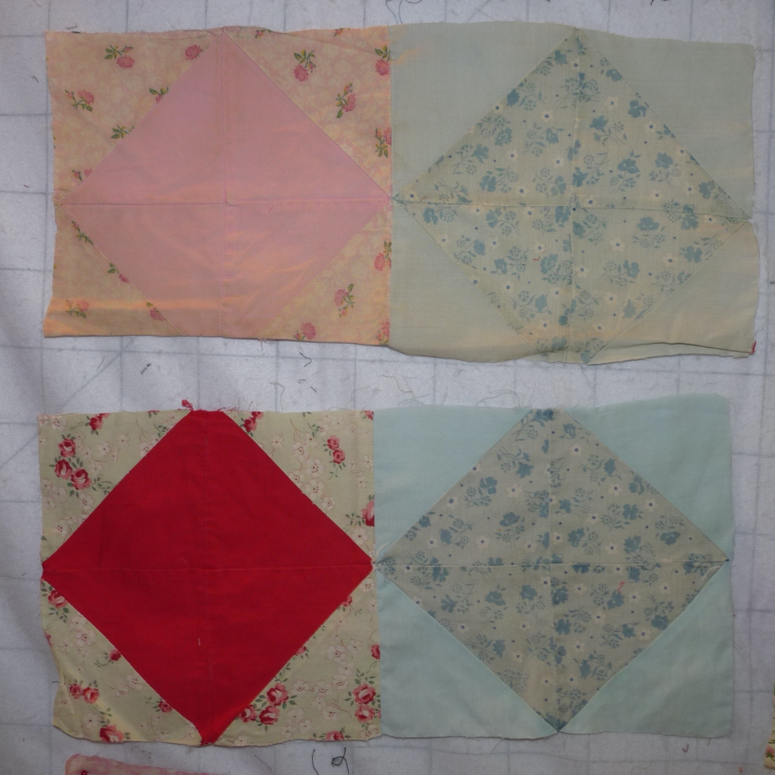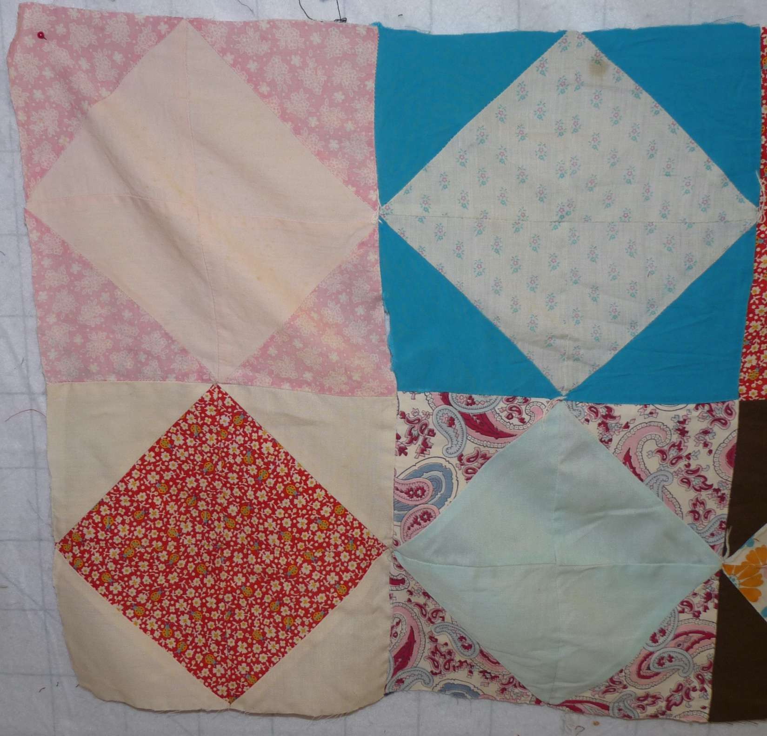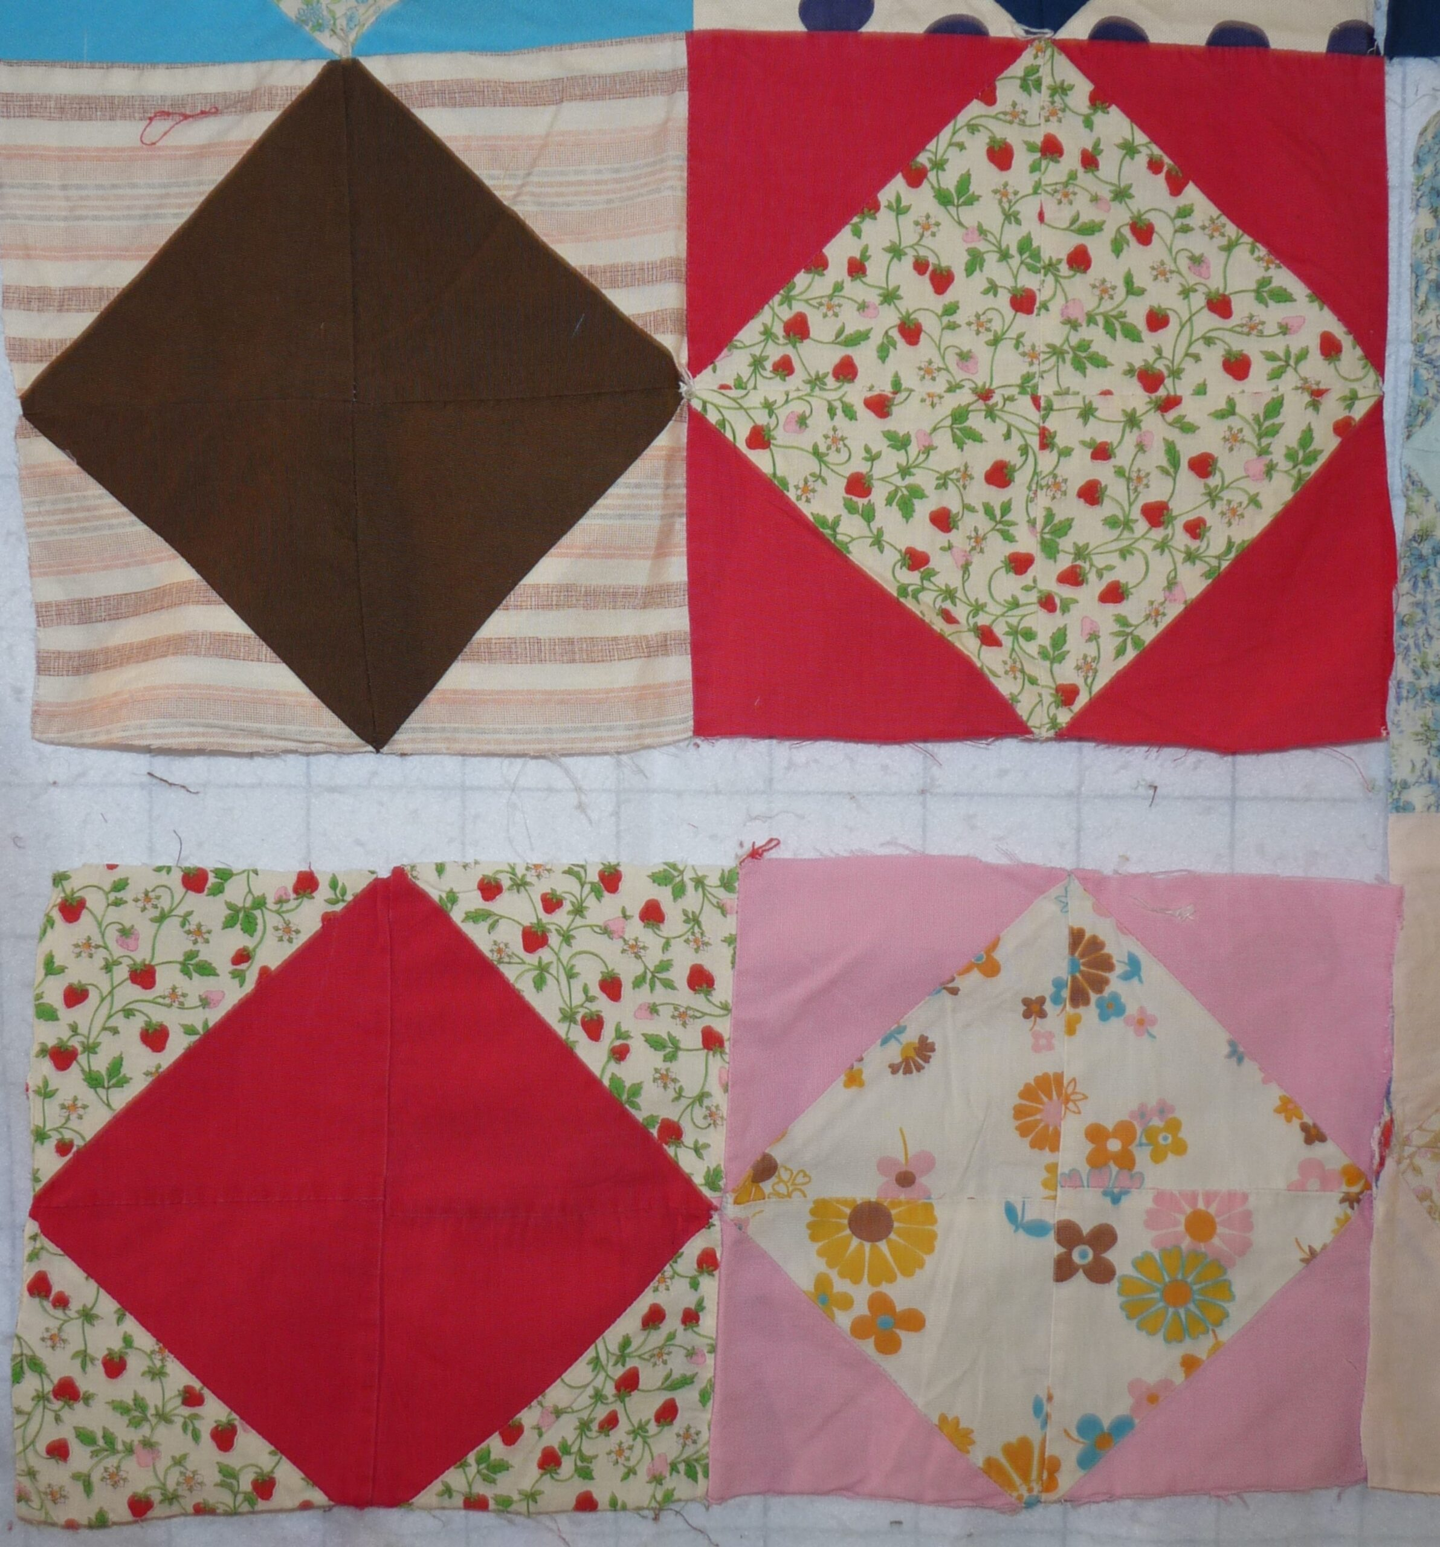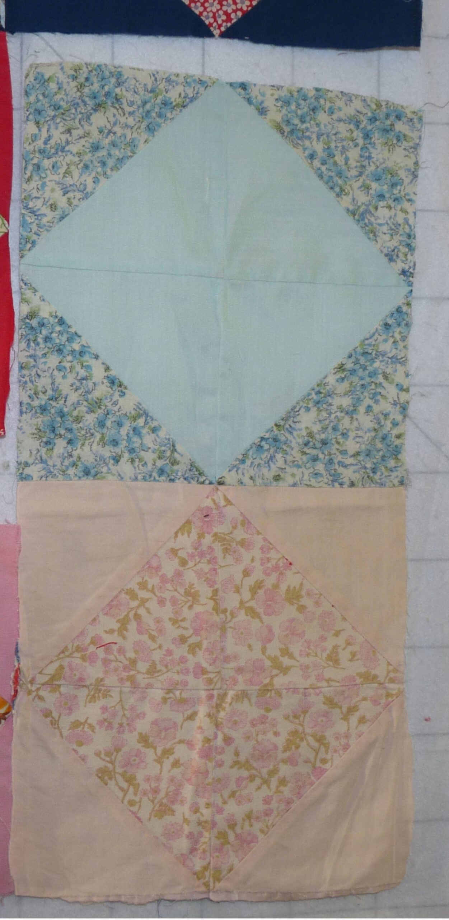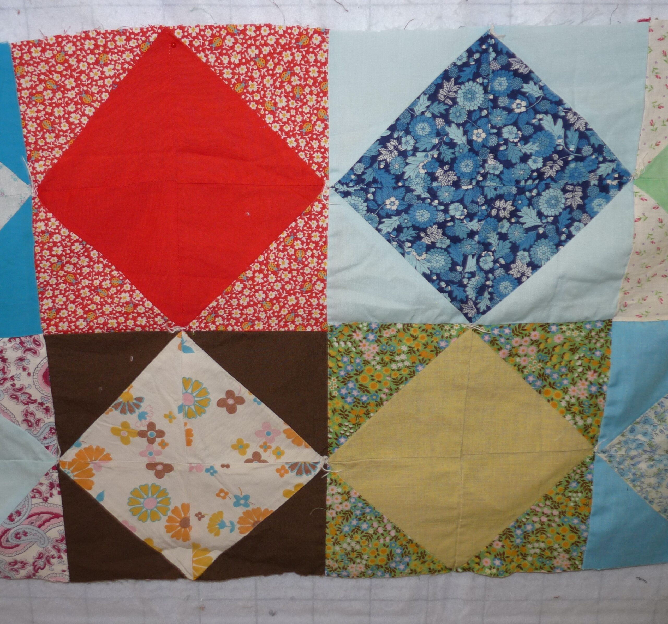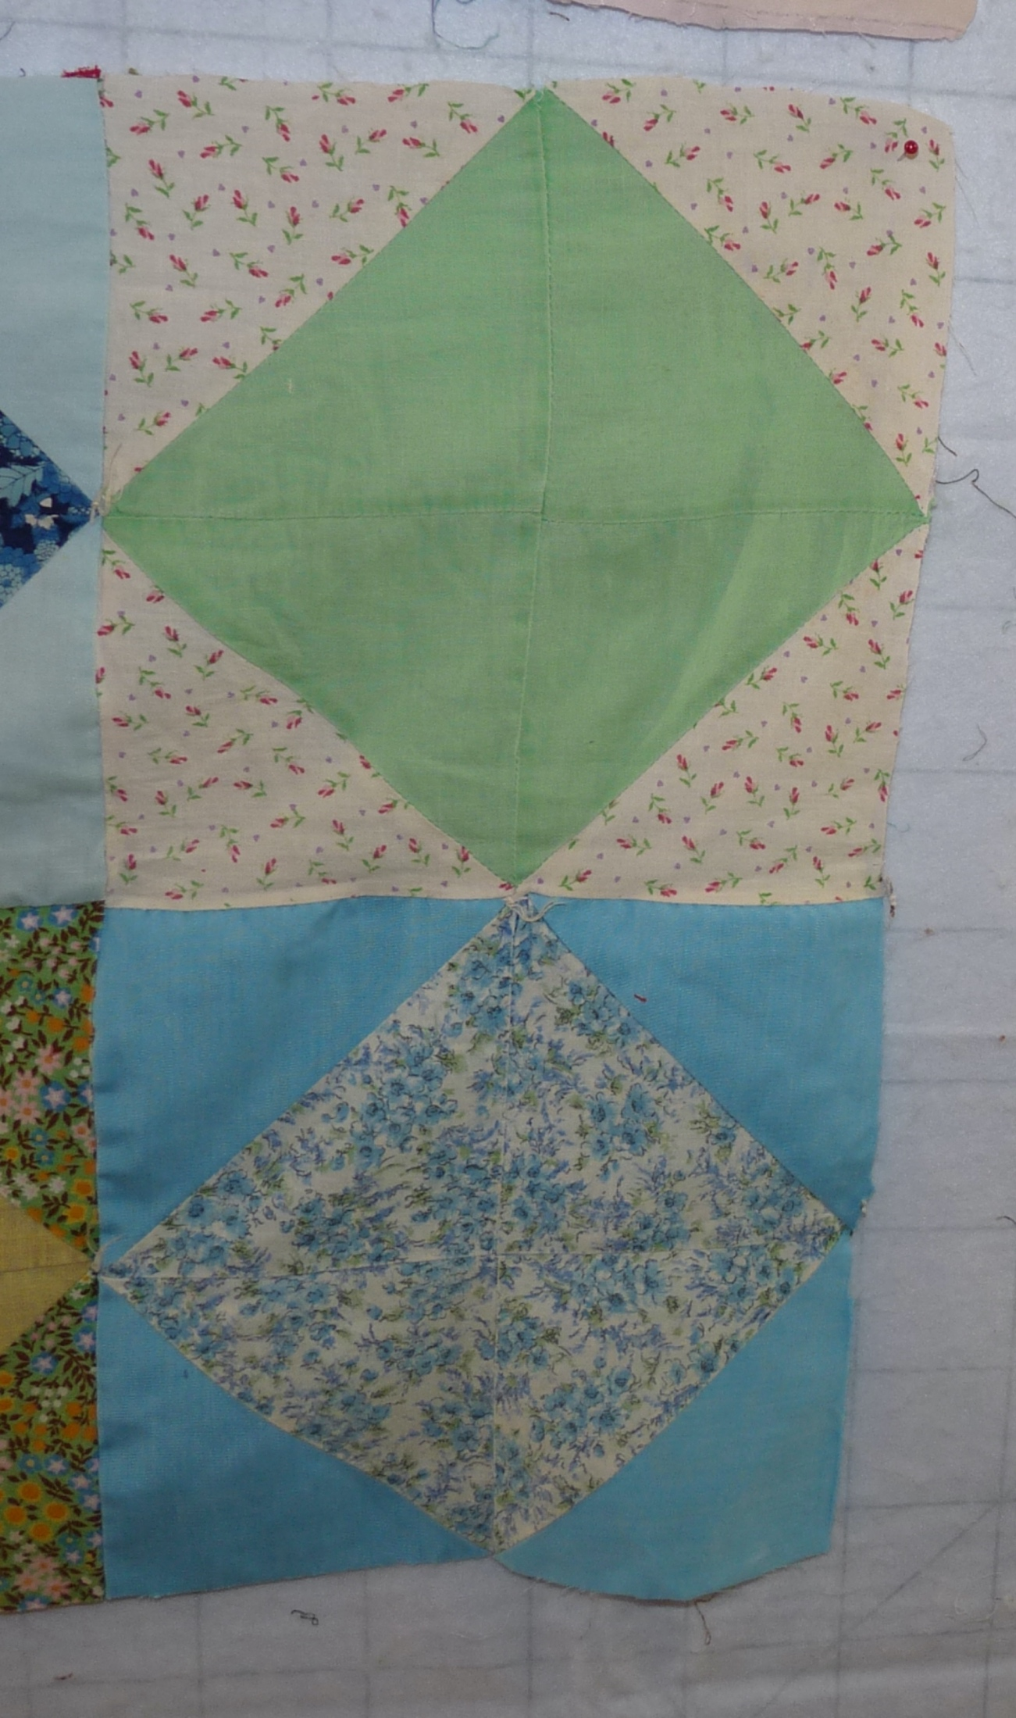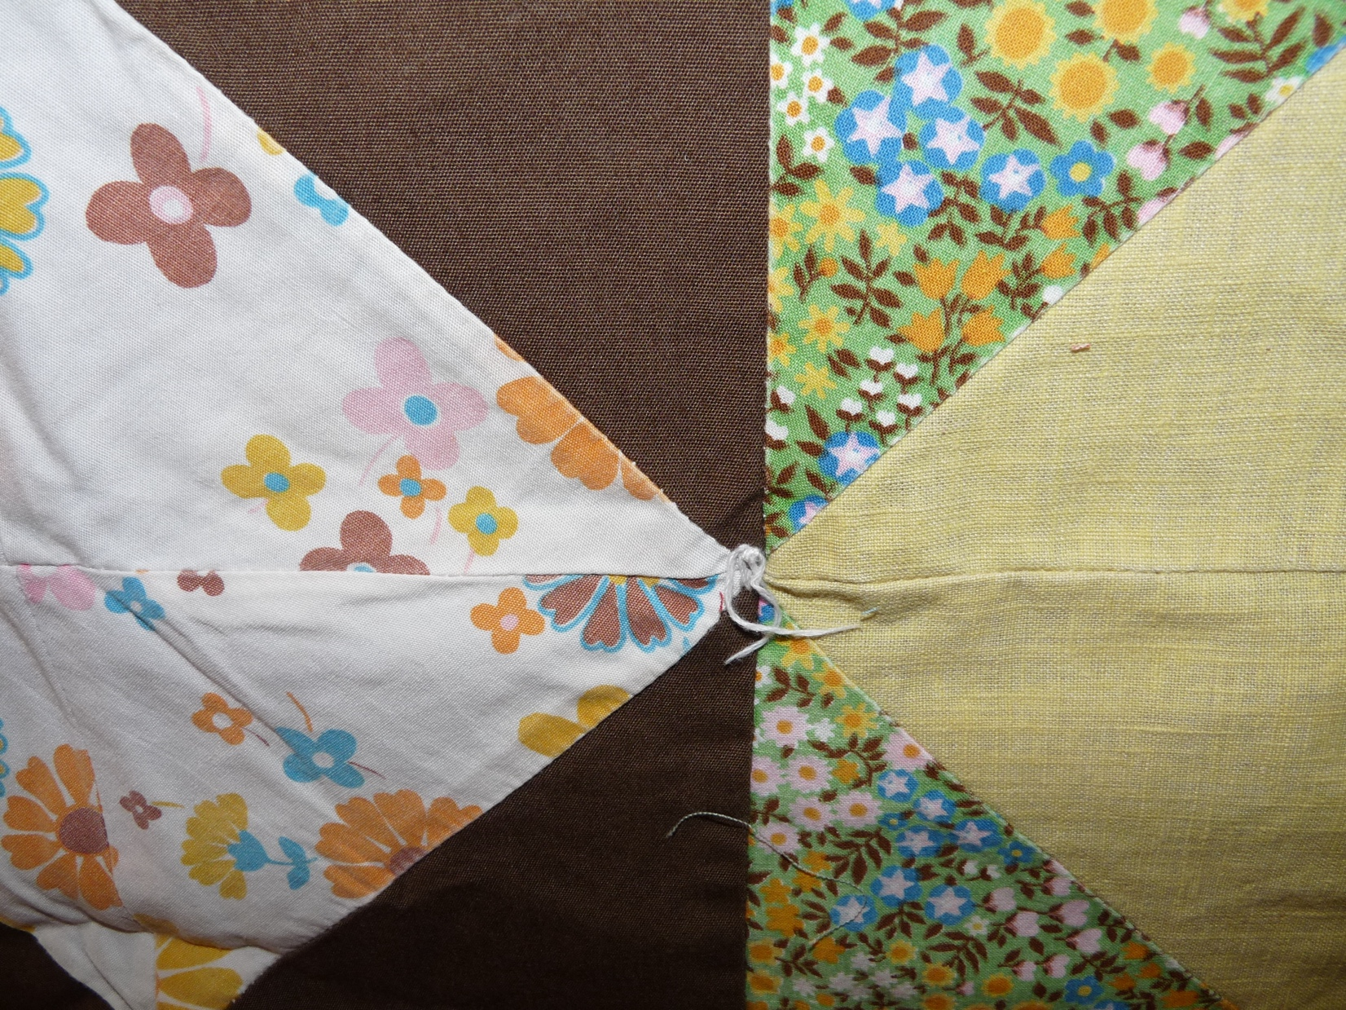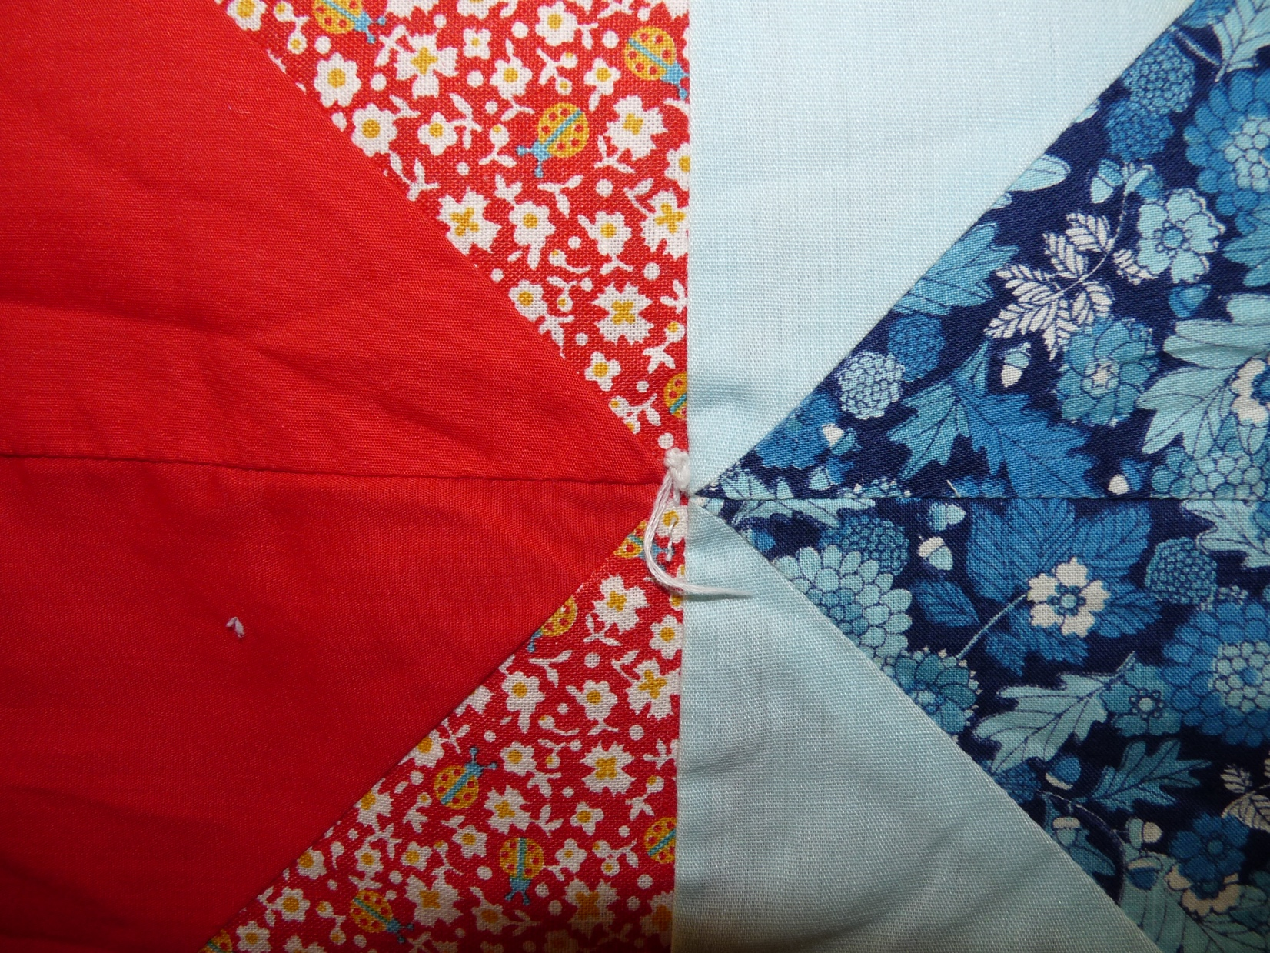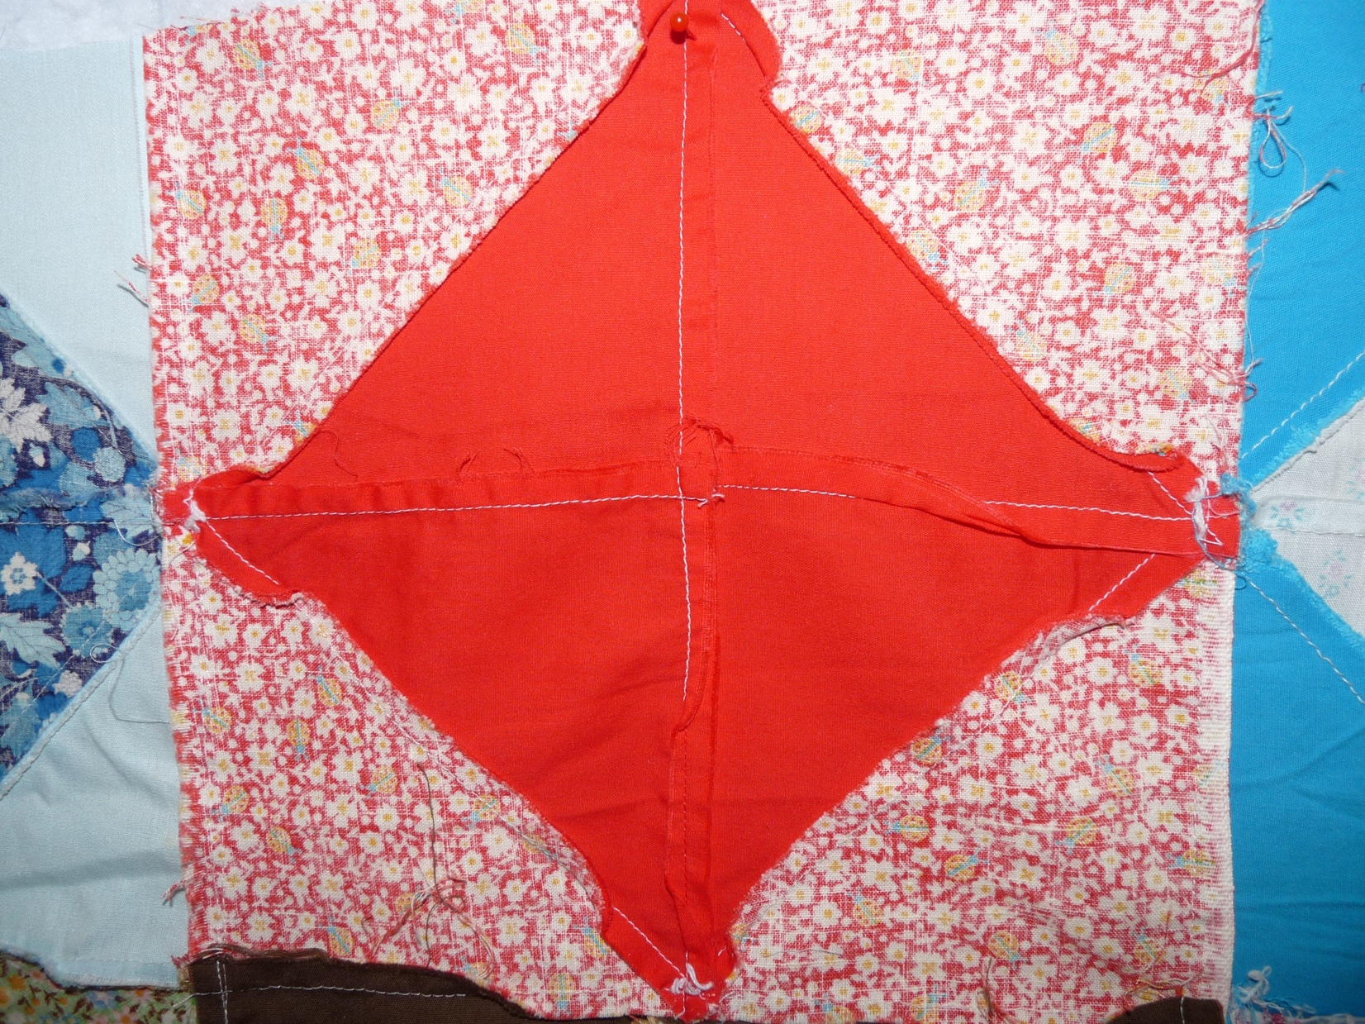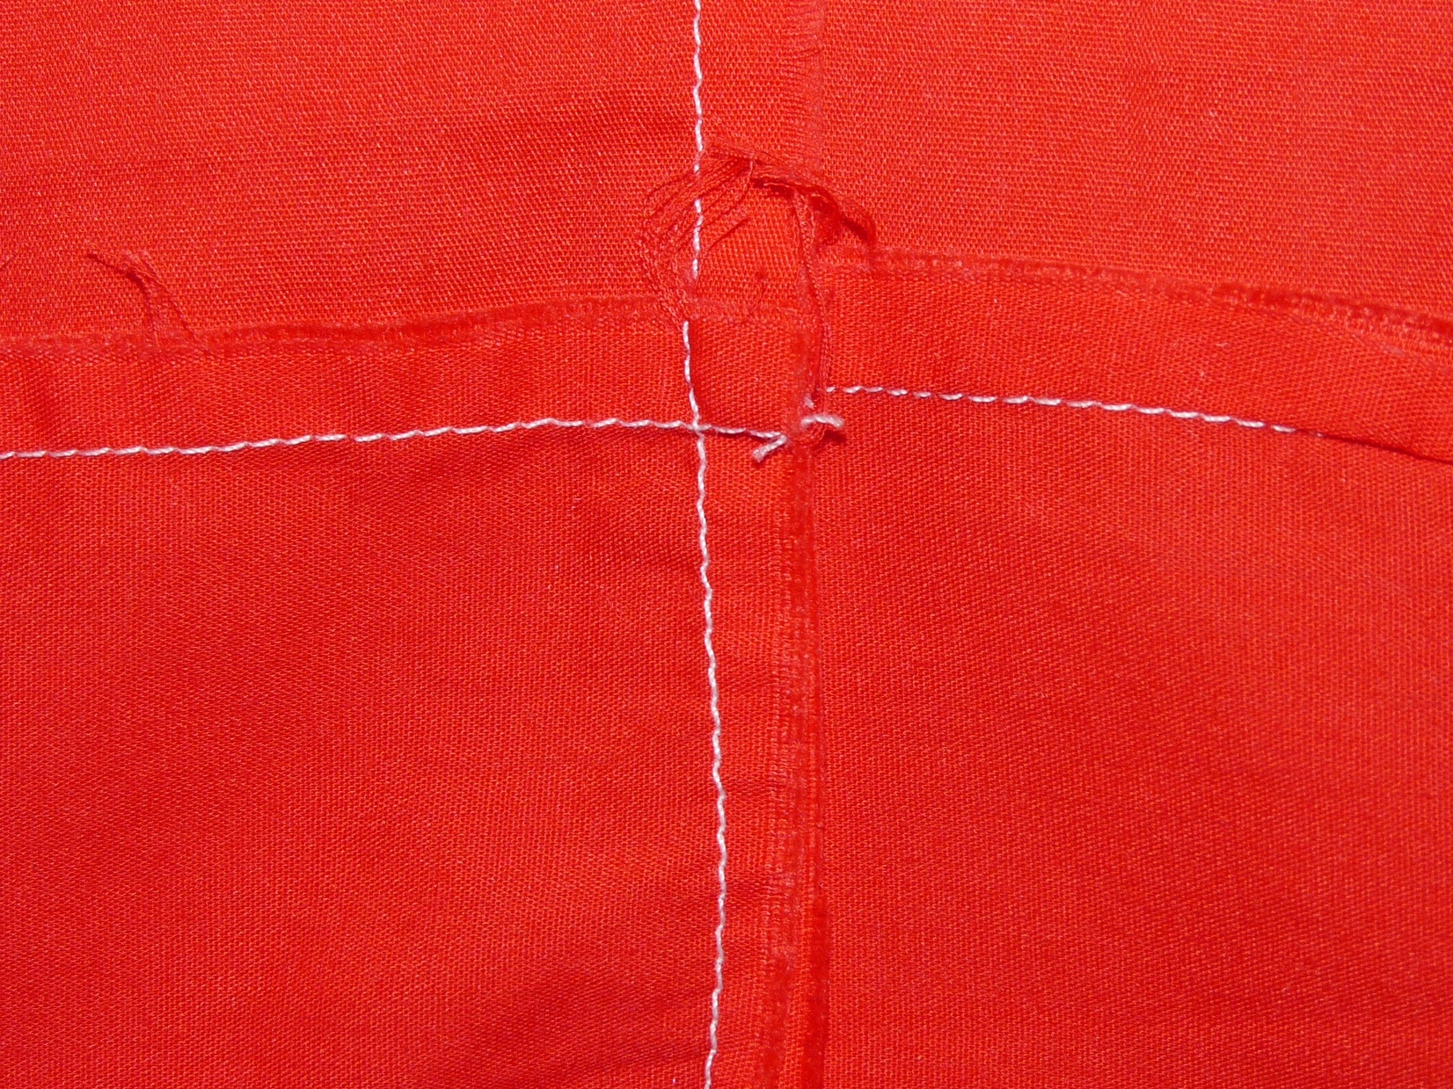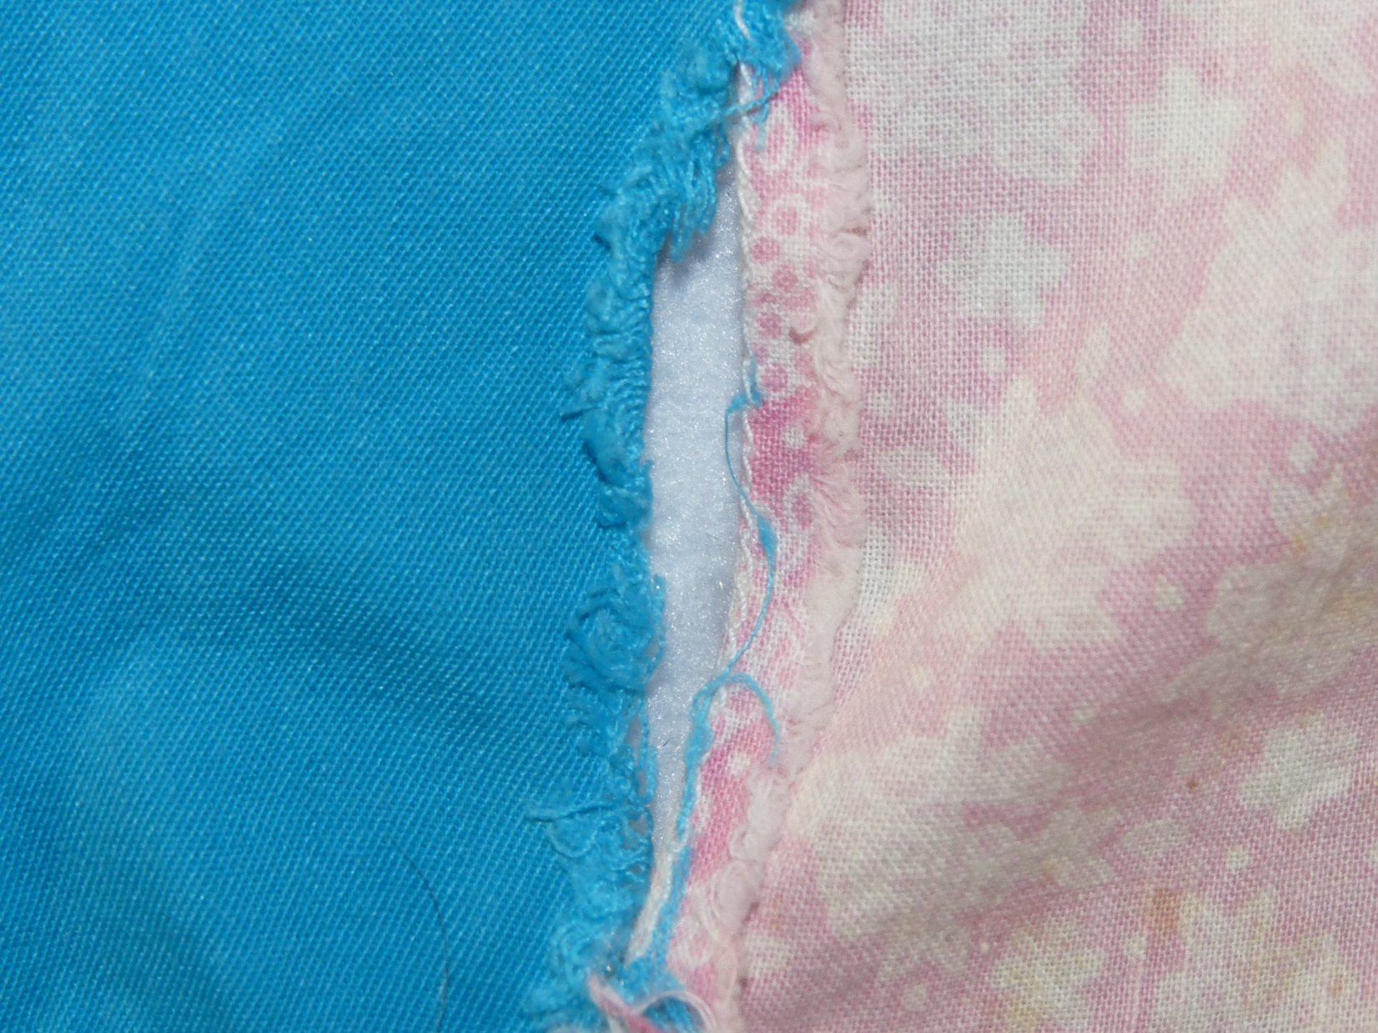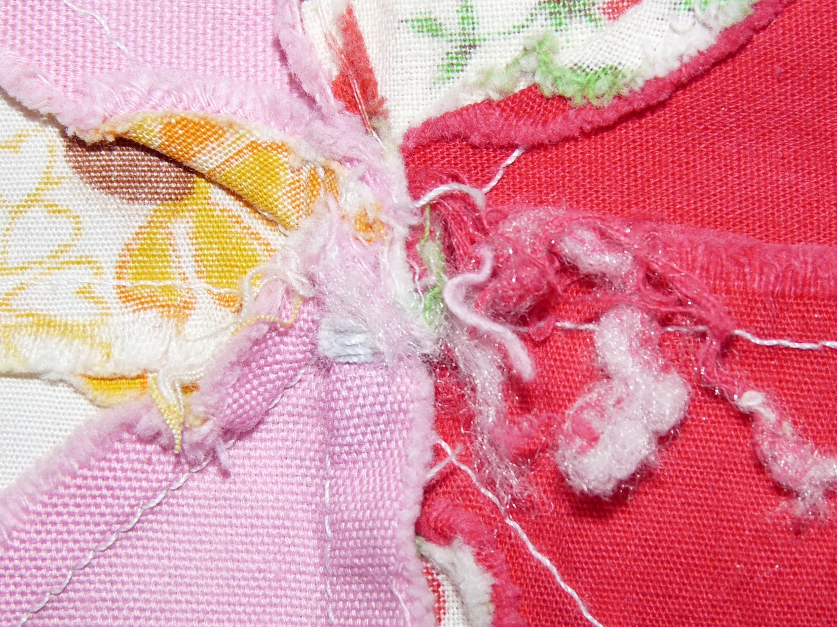

History & Provenance
- Work Credit
  - Piecing: unknown
- Date Made: circa 1945 inferred by fabric
- Ownership History:
  - David Bailey: August 19, 2022
  - Documented by David Bailey

Top / Bottom
Fabric Description
- Cotton
- Prints / Solids
- Predominant Colors: Varied
General Organization
- Loose Blocks
  - Total Unit Count: 41 blocks
  - Unit Description
    - Unit Name: Diamond in a Square
    - Width: 8″
    - Length: 8″
- Techniques: Patchwork
- Stitching Method: Machine
- Workmanship of Piecing: Very Good
- Other Descriptions:
  - This set of blocks appears to have been cut from an intact quilt. Evidence for this includes a lack of seam allowances to display points on the squares where it seems to have been cut. Some pieces appear to have needle tracks. Where blocks are still sewn to each other, there are remnants of ties that were used to anchor the top to the batting and backing.
  - Some blocks are still assembled
    - 10 blocks are in a single set (5 x 2 grid)
    - 4 blocks are in a single set (1 x 4 grid)
    - 22 blocks are sewn together as pairs
    - 5 blocks remain as single blocks
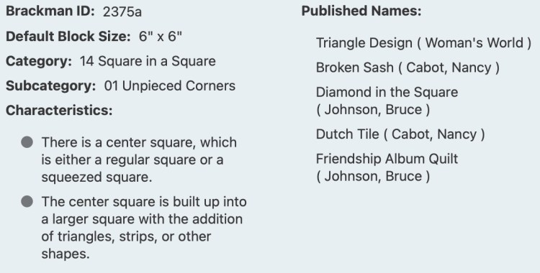Block ID: Encyclopedia of Pieced Quilt Patterns, 3rd ed. Barbara Brackman.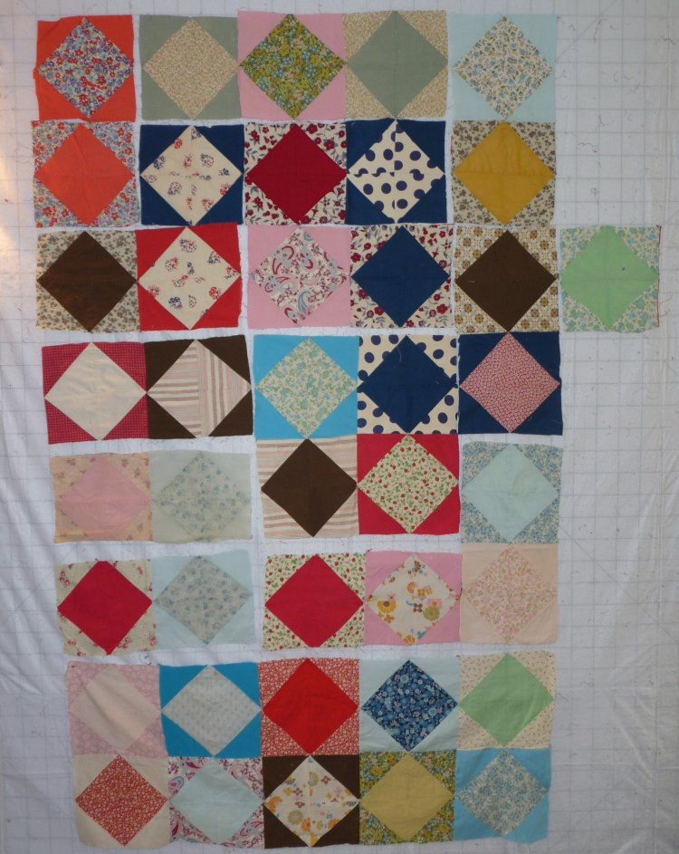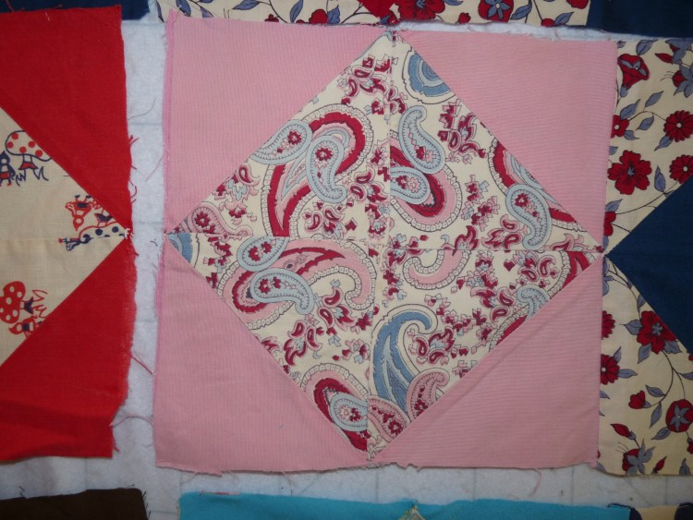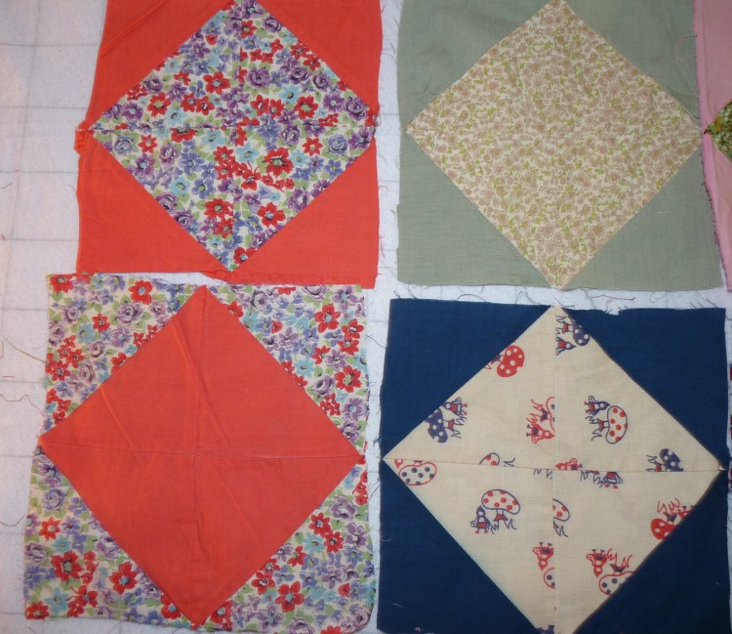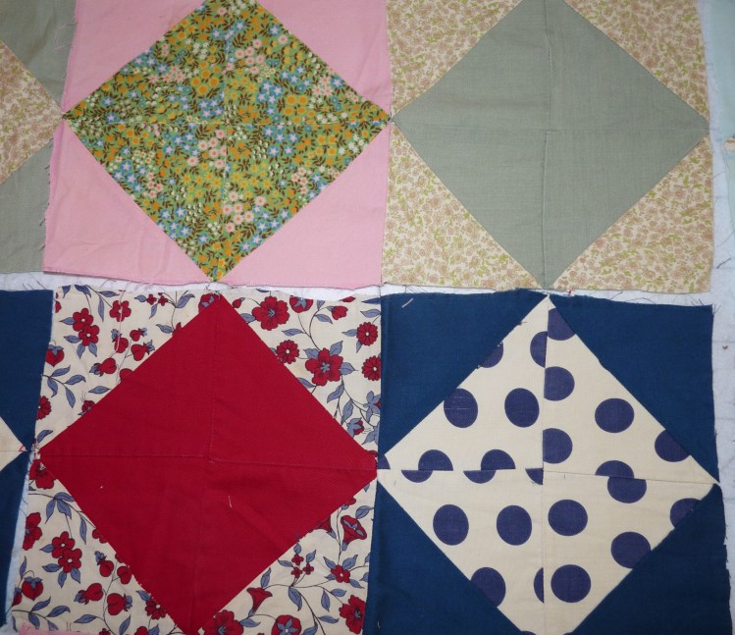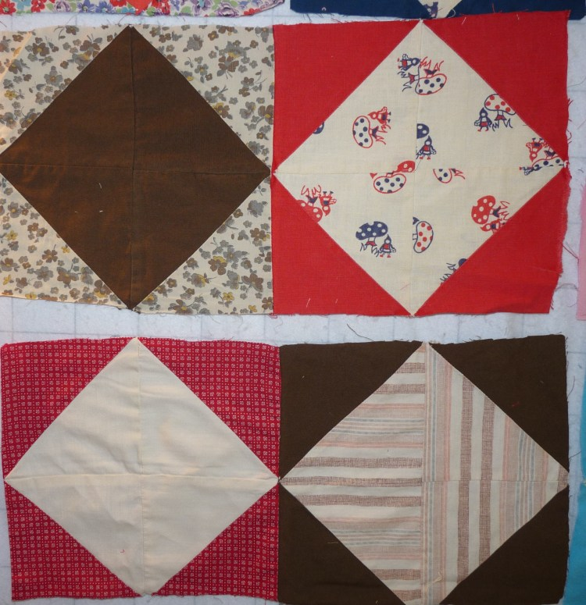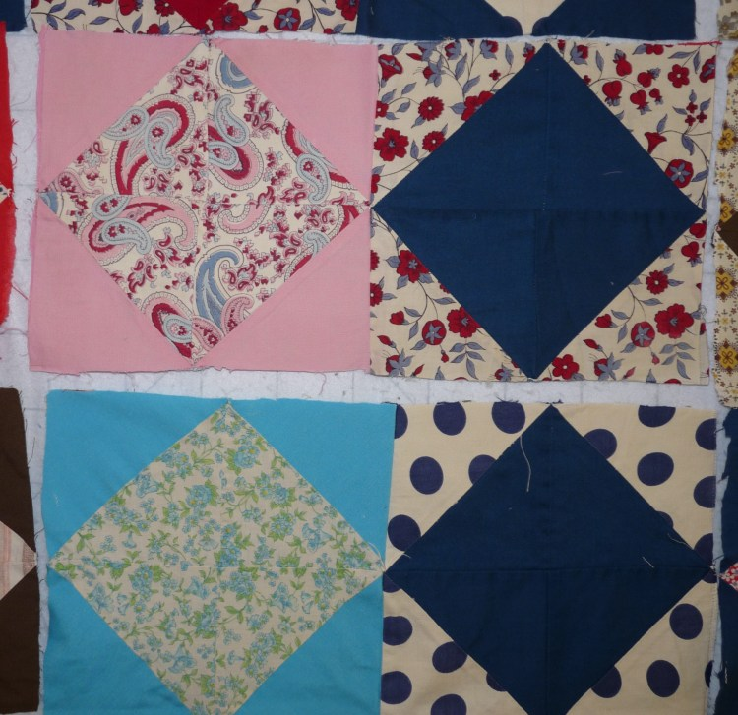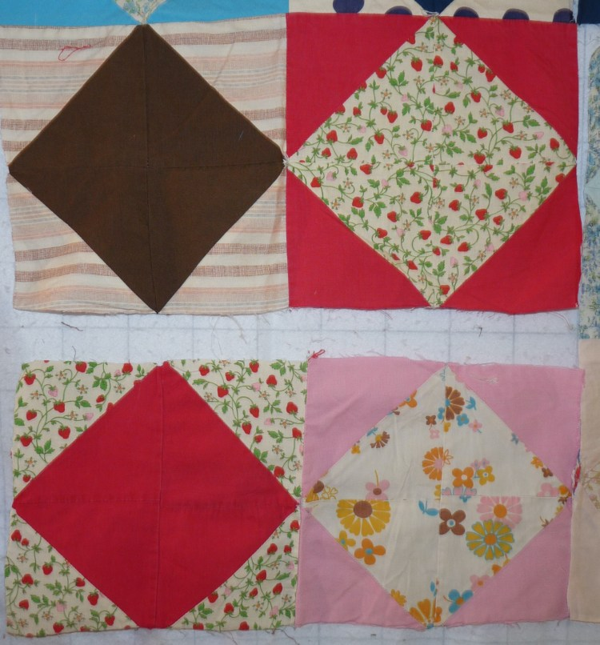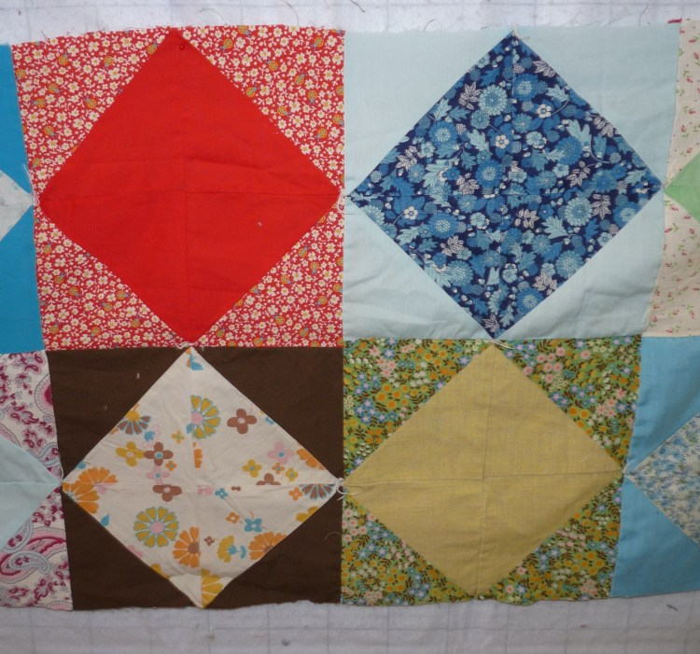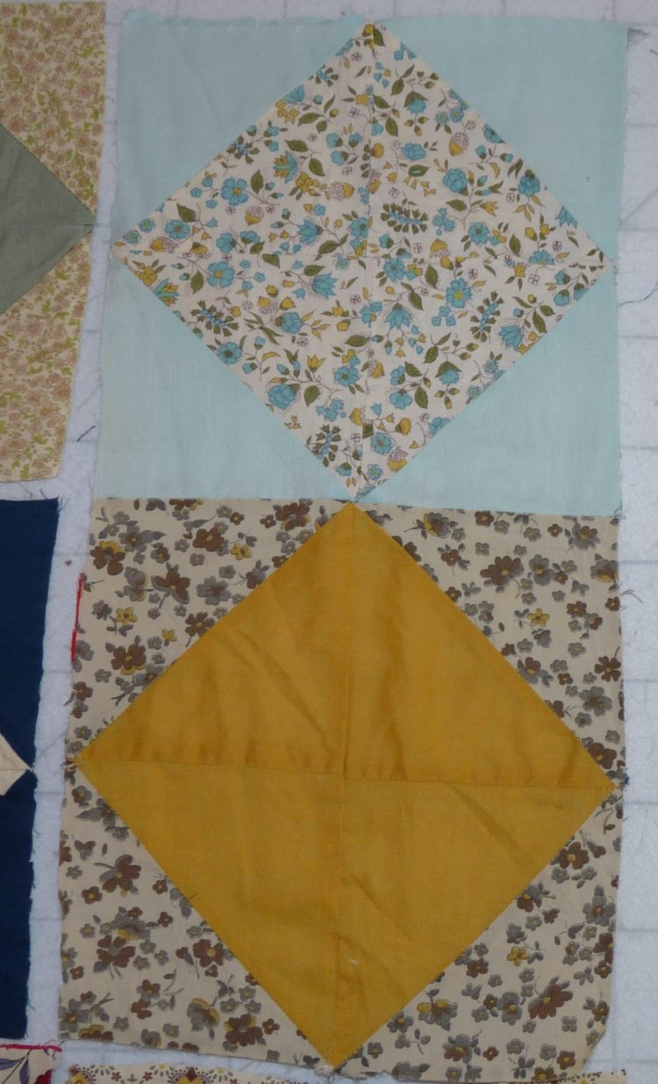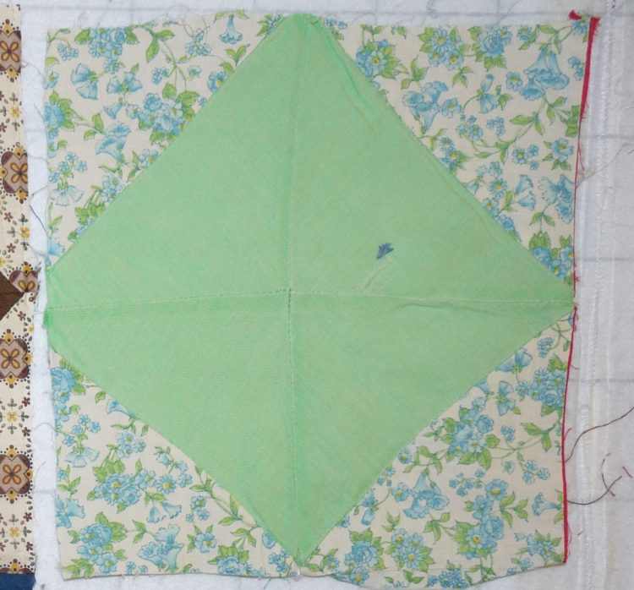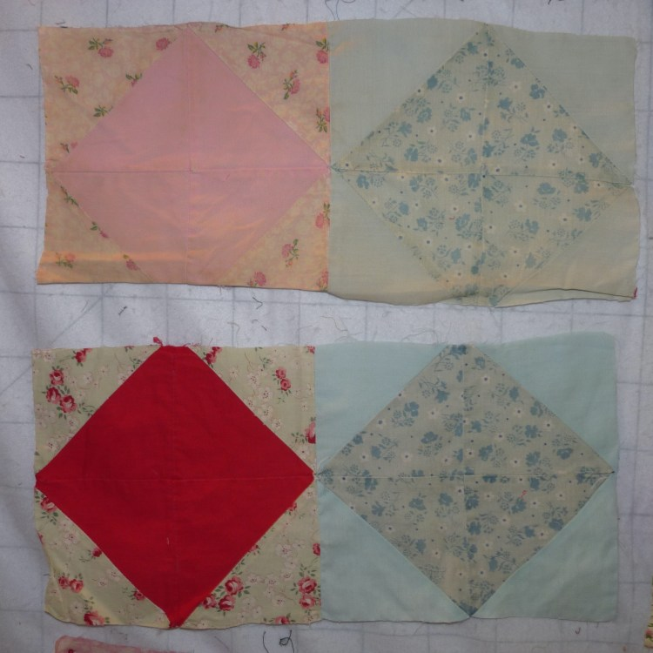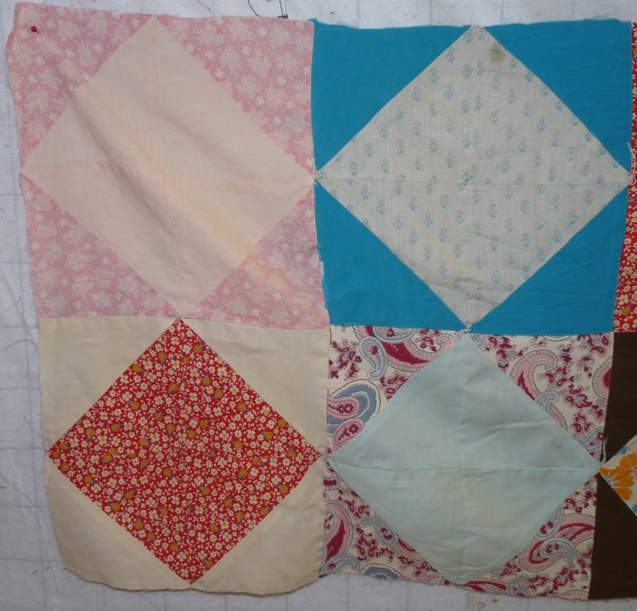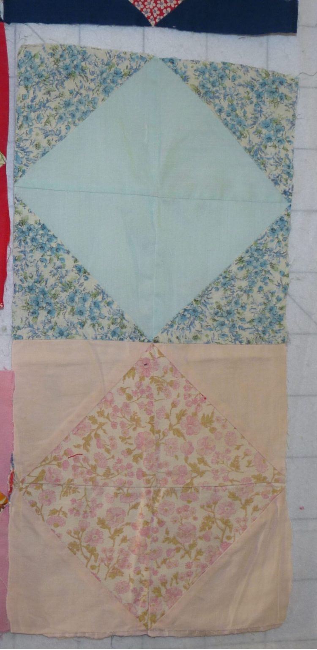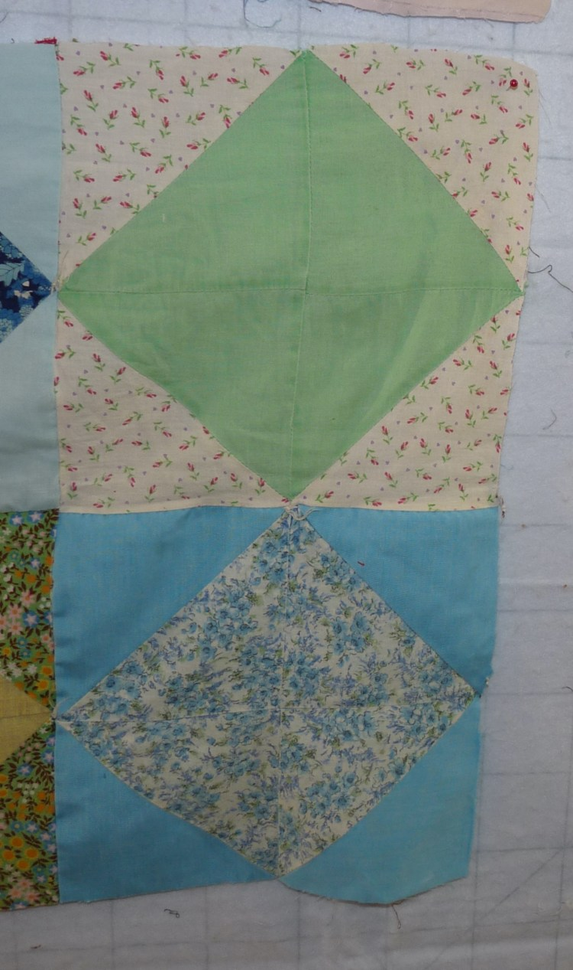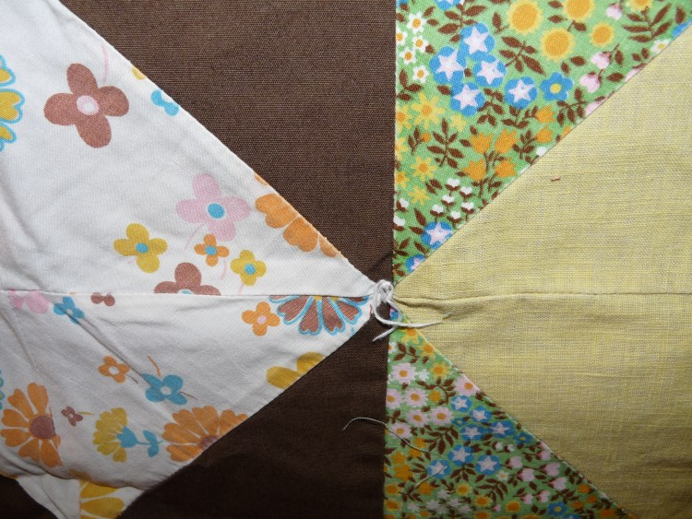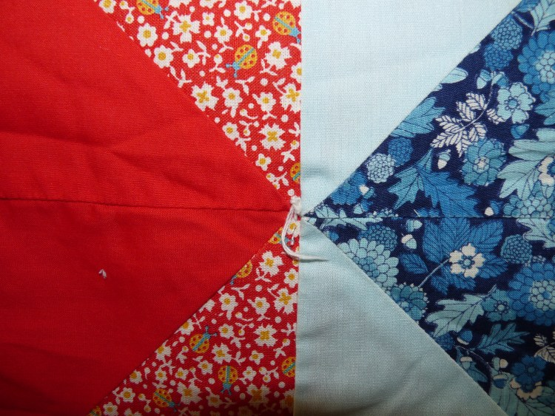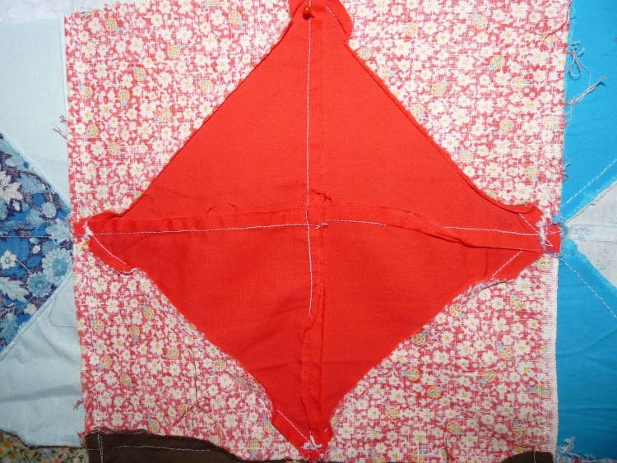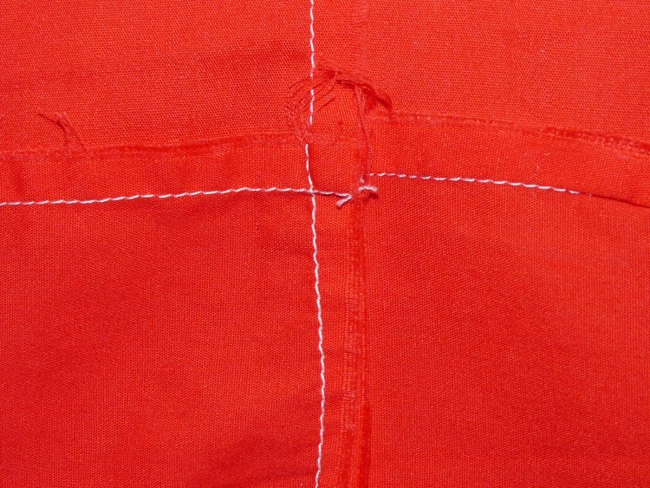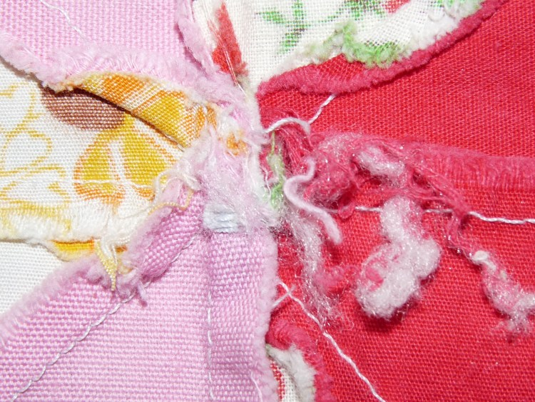

Restoration & Repair Measures
Repair & Restoration:
- Some seams have released and need to be repaired.
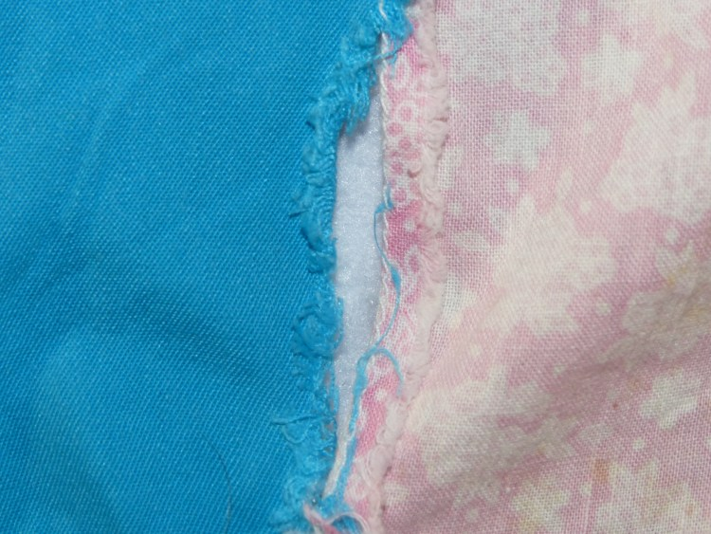

Cost Analysis
Supplies
- Vintage fabrics, blocks, tops: $ 15 for set of 41 blocks.
- Vendor Contact Information:
Wally’s Treasures Antique Mall
1438 28th Street SE
Grand Rapids, MI
616 302 7070
Link back to project page.

Owner History
Owner | From Date | To Date | Acquired at: | Cost
David Bailey | -- | -- | -- | $0
Made in:
--
 | If not purchased, the estimated cost for materials: $0

Display & Publication History
Date | Event | Location / Publication
-- | -- | --

General Description
Quilt Title or Name:  -- | Fabric Date Range: 1935 ± 10 Years  Date Made: -- ± 0 Years  Method of Determination:
Item Type:  Items in Set: 18 | Size: Length: 9“ x Width: 9“
Appraisals:  Has this quilt been professionally appraised?  If so, when: --  ----------- | Other related files:  Scanned Patterns  Images  EQ 8 Files  Research Notes
Additional Information: --

History

Provenance
Describe: --

Quilt Maker
Maker: -- |  | Birth: -- |  | Death: --
 | Location: -- |  | Contributions: --

Purpose and Context
Expression
Art | Personal Enjoyment | Therapy
Income
Personal Income | Fundraising
Presentation
Anniversary | Wedding | Birth
Holiday | Birthday | Other gift
Charitable support
Relationships
Friendship | Commemorative | Memorial
Mourning | Reunion
Skill Building
Challenge / Contest | Learning / Teaching Sample
Use
Bed Quilt | Lap Quilt | Home Décor
Baby / Crib | Wall Hanging
Describe other purpose: --

Construction History
--

Coverlet Design & Construction

Coverlet Top
Warp strand count per inch: 0. | Design: --
Warp fiber: | Weaver: --
Weft strand count per inch: 0” | Location: --
Weft fiber: | Woven for: --
Additional Information: --

Quilt Top Design & Construction

Quilt Top
Layout Design: .
Delete this & the following table rows as appropriate.
One Patch Shape Details
 |  |  | Describe: --
 | Techniques
 |  | Machine pieced | String / Improvisational piecing
 |  | Hand pieced | Foundation piecing
 |  | Strip piecing | English paper piecing
 |  | Describe: --
 | Workmanship
 |  | Seams are stable | Seams are appropriately aligned
 |  | Seams are flat | Points are sharp
 |  | Describe piecing workmanship
Medallion Details
 | Length 0.00” x Width: 0.00” |  | Describe: --
 | Describe: --
 | Techniques
 |  | Machine pieced | String / Improvisational piecing
 |  | Hand pieced | Foundation piecing
 |  | Strip piecing | English paper piecing
 |  | Describe: --
 | Workmanship
 |  | Seams are stable | Seams are appropriately aligned
 |  | Seams are flat | Points are sharp
 |  | Describe piecing workmanship
Blocks / Grid
 |  |  | Grid Dimensions: Length 0 x Width: 0
 |  |  | Block Size: Length: 0.00 “ x Width: 0.00 “
 | Describe: --
 | Pattern name & Brackman or other ID |  | <<Pattern Image>>
 | Techniques
 | Machine pieced |  | String / Improvisational piecing
 | Hand pieced |  | Foundation piecing
 | Strip piecing |  | English paper piecing
 | Describe: --
 | Workmanship
 | Seams are stable |  | Seams are appropriately aligned
 | Seams are flat |  | Points are sharp
 | Describe piecing workmanship

Embellishments
Delete this & the following table rows as appropriate.
Types:
 | Applique – Raw edge | Embroidery | Stuffed Work
 | Applique - Button-hole | Cording | Inking
 | Applique - Needle-turn | Beading | Painting
 | Applique - Reverse | Rhinestones / Gems | Marking lines noted
 | Applique - Other | Other: --
Workmanship
 | Stitches are appropriately small and even.
 | Edges are as design intends (straight, curved, pointed).
 | Work demonstrates appropriate skill for intended purpose.
 | Describe other techniques

Sashing
Delete this & the following table rows as appropriate.
 |  | Width: 0.00 “
Use of corner stones
Techniques
 | Machine pieced |  | String / Improvisational piecing
 | Hand pieced |  | Foundation piecing
 | Strip piecing |  | English paper piecing
 | Describe: --
Workmanship
 | Seams are stable |  | Seams are appropriately aligned
 | Seams are flat |  | Points are sharp
Describe: --
 | Describe piecing workmanship

Borders & Frames
Delete this & the following table rows as appropriate.
Describe borders and frames in order from center to edge.
1 | Width: 0.00“
 |  |  | Describe: --
Techniques
 |  | Machine pieced |  |  | String / Improvisational piecing
 |  | Hand pieced |  |  | Foundation piecing
 |  | Strip piecing |  |  | English paper piecing
 |  | Describe: --
Workmanship
 |  | Seams are stable |  |  | Seams are appropriately aligned
 |  | Seams are flat |  |  | Points are sharp
Describe: --
 |  | Describe piecing workmanship

Assembly
 | Seams are appropriately aligned
Seams are stable | Top has no inappropriate tucks or puckers
Seams are flat | Top lays flat with no overly full areas
Describe: --

Color
Predominant colors
 | Red | Blue | Black
 | Orange | Violet/Purple | Grey
 | Yellow | Brown | White
 | Green | Beige / Tan
Specific Antique Colors |  | NONE NOTED | Neon prints
 | Red – claret / wine | Yellow – chrome | Blue – Lancaster
 | Red – madder / cinnamon | Green - chrome | Blue – Prussian / Lafayette
 | Red – turkey | Green – Nile | Brown – madder
 | Pinks - double | Blue – Cadet | Butterscotch
 | Orange - madder | Blue - Indigo | Bronze
 | Orange – cheddar / antimony / chrome |  | Late 1800’s Purple
Describe: --

Materials
Sources of Fabric |  | NOT KNOWN
 | Companies | Fabric Name & Number | Designer
 | -- | -- | --
 | Describe other sources: --
Fiber Types |  | NOT YET IDENTIFIED
 | Cotton | Silk | Wool
 | Cotton Blend | Linen | Synthetic
 | Describe & Clarify: --
Fabric Types |  | NOT KNOWN
 | Broadcloth | Sateen | Upholstery
 | Flannel | Satin | Chintz
 | Shirting | Muslin | Glazed
 | Suiting | Velvet | Handwoven
 | Denim | Felt | Lindsey-Woolsey
 | Describe & Clarify: --
Print Types |  | NOT YET IDENTIFIED
 | Batik | Floral | Multiple scraps
 | Cheater Panel | Garibaldi Red Prints | Paisley
 | Checked / Gingham | Geometric | Plaid
 | Conversation / Novelty | Hand-dyed | Solid / Plain
 | Dotted | Victorian Mourning Prints | Stamped
 | Feed sack / Feed sack-like |  | Stripes
Describe & Clarify: --

Images

Inscriptions
None Found
Inscription is present. Describe location: --
Content
Makers names | Initials | Date
Single Name | Message | Place
Multiple Names
Transcription: --

Methods
Label | Ink – Ball point | Stencil
Printed onto fabric | Ink – Felt tip | Stamped
Quilted | Ink - Other | Pencil
Embroidery | Applique | Typewriter
Describe & Clarify: --

Images for Inscriptions

Quilt Back Design & Construction

Quilt Back
Layout Design: .
Delete this & the following table rows as appropriate.
One Patch Shape Details
 |  |  | Describe: --
 | Techniques
 |  | Machine pieced | String / Improvisational piecing
 |  | Hand pieced | Foundation piecing
 |  | Strip piecing | English paper piecing
 |  | Describe: --
 | Workmanship
 |  | Seams are stable | Seams are appropriately aligned
 |  | Seams are flat | Points are sharp
 |  | Describe piecing workmanship
Medallion Details
 | Length 0.00” x Width: 0.00” |  | Describe: --
 | Describe: --
 | Techniques
 |  | Machine pieced | String / Improvisational piecing
 |  | Hand pieced | Foundation piecing
 |  | Strip piecing | English paper piecing
 |  | Describe: --
 | Workmanship
 |  | Seams are stable | Seams are appropriately aligned
 |  | Seams are flat | Points are sharp
 |  | Describe piecing workmanship
Blocks / Grid
 |  |  | Grid Dimensions: Length 0 x Width: 0
 |  |  | Block Size: Length: 0.00 “ x Width: 0.00 “
 | Describe: --
 | Pattern name & Brackman or other ID |  | <<Pattern Image>>
 | Techniques
 | Machine pieced |  | String / Improvisational piecing
 | Hand pieced |  | Foundation piecing
 | Strip piecing |  | English paper piecing
 | Describe: --
 | Workmanship
 | Seams are stable |  | Seams are appropriately aligned
 | Seams are flat |  | Points are sharp
 | Describe piecing workmanship

Embellishments
Delete this & the following table rows as appropriate.
Types:
 | Applique – Raw edge | Embroidery | Stuffed Work
 | Applique - Button-hole | Cording | Inking
 | Applique - Needle-turn | Beading | Painting
 | Applique - Reverse | Rhinestones / Gems | Marking lines noted
 | Applique - Other | Other: --
Workmanship
 | Stitches are appropriately small and even.
 | Edges are as design intends (straight, curved, pointed).
 | Work demonstrates appropriate skill for intended purpose.
 | Describe other techniques

Sashing
Delete this & the following table rows as appropriate.
 |  | Width: 0.00 “
Use of corner stones
Techniques
 | Machine pieced |  | String / Improvisational piecing
 | Hand pieced |  | Foundation piecing
 | Strip piecing |  | English paper piecing
 | Describe: --
Workmanship
 | Seams are stable |  | Seams are appropriately aligned
 | Seams are flat |  | Points are sharp
Describe: --
 | Describe piecing workmanship

Borders & Frames
Delete this & the following table rows as appropriate.
Describe borders and frames in order from center to edge.
1 | Width: 0.00“
 |  |  | Describe: --
Techniques
 |  | Machine pieced |  |  | String / Improvisational piecing
 |  | Hand pieced |  |  | Foundation piecing
 |  | Strip piecing |  |  | English paper piecing
 |  | Describe: --
Workmanship
 |  | Seams are stable |  |  | Seams are appropriately aligned
 |  | Seams are flat |  |  | Points are sharp
Describe: --
 |  | Describe piecing workmanship

Assembly
 | Seams are appropriately aligned
Seams are stable | Top has no inappropriate tucks or puckers
Seams are flat | Top lays flat with no overly full areas
Describe: --

Color
Predominant colors
 | Red | Blue | Black
 | Orange | Violet/Purple | Grey
 | Yellow | Brown | White
 | Green | Beige / Tan
Specific Antique Colors |  | NONE NOTED | Neon prints
 | Red – claret / wine | Yellow – chrome | Blue – Lancaster
 | Red – madder / cinnamon | Green - chrome | Blue – Prussian / Lafayette
 | Red – turkey | Green – Nile | Brown – madder
 | Pinks - double | Blue – Cadet | Butterscotch
 | Orange - madder | Blue - Indigo | Bronze
 | Orange – cheddar / antimony / chrome |  | Late 1800’s Purple
Describe: --

Materials
Sources of Fabric |  | NOT KNOWN
 | Companies | Fabric Name & Number | Designer
 | -- | -- | --
 | Describe other sources: --
Fiber Types |  | NOT YET IDENTIFIED
 | Cotton | Silk | Wool
 | Cotton Blend | Linen | Synthetic
 | Describe & Clarify: --
Fabric Types |  | NOT KNOWN
 | Broadcloth | Sateen | Upholstery
 | Flannel | Satin | Chintz
 | Shirting | Muslin | Glazed
 | Suiting | Velvet | Handwoven
 | Denim | Felt | Lindsey-Woolsey
 | Describe & Clarify: --
Print Types |  | NOT YET IDENTIFIED
 | Batik | Floral | Multiple scraps
 | Cheater Panel | Garibaldi Red Prints | Paisley
 | Checked / Gingham | Geometric | Plaid
 | Conversation / Novelty | Hand-dyed | Solid / Plain
 | Dotted | Victorian Mourning Prints | Stamped
 | Feed sack / Feed sack-like |  | Stripes
Describe & Clarify: --

Images

Inscriptions
None Found
Inscription is present. Describe location: --
Content
Makers names | Initials | Date
Single Name | Message | Place
Multiple Names
Transcription: --

Methods
Label | Ink – Ball point | Stencil
Printed onto fabric | Ink – Felt tip | Stamped
Quilted | Ink - Other | Pencil
Embroidery | Applique | Typewriter
Describe & Clarify: --

Images for Inscriptions

Stabilization Method
Stabilization Method:
Delete this & the following table rows as appropriate.
Tied Details
 | Average Distance Between Knots: 0” |  | Placement:
 |  |  | Fiber Used:
Quilting Details
Batting
Quilting Techniques
 | Machine Quilted | Machine – sit-down |  | Corded
 | Machine – computer guided | Hand Quilted |  | Stuffed work
 | Machine – manual long-arm | Quilt-as-you-go
 | Describe: --
Quilting Patterns
 | Meander / Free motion | Lines – single parallel |  | Cables
 | In-the-ditch / To the piece | Lines – double parallel |  | Feathers
 | Echo / Outlined | Lines – triple parallel |  | Wreaths
 | Stipple | Grid – crosshatch |  | Vines
 | Clamshell | Grid – square |  | Floral
 | Elbow / Fan | Grid - diamond |  | Leaves
 | Describe other: --
Thread Choices
 | Brand | Weight |  | Number & Name
 | -- | -- |  | --
Describe: --
Images for Stabilization

Edge Finish
Edge Style:
Finishing Technique
Top Width: 0.00 “ | Binding | Rolled – top to back
Back Width: 0.00“ | Knife edge | Rolled – back to top
1/8 = 0.13, 3/8 = 0.38 | Turned with a closure
5/8 = 0.63, 7/8 = 0.88
Application Method: | Top: | Back:
Embellishments
Fringe | Ruffles | Cording
Lace | Ribbon
Describe: --

Images for Edge

Condition

Flaws
Soiling
Dirty | Stains
Mildew stains | Musty Smell
Discoloration
Running / fugitive color | Faded / bleached color | Crocking
Fabric Damage
Tears / holes | Disintegrating / fall out | Insect damage
Thread bare | Shattering
Sewing / Quilting Damage
Split / open seams | Ties / tufting missing | Embellishments missing
Quilting threads missing | Batting has shifted
Storage Issues
Discoloration from wood | Damage from acid | Fold marks / creases
Describe additional condition issues: --
Images for Condition Issues

Conservation, Restoration, Repairs
Describe Measures: --

Workmanship

Extension of Useful Life
Repair | Useful life of the item was extended.
Prevention of Damage
Conservation | All work is reversible.
Conservation | Further deterioration has been slowed, stabilized or prevented.
Maintaining Function & Integrity
Conservation | Work minimally interferes with the item’s overall appearance.
Restoration | Work blends well with the item’s overall appearance, style and age.
Restoration | Appropriate period reproductions were used.
Restoration | Vintage materials were used.
Restoration | Period appropriate techniques were used.
Restoration | Workmanship is of similar or better quality than original work.

Images for Conservation / Restoration / Repairs

