Documentation Form

Overview

Images
Top | Back
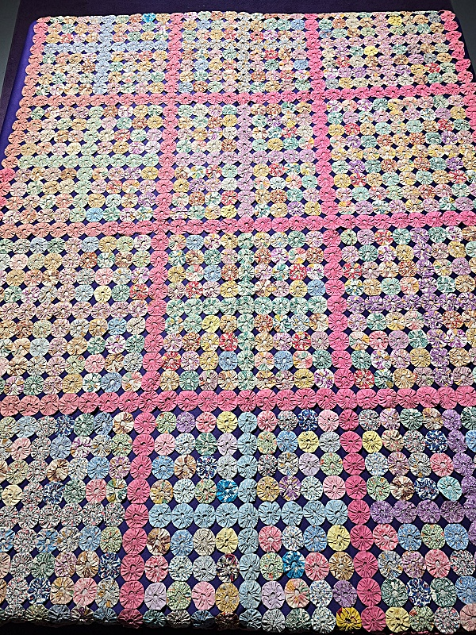

Owner History
Owner | From Date | To Date | Acquired at: | Cost
David Bailey | Jan 25, 2025 | -- | DanaAuctions.com | $90
Made in:
--
 | If not purchased, the estimated cost for materials: $0

Display & Publication History
Date | Event | Location / Publication
-- | -- | --

General Description
Quilt Title or Name:  Yo-yo quilt | Fabric Date Range: 1930 ± 10 Years  Date Made: 1930 ± 10 Years  Method of Determination:
Item Type:  Items in Set: -- | Size: Length: 78“ x Width: 59“
Appraisals:  Has this quilt been professionally appraised?  If so, when: --  ----------- | Other related files:  Scanned Patterns  Images  EQ 8 Files  Research Notes
Additional Information: Hammer price was $90. Buyer's premium was $16.20 . Shipping $30. Total $136.20 -

History

Provenance
Describe: None known.

Quilt Maker
Maker: -unknown- |  | Birth: -- |  | Death: --
 | Location: -- |  | Contributions: --

Quilt Top Design & Construction

Quilt Top
The colors for the 2" circles are arranged to imitate a pieced block quilt with pink "sashing."

Assembly
 | Seams are appropriately aligned
Seams are stable | Top has no inappropriate tucks or puckers
Seams are flat | Top lays flat with no overly full areas
Describe: Good quality. Some of the yo-yo's are pulling away from each other.

Color
Predominant colors
 | Red | Blue | Black
 | Orange | Violet/Purple | Grey
 | Yellow | Brown | White
 | Green | Beige / Tan
Specific Antique Colors |  | NONE NOTED | Neon prints
 | Red – claret / wine | Yellow – chrome | Blue – Lancaster
 | Red – madder / cinnamon | Green - chrome | Blue – Prussian / Lafayette
 | Red – turkey | Green – Nile | Brown – madder
 | Pinks - double | Blue – Cadet | Butterscotch
 | Orange - madder | Blue - Indigo | Bronze
 | Orange – cheddar / antimony / chrome |  | Late 1800’s Purple
Describe: --

Materials
Sources of Fabric |  | NOT KNOWN
 | Companies | Fabric Name & Number | Designer
 | -- | -- | --
 | Describe other sources: --
Fiber Types |  | NOT YET IDENTIFIED
 | Cotton | Silk | Wool
 | Cotton Blend | Linen | Synthetic
 | Describe & Clarify: --
Fabric Types |  | NOT KNOWN
 | Broadcloth | Sateen | Upholstery
 | Flannel | Satin | Chintz
 | Shirting | Muslin | Glazed
 | Suiting | Velvet | Handwoven
 | Denim | Felt | Lindsey-Woolsey
 | Describe & Clarify: --
Print Types |  | NOT YET IDENTIFIED
 | Batik | Floral | Multiple scraps
 | Cheater Panel | Garibaldi Red Prints | Paisley
 | Checked / Gingham | Geometric | Plaid
 | Conversation / Novelty | Hand-dyed | Solid / Plain
 | Dotted | Victorian Mourning Prints | Stamped
 | Feed sack / Feed sack-like |  | Stripes
Describe & Clarify: --

Images
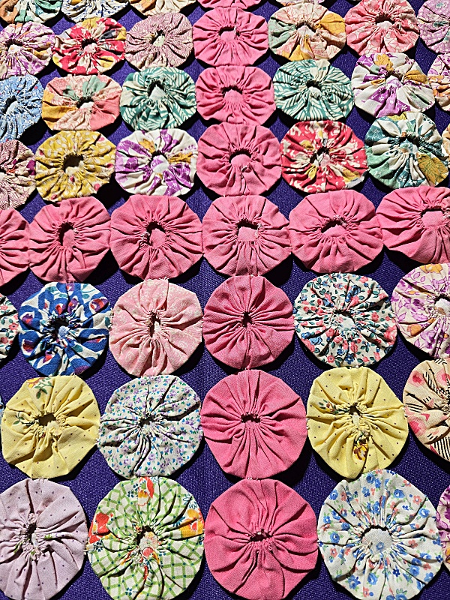 | 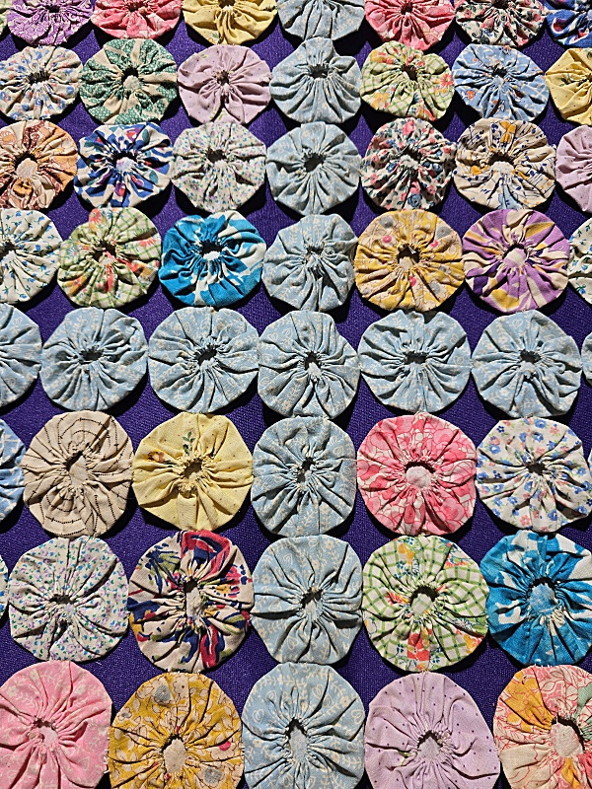

Inscriptions
None Found
Inscription is present. Describe location: --
Content
Makers names | Initials | Date
Single Name | Message | Place
Multiple Names
Transcription: --

Methods
Label | Ink – Ball point | Stencil
Printed onto fabric | Ink – Felt tip | Stamped
Quilted | Ink - Other | Pencil
Embroidery | Applique | Typewriter
Describe & Clarify: --

Images for Inscriptions

Condition

Flaws
Soiling
Dirty | Stains
Mildew stains | Musty Smell
Discoloration
Running / fugitive color | Faded / bleached color | Crocking
Fabric Damage
Tears / holes | Disintegrating / fall out | Insect damage
Thread bare | Shattering
Sewing / Quilting Damage
Split / open seams | Ties / tufting missing | Embellishments missing
Quilting threads missing | Batting has shifted
Storage Issues
Discoloration from wood | Damage from acid | Fold marks / creases
Describe additional condition issues: --
Images for Condition Issues

Conservation, Restoration, Repairs
Describe Measures: --

Workmanship

Extension of Useful Life
Repair | Useful life of the item was extended.
Prevention of Damage
Conservation | All work is reversible.
Conservation | Further deterioration has been slowed, stabilized or prevented.
Maintaining Function & Integrity
Conservation | Work minimally interferes with the item’s overall appearance.
Restoration | Work blends well with the item’s overall appearance, style and age.
Restoration | Appropriate period reproductions were used.
Restoration | Vintage materials were used.
Restoration | Period appropriate techniques were used.
Restoration | Workmanship is of similar or better quality than original work.

Images for Conservation / Restoration / Repairs

