Documentation Form

Overview

Images
Top | Back
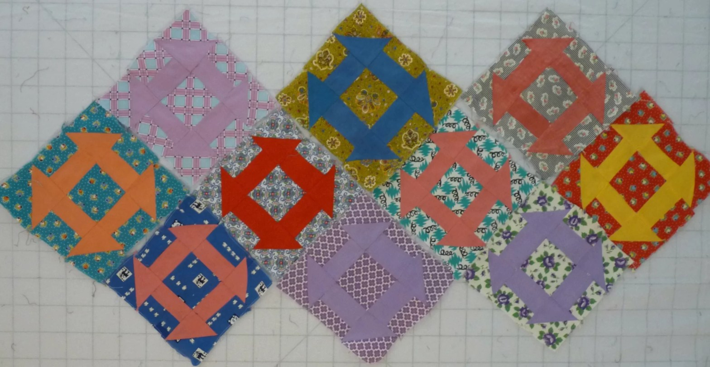 | 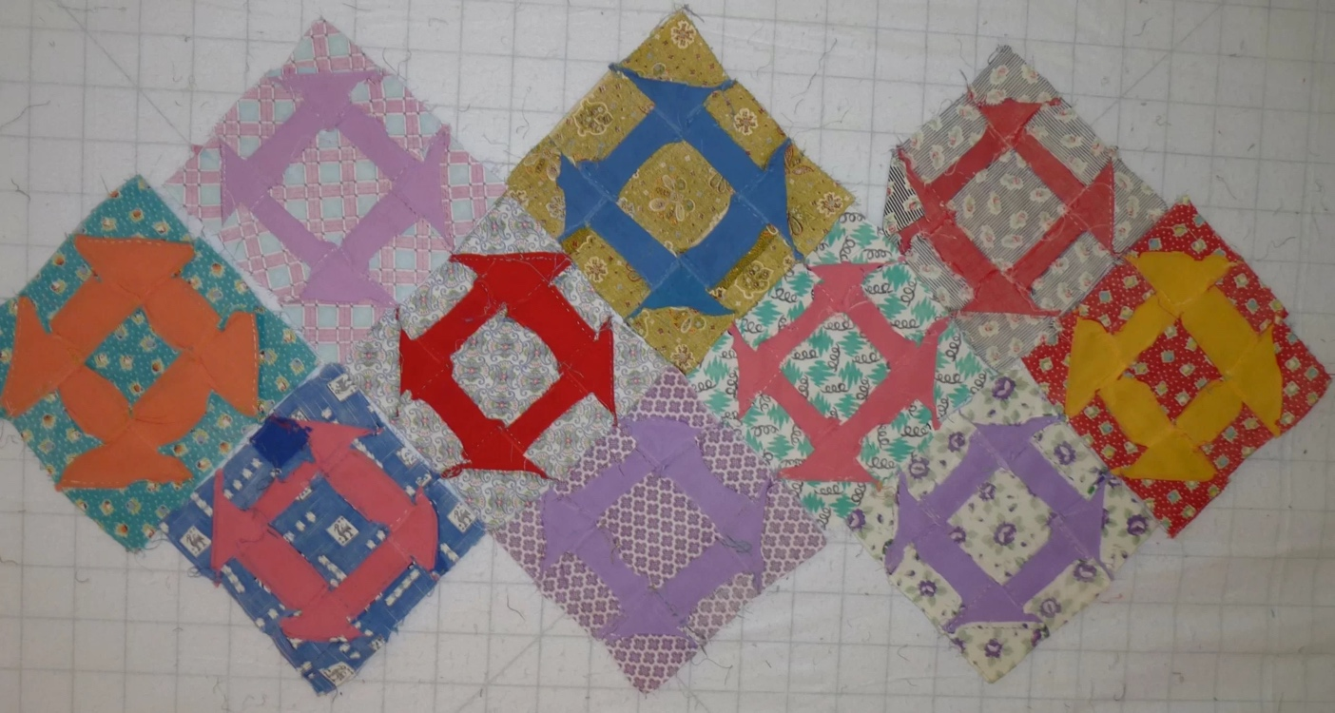

Owner History
Owner | From Date | To Date | Acquired at: | Cost
David Bailey | 2021-12-23 | -- | Antiques Village  Washington Park Plaza  651 Lyons Road  Dayton, Ohio 45459 | $8
Made in:
--
 | If not purchased, the estimated cost for materials: $0

Display & Publication History
Date | Event | Location / Publication
-- | -- | --

General Description
Quilt Title or Name:  Churn Dash Blocks | Fabric Date Range: 1935 ± 10 Years  Date Made: -- ± 0 Years  Method of Determination:
Item Type:  Items in Set: 10 | Size: Length: 10“ x Width: 10“
Appraisals:  Has this quilt been professionally appraised?  If so, when: --  ----------- | Other related files:
Additional Information: --

History

Provenance
Describe: --

Quilt Maker
Maker: unknown |  | Birth: -- |  | Death: --
 | Location: -- |  | Contributions: --

Purpose and Context
Expression
Art | Personal Enjoyment | Therapy
Income
Personal Income | Fundraising
Presentation
Anniversary | Wedding | Birth
Holiday | Birthday | Other gift
Charitable support
Relationships
Friendship | Commemorative | Memorial
Mourning | Reunion
Skill Building
Challenge / Contest | Learning / Teaching Sample
Use
Bed Quilt | Lap Quilt | Home Décor
Baby / Crib | Wall Hanging
Describe other purpose: --

Construction History
--

Quilt Top Design & Construction

Quilt Top
Describe: 10 churn dash blocks in 1940's prints. Hand pieced. BB ID: 1646a.
Pattern name & Brackman or other ID | <<Pattern Image>>
Techniques
Machine pieced | String / Improvisational piecing
Hand pieced | Foundation piecing
Strip piecing | English paper piecing
Describe: --
Workmanship
Seams are stable | Seams are appropriately aligned
Seams are flat | Points are sharp
Describe piecing workmanship

Condition

Flaws
Soiling
Dirty | Stains
Mildew stains | Musty Smell
Discoloration
Running / fugitive color | Faded / bleached color | Crocking
Fabric Damage
Tears / holes | Disintegrating / fall out | Insect damage
Thread bare | Shattering
Sewing / Quilting Damage
Split / open seams | Ties / tufting missing | Embellishments missing
Quilting threads missing | Batting has shifted
Storage Issues
Discoloration from wood | Damage from acid | Fold marks / creases
Describe additional condition issues: --
Images for Condition Issues

Conservation, Restoration, Repairs
Describe Measures:
2022-01-01: The blocks were rinsed, loose seams repaired and stay stitched.

Workmanship

Extension of Useful Life
Repair | Useful life of the item was extended.
Prevention of Damage
Conservation | All work is reversible.
Conservation | Further deterioration has been slowed, stabilized or prevented.
Maintaining Function & Integrity
Conservation | Work minimally interferes with the item’s overall appearance.
Restoration | Work blends well with the item’s overall appearance, style and age.
Restoration | Appropriate period reproductions were used.
Restoration | Vintage materials were used.
Restoration | Period appropriate techniques were used.
Restoration | Workmanship is of similar or better quality than original work.

Images for Conservation / Restoration / Repairs

