Documentation Form

Overview

Images
Top | Back
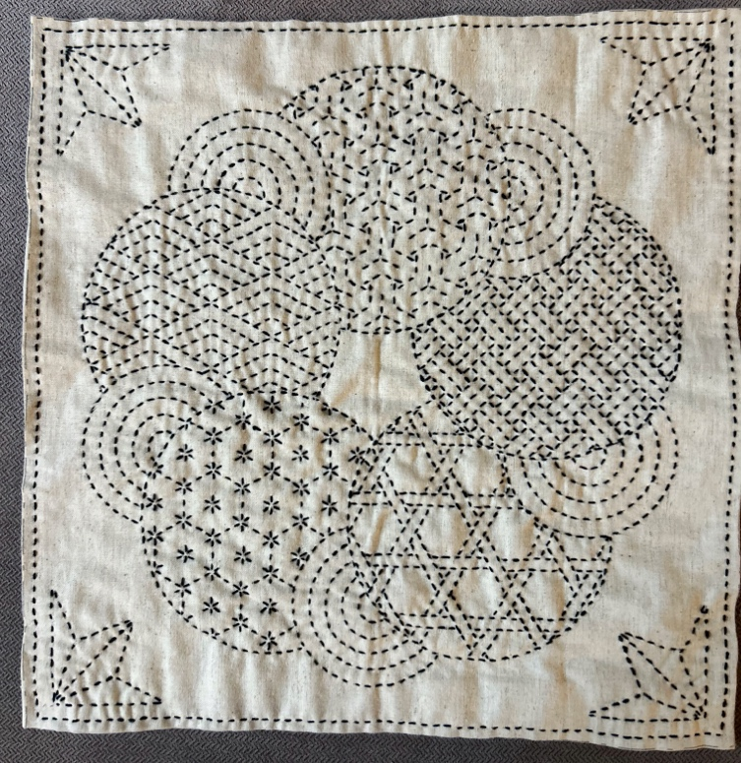 | 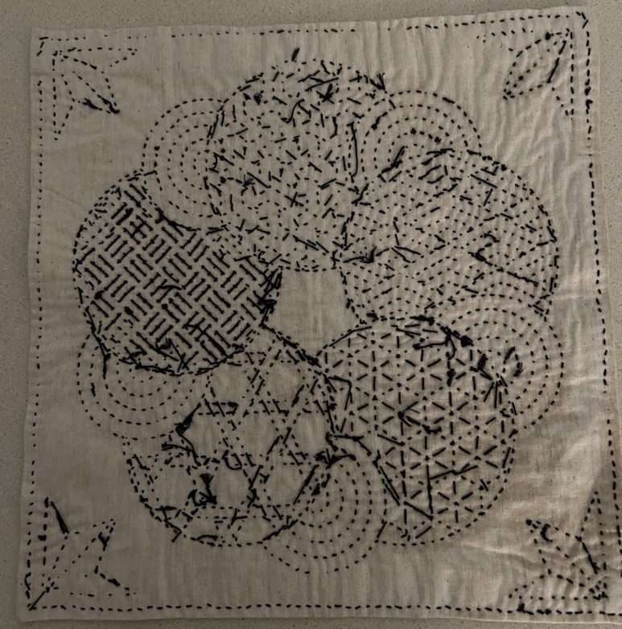

Owner History
Owner | From Date | To Date | Acquired at: | Cost
David Bailey | -- | -- | -- | $0
Made in:
--
 | If not purchased, the estimated cost for materials: $17

Display & Publication History
Date | Event | Location / Publication
-- | -- | --

General Description
Quilt Title or Name:  Sashiko Sampler | Fabric Date Range: 2024 ± 0 Years  Date Made: 2025-01-12 ± 0 Years  Method of Determination:
Item Type:  Items in Set: 1 | Size: Length: 12“ x Width: 12“
Appraisals:  Has this quilt been professionally appraised?  If so, when: --  ----------- | Other related files:
Additional Information: Kit bought on-line in early 2025. Finished by David Bailey.

History

Provenance
Describe: --

Quilt Maker
Maker: David Bailey |  | Birth: July 20, 1967 |  | Death: --
 | Location: Chicago, IL |  | Contributions: Hand needlework

Purpose and Context
Expression
Art | Personal Enjoyment | Therapy
Income
Personal Income | Fundraising
Presentation
Anniversary | Wedding | Birth
Holiday | Birthday | Other gift
Charitable support
Relationships
Friendship | Commemorative | Memorial
Mourning | Reunion
Skill Building
Challenge / Contest | Learning / Teaching Sample
Use
Bed Quilt | Lap Quilt | Home Décor
Baby / Crib | Wall Hanging
Describe other purpose: --

Construction History
--

Quilt Top Design & Construction

Quilt Top
Layout Design: .

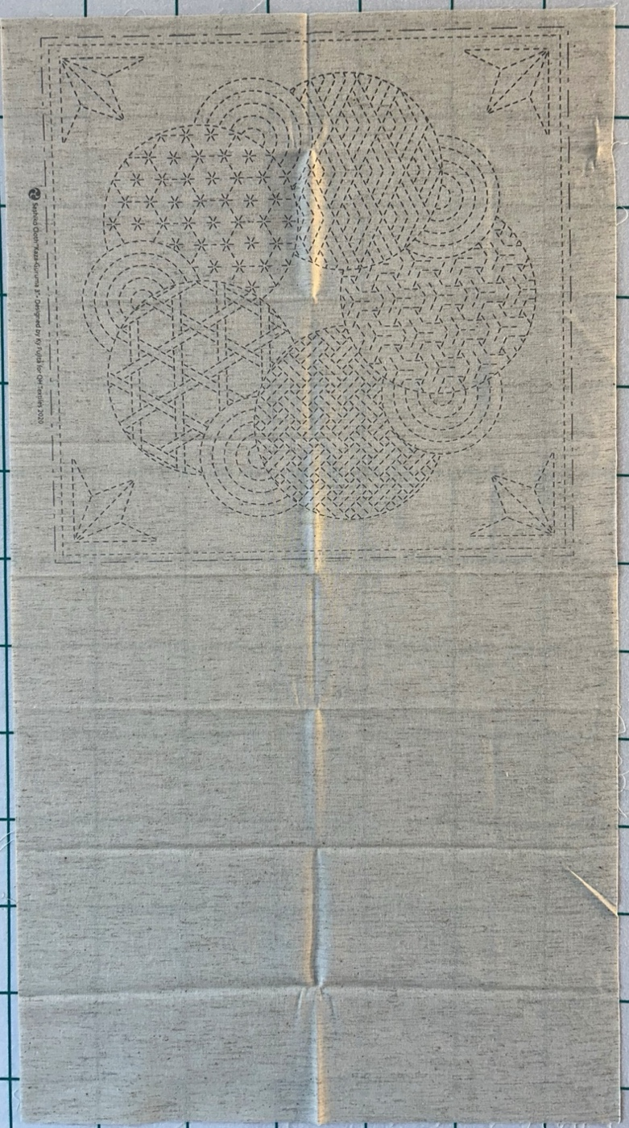
This piece was ordered through Amazon. It is a pattern from www.qhtestiles.com. Sashiko Cloth Kaza-Guruma 3. Item # KF2020-15 greige. 85% cotton, 15% linen. Hand printed. Designed by Ky Fujita for QH Textiles. Black cotton sashiko thread was used, not embroidery thread. The thread did not seem to bleed when tested by wetting it while sitting on white cloth.

The untouched cloth looked like this…. The direction state that the printed pattern is water soluble. I have not tried to wash it out. When the stitching was finished, I did spray the piece with water to press it and remove creases.
The piece was folded in the center to form a square. The raw edges were folded in to prevent unraveling. The fold lines were noted by dot-dash. The dashes were the stitching template.
I stitched the outside border first and followed with the inner “pentagon” of the circle wreath and then the outlines of the 10 partial circles that make up the wreath. From there I moved to the corner motifs, the small circles with the concentric rings and then I filled the large circles.
I was spending a lot of time in a car, hotels and a hospital waiting room and used this project to practice some hand needle work and to occupy otherwise dead time.
I pinned the edge folds Tuesday night and started sewing Wednesday morning in the car. I was done by Monday evening when we returned home.

