Documentation Form

Overview

Images
Top | Back
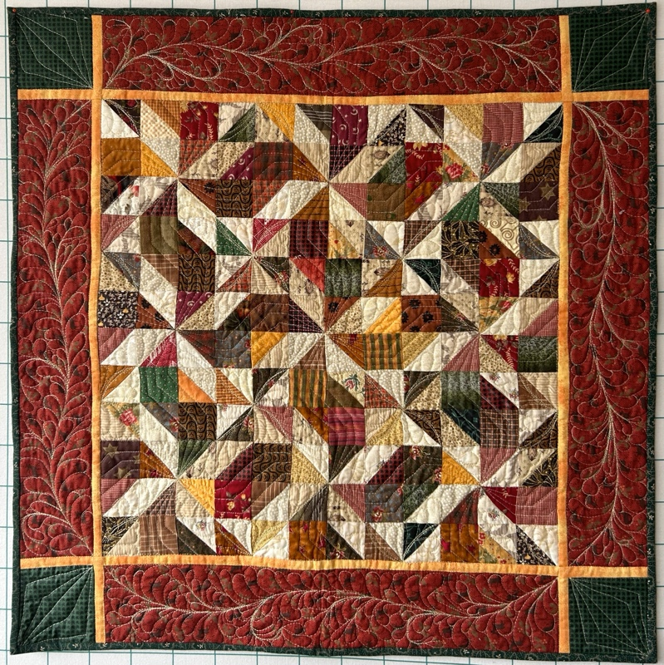 | 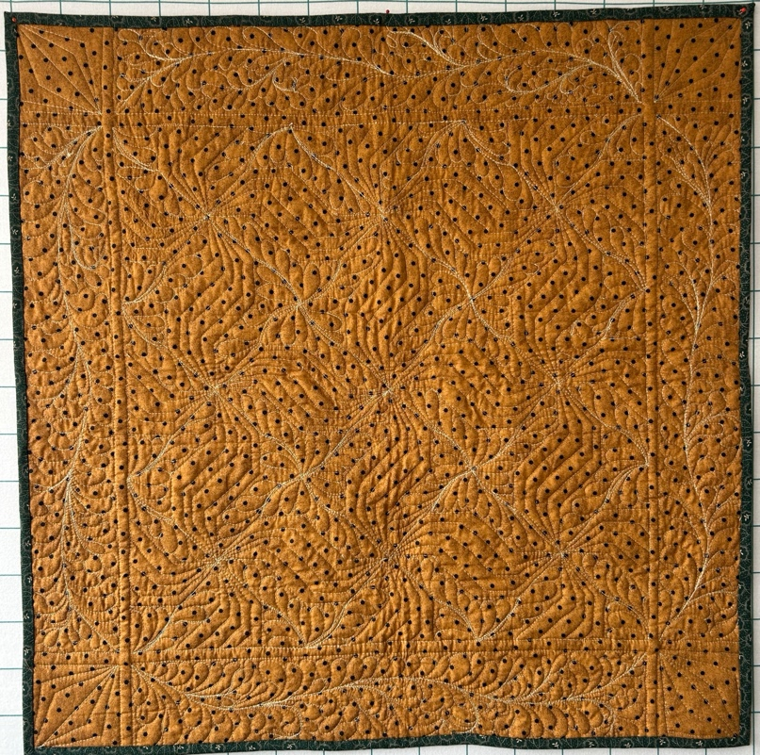

Owner History
Owner | From Date | To Date | Acquired at: | Cost
David Bailey | 2024-07-01 | -- | Naperville, IL | $0
Made in:
--
 | If not purchased, the estimated cost for materials: $0

Display & Publication History
Date | Event | Location / Publication
-- | -- | --

General Description
Quilt Title or Name:  Pinwheel Wall Hanging | Fabric Date Range: 2005 ± 10 Years  Date Made: 2025-03-17 ± 0 Years  Method of Determination:
Item Type:  Items in Set: 1 | Size: Length: 32“ x Width: 32“
Appraisals:  Has this quilt been professionally appraised?  If so, when: --  ----------- | Other related files:
Additional Information: Given to me by Chris Moline from a retiring appraiser. When I received it, it had been pieced, sandwiched, basted and quilting was started.
I finished the quilting.

History

Provenance
Describe: This piece was given to me by Chris Moline who received it from an appraiser who was retiring. The piecing was completed, and the quilting sandwich was stabilized by hand stitching and with safety pins. The quilting was started – some stitch in the ditch and some primitive decorative quilting. and some of the stitch in the ditch quilting was completed. I removed the decorative quilting, left the ditch work and finished the quilting and the binding.

Quilt Maker
Maker: unknown |  | Birth: -- |  | Death: --
 | Location: -- |  | Contributions: piecing, basting - unknown date
Maker: David Bailey |  | Birth: July 20, 1967 |  | Death: --
 | Location: Chicago, IL |  | Contributions: quilting, binding  2025-03-17

Purpose and Context
Expression
Art | Personal Enjoyment | Therapy
Income
Personal Income | Fundraising
Presentation
Anniversary | Wedding | Birth
Holiday | Birthday | Other gift
Charitable support
Relationships
Friendship | Commemorative | Memorial
Mourning | Reunion
Skill Building
Challenge / Contest | Learning / Teaching Sample
Use
Bed Quilt | Lap Quilt | Home Décor
Baby / Crib | Wall Hanging
Describe other purpose: --

Construction History
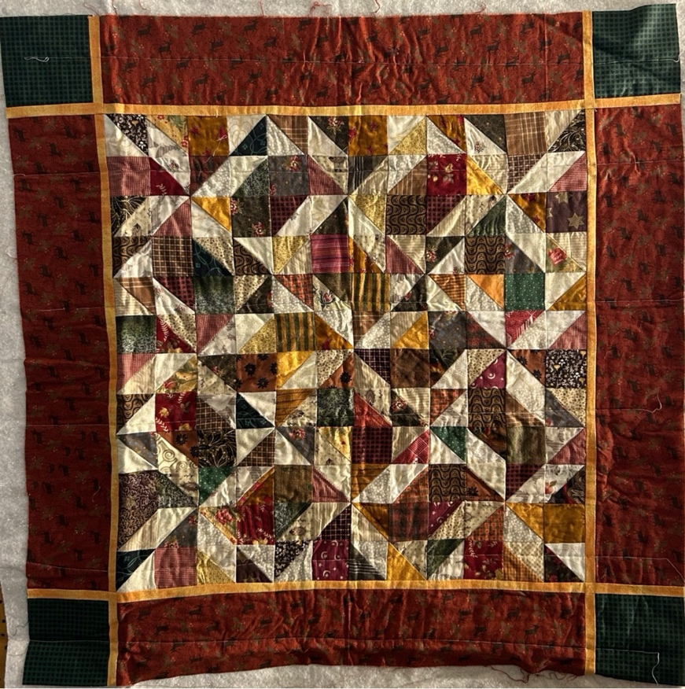
Finished Quilting
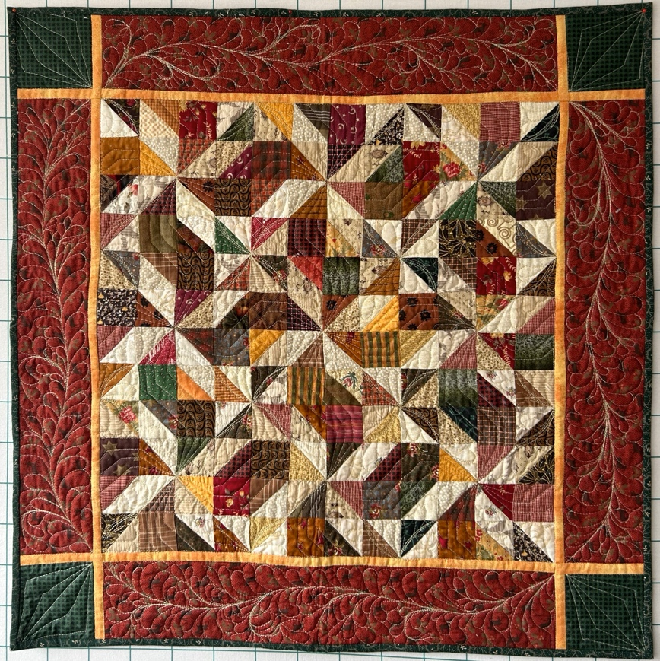

Quilt Top Design & Construction

Quilt Top
Layout Design: .
Blocks / Grid
 |  | Grid Dimensions: Length 12 x Width: 12
 |  | Block Size: Length: 2.00 “ x Width: 2.00 “
 | Describe: Half-square triangles and full squares arranged in a modified pin-wheel design.
 | Techniques
 | Machine pieced | String / Improvisational piecing
 | Hand pieced | Foundation piecing
 | Strip piecing | English paper piecing
 | Describe: --
 | Workmanship
 | Seams are stable | Seams are appropriately aligned
 | Seams are flat | Points are sharp
 | Describe piecing workmanship

Borders & Frames
Describe borders and frames in order from center to edge.
1 | Width: 0.5“
 |  |  | Describe: This orange/yellow boarder.
2 | Width: 4.50“
 |  |  | Describe: Green , red and orange.
Techniques
 |  | Machine pieced |  |  | String / Improvisational piecing
 |  | Hand pieced |  |  | Foundation piecing
 |  | Strip piecing |  |  | English paper piecing
 |  | Describe: --
Workmanship
 |  | Seams are stable |  |  | Seams are appropriately aligned
 |  | Seams are flat |  |  | Points are sharp
Describe: --
 |  | Describe piecing workmanship

Assembly
 | Seams are appropriately aligned
Seams are stable | Top has no inappropriate tucks or puckers
Seams are flat | Top lays flat with no overly full areas
Describe: --

Color
Predominant colors
 | Red | Blue | Black
 | Orange | Violet/Purple | Grey
 | Yellow | Brown | White
 | Green | Beige / Tan
Specific Antique Colors |  | NONE NOTED | Neon prints
 | Red – claret / wine | Yellow – chrome | Blue – Lancaster
 | Red – madder / cinnamon | Green - chrome | Blue – Prussian / Lafayette
 | Red – turkey | Green – Nile | Brown – madder
 | Pinks - double | Blue – Cadet | Butterscotch
 | Orange - madder | Blue - Indigo | Bronze
 | Orange – cheddar / antimony / chrome |  | Late 1800’s Purple
Describe: --

Materials
Sources of Fabric |  | NOT KNOWN
 | Companies | Fabric Name & Number | Designer
 | -- | -- | --
 | Describe other sources: --
Fiber Types |  | NOT YET IDENTIFIED
 | Cotton | Silk | Wool
 | Cotton Blend | Linen | Synthetic
 | Describe & Clarify: --
Fabric Types |  | NOT KNOWN
 | Broadcloth | Sateen | Upholstery
 | Flannel | Satin | Chintz
 | Shirting | Muslin | Glazed
 | Suiting | Velvet | Handwoven
 | Denim | Felt | Lindsey-Woolsey
 | Describe & Clarify: --
Print Types |  | NOT YET IDENTIFIED
 | Batik | Floral | Multiple scraps
 | Cheater Panel | Garibaldi Red Prints | Paisley
 | Checked / Gingham | Geometric | Plaid
 | Conversation / Novelty | Hand-dyed | Solid / Plain
 | Dotted | Victorian Mourning Prints | Stamped
 | Feed sack / Feed sack-like |  | Stripes
Describe & Clarify: -civil war reproductions-

Images

Inscriptions
None Found
Inscription is present. Describe location: --
Content
Makers names | Initials | Date
Single Name | Message | Place
Multiple Names
Transcription: --

Methods
Label | Ink – Ball point | Stencil
Printed onto fabric | Ink – Felt tip | Stamped
Quilted | Ink - Other | Pencil
Embroidery | Applique | Typewriter
Describe & Clarify: --

Images for Inscriptions

Quilt Back Design & Construction

Quilt Back
Layout Design: .

Stabilization Method
Stabilization Method:
Quilting Details
Batting
Quilting Techniques
 | Machine Quilted | Machine – sit-down | Corded
 | Machine – computer guided | Hand Quilted | Stuffed work
 | Machine – manual long-arm | Quilt-as-you-go
 | Describe: --
Quilting Patterns
 | Meander / Free motion | Lines – single parallel | Cables
 | In-the-ditch / To the piece | Lines – double parallel | Feathers
 | Echo / Outlined | Lines – triple parallel | Wreaths
 | Stipple | Grid – crosshatch | Vines
 | Clamshell | Grid – square | Floral
 | Elbow / Fan | Grid - diamond | Leaves
 | Describe other: --

Edge Finish
Edge Style:
Finishing Technique
Top Width: 0.38 “ | Binding | Rolled – top to back
Back Width: 0.38“ | Knife edge | Rolled – back to top
1/8 = 0.13, 3/8 = 0.38 | Turned with a closure
5/8 = 0.63, 7/8 = 0.88
Application Method: | Top: | Back:
Embellishments
Fringe | Ruffles | Cording
Lace | Ribbon
Describe: --

Images for Edge

Condition

Flaws
Soiling
Dirty | Stains
Mildew stains | Musty Smell
Discoloration
Running / fugitive color | Faded / bleached color | Crocking
Fabric Damage
Tears / holes | Disintegrating / fall out | Insect damage
Thread bare | Shattering
Sewing / Quilting Damage
Split / open seams | Ties / tufting missing | Embellishments missing
Quilting threads missing | Batting has shifted
Storage Issues
Discoloration from wood | Damage from acid | Fold marks / creases
Describe additional condition issues: --
Images for Condition Issues

Conservation, Restoration, Repairs
Describe Measures: --

Workmanship

Extension of Useful Life
Repair | Useful life of the item was extended.
Prevention of Damage
Conservation | All work is reversible.
Conservation | Further deterioration has been slowed, stabilized or prevented.
Maintaining Function & Integrity
Conservation | Work minimally interferes with the item’s overall appearance.
Restoration | Work blends well with the item’s overall appearance, style and age.
Restoration | Appropriate period reproductions were used.
Restoration | Vintage materials were used.
Restoration | Period appropriate techniques were used.
Restoration | Workmanship is of similar or better quality than original work.

Images for Conservation / Restoration / Repairs

