Documentation Form

Overview

Images
Top | Back
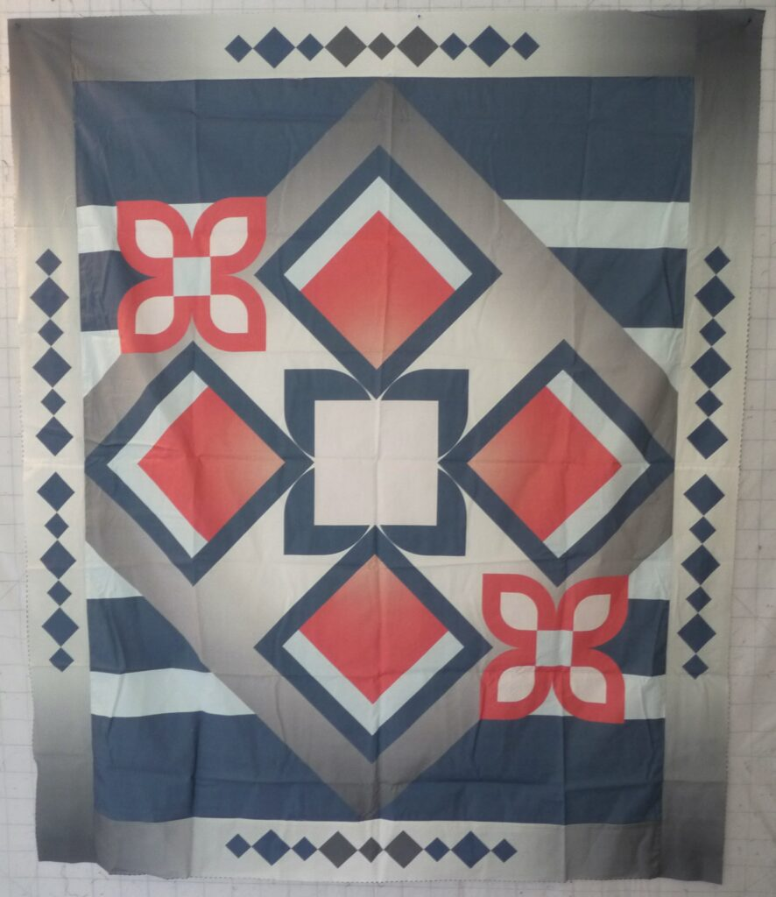 | 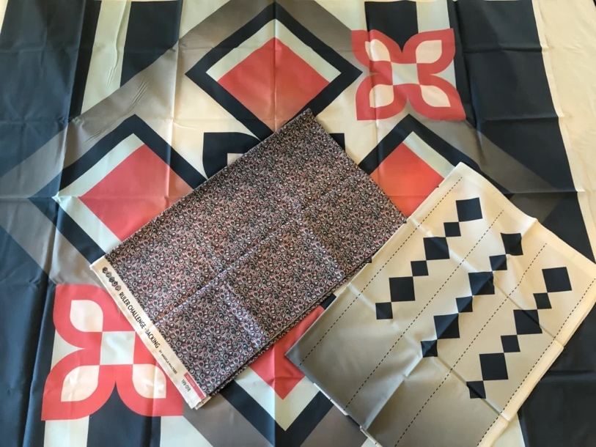

Owner History
Owner | From Date | To Date | Acquired at: | Cost
David Bailey | -- | -- | -- | $0
Made in:
--
 | If not purchased, the estimated cost for materials: $138

Display & Publication History
Date | Event | Location / Publication
-- | -- | --

General Description
Quilt Title or Name:  Freemotion Quilting Ruler Challenge | Fabric Date Range: 2022 ± 0 Years  Date Made: -- ± 0 Years  Method of Determination:
Item Type:  Items in Set: 1 | Size: Length: 60“ x Width: 49“
Appraisals:  Has this quilt been professionally appraised?  If so, when: --  ----------- | Other related files:
Additional Information: --

History

Provenance
Describe: --

Quilt Maker
Maker: David Bailey |  | Birth: July 20, 1967 |  | Death: --
 | Location: Flint, MI |  | Contributions: Assembly

Purpose and Context
Expression
Art | Personal Enjoyment | Therapy
Income
Personal Income | Fundraising
Presentation
Anniversary | Wedding | Birth
Holiday | Birthday | Other gift
Charitable support
Relationships
Friendship | Commemorative | Memorial
Mourning | Reunion
Skill Building
Challenge / Contest | Learning / Teaching Sample
Use
Bed Quilt | Lap Quilt | Home Décor
Baby / Crib | Wall Hanging
Describe other purpose: --

Construction History
--

Quilt Top Design & Construction

Quilt Top
Layout Design: .
This quilt is from Angela Walters (Quilting is my Therapy) – Free Motion Quilting Challenge Series. A printed panel for learning quilting.

Stabilization Method
Stabilization Method:
Delete this & the following table rows as appropriate.
Tied Details
 | Average Distance Between Knots: 0” |  | Placement:
 |  |  | Fiber Used:
Quilting Details
Batting
Quilting Techniques
 | Machine Quilted | Machine – sit-down |  | Corded
 | Machine – computer guided | Hand Quilted |  | Stuffed work
 | Machine – manual long-arm | Quilt-as-you-go
 | Describe: --
Quilting Patterns
 | Meander / Free motion | Lines – single parallel |  | Cables
 | In-the-ditch / To the piece | Lines – double parallel |  | Feathers
 | Echo / Outlined | Lines – triple parallel |  | Wreaths
 | Stipple | Grid – crosshatch |  | Vines
 | Clamshell | Grid – square |  | Floral
 | Elbow / Fan | Grid - diamond |  | Leaves
 | Describe other: --
Thread Choices
 | Brand | Weight |  | Number & Name
 | Glide | 40 wt |  | - Glide Mercury 10643  - Glide Denim 30534  - Glide Peppermint 90177  - Glide Light Turquoise 32975  - Glide Cool Gray 7 10CG7
Describe: --
Images for Stabilization

Edge Finish
Edge Style:
Finishing Technique
Top Width: 0.00 “ | Binding | Rolled – top to back
Back Width: 0.00“ | Knife edge | Rolled – back to top
1/8 = 0.13, 3/8 = 0.38 | Turned with a closure
5/8 = 0.63, 7/8 = 0.88
Application Method: | Top: | Back:
Embellishments
Fringe | Ruffles | Cording
Lace | Ribbon
Describe: --

Images for Edge

Condition

Flaws
Soiling
Dirty | Stains
Mildew stains | Musty Smell
Discoloration
Running / fugitive color | Faded / bleached color | Crocking
Fabric Damage
Tears / holes | Disintegrating / fall out | Insect damage
Thread bare | Shattering
Sewing / Quilting Damage
Split / open seams | Ties / tufting missing | Embellishments missing
Quilting threads missing | Batting has shifted
Storage Issues
Discoloration from wood | Damage from acid | Fold marks / creases
Describe additional condition issues: --
Images for Condition Issues

Conservation, Restoration, Repairs
Describe Measures: --

Workmanship

Extension of Useful Life
Repair | Useful life of the item was extended.
Prevention of Damage
Conservation | All work is reversible.
Conservation | Further deterioration has been slowed, stabilized or prevented.
Maintaining Function & Integrity
Conservation | Work minimally interferes with the item’s overall appearance.
Restoration | Work blends well with the item’s overall appearance, style and age.
Restoration | Appropriate period reproductions were used.
Restoration | Vintage materials were used.
Restoration | Period appropriate techniques were used.
Restoration | Workmanship is of similar or better quality than original work.

Images for Conservation / Restoration / Repairs

