Documentation Form

Overview

Images
Top | Back
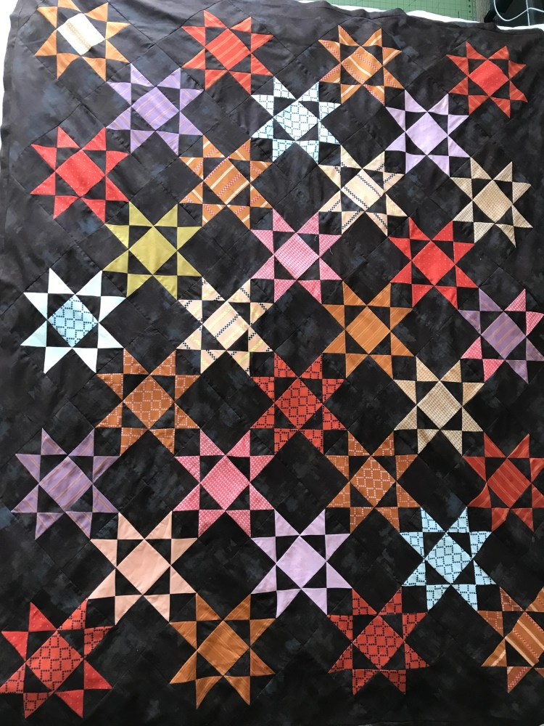 | 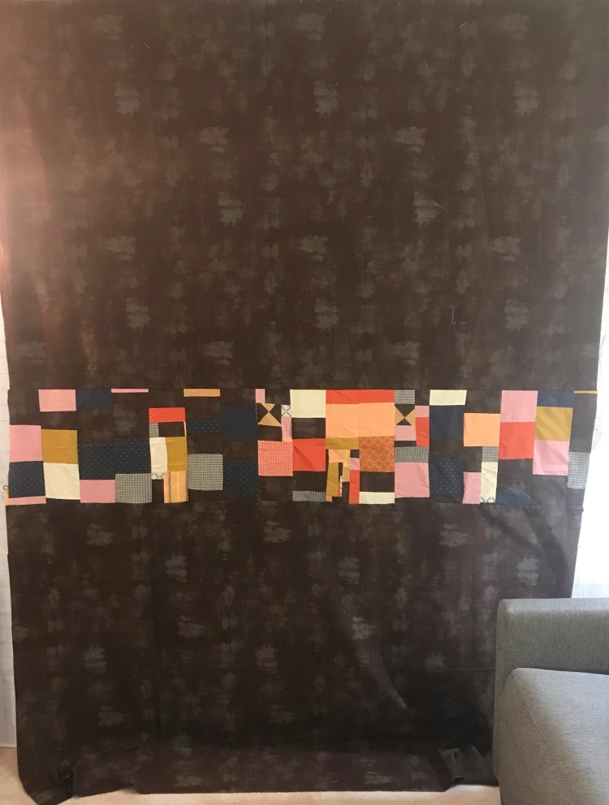

Owner History
Owner | From Date | To Date | Acquired at: | Cost
David Bailey | -- | -- | -- | $0
Made in:
--
 | If not purchased, the estimated cost for materials: $250

Display & Publication History
Date | Event | Location / Publication
-- | -- | --

General Description
Quilt Title or Name:  Eastern Star | Fabric Date Range: 2021 ± 0 Years  Date Made: -- ± 0 Years  Method of Determination:
Item Type:  Items in Set: -- | Size: Length: 77“ x Width: 60“
Appraisals:  Has this quilt been professionally appraised?  If so, when: --  ----------- | Other related files:
Additional Information: --

History

Provenance
Describe: --

Quilt Maker
Maker:David Bailey |  | Birth: July 20, 1967 |  | Death: --
 | Location: Chicago, IL |  | Contributions: Piecing, basting.

Purpose and Context
Expression
Art | Personal Enjoyment | Therapy
Income
Personal Income | Fundraising
Presentation
Anniversary | Wedding | Birth
Holiday | Birthday | Other gift
Charitable support
Relationships
Friendship | Commemorative | Memorial
Mourning | Reunion
Skill Building
Challenge / Contest | Learning / Teaching Sample
Use
Bed Quilt | Lap Quilt | Home Décor
Baby / Crib | Wall Hanging
Describe other purpose: --

Construction History
2021-12-31: Construction started
2021-03-15: Top and back piecing finished. Quilt sandwich basted.

Quilt Top Design & Construction

Quilt Top
Layout Design: .
Blocks / Grid
 |  | Grid Dimensions: Five rows of four blocks alternated with 4 rows of three blocks. 32 total blocks.
 |  | Block Size: Length: 20“ x Width: 20.00 “
 | Describe: No borders, frames or sashing.
 | BB ID 1631c – Eastern Star | <<Pattern Image>>
 | Techniques
 | Machine pieced | String / Improvisational piecing
 | Hand pieced | Foundation piecing
 | Strip piecing | English paper piecing
 | Describe: --
 | Workmanship
 | Seams are stable | Seams are appropriately aligned
 | Seams are flat | Points are sharp
 | Describe piecing workmanship

Assembly
 | Seams are appropriately aligned
Seams are stable | Top has no inappropriate tucks or puckers
Seams are flat | Top lays flat with no overly full areas
Describe: --

Color
Predominant colors
 | Red | Blue | Black
 | Orange | Violet/Purple | Grey
 | Yellow | Brown | White
 | Green | Beige / Tan
Specific Antique Colors |  | NONE NOTED | Neon prints
 | Red – claret / wine | Yellow – chrome | Blue – Lancaster
 | Red – madder / cinnamon | Green - chrome | Blue – Prussian / Lafayette
 | Red – turkey | Green – Nile | Brown – madder
 | Pinks - double | Blue – Cadet | Butterscotch
 | Orange - madder | Blue - Indigo | Bronze
 | Orange – cheddar / antimony / chrome |  | Late 1800’s Purple
Describe: --

Materials
Sources of Fabric |  | NOT KNOWN
 | Companies | Fabric Name & Number | Designer
 | Moda - Warp and weft designs for Ruby Star Society |  | by Alexia Marcelle
 |  | Grunge Basics - Mocha
 | Describe other sources: --
Fiber Types |  | NOT YET IDENTIFIED
 | Cotton | Silk | Wool
 | Cotton Blend | Linen | Synthetic
 | Describe & Clarify: --
Fabric Types |  | NOT KNOWN
 | Broadcloth | Sateen | Upholstery
 | Flannel | Satin | Chintz
 | Shirting | Muslin | Glazed
 | Suiting | Velvet | Handwoven
 | Denim | Felt | Lindsey-Woolsey
 | Describe & Clarify: --
Print Types |  | NOT YET IDENTIFIED
 | Batik | Floral | Multiple scraps
 | Cheater Panel | Garibaldi Red Prints | Paisley
 | Checked / Gingham | Geometric | Plaid
 | Conversation / Novelty | Hand-dyed | Solid / Plain
 | Dotted | Victorian Mourning Prints | Stamped
 | Feed sack / Feed sack-like |  | Stripes
Describe & Clarify: --

Images
Warp & Weft Fabrics
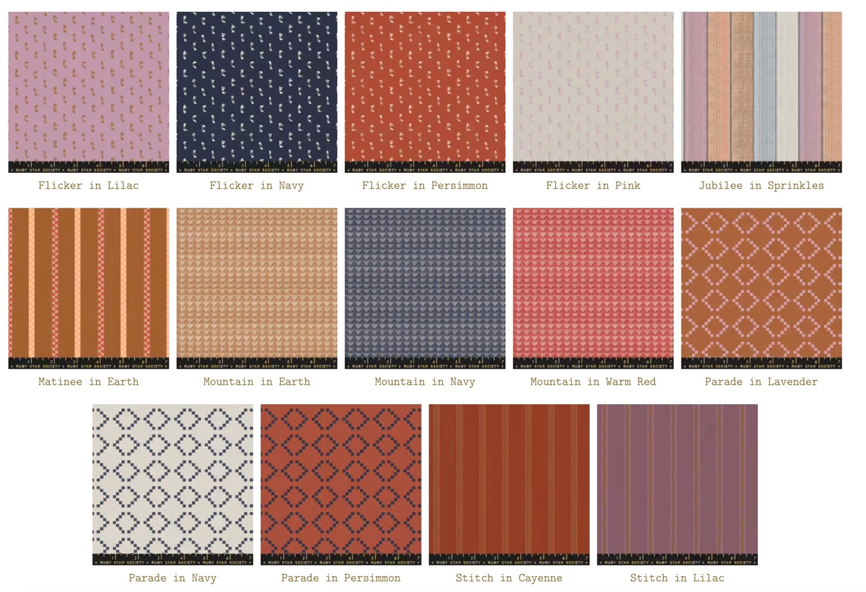

Inscriptions
None Found
Inscription is present. Describe location: --
Content
Makers names | Initials | Date
Single Name | Message | Place
Multiple Names
Transcription: --

Methods
Label | Ink – Ball point | Stencil
Printed onto fabric | Ink – Felt tip | Stamped
Quilted | Ink - Other | Pencil
Embroidery | Applique | Typewriter
Describe & Clarify: --

Images for Inscriptions

Quilt Back Design & Construction

Quilt Back
The quilt back was made from the same fabrics as the top. One 15" strip across the middle of the back is crumb pieced.

Inscriptions
None Found
Inscription is present. Describe location: --
Content
Makers names | Initials | Date
Single Name | Message | Place
Multiple Names
Transcription: --

Methods
Label | Ink – Ball point | Stencil
Printed onto fabric | Ink – Felt tip | Stamped
Quilted | Ink - Other | Pencil
Embroidery | Applique | Typewriter
Describe & Clarify: --

Images for Inscriptions

Stabilization Method
Stabilization Method:
Delete this & the following table rows as appropriate.
Tied Details
 | Average Distance Between Knots: 0” |  | Placement:
 |  |  | Fiber Used:
Quilting Details
Batting
Quilting Techniques
 | Machine Quilted | Machine – sit-down |  | Corded
 | Machine – computer guided | Hand Quilted |  | Stuffed work
 | Machine – manual long-arm | Quilt-as-you-go
 | Describe: --
Quilting Patterns
 | Meander / Free motion | Lines – single parallel |  | Cables
 | In-the-ditch / To the piece | Lines – double parallel |  | Feathers
 | Echo / Outlined | Lines – triple parallel |  | Wreaths
 | Stipple | Grid – crosshatch |  | Vines
 | Clamshell | Grid – square |  | Floral
 | Elbow / Fan | Grid - diamond |  | Leaves
 | Describe other: --
Thread Choices
 | Brand | Weight |  | Number & Name
 | -- | -- |  | --
Describe: --
Images for Stabilization

Edge Finish
Edge Style:
Finishing Technique
Top Width: 0.00 “ | Binding | Rolled – top to back
Back Width: 0.00“ | Knife edge | Rolled – back to top
1/8 = 0.13, 3/8 = 0.38 | Turned with a closure
5/8 = 0.63, 7/8 = 0.88
Application Method: | Top: | Back:
Embellishments
Fringe | Ruffles | Cording
Lace | Ribbon
Describe: --

Images for Edge

Condition

Flaws
Soiling
Dirty | Stains
Mildew stains | Musty Smell
Discoloration
Running / fugitive color | Faded / bleached color | Crocking
Fabric Damage
Tears / holes | Disintegrating / fall out | Insect damage
Thread bare | Shattering
Sewing / Quilting Damage
Split / open seams | Ties / tufting missing | Embellishments missing
Quilting threads missing | Batting has shifted
Storage Issues
Discoloration from wood | Damage from acid | Fold marks / creases
Describe additional condition issues: --
Images for Condition Issues

Conservation, Restoration, Repairs
Describe Measures: --

Workmanship

Extension of Useful Life
Repair | Useful life of the item was extended.
Prevention of Damage
Conservation | All work is reversible.
Conservation | Further deterioration has been slowed, stabilized or prevented.
Maintaining Function & Integrity
Conservation | Work minimally interferes with the item’s overall appearance.
Restoration | Work blends well with the item’s overall appearance, style and age.
Restoration | Appropriate period reproductions were used.
Restoration | Vintage materials were used.
Restoration | Period appropriate techniques were used.
Restoration | Workmanship is of similar or better quality than original work.

Images for Conservation / Restoration / Repairs

