Documentation Form

Overview

Owner History
Owner | From Date | To Date | Acquired at: | Cost
David Bailey | 2024-12-14 | -- | Downtown Antiques & Home Furnishings  Holland, MI | $60
Made in:
--
 | If not purchased, the estimated cost for materials: $0

Display & Publication History
Date | Event | Location / Publication
-- | -- | --

General Description
Item Name:  Child’s Dress | Fabric Date Range: 1910 ± 10 Years  Date Made: 1910 ± 10 Years  Method of Determination:
Item Type:  Items in Set: -- | Size: Length: 35“ x Width: 10" across waist and 25" near bottom of dress.“
Appraisals:  Has this quilt been professionally appraised?  If so, when: --  ----------- | Other related files:
Additional Information: Information from vendor tag: English cotton lawn with French heirloom lace & entradaux. Antique child dress.
My research:
English cotton lawn: What is cotton lawn fabric in the UK?
Cotton Lawn is a plain weave textile made from cotton. It is designed using high thread count yarns which results in it's silky and untextured feel. It is a lightweight fabric and it can be slightly transparent. It is perfect for sewing dresses, skirts, trousers and tops for the warmer weather.

Entredeux is a French word that means "between two" or "insertion". It comes from the French words entre- and deux, which means "two".
Entredeux may also refer to:
--- A sewing technique
--- A popular heirloom sewing technique that involves joining pieces of fabric or lace trims together. It can be used to create a vintage effect, between two seams, or to join lace to fabric.

Images
Top | Back
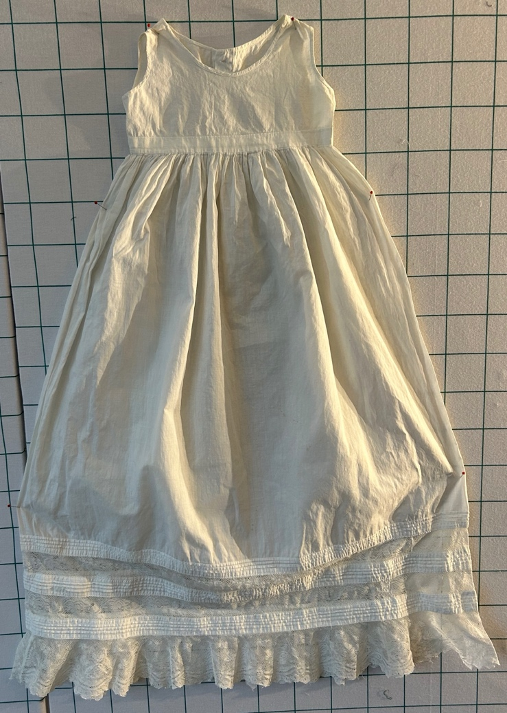 | 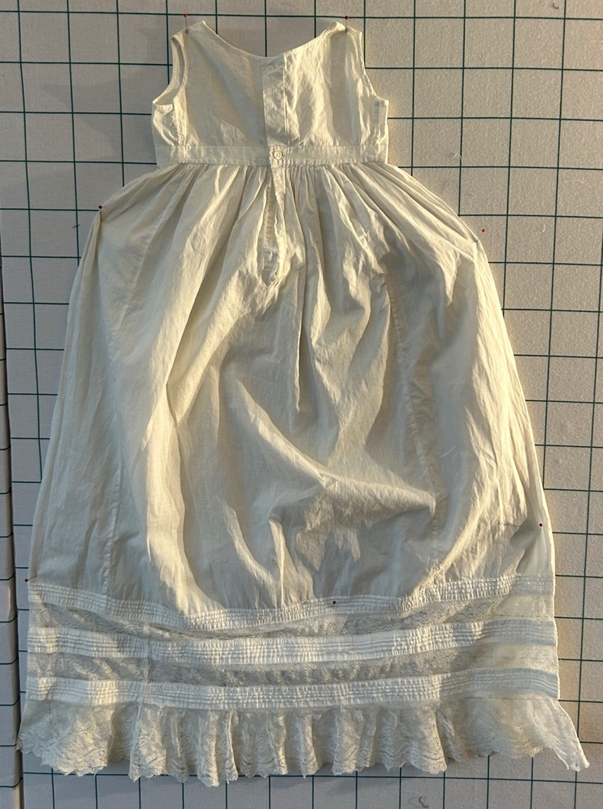

Condition
Good | Has been washed.

Flaws
Soiling
Dirty | Stains
Mildew stains | Musty Smell
Discoloration
Running / fugitive color | Faded / bleached color | Crocking
Fabric Damage
Tears / holes | Disintegrating / fall out | Insect damage
Thread bare | Shattering
Sewing / Quilting Damage
Split / open seams | Ties / tufting missing | Embellishments missing
Quilting threads missing | Batting has shifted
Storage Issues
Discoloration from wood | Damage from acid | Fold marks / creases
Describe additional condition issues: A few small stains that appear to be rust.
Images for Condition Issues

Conservation, Restoration, Repairs
Describe Measures:
2024-12-28
This item was washed. It was washed in Orvis to remove dirt and grease. It was then pre-treated in Restoration for 20 minutes. And then soaked in Restoration again for about 6-8 hours. The dress was rinsed and allowed to soak in cold water overnight for a long rinse. The dress was then then allowed to air dry.

Workmanship

Extension of Useful Life
Repair | Useful life of the item was extended.
Prevention of Damage
Conservation | All work is reversible.
Conservation | Further deterioration has been slowed, stabilized or prevented.
Maintaining Function & Integrity
Conservation | Work minimally interferes with the item’s overall appearance.
Restoration | Work blends well with the item’s overall appearance, style and age.
Restoration | Appropriate period reproductions were used.
Restoration | Vintage materials were used.
Restoration | Period appropriate techniques were used.
Restoration | Workmanship is of similar or better quality than original work.

Images for Conservation / Restoration / Repairs
Before  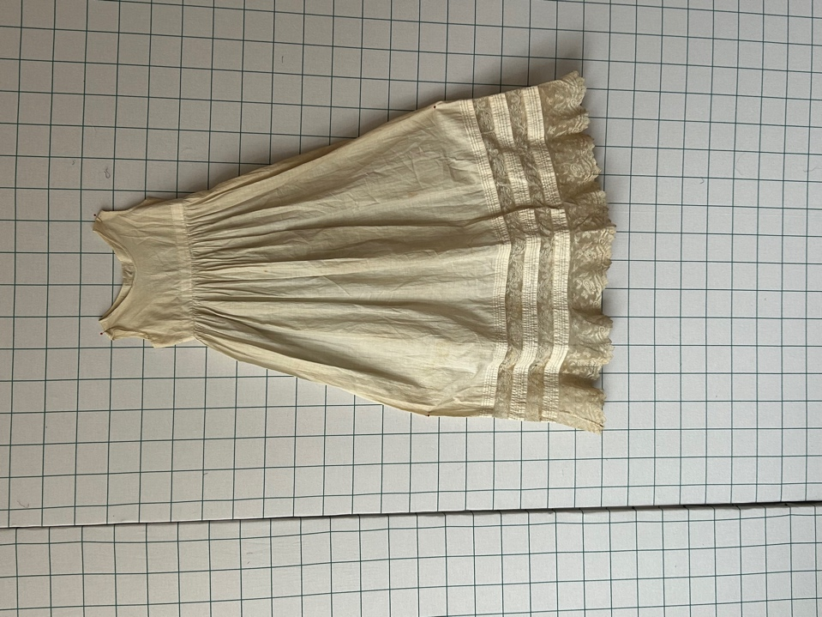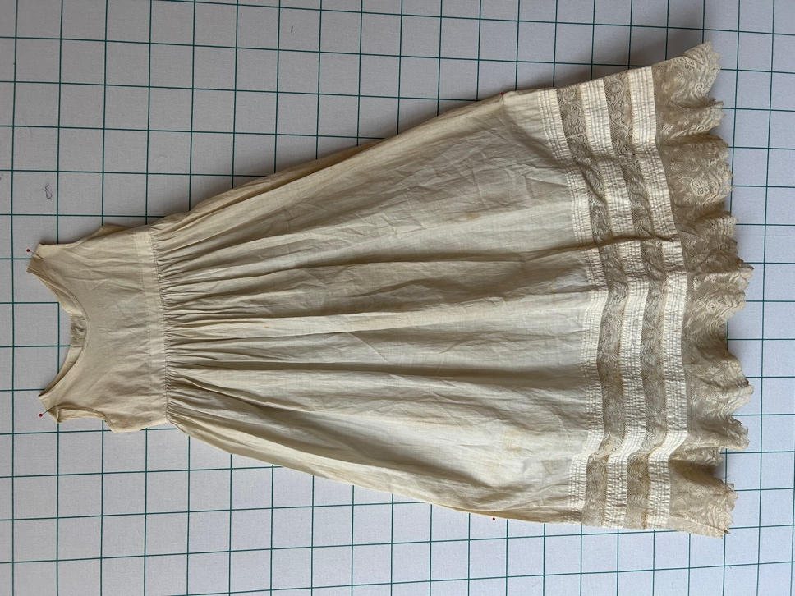 | After  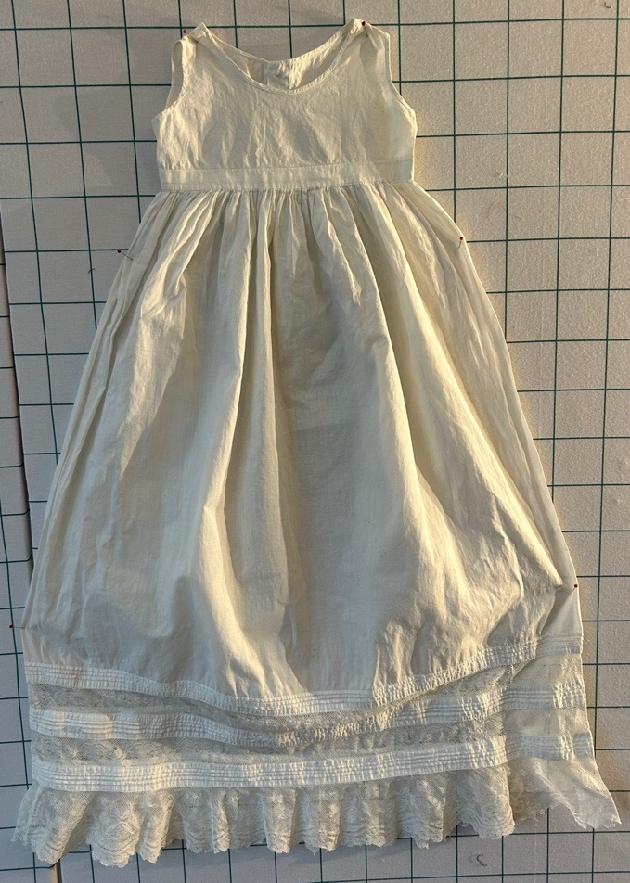
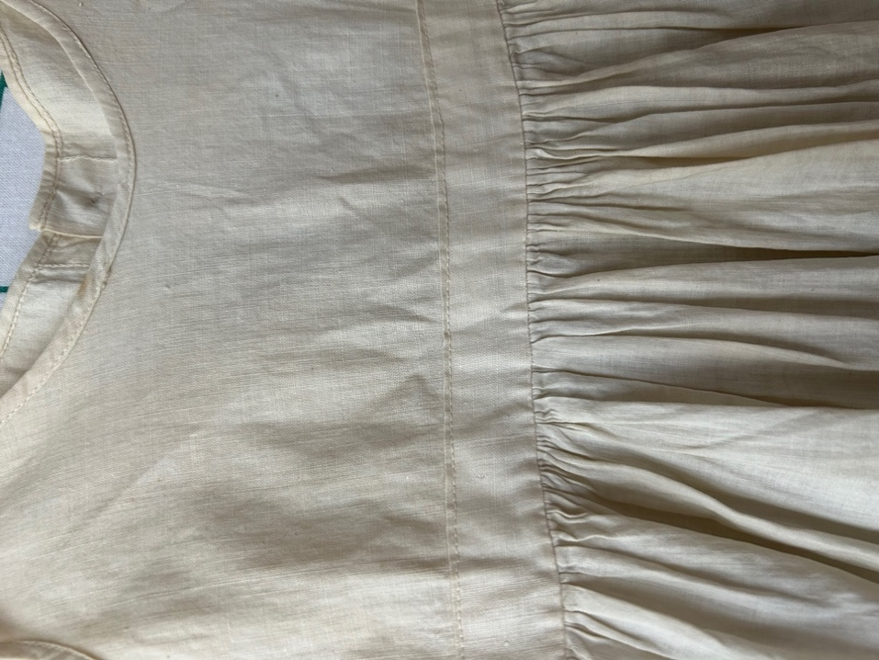
Before  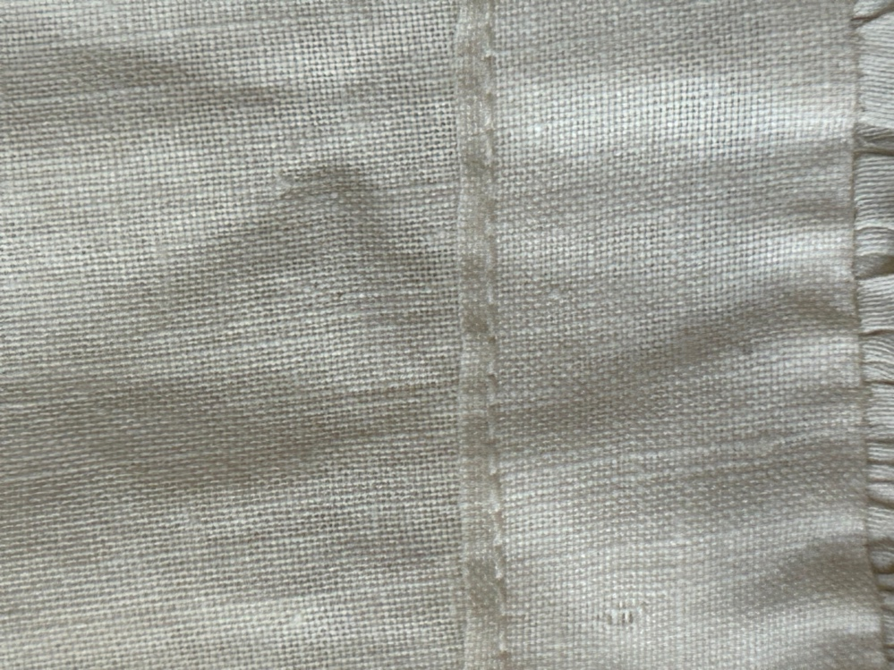 | After
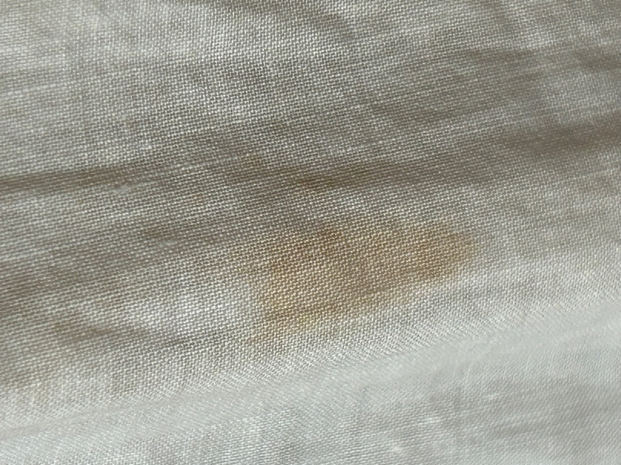
Before  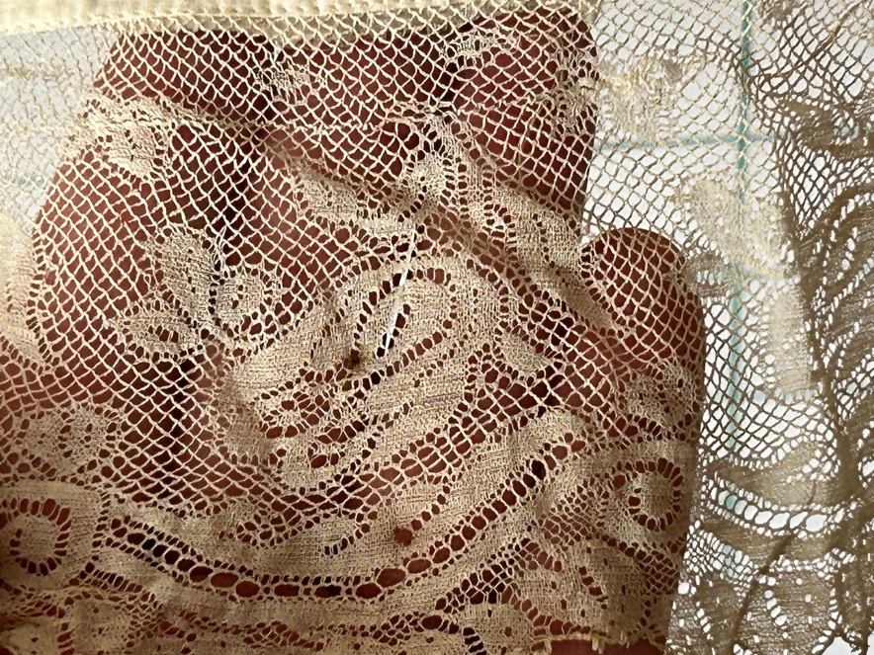 | After  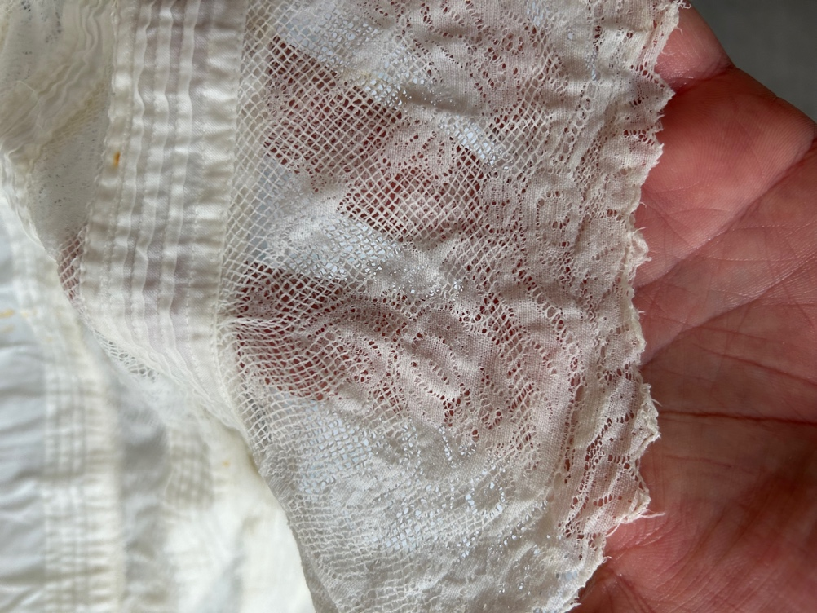
Before  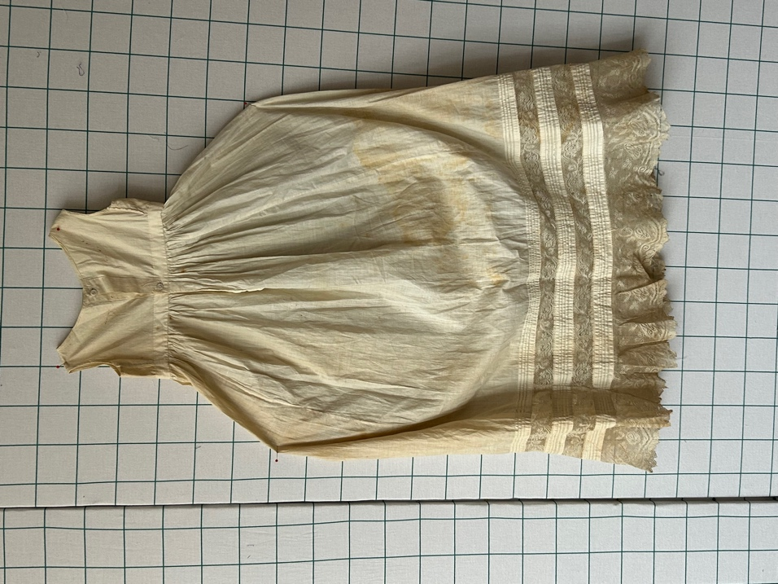 | After  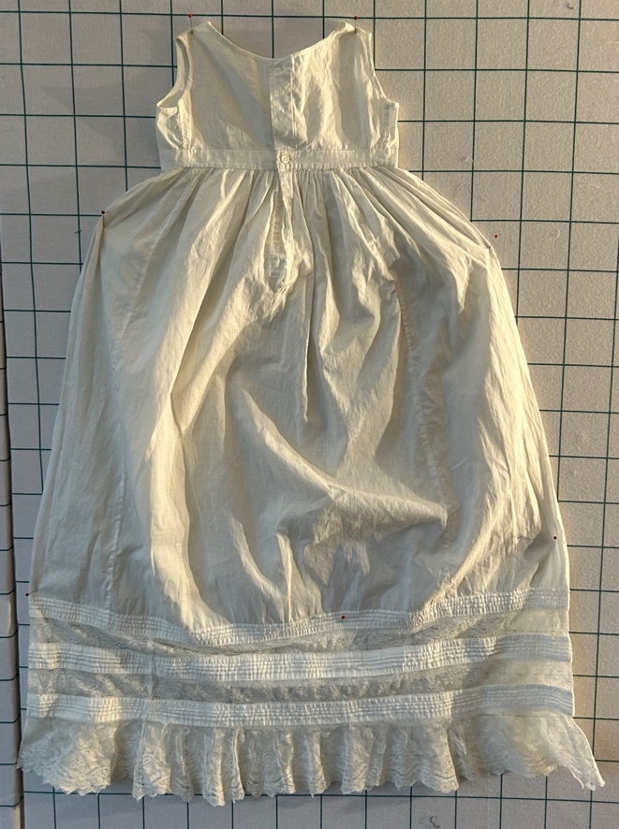
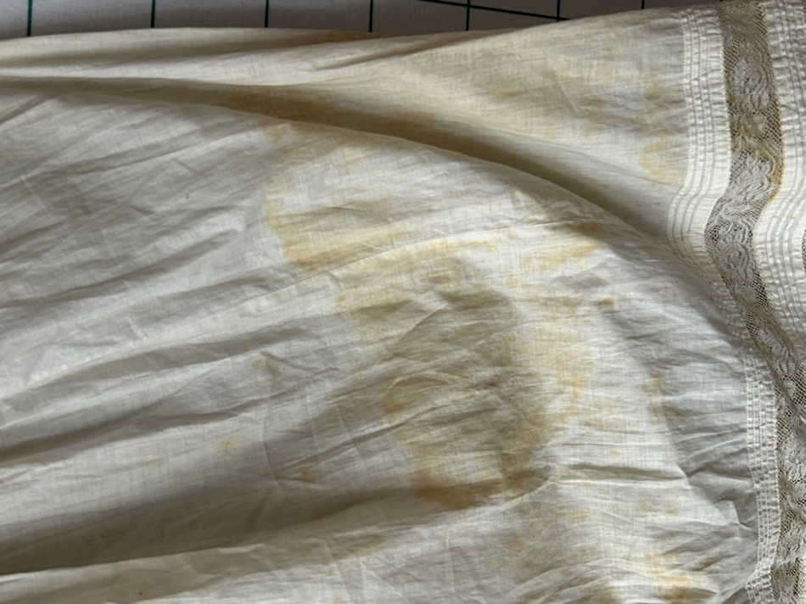 | 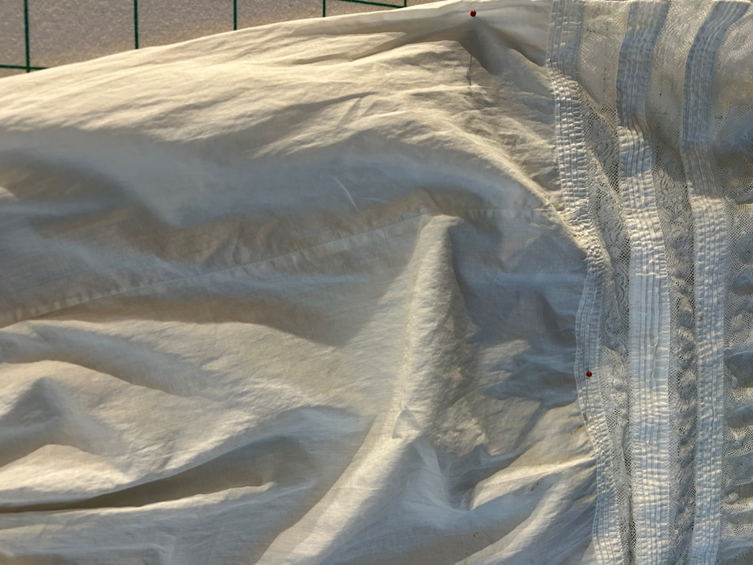
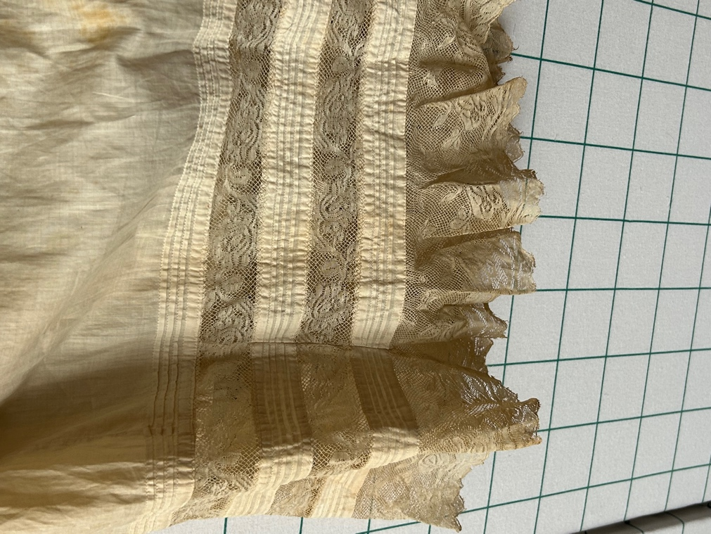 | 