Documentation Form

Overview

Owner History
Owner | From Date | To Date | Acquired at: | Cost
David Bailey | 2022-9-15 | -- | Allegan County Fairgrounds Antique Fair  Allegan County MI | $1
Made in:
--
 | If not purchased, the estimated cost for materials: $0

Display & Publication History
Date | Event | Location / Publication
-- | -- | --

General Description
Quilt Title or Name:  Chrysanthemum Ring | Fabric Date Range: 1945 ± 15 Years  Date Made: -- ± 0 Years  Method of Determination:
Item Type:  Items in Set: 1 | Size: Length: 14“ x Width: 0“
Appraisals:  Has this quilt been professionally appraised?  If so, when: --  ----------- | Other related files:  Link to Sample 118.
Additional Information: These rings were purchased as a set of 22 for $28 or about $1.27 per ring. One of the 22 rings did not actually match the other 21 in either fabric or design, so the purchase has been cateloged as two different samples. The first 21 matched rings cost $26.73 for Sample 118. The remaining ring is cateloged as Sample 117, for $1.27.

Images
Top | Back
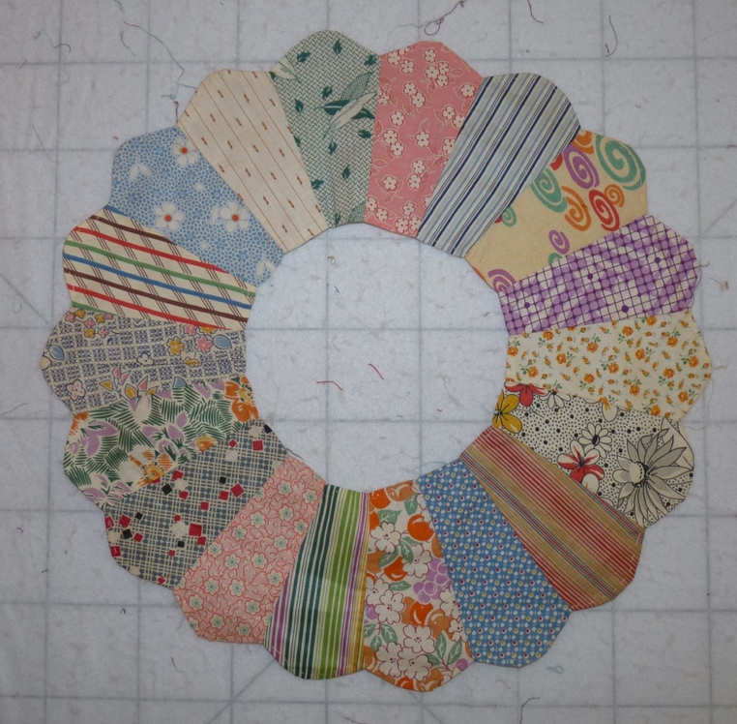 | 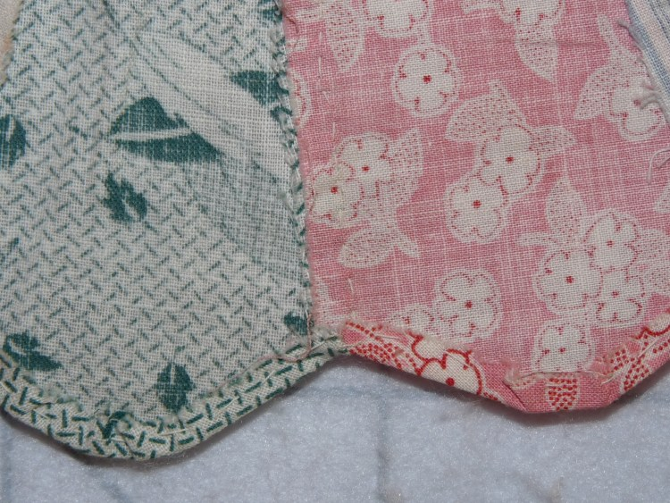
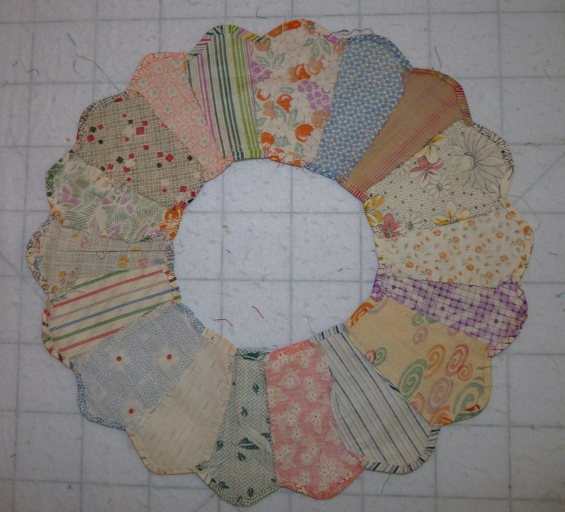

History

Provenance
Describe: --

Quilt Maker
Maker: unknown |  | Birth: -- |  | Death: --
 | Location: -- |  | Contributions: --

Purpose and Context
Expression
Art | Personal Enjoyment | Therapy
Income
Personal Income | Fundraising
Presentation
Anniversary | Wedding | Birth
Holiday | Birthday | Other gift
Charitable support
Relationships
Friendship | Commemorative | Memorial
Mourning | Reunion
Skill Building
Challenge / Contest | Learning / Teaching Sample
Use
Bed Quilt | Lap Quilt | Home Décor
Baby / Crib | Wall Hanging
Describe other purpose: --

This piece is made of cotton calicos and hand-stitched. There are 18 petals, not the usual 16 associated with the Chrysanthemum applique pattern identified by BB ID 27.12. The outside diameter is 16” and the inside diameter is 6”. The outside of the petals are rounded and not pointed.

Condition

Flaws
Soiling
Dirty | Stains
Mildew stains | Musty Smell
Discoloration
Running / fugitive color | Faded / bleached color | Crocking
Fabric Damage
Tears / holes | Disintegrating / fall out | Insect damage
Thread bare | Shattering
Sewing / Quilting Damage
Split / open seams | Ties / tufting missing | Embellishments missing
Quilting threads missing | Batting has shifted
Storage Issues
Discoloration from wood | Damage from acid | Fold marks / creases
Describe additional condition issues: --
Images for Condition Issues

Conservation, Restoration, Repairs
Describe Measures: --

Workmanship

Extension of Useful Life
Repair | Useful life of the item was extended.
Prevention of Damage
Conservation | All work is reversible.
Conservation | Further deterioration has been slowed, stabilized or prevented.
Maintaining Function & Integrity
Conservation | Work minimally interferes with the item’s overall appearance.
Restoration | Work blends well with the item’s overall appearance, style and age.
Restoration | Appropriate period reproductions were used.
Restoration | Vintage materials were used.
Restoration | Period appropriate techniques were used.
Restoration | Workmanship is of similar or better quality than original work.

Images for Conservation / Restoration / Repairs

