Documentation Form

Overview

Owner History
Owner | From Date | To Date | Acquired at: | Cost
David Bailey | 2022-02-12 | -- | Maumee Antique Mall, LLC  1552 Reynolds at Dussel  Maumee, Ohio 43537 | $76
Made in:
--
 | If not purchased, the estimated cost for materials: $0

Display & Publication History
Date | Event | Location / Publication
-- | -- | --

General Description
Quilt Title or Name:  Bow Tie Quilt | Fabric Date Range: 1935 ± 15 Years  Date Made: -- ± 0 Years  Method of Determination:
Item Type:  Items in Set: 1 | Size: Length: 82“ x Width: 66“
Appraisals:  Has this quilt been professionally appraised?  If so, when: --  ----------- | Other related files:
Additional Information: --

Images
Top | Back
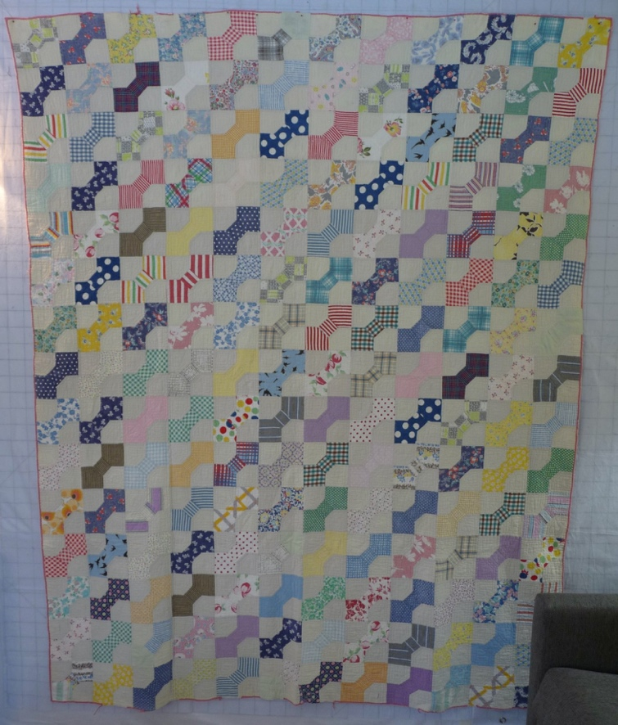 | 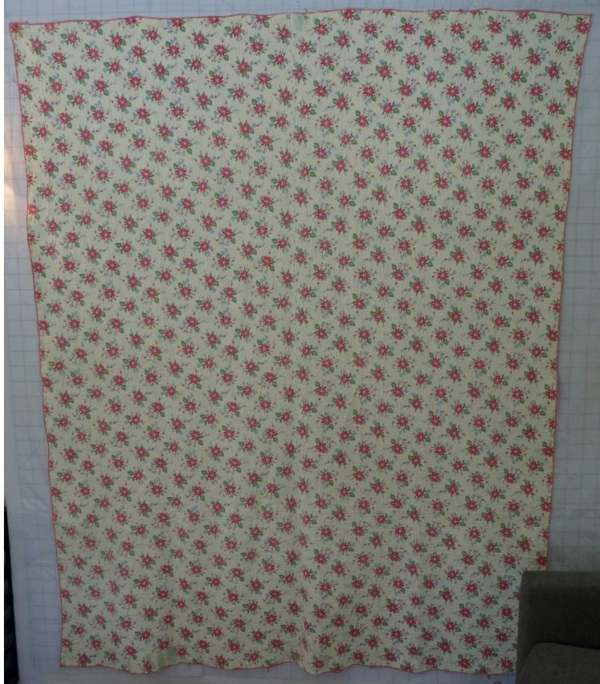

History

Provenance
Describe: --

Quilt Maker
Maker: -unknown- |  | Birth: -- |  | Death: --
 | Location: -- |  | Contributions: --

Purpose and Context
Expression
Art | Personal Enjoyment | Therapy
Income
Personal Income | Fundraising
Presentation
Anniversary | Wedding | Birth
Holiday | Birthday | Other gift
Charitable support
Relationships
Friendship | Commemorative | Memorial
Mourning | Reunion
Skill Building
Challenge / Contest | Learning / Teaching Sample
Use
Bed Quilt | Lap Quilt | Home Décor
Baby / Crib | Wall Hanging
Describe other purpose: --

Quilt Top Design & Construction

Quilt Top
Layout Design: .
Block Pattern Details
 | BB ID 2533 – Colonial Bow Tie | <<Pattern Image>>
 | Describe: Setting is 15 x 12 using 5.5” square blocks. Straight set, full drop. Hand pieced, hand assembled. A variety of cotton fabrics are used – florals, plaids, dots.
Materials
Sources of Fabric |  | NOT KNOWN
 | Companies | Fabric Name & Number | Designer
 | -- | -- | --
 | Describe other sources: --
Fiber Types |  | NOT YET IDENTIFIED
 | Cotton | Silk | Wool
 | Cotton Blend | Linen | Synthetic
 | Describe & Clarify: --
Fabric Types |  | NOT KNOWN
 | Broadcloth | Sateen | Upholstery
 | Flannel | Satin | Chintz
 | Shirting | Muslin | Glazed
 | Suiting | Velvet | Handwoven
 | Denim | Felt | Lindsey-Woolsey
 | Describe & Clarify: --
Print Types |  | NOT YET IDENTIFIED
 | Batik | Floral | Multiple scraps
 | Cheater Panel | Garibaldi Red Prints | Paisley
 | Checked / Gingham | Geometric | Plaid
 | Conversation / Novelty | Hand-dyed | Solid / Plain
 | Dotted | Victorian Mourning Prints | Stamped
 | Feed sack / Feed sack-like |  | Stripes
Describe & Clarify: --

Images for Top
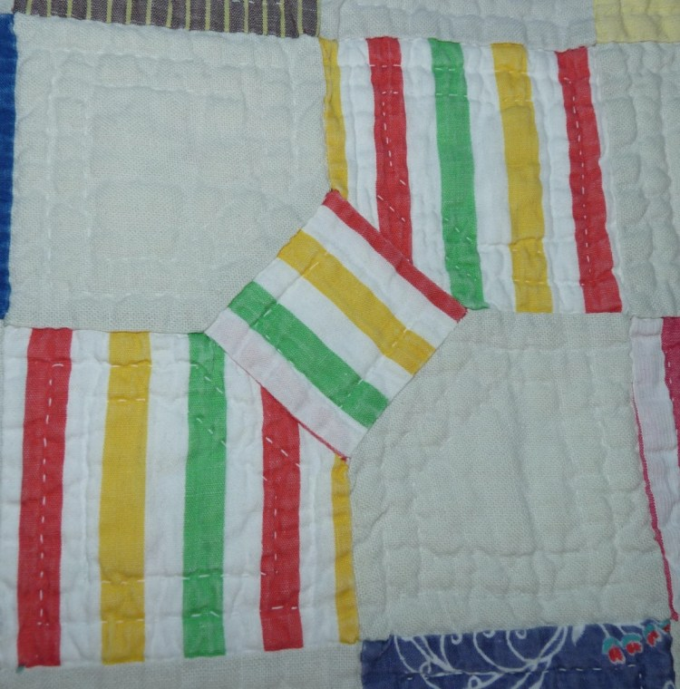 | 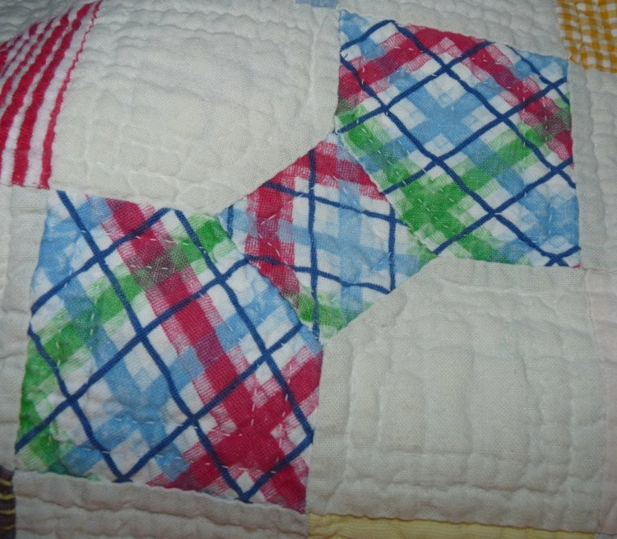
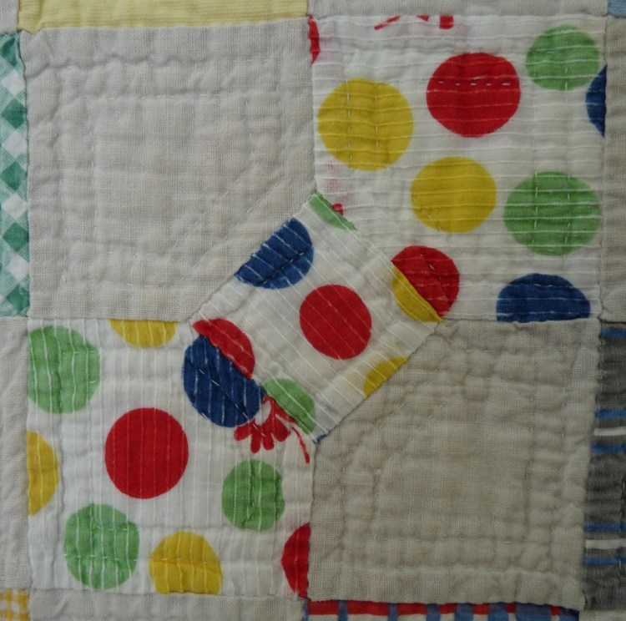 | 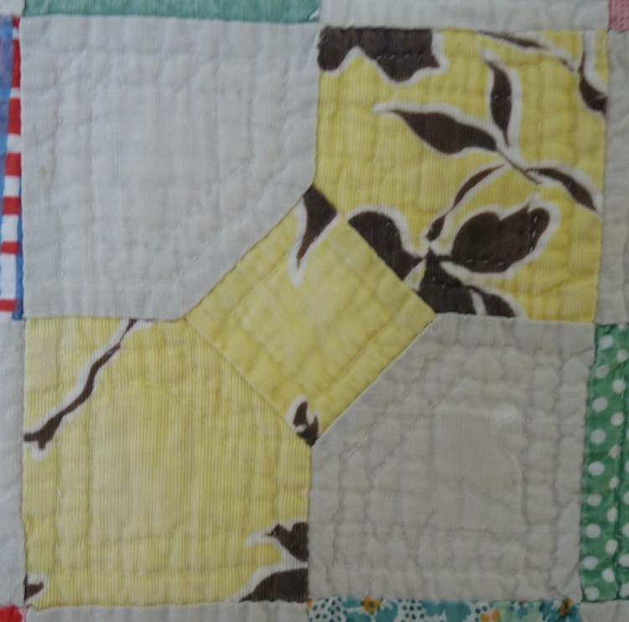

Top Inscriptions
None Found

Quilt Back Design & Construction

Quilt Back
Layout Design: .
Images for Back
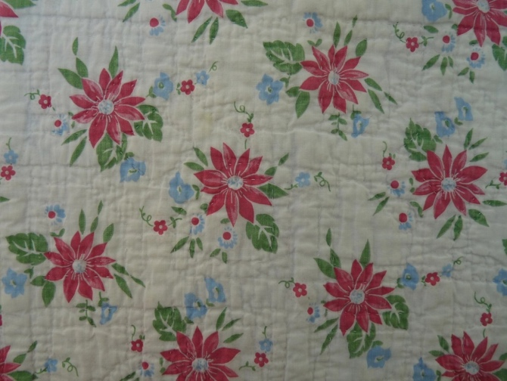

Back Inscriptions
None Found

Stabilization Method
Stabilization Method:
Batting
Quilting Techniques
 | Machine Quilted | Machine – sit-down | Corded
 | Machine – computer guided | Hand Quilted | Stuffed work
 | Machine – manual long-arm | Quilt-as-you-go
 | Describe: --
Quilting Patterns
 | Meander / Free motion | Lines – single parallel | Cables
 | In-the-ditch / To the piece | Lines – double parallel | Feathers
 | Echo / Outlined | Lines – triple parallel | Wreaths
 | Stipple | Grid – crosshatch | Vines
 | Clamshell | Grid – square | Floral
 | Elbow / Fan | Grid - diamond | Leaves
 | Describe other: --
Images for Stabilization

Edge Finish
Edge Style:
Finishing Technique
Top Width: 0.00 “ | Binding | Rolled – top to back
Back Width: 0.00“ | Knife edge | Rolled – back to top
1/8 = 0.13, 3/8 = 0.38 | Turned with a closure
5/8 = 0.63, 7/8 = 0.88
Application Method: | Top: | Back:
Embellishments
Fringe | Ruffles | Cording
Lace | Ribbon
Describe: --

Images for Edge
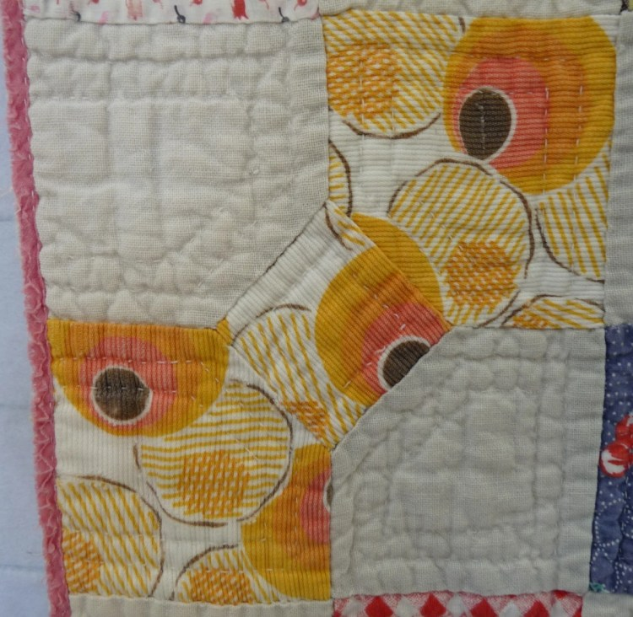

Condition

Flaws
Soiling
Dirty | Stains
Mildew stains | Musty Smell
Discoloration
Running / fugitive color | Faded / bleached color | Crocking
Fabric Damage
Tears / holes | Disintegrating / fall out | Insect damage
Thread bare | Shattering
Sewing / Quilting Damage
Split / open seams | Ties / tufting missing | Embellishments missing
Quilting threads missing | Batting has shifted
Storage Issues
Discoloration from wood | Damage from acid | Fold marks / creases
Describe additional condition issues: --
Images for Condition Issues
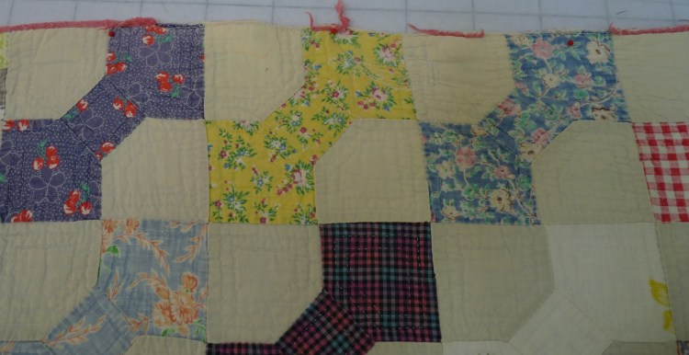

Conservation, Restoration, Repairs
Describe Measures: -Repairs have been made with a machine using a zig-zag stitch. See images for samples.-

Workmanship

Extension of Useful Life
Repair | Useful life of the item was extended.
Prevention of Damage
Conservation | All work is reversible.
Conservation | Further deterioration has been slowed, stabilized or prevented.
Maintaining Function & Integrity
Conservation | Work minimally interferes with the item’s overall appearance.
Restoration | Work blends well with the item’s overall appearance, style and age.
Restoration | Appropriate period reproductions were used.
Restoration | Vintage materials were used.
Restoration | Period appropriate techniques were used.
Restoration | Workmanship is of similar or better quality than original work.

Images for Conservation / Restoration / Repairs
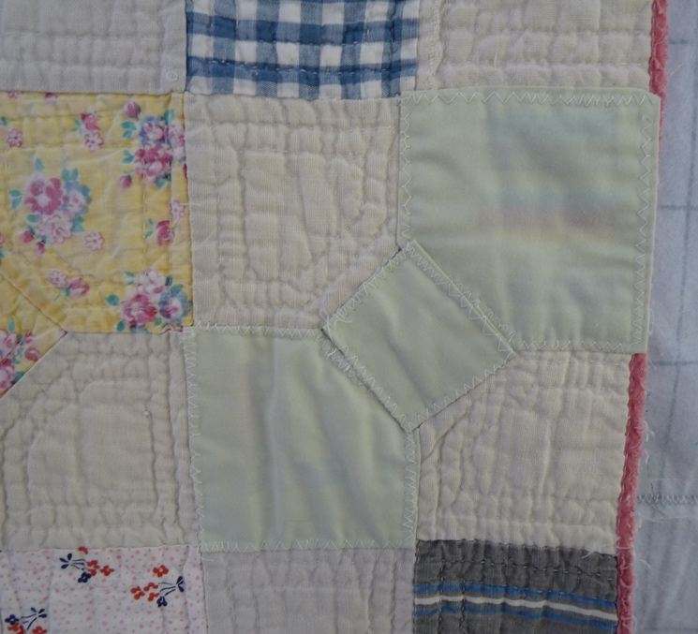 | 