Documentation Form

Overview

Owner History
Owner | From Date | To Date | Acquired at: | Cost
David Bailey | 2022-03-12 | -- | Michigan City, IN | $70
Made in:
--
 | If not purchased, the estimated cost for materials: $0

Display & Publication History
Date | Event | Location / Publication
-- | -- | --

General Description
Quilt Title or Name:  Triangle Strip Top | Fabric Date Range: 1935 ± 15 Years  Date Made: -- ± 0 Years  Method of Determination:
Item Type:  Items in Set: 1 | Size: Length: 80“ x Width: 62“
Appraisals:  Has this quilt been professionally appraised?  If so, when: --  ----------- | Other related files:
Additional Information: --

Images
Top | Back
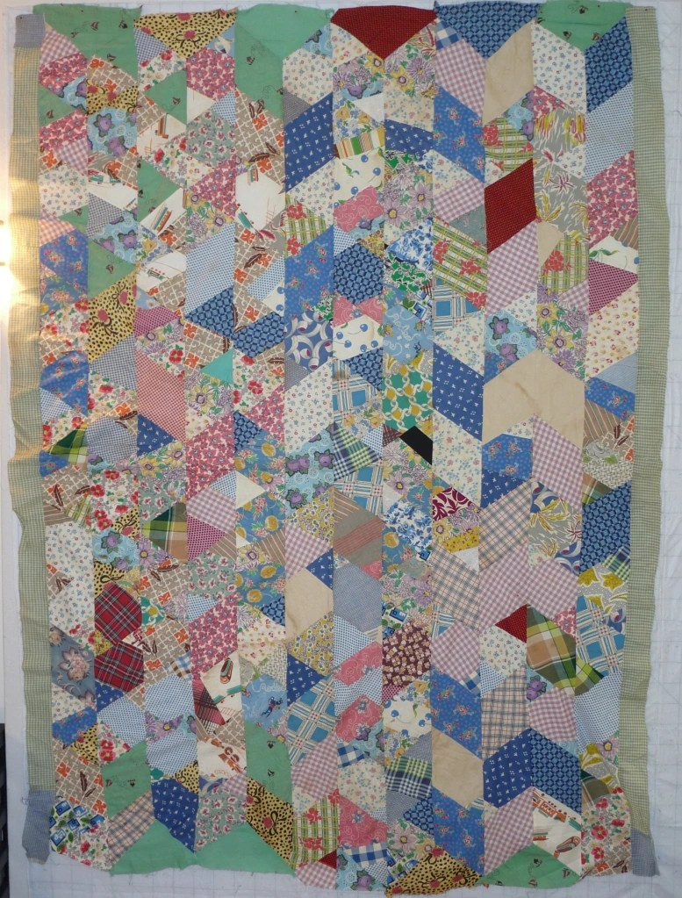

History

Provenance
Describe: --

Quilt Maker
Maker: unknown |  | Birth: -- |  | Death: --
 | Location: -- |  | Contributions: --

Purpose and Context
Expression
Art | Personal Enjoyment | Therapy
Income
Personal Income | Fundraising
Presentation
Anniversary | Wedding | Birth
Holiday | Birthday | Other gift
Charitable support
Relationships
Friendship | Commemorative | Memorial
Mourning | Reunion
Skill Building
Challenge / Contest | Learning / Teaching Sample
Use
Bed Quilt | Lap Quilt | Home Décor
Baby / Crib | Wall Hanging
Describe other purpose: --

Quilt Top Design & Construction

Quilt Top
Layout Design: .
Describe: This quilt top is organized into lengthwise strips. the strips are primarily pieced from diamonds and triangles. The fabrics are cotton - solids and prints. The top is assembled by machine. Foundation piecing was used - the remant papers can be found in some of the seam allowances.

Images for Top
 | 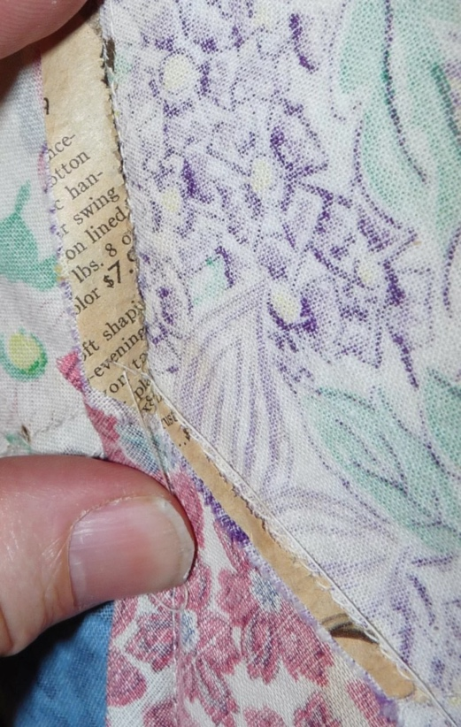 | 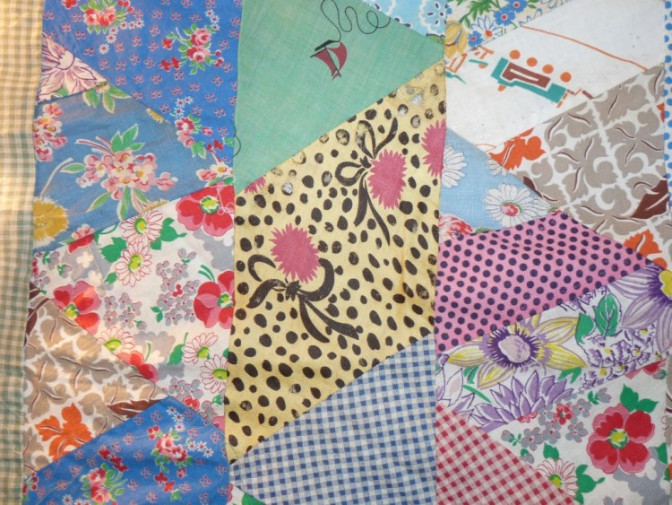

Condition

Flaws
Soiling
Dirty | Stains
Mildew stains | Musty Smell
Discoloration
Running / fugitive color | Faded / bleached color | Crocking
Fabric Damage
Tears / holes | Disintegrating / fall out | Insect damage
Thread bare | Shattering
Sewing / Quilting Damage
Split / open seams | Ties / tufting missing | Embellishments missing
Quilting threads missing | Batting has shifted
Storage Issues
Discoloration from wood | Damage from acid | Fold marks / creases
Describe additional condition issues: --
Images for Condition Issues

Conservation, Restoration, Repairs
Describe Measures: --

Workmanship

Extension of Useful Life
Repair | Useful life of the item was extended.
Prevention of Damage
Conservation | All work is reversible.
Conservation | Further deterioration has been slowed, stabilized or prevented.
Maintaining Function & Integrity
Conservation | Work minimally interferes with the item’s overall appearance.
Restoration | Work blends well with the item’s overall appearance, style and age.
Restoration | Appropriate period reproductions were used.
Restoration | Vintage materials were used.
Restoration | Period appropriate techniques were used.
Restoration | Workmanship is of similar or better quality than original work.

Images for Conservation / Restoration / Repairs

