Documentation Form

Overview

Owner History
Owner | From Date | To Date | Acquired at: | Cost
David Bailey | 2021-12-23 | -- | Centerville Antique Mall  200 Union Street  Centerville, Indiana 4730 | $34
Made in:
--
 | If not purchased, the estimated cost for materials: $0

Display & Publication History
Date | Event | Location / Publication
-- | -- | --

General Description
Quilt Title or Name:  Blue Nine-Patch | Fabric Date Range: 1910 ± 40 Years  Date Made: -- ± 0 Years  Method of Determination:
Item Type:  Items in Set: 1 | Size: Length: 89“ x Width: 77“
Appraisals:  Has this quilt been professionally appraised?  If so, when: --  ----------- | Other related files:
Additional Information: --

Images
Top | Back
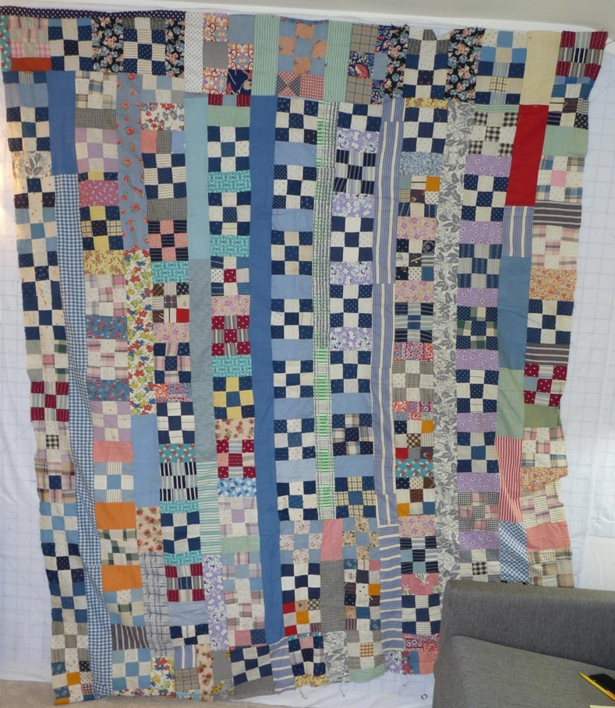

History

Provenance
Describe: --

Quilt Maker
Maker: unknown |  | Birth: -- |  | Death: --
 | Location: -- |  | Contributions: --

Purpose and Context
Expression
Art | Personal Enjoyment | Therapy
Income
Personal Income | Fundraising
Presentation
Anniversary | Wedding | Birth
Holiday | Birthday | Other gift
Charitable support
Relationships
Friendship | Commemorative | Memorial
Mourning | Reunion
Skill Building
Challenge / Contest | Learning / Teaching Sample
Use
Bed Quilt | Lap Quilt | Home Décor
Baby / Crib | Wall Hanging
Describe other purpose: --

Quilt Top Design & Construction

Quilt Top
Layout Design: .
Describe: This quilt top is organized into lengthwise strips. Strip subunits vary. some strips are long lengths of unpieced fabrics. Other strips are 9-patches alternated with bricks of fabric. The fabrics are cotton prints and colids. The primary colors are blues but many other colors are present. Hand stitched.

Top Inscriptions
None Found

Condition

Flaws
Soiling
Dirty | Stains
Mildew stains | Musty Smell
Discoloration
Running / fugitive color | Faded / bleached color | Crocking
Fabric Damage
Tears / holes | Disintegrating / fall out | Insect damage
Thread bare | Shattering
Sewing / Quilting Damage
Split / open seams | Ties / tufting missing | Embellishments missing
Quilting threads missing | Batting has shifted
Storage Issues
Discoloration from wood | Damage from acid | Fold marks / creases
Describe additional condition issues: Top is not square. The shape shown is the closest that the top comes to laying flat.
Images for Condition Issues

Conservation, Restoration, Repairs
Describe Measures: --

Workmanship

Extension of Useful Life
Repair | Useful life of the item was extended.
Prevention of Damage
Conservation | All work is reversible.
Conservation | Further deterioration has been slowed, stabilized or prevented.
Maintaining Function & Integrity
Conservation | Work minimally interferes with the item’s overall appearance.
Restoration | Work blends well with the item’s overall appearance, style and age.
Restoration | Appropriate period reproductions were used.
Restoration | Vintage materials were used.
Restoration | Period appropriate techniques were used.
Restoration | Workmanship is of similar or better quality than original work.

Images for Conservation / Restoration / Repairs

