Documentation Form

Overview

Owner History
Owner | From Date | To Date | Acquired at: | Cost
David Bailey | 2022-12-28 | -- | Hylabrook Antique Mall  204 Chaffin Place  Murfreesboro, TN 37129 | $24
Made in:
--
 | If not purchased, the estimated cost for materials: $0

Display & Publication History
Date | Event | Location / Publication
-- | -- | --

General Description
Quilt Title or Name:  Grandmother's Fan | Fabric Date Range: 1935 ± 10 Years  Date Made: -- ± 0 Years  Method of Determination:
Item Type:  Items in Set: 1 | Size: Length: 83“ x Width: 70“
Appraisals:  Has this quilt been professionally appraised?  If so, when: --  ----------- | Other related files:
Additional Information: --

Images
Top | Back
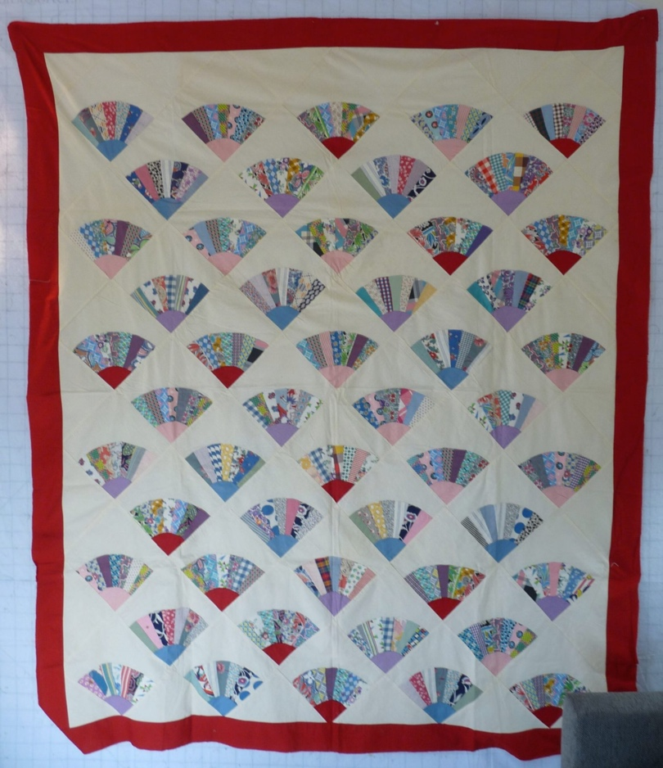

History

Provenance
Describe: --

Quilt Maker
Maker: unknown |  | Birth: -- |  | Death: --
 | Location: -- |  | Contributions: --

Purpose and Context
Expression
Art | Personal Enjoyment | Therapy
Income
Personal Income | Fundraising
Presentation
Anniversary | Wedding | Birth
Holiday | Birthday | Other gift
Charitable support
Relationships
Friendship | Commemorative | Memorial
Mourning | Reunion
Skill Building
Challenge / Contest | Learning / Teaching Sample
Use
Bed Quilt | Lap Quilt | Home Décor
Baby / Crib | Wall Hanging
Describe other purpose: --

Quilt Top Design & Construction

Quilt Top
Layout Design: .
Blocks
Grid & Contained Crazy Details
 |  | Grid Dimensions: 50 fan blocks – 6 rows of 5 blocks alternated with 5 rows of 4 blocks.
 |  | Block Size: Length: 9.00 “ x Width: 9.00 “
Block Pattern Details
 | BB ID 3305 and 3306 variation - Grandmother's Fan - 6-8 blades. This quilt has 7 blades. | <<Pattern Image>>
 | Pattern name & Brackman or other ID | <<Pattern Image>>
 | Describe: The fans and border are cotton fabric. Prints and solids. The cream background for the fans may be linen. The top assembly was done by machine. The fans were applied using a top stitch along the edge of the fan.

Borders & Frames
Delete this & the following table rows as appropriate.
Describe borders and frames in order from center to edge.
1 | Width: 3.5“
 |  | Describe: red

Top Assembly
 | Seams are appropriately aligned
Seams are stable | Top has no inappropriate tucks or puckers
Seams are flat | Top lays flat with no overly full areas
Describe: --

Color
Predominant colors
 | Red | Blue | Black
 | Orange | Violet/Purple | Grey
 | Yellow | Brown | White
 | Green | Beige / Tan
Specific Antique Colors |  | NONE NOTED | Neon prints
 | Red – claret / wine | Yellow – chrome | Blue – Lancaster
 | Red – madder / cinnamon | Green - chrome | Blue – Prussian / Lafayette
 | Red – turkey | Green – Nile | Brown – madder
 | Pinks - double | Blue – Cadet | Butterscotch
 | Orange - madder | Blue - Indigo | Bronze
 | Orange – cheddar / antimony / chrome |  | Late 1800’s Purple
Describe: --

Materials
Sources of Fabric |  | NOT KNOWN
 | Companies | Fabric Name & Number | Designer
 | -- | -- | --
 | Describe other sources: --
Fiber Types |  | NOT YET IDENTIFIED
 | Cotton | Silk | Wool
 | Cotton Blend | Linen | Synthetic
 | Describe & Clarify: --
Fabric Types |  | NOT KNOWN
 | Broadcloth | Sateen | Upholstery
 | Flannel | Satin | Chintz
 | Shirting | Muslin | Glazed
 | Suiting | Velvet | Handwoven
 | Denim | Felt | Lindsey-Woolsey
 | Describe & Clarify: --
Print Types |  | NOT YET IDENTIFIED
 | Batik | Floral | Multiple scraps
 | Cheater Panel | Garibaldi Red Prints | Paisley
 | Checked / Gingham | Geometric | Plaid
 | Conversation / Novelty | Hand-dyed | Solid / Plain
 | Dotted | Victorian Mourning Prints | Stamped
 | Feed sack / Feed sack-like |  | Stripes
Describe & Clarify: --

Images
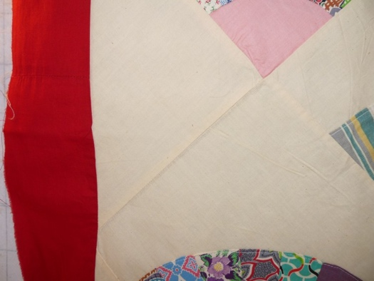

Top Inscriptions
None Found

Condition

Flaws
Soiling
Dirty | Stains
Mildew stains | Musty Smell
Discoloration
Running / fugitive color | Faded / bleached color | Crocking
Fabric Damage
Tears / holes | Disintegrating / fall out | Insect damage
Thread bare | Shattering
Sewing / Quilting Damage
Split / open seams | Ties / tufting missing | Embellishments missing
Quilting threads missing | Batting has shifted
Storage Issues
Discoloration from wood | Damage from acid | Fold marks / creases
Describe additional condition issues: --
Images for Condition Issues

Conservation, Restoration, Repairs
Describe Measures: --

Workmanship

Extension of Useful Life
Repair | Useful life of the item was extended.
Prevention of Damage
Conservation | All work is reversible.
Conservation | Further deterioration has been slowed, stabilized or prevented.
Maintaining Function & Integrity
Conservation | Work minimally interferes with the item’s overall appearance.
Restoration | Work blends well with the item’s overall appearance, style and age.
Restoration | Appropriate period reproductions were used.
Restoration | Vintage materials were used.
Restoration | Period appropriate techniques were used.
Restoration | Workmanship is of similar or better quality than original work.

Images for Conservation / Restoration / Repairs

