Documentation Form

Overview

Owner History
Owner | From Date | To Date | Acquired at: | Cost
David Bailey | 2022-01-08 | -- | Antique Market of Williamston  2991 Williamston Road  Williamston, MI 48895  Mail to PO Box 10  517 655 1350  Booth 649 | $54
Made in:
--
 | If not purchased, the estimated cost for materials: $0

Display & Publication History
Date | Event | Location / Publication
-- | -- | --

General Description
Quilt Title or Name:  Lap Blanket | Fabric Date Range: 1955 ± 10 Years  Date Made: 1955 ± 10 Years  Method of Determination:
Item Type:  Items in Set: 1 | Size: Length: 57“ x Width: 44“
Appraisals:  Has this quilt been professionally appraised?  If so, when: --  ----------- | Other related files:
Additional Information: --

Images
Top | Back
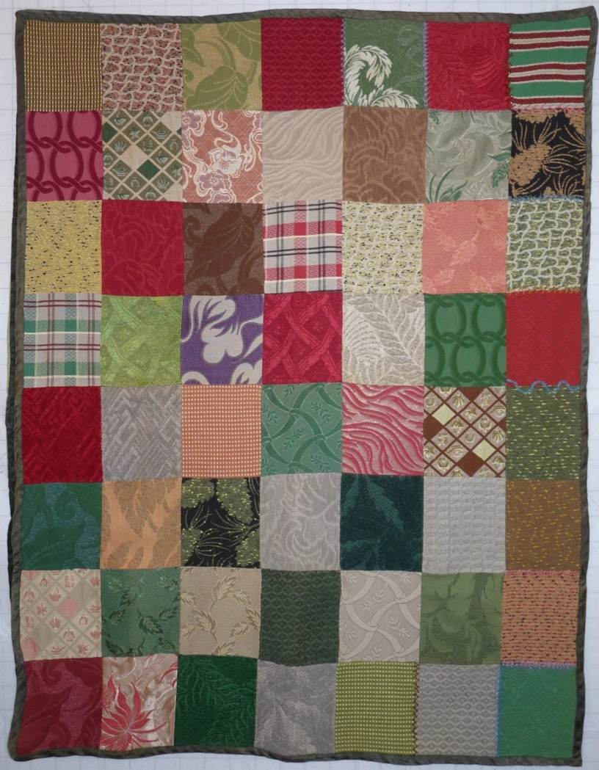 | 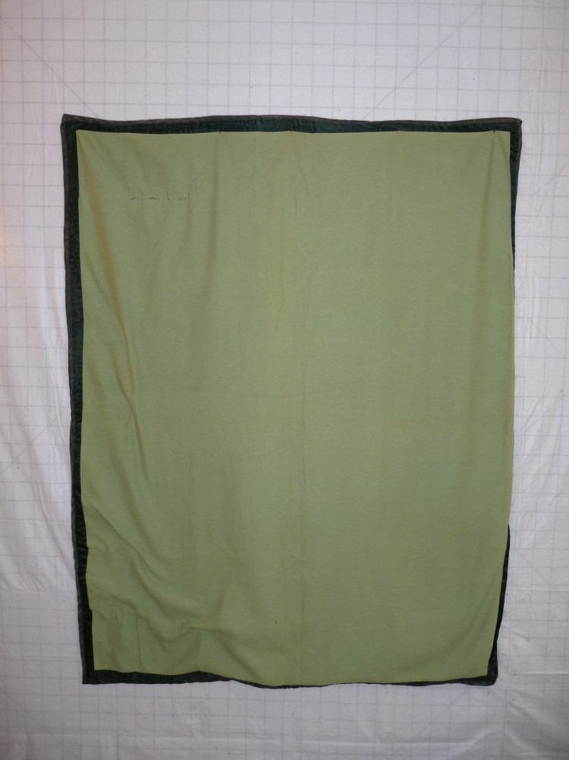

History

Provenance
Describe: --

Quilt Maker
Maker: unknown |  | Birth: -- |  | Death: --
 | Location: -- |  | Contributions: --

Purpose and Context
Expression
Art | Personal Enjoyment | Therapy
Income
Personal Income | Fundraising
Presentation
Anniversary | Wedding | Birth
Holiday | Birthday | Other gift
Charitable support
Relationships
Friendship | Commemorative | Memorial
Mourning | Reunion
Skill Building
Challenge / Contest | Learning / Teaching Sample
Use
Bed Quilt | Lap Quilt | Home Décor
Baby / Crib | Wall Hanging
Describe other purpose: --

Quilt Top Design & Construction

Quilt Top
Layout Design: .
One Patch Shape Details
Describe: Bricks are set in a 8x7 grid. Points are aligned. Fabric appears to be very heavy and may be from an upholstery swatch catalog. The top is assembled by machine. Small areas of the quilt are embroidered. The embroidery appears to have been started after the backing was applied to the top because it can be observed on the backing fabric. There is no batting. Aside from the embroidery, this quilt is not stabilized. No inscriptions have been found on the front or the back.

Images for Stabilization
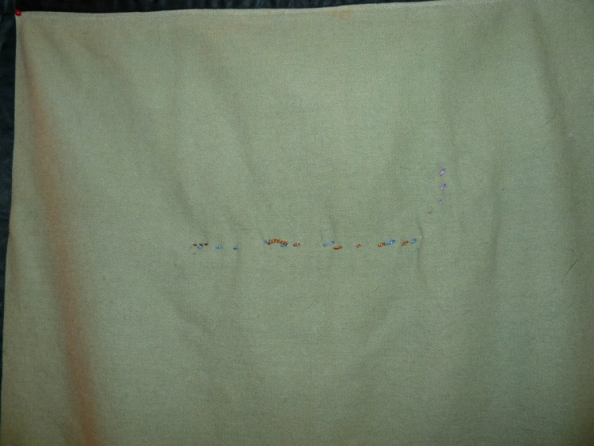

Edge Finish
Edge Style:
Describe: The edge treatment is satin. It appears to be bound to both the top and the back of the blanket by machine. This creates to flaps or flanges that are separated at the edge. See photo. The edge does not always lie flat.

Images for Edge
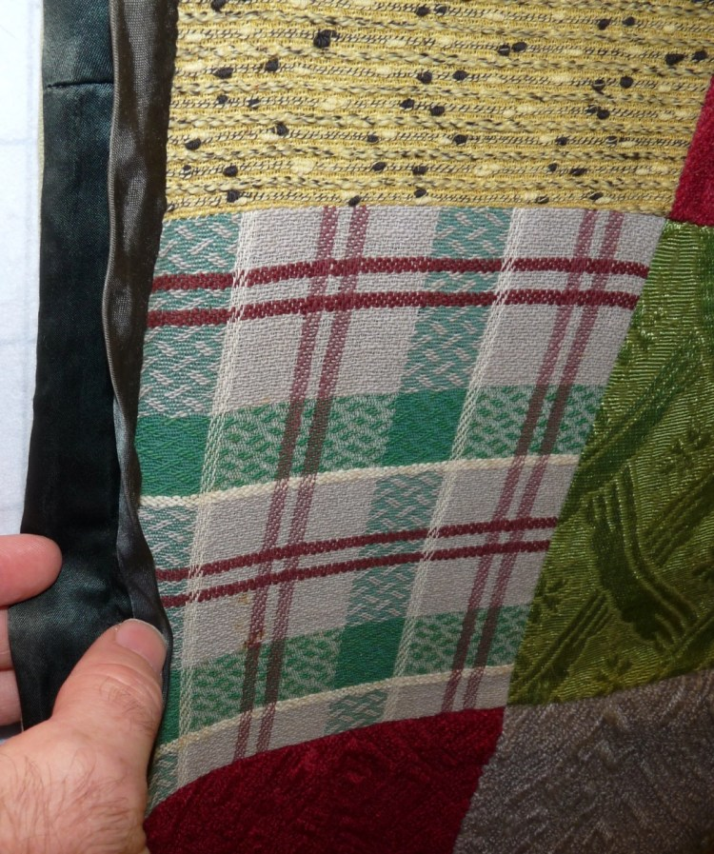 | 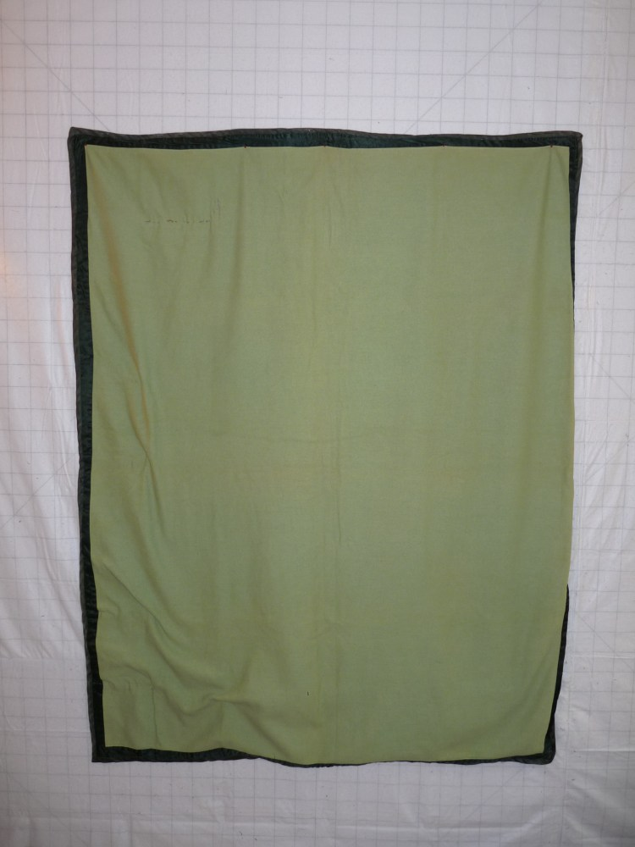

Condition

Flaws
Soiling
Dirty | Stains
Mildew stains | Musty Smell
Discoloration
Running / fugitive color | Faded / bleached color | Crocking
Fabric Damage
Tears / holes | Disintegrating / fall out | Insect damage
Thread bare | Shattering
Sewing / Quilting Damage
Split / open seams | Ties / tufting missing | Embellishments missing
Quilting threads missing | Batting has shifted
Storage Issues
Discoloration from wood | Damage from acid | Fold marks / creases
Describe additional condition issues: --
Images for Condition Issues
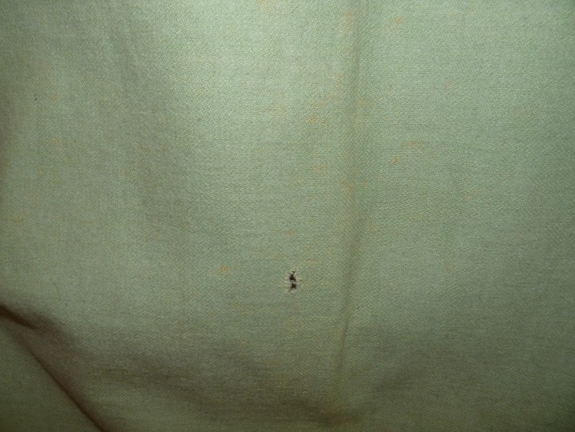

Conservation, Restoration, Repairs
Describe Measures: --

Workmanship

Extension of Useful Life
Repair | Useful life of the item was extended.
Prevention of Damage
Conservation | All work is reversible.
Conservation | Further deterioration has been slowed, stabilized or prevented.
Maintaining Function & Integrity
Conservation | Work minimally interferes with the item’s overall appearance.
Restoration | Work blends well with the item’s overall appearance, style and age.
Restoration | Appropriate period reproductions were used.
Restoration | Vintage materials were used.
Restoration | Period appropriate techniques were used.
Restoration | Workmanship is of similar or better quality than original work.

Images for Conservation / Restoration / Repairs

