Documentation Form

Overview

Owner History
Owner | From Date | To Date | Acquired at: | Cost
David Bailey | 2023-03-07 | -- | Dutch Lady Antiques  401 E Market Street, Suite 4  Nappanee, IN  46550  574 354 0471  Coppescommons.com | $63
Made in:
--
 | If not purchased, the estimated cost for materials: $0

Display & Publication History
Date | Event | Location / Publication
-- | --

General Description
Quilt Title or Name:  Silk Comforter | Fabric Date Range: 1940 ± 10 Years  Date Made: 1940 ± 10 Years  Method of Determination:
Item Type:  Items in Set: 1 | Size: Length: 85“ x Width: 68“
Appraisals:  Has this quilt been professionally appraised?  If so, when: --  ----------- | Other related files:
Additional Information: Found by DJ and purchased for me as a surprise.

Images
Top | Back
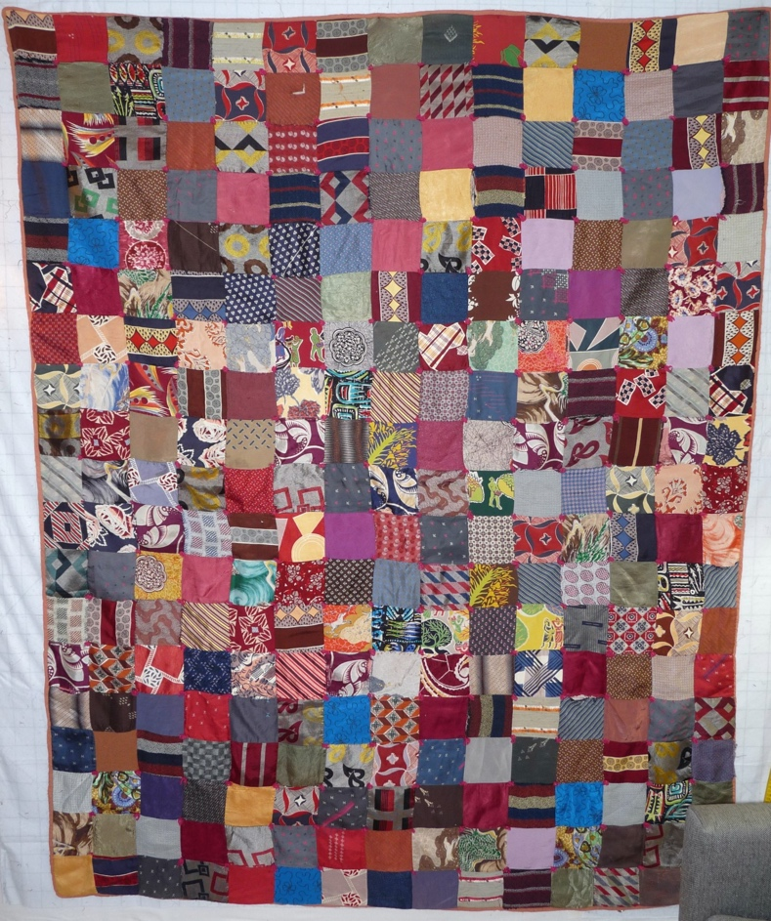 | 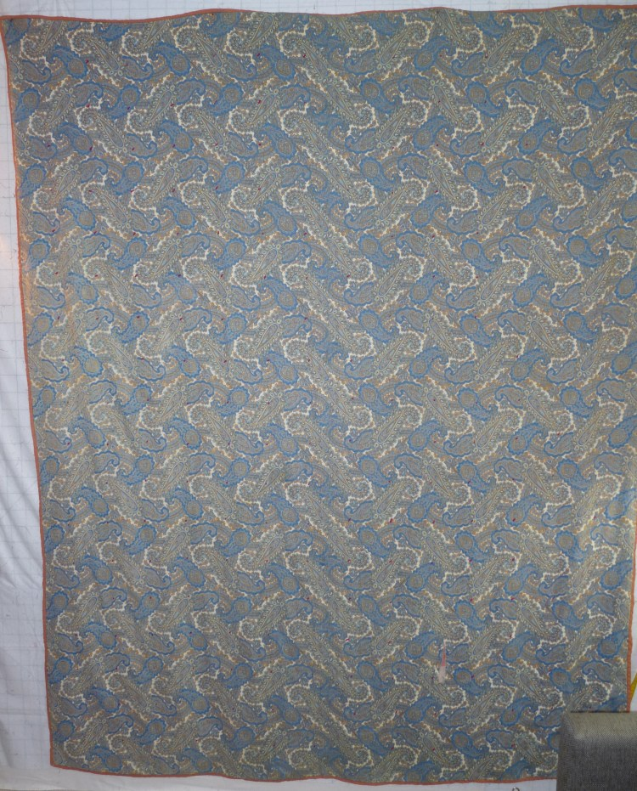

History

Provenance
Describe: --

Quilt Maker
Maker: unknown |  | Birth: -- |  | Death: --
 | Location: -- |  | Contributions: --

Purpose and Context
Expression
Art | Personal Enjoyment | Therapy
Income
Personal Income | Fundraising
Presentation
Anniversary | Wedding | Birth
Holiday | Birthday | Other gift
Charitable support
Relationships
Friendship | Commemorative | Memorial
Mourning | Reunion
Skill Building
Challenge / Contest | Learning / Teaching Sample
Use
Bed Quilt | Lap Quilt | Home Décor
Baby / Crib | Wall Hanging
Describe other purpose: --

Quilt Top Design & Construction

Quilt Top
Layout Design: .
One Patch Shape Details
Describe: 19x15 grid - 285 patches. Straight setting. Full drop. Patchs are about 4.5" square.

Piecing
Techniques
 |  | Machine pieced | String / Improvisational piecing
 |  | Hand pieced | Foundation piecing
 |  | Strip piecing | English paper piecing
 |  | Describe: --
 | Workmanship
 |  | Seams are stable | Seams are appropriately aligned
 |  | Seams are flat | Points are sharp
 |  | Some seams are loose - no stabilizing material was used. Some fabricfs were placed into the quilt with the back of the fabric facing forward.

Color
Predominant colors
 | Red | Blue | Black
 | Orange | Violet/Purple | Grey
 | Yellow | Brown | White
 | Green | Beige / Tan
Specific Antique Colors |  | NONE NOTED | Neon prints
 | Red – claret / wine | Yellow – chrome | Blue – Lancaster
 | Red – madder / cinnamon | Green - chrome | Blue – Prussian / Lafayette
 | Red – turkey | Green – Nile | Brown – madder
 | Pinks - double | Blue – Cadet | Butterscotch
 | Orange - madder | Blue - Indigo | Bronze
 | Orange – cheddar / antimony / chrome |  | Late 1800’s Purple
Describe: --

Materials
Sources of Fabric |  | NOT KNOWN
 | Companies | Fabric Name & Number | Designer
 | -- | -- | --
 | Describe other sources: --
Fiber Types |  | NOT YET IDENTIFIED
 | Cotton | Silk | Wool
 | Cotton Blend | Linen | Synthetic
 | Describe & Clarify: --
Fabric Types |  | NOT KNOWN
 | Broadcloth | Sateen | Upholstery
 | Flannel | Satin | Chintz
 | Shirting | Muslin | Glazed
 | Suiting | Velvet | Handwoven
 | Denim | Felt | Lindsey-Woolsey
 | Describe & Clarify: --
Print Types |  | NOT YET IDENTIFIED
 | Batik | Floral | Multiple scraps
 | Cheater Panel | Garibaldi Red Prints | Paisley
 | Checked / Gingham | Geometric | Plaid
 | Conversation / Novelty | Hand-dyed | Solid / Plain
 | Dotted | Victorian Mourning Prints | Stamped
 | Feed sack / Feed sack-like |  | Stripes
Describe & Clarify: --

Images
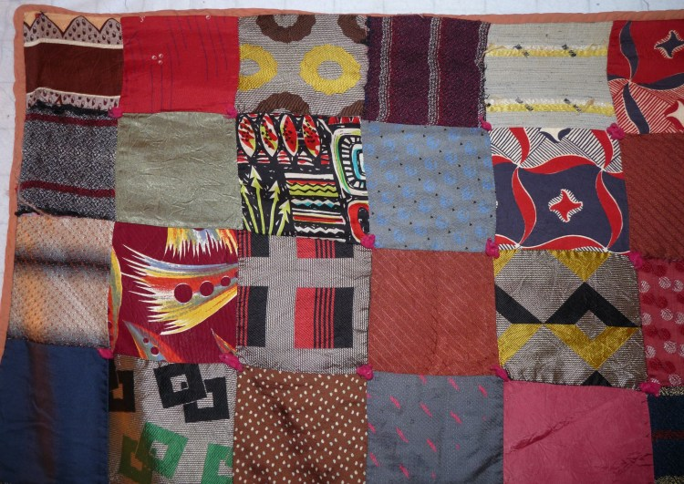 | 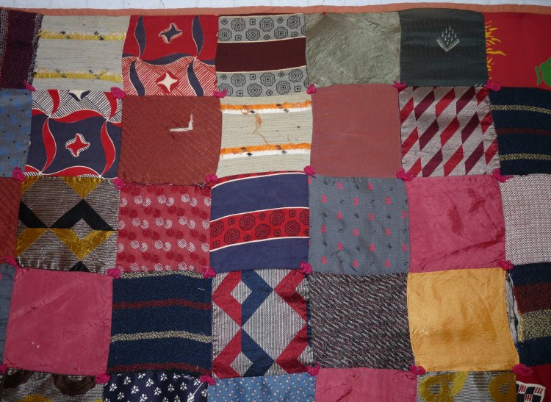
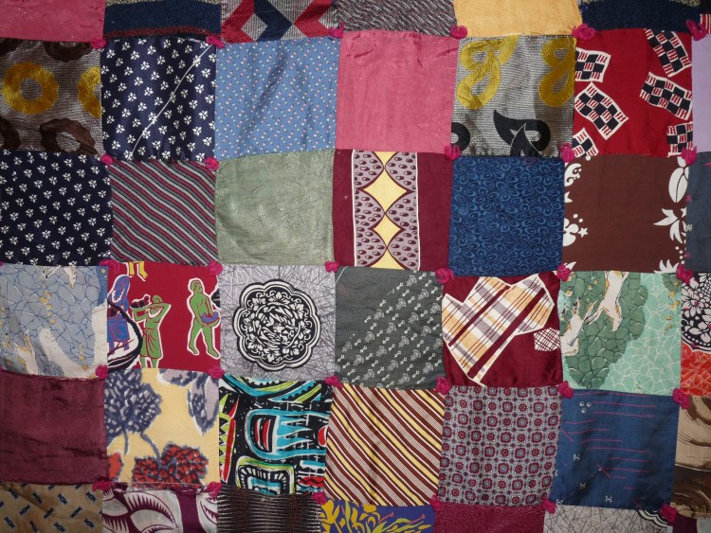 | 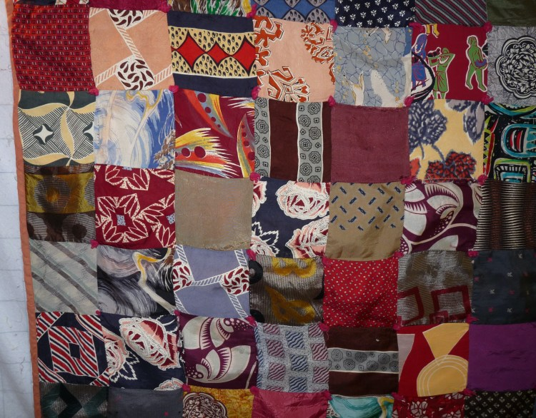

Top Inscriptions
None Found

Quilt Back Design & Construction

Quilt Back
Layout Design: .
Images
 | 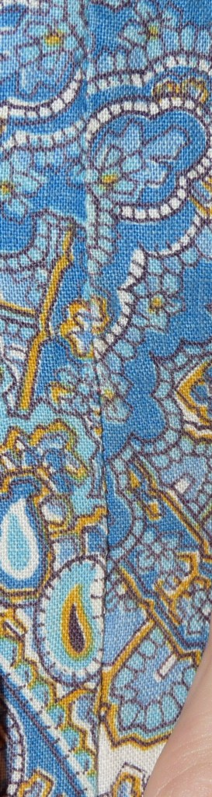 | 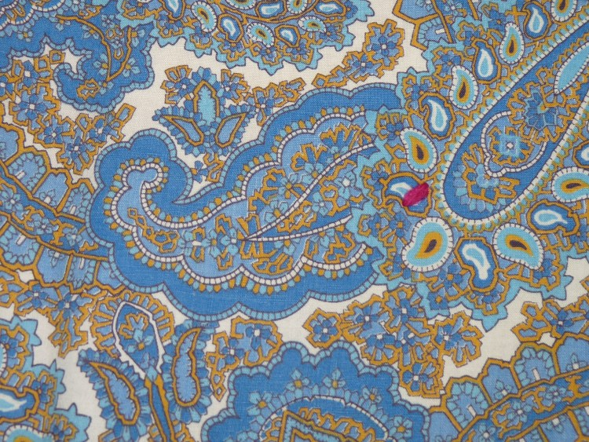

Back Inscriptions
None Found

Stabilization Method
Stabilization Method:
Tied Details
 | Average Distance Between Knots: 0” | Placement:
 |  | Fiber Used:
Images for Stabilization
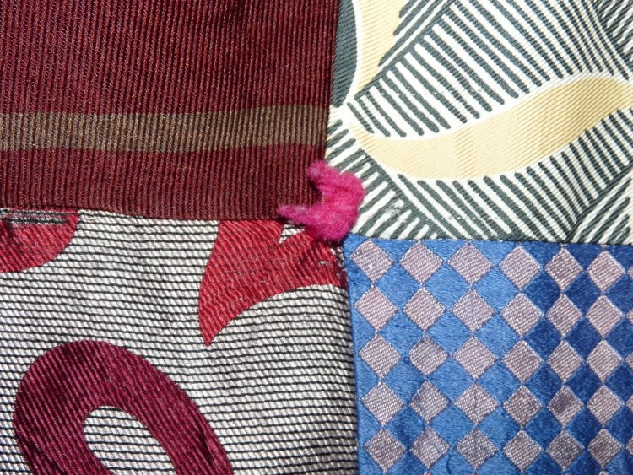

Edge Finish
Edge Style:
Finishing Technique
Top Width: 0.38 “ | Binding | Rolled – top to back
Back Width: 0.50“ | Knife edge | Rolled – back to top
1/8 = 0.13, 3/8 = 0.38 | Turned with a closure
5/8 = 0.63, 7/8 = 0.88
Application Method: | Top: | Back:
Embellishments
Fringe | Ruffles | Cording
Lace | Ribbon
Describe: --

Images for Edge
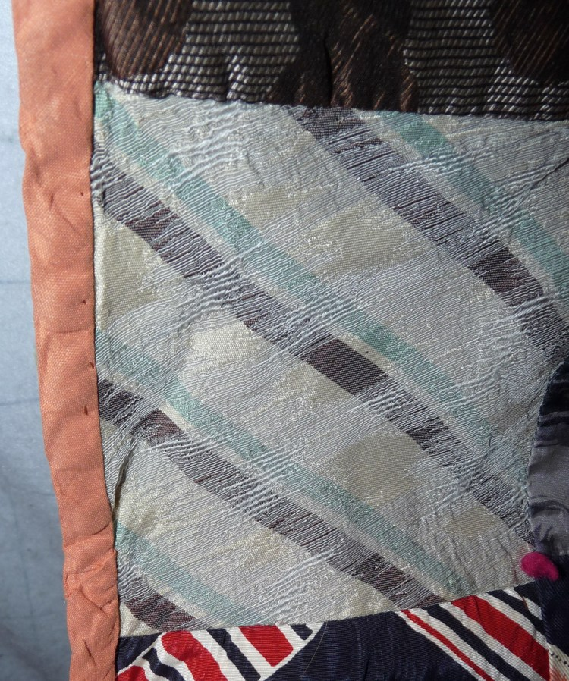

Condition

Flaws
Soiling
Dirty | Stains
Mildew stains | Musty Smell
Discoloration
Running / fugitive color | Faded / bleached color | Crocking
Fabric Damage
Tears / holes | Disintegrating / fall out | Insect damage
Thread bare | Shattering
Sewing / Quilting Damage
Split / open seams | Ties / tufting missing | Embellishments missing
Quilting threads missing | Batting has shifted
Storage Issues
Discoloration from wood | Damage from acid | Fold marks / creases
Describe additional condition issues: some of the yarn tied have fallen out.
Images for Condition Issues
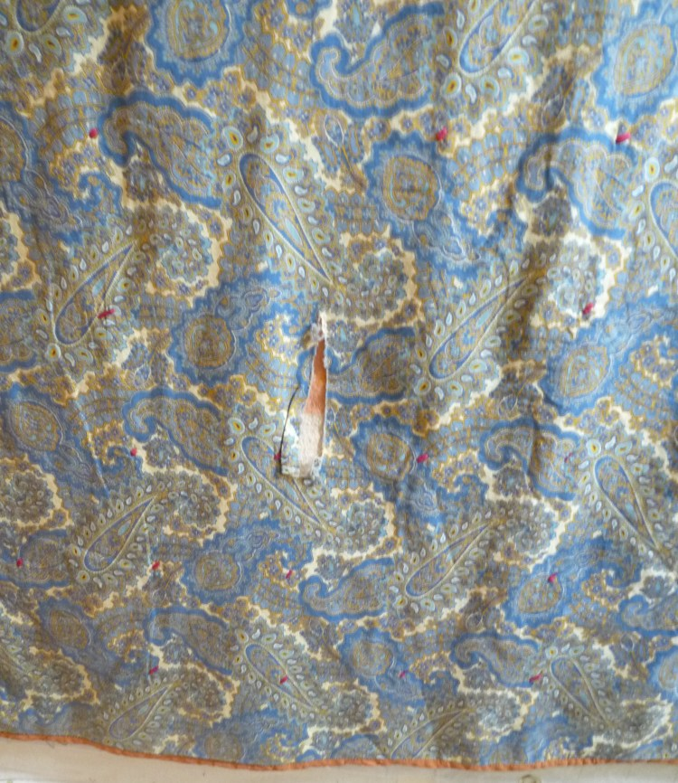 | 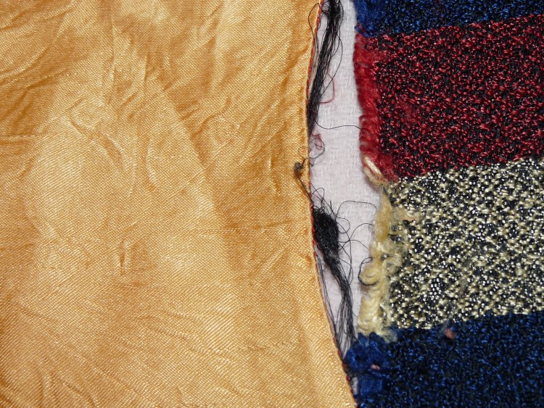

Conservation, Restoration, Repairs
Describe Measures: -
2025-12-25 A white tulle was used over the rip in the back of the quilt to stabilize the tear and prevent it from expanding.-

Images for Conservation / Restoration / Repairs
2025-12-25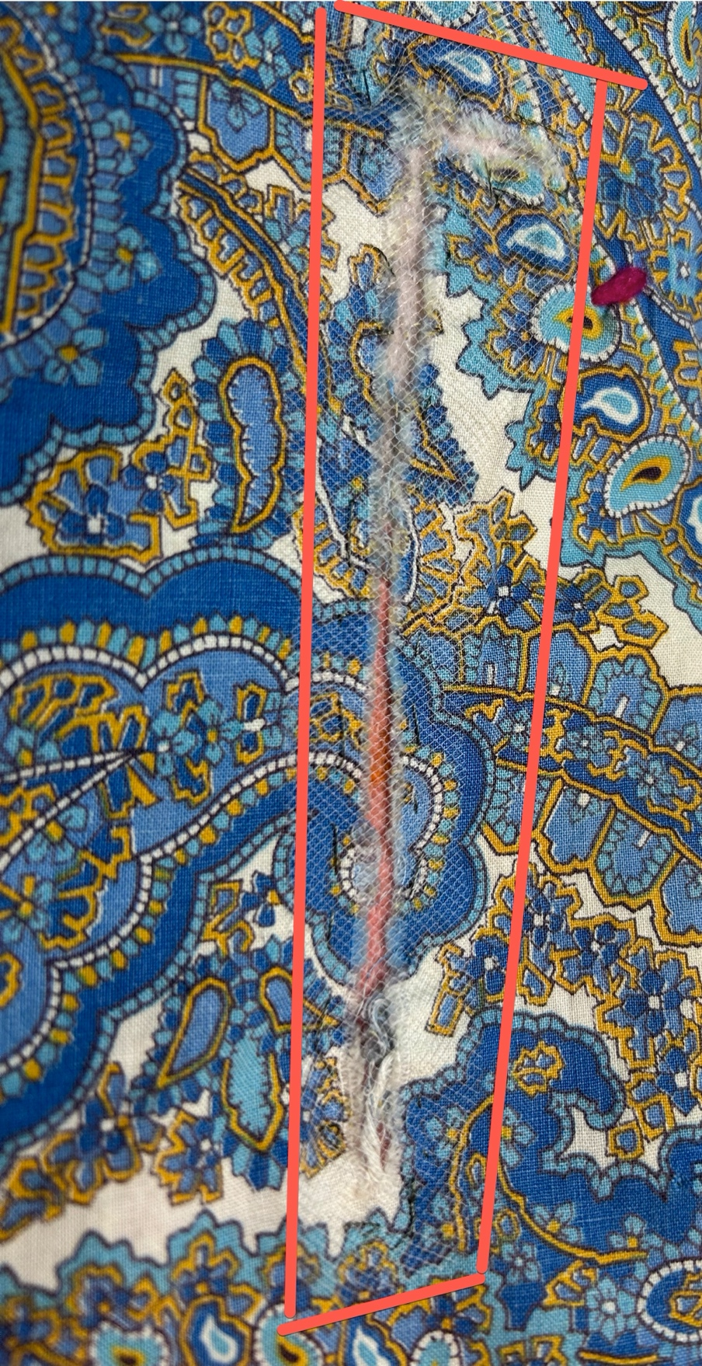

Workmanship

Extension of Useful Life
Repair | Useful life of the item was extended.
Prevention of Damage
Conservation | All work is reversible.
Conservation | Further deterioration has been slowed, stabilized or prevented.
Maintaining Function & Integrity
Conservation | Work minimally interferes with the item’s overall appearance.
Restoration | Work blends well with the item’s overall appearance, style and age.
Restoration | Appropriate period reproductions were used.
Restoration | Vintage materials were used.
Restoration | Period appropriate techniques were used.
Restoration | Workmanship is of similar or better quality than original work.

