Documentation Form

Overview

Owner History
Owner | From Date | To Date | Acquired at: | Cost
David Bailey | 2022-07-31 | -- | Allegan County Fairground Antique Fair  Allegan County, MI | $3
Made in:
--
 | If not purchased, the estimated cost for materials:

Display & Publication History
Date | Event | Location / Publication
-- | -- | --

General Description
Quilt Title or Name:  China Aster Blocks | Fabric Date Range: 1999± 1 Years  Date Made: ± Years  Method of Determination:
Item Type:  Items in Set: 3 | Size: Length: 14“ x Width: 14“
Appraisals:  Has this quilt been professionally appraised?  If so, when: --  ----------- | Other related files:  Fons & Porter Pattern  Sample 0101B
Additional Information: -The original blocks were purchased on July 31, 2022 as a set of 23 for $30 or about $1.30 per block. 20 blocks were used for sample 101B. The remaining 3 are in this sample for a cost of around $3.90. The vendor provided the original pattern with the blocks. It was an article from Fons & Porter March/April 1999.-

Images
Top | Back
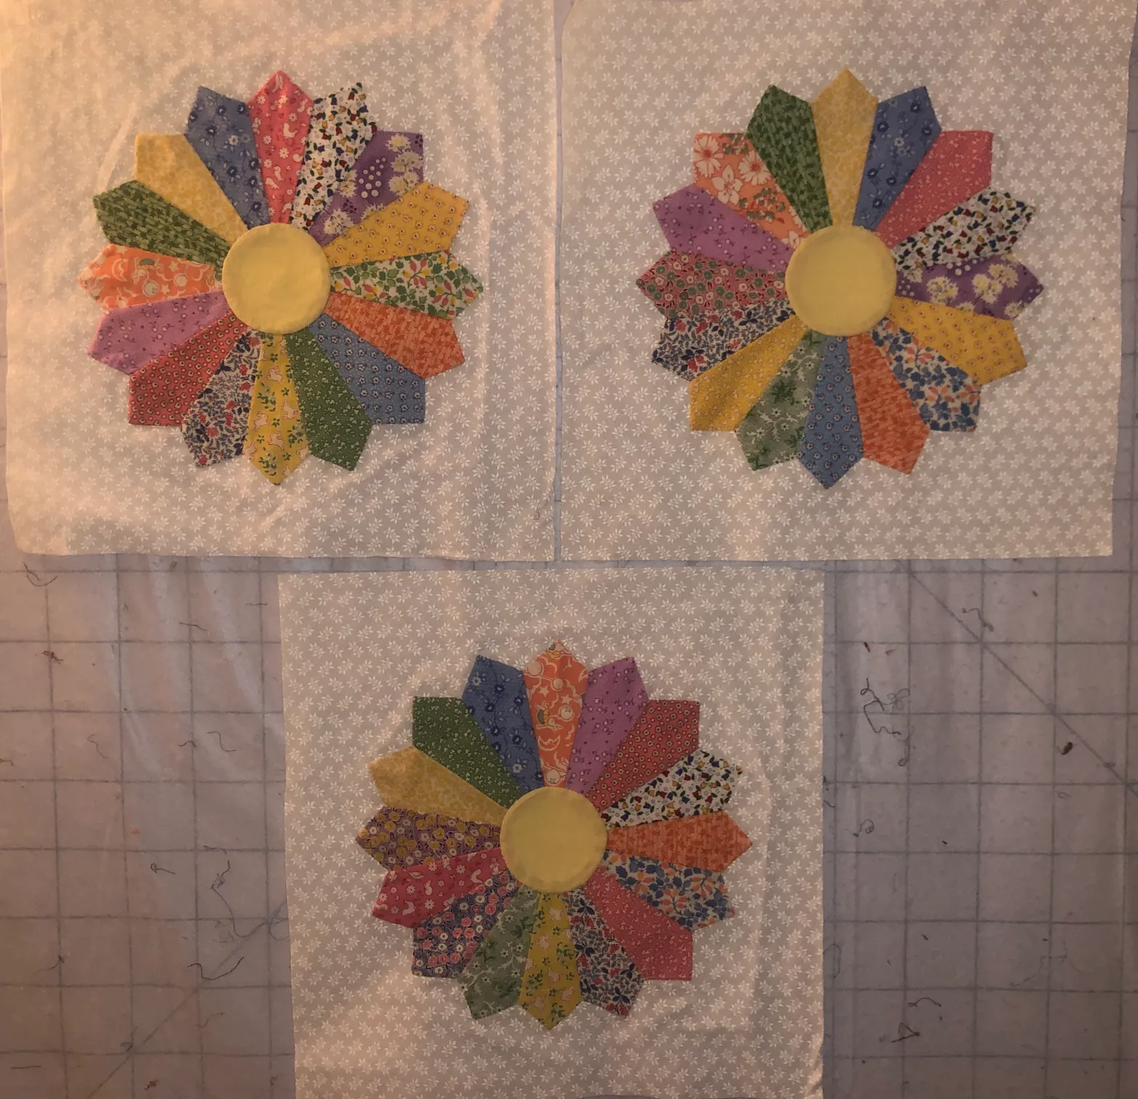

History

Provenance
Describe: --

Quilt Maker
Maker: -unknown- |  | Birth: -- |  | Death: --
 | Location: -- |  | Contributions: --

Purpose and Context
Expression
Art | Personal Enjoyment | Therapy
Income
Personal Income | Fundraising
Presentation
Anniversary | Wedding | Birth
Holiday | Birthday | Other gift
Charitable support
Relationships
Friendship | Commemorative | Memorial
Mourning | Reunion
Skill Building
Challenge / Contest | Learning / Teaching Sample
Use
Bed Quilt | Lap Quilt | Home Décor
Baby / Crib | Wall Hanging
Describe other purpose: --

Quilt Top Design & Construction
Piecing
Techniques
 |  | Machine pieced | String / Improvisational piecing
 |  | Hand pieced | Foundation piecing
 |  | Strip piecing | English paper piecing
 |  | Describe: --
 | Workmanship
 |  | Seams are stable | Seams are appropriately aligned
 |  | Seams are flat | Points are sharp
 |  | Describe piecing workmanship

Embellishments
Delete this & the following table rows as appropriate.
Types:
 | Applique – Raw edge | Embroidery | Stuffed Work
 | Applique - Button-hole | Cording | Inking
 | Applique - Needle-turn | Beading | Painting
 | Applique - Reverse | Rhinestones / Gems | Marking lines noted
 | Applique - Other | Other: --
Workmanship
 | Stitches are appropriately small and even.
 | Edges are as design intends (straight, curved, pointed).
 | Work demonstrates appropriate skill for intended purpose.
 | Describe other techniques

Color

Materials
Sources of Fabric |  | NOT KNOWN
 | Companies | Fabric Name & Number | Designer
 | -- | -- | --
 | Describe other sources: --
Fiber Types |  | NOT YET IDENTIFIED
 | Cotton | Silk | Wool
 | Cotton Blend | Linen | Synthetic
 | Describe & Clarify: --
Fabric Types |  | NOT KNOWN
 | Broadcloth | Sateen | Upholstery
 | Flannel | Satin | Chintz
 | Shirting | Muslin | Glazed
 | Suiting | Velvet | Handwoven
 | Denim | Felt | Lindsey-Woolsey
 | Describe & Clarify: --
Print Types |  | NOT YET IDENTIFIED
 | Batik | Floral | Multiple scraps
 | Cheater Panel | Garibaldi Red Prints | Paisley
 | Checked / Gingham | Geometric | Plaid
 | Conversation / Novelty | Hand-dyed | Solid / Plain
 | Dotted | Victorian Mourning Prints | Stamped
 | Feed sack / Feed sack-like |  | Stripes
Describe & Clarify: --

Images

Condition

Flaws
Soiling
Dirty | Stains
Mildew stains | Musty Smell
Discoloration
Running / fugitive color | Faded / bleached color | Crocking
Fabric Damage
Tears / holes | Disintegrating / fall out | Insect damage
Thread bare | Shattering
Sewing / Quilting Damage
Split / open seams | Ties / tufting missing | Embellishments missing
Quilting threads missing | Batting has shifted
Storage Issues
Discoloration from wood | Damage from acid | Fold marks / creases
Describe additional condition issues: --
Images for Condition Issues

Conservation, Restoration, Repairs
Describe Measures: --

Workmanship

Extension of Useful Life
Repair | Useful life of the item was extended.
Prevention of Damage
Conservation | All work is reversible.
Conservation | Further deterioration has been slowed, stabilized or prevented.
Maintaining Function & Integrity
Conservation | Work minimally interferes with the item’s overall appearance.
Restoration | Work blends well with the item’s overall appearance, style and age.
Restoration | Appropriate period reproductions were used.
Restoration | Vintage materials were used.
Restoration | Period appropriate techniques were used.
Restoration | Workmanship is of similar or better quality than original work.

Images for Conservation / Restoration / Repairs

