Documentation Form

Overview

Owner History
Owner | From Date | To Date | Acquired at: | Cost
David Bailey | 2005-12-25 | -- | Champion, OH | $0
Made in:
--
 | If not purchased, the estimated cost for materials: $0

Display & Publication History
Date | Event | Location / Publication
-- | -- | --

General Description
Quilt Title or Name:  4th of July Stars | Fabric Date Range: 2002 ± 3 Years  Date Made: 2003 ± 2 Years  Method of Determination:
Item Type:  Items in Set: 1 | Size: Length: 32“ x Width: 14“
Appraisals:  Has this quilt been professionally appraised?  If so, when: --  ----------- | Other related files:
Additional Information: This quilt was given to me for a Christmas Present by my Aunt, Nora Mazur

Images
Top | Back
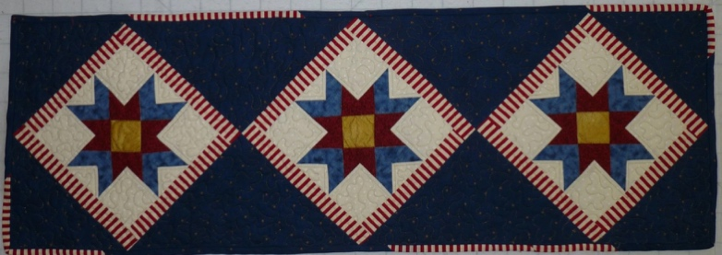 | 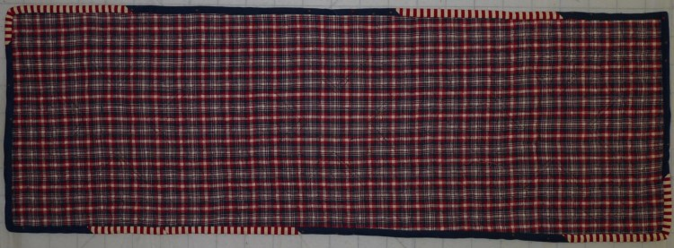

History

Provenance
Describe: --

Quilt Maker
Maker: Nora Mazur |  | Birth: -- |  | Death: --
 | Location: Champion, OH |  | Contributions: --

Purpose and Context
Expression
Art | Personal Enjoyment | Therapy
Income
Personal Income | Fundraising
Presentation
Anniversary | Wedding | Birth
Holiday | Birthday | Other gift
Charitable support
Relationships
Friendship | Commemorative | Memorial
Mourning | Reunion
Skill Building
Challenge / Contest | Learning / Teaching Sample
Use
Bed Quilt | Lap Quilt | Home Décor
Baby / Crib | Wall Hanging
Describe other purpose: --

Quilt Top Design & Construction

Quilt Top
Layout Design: . This quilt is one row of three on-point stars. It is made from cotton fabrics that read solid – red, blue and gold. There are also red/white stripped fabric and a dark blue calico with stars.
Images
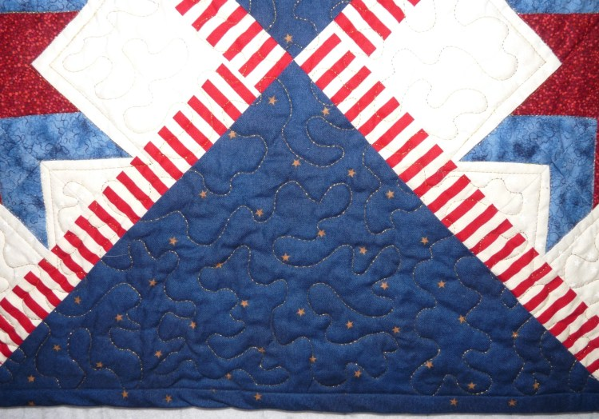

Top Inscriptions
None Found

Quilt Back Design & Construction

Quilt Back
Layout Design: .

Back Inscriptions
None Found

Stabilization Method
Stabilization Method:
Batting
Quilting Techniques
 | Machine Quilted | Machine – sit-down | Corded
 | Machine – computer guided | Hand Quilted | Stuffed work
 | Machine – manual long-arm | Quilt-as-you-go
 | Describe: --
Quilting Patterns
 | Meander / Free motion | Lines – single parallel | Cables
 | In-the-ditch / To the piece | Lines – double parallel | Feathers
 | Echo / Outlined | Lines – triple parallel | Wreaths
 | Stipple | Grid – crosshatch | Vines
 | Clamshell | Grid – square | Floral
 | Elbow / Fan | Grid - diamond | Leaves
 | Describe other: --
Thread Choices
 | Brand | Weight | Number & Name
 | -- | -- | --
Describe: --
Images for Stabilization

Edge Finish
Edge Style:
Finishing Technique
Top Width: 0.00 “ | Binding | Rolled – top to back
Back Width: 0.00“ | Knife edge | Rolled – back to top
1/8 = 0.13, 3/8 = 0.38 | Turned with a closure
5/8 = 0.63, 7/8 = 0.88
Application Method: | Top: | Back:
Embellishments
Fringe | Ruffles | Cording
Lace | Ribbon
Describe: -Pieced binding-

Images for Edge
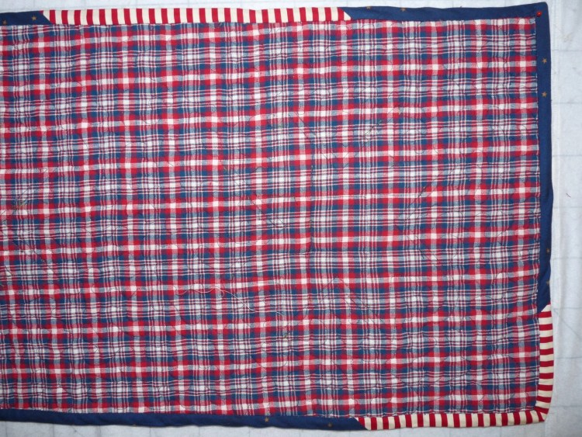

Condition

Flaws
Soiling
Dirty | Stains
Mildew stains | Musty Smell
Discoloration
Running / fugitive color | Faded / bleached color | Crocking
Fabric Damage
Tears / holes | Disintegrating / fall out | Insect damage
Thread bare | Shattering
Sewing / Quilting Damage
Split / open seams | Ties / tufting missing | Embellishments missing
Quilting threads missing | Batting has shifted
Storage Issues
Discoloration from wood | Damage from acid | Fold marks / creases
Describe additional condition issues: --
Images for Condition Issues

Conservation, Restoration, Repairs
Describe Measures: --

Workmanship

Extension of Useful Life
Repair | Useful life of the item was extended.
Prevention of Damage
Conservation | All work is reversible.
Conservation | Further deterioration has been slowed, stabilized or prevented.
Maintaining Function & Integrity
Conservation | Work minimally interferes with the item’s overall appearance.
Restoration | Work blends well with the item’s overall appearance, style and age.
Restoration | Appropriate period reproductions were used.
Restoration | Vintage materials were used.
Restoration | Period appropriate techniques were used.
Restoration | Workmanship is of similar or better quality than original work.

Images for Conservation / Restoration / Repairs

