Documentation Form

Overview

Owner History
Owner | From Date | To Date | Acquired at: | Cost
David Bailey | 2005-12-25 | -- | Newton Falls, OH | $0
Made in:
--
 | If not purchased, the estimated cost for materials: $0

Display & Publication History
Date | Event | Location / Publication
-- | -- | --

General Description
Quilt Title or Name:  Flying Geese Table Runner | Fabric Date Range: 2002 ± 3 Years  Date Made: 2003 ± 2 Years  Method of Determination:
Item Type:  Items in Set: 1 | Size: Length: 48“ x Width: 19“
Appraisals:  Has this quilt been professionally appraised?  If so, when: --  ----------- | Other related files:
Additional Information: -A gift to me from my mother for Xmas.-

Images
Top | Back
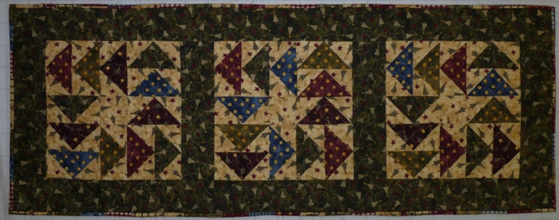 | 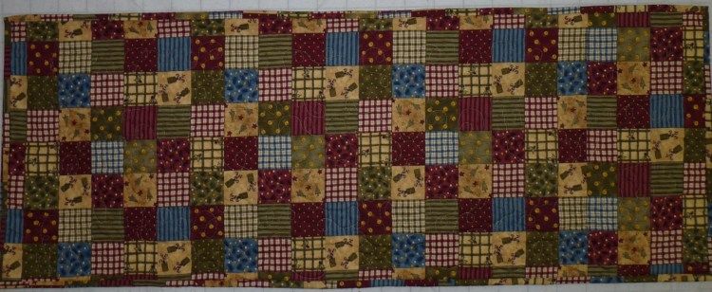

History

Provenance
Describe: --

Quilt Maker
Maker: Linda Bailey |  | Birth: September 9, 1948 |  | Death: --
 | Location: Newton Falls, Ohio |  | Contributions: --

Purpose and Context
Expression
Art | Personal Enjoyment | Therapy
Income
Personal Income | Fundraising
Presentation
Anniversary | Wedding | Birth
Holiday | Birthday | Other gift
Charitable support
Relationships
Friendship | Commemorative | Memorial
Mourning | Reunion
Skill Building
Challenge / Contest | Learning / Teaching Sample
Use
Bed Quilt | Lap Quilt | Home Décor
Baby / Crib | Wall Hanging
Describe other purpose: --

Quilt Top Design & Construction

Quilt Top
Layout Design: .
Describe: This table runner is one row of three flying geese blocks (BB ID 1967). The fabric is cotton prints predominantly blue, maroon and green. There is one border that is made of strips – not pieced fabric. The top is machine pieced.

Images
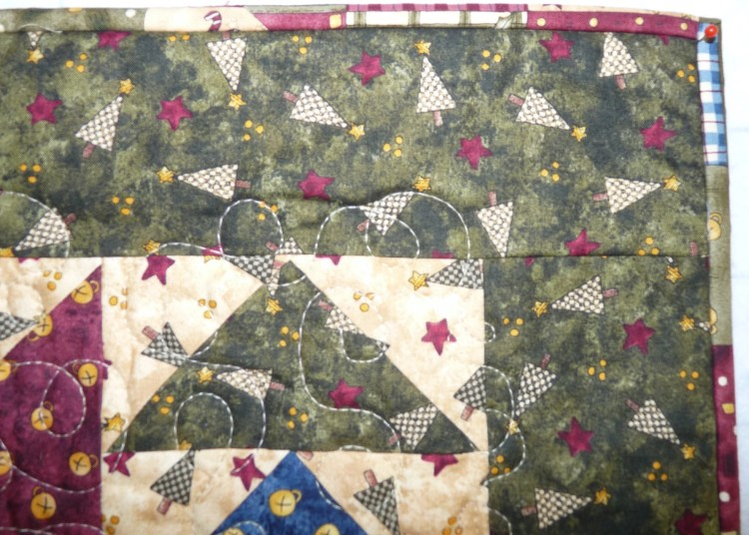

Top Inscriptions
None Found

Quilt Back Design & Construction

Quilt Back
Layout Design: .
Describe: Wholecloth of a cheater cloth that looks like 2” pieced blocks.

Back Inscriptions
None Found

Stabilization Method
Stabilization Method:
Batting
Quilting Techniques
 | Machine Quilted | Machine – sit-down | Corded
 | Machine – computer guided | Hand Quilted | Stuffed work
 | Machine – manual long-arm | Quilt-as-you-go
 | Describe: --
Quilting Patterns
 | Meander / Free motion | Lines – single parallel | Cables
 | In-the-ditch / To the piece | Lines – double parallel | Feathers
 | Echo / Outlined | Lines – triple parallel | Wreaths
 | Stipple | Grid – crosshatch | Vines
 | Clamshell | Grid – square | Floral
 | Elbow / Fan | Grid - diamond | Leaves
 | Describe other: --
Thread Choices
 | Brand | Weight | Number & Name
 | -- | -- | --
Describe: --
Images for Stabilization

Edge Finish
Edge Style:
Finishing Technique
Top Width: 0.00 “ | Binding | Rolled – top to back
Back Width: 0.00“ | Knife edge | Rolled – back to top
1/8 = 0.13, 3/8 = 0.38 | Turned with a closure
5/8 = 0.63, 7/8 = 0.88
Application Method: | Top: | Back:
Embellishments
Fringe | Ruffles | Cording
Lace | Ribbon
Describe: --

Images for Edge
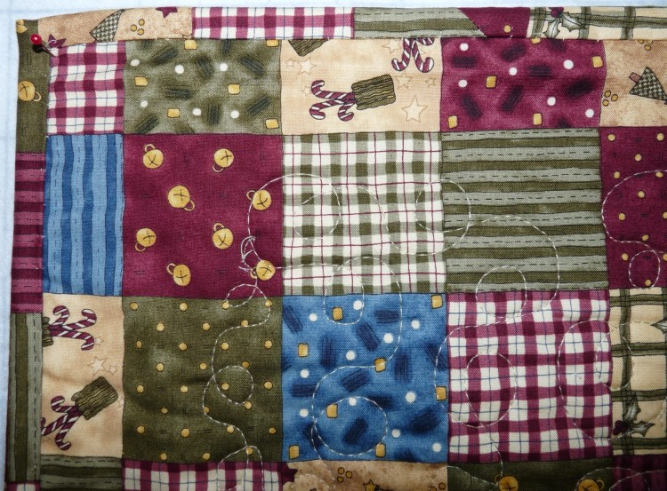

Condition

Flaws
Soiling
Dirty | Stains
Mildew stains | Musty Smell
Discoloration
Running / fugitive color | Faded / bleached color | Crocking
Fabric Damage
Tears / holes | Disintegrating / fall out | Insect damage
Thread bare | Shattering
Sewing / Quilting Damage
Split / open seams | Ties / tufting missing | Embellishments missing
Quilting threads missing | Batting has shifted
Storage Issues
Discoloration from wood | Damage from acid | Fold marks / creases
Describe additional condition issues: --
Images for Condition Issues

Conservation, Restoration, Repairs
Describe Measures: --

Workmanship

Extension of Useful Life
Repair | Useful life of the item was extended.
Prevention of Damage
Conservation | All work is reversible.
Conservation | Further deterioration has been slowed, stabilized or prevented.
Maintaining Function & Integrity
Conservation | Work minimally interferes with the item’s overall appearance.
Restoration | Work blends well with the item’s overall appearance, style and age.
Restoration | Appropriate period reproductions were used.
Restoration | Vintage materials were used.
Restoration | Period appropriate techniques were used.
Restoration | Workmanship is of similar or better quality than original work.

Images for Conservation / Restoration / Repairs

