Documentation Form

Overview

Owner History
Owner | From Date | To Date | Made in: | Cost
David Bailey | 2022-09-13 | -- | Flint, MI | $0
 | If not purchased, the estimated cost for materials: $30

Display & Publication History
Date | Event | Location / Publication
-- | -- | --

General Description
Quilt Title or Name:  Sea Turtles | Fabric Date Range: 2021 ± 0 Years  Date Made: 2022 ± 0 Years  Method of Determination:
Item Type:  Items in Set: 1 | Size: Length: 13“ x Width: 13“
Appraisals:  Has this quilt been professionally appraised?  If so, when: --  ----------- | Other related files:
Additional Information: --

Images
Top | Back
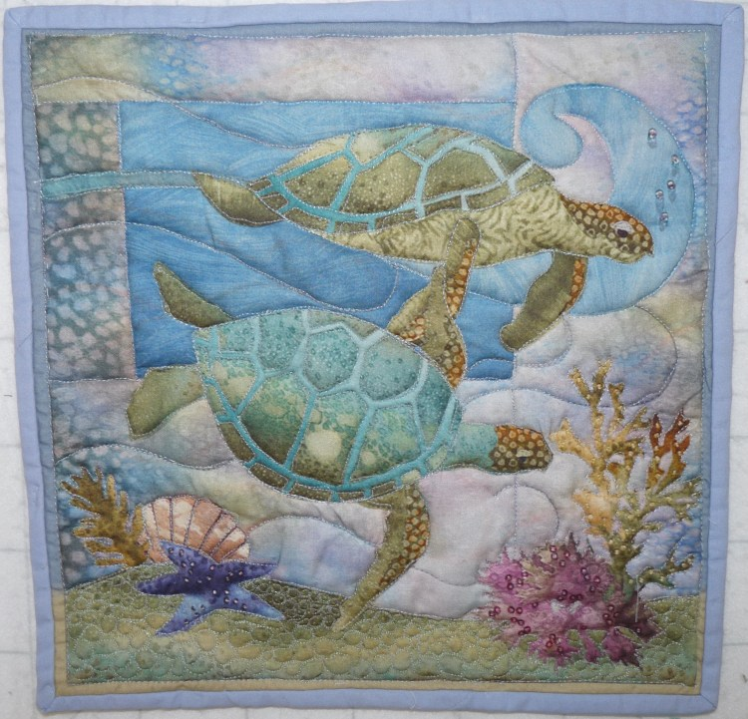 | 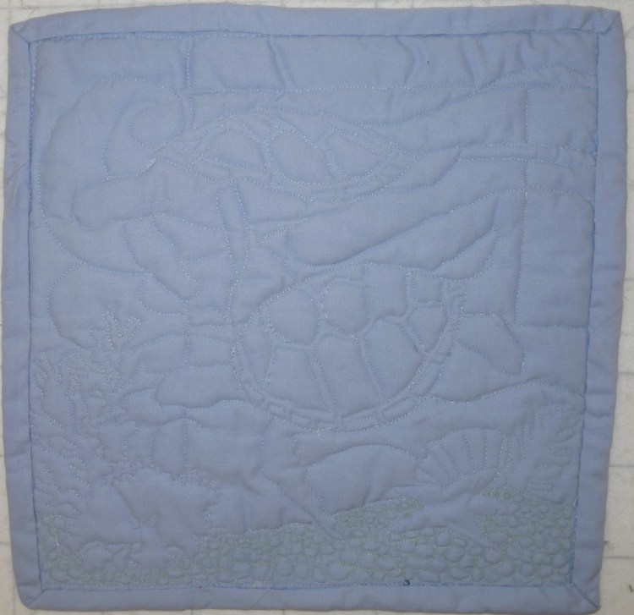

History

Provenance
Describe: --

Quilt Maker
Maker: David Bailey |  | Birth: July 20 1967 |  | Death: --
 | Location: Flint, MI, Chicago, IL |  | Contributions: --

Purpose and Context
Expression
Art | Personal Enjoyment | Therapy
Income
Personal Income | Fundraising
Presentation
Anniversary | Wedding | Birth
Holiday | Birthday | Other gift
Charitable support
Relationships
Friendship | Commemorative | Memorial
Mourning | Reunion
Skill Building
Challenge / Contest | Learning / Teaching Sample
Use
Bed Quilt | Lap Quilt | Home Décor
Baby / Crib | Wall Hanging
Describe other purpose: --

Quilt Top Design & Construction

Quilt Top
Layout Design: .
Describe: Whole cloth printed panel in cotton. The Nerdles Art Print by McKenna Ryan Sea Breeze. Image was used as template for quilting. This was used to learn how to control the sewing machine and the fabric without the use of feeddogs for free motion quilting.

Quilt Back Design & Construction

Quilt Back
Describe: Whole cloth – blue cotton.

Back Inscriptions
None Found
Inscription is present. Describe location: --
Content
Makers names | Initials | Date
Single Name | Message | Place
Multiple Names
Transcription: --

Methods
Label | Ink – Ball point | Stencil
Printed onto fabric | Ink – Felt tip | Stamped
Quilted | Ink - Other | Pencil
Embroidery | Applique | Typewriter
Describe & Clarify: --

Images for Inscriptions

Stabilization Method
Stabilization Method:
Batting
Quilting Techniques
 | Machine Quilted | Machine – sit-down | Corded
 | Machine – computer guided | Hand Quilted | Stuffed work
 | Machine – manual long-arm | Quilt-as-you-go
 | Describe: --
Quilting Patterns
 | Meander / Free motion | Lines – single parallel | Cables
 | In-the-ditch / To the piece | Lines – double parallel | Feathers
 | Echo / Outlined | Lines – triple parallel | Wreaths
 | Stipple | Grid – crosshatch | Vines
 | Clamshell | Grid – square | Floral
 | Elbow / Fan | Grid - diamond | Leaves
 | Describe other: --
Thread Choices
 | Brand | Weight | Number & Name
 | -- | -- | --
Describe: --
Images for Stabilization

Edge Finish
Edge Style:
Finishing Technique
Top Width: 0.00 “ | Binding | Rolled – top to back
Back Width: 0.00“ | Knife edge | Rolled – back to top
1/8 = 0.13, 3/8 = 0.38 | Turned with a closure
5/8 = 0.63, 7/8 = 0.88
Application Method: | Top: | Back:
Embellishments
Fringe | Ruffles | Cording
Lace | Ribbon
Describe: --

Images for Edge

Condition

Flaws
Soiling
Dirty | Stains
Mildew stains | Musty Smell
Discoloration
Running / fugitive color | Faded / bleached color | Crocking
Fabric Damage
Tears / holes | Disintegrating / fall out | Insect damage
Thread bare | Shattering
Sewing / Quilting Damage
Split / open seams | Ties / tufting missing | Embellishments missing
Quilting threads missing | Batting has shifted
Storage Issues
Discoloration from wood | Damage from acid | Fold marks / creases
Describe additional condition issues: --
Images for Condition Issues

Conservation, Restoration, Repairs
Describe Measures: --

Workmanship

Extension of Useful Life
Repair | Useful life of the item was extended.
Prevention of Damage
Conservation | All work is reversible.
Conservation | Further deterioration has been slowed, stabilized or prevented.
Maintaining Function & Integrity
Conservation | Work minimally interferes with the item’s overall appearance.
Restoration | Work blends well with the item’s overall appearance, style and age.
Restoration | Appropriate period reproductions were used.
Restoration | Vintage materials were used.
Restoration | Period appropriate techniques were used.
Restoration | Workmanship is of similar or better quality than original work.

Images for Conservation / Restoration / Repairs

