Documentation Form

Overview

Owner History
Owner | From Date | To Date | Location | Cost
David Bailey | 2022-07-20 | -- | unknown - see below under additional information | $0.00
 | If not purchased, the estimated cost for materials: $0

Display & Publication History
Date | Event | Location / Publication | Pro-Rated  Reimbursement
-- | -- | -- | $0

General Description
Quilt Title or Name:  Goose Tracks Quilt Top | Fabric Date Range: 1880 ± 20 Years  Date Made: 1890 ± 10 Years  Method of Determination:
Item Type: | Size: Length: 93“ x Width: 64“
Appraisals:  Has this quilt been professionally appraised?  If so, when: --  ----------- | Other related files:  Scanned Patterns  Images  EQ 8 Files  Research Notes
Additional Information: The price paid for this item is not known. It was a gift. The price paid is not known. There was a sticker on the quilt top when it was unfolded. The sticker was a return address. I do not know if the person listed is the vendor or a previous owner/maker.
William Mills
4207 W Brocker Road
Metamora, MI 48455-9796

The piecing was done by hand and the solid white fabric was added by machine - probably at a much later date. The fabric dates apply to the pieced blocks only. I suspect that the pieced blocks were taken from another quilt - because the points are all buried in the seam allowance.

Images
Top | Back
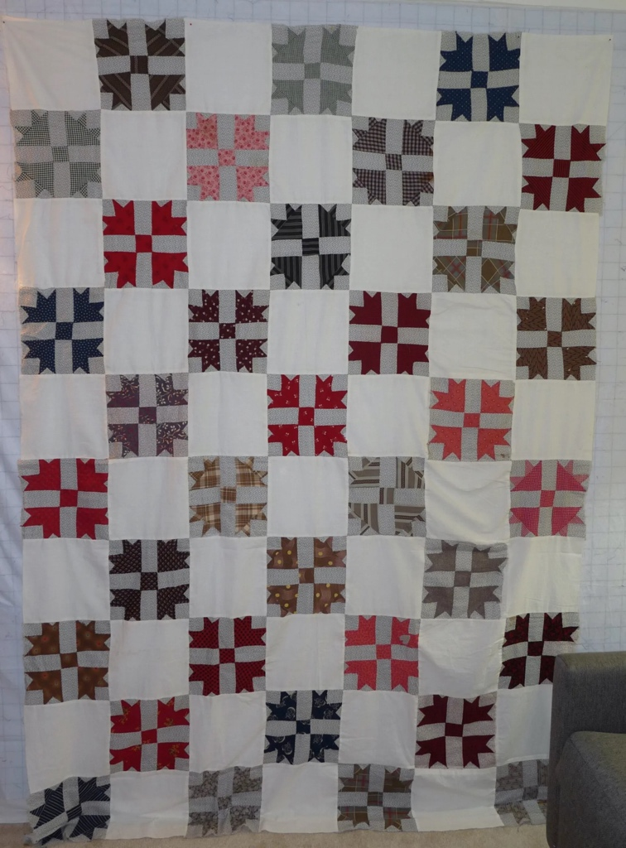 | 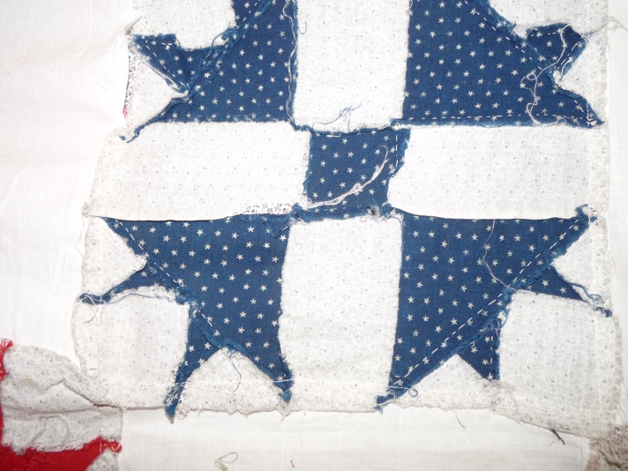

History

Provenance
Describe: See additional information listed above.

Quilt Maker
Maker: unknown |  | Birth: -- |  | Death: --
 | Location: -- |  | Contributions: --

Purpose and Context
Expression
Art | Personal Enjoyment | Therapy
Income
Personal Income | Fundraising
Presentation
Anniversary | Wedding | Birth
Holiday | Birthday | Other gift
Charitable support
Relationships
Friendship | Commemorative | Memorial
Mourning | Reunion
Skill Building
Challenge / Contest | Learning / Teaching Sample
Use
Bed Quilt | Lap Quilt | Home Décor
Baby / Crib | Wall Hanging
Describe other purpose: --

Quilt Top Design & Construction

Quilt Top
Layout
. Describe: --
Blocks
Grid & Contained Crazy Details
 |  | Grid Dimensions: Length 10 x Width: 7
 |  | Block Size: Length: 9“ x Width: 9“
Block Pattern Details
 | BB ID: 1863a and b | <<Pattern Image>>  
Cross and Crown, Goose Tracks

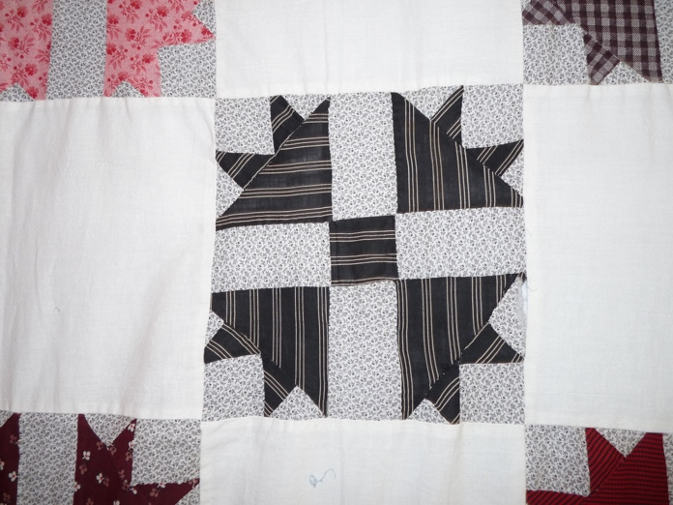

Piecing
Techniques
 |  | Machine pieced | String / Improvisational piecing
 |  | Hand pieced | Foundation piecing
 |  | Strip piecing | English paper piecing
 |  | Describe: --
 | Workmanship
 |  | Seams are stable | Seams are appropriately aligned
 |  | Seams are flat | Points are sharp
 |  | Some of the seams are starting to release - especially between the pieced blocks and the solid white fabric.

Top Assembly
Seams are stable | Top has no inappropriate tucks or puckers
Seams are flat | Top lays flat with no overly full areas
Seams are appropriately aligned

Color
Predominant colors
 | Red | Blue | Black
 | Orange | Violet/Purple | Grey
 | Yellow | Brown | White
 | Green | Beige / Tan
Specific Antique Colors |  | NONE NOTED | Neon prints
 | Red – claret / wine | Yellow – chrome | Blue – Lancaster
 | Red – madder / cinnamon | Green - chrome | Blue – Prussian / Lafayette
 | Red – turkey | Green – Nile | Brown – madder
 | Pinks - double | Blue – Cadet | Butterscotch
 | Orange - madder | Blue - Indigo | Bronze
 | Orange – cheddar / antimony / chrome |  | Late 1800’s Purple

Materials
Sources of Fabric |  | NOT KNOWN
 | Companies | Fabric Name & Number | Designer
 | -- | -- | --
 | Describe other sources: --
Fiber Types |  | NOT YET IDENTIFIED
 | Cotton | Silk | Wool
 | Cotton Blend | Linen | Synthetic
 | Describe & Clarify: --
Fabric Types |  | NOT KNOWN
 | Broadcloth | Sateen | Upholstery
 | Flannel | Satin | Chintz
 | Shirting | Muslin | Glazed
 | Suiting | Velvet | Handwoven
 | Denim | Felt | Lindsey-Woolsey
 | Describe & Clarify: --
Print Types |  | NOT YET IDENTIFIED
 | Batik | Floral | Plaid
 | Cheater Panel | Geometric | Solid / Plain
 | Checked / Gingham | Hand-dyed | Stamped
 | Conversation / Novelty | Victorian Mourning Prints | Stripes
 | Dotted | Multiple scraps
 | Feed sack / Feed sack-like | Paisley
 | Describe & Clarify: --

Images for Top

Condition

Flaws
Soiling
Dirty | Stains
Mildew stains | Musty Smell
Discoloration
Running / fugitive color | Faded / bleached color | Crocking
Fabric Damage
Tears / holes | Disintegrating / fall out | Insect damage
Thread bare | Shattering
Sewing / Quilting Damage
Split / open seams | Ties / tufting missing | Embellishments missing
Quilting threads missing | Batting has shifted
Storage Issues
Discoloration from wood | Damage from acid | Fold marks / creases
Describe additional condition issues: --
Images for Condition Issues

Conservation, Restoration, Repairs
Describe Measures: --

Workmanship

Extension of Useful Life
Repair | Useful life of the item was extended.
Prevention of Damage
Conservation | All work is reversible.
Conservation | Further deterioration has been slowed, stabilized or prevented.
Maintaining Function & Integrity
Conservation | Work minimally interferes with the item’s overall appearance.
Restoration | Work blends well with the item’s overall appearance, style and age.
Restoration | Appropriate period reproductions were used.
Restoration | Vintage materials were used.
Restoration | Period appropriate techniques were used.
Restoration | Workmanship is of similar or better quality than original work.

Images for Conservation / Restoration / Repairs

