Documentation Form

Overview

Owner History
Owner | From Date | To Date | Location | Cost
David Bailey | 2024-11-18 | -- | The Antique Warehouse and Specialty Shops  1122 Tittabawassee  Saginaw, MI 48604  989 755 4343  www.saginawantiquewarehouse.com  saginawantiquewarehouse@gmail.com | $139.00
 | If not purchased, the estimated cost for materials: $0

Display & Publication History
Date | Event | Location / Publication | Pro-Rated  Reimbursement
-- | -- | -- | $0

General Description
Quilt Title or Name:  Sampler Tied Comforter | Fabric Date Range: 1880 ± 10 Years  Date Made: 1895 ± 10 Years  Method of Determination:
Item Type: | Size: Length: 89“ x Width: 76“
Appraisals:  Has this quilt been professionally appraised?  If so, when: --  ----------- | Other related files:
Additional Information: -The finish date was recommended by Chris Moline and considers the stabilization method, which for this quilt is tied. She feels that this quilt top was likely one of many that were made during the 1880's and then quickly finished during the 1890 for a series of hard winters that the mid-west experienced during that decade.-

Images
Top | Back
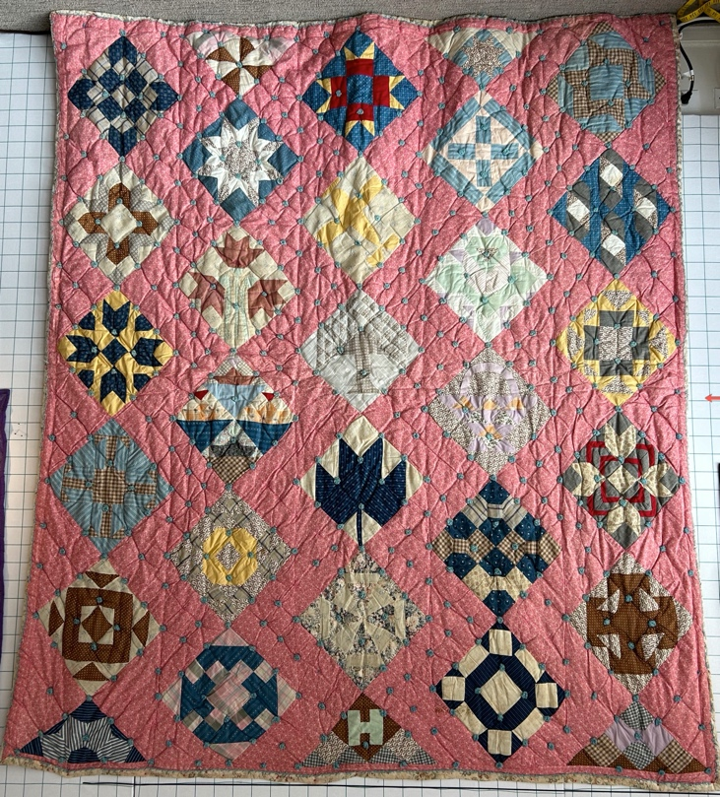 | 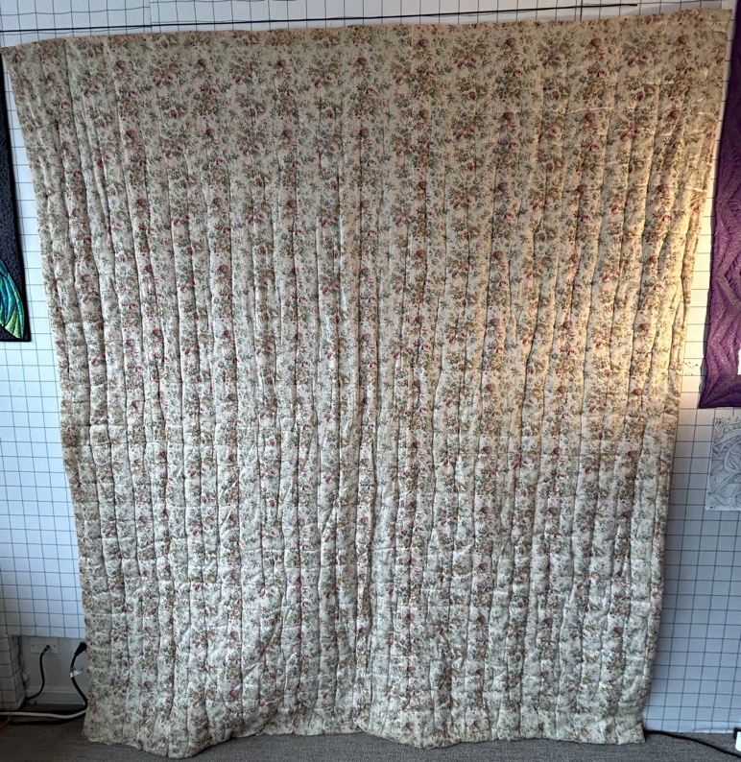

History

Provenance
Describe: --

Quilt Maker
Maker: -unknown- |  | Birth: -- |  | Death: --
 | Location: -- |  | Contributions: --

Purpose and Context
Expression
Art | Personal Enjoyment | Therapy
Income
Personal Income | Fundraising
Presentation
Anniversary | Wedding | Birth
Holiday | Birthday | Other gift
Charitable support
Relationships
Friendship | Commemorative | Memorial
Mourning | Reunion
Skill Building
Challenge / Contest | Learning / Teaching Sample
Use
Bed Quilt | Lap Quilt | Home Décor
Baby / Crib | Wall Hanging
Describe other purpose: --

Quilt Top Design & Construction

Quilt Top
Layout
. Describe: Sampler piecing. On-point. Half drop. 5x5.5 grid.
Blocks
Grid & Contained Crazy Details
 |  | Grid Dimensions: Length 5 x Width: 5
 |  | Block Size: Length: 0“ x Width: 0“
Block Pattern Details
 | Pattern source | <<Pattern Image>>
 | Pattern name & Brackman or other ID | <<Pattern Image>>

Piecing
Techniques
 |  | Machine pieced | String / Improvisational piecing
 |  | Hand pieced | Foundation piecing
 |  | Strip piecing | English paper piecing
 |  | Describe: --
 | Workmanship
 |  | Seams are stable | Seams are appropriately aligned
 |  | Seams are flat | Points are sharp
 |  | Describe piecing workmanship

Sashing
Length: 0“ x Width: 0“
Use of corner stones

Top Assembly
Seams are stable | Top has no inappropriate tucks or puckers
Seams are flat | Top lays flat with no overly full areas
Seams are appropriately aligned

Color
Predominant colors
 | Red | Blue | Black
 | Orange | Violet/Purple | Grey
 | Yellow | Brown | White
 | Green | Beige / Tan
Specific Antique Colors |  | NONE NOTED | Neon prints
 | Red – claret / wine | Yellow – chrome | Blue – Lancaster
 | Red – madder / cinnamon | Green - chrome | Blue – Prussian / Lafayette
 | Red – turkey | Green – Nile | Brown – madder
 | Pinks - double | Blue – Cadet | Butterscotch
 | Orange - madder | Blue - Indigo | Bronze
 | Orange – cheddar / antimony / chrome |  | Late 1800’s Purple

Materials
Sources of Fabric |  | NOT KNOWN
 | Companies | Fabric Name & Number | Designer
 | -- | -- | --
 | Describe other sources: --
Fiber Types |  | NOT YET IDENTIFIED
 | Cotton | Silk | Wool
 | Cotton Blend | Linen | Synthetic
 | Describe & Clarify: --
Fabric Types |  | NOT KNOWN
 | Broadcloth | Sateen | Upholstery
 | Flannel | Satin | Chintz
 | Shirting | Muslin | Glazed
 | Suiting | Velvet | Handwoven
 | Denim | Felt | Lindsey-Woolsey
 | Describe & Clarify: --
Print Types |  | NOT YET IDENTIFIED
 | Batik | Floral | Plaid
 | Cheater Panel | Geometric | Solid / Plain
 | Checked / Gingham | Hand-dyed | Stamped
 | Conversation / Novelty | Victorian Mourning Prints | Stripes
 | Dotted | Multiple scraps
 | Feed sack / Feed sack-like | Paisley
 | Describe & Clarify: --

Images for Top
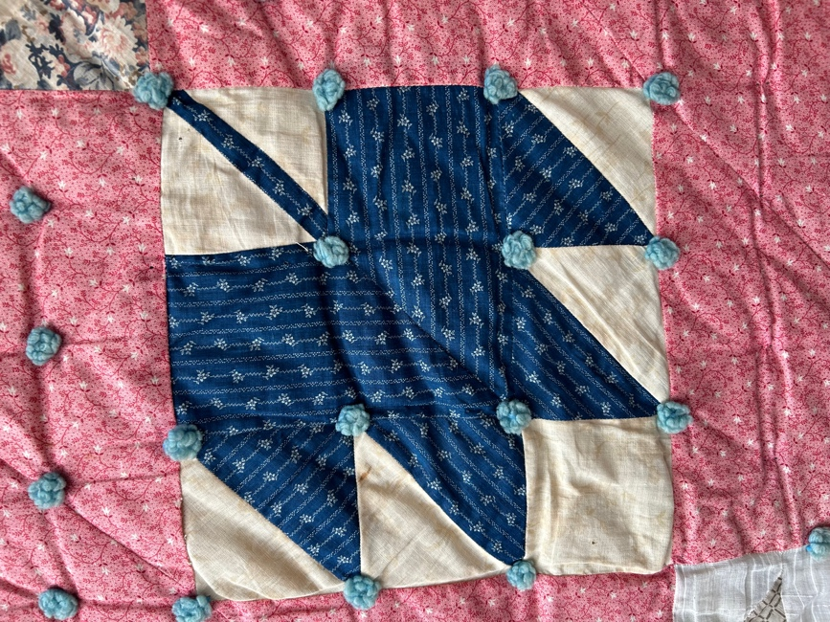 | 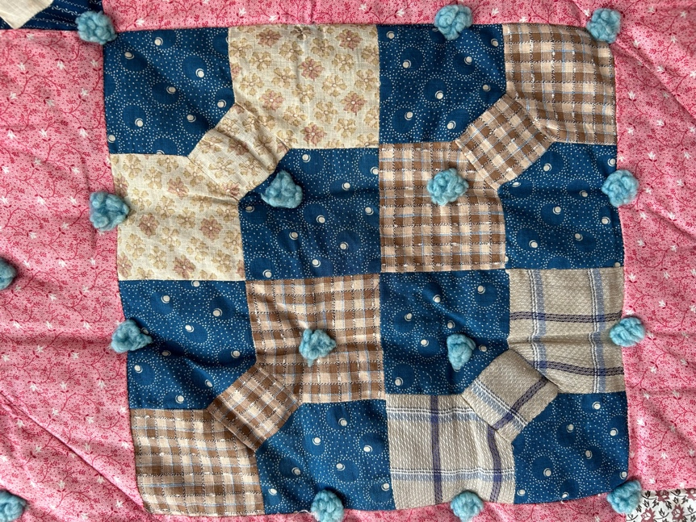
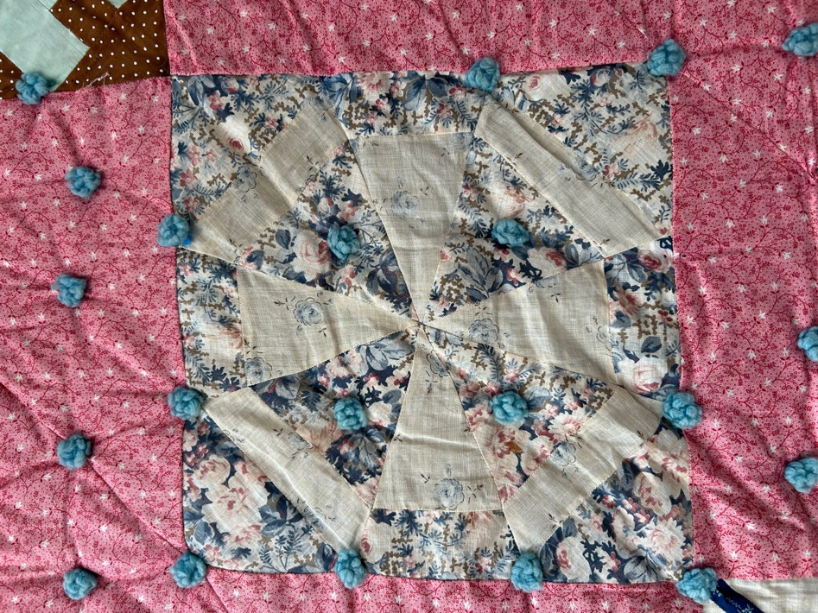 | 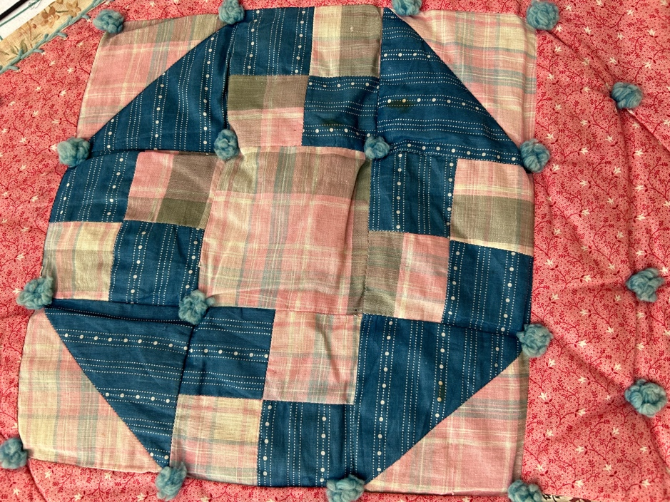
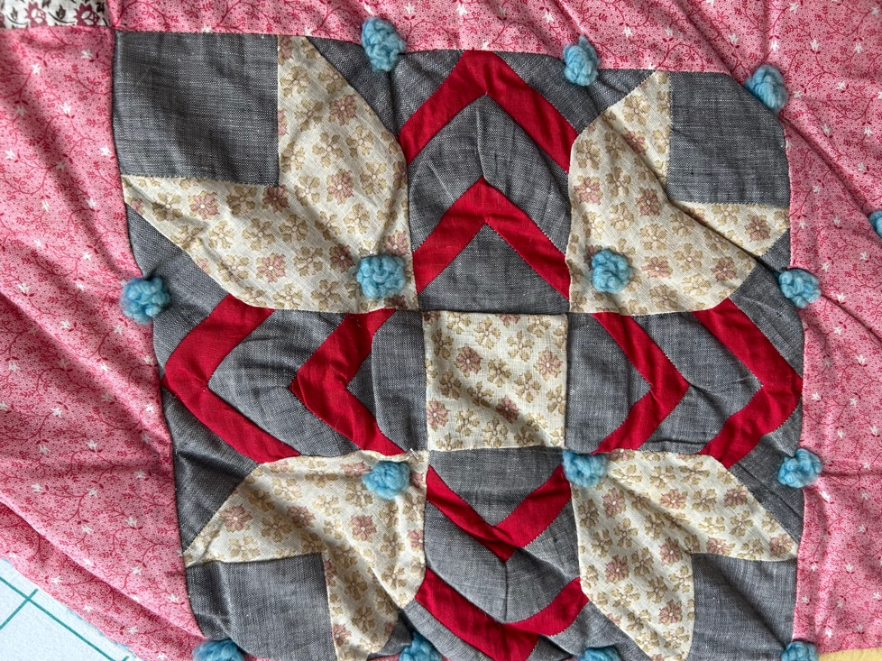 | 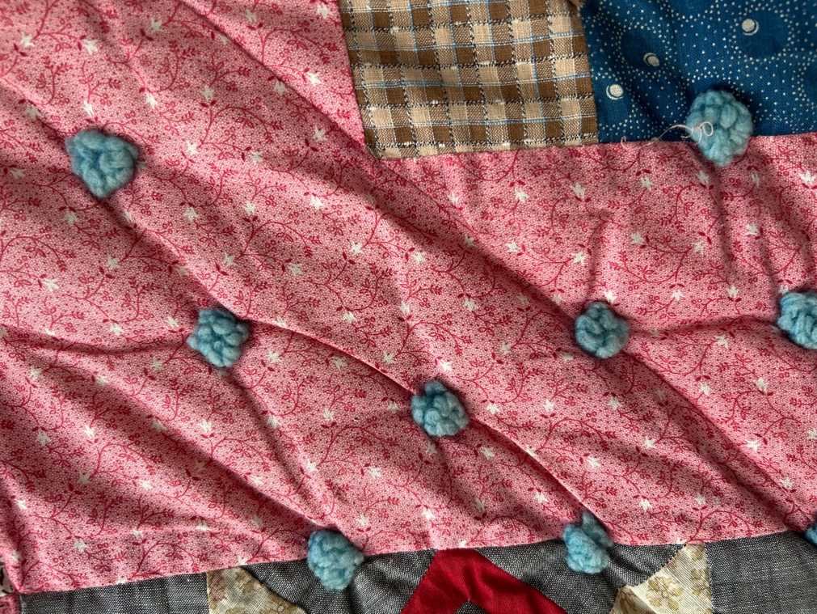

Top Inscriptions
None Found
Inscription is present. Describe location: --
Content
Makers names | Initials | Date
Single Name | Message | Place
Multiple Names
Transcription: --

Methods
Label | Ink – Ball point | Stencil
Printed onto fabric | Ink – Felt tip | Stamped
Quilted | Ink - Other | Pencil
Embroidery | Applique | Typewriter
Describe & Clarify: --

Images for Inscriptions

Quilt Back Design & Construction

Quilt Back
Layout
. Describe: -Medium to large scale floral print. Relatively open weave. Cotton.-
Images for Back
 | 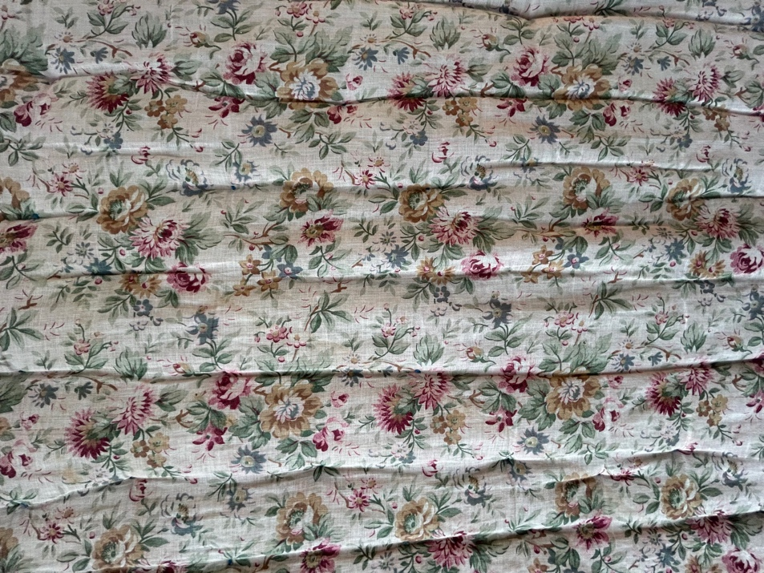 | 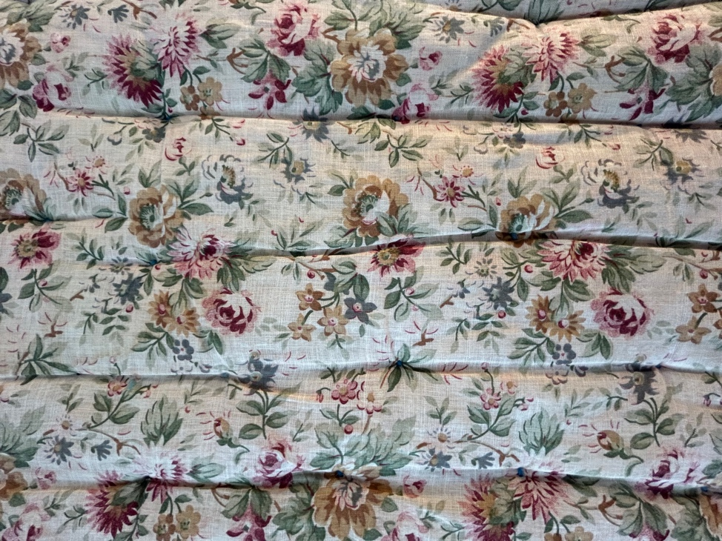

Back Inscriptions
None found
Inscription is present. Describe location: --
Content
Makers names | Initials | Date
Single Name | Message | Place
Multiple Names
Transcription: --

Methods
Label | Ink – Ball point | Stencil
Printed onto fabric | Ink – Felt tip | Stamped
Quilted | Ink - Other | Pencil
Embroidery | Applique | Typewriter
Describe & Clarify: --

Images for Back

Stabilization Method
Stabilization Method:
Tied Details
 | Average Distance Between Knots: 2” |  | Placement:
 |  |  | Fiber Used:
Batting
Images for Quilting
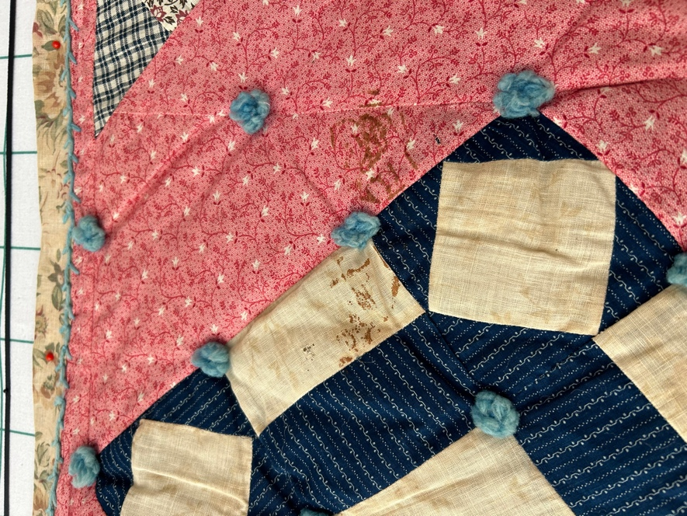 | 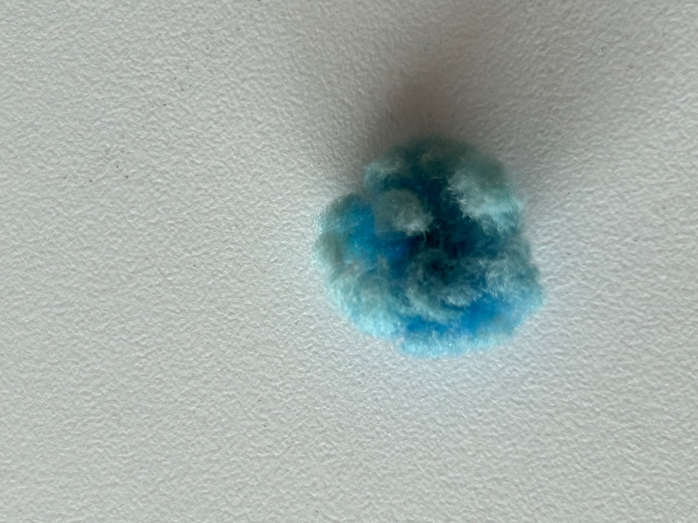

Edge Finish
Edge Style:
Finishing Technique
Top Width: 0.00 “ | Binding | Rolled – top to back
Back Width: 0.00“ | Front – machine | Rolled – back to top
1/8 = 0.13, 3/8 = 0.38 | Front – hand | Knife edge
5/8 = 0.63, 7/8 = 0.88 | Back – machine | Turned
 | Back - hand
Embellishments
Fringe | Ruffles | Cording
Lace | Ribbon
Describe: The edge is rolled from back to front and applied with the same blue yarn used for the ties. Ties form rosettes.--

Images for Edge

Condition

Flaws
Soiling
Dirty | Stains
Mildew stains | Musty Smell
Discoloration
Running / fugitive color | Faded / bleached color | Crocking
Fabric Damage
Tears / holes | Disintegrating / fall out | Insect damage
Thread bare | Shattering
Sewing / Quilting Damage
Split / open seams | Ties / tufting missing | Embellishments missing
Quilting threads missing | Batting has shifted
Storage Issues
Discoloration from wood | Damage from acid | Fold marks / creases
Describe additional condition issues: -Stains are minor. The yarn ties have started popping off because of the vloume of the batting.-
Images for Condition Issues
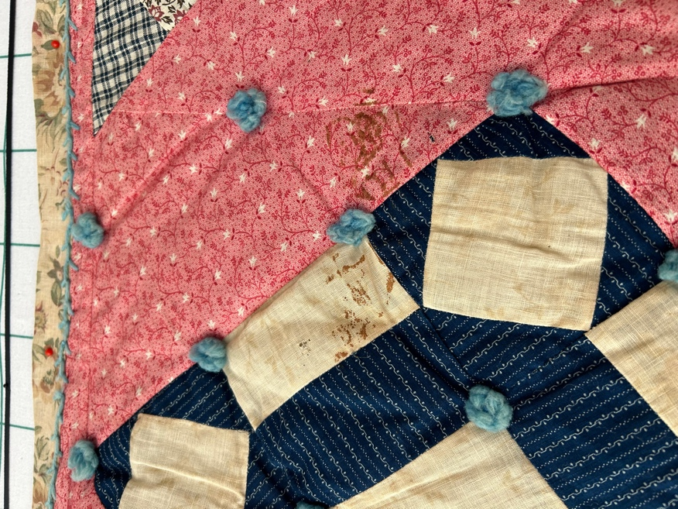

Conservation, Restoration, Repairs
Describe Measures: --

Workmanship

Extension of Useful Life
Repair | Useful life of the item was extended.
Prevention of Damage
Conservation | All work is reversible.
Conservation | Further deterioration has been slowed, stabilized or prevented.
Maintaining Function & Integrity
Conservation | Work minimally interferes with the item’s overall appearance.
Restoration | Work blends well with the item’s overall appearance, style and age.
Restoration | Appropriate period reproductions were used.
Restoration | Vintage materials were used.
Restoration | Period appropriate techniques were used.
Restoration | Workmanship is of similar or better quality than original work.

Images for Conservation / Restoration / Repairs

