Documentation Form

Overview

Owner History
Owner | From Date | To Date | Location | Cost
David Bailey | 2022-03-22 | -- | The Antique Warehouse  1122 Tittabawassee Road  Saginaw, MI 48604 | $49.50
 | If not purchased, the estimated cost for materials: $0

Display & Publication History
Date | Event | Location / Publication
Oct 7, 2024 | Montcomb County Quilter's Guild Meeting | Trinity Lutheran Church, Clinton Township, MI
Nov 18, 2024 | Anchor Bay Quilter’s Guild Meeting | New Baltimore, MI

General Description
Quilt Title or Name:  Flower Basket Quilt | Fabric Date Range: 1935 ± 15 Years  Date Made: 1935 ± 15 Years  Method of Determination:
Item Type: | Size: Length: 70“ x Width: 61“
Appraisals:  Has this quilt been professionally appraised?  If so, when: --  ----------- | Other related files:
Additional Information: -This quilt was very badly stained when I bought it and I thought that I might be able to clean it up. The washing process did not work. It bleached out the flower baskets. They were orginally nile green and purple pastels. Now they are - well - what the are now. Beige. The stains on the background are reduced but not gone. Oh well. Chalk this one up to experience. See the before and after pictures under Repair and Restoration.-

Images
Top | Back
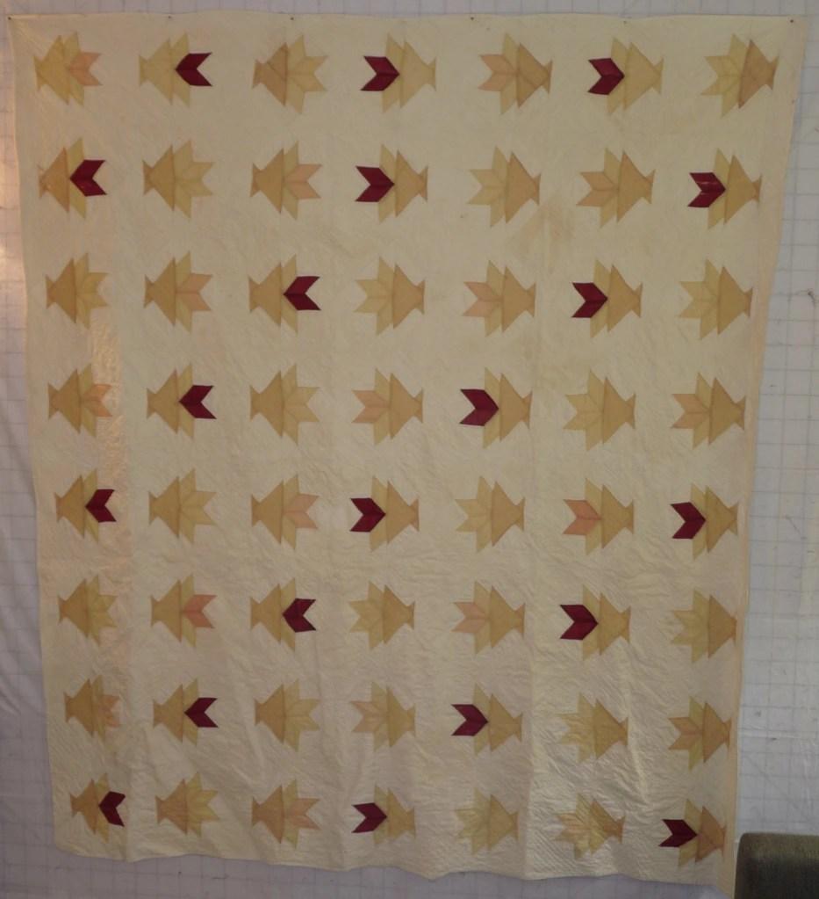

History

Provenance
Describe: --

Quilt Maker
Maker: -- |  | Birth: -- |  | Death: --
 | Location: -- |  | Contributions: --

Purpose and Context
Expression
Art | Personal Enjoyment | Therapy
Income
Personal Income | Fundraising
Presentation
Anniversary | Wedding | Birth
Holiday | Birthday | Other gift
Charitable support
Relationships
Friendship | Commemorative | Memorial
Mourning | Reunion
Skill Building
Challenge / Contest | Learning / Teaching Sample
Use
Bed Quilt | Lap Quilt | Home Décor
Baby / Crib | Wall Hanging
Describe other purpose: --

Coverlet Design & Construction

Coverlet Top
Warp strand count per inch: 0. | Design: --
Warp fiber: | Weaver: --
Weft strand count per inch: 0” | Location: --
Weft fiber: | Woven for: --

Quilt Top Design & Construction

Quilt Top
Layout
. Describe: -The fabrics used for piecing in the top are very sheer. - Almost like gauze. If it weren't for the colors I would have placed the quality of this fabric in the 1910's.-
Blocks
Grid & Contained Crazy Details
 |  | Grid Dimensions: Length 8 x Width: 7
 |  | Block Size: Length: 0“ x Width: 0“
Block Pattern Details
 | BB ID 730 Cactus Basket or Flower Pot | 
 | Pattern name & Brackman or other ID

Piecing
Techniques
 |  | Machine pieced | String / Improvisational piecing
 |  | Hand pieced | Foundation piecing
 |  | Strip piecing | English paper piecing
 |  | Describe: --
 | Workmanship
 |  | Seams are stable | Seams are appropriately aligned
 |  | Seams are flat | Points are sharp
 |  | Describe piecing workmanship

Top Assembly
Seams are stable | Top has no inappropriate tucks or puckers
Seams are flat | Top lays flat with no overly full areas
Seams are appropriately aligned

Color
Predominant colors
 | Red | Blue | Black
 | Orange | Violet/Purple | Grey
 | Yellow | Brown | White
 | Green | Beige / Tan
Specific Antique Colors |  | NONE NOTED | Neon prints
 | Red – claret / wine | Yellow – chrome | Blue – Lancaster
 | Red – madder / cinnamon | Green - chrome | Blue – Prussian / Lafayette
 | Red – turkey | Green – Nile | Brown – madder
 | Pinks - double | Blue – Cadet | Butterscotch
 | Orange - madder | Blue - Indigo | Bronze
 | Orange – cheddar / antimony / chrome |  | Late 1800’s Purple

Materials
Sources of Fabric |  | NOT KNOWN
Fiber Types |  | NOT YET IDENTIFIED
 | Cotton | Silk | Wool
 | Cotton Blend | Linen | Synthetic
 | Describe & Clarify: --
Fabric Types |  | NOT KNOWN
 | Broadcloth | Sateen | Upholstery
 | Flannel | Satin | Chintz
 | Shirting | Muslin | Glazed
 | Suiting | Velvet | Handwoven
 | Denim | Felt | Lindsey-Woolsey
 | Describe & Clarify: --
Print Types |  | NOT YET IDENTIFIED
 | Batik | Floral | Plaid
 | Cheater Panel | Geometric | Solid / Plain
 | Checked / Gingham | Hand-dyed | Stamped
 | Conversation / Novelty | Victorian Mourning Prints | Stripes
 | Dotted | Multiple scraps
 | Feed sack / Feed sack-like | Paisley
 | Describe & Clarify: --

Images for Top

Top Inscriptions
None Found
Inscription is present. Describe location: --
Content
Makers names | Initials | Date
Single Name | Message | Place
Multiple Names
Transcription: --

Methods
Label | Ink – Ball point | Stencil
Printed onto fabric | Ink – Felt tip | Stamped
Quilted | Ink - Other | Pencil
Embroidery | Applique | Typewriter
Describe & Clarify: --

Images for Inscriptions

Quilt Back Design & Construction

Quilt Back
Layout
. Describe: -Solid white cotton - one seam. The seam is differently sewn than others that I have seen. It is almost like it is inclosed before the back was used in the sandwich. - Like a rolled hem or a french finish.-

Back Inscriptions
None found
Inscription is present. Describe location: --
Content
Makers names | Initials | Date
Single Name | Message | Place
Multiple Names
Transcription: --

Methods
Label | Ink – Ball point | Stencil
Printed onto fabric | Ink – Felt tip | Stamped
Quilted | Ink - Other | Pencil
Embroidery | Applique | Typewriter
Describe & Clarify: --

Images for Back

Stabilization Method
Stabilization Method:
Batting
Quilting Techniques
 | Machine Quilted | Machine – sit-down | Corded
 | Machine – computer guided | Hand Quilted | Stuffed work
 | Machine – manual long-arm | Quilt-as-you-go
 | Describe: --
Quilting Patterns
 | Meander / Free motion | Lines – single parallel | Cables
 | In-the-ditch / To the piece | Lines – double parallel | Feathers
 | Echo / Outlined | Lines – triple parallel | Wreaths
 | Stipple | Grid – crosshatch | Vines
 | Clamshell | Grid – square | Floral
 | Elbow / Fan | Grid - diamond | Leaves
 | Describe other: --
Thread Choices
 | Brand | Weight | Number & Name
 | -- | -- | --
Images for Quilting

Edge Finish
Edge Style:
Finishing Technique
Top Width: 0.00 “ | Binding | Rolled – top to back
Back Width: 0.00“ | Front – machine | Rolled – back to top
1/8 = 0.13, 3/8 = 0.38 | Front – hand | Knife edge
5/8 = 0.63, 7/8 = 0.88 | Back – machine | Turned
 | Back - hand
Embellishments
Fringe | Ruffles | Cording
Lace | Ribbon
Describe: --

Images for Edge

Condition

Flaws
Soiling
Dirty | Stains
Mildew stains | Musty Smell
Discoloration
Running / fugitive color | Faded / bleached color | Crocking
Fabric Damage
Tears / holes | Disintegrating / fall out | Insect damage
Thread bare | Shattering
Sewing / Quilting Damage
Split / open seams | Ties / tufting missing | Embellishments missing
Quilting threads missing | Batting has shifted
Storage Issues
Discoloration from wood | Damage from acid | Fold marks / creases
Describe additional condition issues: --
Images for Condition Issues

Conservation, Restoration, Repairs
Describe Measures: Washed – and NOT made better.

Workmanship

Extension of Useful Life
Repair | Useful life of the item was extended.
Prevention of Damage
Conservation | All work is reversible.
Conservation | Further deterioration has been slowed, stabilized or prevented.
Maintaining Function & Integrity
Conservation | Work minimally interferes with the item’s overall appearance.
Restoration | Work blends well with the item’s overall appearance, style and age.
Restoration | Appropriate period reproductions were used.
Restoration | Vintage materials were used.
Restoration | Period appropriate techniques were used.
Restoration | Workmanship is of similar or better quality than original work.

Images for Conservation / Restoration / Repairs
Before cleaning  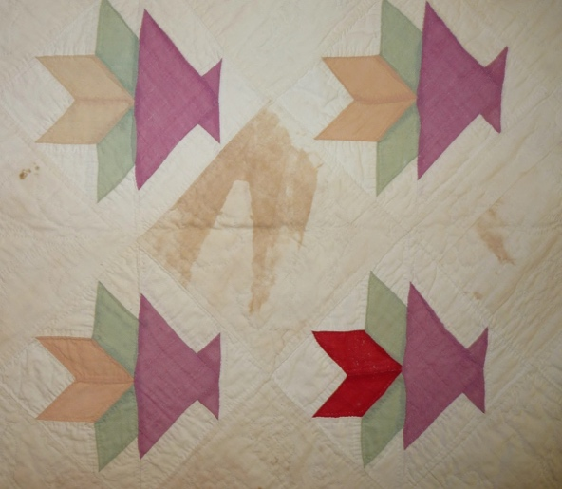 | After cleaning  