Documentation Form

Overview

Owner History
Owner | From Date | To Date | Location | Cost
David Bailey | 2022-07-31 | -- | Allegan County Fairgrounds Vendor | $5.00
 | If not purchased, the estimated cost for materials: $0

Display & Publication History
Date | Event | Location / Publication
Oct 7, 2024 | Montcomb County Quilter's Guild Meeting | Trinity Lutheran Church, Clinton Township, MI
Nov 18, 2024 | Anchor Bay Quilter’s Guild Meeting | New Baltimore, MI

General Description
Quilt Title or Name:  Red & White Crescent Star Block | Fabric Date Range: 1895 ± 10 Years  Date Made: -- ± 0 Years  Method of Determination:
Item Type: | Size: Length: 16“ x Width: 16“
Appraisals:  Has this quilt been professionally appraised?  If so, when: --  ----------- | Other related files:
Additional Information: -This is one block that was likely cut from a larger piece. The pattern is Star and Crescent. In this version, the star is pieced and the outside cresents are appliqued. The fabric is solid white and solid turkey red. The work was all by hand. The block dimensions are 16" square. -

Images
Top | Back
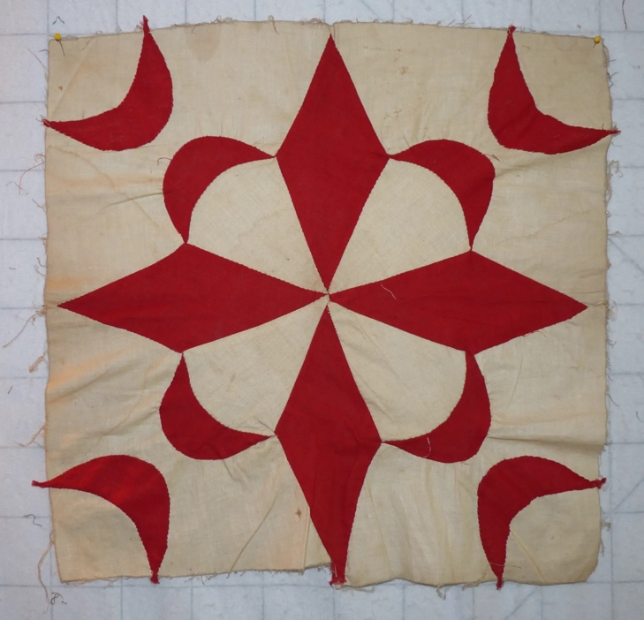 | 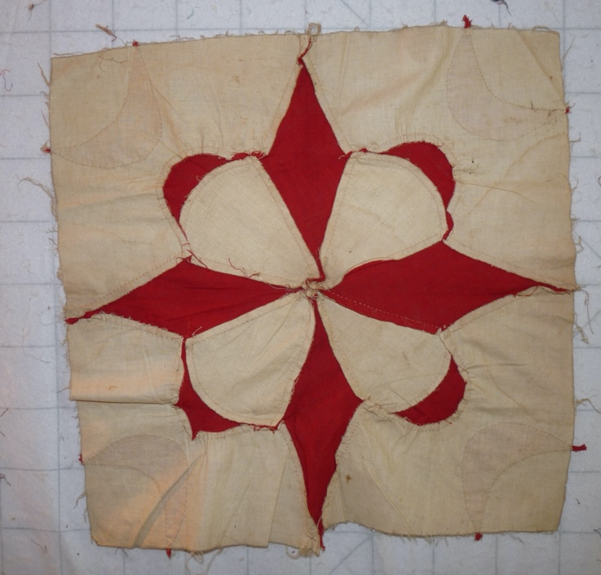

History

Provenance
Describe: --

Quilt Maker
Maker: unknown |  | Birth: -- |  | Death: --
 | Location: -- |  | Contributions: --

Purpose and Context
Expression
Art | Personal Enjoyment | Therapy
Income
Personal Income | Fundraising
Presentation
Anniversary | Wedding | Birth
Holiday | Birthday | Other gift
Charitable support
Relationships
Friendship | Commemorative | Memorial
Mourning | Reunion
Skill Building
Challenge / Contest | Learning / Teaching Sample
Use
Bed Quilt | Lap Quilt | Home Décor
Baby / Crib | Wall Hanging
Describe other purpose: --

Condition

Flaws
Soiling
Dirty | Stains
Mildew stains | Musty Smell
Discoloration
Running / fugitive color | Faded / bleached color | Crocking
Fabric Damage
Tears / holes | Disintegrating / fall out | Insect damage
Thread bare | Shattering
Sewing / Quilting Damage
Split / open seams | Ties / tufting missing | Embellishments missing
Quilting threads missing | Batting has shifted
Storage Issues
Discoloration from wood | Damage from acid | Fold marks / creases
Describe additional condition issues: --
Images for Condition Issues

Conservation, Restoration, Repairs
Describe Measures: --

Workmanship

Extension of Useful Life
Repair | Useful life of the item was extended.
Prevention of Damage
Conservation | All work is reversible.
Conservation | Further deterioration has been slowed, stabilized or prevented.
Maintaining Function & Integrity
Conservation | Work minimally interferes with the item’s overall appearance.
Restoration | Work blends well with the item’s overall appearance, style and age.
Restoration | Appropriate period reproductions were used.
Restoration | Vintage materials were used.
Restoration | Period appropriate techniques were used.
Restoration | Workmanship is of similar or better quality than original work.

Images for Conservation / Restoration / Repairs

