Documentation Form

Overview

Owner History
Owner | From Date | To Date | Location | Cost
David Bailey | 2022-03-24 | -- | Antique Warehouse & Specialty Shoppes  1122 Tittabawassee Road  Saginaw, MI 48604  989 755 4343  www.saginawantiquewarehouse.com  saginawantiquewarehouse@gmail.com | $56.00
 | If not purchased, the estimated cost for materials: $0

Display & Publication History
Date | Event | Location / Publication | Pro-Rated  Reimbursement
-- | -- | -- | $0

General Description
Quilt Title or Name:  Old Maid’s Puzzle | Fabric Date Range: 1875 ± 15 Years  Date Made: 1880 ± 10 Years  Method of Determination:
Item Type: | Size: Length: 81“ x Width: 61“
Appraisals:  Has this quilt been professionally appraised?  If so, when:  ----------- | Other related files:
Additional Information:
April 2023
During an appraiser's professional development class, this quilt was valued at around $350.--

Images
Top | Back
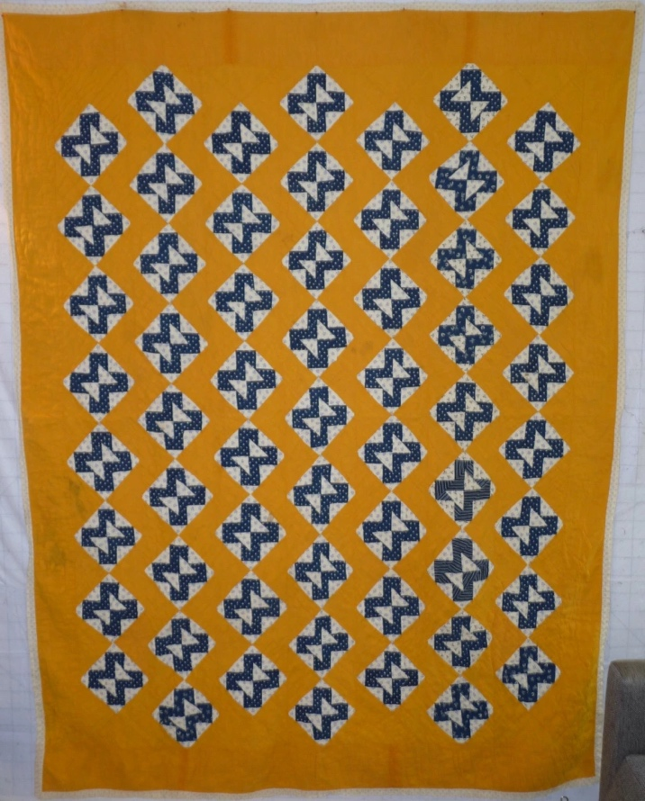 | 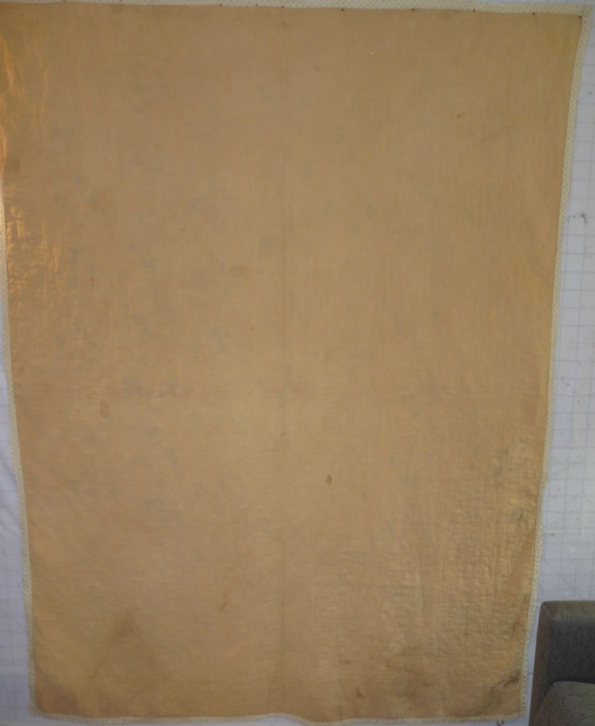

History

Provenance
Describe: --

Quilt Maker
Maker: -unknown- |  | Birth: -- |  | Death: --
 | Location: -- |  | Contributions: --

Purpose and Context
Expression
Art | Personal Enjoyment | Therapy
Income
Personal Income | Fundraising
Presentation
Anniversary | Wedding | Birth
Holiday | Birthday | Other gift
Charitable support
Relationships
Friendship | Commemorative | Memorial
Mourning | Reunion
Skill Building
Challenge / Contest | Learning / Teaching Sample
Use
Bed Quilt | Lap Quilt | Home Décor
Baby / Crib | Wall Hanging
Describe other purpose: --

Quilt Top Design & Construction

Quilt Top
Layout
. Describe: Old Maid's Puzzle block in an on-point setting with a half drop. Pieced block is blue with white background. The pieced blocks are set on a background of solid cheddar. Blocks are assembled by hand. The top is assembled by machine.
Blocks
Grid & Contained Crazy Details
 |  | Grid Dimensions: Length 8 x Width: 7
 |  | Block Size: Length: 0“ x Width: 0“
Block Pattern Details
 | BB ID 3220 | <<Pattern Image>>
 | Pattern name & Brackman or other ID | <<Pattern Image>>

Piecing
Techniques
 |  | Machine pieced | String / Improvisational piecing
 |  | Hand pieced | Foundation piecing
 |  | Strip piecing | English paper piecing
 |  | Describe: --
 | Workmanship
 |  | Seams are stable | Seams are appropriately aligned
 |  | Seams are flat | Points are sharp
 |  | Describe piecing workmanship

Sashing
Length: 0“ x Width: 0“
Use of corner stones

Borders & Frames
Describe borders and frames in order from center to edge.
1 | Width: 0.00“
 |  | Describe: --

Top Assembly
Seams are stable | Top has no inappropriate tucks or puckers
Seams are flat | Top lays flat with no overly full areas
Seams are appropriately aligned

Color
Predominant colors
 | Red | Blue | Black
 | Orange | Violet/Purple | Grey
 | Yellow | Brown | White
 | Green | Beige / Tan
Specific Antique Colors |  | NONE NOTED | Neon prints
 | Red – claret / wine | Yellow – chrome | Blue – Lancaster
 | Red – madder / cinnamon | Green - chrome | Blue – Prussian / Lafayette
 | Red – turkey | Green – Nile | Brown – madder
 | Pinks - double | Blue – Cadet | Butterscotch
 | Orange - madder | Blue - Indigo | Bronze
 | Orange – cheddar / antimony / chrome |  | Late 1800’s Purple

Materials
Sources of Fabric |  | NOT KNOWN
 | Companies | Fabric Name & Number | Designer
 | -- | -- | --
 | Describe other sources: --
Fiber Types |  | NOT YET IDENTIFIED
 | Cotton | Silk | Wool
 | Cotton Blend | Linen | Synthetic
 | Describe & Clarify: --
Fabric Types |  | NOT KNOWN
 | Broadcloth | Sateen | Upholstery
 | Flannel | Satin | Chintz
 | Shirting | Muslin | Glazed
 | Suiting | Velvet | Handwoven
 | Denim | Felt | Lindsey-Woolsey
 | Describe & Clarify: --
Print Types |  | NOT YET IDENTIFIED
 | Batik | Floral | Plaid
 | Cheater Panel | Geometric | Solid / Plain
 | Checked / Gingham | Hand-dyed | Stamped
 | Conversation / Novelty | Victorian Mourning Prints | Stripes
 | Dotted | Multiple scraps
 | Feed sack / Feed sack-like | Paisley
 | Describe & Clarify: --

Images for Top

Top Inscriptions
None Found
Inscription is present. Describe location: --
Content
Makers names | Initials | Date
Single Name | Message | Place
Multiple Names
Transcription: --

Methods
Label | Ink – Ball point | Stencil
Printed onto fabric | Ink – Felt tip | Stamped
Quilted | Ink - Other | Pencil
Embroidery | Applique | Typewriter
Describe & Clarify: --

Images for Inscriptions

Quilt Back Design & Construction

Quilt Back
Layout
. Describe: Solid beige cotton.

Stabilization Method
Stabilization Method:
Batting
Quilting Techniques
 | Machine Quilted | Machine – sit-down | Corded
 | Machine – computer guided | Hand Quilted | Stuffed work
 | Machine – manual long-arm | Quilt-as-you-go
 | Describe: --
Quilting Patterns
 | Meander / Free motion | Lines – single parallel | Cables
 | In-the-ditch / To the piece | Lines – double parallel | Feathers
 | Echo / Outlined | Lines – triple parallel | Wreaths
 | Stipple | Grid – crosshatch | Vines
 | Clamshell | Grid – square | Floral
 | Elbow / Fan | Grid - diamond | Leaves
 | Describe other: --
Thread Choices
 | Brand | Weight | Number & Name
 | -- | -- | --
Images for Quilting

Edge Finish
Edge Style:
Finishing Technique
Top Width: 0.00 “ | Binding | Rolled – top to back
Back Width: 0.00“ | Front – machine | Rolled – back to top
1/8 = 0.13, 3/8 = 0.38 | Front – hand | Knife edge
5/8 = 0.63, 7/8 = 0.88 | Back – machine | Turned
 | Back - hand
Embellishments
Fringe | Ruffles | Cording
Lace | Ribbon
Describe: -The edge treatment appears to have been repladced. The fabric used for the replacement binding was likely made around 1900 to 1920 and was machine applied and not found anywhere else in the quilt. The beinding was wrapped around the edge and then sewn through both layers of the binding and the entire quilt in one pass.

Images for Edge

Condition

Flaws
Soiling
Dirty | Stains
Mildew stains | Musty Smell
Discoloration
Running / fugitive color | Faded / bleached color | Crocking
Fabric Damage
Tears / holes | Disintegrating / fall out | Insect damage
Thread bare | Shattering
Sewing / Quilting Damage
Split / open seams | Ties / tufting missing | Embellishments missing
Quilting threads missing | Batting has shifted
Storage Issues
Discoloration from wood | Damage from acid | Fold marks / creases
Describe additional condition issues: --
Images for Condition Issues

Conservation, Restoration, Repairs
Describe Measures: -Aside from the replaced binding, it is unclear what repair measures have taken place. One appraiser felt that the quilt lost its original back and the fabric that was used as the original batting was promoted to the backing that is now present. -

Workmanship

Extension of Useful Life
Repair | Useful life of the item was extended.
Prevention of Damage
Conservation | All work is reversible.
Conservation | Further deterioration has been slowed, stabilized or prevented.
Maintaining Function & Integrity
Conservation | Work minimally interferes with the item’s overall appearance.
Restoration | Work blends well with the item’s overall appearance, style and age.
Restoration | Appropriate period reproductions were used.
Restoration | Vintage materials were used.
Restoration | Period appropriate techniques were used.
Restoration | Workmanship is of similar or better quality than original work.

Images for Conservation / Restoration / Repairs

