Documentation Form

Overview

Owner History
Owner | From Date | To Date | Location | Cost
David Bailey | 2023-04-28 | -- | AQS Show Vendor  Paducah KY | $208.23
 | If not purchased, the estimated cost for materials: $0

Display & Publication History
Date | Event | Location / Publication
Oct 7, 2024 | Montcomb County Quilter's Guild Meeting | Trinity Lutheran Church, Clinton Township, MI
Nov 18, 2024 | Anchor Bay Quilter’s Guild Meeting | New Baltimore, MI

General Description
Quilt Title or Name:  Iron Cross Quilt | Fabric Date Range: 1880 ± 15 Years  Date Made: 1885 ± 10 Years  Method of Determination:
Item Type: | Size: Length: 76“ x Width: 64“
Appraisals:  Has this quilt been professionally appraised?  If so, when: --  ----------- | Other related files:
Additional Information: --

Images
Top | Back
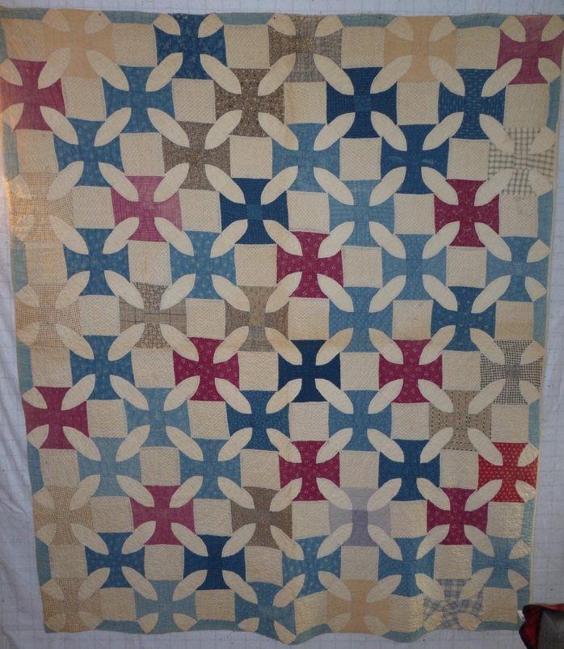 | 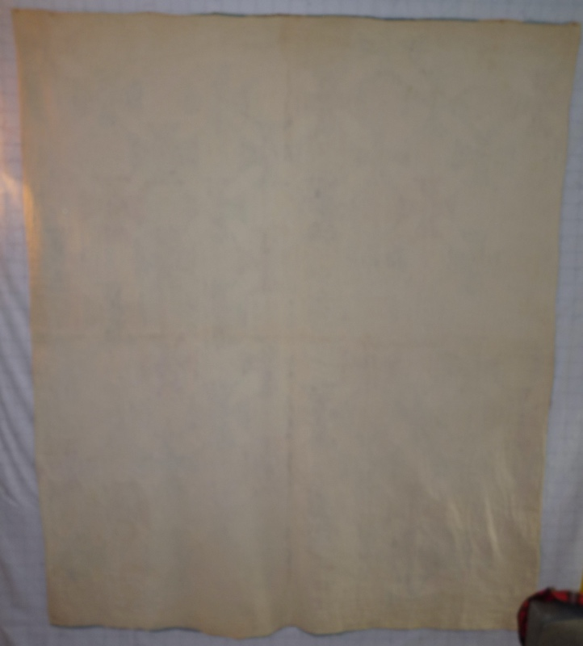

History

Provenance
Describe: --

Quilt Maker
Maker: -unknown- |  | Birth: -- |  | Death: --
 | Location: -- |  | Contributions: --

Purpose and Context
Expression
Art | Personal Enjoyment | Therapy
Income
Personal Income | Fundraising
Presentation
Anniversary | Wedding | Birth
Holiday | Birthday | Other gift
Charitable support
Relationships
Friendship | Commemorative | Memorial
Mourning | Reunion
Skill Building
Challenge / Contest | Learning / Teaching Sample
Use
Bed Quilt | Lap Quilt | Home Décor
Baby / Crib | Wall Hanging
Describe other purpose: --

Quilt Top Design & Construction

Quilt Top
Layout
. Describe: -Piecing is a variation on Papa's Delight - BB ID: 3082. The grid is made up of interlocking blocks made from octagons (crosses) and squares. The blocks are arranged in a straight setting with a half drop. 5 blocks across the width and 12 blocks along the length. The ocagons are about 7.5" and the squares are about 5". Fabrics are cotton. Antique colors are indigo blue, cadet blue, clarets, buffs and black/white prints. The quilt is given a straight edge with cadet blue fabrics.-
Piecing
Techniques
 |  | Machine pieced | String / Improvisational piecing
 |  | Hand pieced | Foundation piecing
 |  | Strip piecing | English paper piecing
 |  | Describe: --
 | Workmanship
 |  | Seams are stable | Seams are appropriately aligned
 |  | Seams are flat | Points are sharp
 |  | Describe piecing workmanship

Top Assembly
Seams are stable | Top has no inappropriate tucks or puckers
Seams are flat | Top lays flat with no overly full areas
Seams are appropriately aligned

Top Inscriptions
None Found
Inscription is present. Describe location: --
Content
Makers names | Initials | Date
Single Name | Message | Place
Multiple Names
Transcription: --

Methods
Label | Ink – Ball point | Stencil
Printed onto fabric | Ink – Felt tip | Stamped
Quilted | Ink - Other | Pencil
Embroidery | Applique | Typewriter
Describe & Clarify: --

Images for Inscriptions

Quilt Back Design & Construction

Quilt Back
Layout
. Describe: Solid white cotton - 32" max width

Stabilization Method
Stabilization Method:
Batting
Quilting Techniques
 | Machine Quilted | Machine – sit-down | Corded
 | Machine – computer guided | Hand Quilted | Stuffed work
 | Machine – manual long-arm | Quilt-as-you-go
 | Describe: --
Quilting Patterns
 | Meander / Free motion | Lines – single parallel | Cables
 | In-the-ditch / To the piece | Lines – double parallel | Feathers
 | Echo / Outlined | Lines – triple parallel | Wreaths
 | Stipple | Grid – crosshatch | Vines
 | Clamshell | Grid – square | Floral
 | Elbow / Fan | Grid - diamond | Leaves
 | Describe other: --
Thread Choices
 | Brand | Weight | Number & Name
 | -- | -- | --
Images for Quilting

Edge Finish
Edge Style:
Finishing Technique
Top Width: 0.00 “ | Binding | Rolled – top to back
Back Width: 0.00“ | Front – machine | Rolled – back to top
1/8 = 0.13, 3/8 = 0.38 | Front – hand | Knife edge
5/8 = 0.63, 7/8 = 0.88 | Back – machine | Turned
 | Back - hand
Embellishments
Fringe | Ruffles | Cording
Lace | Ribbon
Describe: -The edge treatment varies by the edge. Three edges appear to use a knife edge that was secured by hand. The fourth side is rolled from the front to the back and finished by machine. This last edge may indicate a repair.-

Images for Edge
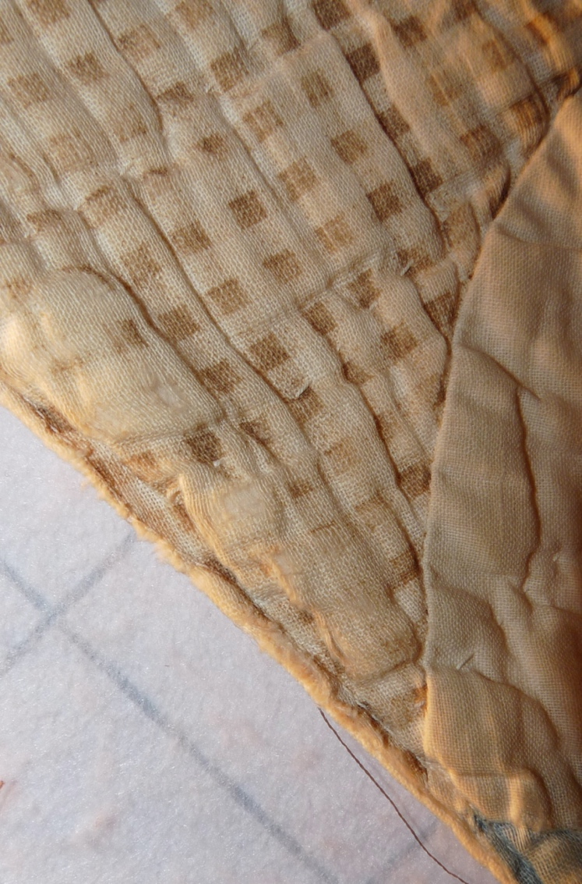 | 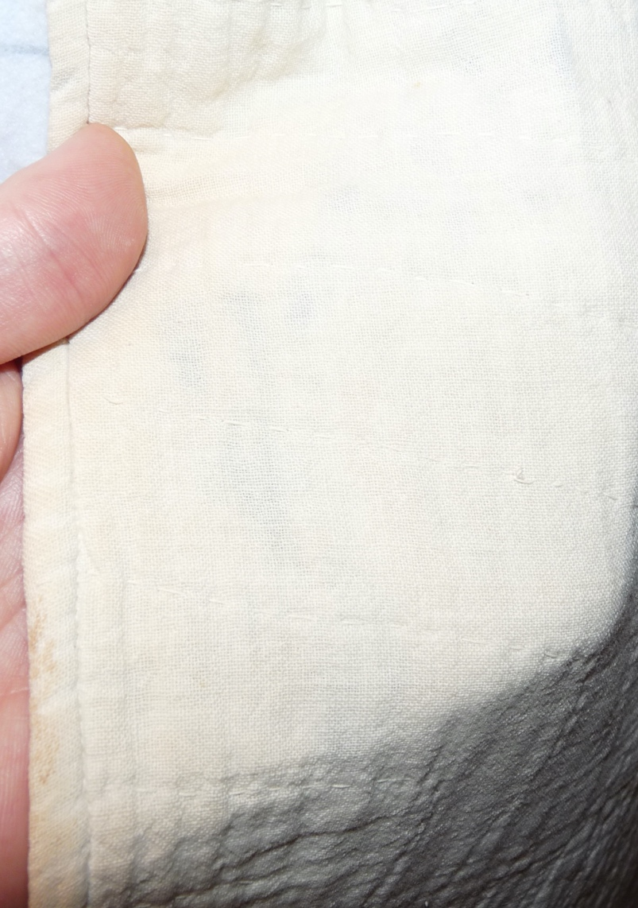

Condition

Flaws
Soiling
Dirty | Stains
Mildew stains | Musty Smell
Discoloration
Running / fugitive color | Faded / bleached color | Crocking
Fabric Damage
Tears / holes | Disintegrating / fall out | Insect damage
Thread bare | Shattering
Sewing / Quilting Damage
Split / open seams | Ties / tufting missing | Embellishments missing
Quilting threads missing | Batting has shifted
Storage Issues
Discoloration from wood | Damage from acid | Fold marks / creases
Describe additional condition issues: --
Images for Condition Issues

Conservation, Restoration, Repairs
Describe Measures: -See notes under the edge treatment.-

Workmanship

Extension of Useful Life
Repair | Useful life of the item was extended.
Prevention of Damage
Conservation | All work is reversible.
Conservation | Further deterioration has been slowed, stabilized or prevented.
Maintaining Function & Integrity
Conservation | Work minimally interferes with the item’s overall appearance.
Restoration | Work blends well with the item’s overall appearance, style and age.
Restoration | Appropriate period reproductions were used.
Restoration | Vintage materials were used.
Restoration | Period appropriate techniques were used.
Restoration | Workmanship is of similar or better quality than original work.

Images for Conservation / Restoration / Repairs

