Documentation Form

Overview

Owner History
Owner | From Date | To Date | Location | Cost
David Bailey | 2023-09 | -- | AQSG Seminar Vendor  Loiseville KY  PIQUE Antique Quilts & Textiles  Julia Kelly-Hodenius  781 572 1856  www.piquerovouver.com  pique@piquerouver.com | $50.00
 | If not purchased, the estimated cost for materials: $0

Display & Publication History
Date | Event | Location / Publication
Oct 7, 2024 | Montcomb County Quilter's Guild Meeting | Trinity Lutheran Church, Clinton Township, MI
Nov 18, 2024 | Anchor Bay Quilter’s Guild Meeting | New Baltimore, MI

General Description
Quilt Title or Name:  Glazed American Chintz Fabric | Fabric Date Range: 1825± 10 Years  Date Made: -- ± 0 Years  Method of Determination:
Item Type: | Size: Length: 24“ x Width: 17“
Appraisals:  Has this quilt been professionally appraised?  If so, when: --  ----------- | Other related files:
Additional Information: Chris Moline dated this fabric. She also feels it is American chintz based on the width of the fabric and the quality of the print.

Images
Top | Back
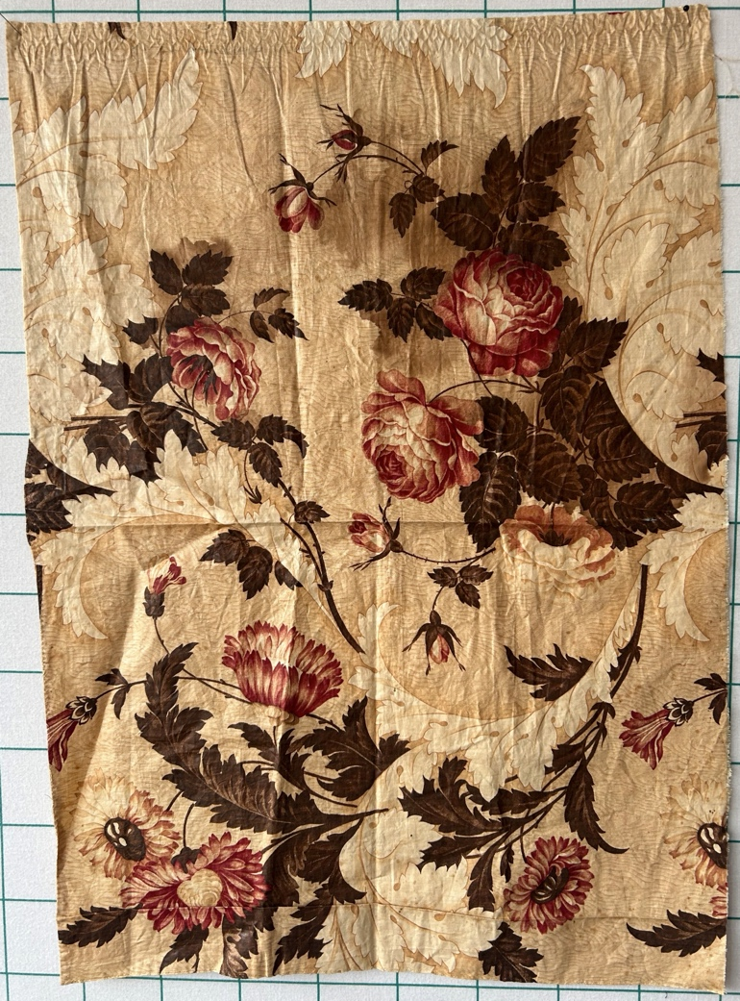 | 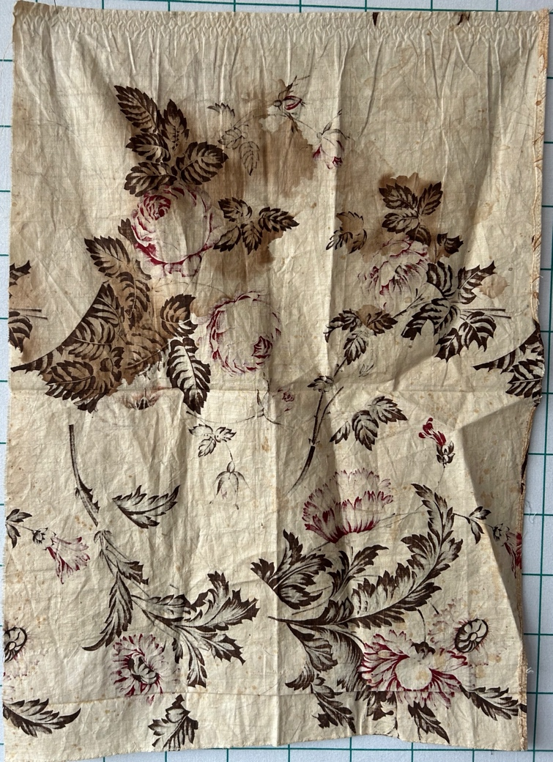

Condition

Flaws
Soiling
Dirty | Stains
Mildew stains | Musty Smell
Discoloration
Running / fugitive color | Faded / bleached color | Crocking
Fabric Damage
Tears / holes | Disintegrating / fall out | Insect damage
Thread bare | Shattering
Sewing / Quilting Damage
Split / open seams | Ties / tufting missing | Embellishments missing
Quilting threads missing | Batting has shifted
Storage Issues
Discoloration from wood | Damage from acid | Fold marks / creases
Describe additional condition issues: -Tears are small and located at creases.-
Images for Condition Issues

Conservation, Restoration, Repairs
Describe Measures: --

Workmanship

Extension of Useful Life
Repair | Useful life of the item was extended.
Prevention of Damage
Conservation | All work is reversible.
Conservation | Further deterioration has been slowed, stabilized or prevented.
Maintaining Function & Integrity
Conservation | Work minimally interferes with the item’s overall appearance.
Restoration | Work blends well with the item’s overall appearance, style and age.
Restoration | Appropriate period reproductions were used.
Restoration | Vintage materials were used.
Restoration | Period appropriate techniques were used.
Restoration | Workmanship is of similar or better quality than original work.

Images for Conservation / Restoration / Repairs

