Documentation Form

Overview

Owner History
Owner | From Date | To Date | Location | Cost
David Bailey | 2023-04-16 | -- | An antique mall in northern Indiana | $45.00
 | If not purchased, the estimated cost for materials: $0

Display & Publication History
Date | Event | Location / Publication | Pro-Rated  Reimbursement
-- | -- | -- | $0

General Description
Quilt Title or Name:  Green & Gold Inscribed Quilt | Date Made: 1935 ± 10 Years  Method of Determination:  Fabric Date Range: 1935 ± 10 Years  Method of Determination:
Item Type: | Size: Length: 73“ x Width: 66“
Appraisals:  Has this quilt been professionally appraised?  If so, when: --  ----------- | Other related files:  EQ 8 Files
Additional Information: This quilt has 48 stitched names on the front. I believe that most if not all are female. Given the colors and the location that the quilt was found, I wonder if this doesn't represent a women's college class - perhaps nursing - at a school like Notre Dame. The quilt was possibly a gift to an instructor.

Images
Top | Back
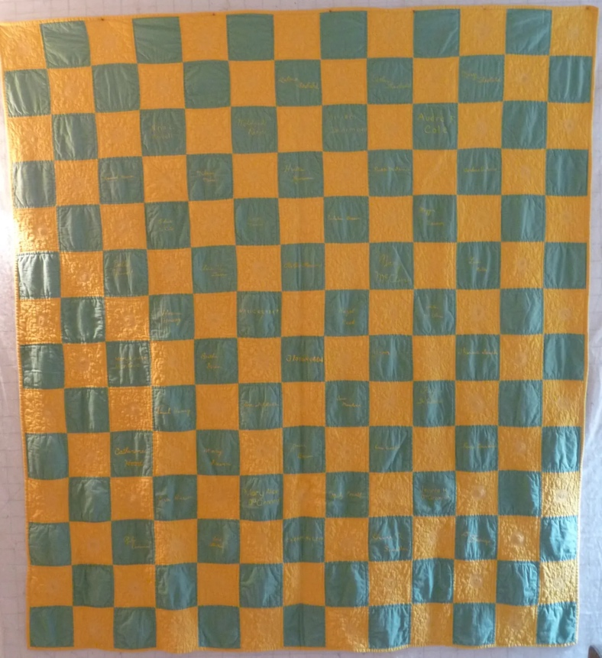 | 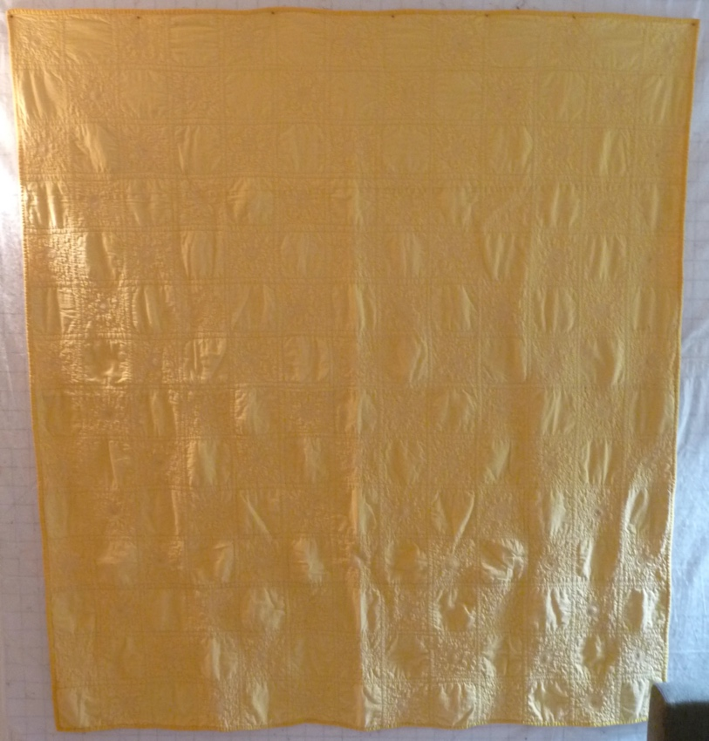

History

Provenance
Describe: --

Quilt Maker
Maker: unknown |  | Birth: -- |  | Death: --
 | Location: -- |  | Contributions: --

Purpose and Context
Expression
Art | Personal Enjoyment | Therapy
Income
Personal Income | Fundraising
Presentation
Anniversary | Wedding | Birth
Holiday | Birthday | Other gift
Charitable support
Relationships
Friendship | Commemorative | Memorial
Mourning | Reunion
Skill Building
Challenge / Contest | Learning / Teaching Sample
Use
Bed Quilt | Lap Quilt | Home Décor
Baby / Crib | Wall Hanging
Describe other purpose: --

Quilt Top Design & Construction

Quilt Top
Layout
. Describe: 14x13 grid of green and gold 5" squares set in a checker board pattern.
One Patch Shape Details
Describe: --

Piecing
Delete this & the following table rows as appropriate.
Techniques
 |  | Machine pieced | String / Improvisational piecing
 |  | Hand pieced | Foundation piecing
 |  | Strip piecing | English paper piecing
 |  | Describe: --
 | Workmanship
 |  | Seams are stable | Seams are appropriately aligned
 |  | Seams are flat | Points are sharp
 |  | Describe piecing workmanship

Embellishments
Types:
 | Applique – Raw edge | Embroidery | Stuffed Work
 | Applique - Button-hole | Cording | Inking
 | Applique - Needle-turn | Beading | Painting
 | Applique - Reverse | Rhinestones / Gems | Marking lines noted
 | Applique - Other | Other: --
Workmanship
 | Stitches are appropriately small and even.
 | Edges are as design intends (straight, curved, pointed).
 | Work demonstrates appropriate skill for intended purpose.
 | The embroidery is of the different names. it is clear that different people did the stitching - possibly each person who had a name on the quilt did their own. - As a result, the stitching quality varies.

Top Assembly
Seams are stable | Top has no inappropriate tucks or puckers
Seams are flat | Top lays flat with no overly full areas
Seams are appropriately aligned

Color
Predominant colors
 | Red | Blue | Black
 | Orange | Violet/Purple | Grey
 | Yellow | Brown | White
 | Green | Beige / Tan
Specific Antique Colors |  | NONE NOTED | Neon prints
 | Red – claret / wine | Yellow – chrome | Blue – Lancaster
 | Red – madder / cinnamon | Green - chrome | Blue – Prussian / Lafayette
 | Red – turkey | Green – Nile | Brown – madder
 | Pinks - double | Blue – Cadet | Butterscotch
 | Orange - madder | Blue - Indigo | Bronze
 | Orange – cheddar / antimony / chrome |  | Late 1800’s Purple

Materials
Sources of Fabric |  | NOT KNOWN
 | Companies | Fabric Name & Number | Designer
 | -- | -- | --
 | Describe other sources: --
Fiber Types |  | NOT YET IDENTIFIED
 | Cotton | Silk | Wool
 | Cotton Blend | Linen | Synthetic
 | Describe & Clarify: --
Fabric Types |  | NOT KNOWN
 | Broadcloth | Sateen | Upholstery
 | Flannel | Satin | Chintz
 | Shirting | Muslin | Glazed
 | Suiting | Velvet | Handwoven
 | Denim | Felt | Lindsey-Woolsey
 | Describe & Clarify: --
Print Types |  | NOT YET IDENTIFIED
 | Batik | Floral | Plaid
 | Cheater Panel | Geometric | Solid / Plain
 | Checked / Gingham | Hand-dyed | Stamped
 | Conversation / Novelty | Victorian Mourning Prints | Stripes
 | Dotted | Multiple scraps
 | Feed sack / Feed sack-like | Paisley
 | Describe & Clarify: --

Images for Top
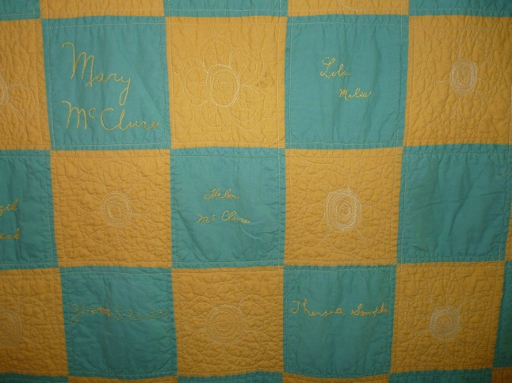

Top Inscriptions
None Found
Inscription is present. Describe location: -48 names embroidered with gold floss on green squares.-
Content
Makers names | Initials | Date
Single Name | Message | Place
Multiple Names
Transcription: --

Methods
Label | Ink – Ball point | Stencil
Printed onto fabric | Ink – Felt tip | Stamped
Quilted | Ink - Other | Pencil
Embroidery | Applique | Typewriter
Describe & Clarify: --

Images for Inscriptions

Quilt Back Design & Construction

Quilt Back
Layout
. Describe: Gold

Stabilization Method
Stabilization Method:
Batting
Quilting Techniques
 | Machine Quilted | Machine – sit-down | Corded
 | Machine – computer guided | Hand Quilted | Stuffed work
 | Machine – manual long-arm | Quilt-as-you-go
 | Describe: --
Quilting Patterns
 | Meander / Free motion | Lines – single parallel | Cables
 | In-the-ditch / To the piece | Lines – double parallel | Feathers
 | Echo / Outlined | Lines – triple parallel | Wreaths
 | Stipple | Grid – crosshatch | Vines
 | Clamshell | Grid – square | Floral
 | Elbow / Fan | Grid - diamond | Leaves
 | Describe other: --
Thread Choices
 | Brand | Weight | Number & Name
 | -- | -- | --
Images for Quilting
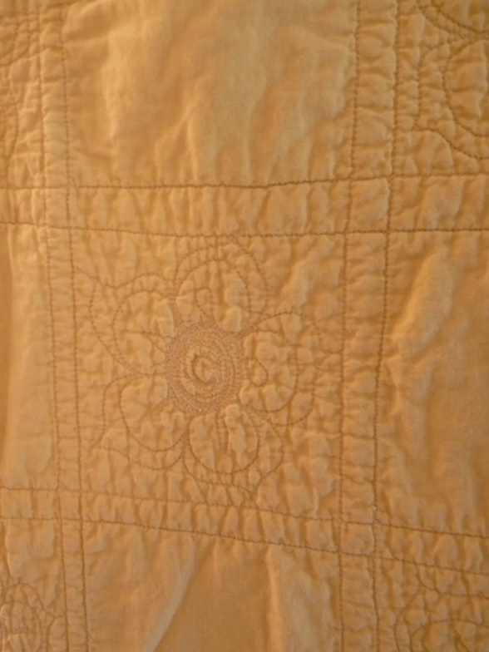

Edge Finish
Edge Style:
Finishing Technique
Top Width: 0.50 “ | Binding | Rolled – top to back
Back Width: 0.50“ | Front – machine | Rolled – back to top
1/8 = 0.13, 3/8 = 0.38 | Front – hand | Knife edge
5/8 = 0.63, 7/8 = 0.88 | Back – machine | Turned
 | Back - hand
Embellishments
Fringe | Ruffles | Cording
Lace | Ribbon
Describe: --

Images for Edge
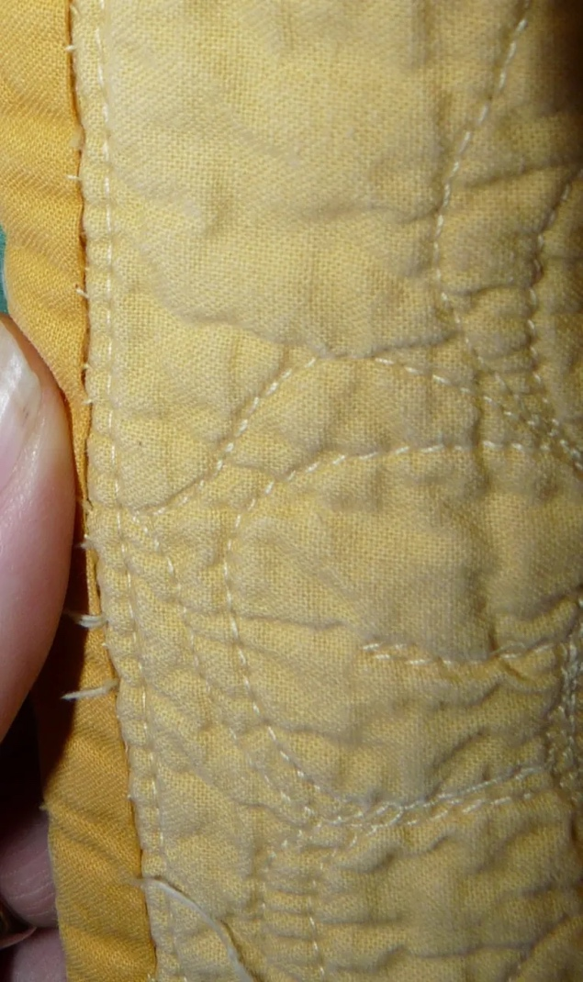

Condition

Flaws
Soiling
Dirty | Stains
Mildew stains | Musty Smell
Discoloration
Running / fugitive color | Faded / bleached color | Crocking
Fabric Damage
Tears / holes | Disintegrating / fall out | Insect damage
Thread bare | Shattering
Sewing / Quilting Damage
Split / open seams | Ties / tufting missing | Embellishments missing
Quilting threads missing | Batting has shifted
Storage Issues
Discoloration from wood | Damage from acid | Fold marks / creases
Describe additional condition issues: -The fabric may have faded over time but the fading seems even.-
Images for Condition Issues

Conservation, Restoration, Repairs
Describe Measures: --

Workmanship

Extension of Useful Life
Repair | Useful life of the item was extended.
Prevention of Damage
Conservation | All work is reversible.
Conservation | Further deterioration has been slowed, stabilized or prevented.
Maintaining Function & Integrity
Conservation | Work minimally interferes with the item’s overall appearance.
Restoration | Work blends well with the item’s overall appearance, style and age.
Restoration | Appropriate period reproductions were used.
Restoration | Vintage materials were used.
Restoration | Period appropriate techniques were used.
Restoration | Workmanship is of similar or better quality than original work.

Images for Conservation / Restoration / Repairs

