Documentation Form

Overview

Owner History
Owner | From Date | To Date | Location | Cost
David Bailey | 2023-04-23 | -- | Antiques and more  606 S Staley Road Suite A  Champaign, IL 61822  217 351 3488  Claire "Quilts"  217 778 8454 | $70.00
 | If not purchased, the estimated cost for materials: $0

Display & Publication History
Date | Event | Location / Publication
Oct 7, 2024 | Montcomb County Quilter's Guild Meeting | Trinity Lutheran Church, Clinton Township, MI
Nov 18, 2024 | Anchor Bay Quilter’s Guild Meeting | New Baltimore, MI

General Description
Quilt Title or Name:  Blue & White Crescent Star | Date Made: 1925 ± 10 Years  Method of Determination:  Fabric Date Range: 1925 ± 10 Years  Method of Determination:
Item Type: | Size: Length: 85“ x Width: 83“
Appraisals:  Has this quilt been professionally appraised?  If so, when: --  ----------- | Other related files:
Additional Information: This quilt was bought directly from the vendor whom I met in the antique store stocking her booth. She sold me this quilt and then one other by mail. The vendor claimed that both quilts were made by two sisters who were born in the 1880's.
I have a very difficult time identifying age from solid fabrics. The blue - as shown in the pictures - is thread bare and faded. But evenly so. The fabric is fairly thin - even where it is not worn.

Images
Top | Back
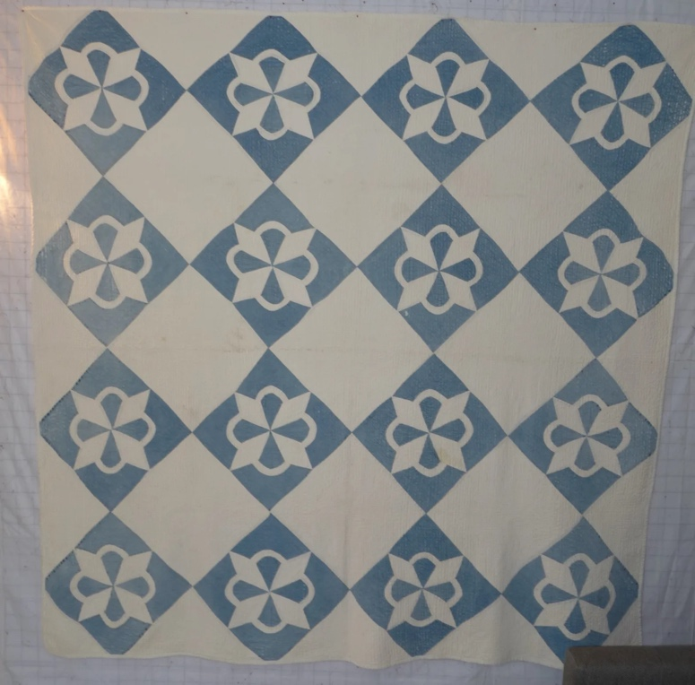 | 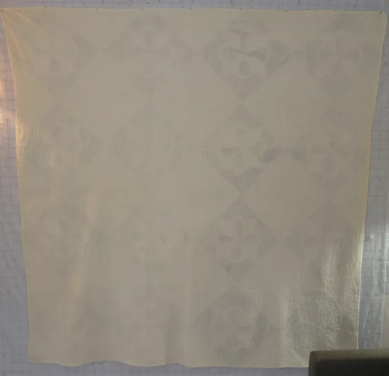

History

Provenance
Describe:

Quilt Maker
Maker: unknown |  | Birth: -- |  | Death: --
 | Location: -- |  | Contributions: --

Purpose and Context
Expression
Art | Personal Enjoyment | Therapy
Income
Personal Income | Fundraising
Presentation
Anniversary | Wedding | Birth
Holiday | Birthday | Other gift
Charitable support
Relationships
Friendship | Commemorative | Memorial
Mourning | Reunion
Skill Building
Challenge / Contest | Learning / Teaching Sample
Use
Bed Quilt | Lap Quilt | Home Décor
Baby / Crib | Wall Hanging
Describe other purpose: --

Quilt Top Design & Construction

Quilt Top
Layout
. Describe: This is a 4x4 on-point grid with a full drop. Alternate blocks are white. Pieced blocks are blue and white and feature a crescent star. The blocks range between 13" and 14".
Block Pattern Details
 | Pattern source | <<Pattern Image>>
 | BB ID 3902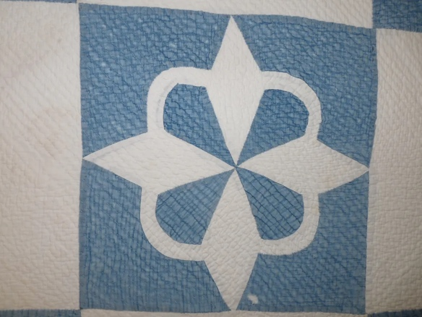

Piecing
Techniques
 |  | Machine pieced | String / Improvisational piecing
 |  | Hand pieced | Foundation piecing
 |  | Strip piecing | English paper piecing
 |  | Describe: --
 | Workmanship
 |  | Seams are stable | Seams are appropriately aligned
 |  | Seams are flat | Points are sharp
 |  | Describe piecing workmanship

Top Assembly
Seams are stable | Top has no inappropriate tucks or puckers
Seams are flat | Top lays flat with no overly full areas
Seams are appropriately aligned

Color
Predominant colors
 | Red | Blue | Black
 | Orange | Violet/Purple | Grey
 | Yellow | Brown | White
 | Green | Beige / Tan
Specific Antique Colors |  | NONE NOTED | Neon prints
 | Red – claret / wine | Yellow – chrome | Blue – Lancaster
 | Red – madder / cinnamon | Green - chrome | Blue – Prussian / Lafayette
 | Red – turkey | Green – Nile | Brown – madder
 | Pinks - double | Blue – Cadet | Butterscotch
 | Orange - madder | Blue - Indigo | Bronze
 | Orange – cheddar / antimony / chrome |  | Late 1800’s Purple

Materials
Sources of Fabric |  | NOT KNOWN
 | Companies | Fabric Name & Number | Designer
 | -- | -- | --
 | Describe other sources: --
Fiber Types |  | NOT YET IDENTIFIED
 | Cotton | Silk | Wool
 | Cotton Blend | Linen | Synthetic
 | Describe & Clarify: --
Fabric Types |  | NOT KNOWN
 | Broadcloth | Sateen | Upholstery
 | Flannel | Satin | Chintz
 | Shirting | Muslin | Glazed
 | Suiting | Velvet | Handwoven
 | Denim | Felt | Lindsey-Woolsey
 | Describe & Clarify: --
Print Types |  | NOT YET IDENTIFIED
 | Batik | Floral | Plaid
 | Cheater Panel | Geometric | Solid / Plain
 | Checked / Gingham | Hand-dyed | Stamped
 | Conversation / Novelty | Victorian Mourning Prints | Stripes
 | Dotted | Multiple scraps
 | Feed sack / Feed sack-like | Paisley
 | Describe & Clarify: --

Images for Top
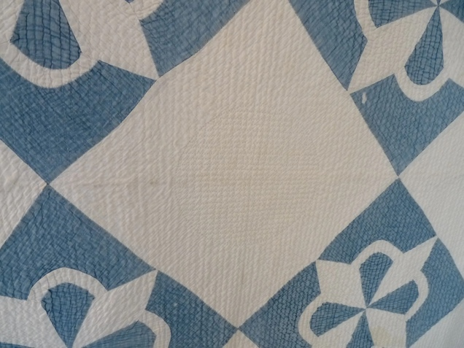

Top Inscriptions
None Found
Inscription is present. Describe location: --
Content
Makers names | Initials | Date
Single Name | Message | Place
Multiple Names
Transcription: --

Methods
Label | Ink – Ball point | Stencil
Printed onto fabric | Ink – Felt tip | Stamped
Quilted | Ink - Other | Pencil
Embroidery | Applique | Typewriter
Describe & Clarify: --

Images for Inscriptions

Quilt Back Design & Construction

Quilt Back
Layout
. Describe: White with several seams.

Back Assembly
Seams are stable | Back has no inappropriate tucks or puckers
Seams are flat | Back lays flat with no overly full areas
Seams are appropriately aligned

Color
Predominant colors
 | Red | Blue | Black
 | Orange | Violet/Purple | Grey
 | Yellow | Brown | White
 | Green | Beige / Tan
Specific Antique Colors |  | NONE NOTED | Neon prints
 | Red – claret / wine | Yellow – chrome | Blue – Lancaster
 | Red – madder / cinnamon | Green - chrome | Blue – Prussian / Lafayette
 | Red – turkey | Green – Nile | Brown – madder
 | Pinks - double | Blue – Cadet | Butterscotch
 | Orange - madder | Blue - Indigo | Bronze
 | Orange – cheddar / antimony / chrome |  | Late 1800’s Purple

Materials
Sources of Fabric |  | NOT KNOWN
 | Companies | Fabric Name & Number | Designer
 | -- | -- | --
 | Describe other sources: --
Fiber Types |  | NOT YET IDENTIFIED
 | Cotton | Silk | Wool
 | Cotton Blend | Linen | Synthetic
 | Describe & Clarify: --
Fabric Types |  | NOT KNOWN
 | Broadcloth | Sateen | Upholstery
 | Flannel | Satin | Chintz
 | Shirting | Muslin | Glazed
 | Suiting | Velvet | Handwoven
 | Denim | Felt | Lindsey-Woolsey
 | Describe & Clarify: --
Print Types |  | NOT YET IDENTIFIED
 | Batik | Floral | Plaid
 | Cheater Panel | Geometric | Solid / Plain
 | Checked / Gingham | Hand-dyed | Stamped
 | Conversation / Novelty | Victorian Mourning Prints | Stripes
 | Dotted | Multiple scraps
 | Feed sack / Feed sack-like | Paisley
 | Describe & Clarify: --

Images for Back

Back Inscriptions
None found
Inscription is present. Describe location: --
Content
Makers names | Initials | Date
Single Name | Message | Place
Multiple Names
Transcription: --

Methods
Label | Ink – Ball point | Stencil
Printed onto fabric | Ink – Felt tip | Stamped
Quilted | Ink - Other | Pencil
Embroidery | Applique | Typewriter
Describe & Clarify: --

Images for Back

Stabilization Method
Stabilization Method:
Batting
Quilting Techniques
 | Machine Quilted | Machine – sit-down | Corded
 | Machine – computer guided | Hand Quilted | Stuffed work
 | Machine – manual long-arm | Quilt-as-you-go
 | Describe: --
Quilting Patterns
 | Meander / Free motion | Lines – single parallel | Cables
 | In-the-ditch / To the piece | Lines – double parallel | Feathers
 | Echo / Outlined | Lines – triple parallel | Wreaths
 | Stipple | Grid – crosshatch | Vines
 | Clamshell | Grid – square | Floral
 | Elbow / Fan | Grid - diamond | Leaves
 | Describe other: --
Thread Choices
 | Brand | Weight | Number & Name
 | -- | -- | --
Images for Quilting
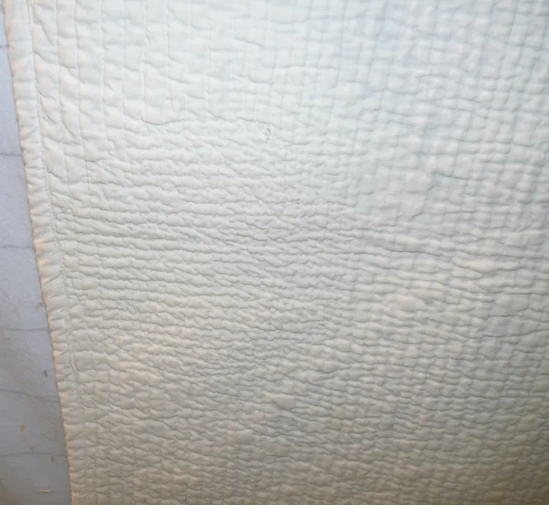

Edge Finish
Edge Style:
Finishing Technique
Top Width: 0.50 “ | Binding | Rolled – top to back
Back Width: 0.50“ | Front – machine | Rolled – back to top
1/8 = 0.13, 3/8 = 0.38 | Front – hand | Knife edge
5/8 = 0.63, 7/8 = 0.88 | Back – machine | Turned
 | Back - hand
Embellishments
Fringe | Ruffles | Cording
Lace | Ribbon
Describe: -This is likely a replacement binding. The thread count of the binding seems higher than the fabric used in the quilt.

Images for Edge
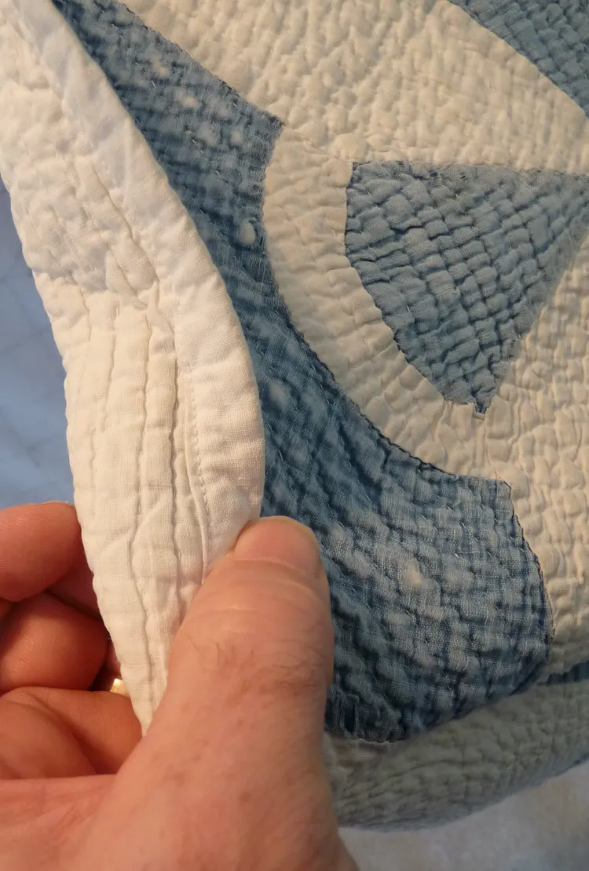

Condition

Flaws
Soiling
Dirty | Stains
Mildew stains | Musty Smell
Discoloration
Running / fugitive color | Faded / bleached color | Crocking
Fabric Damage
Tears / holes | Disintegrating / fall out | Insect damage
Thread bare | Shattering
Sewing / Quilting Damage
Split / open seams | Ties / tufting missing | Embellishments missing
Quilting threads missing | Batting has shifted
Storage Issues
Discoloration from wood | Damage from acid | Fold marks / creases
Describe additional condition issues: There are no stains to speak of. The bigggest issues are the fading and that most of the fabric is wearing thin.
Images for Condition Issues
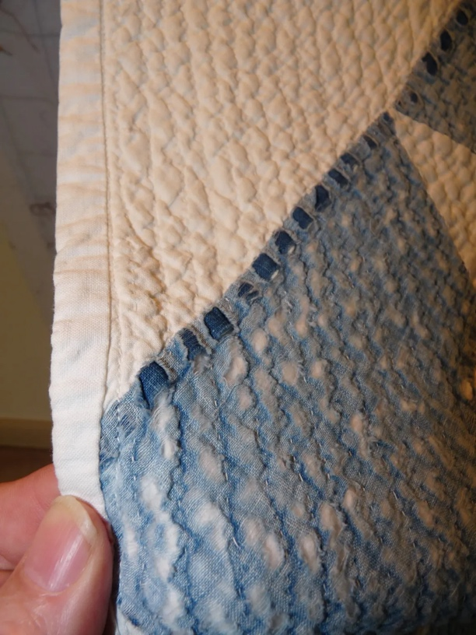

Conservation, Restoration, Repairs
Describe Measures: --

Workmanship

Extension of Useful Life
Repair | Useful life of the item was extended.
Prevention of Damage
Conservation | All work is reversible.
Conservation | Further deterioration has been slowed, stabilized or prevented.
Maintaining Function & Integrity
Conservation | Work minimally interferes with the item’s overall appearance.
Restoration | Work blends well with the item’s overall appearance, style and age.
Restoration | Appropriate period reproductions were used.
Restoration | Vintage materials were used.
Restoration | Period appropriate techniques were used.
Restoration | Workmanship is of similar or better quality than original work.

Images for Conservation / Restoration / Repairs

