Documentation Form

Overview

Owner History
Owner | From Date | To Date | Location | Cost
David Bailey | July 31 2022 | -- | Vendor at the Allegan County Fairgrounds Antique Fair, MI | $25.00
 | If not purchased, the estimated cost for materials: $0
The set of 32 cost $25.
This is $1.28 per block.
There are two blocks left. Those cost $2.56 for the set.

Display & Publication History
Date | Event | Location / Publication | Pro-Rated  Reimbursement
-- | -- | -- | $0

General Description
Quilt Title or Name:  Log Cabin Blocks | Date Made: 2000  Exact  circa +/- 10 Years  Method of Determination:  Fabric Range: 2000 +/- 10
Item Type: | Size: Length: 10“ x Width: 11“
Appraisals:  Has this quilt been professionally appraised?  If so, when: --  ----------- | Other related files:  Sample 0064b
Additional Information:
July 31, 2022 - I bought a set of 32 blocks for $25. The blocks were not well made. The logs were not even and they were off of square by 0.75".

September 15, 2022 - I used 30 of the blocks to make a quilt. This item is listed as sample 64b.

Images
Initial Set | Remaining Two
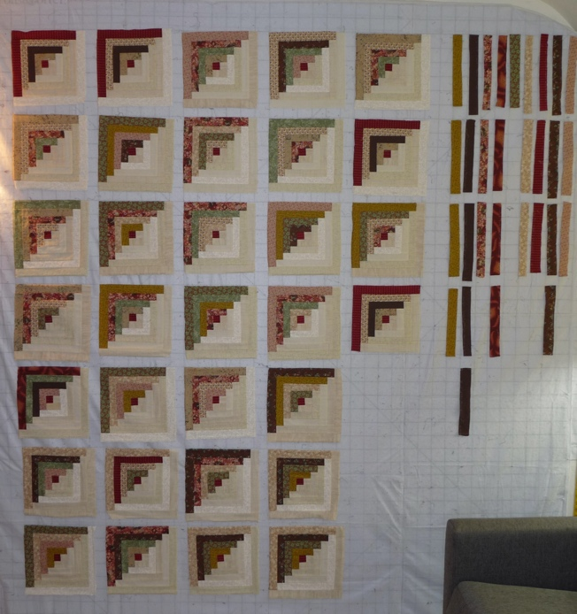 | 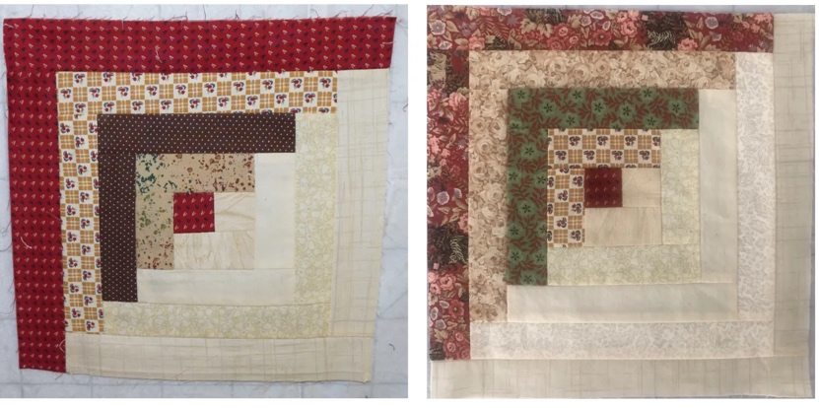

History

Provenance
Describe: --

Quilt Maker
Maker: unkonwn |  | Birth: -- |  | Death: --
 | Location: -- |  | Contributions: --

Quilt Top Design & Construction

Quilt Top
Layout
Block Pattern Details
Pattern source
Log Cabin Block BB ID 2576

Color
Predominant colors
 | Red | Blue | Black
 | Orange | Violet/Purple | Grey
 | Yellow | Brown | White
 | Green | Beige / Tan
Specific Antique Colors |  | NONE NOTED
 | Red – claret / wine | Yellow – chrome | Blue – Lancaster
 | Red – madder / cinnamon | Green - chrome | Blue – Prussian / Lafayette
 | Red – turkey | Green – Nile | Brown – madder
 | Pinks - double | Blue – Cadet | Butterscotch
 | Orange - madder | Blue - Indigo | Bronze
 | Orange – cheddar / antimony / chrome |  | Late 1800’s Purple

Materials
Sources of Fabric |  | NOT KNOWN
 | Companies | Fabric Name & Number | Designer
 | -- | -- | --
 | Describe other sources: --
Fiber Types |  | NOT YET IDENTIFIED
 | Cotton | Silk | Wool
 | Cotton Blend | Linen | Synthetic
 | Describe & Clarify: --
Fabric Types |  | NOT KNOWN
 | Broadcloth | Sateen | Upholstery
 | Flannel | Satin | Chintz
 | Shirting | Muslin | Glazed
 | Suiting | Velvet | Handwoven
 | Denim | Felt | Lindsey-Woolsey
 | Describe & Clarify: --
Print Types |  | NOT YET IDENTIFIED
 | Batik | Floral | Plaid
 | Cheater Panel | Geometric | Solid / Plain
 | Checked / Gingham | Hand-dyed | Stamped
 | Conversation / Novelty | Victorian Mourning Prints | Stripes
 | Dotted | Multiple scraps
 | Feed sack / Feed sack-like | Paisley
 | Describe & Clarify: --

Condition

Flaws
Soiling
Dirty | Stains
Mildew stains | Musty Smell
Discoloration
Running / fugitive color | Faded / bleached color | Crocking
Fabric Damage
Tears / holes | Disintegrating / fall out | Insect damage
Thread bare | Shattering
Sewing / Quilting Damage
Split / open seams | Ties / tufting missing | Embellishments missing
Quilting threads missing | Batting has shifted
Storage Issues
Discoloration from wood | Damage from acid | Fold marks / creases
Describe additional condition issues: Aside from the fact that they were not pieced accurately, the fabric was in good shape.
Images for Condition Issues

Conservation, Restoration, Repairs
Describe Measures: None

Workmanship

Extension of Useful Life
Repair | Useful life of the item was extended.
Prevention of Damage
Conservation | All work is reversible.
Conservation | Further deterioration has been slowed, stabilized or prevented.
Maintaining Function & Integrity
Conservation | Work minimally interferes with the item’s overall appearance.
Restoration | Work blends well with the item’s overall appearance, style and age.
Restoration | Appropriate period reproductions were used.
Restoration | Vintage materials were used.
Restoration | Period appropriate techniques were used.
Restoration | Workmanship is of similar or better quality than original work.

Images for Conservation / Restoration / Repairs

