Documentation Form

Overview

Owner History
Owner | From Date | To Date | Location | Cost
David Bailey | 2022-07 | -- | Flint, MI | $0.00
 | If not purchased, the estimated cost for materials: $55

Display & Publication History
Date | Event | Location / Publication | Pro-Rated  Reimbursement
-- | -- | -- | $0

General Description
Quilt Title or Name:  Bird in Flight | Date Made: 2021-07 ± 0 Years  Method of Determination:  Fabric Date Range: 2021 ± 0 Years  Method of Determination:
Item Type: | Size: Length: 33“ x Width: 33“
Appraisals:  Has this quilt been professionally appraised?  If so, when: --  ----------- | Other related files:  EQ 8 Files  Inspirational Image A  Inspirational Image B  Inspirational Image C
Additional Information: This quilt was inspired by a wonky log-cabin block that I saw. It was used to form something like a palm leaf. The more I worked with the design, the more it reminded me of bird wings…. Design, piecing, quilting, binding by David Bailey. So, I guess this is one of the first times that I created something from beginning to end.`

Images
Top | Back
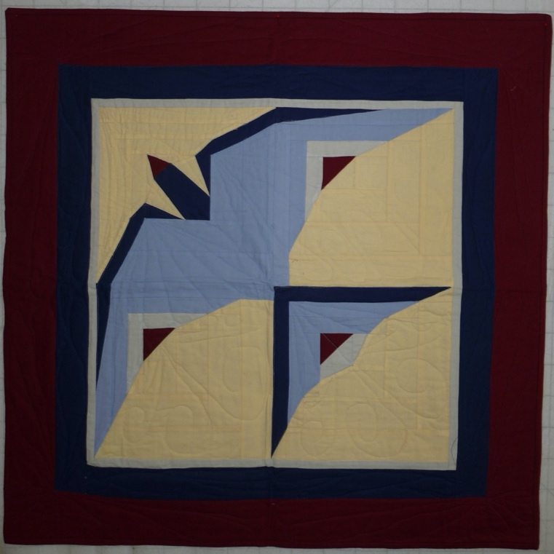 | 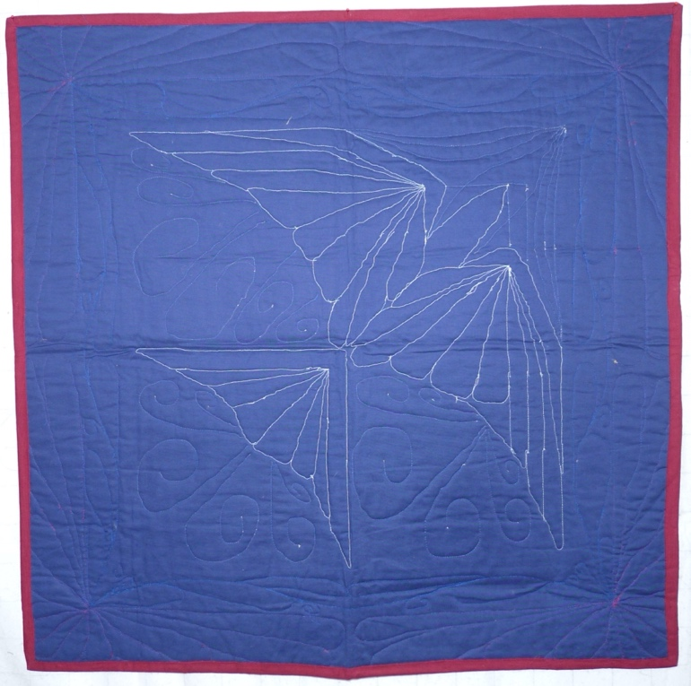

History

Provenance
Describe: --

Quilt Maker
Maker: `David Bailey -- |  | Birth: July 20, 1967 |  | Death: --
 | Location: Flint, MI |  | Contributions: Design, fabric choice, piecing, quilting, binding

Purpose and Context
Expression
Art | Personal Enjoyment | Therapy
Income
Personal Income | Fundraising
Presentation
Anniversary | Wedding | Birth
Holiday | Birthday | Other gift
Charitable support
Relationships
Friendship | Commemorative | Memorial
Mourning | Reunion
Skill Building
Challenge / Contest | Learning / Teaching Sample
Use
Bed Quilt | Lap Quilt | Home Décor
Baby / Crib | Wall Hanging
Describe other purpose: --

Quilt Top Design & Construction

Quilt Top
Layout
. Describe: 4 blocks in a 2x2 grid. The blocks are a modified log-cabin block so that the halves of the block have unequal areas. Fabrics are placed to depict a bird in flight.
Blocks
Grid & Contained Crazy Details
Grid Dimensions: Length 2 x Width: 2
Block Size: Length: 0“ x Width: 0“

Piecing
Techniques
 |  | Machine pieced | String / Improvisational piecing
 |  | Hand pieced | Foundation piecing
 |  | Strip piecing | English paper piecing
 |  | Describe: --
 | Workmanship
 |  | Seams are stable | Seams are appropriately aligned
 |  | Seams are flat | Points are sharp
 |  | Describe piecing workmanship

Borders & Frames
Delete this & the following table rows as appropriate.
Describe borders and frames in order from center to edge.
1 | Width: 0.00“
 |  | Describe: Light blue
2 | Width: 0.00“
 |  | Describe: Dark Blue
3 | Width: 0.00“
 |  | Describe: Maroon

Top Assembly
Seams are stable | Top has no inappropriate tucks or puckers
Seams are flat | Top lays flat with no overly full areas
Seams are appropriately aligned

Color
Predominant colors
 | Red | Blue | Black
 | Orange | Violet/Purple | Grey
 | Yellow | Brown | White
 | Green | Beige / Tan
Specific Antique Colors |  | NONE NOTED | Neon prints
 | Red – claret / wine | Yellow – chrome | Blue – Lancaster
 | Red – madder / cinnamon | Green - chrome | Blue – Prussian / Lafayette
 | Red – turkey | Green – Nile | Brown – madder
 | Pinks - double | Blue – Cadet | Butterscotch
 | Orange - madder | Blue - Indigo | Bronze
 | Orange – cheddar / antimony / chrome |  | Late 1800’s Purple

Materials
Sources of Fabric |  | NOT KNOWN
 | Companies | Fabric Name & Number | Designer
 | Kona | Butter 1055 | --
 | Kona | Grapemist 318 | --
 | Kona | Nightfall 140 | --
 | Kona | Crimson 1091 | --
 | Describe other sources: -Light blue and grey from unknown sources.-
Fiber Types |  | NOT YET IDENTIFIED
 | Cotton | Silk | Wool
 | Cotton Blend | Linen | Synthetic
 | Describe & Clarify: --
Fabric Types |  | NOT KNOWN
 | Broadcloth | Sateen | Upholstery
 | Flannel | Satin | Chintz
 | Shirting | Muslin | Glazed
 | Suiting | Velvet | Handwoven
 | Denim | Felt | Lindsey-Woolsey
 | Describe & Clarify: --
Print Types |  | NOT YET IDENTIFIED
 | Batik | Floral | Plaid
 | Cheater Panel | Geometric | Solid / Plain
 | Checked / Gingham | Hand-dyed | Stamped
 | Conversation / Novelty | Victorian Mourning Prints | Stripes
 | Dotted | Multiple scraps
 | Feed sack / Feed sack-like | Paisley
 | Describe & Clarify: --

Images for Top
 | 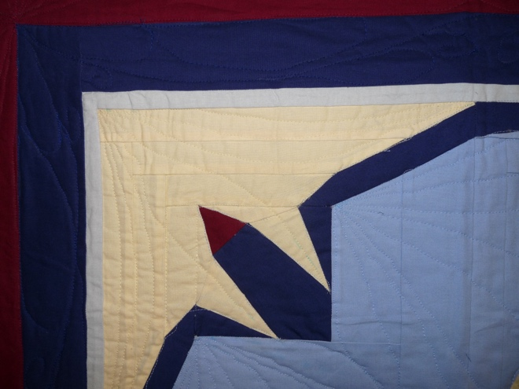 | 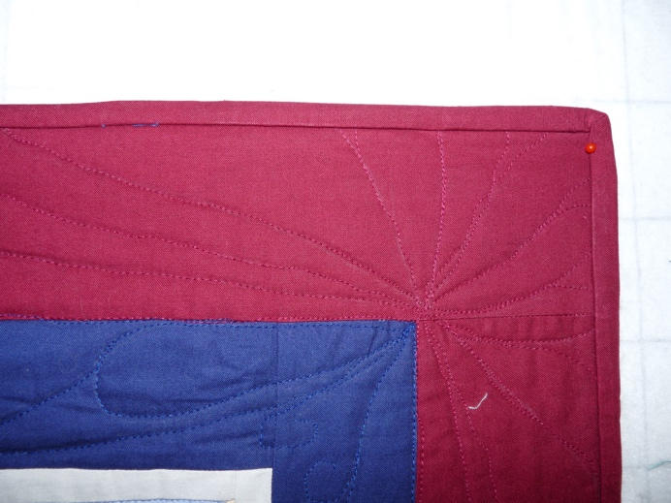
 | 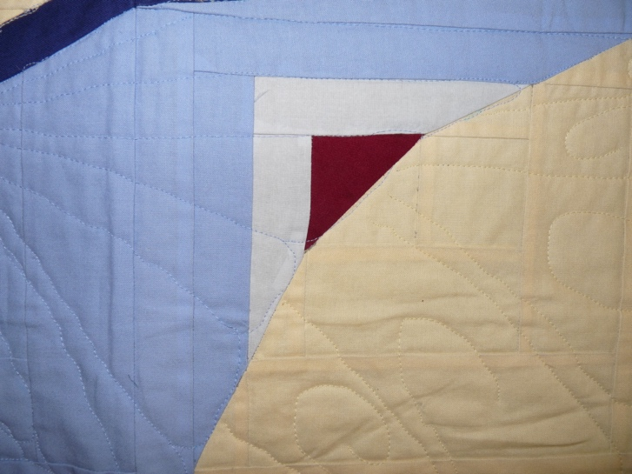

Top Inscriptions
None Found

Quilt Back Design & Construction

Quilt Back
Layout
. Describe: --

Color
Predominant colors
 | Red | Blue | Black
 | Orange | Violet/Purple | Grey
 | Yellow | Brown | White
 | Green | Beige / Tan
Specific Antique Colors |  | NONE NOTED | Neon prints
 | Red – claret / wine | Yellow – chrome | Blue – Lancaster
 | Red – madder / cinnamon | Green - chrome | Blue – Prussian / Lafayette
 | Red – turkey | Green – Nile | Brown – madder
 | Pinks - double | Blue – Cadet | Butterscotch
 | Orange - madder | Blue - Indigo | Bronze
 | Orange – cheddar / antimony / chrome |  | Late 1800’s Purple

Back Inscriptions
None found
Inscription is present. Describe location: --
Content
Makers names | Initials | Date
Single Name | Message | Place
Multiple Names
Transcription: --

Methods
Label | Ink – Ball point | Stencil
Printed onto fabric | Ink – Felt tip | Stamped
Quilted | Ink - Other | Pencil
Embroidery | Applique | Typewriter
Describe & Clarify: --

Stabilization Method
Stabilization Method:
Batting
Quilting Techniques
 | Machine Quilted | Machine – sit-down | Corded
 | Machine – computer guided | Hand Quilted | Stuffed work
 | Machine – manual long-arm | Quilt-as-you-go
 | Describe: --
Quilting Patterns
 | Meander / Free motion | Lines – single parallel | Cables
 | In-the-ditch / To the piece | Lines – double parallel | Feathers
 | Echo / Outlined | Lines – triple parallel | Wreaths
 | Stipple | Grid – crosshatch | Vines
 | Clamshell | Grid – square | Floral
 | Elbow / Fan | Grid - diamond | Leaves
 | Describe other: --
Thread Choices
 | Brand | Weight | Number & Name
 | -- | -- | --
Images for Quilting

Edge Finish
Edge Style:
Finishing Technique
Top Width: 0.00 “ | Binding | Rolled – top to back
Back Width: 0.00“ | Front – machine | Rolled – back to top
1/8 = 0.13, 3/8 = 0.38 | Front – hand | Knife edge
5/8 = 0.63, 7/8 = 0.88 | Back – machine | Turned
 | Back - hand
Embellishments
Fringe | Ruffles | Cording
Lace | Ribbon
Describe: --

Images for Edge

Condition

Flaws
Soiling
Dirty | Stains
Mildew stains | Musty Smell
Discoloration
Running / fugitive color | Faded / bleached color | Crocking
Fabric Damage
Tears / holes | Disintegrating / fall out | Insect damage
Thread bare | Shattering
Sewing / Quilting Damage
Split / open seams | Ties / tufting missing | Embellishments missing
Quilting threads missing | Batting has shifted
Storage Issues
Discoloration from wood | Damage from acid | Fold marks / creases
Describe additional condition issues: There is a difference between condition and workmanship. Condition here is good. Workmanship is not.
Images for Condition Issues

Conservation, Restoration, Repairs
Describe Measures: --

Workmanship

Extension of Useful Life
Repair | Useful life of the item was extended.
Prevention of Damage
Conservation | All work is reversible.
Conservation | Further deterioration has been slowed, stabilized or prevented.
Maintaining Function & Integrity
Conservation | Work minimally interferes with the item’s overall appearance.
Restoration | Work blends well with the item’s overall appearance, style and age.
Restoration | Appropriate period reproductions were used.
Restoration | Vintage materials were used.
Restoration | Period appropriate techniques were used.
Restoration | Workmanship is of similar or better quality than original work.

Images for Conservation / Restoration / Repairs

