Documentation Form

Overview

Owner History
Owner | From Date | To Date | Location | Cost
David Bailey | 2024-07 | -- | Naperville, IL | $0.00
 | If not purchased, the estimated cost for materials: $0

Display & Publication History
Date | Event | Location / Publication
Oct 7, 2024 | Montcomb County Quilter's Guild Meeting | Trinity Lutheran Church, Clinton Township, MI
Nov 18, 2024 | Anchor Bay Quilter’s Guild Meeting | New Baltimore, MI

General Description
Quilt Title or Name:  Glazed Chintz Quilt Block | Date Made: 1840 ± 10 Years  Fabric Date Range: 1840± 10 Years  Method of Determination:
Item Type: | Size: Length: 12“ x Width: 11“
Appraisals:  Has this quilt been professionally appraised?  If so, when: --  ----------- | Other related files:
Additional Information: -This piece was given to me by Chris Moline who received it from a retiring appraiser. It is likely cut out of a larger quilt and shows part of a whole cloth pillar print on both sides. The front - as shown here - is in better shape than the back. The piece is quilted, but unbound.

Images
Top | Back
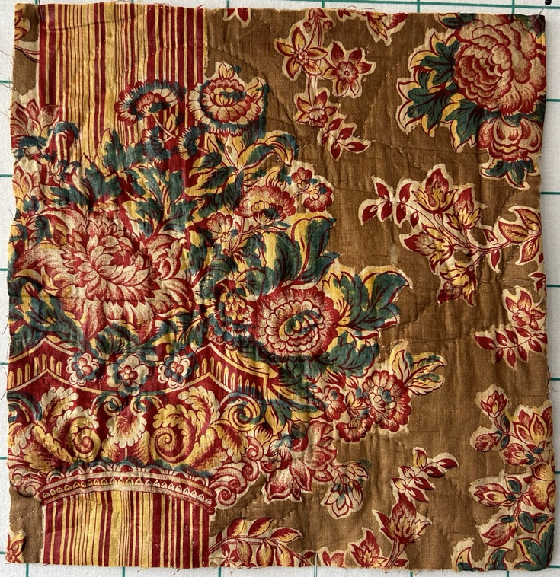 | 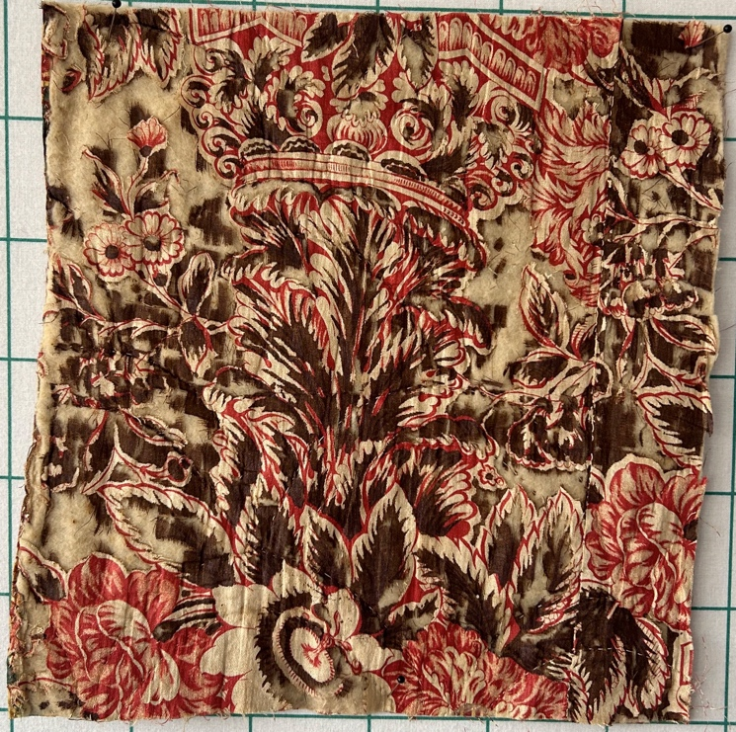

History

Provenance
Describe: --

Quilt Maker
Maker: -unknown- |  | Birth: -- |  | Death: --
 | Location: -- |  | Contributions: --

Purpose and Context
Expression
Art | Personal Enjoyment | Therapy
Income
Personal Income | Fundraising
Presentation
Anniversary | Wedding | Birth
Holiday | Birthday | Other gift
Charitable support
Relationships
Friendship | Commemorative | Memorial
Mourning | Reunion
Skill Building
Challenge / Contest | Learning / Teaching Sample
Use
Bed Quilt | Lap Quilt | Home Décor
Baby / Crib | Wall Hanging
Describe other purpose: --

Stabilization Method
Stabilization Method:
Batting
Quilting Techniques
 | Machine Quilted | Machine – sit-down | Corded
 | Machine – computer guided | Hand Quilted | Stuffed work
 | Machine – manual long-arm | Quilt-as-you-go
 | Describe: --
Quilting Patterns
 | Meander / Free motion | Lines – single parallel | Cables
 | In-the-ditch / To the piece | Lines – double parallel | Feathers
 | Echo / Outlined | Lines – triple parallel | Wreaths
 | Stipple | Grid – crosshatch | Vines
 | Clamshell | Grid – square | Floral
 | Elbow / Fan | Grid - diamond | Leaves
 | Describe other: --
Thread Choices
 | Brand | Weight | Number & Name
 | -- | -- | --
Images for Quilting

Condition

Flaws
Soiling
Dirty | Stains
Mildew stains | Musty Smell
Discoloration
Running / fugitive color | Faded / bleached color | Crocking
Fabric Damage
Tears / holes | Disintegrating / fall out | Insect damage
Thread bare | Shattering
Sewing / Quilting Damage
Split / open seams | Ties / tufting missing | Embellishments missing
Quilting threads missing | Batting has shifted
Storage Issues
Discoloration from wood | Damage from acid | Fold marks / creases
Describe additional condition issues: -The fall out is primarly on one side.-
Images for Condition Issues

